**Pet Diet and HealthCare Planner**

**By**

Mahpara Saleem

01-235142-028

**Supervised by**

Miss. Saima Jawad

In partial fulfillment of requirement for the client

# 

# Certificate

I, Mahpara Saleem stated that the project ’Pet Diet and Healthcare Planner’ and the work offered in it, is my own. From where I have checked the available effort and support, this is openly mentioned in this document. I have clearly accredited the core resources of support.

__________________ __________________

Dr. Faisal Bashir Supervisor: Mrs. Saima Jawad

__________________ __________________

Internal Examiner External Examiner

# Abstract

Pet Diet and Healthcare Planner is an industrial project which is being designed and developed for the Islamabad Pets & AVIAN Hospital G-10/4. Currently project focuses on cats, dogs, chickens/hens, parrots and fishes and their common breeds. Android Application is supportive to generate daily and weekly diet plans (according to their age and specie), notify the owner on the proper timings that when their pet need food and also provide pet diseases and treatment suggestions. Users can take the appointment through android application and as well as through website. Website user can view information like hospital services etc as per hospital requirement.

Contents

Certificate i

Acknowledgements ii

Abstract iii

Chapter # 1 2

Introduction 2

1.1 Background 3

1.2 Problem Description 3

1.3 Objectives 4

1.4 Project Scope 4

Chapter # 2 5

Literature Review 5

2.1 Dog Walk 6

2.2 My Pet Reminders 7

2.3 Dog Sync 8

2.4 ASPCA Pet Safety 9

2.5 Dog Health 10

2.6 Pet Coach 11

2.7 Pet-First Aid 12

2.8 Rover 13

Chapter # 3 15

Requirement Specifications 15

3.1 Existing System 16

3.2 Proposed Systems 16

3.3 Requirement Specifications 16

3.3.1 Functional Requirements 16

3.3.2 Subsystem Functional Requirement 18

3.3.3 Non Functional Requirement 18

3.4 Use Cases 20

3.4.1 Use Case (System Diagram) 20

Chapter # 4 34

System Design 34

4.1 System Architecture Diagram 35

4.2 Design Methodology 36

4.3 High Level Deign 37

4.3.1 Flow Chart 37

4.3.2 Activity Diagrams 39

Chapter # 5 41

System Implementation 41

5.1 System Architecture 42

5.2 Tools and Technology Used 42

5.3 Processing Logic 44

Chapter # 6 48

System Testing and Evaluation 48

6.1 Test Cases 49

6.1.1 User Authentication 49

6.1.2 Add Pet Profile 50

6.1.3 Add Doctor Profile 51

6.1.4 View Pet Profile 52

6.1.5 Generate pet Diet Plan 53

6.1.6 View Pet Diseases Detail 54

6.1.7 Notification Alarm 55

6.1.8 Take / Cancel Appointment 56

6.1.9 Logout 57

6.1.10 Website Test case 58

Chapter # 7 59

Conclusion 59

7.1 Future Recommendations 60

References 61

Appendices-A 64

Appendices-B 71

list of tables

Table 3.1: View Information (website) 21

Table 3.2: Appointment (website) 22

Table 3.3: Registration/Login 23

Table 3.4: Add Pet Profile 24

Table 3.5: View Pet Profile 25

Table 3.6: Add Doctor Profile 26

Table 3.7: Generate and Download Diet Plan 27

Table 3.8: View Pet Diseases Details 28

Table 3.9: Add Notification Alarm 29

Table 3.10: View Notification List 30

Table 3.11: Delete Notification Alarm 31

Table 3.12: Take / Cancel Appointment 32

Table 3.13: Logout Details Specification 33

Table 6.1 User Authentication 49

Table 6.2 Add Pet Profile 50

Table 6.3 Add Doctor Profile 51

Table 6.4 View Pet Profile 52

Table 6.5 Generate pet Diet Plan 53

Table 6.6 View Pet Diseases Detail 54

Table 6.7 Notification Alarm 55

Table 6.8 Take / Cancel Appointment 56

Table 6.9 Logout 57

Table 6.10 View Pet Profile 58

List of Figures

figure 2.1 dog walk 6

figure 2.2 my pet reminders 7

figure 2.3 dog sync 8

figure 2.4 aspca 9

figure 2.5 dog health 10

figure 2.6 pet coach 11

figure 2.7pet first aid 12

figure 2.8 rover 13

figure 3.1 use case diagram 20

figure 3.2 view information (website) 21

figure 3.3 appointment (website) 22

figure 3.4 registrations/ login 23

figure 3.5 add pet profile 24

figure 3.6 view pet profile 25

figure 3.7 add doctor profile 26

figure 3.8 generate and download diet plan 27

figure 3.9 view pet diseases details 28

figure 3.10 add notification alarm 29

figure 3.11 view notification list 30

figure 3.12 delete notification alarm 31

figure 3.13 take / cancel appointment 32

figure 3.14 logout 33

figure 4.1 system architecture diagram 35

figure 4.2 design model 36

figure 4.3 flow diagram of a system (website user) 37

figure 4.4 flow diagram of a system (android application user) 38

figure 4.5 activity diagram for a web user 39

figure 4.6 activity diagram for an android app user 40

figure 5.1 activity processing logic 44

figure 5.2 firebase authentication 45

figure 5.3 firebase database 46

figure 5.4 firebase storage 46

# Chapter # 1

# Introduction

## Background

Pets are not humanoid however they show a lot of human aptitudes like sturdy personality, excitements, spirits etc. Pets work virtue for our soul, body, and mind. They offer us friendship, provide us enjoyment, and overhead everything they provide us happiness. Pet usually do not care about; how we are looking? , what is our financial status? , and what is our state of mind, race, age and health. They understand and appreciate us for what we are; subtracting the frills of our daily life.

Anyone who has kept a pet will know well that pets are the cause of relaxation in times of stress and sadness. Pets are like family members, caring for a pet is like caring for a child. Taking care of a pet usually includes actions, for example walking with the pet, training the pet, monitoring the pet, playing with the pets. These all actions are significant since they support the pet owner to keep energetic. So it is very necessary to develop such applications which are essential for the health and survival of pets.

## Problem Description

Understanding the needs of a pet is usually the most difficult task for pet owners. People do not know how to take care of their pets if they are sick and they rely only on their own past experiences with a specific animal. Usually people forget to feed their pets on time because of working in office or many other reasons. So it would be better to notify users regularly and timely using an android application. Most of us are hesitant to keep pets due to lack of guidance, and fear of loss of their life. Pet’s needs to be carefully fed, with a proper diet plan and visiting a veteran if they are sick.

## Objectives

“To develop an Android Application supported with a web portal for the pet diet planning and healthcare services.”

## 1.4 Project Scope

1. Currently the application focuses on the following cats, dogs, chickens/hens, parrots and fishes and their common breeds.
2. Pet diet plans (daily and weekly) are the part of this project.
3. Common diseases and treatment suggestions of the pet.
4. Generate notification alarm at pet food time.
5. Pet tracking can be the part of this project in future.
6. Users can take the appointment through Android Application and as well as through website.
7. Website user can view information like hospital services etc as per hospital requirement.
8. The application may support (Firebase, SQLite or My-PHP-Admin database’s) as per requirement.

# Chapter # 2

# Literature Review

Pet Diet and Healthcare Planner is important for our daily life which is used by the pet owner. Pets are the member of our family and it is very important to take care of them. The application will help pet owner to take care of their beloved pets and keep in touch with by proper diet plans, treatment suggestions and take appointment or contact with pet doctor in case of emergency. Some other applications that are in market are as follows:

## 2.1 Dog Walk [9]

It is application for both android as well as IOS users. The application is very helpful. The application users can perform multiple tasks through this application; for example user can track and record pet daily routine base activities like walk of dog. The walk is recorded when pet owner or user turn on the GPS in his mobile. Through this application pet owner can see the moves of his dog but the application is confined to the walk of your dog. Pet diet plans, diseases details and treatment suggestions are missing

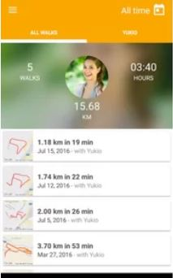

#### Figure 2.1 Dog Walk

## 2.2 My Pet Reminders [10]

## My pet Reminder is mobile base application for android and IOS mobile user. This is useful in making a pet profile, generating a reminder of pet important dates for example birthday or appointment but the pet diet, diseases, treatment suggestions and healthcare services functionalities are not the part of this application currently.

## C:\Users\cell spot\Desktop\PET-PICS\pet-reaminder.JPG

## Figure 2.2 My Pet Reminders

## 2.3 Dog Sync [11]

## It is web portal. This is very useful application in recording pet activities for example when the pet watered, when the pet walked, when the medicine is given and when the pet is fed. User can also share this record with the friends and other users of this application. This web application lacks the pet diet plans and diseases details and some other necessary healthcare services. This application is limited to only dogs. Android version and IOS version of this application is currently not available.

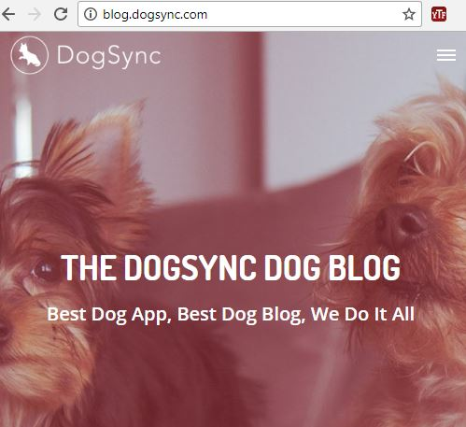

#### 

#### Figure 2.3 Dog Sync

## 2.4 ASPCA Pet Safety [12]

The ASPCA has number of applications for the pet owners. This application is limited to pet safety in case of pet is lost. The application also helps in finding the pet. The ASPCA Pet Safety app is accessible for both Android and IOS users. The application plays an important role in helping the users to make plan for pet protection during disasters, natural ruins and in extreme climate. The application imparts protection and awareness hints, and offers different techniques that how user can search for his/her lost pets in the case of emergency and what kind of tools are useful in storing. ASPCA is confined or limited to the pets protection it lacks pets daily and weekly diet plans and diseases and some other healthcare services.

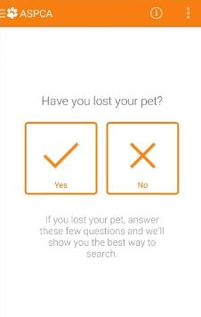

#### 

#### Figure 2.4 ASPCA

## 2.5 Dog Health [13]

This is a mobile base application and it is very useful application and is used to generate reminders about the appointments. This application also keeps the record of the previous visits to the pet doctor and stores all the medication that has to be done. Currently the application is limited to dogs and other kinds of pet like cats; hens etc are not the part of this application.

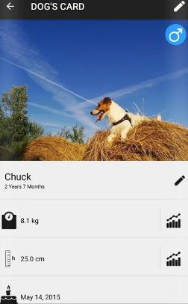

#### Figure 2.5 Dog Health

## 

## 2.6 Pet Coach [14]

Pet coach is a complete platform for the web, android and IOS users. The application generates the advices and tips for pet’s health from the professional pet doctors. After installing this application anyone can post the question related to his pet diet, behavior and training. Consultations are free and well as paid for the users. Although pet coach is a very useful application but this is limited to take an appointment or advises from the doctor. While weekly and daily diet plan, pet common diseases, treatment plan and notifications features are considered as out of scope now.

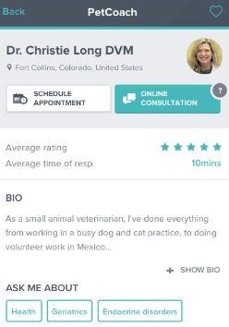

## 

#### Figure 2.6 Pet Coach

## 2.7 Pet-First Aid [15]

Pet-First Aid based upon a very unique idea by American android and IOS developer Red Cross. Application includes the photos, videos, tips and first aid guidelines in case of emergency or injury. If the injury of the pet is very severe then the application can view the hospital list located nearby or contact the pet doctor. While using this application user can’t view the diet plan, common diseases, treatment plan and notification features.

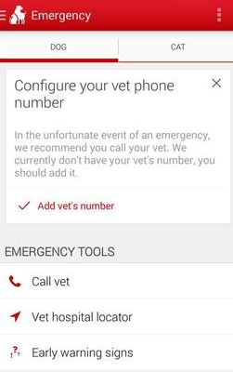

#### Figure 2.7Pet First Aid

## 2.8 Rover [16]

Rover is complete platform web, android and IOS users. It basically establishes the network of such persons who are dog owner. Dog owners usually find too much difficulty in finding the sitters and boarding. This application is limited to provide facility to the dog owners in booking sitters for their dogs for boarding purpose, finding dogs care center, and send notifications to the pet users related to the updated photos of home sittings. Although this is very useful but confined to the dogs day care centers and homes.

#### 

#### Figure 2.8 Rover

There are many mobile applications which are related to pets but few are discussed in details. Most of them work on the specific single feature; for example Rover is an application which helps in searching the dog day care centers. Pet First Aid helps in searching out the pet hospitals in case of emergency. Pet Coach helps in taking out the advices and tips from the professional pet doctor. Dog Health is confined to the dog health only. ASPCA Pet Safety helps the pet owners in the case of pet loss. Dog walk is limited to record the walk and activities of dog. My Pet Remainder helps to notify the owner related to important dates of his pet like birthday etc. “Pet Diet and Healthcare Planner” is focusing on many features like generate pet diet plan, diseases details, generate alarm notification on pet food time and take an appointment.

# Chapter # 3

# Requirement Specifications

## 

## 3.1 Existing System

Currently, there is no online system which is being used by the Islamabad Pet & AVIAN Hospital G-10/4. Currently they are using manual system. No website and android application is still being used by the hospital.

## 3.2 Proposed Systems

Layman who buys the pet does not know the proper diet plans, their common diseases, treatment suggestions and sometime forget to fed . Pet Diet and Healthcare planner is an industrial project and it is designed and developed for the Islamabad Pets & AVIAN Hospital. It is a complete platform. The android application will support the user in generating pet diet plans, notify the owner on the proper timings that when your pet need food and also provide the pet disease and treatment suggestions. Users can take the appointment through android application and as well as through website. Website user can view information like hospital services etc as per as hospital requirement.

## 3.3 Requirement Specifications

Requirements specification includes functional and as well as non functional requirements.

## 3.3.1 **Functional Requirements**

### Functional Requirement 1 (Registration)

Description:

Registration is compulsory for everyone who is using the Android Application for the first time. Registration will be perform to ensure the user account.

### Functional Requirement 2 (Login)

Description:

After the successful registration user is able to log in into the Android Application through the already registered email and password.

### Functional Requirement 3 (Add / View Pet Profile Details)

Description:

Android Application user can add and view the pet profiles.

### Functional Requirement 3 (View/ Download Details)

Description:

Android Application user can view and download the diet plans and diseases details and treatment details.

### Functional Requirement 3 (Generate Notification)

Description:

Application user can generate the alarm notification so that pet feed on proper timing.

### Functional Requirement 3 (Take an Appointment)

Description:

Users can take the appointment through Android Application and as well as through website.

### Functional Requirement 5 (Website Application)

Description:

Website user can take an appointment and view information like hospital services etc as per as hospital requirements.

### Functional Requirement 6 (Add as a Doctor)

Description:

Android user can be a hospital doctor so user is able to register if assigned hospital id matches with the entered id.

### Functional Requirement 7(Logout)

Description:

Application users can logout at any time.

## 3.3.2 Subsystem Functional Requirement

### Login Processing

Description

Login activity is being performed on the system.

### Validation Check

Description

While log in into the system; system will perform validation either the email or password is correct or not.

## 3.3.3 Non Functional Requirement

### Performance

Least specification constraint is performed by the personal computer and which is necessary for every platform like android or web application. Memory, processor and operation system should match with the application.

### Accuracy

If the application display the correct results like application is fetching correctly the pet diseases or treatment details etc according to user choice, at run time then the application will be accurate.

### Maintainability

The developer will perform the maintenance of both applications; android as well as web application if some issue occur.

### Portability

It is true that now a day’s users demand the portable applications. Pet Diet and Healthcare is portable because it is available on both platforms android and as well as web.

### Availability

Application user is capable to perform and view application details on any time.

### Flexibility

Pet diet and Healthcare planner is fully compatible and flexible system and easy to use for the end users.

### Usability

The interface and Graphical User Interface design of the application is user friendly with no training required.

## 3.4 Use Cases

Uses case diagrams are very important because they help in understanding the whole system in a shorter time or quickly. Use case diagrams are designed for the both platforms android as well as for the web site.

### 3.4.1 Use Case (System Diagram)

Website user can view the information and make an appointment through website.

Android Application user or pet owner can register then login into the system. After logging into the system the user can generate pet diet plan, view diseases details, add/view pet profiles, Add/view/delete food timings notification alarm, take/cancel appointment and logout.

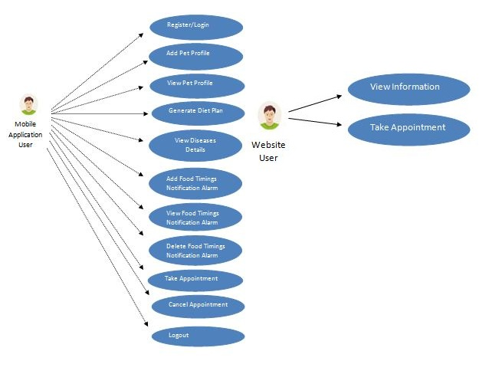

#### Figure 3.1 Use Case Diagram

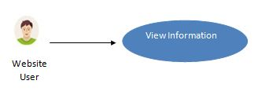

#### Figure 3.2 View Information (website)

*Website user can* view the every information which is provided by the pet hospital like services etc.

|  |  |
| --- | --- |
| **Name** | View Information(website) |
| **Actor** | *Website user* |
| **Brief Description** | Website user is able to view the every information which is mentioned on the website. |
| **Flow of Events** | *User can view hospital services, about us and doctors detail etc or any further information provided by the hospital.* |
| **Alternate Flow of**  **Events** | User will take an appointment. |
| **Pre-condition** | Should click on any button in the menu bar or scroll down the cursor. |
| **Post condition** | User might take a decision of appointment. |

##### Table 3.1: View Information (website)

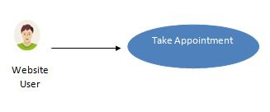

#### Figure 3.3 Appointment (website)

*Website user can* take the appointment.

|  |  |
| --- | --- |
| **Name** | Appointment(website) |
| **Actor** | *Website user* |
| **Brief Description** | Website user is able to take an appointment. |
| **Flow of Events** | *User will fill all the inputs text fields required for taking an appointment. Like enter mobile number, pet name, date and times etc.* |
| **Alternate Flow of**  **Events** | User will view the information. |
| **Pre-condition** | Fill all the input text fields. |
| **Post condition** | Response email will be send to the user. |

##### Table 3.2: Appointment (website)

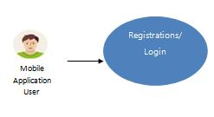

#### Figure 3.4 Registrations/ Login

First of all *Android Application User* will register himself by filling registration form in order to login into the system or perform other activities.

|  |  |
| --- | --- |
| **Name** | Registration/ Login |
| **Actor** | *Android Application User* |
| **Brief Description** | Registration is compulsory for the first time to login*.* |
| **Flow of Events** | *Fill all the input text fields.* *Provided information will be verified then user will be register*.  *If user is already register then there is no need of performing registration. Registration is compulsory for the first time to login.* |
| **Alternate Flow of**  **Events** | If validation fails, then user can resend it. |
| **Pre-condition** | All fields of registration and login are essential. |
| **Post condition** | User will login into the system and perform other activities. |

##### Table 3.3: Registration/Login

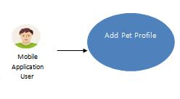

#### Figure 3.5 Add Pet Profile

*Android Application User* can add pet profile details upon successful login.

|  |  |
| --- | --- |
| **Name** | Add Pet Profile |
| **Actor** | *Android Application User* |
| **Brief Description** | *User* is able to add the pet profiles. |
| **Flow of Events** | *Fill the all input text fields necessary for the pet profile then added profiles are saved into the database.* |
| **Alternate Flow of**  **Events** | If fields are missing then user can refill them. |
| **Pre-condition** | Some information is necessary |
| **Post condition** | Added information can be viewed. |

##### Table 3.4: Add Pet Profile

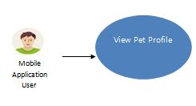

#### Figure 3.6 View Pet Profile

*Android Application User* can also view the pet profile.

|  |  |
| --- | --- |
| **Name** | View Pet Profile |
| **Actor** | *Android Application User* |
| **Brief Description** | *User* is able to view the pet profile fetched from the databases. |
| **Flow of Events** | *After clicking the view profile button user is able to view the pet profile*. |
| **Alternate Flow of**  **Events** | If click on any other button. |
| **Pre-condition** | If view profile button is clicked. |
| **Post condition** | Viewed information is fetched from database. |

##### Table 3.5: View Pet Profile

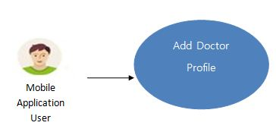

#### Figure 3.7 Add Doctor Profile

*Android Application User* can be a add doctor. User can register himself as a doctor if and only if the entered hospital id matches with the assigned hospital id.

|  |  |
| --- | --- |
| **Name** | Add Doctor |
| **Actor** | *Android Application User* |
| **Brief Description** | *User* is able to add himself as a doctor if and only if the hospital id matches. |
| **Flow of Events** | *Fill the all input text fields necessary for the profile then added profiles are saved into the database.* |
| **Alternate Flow of**  **Events** | If fields are missing then user can refill them. |
| **Pre-condition** | Some information is necessary |
| **Post condition** | Added information can be viewed. |

##### Table 3.6: Add Doctor Profile

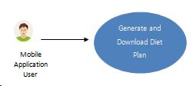

#### Figure 3.8 Generate and Download Diet Plan

*Android Application User* can also generate and download the pet diet plan. Diet plans are generated on the basis of pet specie, breed(weekly or daily) ,age and type of plan.

|  |  |
| --- | --- |
| **Name** | View / Download Diet Plan |
| **Actor** | *Android Application User* |
| **Brief Description** | *User* is able to view and download the pet diet plan. |
| **Flow of Events** | *Select the pet specie, breed, age and type of plan (weekly or daily) then click on generate plan button then diet plan will be generated from the database.* |
| **Alternate Flow of**  **Events** | If any filed is missing then no plan will be shown and downloaded. |
| **Pre-condition** | If generate or download diet plan button is clicked. |
| **Post condition** | Information is fetched from database. |

##### Table 3.7: Generate and Download Diet Plan

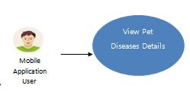

#### Figure 3.9 View Pet Diseases Details

*Android Application User* can also view the common diseases details.

|  |  |
| --- | --- |
| **Name** | View Pet Diseases Details |
| **Actor** | *Android Application User* |
| **Brief Description** | *User* is able to view the common diseases details fetched from the databases. |
| **Flow of Events** | *Select the pet specie.*  *Then after clicking the view button user is able to view the* common diseases details. |
| **Alternate Flow of**  **Events** | If click on any other button. |
| **Pre-condition** | If pet diseases detail button is clicked. |
| **Post condition** | Information is fetched from database. |

##### Table 3.8: View Pet Diseases Details

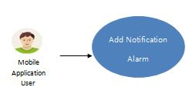

#### Figure 3.10 Add Notification Alarm

*Application User* can add notification alarm for the multiple pets.

|  |  |
| --- | --- |
| **Name** | Add Notification Alarm |
| **Actor** | *Android Application User* |
| **Brief Description** | *User* is able to add the notification alarm related to pet food timings for the multiple pets. |
| **Flow of Events** | *Set the alarm time and then enter the pet name. Then click on set alarm button.*  *Alarm will be set down.* |
| **Alternate Flow of**  **Events** | User can delete any list item. |
| **Pre-condition** | Pet name, time and click on set alarm button are necessary. |
| **Post condition** | Alarm can be deleted. |

##### Table 3.9: Add Notification Alarm

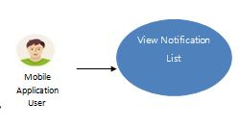

#### Figure 3.11 View Notification List

*Application User* can also view the all information available on application related to notifications of pet food timings.

|  |  |
| --- | --- |
| **Name** | View Notification List |
| **Actor** | *Android Application User* |
| **Brief Description** | *User* is able to view the notification list related to pet food timings. |
| **Flow of Events** | *Click on Alarm list then user will be able to view the notification alarm list.* |
| **Alternate Flow of**  **Events** | User can delete any list item.  User can turn off the alarm. |
| **Pre-condition** | Click on alarm list button is necessary. |
| **Post condition** | Viewed information can be deleted. |

##### Table 3.10: View Notification List

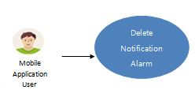

#### Figure 3.12 Delete Notification Alarm

*Application User* can delete the notification list items one by one.

|  |  |
| --- | --- |
| **Name** | Delete Notification Alarm |
| **Actor** | *Android Application User* |
| **Brief Description** | *User* is able to delete the any notification list item related to pet food timings. |
| **Flow of Events** | *Click on Alarm list then click on cross sign; a dialog box will be opened if yes is clicked then alarm will be deleted...* |
| **Alternate Flow of**  **Events** | User can turn off any alarm. |
| **Pre-condition** | If yes in clicked. |
| **Post condition** | Can perform on other activities or add a new alarm. |

##### Table 3.11: Delete Notification Alarm

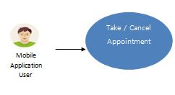

#### Figure 3.13 Take / Cancel Appointment

*Android Application user* is able to take an appointment or cancel it.

|  |  |
| --- | --- |
| **Name** | Take / Cancel Appointment |
| **Actor** | *Android Application User* |
| **Brief Description** | *Emails will send for the both cases if appointment is taken or cancelled.* |
| **Flow of Events** | *If appointment button is clicked then appointment email will be send.*  *If cancel button is clicked then cancel the appointment message is send.* |
| **Alternate Flow of**  **Events** | User can view the doctors’ information. |
| **Pre-condition** | If appoint or cancel button in clicked. |
| **Post condition** | Can perform other activities within the application... |

##### Table 3.12: Take / Cancel Appointment

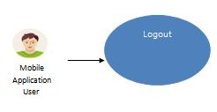

#### Figure 3.14 Logout

*Application User* is able to logout at any time.

|  |  |
| --- | --- |
| **Name** | Logout |
| **Actor** | *Android Application User* |
| **Brief Description** | After successful login *Application User* is able to logout at any time. |
| **Flow of Events** | *Click on logout button then user will be logout from the application.* |
| **Alternate Flow of**  **Events** | Shut down the system. |
| **Pre-condition** | All activates are completed no more need to stay log in. |
| **Post condition** | User is able to re login into the system at any time. |

##### Table 3.13: Logout Details Specification

# Chapter # 4

# System Design

## 4.1 System Architecture Diagram

System Architecture Diagram is a theoretic model that defines the overall view of a system. In architecture diagram we basically have defined the whole structure of a system. Android user can login/register using android application and can add and view any details like add pet profile, view pet profile, generate diet plan, alarm notification details and appointment. Added information is saved into the database and fetched from the database. While can view the information displayed on the website. Appointments can be taken through android and as well as through website user. The system architecture diagram is given below:

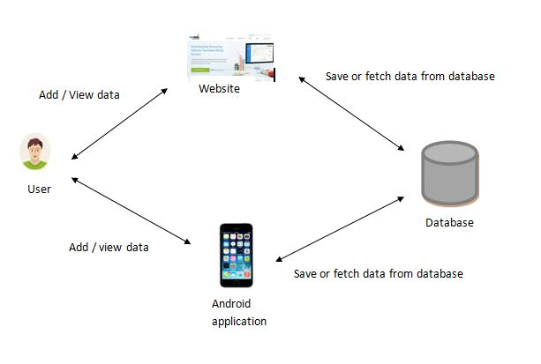

#### Figure 4.1 System Architecture Diagram

## 4.2 Design Methodology

Agile methodology is used to develop this project as; our requirements are incremental.

Agile Methodology

#### Figure 4.2 Design Model

## 4.3 High Level Deign

High level designs include flow charts and activity diagrams of the website and android application.

## 4.3.1 Flow Chart

### Flow Chart (website user)

Website user first of all; will login into the system. If email and password is correct then user can only view the details available on the web application or take an appointment run time.

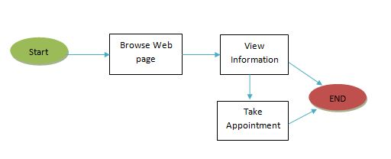

#### Figure 4.3 Flow Diagram of a system (Website user)

### Flow Chart (Android Application user)

First of all android user will login into the system if the email and password is correct then android will be able to view details. User can add, delete and update data which is specific to pet profile. Changes in pet profile will be saved and he can fetch and re view them. Android user can take appointment or contact the doctor in case of any emergency. Android user can log out at any time.

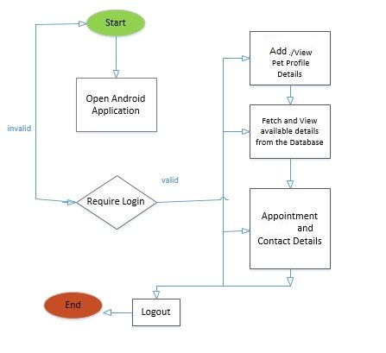

#### Figure 4.4 Flow Diagram of a system (Android Application User)

## 4.3.2 Activity Diagrams

### Activity Diagram (website user)

Web user can view the details available on the web application or take an appointment at any time.

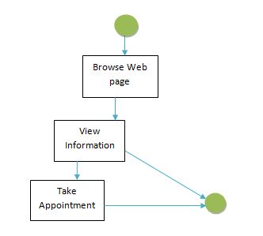

#### Figure 4.5 Activity Diagram for a web user

### Activity Diagram (Android Application user)

First of all android user will login into the system if the email and password is correct then android will be to view details. User can add and view data which is specific to pet profile. User can view and generate and download the diet plans and diseases details. Android user can take appointment or contact the doctor in case of any emergency. Android user can log out at any time.

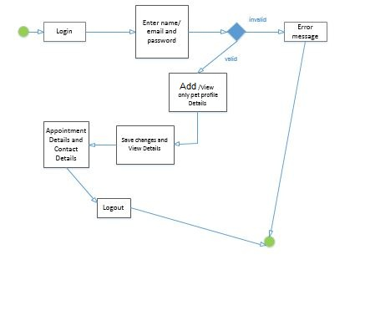**Figure 4.6 Activity Diagram for an Android app user**

# Chapter # 5

# System Implementation

## 5.1 System Architecture

Pet Diet and Healthcare planner consists of android application and as well as web application. The android application will generate the pet diet plan, pet diseases details, diet notification alarm and doctor appointment. Pet diet plans are saved into the cloud base database and that are retrieve on the basis of pet age, specie and kind of breed. Diseases details will be shown on the basis of pet specie. Notification alarm will be generated on the proper timings within a day. Email will send on time when the user click on the appointment button in android application. The web application will display the hospital information like hospital services and doctors.

## 5.2 Tools and Technology Used

1. Microsoft office

Microsoft office is used for project documentation and presentation. Microsoft Visio is useful for designing flow charts, activity and system diagrams.

1. Adobe Photoshop for designing

Adobe photo shop is very helpful for designing the mobile application layouts, compressing the images size and increasing the resolution.

1. Canva online designing tool

Canva is the online tool for graphics. The tool has been used for shades and image transparency.

**5.2.1 Developer Tools**

1. Android studio 3.0.1

Currently the most stable version of android studio is android studio 3.0.1. Provide many facilities like latest use of libraries and API’s.

1. Firebase database

Firebase is GOOGLE supported Cloud base platform. It is highly flexible and responsive. Providing user authentication, storage and hosting etc.

1. Sublime Text3

Sublime Text3 tool is used in developing web pages.

**5.2.2 Languages Used**

1. html, css, bootstrap

Web application is developed under html, css, and bootstrap and java script.

1. Java

Android mobile application support java.

1. Xml

Android studio support XML for designing application layouts or mockups.

## 5.3 Processing Logic

Firstly user will login into the android app then user can view the main home activity. User can input the information related to pet specie, breed and age and then view the detail which is generated by the firebase database. User can generate the food timing notification alarm to feed his/her pet on time. Appointment can be taken through android and as well as through the website user.

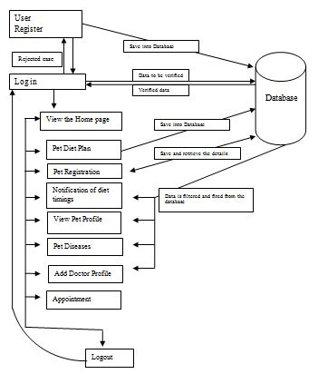

#### Figure 5.1 Activity Processing Logic

Website will only display the data which is provided by the Islamabad Pets & AVIAN Hospital G-10/4 sector. Website will handle and full fill the requirements of the hospital. Currently the website is displaying the Hospital information, services, doctors details and appointment facility.

**5.4 Application Access Security**

Cloud base database (firebase) which provides many services like secure authentication, push notification, cloud messaging, remote access, real time database etc. Security reasons, fast access and the reliable user authentication firebase database; used for this android project. Recently Gmail authentication is used for the user login in; later on other authentication methods might be used for the user access.

**5.5 Database Security**

Firebase is a real time database which has separate security rules for user authentication, database and for the storage access.

Authentication methods are listed in the given below picture.

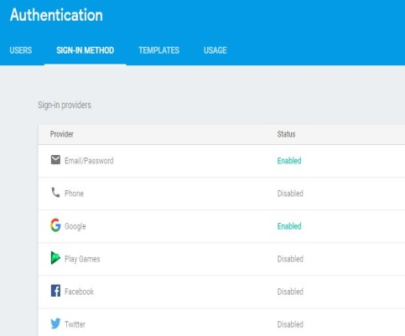

#### Figure 5.2 Firebase Authentication

Database security rules are shown in below picture.

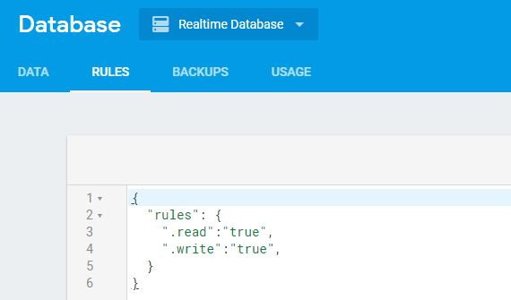

#### Figure 5.3 Firebase Database

Storage security rules are shown in below picture.

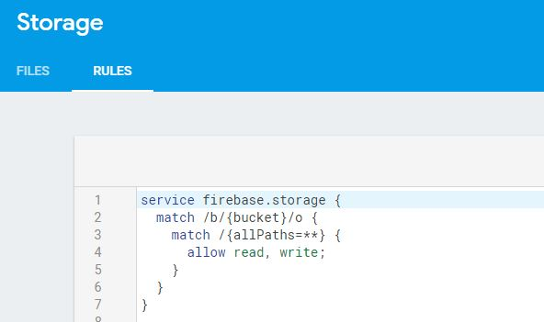

#### Figure 5.4 Firebase Storage

Data is stored in the form of nodes into the JSON format. Unique keys or ids are created against each record. Security rules and creation of unique keys is a very handsome feature of firebase which make it different from other in aspect of authentication and database security.

# Chapter # 6

# System Testing and Evaluation

## 

## 6.1 Test Cases

Testing is extremely important, both to ensure that the system meets requirements and to ensure that it is free of errors. That is why it is performed throughout the development process at every level.

### 6.1.1 User Authentication

|  |  |
| --- | --- |
| **Test Case ID** | **Test 1** |
| **Objective** | Verify Registration/ login activity. |
| **Environment** | Android Application |
| **Prerequisite** | Application must run. |
| **Method** | 1. Enter valid email. 2. Enter valid password. 3. Click on Register/Login button. |
| **Expected Results** | **After successful verification user is able to login into the system.** |
| Verification should be performed. | Pass |

##### Table 6.1 User Authentication

### 6.1.2 Add Pet Profile

|  |  |
| --- | --- |
| **Test Case ID** | **Test 2** |
| **Objective** | Pet profiles details should be added into the database successfully. |
| **Environment** | Android Application |
| **Prerequisite** | Application must run. |
| **Method** | 1. Fill the all the input text fields properly. 2. Click on save button. |
| **Expected Results** | **Should save into the database successfully.** |
| If database is updated successfully. | Pass |

##### Table 6.2 Add Pet Profile

### 6.1.3 Add Doctor Profile

|  |  |
| --- | --- |
| **Test Case ID** | **Test 2** |
| **Objective** | Doctor profiles details should be added into the database successfully. |
| **Environment** | Android Application |
| **Prerequisite** | Application must run. |
| **Method** | 1. Fill the all the input text fields properly. 2. Enter correct hospital id assigned by the hospital. 3. Click on save button. |
| **Expected Results** | **Should save into the database successfully.** |
| If database is updated successfully. | Pass |

##### Table 6.3 Add Doctor Profile

### 6.1.4 View Pet Profile

|  |  |
| --- | --- |
| **Test Case ID** | **Test 3** |
| **Objective** | To view to pet profile. |
| **Environment** | Android Application |
| **Prerequisite** | Application must run. |
| **Method** | 1. Click on View profile button. |
| **Expected Results** | **Pet profile should be fetched from the database successfully.** |
| If profile is successfully fetched. | Pass |

##### Table 6.4 View Pet Profile

### 6.1.5 Generate pet Diet Plan

|  |  |
| --- | --- |
| **Test Case ID** | **Test 4** |
| **Objective** | Diet plan should be fetched successfully. |
| **Environment** | Android Application |
| **Prerequisite** | Application must run. |
| **Method** | 1. Select pet specie, breed and age. 2. Click on Generate Plan button. |
| **Expected Results** | **Diet plan should be fetched from database successfully.** |
| If successfully fetch from database | Pass |

##### Table 6.5 Generate pet Diet Plan

### 6.1.6 View Pet Diseases Detail

|  |  |
| --- | --- |
| **Test Case ID** | **Test 5** |
| **Objective** | Common diseases details should be fetched from the database successfully. |
| **Environment** | Android Application |
| **Prerequisite** | Application must run. |
| **Method** | 1. Select pet specie. 2. Click on View Details button. |
| **Expected Results** | **Details should be fetched from database successfully.** |
| If successfully fetch from database | Pass |

##### Table 6.6 View Pet Diseases Detail

### 6.1.7 Notification Alarm

|  |  |
| --- | --- |
| **Test Case ID** | **Test 6** |
| **Objective** | Alarm should be generated on time and can be deleted at any time. |
| **Environment** | Android Application |
| **Prerequisite** | Application must run. |
| **Method** | 1. Enter the pet name and set the alarm time. 2. Click on Set Alarm button. 3. Click on alarm list to view the list. 4. Click on turnoff sign to turn off or delete button to delete the alarm. |
| **Expected Results** | **Alarm should be generated on time and can be deleted at any time.** |
| If alarm is generated on time. | Pass |

##### Table 6.7 Notification Alarm

### 6.1.8 Take / Cancel Appointment

|  |  |
| --- | --- |
| **Test Case ID** | **Test 7** |
| **Objective** | Test the Appointment activity. |
| **Environment** | Android Application |
| **Prerequisite** | Application must run. |
| **Method** | 1-If Appointment button is clicked then email should be send and button should be disabled.  2-If Cancel button is clicked then email should be send and button should be disabled. |
| **Expected Results** | **Email should be send in both functions.** |
| Correct email should be fire in both cases. | Pass |

##### Table 6.8 Take / Cancel Appointment

### 6.1.9 Logout

|  |  |
| --- | --- |
| **Test Case ID** | **Test 8** |
| **Objective** | Verify logout functionality. |
| **Environment** | Android Application |
| **Prerequisite** | Application must run. |
| **Method** | 1. Click on Logout button. |
| **Expected Results** | **When click on logout user should log out.** |
| User should be log out from application when clicked. | Pass |

##### Table 6.9 Logout

### 6.1.10 Website Test case

|  |  |
| --- | --- |
| **Test Case ID** | **Test 3** |
| **Objective** | Relevant information should be displayed and appointment can be taken successfully. |
| **Environment** | Website Application |
| **Prerequisite** | Website must run. |
| **Method** | 1. Click on any button for information. 2. Input correct information for appointment. |
| **Expected Results** | **Information should be displayed successfully and appointment is taken.** |
| If is successfully viewed. | Pass |

##### Table 6.10 View Pet Profile

# Chapter # 7

# Conclusion

The main objective of this project is to full fill the user requirements. All requirements given by the pet hospital is successfully implemented and tested. Using firebase database first time for android application and as well as for the web application was a big challenge. I am very glad that I have successfully synchronized the two applications at a single platform. More over I have learned a lot like Time Management, Implementation with firebase database, GUI design Interaction with different tools and technologies.

## 7.1 Future Recommendations

1. Pet tracking using android application can be implemented.
2. Pets training and learning information can be added.
3. Pet home and shelter scales and purchase module can be added.

# References

1. Pet Coach - Ask a Vet Online for Free, 24/7. (n.d.). Retrieved September 26, 2017, from <https://www.petcoach.co/>.

2. Pet First Aid - Red Cross - Android Apps on Google Play. (n.d.). Retrieved September 26, 2017, from <https://play.google.com/store/apps/details?id=com.cube.arc.pfa&hl=en>.

3. Point, Tutorials. “Android Tutorial.” Www.tutorialspoint.com, Tutorials Point, 31 Dec. 1969, www.tutorialspoint.com/android/. Accessed 19 Sept. 2017.

4. Read and Write Data on Android | Firebase. (n.d.). Retrieved September 19, 2017, from <https://firebase.google.com/docs/database/android/read-and-write>.

5. Other Items of Interest. (n.d.). Retrieved September 19, 2017, from <https://www.raywenderlich.com/category/android>.

6. Pet Web Site. (n.d.). Retrieved September 21, 2017, from <http://www.petwebsite.co.uk/>.

7.10 Best Apps For Every Pet Parent. (n.d.). Retrieved December 28, 2017, from <http://www.mypet.com/basic-pet-care/10-best-apps.aspx>.

8. Corpuz, J. (2017, October 24). 20 Apps for Pet Lovers. Retrieved December 28, 2017, from <https://www.tomsguide.com/us/pictures-story/1074-best-pet-apps.html#s2>.

9. Track the daily walks with your beloved four-legged friend! (n.d.). Retrieved December 28, 2017, from <https://dogwalk.tractive.com/en/>.

10. MyPetReminders - Android Apps on Google Play. (n.d.). Retrieved December 28, 2017, from <https://play.google.com/store/apps/details?id=com.mypetreminders&hl=en>.

11. Full Android release coming soon. (n.d.). Retrieved December 28, 2017, from <http://dogsync.com/wait.php>.

12. Adopt a Pet. (n.d.). Retrieved December 28, 2017, from <https://www.aspca.org/adopt-pet>.

13. Dog Health - Android Apps on Google Play. (n.d.). Retrieved December 28, 2017, from <https://play.google.com/store/apps/details?id=it.lobofun.doghealt&hl=en>.

14. PetCoach - Ask a vet for free - Android Apps on Google Play. (n.d.). Retrieved December 28, 2017, from <https://play.google.com/store/apps/details?id=co.petcoach&hl=en>.

15. First Aid For Pets - Android Apps on Google Play. (n.d.). Retrieved December 28, 2017, from <https://play.google.com/store/apps/details?id=com.boehringer.FirstAidForPets&hl=en>.

16. Rover - Dog Boarding & Walking - Android Apps on Google Play. (n.d.). Retrieved December 28, 2017, from<https://play.google.com/store/apps/details?id=com.rover.android&hl=en>.

# Appendices-A

Appendices are provided to give supplementary information, which is included in the main text and images which helps in understanding the flow of application.

**A-Android Application**

1. Splash Screen:

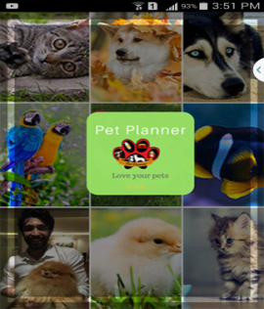

Splash screen will be displayed for few seconds.

1. Login

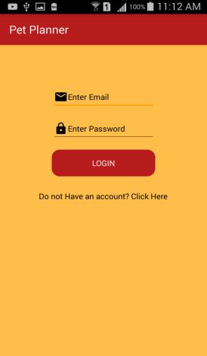

User will enter valid email and password to login into the application.

1. Registration

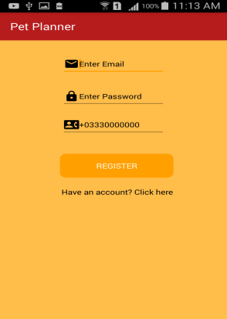

If user is new then he/she will register into the system.

1. Home Page

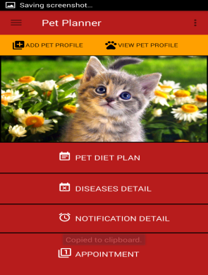

After the successful login user is able to add pet profile, view pet

Profile, generate diet plan, view diseases details, generate alarm notifications and take appointment.

1. Diet Plan

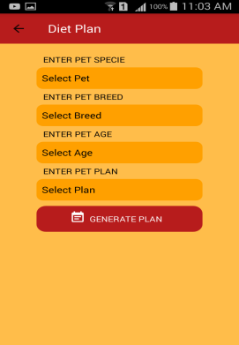

User can select pet specie, breed, age and plan to generate and download diet plan.

1. Diseases Details

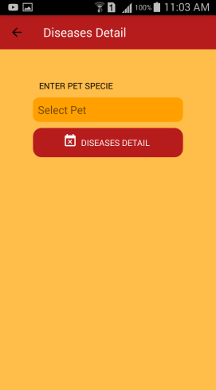

User can select pet specie to view pet diseases details.

1. Notification Details

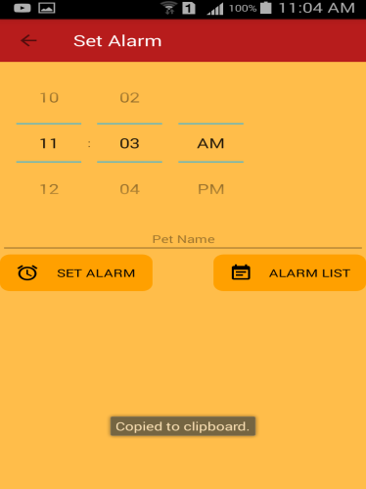

User can set alarm so that his pet could be feed.

1. Appointment

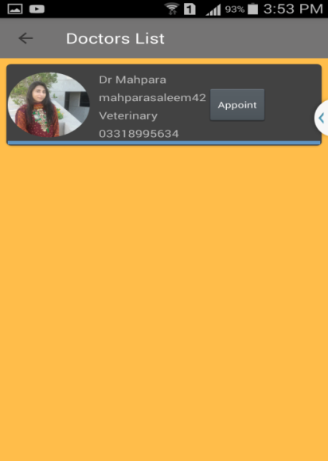

User can take appointment by clicking on Appoint button.

1. Add Pet Profile

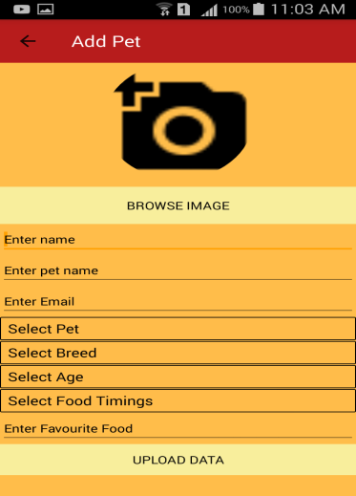

User can add pet details by filling all the fields.

1. View Pet Profile

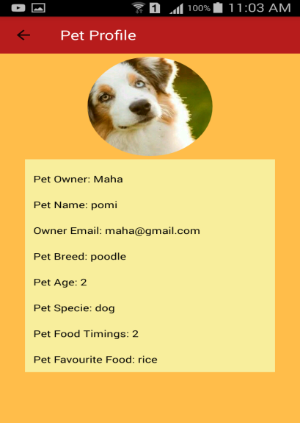

By clicking on view pet profile user is able to view pet profile.

1. Add as a Doctor

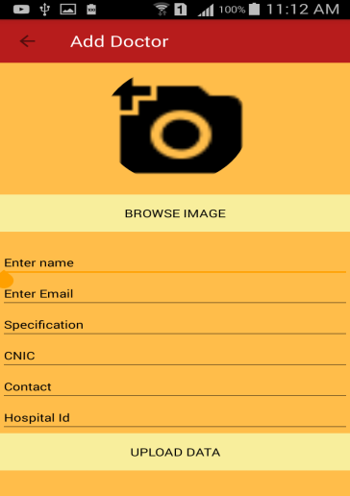

User can be a doctor so he can register him/ herself by entering the correct hospital id assigned by the hospital to the doctor.

# Appendices-B

**B-Web Application**

1. Home Button

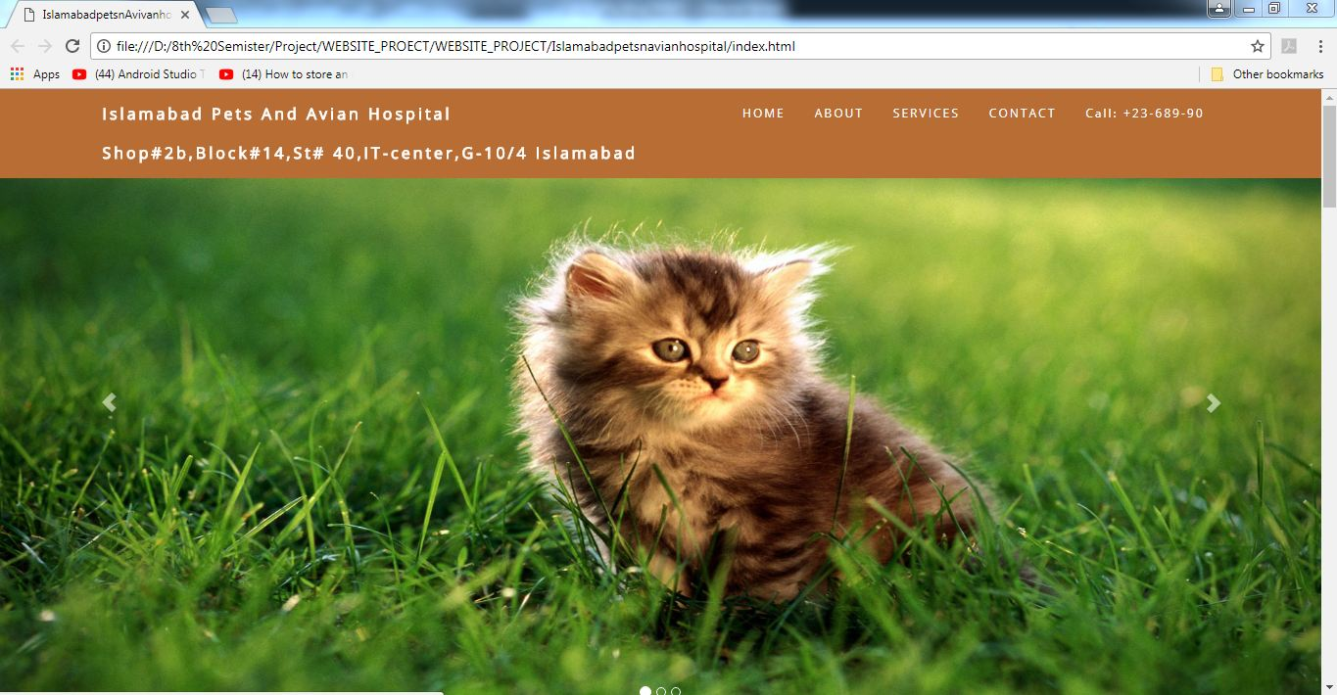

From Index page by clicking HOME will navigate to HOME screen

1. About us

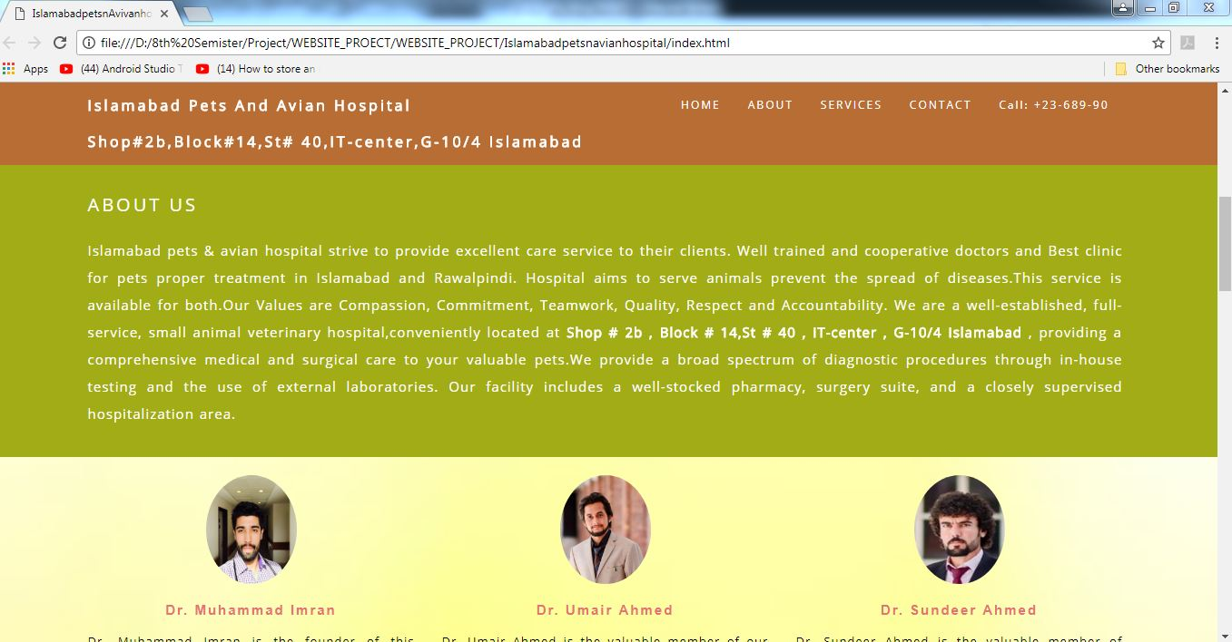

On selecting ABOUT from menu we navigate to ABOUT US screen

1. Services Details

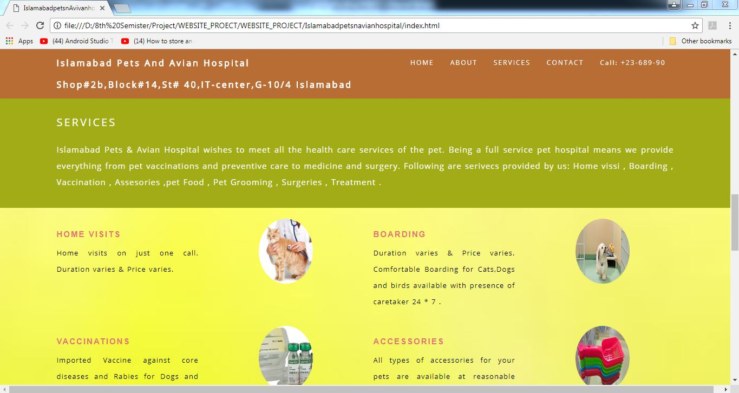

On selecting SERVICES from menu we navigate to SERVICES Screen

1. Contact Us

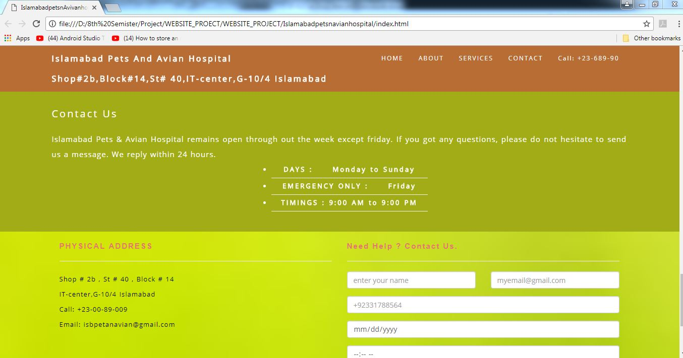

On selecting CONTACT from menu we navigate to CONTACT Screen.

1. Appointment

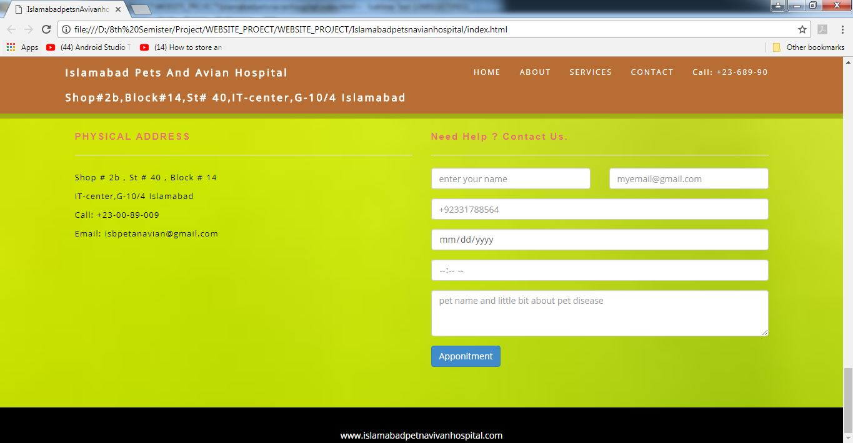

User can take APPOINTMENT by full filling the entire field.