USECASE: 3.1 figure

user.jpg

Mobile Application User

USECASE : 3.1 figure

Website User

user.jpg

user.jpg

Website User

Replace:

Take Appointment

user.jpg

Mobile Application User

Replace:

Register/Login

Add Pet Profile

View Pet Profile

Generate Diet Plan

Add Doctor

View Diseases Details

Add Food Timings Notification Alarm

View Food Timings Notification Alarm

Delete Food Timings Notification Alarm

Take Appointment

Cancel Appointment

Logout

Figure 4.1



Save or fetch data from database

Add / View data

Website

user.jpg

User

User

Database

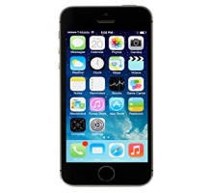

Save or fetch data from database

Add / view data

Android application

User

Pet

Add Profile

View Profile

Doctor

Diet Plan

Diseases Details

Food Alarm

Add Doctor

Appointment

Admin

4.2 and 4.3

Take Appointment

Take Appointment

View Information

n

Browse Web page

View Information

n

Browse Web page