Cloud-Native Engineering Standards

Table of Contents
Foundational Principles 3
Core Philosophy 3
Engineering Tenets 4
Tradeoffs & Decision Framework 5
Security & Privacy 5
Reliability Patterns 6
Performance Targets 6
Architectural Principles 6
Technology Selection Criteria 7
Technology Standards 7
Backend: Java/Spring 8
Frontend: React/TypeScript 10
Database 12
Caching 13
Containers 14
Messaging 14
Tool Matrix 15
DevOps Standards 15
Tools 16
Branching Strategy 16
CI/CD Pipeline 17
Deployment Strategies 19
GitOps 20
Testing Strategy 21
Release Management 22
Developer Experience 22
Environment Management 24
Architecture Patterns 24
Domain-Driven Design (DDD) 24
Hexagonal Architecture (Ports & Adapters) 27
Event-Driven Architecture 27
CQRS (Command Query Responsibility Segregation) 29
Resilience Patterns 30
Sample Application Architecture 31
System Overview 31
Project Structure 32
Service Details 34
Deployment Architecture 35
Data Flow 36
Event Schema 36
API Structure 37
Security Architecture 39
Observability Stack 40
Development Workflow 40
Getting Started 40
Related Standards 41

Foundational Principles
Foundational principles that guide all architectural and implementation decisions.

Core Philosophy

1. Composable Architecture & Domain-Driven Design
Focus on separation of concerns, bounded contexts, and ubiquitous language for maintainability. Design systems as composable modules that can be independently developed, deployed, and scaled.

2. Microservices, API-First & Contract-Driven, Cloud-native (MACH)
Design independent services with clear contracts, RESTful APIs, cloud-native principles, container-first deployment, and eventual consistency for system flexibility. Microservices, API-first, Cloud-native, and Headless architecture.

3. Cloud Portability
Ensure all software is portable across providers. Abstract cloud-specific implementations to enable seamless multi-cloud deployments without vendor lock-in. Use open standards and avoid proprietary APIs where possible.

4. Observability by Default
Implement distributed tracing, structured logging, metrics, and alerts for complete system visibility and rapid issue resolution. Observability is not optional—it’s a first-class requirement.

5. Zero Trust Security
Assume the environment is compromised. Authenticate, authorize, and encrypt all flows across all layers. Implement mTLS for service-to-service communication. Apply principle of least privilege everywhere.

6. Performance & Optimization
Optimize through intelligent caching, compression, and efficient algorithms for minimal latency. Define SLOs and measure against them continuously.

7. High Availability
Design for redundancy, failover mechanisms, and graceful degradation under failure conditions. No single points of failure. Multi-zone and multi-region awareness.

8. Reliability & Resilience
Ensure data consistency, fault tolerance, backup and restore/recovery mechanisms, cross-region replication to meet SLO/SLA requirements. Practice chaos engineering and regular testing.

9. Cost Optimization
Right-size resources, monitor spending, use auto-scaling and spot instances to minimize cloud waste. Implement FinOps practices from day one.

10. Automation First
Integrate CI/CD, automated testing, and security scanning into every stage from requirements through deployment. Manual processes are technical debt.

11. Infrastructure as Code
Treat all infrastructure, configuration, and deployments as version-controlled, repeatable code artifacts. Everything is auditable and reproducible.

12. Open source and open standards
Rely on open source and open standards such as OAUTH, Open Telemetry, Java, Spring, Kubernetes over proprietary standards, protocols, libraries.

Engineering Tenets

Clarity Over Cleverness
- Optimize for readability and explicitness
- Align to business and domain terminology
- Code is read more than written
- Prefer boring, predictable solutions

Small, Safe Changes
- Incremental delivery with tests and feature flags
- Minimize blast radius of changes
- Enable rapid rollback

Separation of Concerns
- Isolate domains, interfaces, and implementations
- Clear boundaries between layers
- Single responsibility at every level

Defensive Boundaries
- Validate inputs at system edges
- Trust internal invariants after validation
- Fail fast on invalid state

Tradeoffs & Decision Framework

Performance vs Maintainability
Prefer maintainable solutions; optimize hotspots proven by profiling. Premature optimization is the root of all evil.

Consistency vs Local Optimization
Favor repository-wide and organization-wide conventions. Exceptions must be justified and documented.

Abstraction vs Simplicity
Abstract only repeated patterns (Rule of Three). Avoid premature indirection. Three similar lines of code are better than a premature abstraction.

Security & Privacy
Principle | Implementation
Secure coding | Follow secure coding standards and prioritise OWASP Top 10 in development life cycle
Authentication everywhere | Authenticate all flows internal and external
Least Privilege | Minimize permissions and accessible data at every level
Input Validation | Sanitize at boundaries; reject malformed or unexpected inputs
Secrets Management | Never hardcode; use vaults/env; rotate keys automatically
PII & Confidential Data Handling | Mask at rest and in logs; adhere to data minimization
Encryption all flows | Encrypt all data in transit and use mTLS
Vulnerabilities & misconfig
Audit trails | Generate security audit trails for critical operations
Protective monitoring | Setup monitoring and alerting for security events

Reliability Patterns
Pattern | Description
Idempotence | Make external effects safe to retry
Timeouts & Retries | Bounded retries with exponential backoff; circuit breakers for unstable dependencies
Fail Fast | Detect and surface errors early; avoid silent failures
Graceful Degradation | Reduced functionality over total outage
Backup & Restore | Automated backups, restoration process

Performance Targets
- Latency Budgets: Define per endpoint/service SLOs (e.g., p95 ≤ 250ms for critical APIs)
- Resource Usage: Bound memory/CPU; monitor and alert on regressions
- Start-up Time: Services start within defined thresholds; lazy-init non-critical components
- Cold Start: Optimize for serverless/container cold starts

Architectural Principles

Statelessness
Services must be stateless; externalize all state to persistent stores for horizontal scaling.

Immutability
Use immutable containers and deployments; avoid in-place updates to ensure consistency and simplify rollbacks.

Backwards Compatibility
Maintain API stability; support multiple versions during transitions for independent service evolution.

Team Autonomy
Organize teams around business domains; enable independent service ownership and deployment (Conway’s Law).

Technology Selection Criteria
- Open standards preferred over proprietary solutions
- Libraries with zero critical and high vulnerabilities
- Active maintenance and community support
- Clear licensing compatible with commercial use
- Performance characteristics matching requirements

Technology Standards
Technology stack and standards for selection and implementation.

Technology Stack
- API Gateway: Native API Gateway for rate limiting at the edge, request routing, or API composition patterns
- Backend: Latest Java LTS (25+), Spring Boot 4.0+, Gradle (multi-module monorepo)
- Frontend: React with TypeScript, Vite
- Spring Cloud: Microservices patterns and distributed system support
- Containers: Docker for all services
- Orchestration: Kubernetes (Kind locally, Cloud Run on GCP)
- Infrastructure: Terraform for IaC to setup core GCP resources
- Database: CloudSQL (GCP), local SQL/H2 for development
- Caching: Redis, cloud native
- Secrets: GCP Secrets manager for runtime, GitHub secrets for build
- Events/Integration: GCP Pub/Sub, Kafka
- Config: YAML for all Kubernetes and application configs
- OpenTelemetry: Unified observability (traces, metrics, logs)
- React 19+: Latest react library for web and native use interfaces.

Backend: Java/Spring

Version Requirements
- Java: Latest LTS (21+), prefer 25 when available
- Spring Boot: 3.4+ (4.0+ when stable)
- Spring Framework: 6.x (7.x with Spring Boot 4)
- Gradle: Latest stable for build automation

Java Standards
// Use records for immutable data
public record OrderId(UUID value) {
public OrderId {
Objects.requireNonNull(value, "OrderId cannot be null");
}
}
// Use sealed classes for type safety
public sealed interface PaymentMethod
permits CreditCard, DebitCard, BankTransfer {}
// Use pattern matching
public String describe(PaymentMethod method) {
return switch (method) {
case CreditCard cc -> "Credit: " + cc.lastFour();
case DebitCard dc -> "Debit: " + dc.lastFour();
case BankTransfer bt -> "Bank: " + bt.accountMask();
};
}
// Use virtual threads for I/O-bound operations
@Bean
public Executor taskExecutor() {
return Executors.newVirtualThreadPerTaskExecutor();
}

Spring Boot Configuration
@SpringBootApplication
@EnableCaching
@EnableAsync
@EnableScheduling
public class ServiceApplication {
public static void main(String[] args) {
SpringApplication.run(ServiceApplication.class, args);
}
}
// Constructor injection (no @Autowired on constructors)
@Service
public class OrderService {
private final OrderRepository orderRepository;
private final EventPublisher eventPublisher;
public OrderService(OrderRepository orderRepository,
EventPublisher eventPublisher) {
this.orderRepository = orderRepository;
this.eventPublisher = eventPublisher;
}
}

Application Configuration
# application.yml
spring:
application:
name: order-service
profiles:
active: ${SPRING_PROFILES_ACTIVE:local}
server:
port: 8080
shutdown: graceful
management:
endpoints:
web:
exposure:
include: health,metrics,prometheus,info
endpoint:
health:
show-details: when_authorized
probes:
enabled: true

Build Configuration (Gradle)
plugins {
id 'java'
id 'org.springframework.boot' version '3.4.0'
id 'io.spring.dependency-management' version '1.1.4'
id 'jacoco'
}
java {
sourceCompatibility = '21'
}
dependencies {
implementation 'org.springframework.boot:spring-boot-starter-web'
implementation 'org.springframework.boot:spring-boot-starter-data-jpa'
implementation 'org.springframework.boot:spring-boot-starter-actuator'
implementation 'org.springframework.boot:spring-boot-starter-validation'
runtimeOnly 'org.postgresql:postgresql'
runtimeOnly 'io.micrometer:micrometer-registry-prometheus'
testImplementation 'org.springframework.boot:spring-boot-starter-test'
testImplementation 'org.testcontainers:postgresql'
}
test {
useJUnitPlatform()
finalizedBy jacocoTestReport
}

Frontend: React/TypeScript

Version Requirements
- React: 19+
- TypeScript: 5.x with strict mode
- Vite: Latest stable for build tooling
- Node.js: LTS version

TypeScript Configuration
{
"compilerOptions": {
"strict": true,
"noImplicitAny": true,
"strictNullChecks": true,
"noUnusedLocals": true,
"noUnusedParameters": true,
"noImplicitReturns": true,
"esModuleInterop": true,
"skipLibCheck": true,
"forceConsistentCasingInFileNames": true
}
}

React Standards
// Use functional components with hooks
interface OrderProps {
orderId: string;
onUpdate: (order: Order) => void;
}
export const OrderDetails: React.FC<OrderProps> = ({ orderId, onUpdate }) => {
const [order, setOrder] = useState<Order | null>(null);
const [loading, setLoading] = useState(true);
useEffect(() => {
fetchOrder(orderId)
.then(setOrder)
.finally(() => setLoading(false));
}, [orderId]);
if (loading) return <Spinner />;
if (!order) return <NotFound />;
return <OrderView order={order} onUpdate={onUpdate} />;
};
// API clients in src/api/
export const orderApi = {
getOrder: (id: string): Promise<Order> =>
fetch(`/api/v1/orders/${id}`).then(handleResponse),
createOrder: (data: CreateOrderRequest): Promise<Order> =>
fetch('/api/v1/orders', {
method: 'POST',
headers: { 'Content-Type': 'application/json' },
body: JSON.stringify(data),
}).then(handleResponse),
};

Project Structure
src/
├── api/ # API clients
├── components/ # Reusable UI components
├── features/ # Feature-specific components
├── hooks/ # Custom React hooks
├── pages/ # Route components
├── store/ # State management
├── types/ # TypeScript interfaces
└── utils/ # Helper functions

Database

PostgreSQL Standards
- Use CloudSQL (GCP) for production
- H2 or local PostgreSQL for development
- Connection pooling via HikariCP
- Flyway for migrations

Migration Standards
-- V1__create_orders_table.sql
CREATE TABLE orders (
id UUID PRIMARY KEY,
customer_id UUID NOT NULL,
status VARCHAR(50) NOT NULL,
total_amount DECIMAL(19,2) NOT NULL,
created_at TIMESTAMP WITH TIME ZONE DEFAULT NOW(),
updated_at TIMESTAMP WITH TIME ZONE DEFAULT NOW()
);
CREATE INDEX idx_orders_customer_id ON orders(customer_id);
CREATE INDEX idx_orders_status ON orders(status);

Naming Conventions
- Tables: lowercase, plural (orders, order_lines)
- Columns: lowercase, snake_case (customer_id, created_at)
- Indexes: idx_<table>_<column>
- Foreign keys: fk_<table>_<referenced_table>

Caching

Redis Standards
- Use managed Redis (e.g., GCP Memorystore)
- Connection pooling via Lettuce
- TTL on all cache entries
- Cache key namespacing

Configuration
@Configuration
@EnableCaching
public class CacheConfig {
@Bean
public CacheManager cacheManager(RedisConnectionFactory factory) {
RedisCacheConfiguration config = RedisCacheConfiguration
.defaultCacheConfig()
.entryTtl(Duration.ofMinutes(10))
.serializeKeysWith(SerializationPair
.fromSerializer(new StringRedisSerializer()))
.serializeValuesWith(SerializationPair
.fromSerializer(new GenericJackson2JsonRedisSerializer()));
return RedisCacheManager.builder(factory)
.cacheDefaults(config)
.withCacheConfiguration("orders",
config.entryTtl(Duration.ofMinutes(5)))
.build();
}
}

Cache Patterns
Pattern | Use Case
Cache-Aside | Read-heavy, tolerate stale data
Write-Through | Consistency critical
Write-Behind | High write volume

Containers

Docker Standards
FROM eclipse-temurin:21-jdk-alpine AS builder
WORKDIR /app
COPY . .
RUN ./gradlew clean bootJar --no-daemon
FROM eclipse-temurin:21-jre-alpine
WORKDIR /app
# Run as non-root
RUN addgroup -g 1001 appuser && \
adduser -D -u 1001 -G appuser appuser
USER appuser
COPY --from=builder /app/build/libs/*.jar app.jar
EXPOSE 8080
ENTRYPOINT ["java", \
"-XX:+UseZGC", \
"-XX:+UseContainerSupport", \
"-XX:MaxRAMPercentage=75.0", \
"-jar", "app.jar"]

Image Requirements
- Multi-stage builds for minimal size
- Non-root user execution
- No secrets in images
- Versioned tags (no latest in production)
- Base images from trusted sources

Messaging

Kafka/Pub-Sub Standards
- Schema registry for all events
- Avro or Protobuf serialization
- Dead-letter queue for failed messages
- Idempotent consumers

Event Schema Example (Avro)
{
"type": "record",
"name": "OrderCreatedEvent",
"namespace": "com.example.events",
"fields": [
{"name": "eventId", "type": "string"},
{"name": "orderId", "type": "string"},
{"name": "customerId", "type": "string"},
{"name": "totalAmount", "type": "double"},
{"name": "timestamp", "type": "long", "logicalType": "timestamp-millis"}
]
}

Tool Matrix
Category | Tool | Purpose
IDE | VS Code | Primary development environment
Source Control | GitHub | Code repository and collaboration
CI/CD | GitHub Actions | Build and deployment pipelines
Build (Java) | Gradle | Java project build automation
Build (JS) | npm/Vite | Frontend build tooling
Code Quality | SonarQube | Static code analysis
Security Scan | OWASP Dependency Check | Vulnerability scanning
Unit Test (Java) | JUnit 5 | Java unit testing
Unit Test (JS) | Jest | JavaScript testing
Contract Test | Pact | Consumer-driven contracts
Integration Test | Testcontainers, Cucumber | End-to-end testing
Performance Test | Grafana K6 | Load and performance testing
Infrastructure | Terraform | Infrastructure as Code
Container Registry | GCP Artifact Registry | Docker image storage

DevOps Standards
Tools and standards for CI/CD, deployment, and developer experience.

Tools
Tools | Capabilities | Details
GitHub | Source Control, Secrets | All code to be maintained in GitHub
GitHub Actions | Build and Deploy pipelines | All build and deployment via GitHub Actions
Code quality and security | Sonar Scanner | Static Code Aanalysis
Build scripting | Gradle, npm | Gradle for all java build scripting, npm for front-end node
Secret Management | GitHub Secrets & GCP | Secrets for build and deploy in GitHub and GCP for runtime secrets
Infrastructure as Code | Terraform | All infrastructure provisioning to be done via Terraform
IDE | VS Code | Engineers to use VSCode as IDE
Artifact management | GCP Artifact Registry | All generated artifadcts
Unit testing | Junit (Java), Jest(JS) | Junit for java tests, Jest for javascript
Contract testing | PACT | contract-based testing for Consumer-Driven tests
Integration testing | Cucumber, Testcontainers | BDD Style tests for integration tests and test containers to manage services
Performance testing | Grafana K6 | Use K6 for load and performance testing of critical flows

Branching Strategy

Trunk-Based Development
- main is the single source of truth
- main is always deployable
- main is protected and requires PR approvals
- Short-lived feature branches (< 2 days)
- No long-running release branches

Branch Naming
feature/TICKET-123-add-order-api
fix/TICKET-456-null-pointer-exception
chore/update-dependencies
docs/api-documentation

Commit Messages
Follow Conventional Commits:
feat: add order creation endpoint
fix: handle null customer ID gracefully
refactor: extract order validation logic
docs: update API documentation
chore: update Spring Boot to 3.4.0
test: add integration tests for payment flow

CI/CD Pipeline

Pipeline Stages
┌─────────────┐ ┌─────────────┐ ┌─────────────┐ ┌─────────────┐
│ Build │ -> │ Test │ -> │ Security │ -> │ Deploy │
└─────────────┘ └─────────────┘ └─────────────┘ └─────────────┘
│ │ │ │
├── Compile ├── Unit ├── SAST ├── Non-Prod
├── Dependencies ├── Integration ├── SCA ├── Prod
└── Artifact Build ├── Contract ├── DAST └── Release (BG/Canary)
└── Performance └── Container Scan

GitHub Actions Structure
.github/
├── workflows/
│ ├── ci.yml # PR validation
│ ├── build.yml # Build and test
│ ├── security.yml # Security scans
│ ├── deploy-nonprod.yml # Non-prod deployment
│ └── deploy-prod.yml # Production deployment
└── actions/
├── setup-java/ # Reusable setup
└── deploy-cloudrun/ # Reusable deploy

CI Workflow Example
name: CI
on:
pull_request:
branches: [main]
jobs:
build:
runs-on: ubuntu-latest
steps:
- uses: actions/checkout@v4
- name: Set up JDK 21
uses: actions/setup-java@v4
with:
distribution: 'temurin'
java-version: '21'
cache: 'gradle'
- name: Build
run: ./gradlew clean build -x test
- name: Unit Tests
run: ./gradlew test
- name: Integration Tests
run: ./gradlew integrationTest
- name: Code Coverage
run: ./gradlew jacocoTestReport
- name: Upload Coverage
uses: codecov/codecov-action@v4
with:
files: ./build/reports/jacoco/test/jacocoTestReport.xml
security:
runs-on: ubuntu-latest
needs: build
steps:
- uses: actions/checkout@v4
- name: OWASP Dependency Check
run: ./gradlew dependencyCheckAnalyze
- name: SonarQube Scan
run: ./gradlew sonar
env:
SONAR_TOKEN: ${{ secrets.SONAR_TOKEN }}

Deployment Strategies

Environment Progression
Feature Branch -> Non-Production -> Production
│ │ │
└── PR Tests └── Full Tests └── Blue Green/Canary + Full

Canary Deployment
apiVersion: argoproj.io/v1alpha1
kind: Rollout
metadata:
name: order-service
spec:
replicas: 5
strategy:
canary:
steps:
- setWeight: 10
- pause: {duration: 5m}
- setWeight: 25
- pause: {duration: 5m}
- setWeight: 50
- pause: {duration: 5m}
- setWeight: 100
analysis:
templates:
- templateName: success-rate
startingStep: 1

Blue-Green Deployment
apiVersion: argoproj.io/v1alpha1
kind: Rollout
metadata:
name: order-service
spec:
replicas: 3
strategy:
blueGreen:
activeService: order-service-active
previewService: order-service-preview
autoPromotionEnabled: false

Rollback Triggers
- Error rate > 5% for 2 minutes
- Latency p99 > 2x baseline
- Circuit breaker open
- Health check failures

GitOps

ArgoCD Application
apiVersion: argoproj.io/v1alpha1
kind: Application
metadata:
name: order-service
namespace: argocd
spec:
project: default
source:
repoURL: https://github.com/org/config-repo
targetRevision: main
path: environments/production/order-service
destination:
server: https://kubernetes.default.svc
namespace: production
syncPolicy:
automated:
prune: true
selfHeal: true
syncOptions:
- CreateNamespace=true

Repository Structure
config-repo/
├── base/
│ └── order-service/
│ ├── deployment.yaml
│ ├── service.yaml
│ └── kustomization.yaml
└── environments/
├── nonprod/
│ └── order-service/
│ ├── kustomization.yaml
│ └── patches/
└── production/
└── order-service/
├── kustomization.yaml
└── patches/

Testing Strategy

Test Pyramid
/\
/ \ E2E Tests (Few)
/────\ - Critical paths only
/ \ - Run pre-deploy
/────────\ Integration Tests (Some)
/ \ - Service boundaries
/────────────\ - Testcontainers
/ \ Unit Tests (Many)
/────────────────\ - Fast, isolated

Testing Requirements
Type | Coverage | When Run
Unit | > 80% | Every commit
Integration | Critical paths | Every PR
Contract | API boundaries | Every PR
E2E | Happy paths | Pre-deploy
Performance | Baseline | Weekly + pre-release

Contract Testing (Pact)
@Pact(consumer = "order-service", provider = "catalog-service")
public RequestResponsePact getProductPact(PactDslWithProvider builder) {
return builder
.given("product exists")
.uponReceiving("get product by id")
.path("/api/v1/products/123")
.method("GET")
.willRespondWith()
.status(200)
.body(newJsonBody(body -> {
body.stringType("id", "123");
body.stringType("name", "Product Name");
body.decimalType("price", 99.99);
}).build())
.toPact();
}

Release Management

Versioning
- Semantic versioning: MAJOR.MINOR.PATCH
- Container images tagged with git SHA + version
- Immutable releases - never overwrite tags

Release Notes
Automated from conventional commits:
- name: Generate Release Notes
uses: release-drafter/release-drafter@v5
with:
config-name: release-drafter.yml

Release Process
- Merge to main triggers build
- Automated tests and security scans
- Build versioned, immutable artifact
- Deploy to non-production
- Run E2E tests
- Manual approval for production
- Progressive rollout to production
- Automated rollback if metrics degrade

Developer Experience

Local Development
# docker-compose.yml for local dependencies
services:
postgres:
image: postgres:16
environment:
POSTGRES_DB: orderdb
POSTGRES_USER: dev
POSTGRES_PASSWORD: dev
ports:
- "5432:5432"
redis:
image: redis:7-alpine
ports:
- "6379:6379"

Local Kubernetes (Kind)
# kind-config.yaml
kind: Cluster
apiVersion: kind.x-k8s.io/v1alpha4
nodes:
- role: control-plane
- role: worker
- role: worker

Skaffold Configuration
apiVersion: skaffold/v4beta6
kind: Config
metadata:
name: order-service
build:
artifacts:
- image: order-service
docker:
dockerfile: Dockerfile
deploy:
kubectl:
manifests:
- k8s/*.yaml

Inner Loop Optimization
- Hot reload for local development
- Fast incremental builds
- Local container registry
- Port forwarding for debugging

Environment Management

Environment Parity
All environments should be as similar as possible: - Same container images - Same Kubernetes configurations (with env-specific patches) - Same network policies - Different only: secrets, scaling, resource limits

Environment Variables
# base configuration
spec:
containers:
- name: order-service
env:
- name: SPRING_PROFILES_ACTIVE
value: "kubernetes"
- name: DB_HOST
valueFrom:
secretKeyRef:
name: db-credentials
key: host

Feature Flags
- Use external feature flag service (LaunchDarkly, Unleash)
- Default to feature off in production
- Gradual rollout percentage
- Kill switch for emergencies

Architecture Patterns
Standards for implementing core architectural patterns in cloud-native systems.

Domain-Driven Design (DDD)

Strategic Patterns

Bounded Contexts
- Each microservice represents one bounded context
- Define ubiquitous language per context
- Use context mapping for inter-service relationships

Context Mapping Types
Pattern | Use When
Partnership | Two teams cooperate closely
Shared Kernel | Multiple contexts share a small model
Customer-Supplier | Upstream/downstream relationship
Conformist | Downstream adopts upstream model
Anti-corruption Layer | Protect from external model pollution
Open Host Service | Expose well-defined protocol
Published Language | Documented interchange format

Tactical Patterns

Aggregates
@Entity
public class Order {
@Id
private OrderId id;
private CustomerId customerId;
private OrderStatus status;
@OneToMany(cascade = CascadeType.ALL, orphanRemoval = true)
private List<OrderLine> orderLines;
// Enforce invariants within aggregate boundary
public void addOrderLine(Product product, int quantity) {
validateOrderLine(product, quantity);
orderLines.add(new OrderLine(product, quantity));
registerEvent(new OrderLineAdded(id, product.getId(), quantity));
}
}

Value Objects
public record OrderId(UUID value) {
public OrderId {
Objects.requireNonNull(value, "OrderId cannot be null");
}
public static OrderId generate() {
return new OrderId(UUID.randomUUID());
}
}
public record Money(BigDecimal amount, Currency currency) {
public Money {
if (amount.compareTo(BigDecimal.ZERO) < 0) {
throw new IllegalArgumentException("Amount cannot be negative");
}
Objects.requireNonNull(currency);
}
public Money add(Money other) {
requireSameCurrency(other);
return new Money(amount.add(other.amount), currency);
}
}

Domain Events
public sealed interface DomainEvent permits OrderCreated, OrderShipped, OrderCancelled {
Instant occurredAt();
String aggregateId();
}
public record OrderCreated(
OrderId orderId,
CustomerId customerId,
Instant occurredAt
) implements DomainEvent {
@Override
public String aggregateId() {
return orderId.value().toString();
}
}

Domain Services
Use when logic doesn’t naturally belong to a single entity:
public class PricingService {
public Money calculateTotal(Order order, DiscountPolicy discountPolicy) {
Money subtotal = order.calculateSubtotal();
Money discount = discountPolicy.apply(subtotal, order.getCustomerId());
return subtotal.subtract(discount);
}
}

Hexagonal Architecture (Ports & Adapters)

Overview
Hexagonal architecture separates core business logic from external concerns through ports (interfaces) and adapters (implementations).

Structure of a Hexagonal service
src/main/java/
├── domain/ # Core business logic (NO framework dependencies)
│ ├── model/ # Entities, Value Objects, Aggregates
│ ├── repository/ # Repository interfaces (ports)
│ ├── service/ # Domain services
│ └── event/ # Domain events
├── application/ # Application services and use cases
│ ├── command/ # Command handlers (write operations)
│ ├── query/ # Query handlers (read operations)
│ └── dto/ # Data transfer objects
├── infrastructure/ # Technical implementations (adapters)
│ ├── persistence/ # Database implementations
│ ├── messaging/ # Event publishing/consuming
│ ├── cache/ # Caching implementations
│ └── external/ # External service clients
└── api/ # Inbound adapters
├── rest/ # REST controllers
└── graphql/ # GraphQL resolvers

Rules
- Domain has zero dependencies on frameworks or infrastructure
- Ports are interfaces defined in the domain layer
- Adapters implement ports and live in infrastructure
- Dependencies point inward toward the domain

Event-Driven Architecture

Event Types
Type | Purpose | Example
Domain Events | Record business facts | OrderPlaced, PaymentReceived
Integration Events | Cross-service communication | OrderCreatedIntegrationEvent
Command Events | Request action | ProcessPaymentCommand

Event Design
// Integration event with schema versioning
public record OrderCreatedEvent(
@JsonProperty("event_id") UUID eventId,
@JsonProperty("event_type") String eventType,
@JsonProperty("event_version") int version,
@JsonProperty("timestamp") Instant timestamp,
@JsonProperty("payload") OrderPayload payload
) {
public static final String EVENT_TYPE = "order.created";
public static final int CURRENT_VERSION = 1;
}

Patterns

Outbox Pattern
Ensure reliable event publishing with transactional outbox:
@Transactional
public Order createOrder(CreateOrderCommand command) {
Order order = orderFactory.create(command);
orderRepository.save(order);
// Store event in outbox table (same transaction)
outboxRepository.save(new OutboxEvent(
order.getId(),
"OrderCreated",
serialize(order.toDomainEvent())
));
return order;
}

Saga Pattern
Coordinate distributed transactions:
OrderSaga:
1. CreateOrder -> OrderCreated
2. ReserveInventory -> InventoryReserved | InventoryFailed
3. ProcessPayment -> PaymentProcessed | PaymentFailed
4. ConfirmOrder -> OrderConfirmed
Compensations:
- PaymentFailed -> ReleaseInventory
- InventoryFailed -> CancelOrder

Dead Letter Queue
Handle failed message processing:
spring:
cloud:
stream:
bindings:
orderProcessor-in-0:
destination: orders
group: order-service
consumer:
max-attempts: 3
back-off-initial-interval: 1000
back-off-max-interval: 10000
dlq-name: orders.dlq

CQRS (Command Query Responsibility Segregation)

When to Use
- Complex domains with different read/write patterns
- High read-to-write ratio
- Need for optimized read models with simpler structure and queries
- Event sourcing systems

Structure
├── command/
│ ├── CreateOrderCommand.java
│ ├── CreateOrderCommandHandler.java
│ └── OrderCommandRepository.java # Write-optimized
├── query/
│ ├── GetOrderQuery.java
│ ├── GetOrderQueryHandler.java
│ ├── OrderReadModel.java # Denormalized for reads
│ └── OrderQueryRepository.java # Read-optimized

Implementation
// Command side - enforces invariants
@Component
public class CreateOrderCommandHandler {
public OrderId handle(CreateOrderCommand command) {
Order order = Order.create(command);
orderRepository.save(order);
eventPublisher.publish(order.getDomainEvents());
return order.getId();
}
}
// Query side - optimized for reads
@Component
public class OrderQueryHandler {
public OrderReadModel handle(GetOrderQuery query) {
return orderReadRepository.findById(query.orderId())
.orElseThrow(() -> new OrderNotFoundException(query.orderId()));
}
}

Resilience Patterns

Circuit Breaker
@CircuitBreaker(name = "payment-service", fallbackMethod = "paymentFallback")
@Retry(name = "payment-service")
@TimeLimiter(name = "payment-service")
public PaymentResult processPayment(PaymentRequest request) {
return paymentClient.process(request);
}
private PaymentResult paymentFallback(PaymentRequest request, Exception ex) {
log.warn("Payment service unavailable, queuing", ex);
return PaymentResult.queued(request.transactionId());
}

Configuration
resilience4j:
circuitbreaker:
instances:
payment-service:
failure-rate-threshold: 50
wait-duration-in-open-state: 30s
sliding-window-size: 10
minimum-number-of-calls: 5
retry:
instances:
payment-service:
max-attempts: 3
wait-duration: 500ms
retry-exceptions:
- java.util.concurrent.TimeoutException
- java.net.ConnectException
bulkhead:
instances:
payment-service:
max-concurrent-calls: 10
max-wait-duration: 100ms

Resilience Patterns Summary
Pattern | Purpose | Configuration
Circuit Breaker | Stop cascading failures | failure threshold, wait duration
Retry | Handle transient failures | max attempts, backoff strategy
Bulkhead | Isolate failures | max concurrent calls, queue size
Rate Limiter | Control throughput | requests per period
Time Limiter | Bound execution time | timeout duration

Sample Application Architecture
Reference architecture for a cloud-native e-commerce platform demonstrating the standards in practice.

System Overview
A full-stack e-commerce demonstration featuring microservices (Java 21/Spring Boot) and React frontend with Google OAuth and local authentication. Supports deployment on both local Kind clusters and GCP Cloud Run.
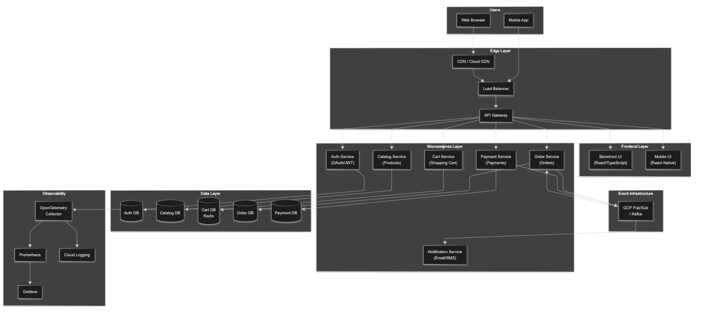

Project Structure

Repository Layout
├── .github/ # GitHub Actions workflows
│ └── workflows/
│ ├── ci.yml # PR validation
│ ├── build.yml # Build and test
│ ├── security.yml # Security scans
│ └── deploy.yml # Deployment
│
├── services/ # Backend Microservices
│ ├── auth-service/ # Authentication & Authorization
│ │ ├── src/main/java/
│ │ │ ├── domain/ # Core business logic
│ │ │ ├── application/ # Use cases
│ │ │ ├── infrastructure/ # Adapters
│ │ │ └── api/ # REST controllers
│ │ ├── src/test/
│ │ ├── build.gradle
│ │ └── Dockerfile
│ │
│ ├── catalog-service/ # Product catalog
│ ├── cart-service/ # Shopping cart
│ ├── order-service/ # Order management
│ ├── payment-service/ # Payment processing
│ ├── notification-service/ # Notifications
│ │
│ └── libs/ # Shared libraries
│ ├── jwt-common/ # JWT utilities
│ ├── event-common/ # Event schemas
│ └── observability/ # OTel configuration
│
├── ui/ # Frontend Applications
│ ├── storefront-ui/ # React + TypeScript (Vite)
│ │ ├── src/
│ │ │ ├── api/ # API clients
│ │ │ ├── components/ # UI components
│ │ │ ├── features/ # Feature modules
│ │ │ ├── hooks/ # Custom hooks
│ │ │ └── pages/ # Route components
│ │ ├── package.json
│ │ └── vite.config.ts
│ │
│ ├── mobile-ui/ # React Native
│ └── commons/ # Shared UI libraries
│
├── infra/ # Infrastructure as Code
│ ├── terraform/ # GCP resources
│ │ ├── modules/
│ │ │ ├── cloudrun/
│ │ │ ├── cloudsql/
│ │ │ ├── pubsub/
│ │ │ └── networking/
│ │ ├── environments/
│ │ │ ├── nonprod/
│ │ │ └── prod/
│ │ └── main.tf
│ │
│ └── k8s/ # Kubernetes manifests
│ ├── base/ # Base configurations
│ ├── overlays/
│ │ ├── local/ # Kind cluster
│ │ ├── nonprod/
│ │ └── prod/
│ └── kustomization.yaml
│
├── docs/ # Documentation
│ ├── adr/ # Architecture Decision Records
│ ├── api/ # API documentation
│ └── runbooks/ # Operational runbooks
│
└── scripts/ # Utility scripts
├── local-setup.sh
└── deploy.sh

Service Details

Service Matrix
Service | Responsibilities | Database | Events Published | Events Consumed
auth-service | OAuth, JWT, User mgmt | PostgreSQL | UserCreated, UserLoggedIn | -
catalog-service | Products, Categories, Search | PostgreSQL | ProductUpdated | -
cart-service | Shopping cart, Sessions | Redis | CartUpdated | UserLoggedIn
order-service | Orders, Order history | PostgreSQL | OrderCreated, OrderShipped | PaymentProcessed
payment-service | Payment processing | PostgreSQL | PaymentProcessed, PaymentFailed | OrderCreated
notification-service | Email, SMS, Push | - | - | OrderCreated, PaymentProcessed

Deployment Architecture

GCP Cloud Run Deployment
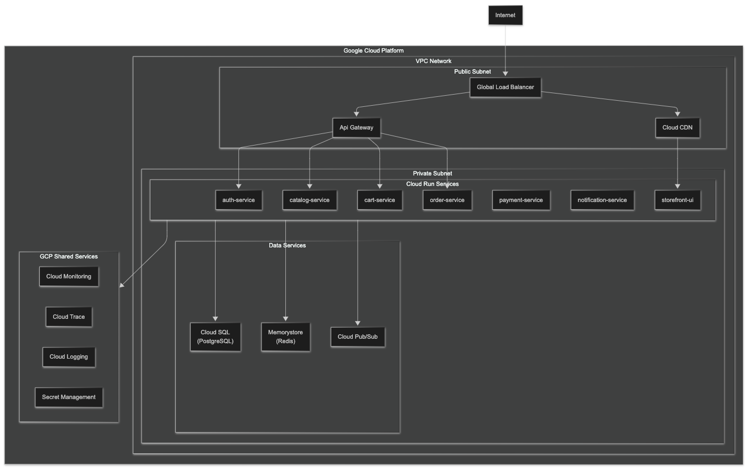

Data Flow

Order Processing Flow
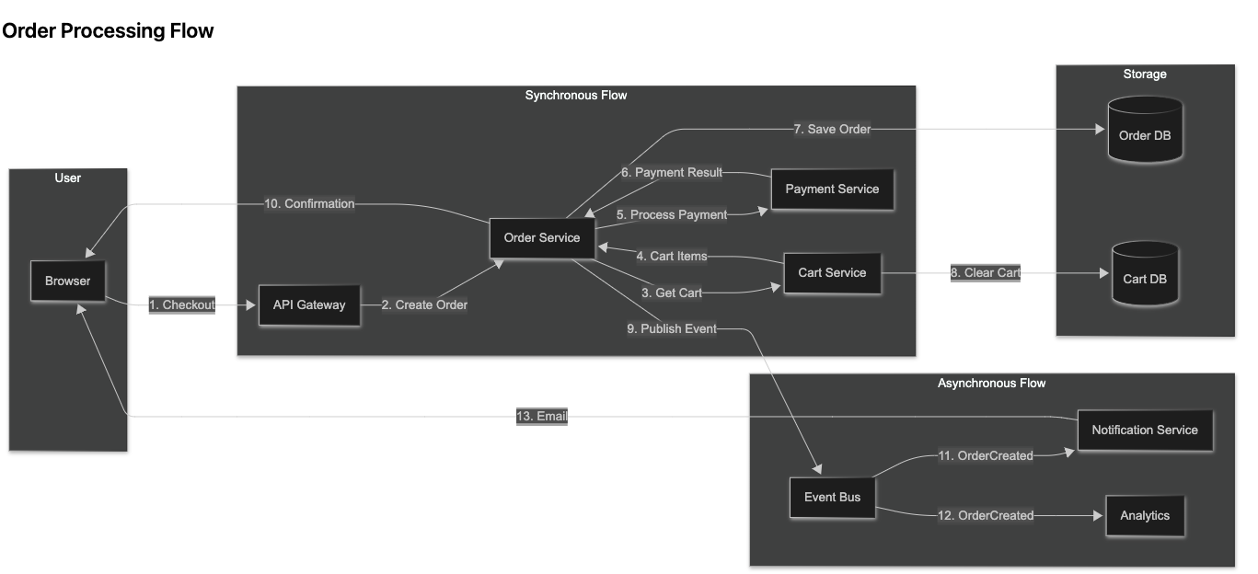

Event Schema

Domain Events
classDiagram
class DomainEvent {
<<interface>>
+UUID eventId
+String eventType
+Instant occurredAt
+String aggregateId
}
class OrderCreated {
+UUID orderId
+UUID customerId
+Money totalAmount
+List~OrderLine~ items
}
class OrderShipped {
+UUID orderId
+String trackingNumber
+Instant shippedAt
}
class PaymentProcessed {
+UUID paymentId
+UUID orderId
+Money amount
+PaymentStatus status
}
class UserCreated {
+UUID userId
+String email
+Instant createdAt
}
DomainEvent <|-- OrderCreated
DomainEvent <|-- OrderShipped
DomainEvent <|-- PaymentProcessed
DomainEvent <|-- UserCreated

API Structure

RESTful Endpoints
Auth Service
├── POST /api/v1/auth/login
├── POST /api/v1/auth/register
├── POST /api/v1/auth/refresh
├── GET /api/v1/auth/oauth/google
└── GET /api/v1/users/me
Catalog Service
├── GET /api/v1/products
├── GET /api/v1/products/{id}
├── GET /api/v1/products/search?q=
├── GET /api/v1/categories
└── GET /api/v1/categories/{id}/products
Cart Service
├── GET /api/v1/cart
├── POST /api/v1/cart/items
├── PUT /api/v1/cart/items/{id}
├── DELETE /api/v1/cart/items/{id}
└── DELETE /api/v1/cart
Order Service
├── POST /api/v1/orders
├── GET /api/v1/orders
├── GET /api/v1/orders/{id}
└── POST /api/v1/orders/{id}/cancel
Payment Service
├── POST /api/v1/payments
├── GET /api/v1/payments/{id}
└── POST /api/v1/payments/{id}/refund

Security Architecture
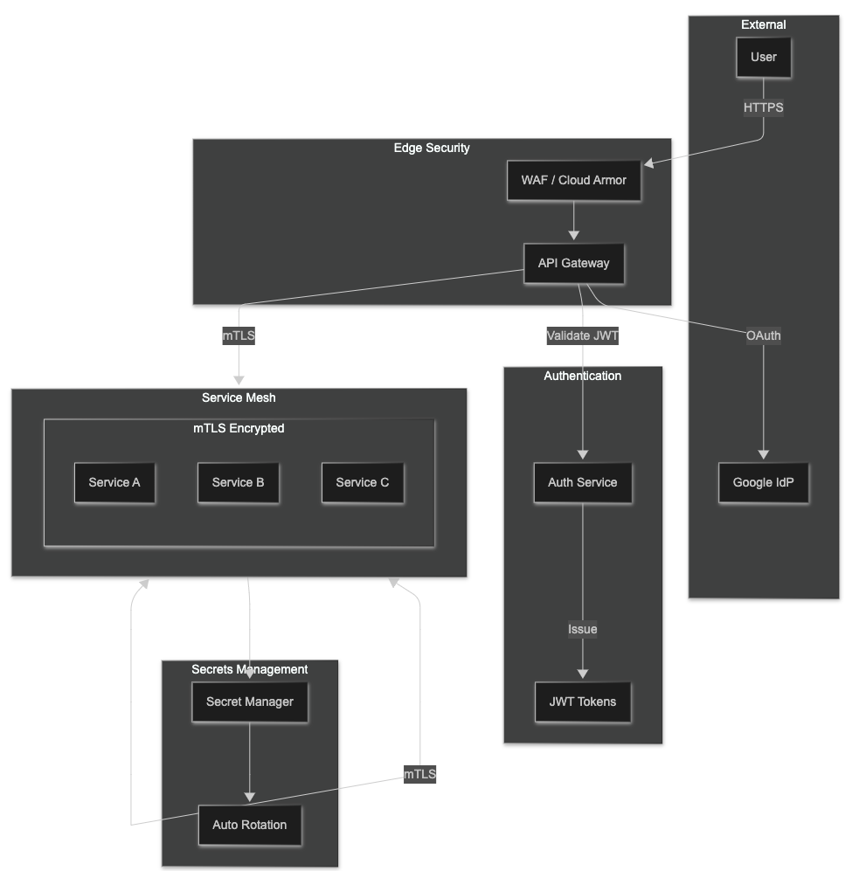

Observability Stack
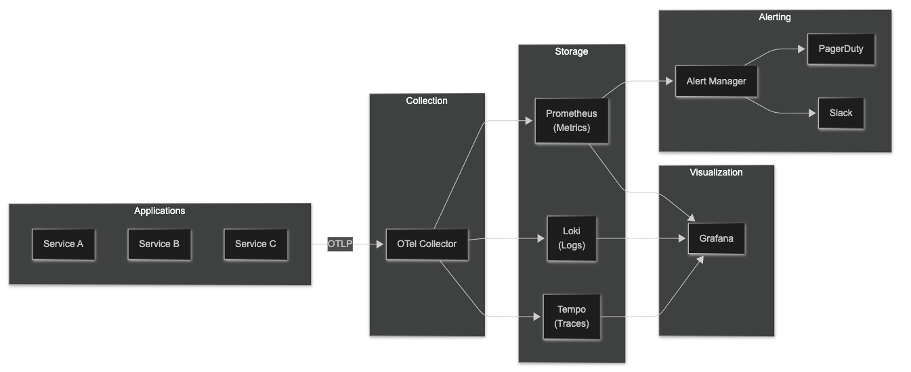

Development Workflow
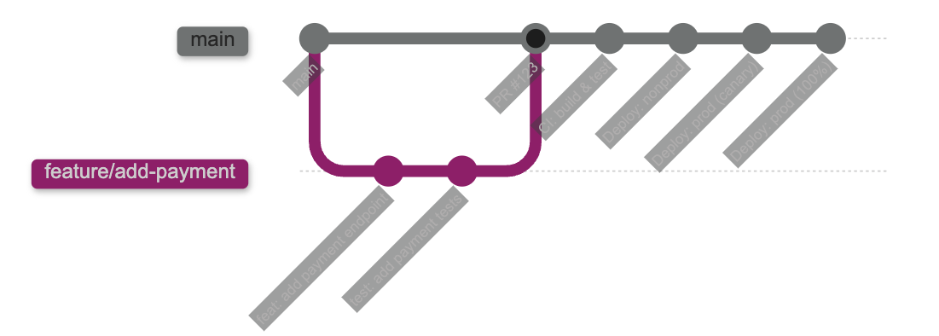

Getting Started

Prerequisites
# Required tools
java --version # Java 21+
node --version # Node.js LTS
docker --version # Docker
kubectl version # kubectl
kind version # Kind (optional)

Local Development
# Clone repository
git clone https://github.com/org/ecommerce-platform.git
cd ecommerce-platform
# Start infrastructure
docker-compose up -d
# Start backend service
cd services/catalog-service
./gradlew bootRun
# Start frontend
cd ui/storefront-ui
npm install && npm run dev

Local Kubernetes
# Create Kind cluster
kind create cluster --config infra/k8s/kind-config.yaml
# Deploy all services
kubectl apply -k infra/k8s/overlays/local/
# Port forward
kubectl port-forward svc/storefront-ui 3000:80

Related Standards
- PRINCIPLES.md - Core engineering principles
- PATTERNS.md - DDD, Hexagonal, Event driven & Resilience patterns
- TECHNOLOGY-STANDARDS.md - Java/Spring, React standards
- SECURITY-STANDARDS.md - Security implementation
- DEVOPS-STANDARDS.md - CI/CD pipelines
- OBSERVABILITY-STANDARDS.md - Monitoring setup

