Select-image-crop

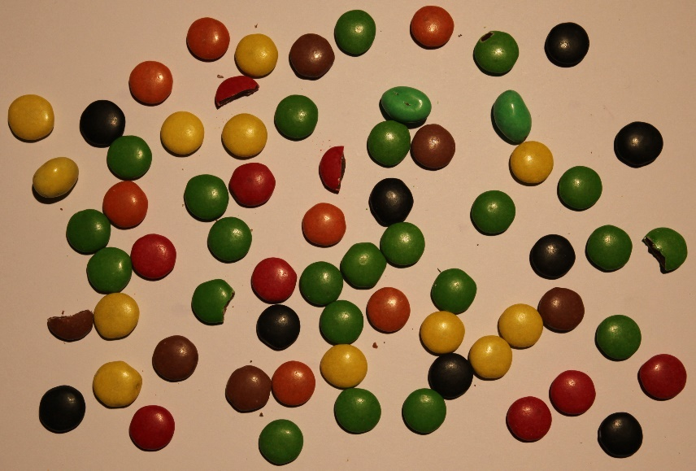

Make image 8bit from 16bit: image-type-8bit

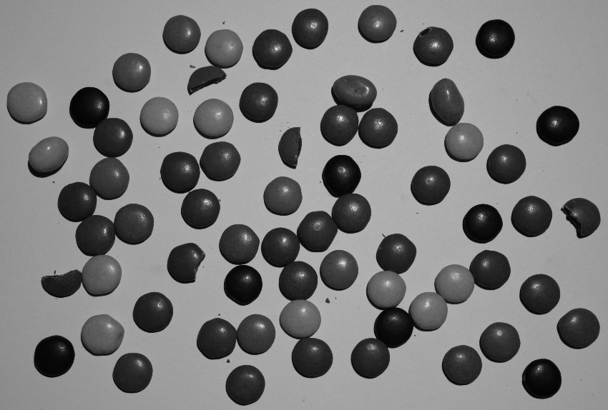

Image-adjust-auto_threshold-try all



Chosen triangle because of few holes: Image-adjust-auto_threshold-triangle

Edit-invert



Process-binary-fill holes



* analyze
  + set measurements (set the shape descriptors you want)

Since, it is a binary image, max value-255, min0.

Checking only the area, shape descriptions, perimeter and display label

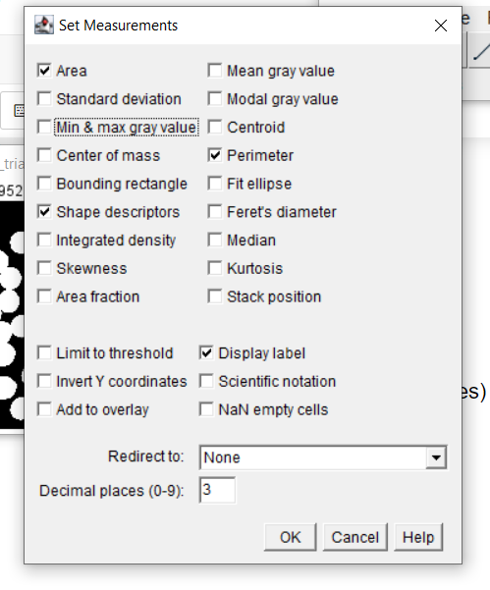

* analyze
  + analyze particle
  + count without changing the size
* click on the reesult--file-save-as CSV

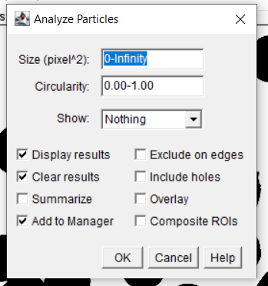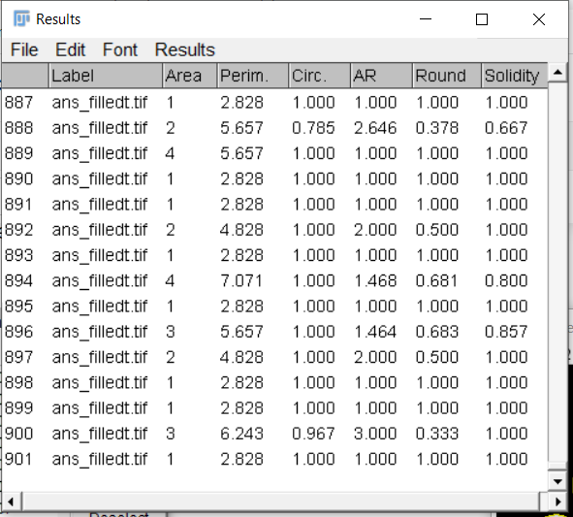

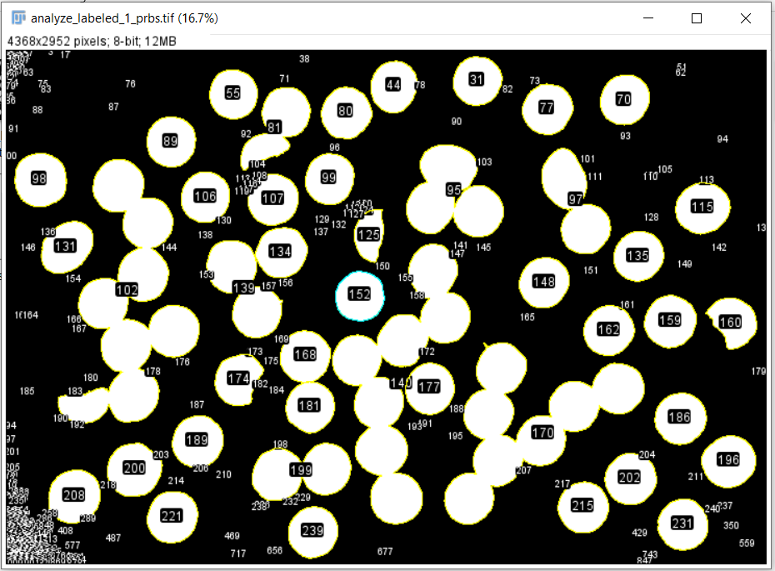

* analyze
  + analyze particle
  + changed the starting size to 1000 for ignoring the noises/small particles
  + click on the reesult--file-save-as CSV

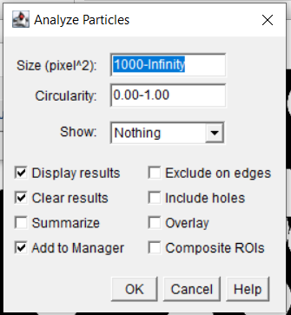

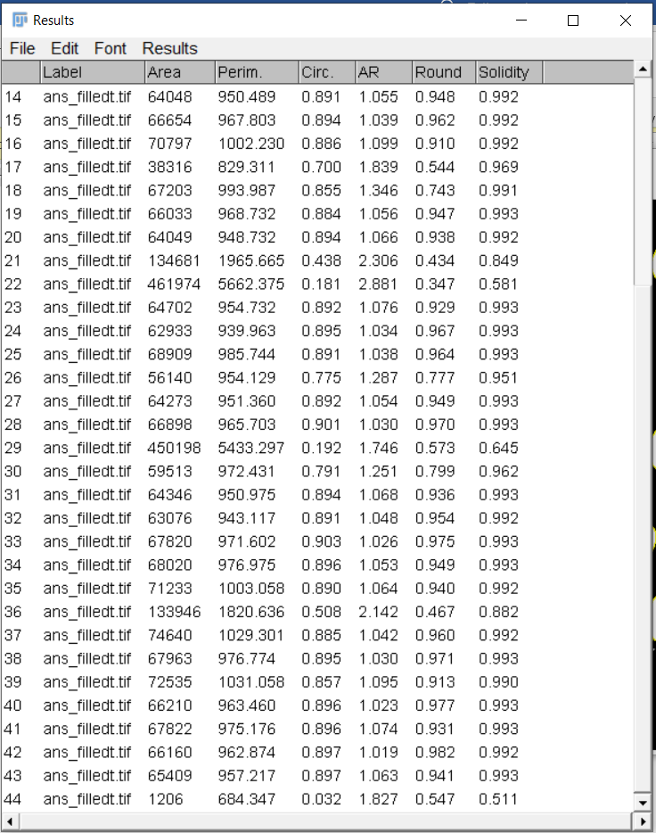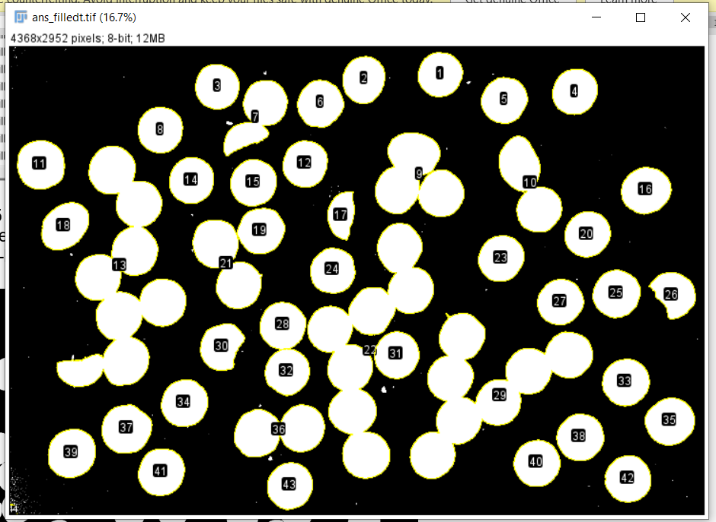

* Have 44 objects, but few are joined together. For separating the image, we have to use watershed.
* process-binary-watershed (elongated one will division/separations)



* Analyzing with the watershed image where the objects are separated. Now we have 83 separate objects which are M&M or Nonstops.  
  + analyze
  + click on the reesult--file-save-as CSV

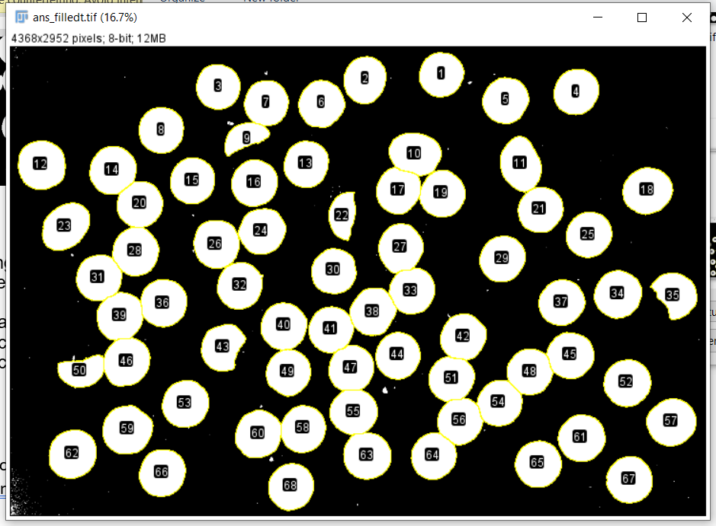

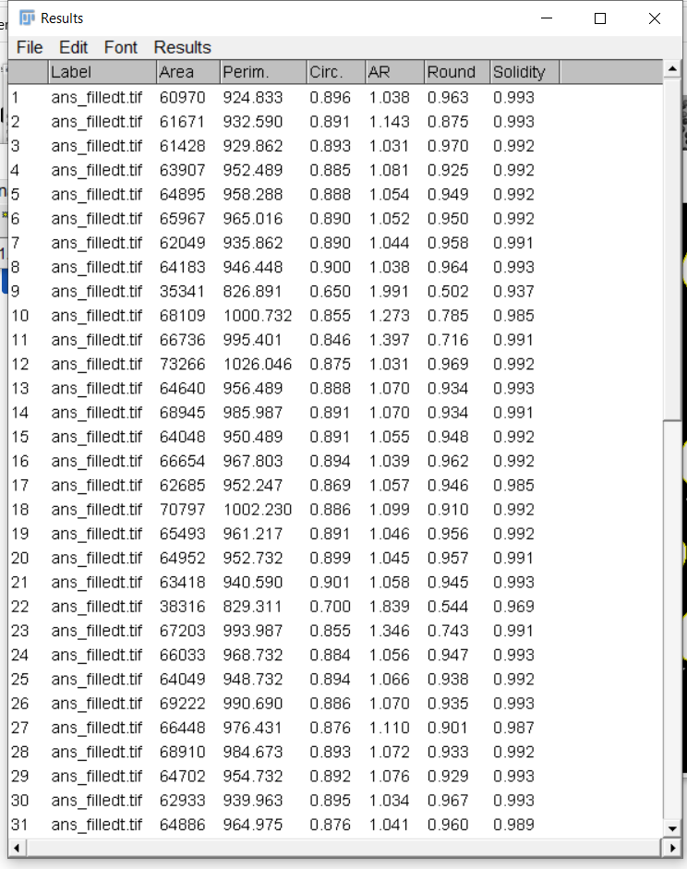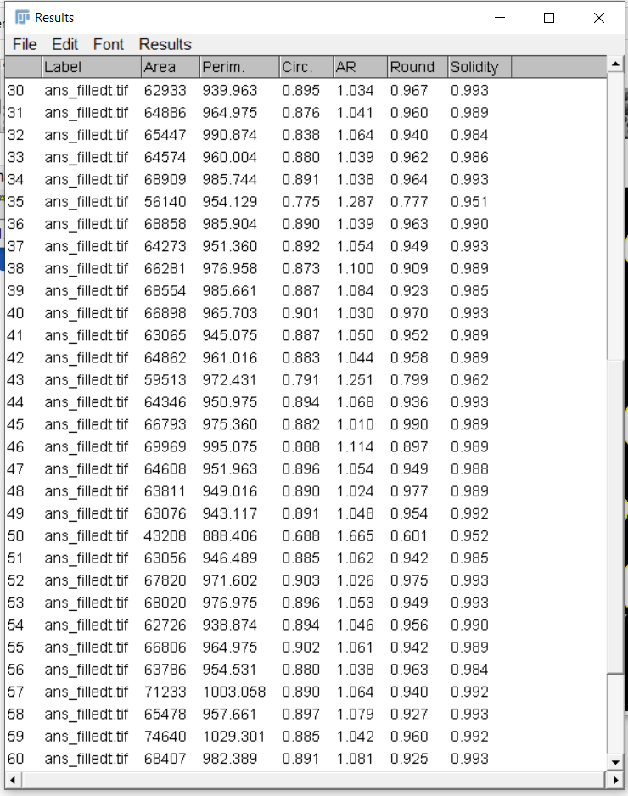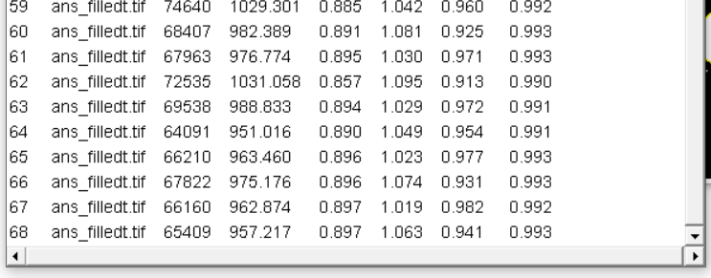

From general knowledge, we know the Non-Stops are Round and M&M’s have a more of an elongated shape. If the roundness (Round) is approximately 1 that means the object is completely round. So, they are Non-stops. Otherwise, M&M.  
  
Few of the chocolates are eaten, if the area is over 60,000, then it is full chocolate. Otherwise, eaten. Half-eaten chocolate will have a half of round. So, if a Non-stop is half eaten, it will have Round of 0.45~0.6. With this logic, we can easily identify Non-Stops and M&M’s  
if area >= 60000: # full chocolate  
 If round>=0.85, then Non-stop,   
 else, M&M

Else: # Eaten chocolate  
 If round>=0.40 and round<=0.6, then Non-stop,   
 ­­else, M&M

|  |  |  |  |  |  |  |
| --- | --- | --- | --- | --- | --- | --- |
|  | Area | Perim. | Circ. | AR | Round | Manual Labeling |
| 1 | 60970 | 924.833 | 0.896 | 1.038 | 0.963 | Non_stop |
| 2 | 61671 | 932.59 | 0.891 | 1.143 | 0.875 | M&M |
| 3 | 61428 | 929.862 | 0.893 | 1.031 | 0.97 | Non_stop |
| 4 | 63907 | 952.489 | 0.885 | 1.081 | 0.925 | Non_stop |
| 5 | 64895 | 958.288 | 0.888 | 1.054 | 0.949 | Non_stop |
| 6 | 65967 | 965.016 | 0.89 | 1.052 | 0.95 | Non_stop |
| 7 | 62049 | 935.862 | 0.89 | 1.044 | 0.958 | Non_stop |
| 8 | 64183 | 946.448 | 0.9 | 1.038 | 0.964 | Non_stop |
| 9 | 35341 | 826.891 | 0.65 | 1.991 | 0.502 | The area is almost half compared to the other chocolates. Visibly the chocolate is half eaten. With this logic, the round should be almost half of 1 (0.5).  So, it is a Non_stop |
| 10 | 68109 | 1000.732 | 0.855 | 1.273 | 0.785 | M&M |
| 11 | 66736 | 995.401 | 0.846 | 1.397 | 0.716 | M&M |
| 12 | 73266 | 1026.046 | 0.875 | 1.031 | 0.969 | Non_stop |
| 13 | 64640 | 956.489 | 0.888 | 1.07 | 0.934 | Non_stop |
| 14 | 68945 | 985.987 | 0.891 | 1.07 | 0.934 | Non_stop |
| 15 | 64048 | 950.489 | 0.891 | 1.055 | 0.948 | Non_stop |
| 16 | 66654 | 967.803 | 0.894 | 1.039 | 0.962 | Non_stop |
| 17 | 62685 | 952.247 | 0.869 | 1.057 | 0.946 | Non_stop |
| 18 | 70797 | 1002.23 | 0.886 | 1.099 | 0.91 | Non_stop |
| 19 | 65493 | 961.217 | 0.891 | 1.046 | 0.956 | Non_stop |
| 20 | 64952 | 952.732 | 0.899 | 1.045 | 0.957 | Non_stop |
| 21 | 63418 | 940.59 | 0.901 | 1.058 | 0.945 | Non_stop |
| 22 | 38316 | 829.311 | 0.7 | 1.839 | 0.544 | The area is almost half compared to the other chocolates. Visibly the chocolate is half eaten. With this logic, the round should be almost half of 1 (0.5).  So, it is a Non_stop |
| 23 | 67203 | 993.987 | 0.855 | 1.346 | 0.743 | M&M |
| 24 | 66033 | 968.732 | 0.884 | 1.056 | 0.947 | Non_stop |
| 25 | 64049 | 948.732 | 0.894 | 1.066 | 0.938 | Non_stop |
| 26 | 69222 | 990.69 | 0.886 | 1.07 | 0.935 | Non_stop |
| 27 | 66448 | 976.431 | 0.876 | 1.11 | 0.901 | Not sure, might be both (Shade problem) |
| 28 | 68910 | 984.673 | 0.893 | 1.072 | 0.933 | Non_stop |
| 29 | 64702 | 954.732 | 0.892 | 1.076 | 0.929 | Non_stop |
| 30 | 62933 | 939.963 | 0.895 | 1.034 | 0.967 | Non_stop |
| 31 | 64886 | 964.975 | 0.876 | 1.041 | 0.96 | Non_stop |
| 32 | 65447 | 990.874 | 0.838 | 1.064 | 0.94 | Non_stop |
| 33 | 64574 | 960.004 | 0.88 | 1.039 | 0.962 | Non_stop |
| 34 | 68909 | 985.744 | 0.891 | 1.038 | 0.964 | Non_stop |
| 35 | 56140 | 954.129 | 0.775 | 1.287 | 0.777 | Slightly eaten, because the area is comparatively less than the others. But the round is less than 0.9 and over 0.5. So, with the logic of half-eaten non-stops, it is an m&M |
| 36 | 68858 | 985.904 | 0.89 | 1.039 | 0.963 | Non_stop |
| 37 | 64273 | 951.36 | 0.892 | 1.054 | 0.949 | Non_stop |
| 38 | 66281 | 976.958 | 0.873 | 1.1 | 0.909 | Non_stop |
| 39 | 68554 | 985.661 | 0.887 | 1.084 | 0.923 | Non_stop |
| 40 | 66898 | 965.703 | 0.901 | 1.03 | 0.97 | Non_stop |
| 41 | 63065 | 945.075 | 0.887 | 1.05 | 0.952 | Non_stop |
| 42 | 64862 | 961.016 | 0.883 | 1.044 | 0.958 | Non_stop |
| 43 | 59513 | 972.431 | 0.791 | 1.251 | 0.799 | Slightly eaten, because the area is comparatively less than the others. But the round is less than 0.9 and over 0.5. So, with the logic of half-eaten non-stops, it is an m&M |
| 44 | 64346 | 950.975 | 0.894 | 1.068 | 0.936 | Non_stop |
| 45 | 66793 | 975.36 | 0.882 | 1.01 | 0.99 | Non_stop |
| 46 | 69969 | 995.075 | 0.888 | 1.114 | 0.897 | M&M |
| 47 | 64608 | 951.963 | 0.896 | 1.054 | 0.949 | Non_stop |
| 48 | 63811 | 949.016 | 0.89 | 1.024 | 0.977 | Non_stop |
| 49 | 63076 | 943.117 | 0.891 | 1.048 | 0.954 | Non_stop |
| 50 | 43208 | 888.406 | 0.688 | 1.665 | 0.601 | The area is almost half compared to the other chocolates. Visibly the chocolate is half eaten. With this logic, the round should be almost half of 1 (0.5).  So, it is a Non_stop |
| 51 | 63056 | 946.489 | 0.885 | 1.062 | 0.942 | Non_stop |
| 52 | 67820 | 971.602 | 0.903 | 1.026 | 0.975 | Non_stop |
| 53 | 68020 | 976.975 | 0.896 | 1.053 | 0.949 | Non_stop |
| 54 | 62726 | 938.874 | 0.894 | 1.046 | 0.956 | Non_stop |
| 55 | 66806 | 964.975 | 0.902 | 1.061 | 0.942 | Non_stop |
| 56 | 63786 | 954.531 | 0.88 | 1.038 | 0.963 | Non_stop |
| 57 | 71233 | 1003.058 | 0.89 | 1.064 | 0.94 | Non_stop |
| 58 | 65478 | 957.661 | 0.897 | 1.079 | 0.927 | Non_stop |
| 59 | 74640 | 1029.301 | 0.885 | 1.042 | 0.96 | Non_stop |
| 60 | 68407 | 982.389 | 0.891 | 1.081 | 0.925 | Non_stop |
| 61 | 67963 | 976.774 | 0.895 | 1.03 | 0.971 | Non_stop |
| 62 | 72535 | 1031.058 | 0.857 | 1.095 | 0.913 | Non_stop |
| 63 | 69538 | 988.833 | 0.894 | 1.029 | 0.972 | Non_stop |
| 64 | 64091 | 951.016 | 0.89 | 1.049 | 0.954 | Non_stop |
| 65 | 66210 | 963.46 | 0.896 | 1.023 | 0.977 | Non_stop |
| 66 | 67822 | 975.176 | 0.896 | 1.074 | 0.931 | Non_stop |
| 67 | 66160 | 962.874 | 0.897 | 1.019 | 0.982 | Non_stop |
| 68 | 65409 | 957.217 | 0.897 | 1.063 | 0.941 | Non_stop |