ALBERTO
WATCH COMPANY
USER GUIDE
Responsive Watch Retail Website
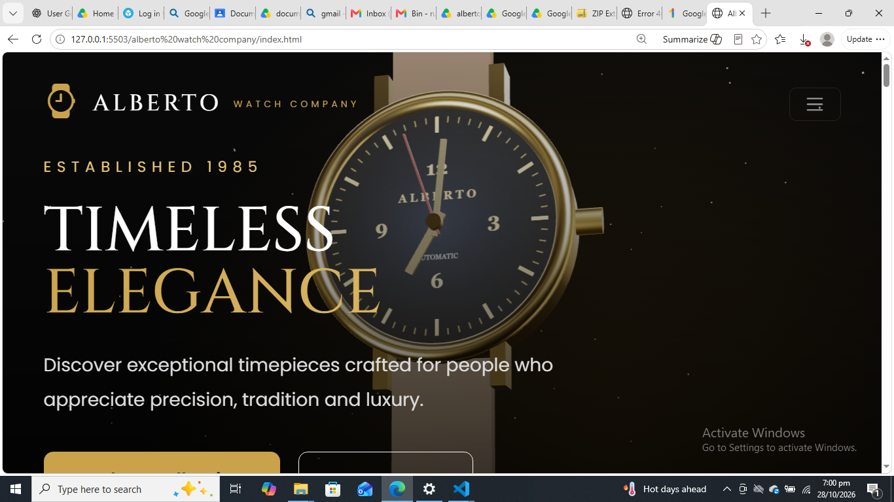
Project documentation

Institute | Aptech
Course | CPISM
Batch Code | 2606E2
Group Members | Rumaisa Danish — ID: Student1733464  Mahrosh Waqas — ID: Student1735499  Hamza — ID: Student1733926  Abu Bakar — ID: Student1733171
Abstract
The Alberto Watch Company website is a front-end website concept for presenting luxury watches and related brand information. The interface uses a black-and-gold visual theme and provides sections for browsing watch products, learning about watch technology, viewing a gallery, reading about the company, and contacting the business. The supplied screenshots show product cards with prices and Quick View controls, gallery categories and search, technology options, contact enquiry fields, store-location information, and newsletter areas.
This user guide explains how to open the website through Visual Studio Code Live Server, navigate its main sections, and understand the visible controls. The project is described as using HTML, CSS, and JavaScript, as confirmed by the project team. Any behaviour that has not been tested—such as successful form submission, email delivery, cart checkout, or newsletter subscription—is not treated as confirmed.
Acknowledgement
We would like to express our gratitude to Aptech and our CPISM instructors for providing the opportunity to develop this website project. We also acknowledge the efforts of our group members in planning, designing, and assembling the Alberto Watch Company website. This user guide has been prepared to help users understand the website layout and navigate its available sections.
Table of Contents
1. Introduction 4
1.1 Introduction to the Website 4
1.2 Purpose of the Website 4
1.3 Scope of the Website 4
2. Project Overview 4
2.1 What the Website Provides 4
2.2 Main User Journey 4
2.3 Main Website Sections 5
3. Target Users 5
4. System Requirements 5
4.1 Hardware Requirements 5
4.2 Software Requirements 5
5. Getting Started 5
5.1 Opening the Website 5
5.2 What the User Sees First 6
5.3 Basic Navigation 6
6. Website Navigation 7
6.1 Navigation Tips 7
7. Home Page 8
How to Use the Home Page 8
8. About Us Page 10
How to Use the About Page 10
9. Contact Page 11
How to Use the Contact Form 11
Store Location Information 11
10. Menu / Products Page 13
How to Browse Products 13
11. Gallery Page 15
How to Use the Gallery 15
12. Technology Page 17
How to Use the Technology Page 17
13. Diagrams 18
13.1 User Journey Flowchart 18
13.2 High-Level Data Flow Diagram (DFD) 18
14. Common User Issues and Solutions 20
15. Conclusion 20

1. Introduction

1.1 Introduction to the Website
Alberto Watch Company is a responsive watch-company website designed to present watches in a premium retail style. Its interface combines dark backgrounds, gold accents, watch photography, and navigation links to make the main sections easy to identify.

1.2 Purpose of the Website
The main purposes of the website are to:
- Present watch products and their displayed prices.
- Let visitors explore product categories and visible product controls.
- Introduce watch technology and different movement types.
- Display watch photographs in a dedicated gallery.
- Provide company information and contact/enquiry details.
- Present store-location information and a newsletter subscription area.

1.3 Scope of the Website
The visible scope includes the Home, Products, Technology, Gallery, About, and Contact sections, together with navigation menus and footer links. The supplied screenshots show a local development version running through VS Code Live Server. The guide covers the visible front-end interface. A working backend, database, payment service, order processing, or actual email delivery has not been confirmed.

2. Project Overview

2.1 What the Website Provides
- A branded home page with a luxury watch hero image and calls to explore the collection.
- A product catalogue showing watch images, names, prices, category links, filters, and Quick View buttons.
- A Technology section introducing Mechanical, Automatic, Quartz, and Smart watch movements.
- A Gallery with image categories such as Couple, Gents, Ladies, and Other, plus a search field.
- An About section introducing the company’s heritage and brand story.
- A Contact section with enquiry fields, email details, business hours, and store destination/map information.
- Footer links and a newsletter subscription area.

2.2 Main User Journey
A typical visitor opens the Home page, uses the navigation menu to choose a section, browses products or informational content, and then visits the Contact section if they need to make an enquiry. Visitors can return to the navigation menu at any time to explore another section.

2.3 Main Website Sections
Section | Purpose
Home | Brand introduction and collection entry point
Products | Browse watches, prices, categories, and visible product controls
Technology | Read about watch movements and technology types
Gallery | Browse watch photography and use visible categories/search
About | Learn about the company and its brand story
Contact | View enquiry form, contact details, hours, and store destinations

3. Target Users
The website may be useful to the following visitor groups:
- Potential customers who want to view watch styles and displayed prices.
- Watch enthusiasts interested in different movement types and watch design.
- Visitors looking for company information or store-location details.
- Customers who want to use the contact enquiry form to ask a question.
- Users browsing watch photographs by gallery category.
The website helps these users by placing product, brand, gallery, technology, and contact information in clearly labelled sections. The website should not be treated as proof that an online purchase or enquiry has completed unless the relevant action is tested successfully.

4. System Requirements

4.1 Hardware Requirements
- A desktop computer or laptop capable of running a modern web browser.
- Keyboard and mouse or touchpad for navigation and form input.
- Sufficient memory and storage to run the operating system, browser, and project files.

4.2 Software Requirements
- Operating system: Windows or another operating system supported by Visual Studio Code and a modern browser.
- Code editor / development environment: Visual Studio Code.
- Local preview: Live Server extension for VS Code (as used for the supplied local screenshots).
- Web browser: a modern browser such as Microsoft Edge, Google Chrome, or Mozilla Firefox.
- Front-end technologies: HTML, CSS, and JavaScript (as confirmed by the project team).
Internet access may be needed for externally hosted images, map embeds, or other online resources. The exact dependency on internet access should be checked on the computer where the project is run.

5. Getting Started

5.1 Opening the Website
- Open Visual Studio Code.
- Choose File > Open Folder and select the Alberto Watch Company project folder.
- In the Explorer panel, locate the main index.html file.
- If the Live Server extension is installed, right-click index.html and choose “Open with Live Server,” or use the Go Live control.
- The website should open in the default browser at a local address similar to http://127.0.0.1:5503/.... The port number may differ.

5.2 What the User Sees First
The Home page displays the Alberto Watch Company logo, a dark hero area with a large watch image, the “Established 1985” label, the headline “Timeless Elegance,” supporting text, navigation, and calls to explore the collection.

5.3 Basic Navigation
- Use the top navigation links to open Home, Products, Technology, Gallery, About, or Contact.
- On the Products page, scroll through the product cards and use the visible category, Filters, or Quick View controls as available.
- On the Technology page, select a movement option to explore its related content if the controls are interactive.
- On the Gallery page, use the category buttons or search field to find images if these controls are functioning.
- Use the footer links to move to other sections, and use the back-to-top control where available.

6. Website Navigation
The website uses a top navigation bar and footer links. The navigation labels vary slightly between pages, but the screenshots show links to Home, Products/Collections, Technology, Gallery, About, and Contact. Some pages use “Collections” or “Store” labels in the footer. If a link opens a separate HTML file, use the browser’s normal back button to return to the previous page.

6.1 Navigation Tips
- Click a navigation label once and wait for the selected page or section to load.
- If a page is longer than the screen, scroll down to view lower content and the footer.
- Use the browser back button if you open a page and want to return to the previous page.
- If the page appears incomplete, check that Live Server is still running and that the project files have not been moved.

7. Home Page
The Home page is the main entry point to the Alberto Watch Company website. It introduces the brand through a black-and-gold design, a prominent watch image, and the “Timeless Elegance” message. The navigation menu provides access to the other website sections, and the page includes a call to explore the collection.
Figure 1. Home page hero area and main navigation.

How to Use the Home Page
- Read the main headline and supporting introduction to understand the brand presentation.
- Use the navigation menu to move to Products, Technology, Gallery, About, or Contact.
- Select the collection/shop call-to-action to explore the product area, if the link is available.
- Scroll down to view lower sections, newsletter content, and footer links.
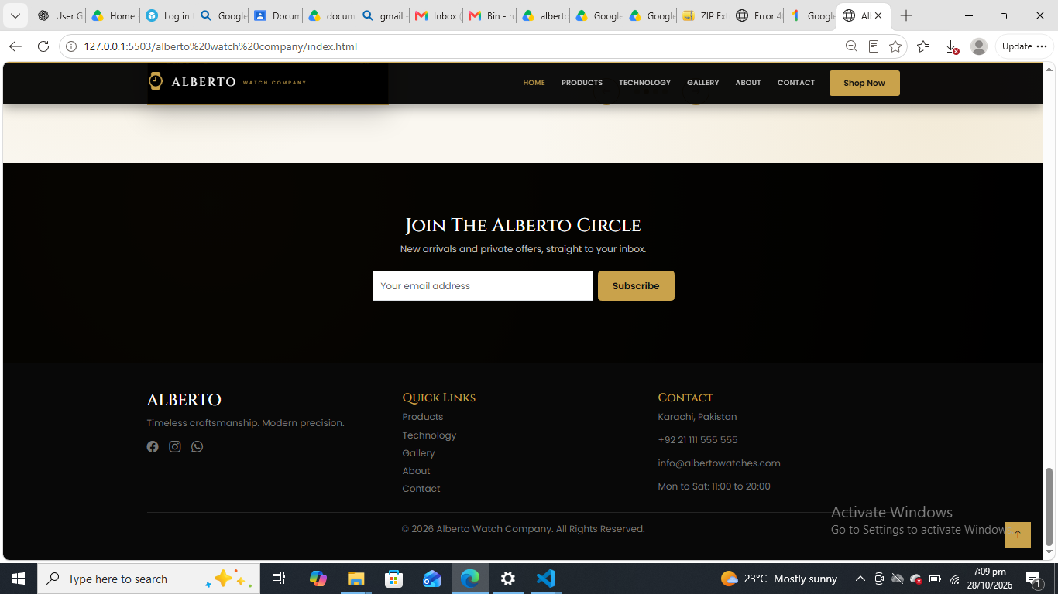
Figure 2. Home page newsletter area and footer links.

8. About Us Page
The About page presents the company’s brand story and heritage. The supplied screenshot shows the heading “More Than a Moment,” supporting text about precision and timeless design, and a “Discover Our Story” call-to-action.
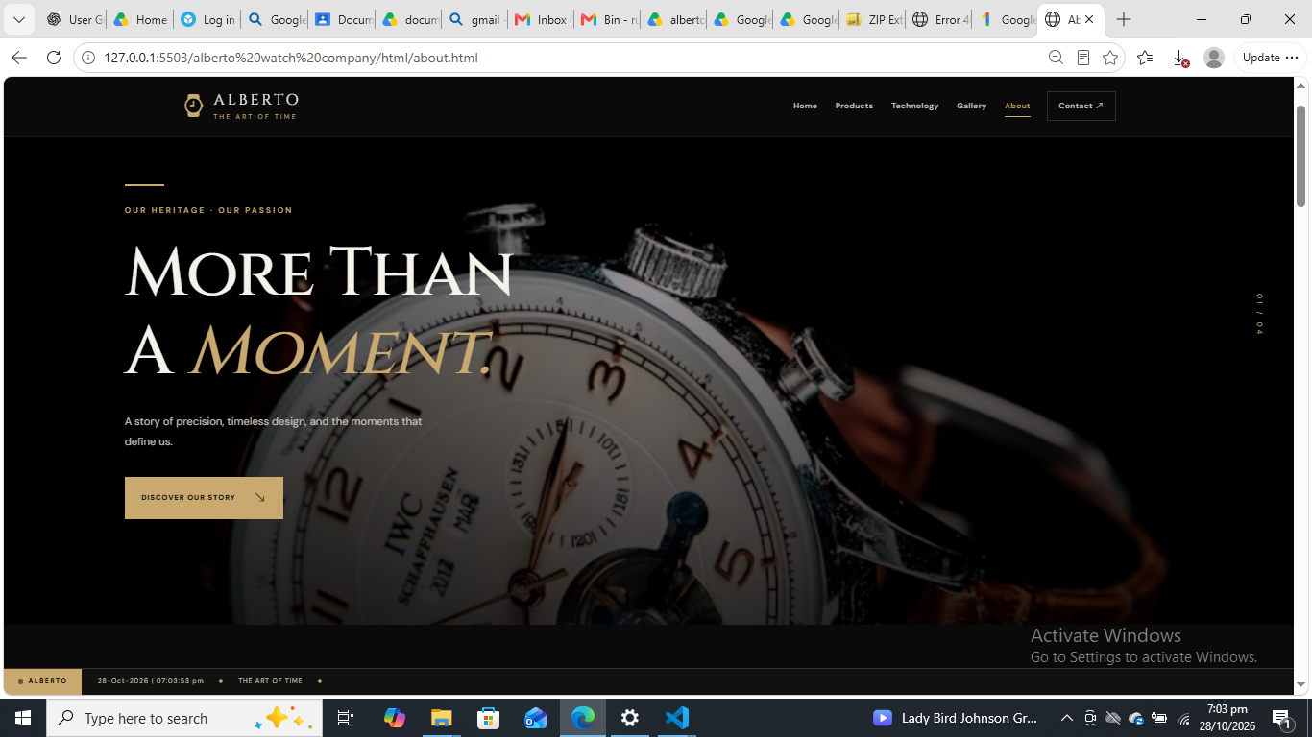
Figure 3. About page introduction and brand-story area.

How to Use the About Page
- Select About from the navigation menu or a relevant footer link.
- Read the introduction to learn how the website presents the company’s identity.
- Use the “Discover Our Story” button if you want to move to the story content and the button is active.
- Scroll through the page for any additional company information.

9. Contact Page
The Contact page is intended for visitors who have questions about watches or collections. The screenshot shows an enquiry form with Full Name, Email Address, Enquiry Type, and Your Message fields, a confirmation checkbox, and a “Send Your Message” button. It also displays an email address, business hours, a map, and store destination options.
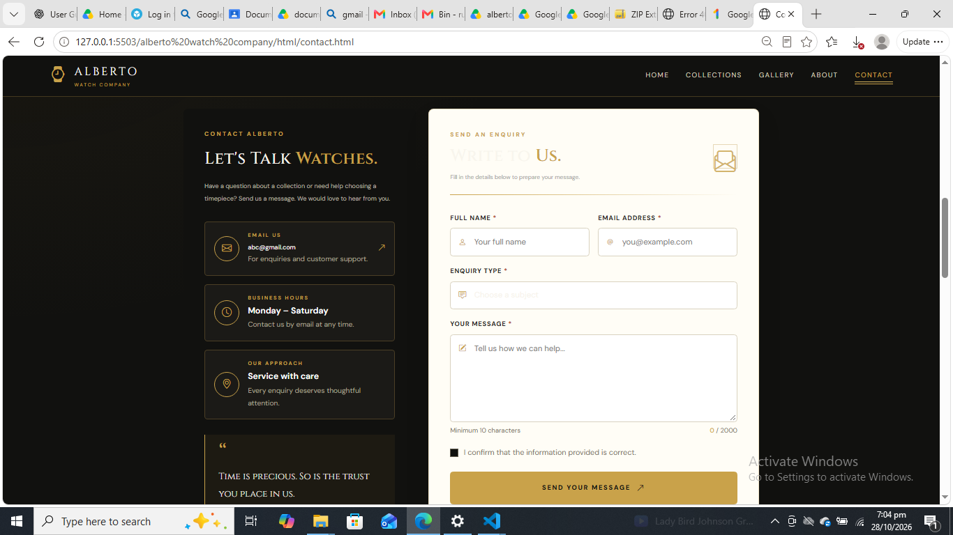
Figure 4. Contact page enquiry form and contact information.

How to Use the Contact Form
- Enter your full name in the Full Name field.
- Enter a valid email address in the Email Address field.
- Choose an enquiry type from the available options.
- Write your question or message in the message box. The screen indicates a minimum of 10 characters and a maximum of 2,000 characters.
- Tick the confirmation checkbox if the information is correct.
- Select “Send Your Message” to attempt submission. The form’s actual submission behaviour has not yet been tested, so check for a confirmation message before assuming the message was sent.

Store Location Information
The lower contact section includes a map and store destination options for cities such as Karachi, Lahore, Islamabad & Rawalpindi, Faisalabad, Hyderabad, and Multan. The map and destination links may open an external map service.
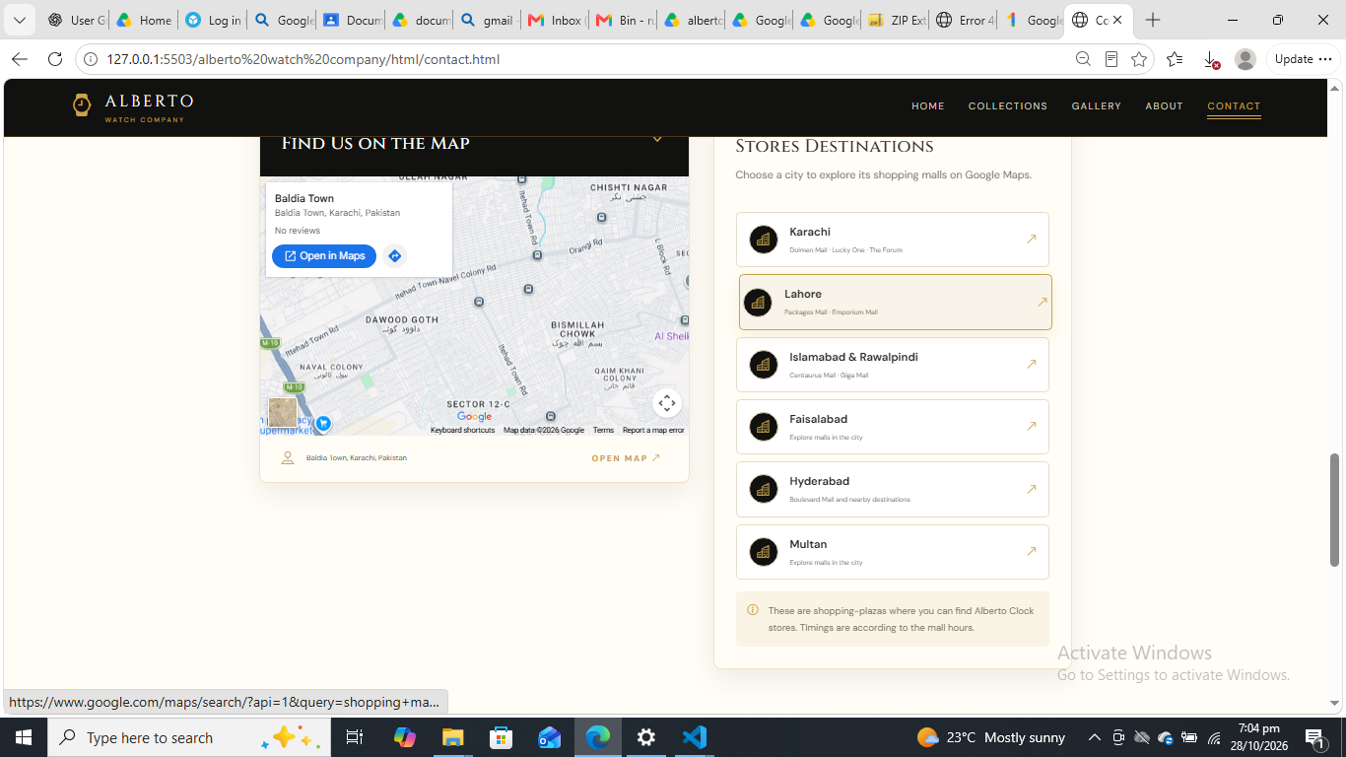
Figure 5. Contact page map and store destination options.
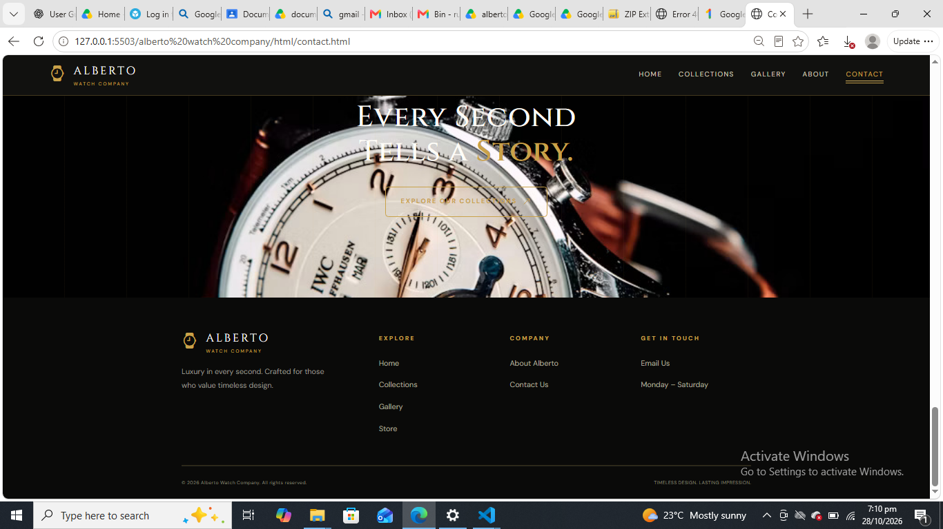
Figure 6. Contact page lower banner and footer navigation.

10. Menu / Products Page
The Products page displays a catalogue of watches in product cards. The supplied screenshots show watch photographs, product names such as Retro Round 1971, Velvet Night, Emerald Classic, and Noble Steel, prices in Pakistani rupees, and Quick View buttons. The page also shows category links, Filters, and a cart icon.
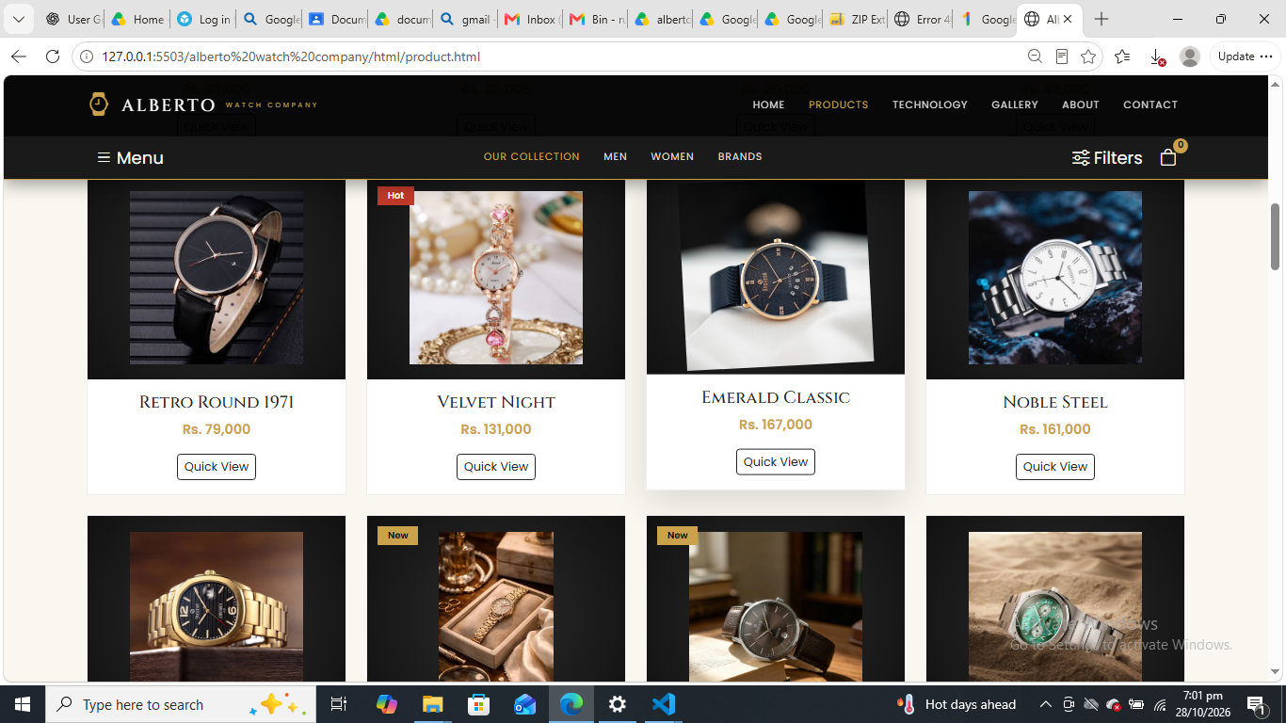
Figure 7. Products page with product cards, prices, and catalogue controls.

How to Browse Products
- Open Products from the top navigation.
- Scroll through the product cards to compare the displayed watch designs and prices.
- Use category options such as Men, Women, or Brands if available.
- Select Filters to view filtering options if the control is active.
- Select Quick View on a product to try opening its additional details.
- The cart icon is visible in the interface, but checkout or purchase functionality has not been confirmed.
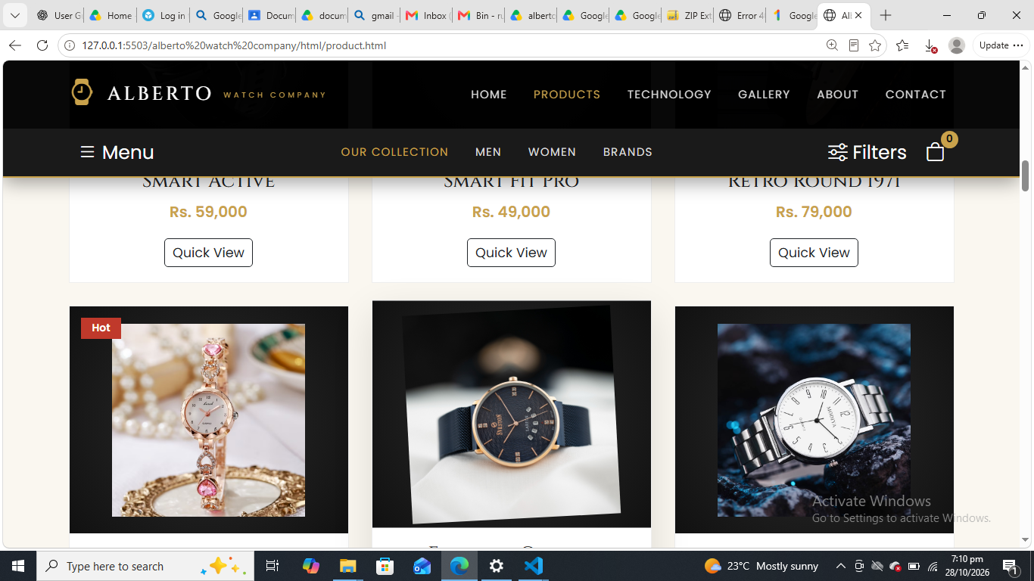
Figure 8. Additional product cards in the watch catalogue.

11. Gallery Page
The Gallery page presents watch photography and collection imagery. The visible interface shows a gallery introduction, counts for photos, collections, and films, category filters for All, Couple, Gents, Ladies, and Other, plus a search field.
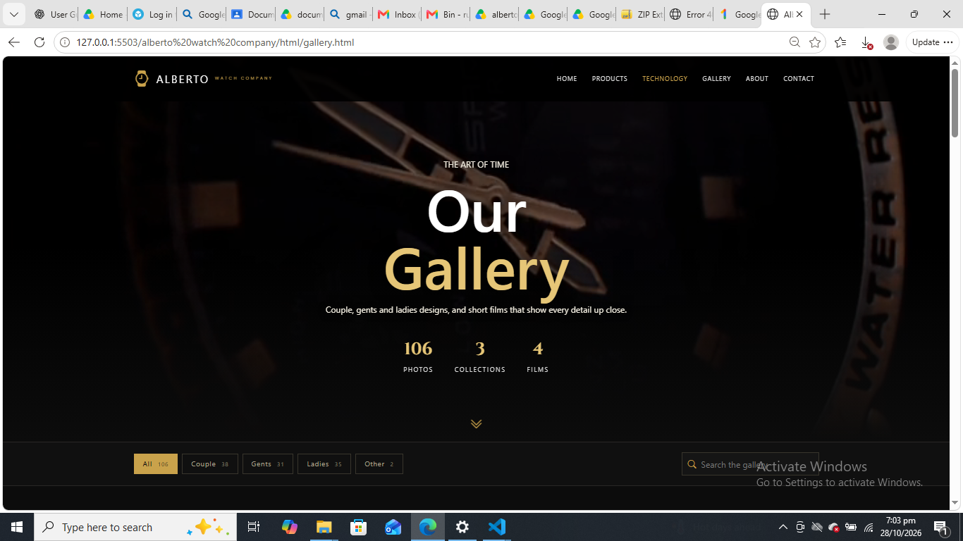
Figure 9. Gallery page introduction and category/search controls.

How to Use the Gallery
- Select Gallery from the top navigation.
- Use the category controls to focus on a type of gallery image, if the filters are active.
- Enter a keyword in the gallery search field if search is enabled.
- Scroll down to browse the image grid.
- Select an image only if you want to inspect it and the interface supports opening a larger view.
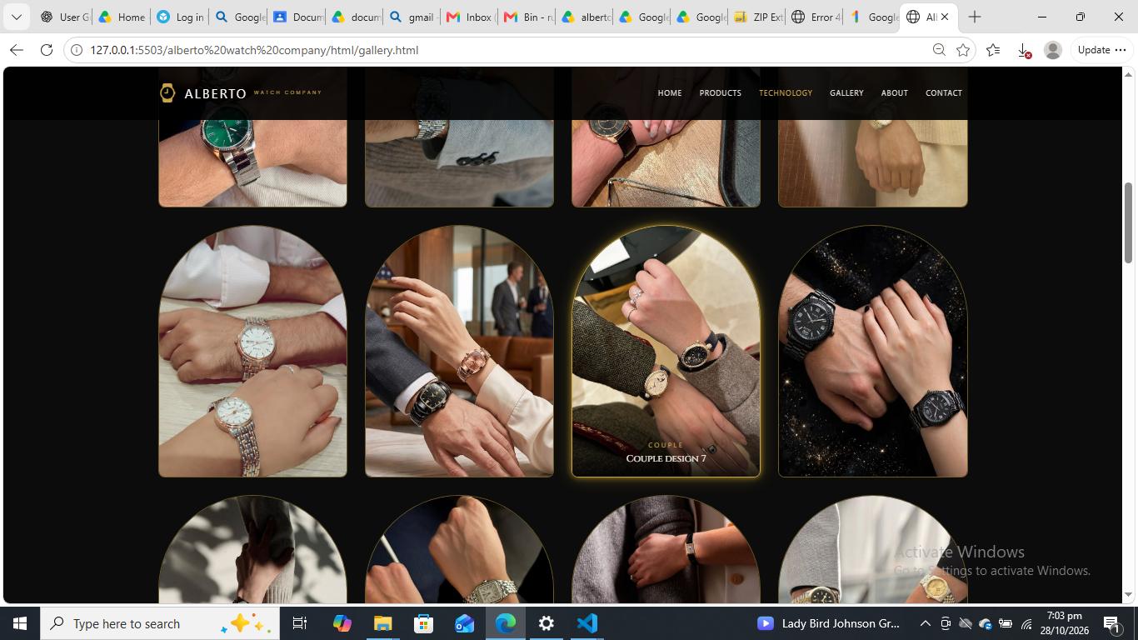
Figure 10. Gallery image grid with watch and couple-design photographs.

12. Technology Page
The Technology page introduces watch movements and explains that the movement is the mechanism inside a watch. The screenshot shows four selectable options: Mechanical, Automatic, Quartz, and Smart.
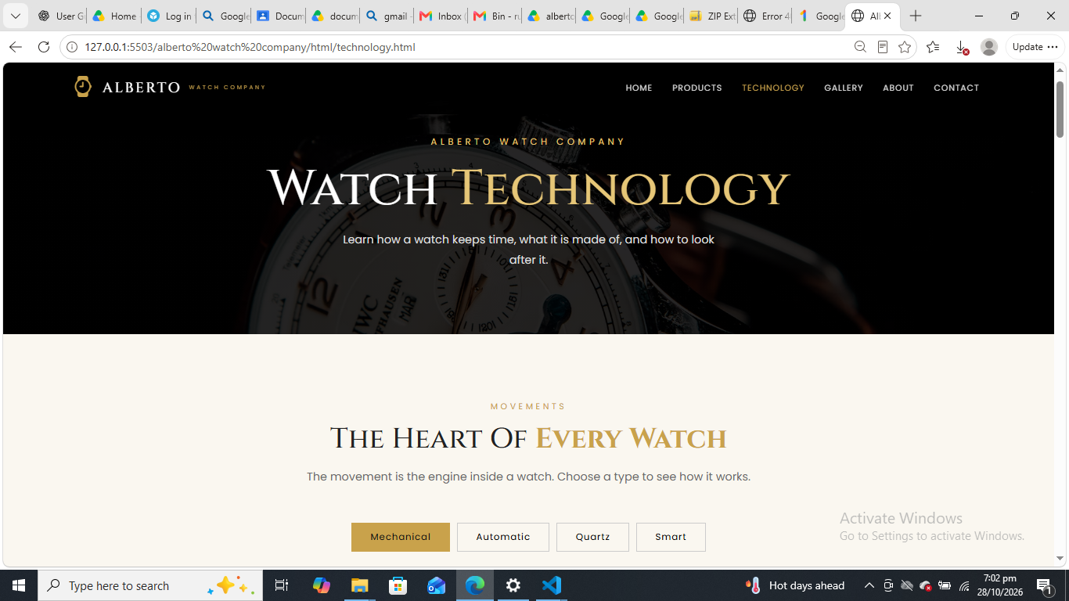
Figure 11. Technology page and movement-type options.

How to Use the Technology Page
- Select Technology from the main navigation.
- Read the introduction about watch movements.
- Select Mechanical, Automatic, Quartz, or Smart to explore the corresponding content if the buttons are active.
- Use the navigation bar to return to other sections.

13. Diagrams

13.1 User Journey Flowchart
The flowchart below illustrates a typical visitor journey based on the website sections visible in the supplied screenshots. It is a guide to navigation, not a claim that every button or interaction has been function-tested.
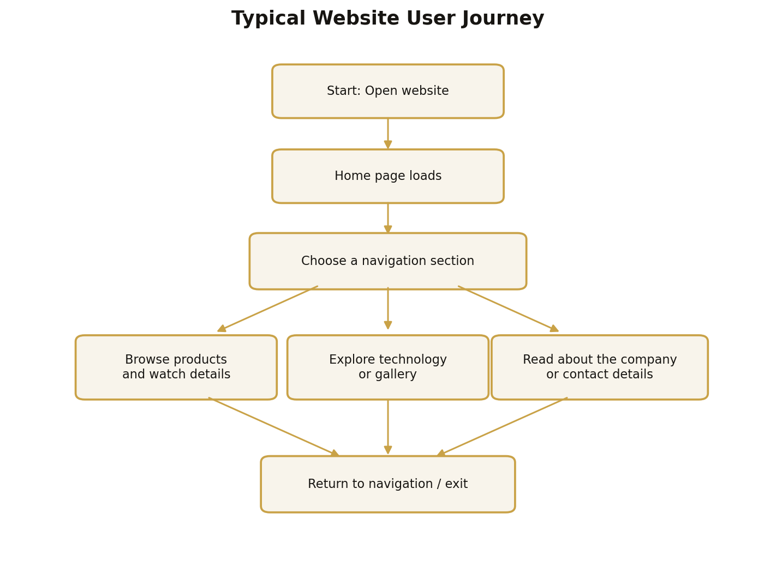
Figure 12. Typical user journey through the website.

13.2 High-Level Data Flow Diagram (DFD)
This high-level DFD shows the visitor interacting with the front-end website through a browser. Since the project files and backend were not inspected, no database or server-side process is included as a confirmed component.
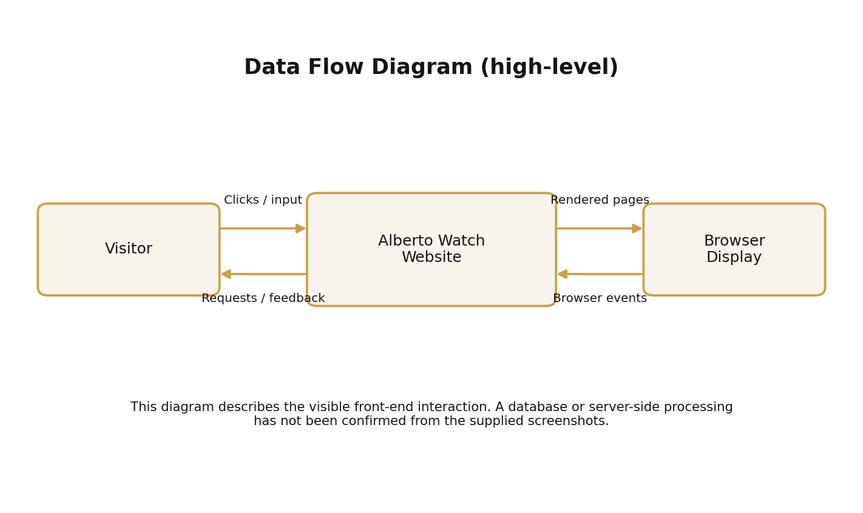
Figure 13. High-level front-end interaction DFD.

14. Common User Issues and Solutions
Issue | Suggested solution
Website does not open | Confirm that the correct project folder is open in VS Code, index.html exists, and Live Server is running.
Page or image appears missing | Check the spelling and relative paths of HTML, CSS, JavaScript, and image files. Keep the folder structure unchanged.
Navigation link does not work | Check that the link points to the correct HTML file or section ID and reload the page.
Layout looks different on screen | Try a modern browser, zoom to 100%, and resize the window. Responsive behaviour should be checked on mobile and desktop sizes.
Contact form does not show confirmation | The form has not been tested. Check required fields and browser messages; verify implementation before assuming that a message was delivered.
Newsletter or cart does not respond | These controls are visible in screenshots, but their full functionality is not confirmed. Check the JavaScript and any required backend integration.
Map does not load | Check internet access and whether the map is embedded from an external service.

15. Conclusion
The Alberto Watch Company website provides a visually consistent front-end experience for presenting luxury watch products and related information. Its main sections allow visitors to browse watches, explore watch technology, view a gallery, learn about the company, and locate contact information. This guide explains how to launch the local project through VS Code Live Server and how to navigate the visible sections. Before the website is used as a live commercial service, interactive features such as contact submission, newsletter subscription, product filtering, cart operations, and responsive behaviour should be tested.
Prepared for: CPISM | Aptech | Batch 2606E2

