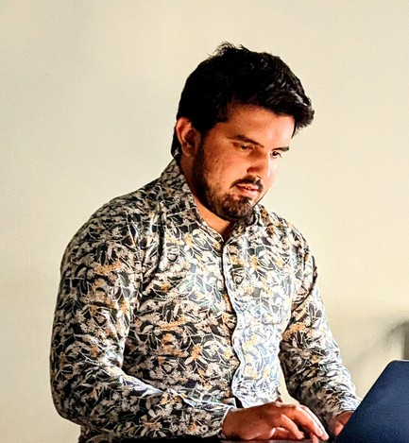

Malik Mahsam Awan

# Senior Software Engineer

+92 333 6307767 **@** [malik_mahsam@hotmail.com](mailto:malik_mahsam@hotmail.com)

 [https://www.linkedin.com/in/malik-](https://www.linkedin.com/in/zkykhan/)[mahsam](https://www.linkedin.com/in/malik-mahsam-awan-61715088/)[-awan-61715088/](https://www.linkedin.com/in/zkykhan/) <https://github.com/mahsammalik>

# SUMMARY

I have 6+ years of experience in the Software Industry in Designing & Developing enterprise/cloud products for E-Commerce, Fintech, and the Healthcare Industry. Developed high-end products using advanced analytics. In my free time, I love going for long walks, hiking, and camping.

# EDUCATION

**M.Sc in Computer Science**

Superior University, Lahore

*2014 - 2017*

**BS in Computer Science** IUB University, Bahawalpur *2011 - 2014*

# CAREER SUMMARY

**Senior Software Engineer**

[AKSA-SDS - March 2022 - Continue - Islamabad, PK,](https://www.aksa-sds.com/)

**PROJECT**: [**JAZZCASH**](https://jazzcash.com/)

Worked as Technical Architect for building powerful services that power Fintech. Built entire backend powered with Microservices using REST, API connect.

Built Real-Time Notification Engine that powers customer reminder notifications for repayments and eligibility for a new loan product.

Day-to-day activities include:- Schema model design.

Writing NoSQL queries using mongoose as ORM.

Integrating CPS API ( Huawei Wallet Management system ) and third-party API. Caching of data in Red had a data grid.

Consuming Kafka topics and generating reports in DB2.

At a time we are handling multiple projects and collaborating with team members to ensure the delivery of assigned tasks.

Making of response code objects.

Troubleshooting / debugging issues ( checking logs on OPENSHIFT and KIBANA ) - Deployment of code on staging by using OPENSHIFT CLIENT.

# Senior Software Engineer

[Reactive Space - January 2022 - March 2022 - Bahria Town, Islamabad, PK](https://www.reactivespace.com/)

Create a decentralised cryptocurrency exchange (dEx) powered by Ethereum smart contracts. Designed frontend in ReactJs for exchange.

Wrote smart contracts for depositing/Withdrawing and placing orders for Aimedis Tokens. Nest/Node/React Integration with Web3 and Blockchain.

Experienced with distributed AWS cloud platform configuration, deployments, and lifecycle management automation tools like Jenkins or Github.

# Senior Software Engineer

[TECFOLK - January 2017 - December 2021 - Bahria Town, Islamabad, PK](http://tecfolk.com/)

Develop software that takes in API files and interacts with databases using React/Meteor/Node/MongoDB and MySQL.

Also developed Mobile App with React Native/Redux and RocketChat Framework technology. Development using Visual Studio, Dot Net, C#, MS SQL, DB queries, API integration, SFTP file transfer using C#, Windows service creation and XML/JSON/CSV file creation for data transfers and processing.

# PROFESSIONAL SKILLS

## Coding Languages

**Node.js, TypeScript, JavaScript, .NET Core, React.js, React Native**

## Frameworks/Systems

**Angular, IBM App Connect, API Connect, Redhat, Kubernetes, Docker, Linux, Ace Cloud, AWS, Git, OpenShift**

## Databases

**SQL/DB2, MongoDB, SQL Server, MySQL**

## Machine Learning

**Power BI, Qlick Sense**

# HOBBIES

**cycling - jogging - hiking - pingpong - travelling**

# CHARACTER REFERENCES

## [Muhammad Danish](http://linkedin.com/in/muhammad-danish-b7b47255)

**Lead Backend Development, Axian Group Cell: +92 3349549501**

## [Mohsin Mustafa](http://linkedin.com/in/mohsinmustufa)

**Manager Backend Development, Jazz Email:** [**mohsinmustufa@yahoo.com**](mailto:mohsinmustufa@yahoo.com) **Cell: +92 3458509046**