LAB 05
Stage v (Verify): Home Activities
Defining Data, Strings and Arrays in Assembly Language (MASM)
Submitted by | Muhammad Ahsan
Registration No. | FA24-BCS-059
Submitted to | Sir Taimur Shahzad
Subject | COAL
Lab | Lab 05: Stage v (Verify), Home Activities

Contents and Setup
Each home task is a complete 32-bit MASM program that uses Kip Irvine's Irvine32 library (the setup used in the lab with Visual Studio). Every program declares the data the task asks for and then prints it, so the output can be checked against the declarations.
Task | Topic | Program
Home Task 1 | Defining data (BYTE, WORD, DWORD, SBYTE, ?) | HomeTask1.asm
Home Task 2 | A multi-line menu declared as one string | HomeTask2.asm
Home Task 3 | 1-D, 2-D and 3-D arrays with DUP | HomeTask3.asm
Home Task 4 | C++ char / int declarations in MASM | HomeTask4.asm

How the programs were built and run
- Assembler: JWasm v2.21, a MASM-compatible assembler that accepts the same source as Visual Studio's ml.exe.
- Linker: JWlink, linking each program with Irvine32.lib, Kernel32.lib and User32.lib into a 32-bit Windows console program (.exe).
- Run: each .exe was started from cmd.exe in a Win32 console window (using Wine), and the screenshots show that window.
- The same .asm files build in Visual Studio with the usual Irvine32 project: add the file to the project and press Ctrl+F5.

Home Task 1: Defining Data

Task statement
Define the following data in Assembly:
Sort BYTE 'y' ; ASCII of y = 79H
value WORD 25159 ; 25159D = 6247H
total DWORD 542803535 ; 542803535D = 205A864FH
marks DWORD 0, 0, 0, 0, 0, 0, 0, 0
value1 BYTE 'A' ; character constant
value2 BYTE 0 ; smallest unsigned byte
value3 BYTE 255 ; largest unsigned byte
value4 SBYTE -128 ; smallest signed byte
value5 SBYTE +127 ; largest signed byte
value6 BYTE ? ; uninitialized byte

Declarations (answer)
Variable | Type | Initializer | Hex value | Bytes in memory
Sort | BYTE | 'y' | 79h | 79
value | WORD | 25159 | 6247h | 47 62
total | DWORD | 542803535 | 205A864Fh | 4F 86 5A 20
marks | DWORD | 0, 0, 0, 0, 0, 0, 0, 0 | 8 x 00000000h | 32 x 00
value1 | BYTE | 'A' | 41h | 41
value2 | BYTE | 0 | 00h | 00
value3 | BYTE | 255 | FFh | FF
value4 | SBYTE | -128 | 80h | 80
value5 | SBYTE | +127 | 7Fh | 7F
value6 | BYTE | ? (uninitialized) | 00h | 00

Source code: HomeTask1.asm
1 TITLE Lab 05 - Home Task 1 : Defining Data (HomeTask1.asm)
2
3 ;--------------------------------------------------------------------
4 ; Name : Muhammad Ahsan
5 ; Reg. No. : FA24-BCS-059
6 ; Subject : COAL
7 ; Submitted to : Sir Taimur Shahzad
8 ; Lab 05 : Stage v (verify) - Home Activities
9 ;
10 ; Home Task 1 : Define the given data in assembly language, then
11 ; display every variable in hexadecimal and decimal
12 ; and dump the memory that holds all of them.
13 ;--------------------------------------------------------------------
14
15 INCLUDE Irvine32.inc
16
17 .data
18 ;------------------ Home Task 1 : data definitions ------------------
19 Sort BYTE 'y' ; ASCII of y = 79H
20 value WORD 25159 ; 25159D = 6247H
21 total DWORD 542803535 ; 542803535D = 205A864FH
22 marks DWORD 0, 0, 0, 0, 0, 0, 0, 0 ; array of eight doublewords
23 value1 BYTE 'A' ; character constant
24 value2 BYTE 0 ; smallest unsigned byte
25 value3 BYTE 255 ; largest unsigned byte
26 value4 SBYTE -128 ; smallest signed byte
27 value5 SBYTE +127 ; largest signed byte
28 value6 BYTE ? ; uninitialized byte
29
30 DataSize = ($ - Sort) ; bytes used by the data above
31
32 ;---------------------- strings for the output ----------------------
33 banner1 BYTE "Lab 05 - Home Task 1 : Defining Data in Assembly",0
34 banner2 BYTE "Muhammad Ahsan | FA24-BCS-059 | COAL",0
35 dashes BYTE "-------------------------------------------------",0
36 header BYTE "Variable Type Hex Decimal",0
37 hdrLine BYTE "-------- ------ ----------- ----------------",0
38
39 lSort BYTE "Sort BYTE ",0
40 lValue BYTE "value WORD ",0
41 lTotal BYTE "total DWORD ",0
42 lMarks BYTE "marks DWORD ",0
43 lValue1 BYTE "value1 BYTE ",0
44 lValue2 BYTE "value2 BYTE ",0
45 lValue3 BYTE "value3 BYTE ",0
46 lValue4 BYTE "value4 SBYTE ",0
47 lValue5 BYTE "value5 SBYTE ",0
48 lValue6 BYTE "value6 BYTE ",0
49
50 sOpen BYTE " ('",0
51 sClose BYTE "')",0
52 sEach BYTE "8 elements ",0
53 sMarks1 BYTE "LENGTHOF = ",0
54 sMarks2 BYTE ", SIZEOF = ",0
55 sMarks3 BYTE " bytes",0
56 sUninit BYTE " (uninitialized ?)",0
57 sDump BYTE "Memory dump of all the variables above (",0
58 sDump2 BYTE " bytes, little-endian):",0
59
60 .code
61 main PROC
62 ; ---- title ----
63 mov edx, OFFSET banner1
64 call WriteString
65 call Crlf
66 mov edx, OFFSET banner2
67 call WriteString
68 call Crlf
69 mov edx, OFFSET dashes
70 call WriteString
71 call Crlf
72 mov edx, OFFSET header
73 call WriteString
74 call Crlf
75 mov edx, OFFSET hdrLine
76 call WriteString
77 call Crlf
78
79 ; ---- Sort BYTE 'y' ----
80 mov edx, OFFSET lSort
81 call WriteString
82 movzx eax, Sort
83 mov ebx, TYPE Sort
84 call ShowHex
85 call WriteDec ; 121
86 mov edx, OFFSET sOpen
87 call WriteString
88 call WriteChar ; y
89 mov edx, OFFSET sClose
90 call WriteString
91 call Crlf
92
93 ; ---- value WORD 25159 ----
94 mov edx, OFFSET lValue
95 call WriteString
96 movzx eax, value
97 mov ebx, TYPE value
98 call ShowHex
99 call WriteDec
100 call Crlf
101
102 ; ---- total DWORD 542803535 ----
103 mov edx, OFFSET lTotal
104 call WriteString
105 mov eax, total
106 mov ebx, TYPE total
107 call ShowHex
108 call WriteDec
109 call Crlf
110
111 ; ---- marks DWORD 0,0,0,0,0,0,0,0 ----
112 mov edx, OFFSET lMarks
113 call WriteString
114 mov edx, OFFSET sEach
115 call WriteString
116 mov esi, OFFSET marks
117 mov ecx, LENGTHOF marks ; 8 elements
118 L1: mov eax, [esi]
119 call WriteDec
120 mov al, ' '
121 call WriteChar
122 add esi, TYPE marks
123 loop L1
124 call Crlf
125
126 ; LENGTHOF and SIZEOF of marks
127 mov ecx, 31 ; indent to the Decimal column
128 L2: mov al, ' '
129 call WriteChar
130 loop L2
131 mov edx, OFFSET sMarks1
132 call WriteString
133 mov eax, LENGTHOF marks
134 call WriteDec
135 mov edx, OFFSET sMarks2
136 call WriteString
137 mov eax, SIZEOF marks
138 call WriteDec
139 mov edx, OFFSET sMarks3
140 call WriteString
141 call Crlf
142
143 ; ---- value1 BYTE 'A' ----
144 mov edx, OFFSET lValue1
145 call WriteString
146 movzx eax, value1
147 mov ebx, TYPE value1
148 call ShowHex
149 call WriteDec ; 65
150 mov edx, OFFSET sOpen
151 call WriteString
152 call WriteChar ; A
153 mov edx, OFFSET sClose
154 call WriteString
155 call Crlf
156
157 ; ---- value2 BYTE 0 ----
158 mov edx, OFFSET lValue2
159 call WriteString
160 movzx eax, value2
161 mov ebx, TYPE value2
162 call ShowHex
163 call WriteDec
164 call Crlf
165
166 ; ---- value3 BYTE 255 ----
167 mov edx, OFFSET lValue3
168 call WriteString
169 movzx eax, value3
170 mov ebx, TYPE value3
171 call ShowHex
172 call WriteDec
173 call Crlf
174
175 ; ---- value4 SBYTE -128 (signed, so use MOVSX and WriteInt) ----
176 mov edx, OFFSET lValue4
177 call WriteString
178 movsx eax, value4
179 mov ebx, TYPE value4
180 call ShowHex
181 call WriteInt
182 call Crlf
183
184 ; ---- value5 SBYTE +127 ----
185 mov edx, OFFSET lValue5
186 call WriteString
187 movsx eax, value5
188 mov ebx, TYPE value5
189 call ShowHex
190 call WriteInt
191 call Crlf
192
193 ; ---- value6 BYTE ? ----
194 mov edx, OFFSET lValue6
195 call WriteString
196 movzx eax, value6
197 mov ebx, TYPE value6
198 call ShowHex
199 call WriteDec
200 mov edx, OFFSET sUninit
201 call WriteString
202 call Crlf
203
204 ; ---- memory dump of every byte defined above ----
205 call Crlf
206 mov edx, OFFSET sDump
207 call WriteString
208 mov eax, DataSize
209 call WriteDec
210 mov edx, OFFSET sDump2
211 call WriteString
212 call Crlf
213 mov esi, OFFSET Sort ; starting address
214 mov ecx, DataSize ; number of units
215 mov ebx, TYPE BYTE ; unit size = 1 byte
216 call DumpMem
217
218 exit
219 main ENDP
220
221 ;--------------------------------------------------------------------
222 ShowHex PROC
223 ;
224 ; Writes EAX in hexadecimal using EBX bytes (1, 2 or 4), adds the
225 ; suffix 'h' and pads with spaces so that the next column always
226 ; starts at the same position.
227 ; Receives: EAX = value, EBX = size of the value in bytes
228 ; Returns: nothing (EAX, EBX and ECX are preserved)
229 ;--------------------------------------------------------------------
230 push eax
231 push ecx
232 call WriteHexB ; 2, 4 or 8 hex digits
233 mov al, 'h'
234 call WriteChar
235 mov ecx, 12 ; spaces = 12 - 2 * size
236 sub ecx, ebx
237 sub ecx, ebx
238 mov al, ' '
239 SH1:call WriteChar
240 loop SH1
241 pop ecx
242 pop eax
243 ret
244 ShowHex ENDP
245
246 END main

Output
Console window after running HomeTask1.exe:
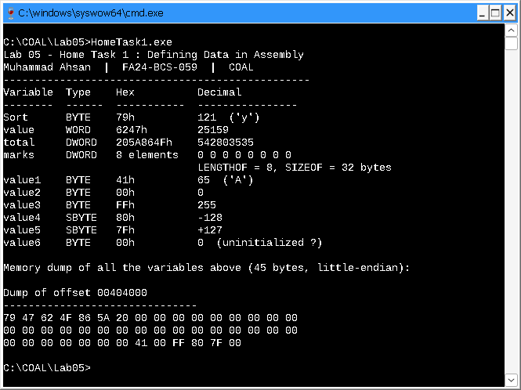
Figure 1: Output of HomeTask1.exe

Assembler listing (data section)
Offset of each variable (left) and the bytes the assembler stored for it. This listing is part of the build output (HomeTask1.lst).
00000000 79 Sort BYTE 'y'
00000001 4762 value WORD 25159
00000003 4F865A20 total DWORD 542803535
00000007 000000000000000000 marks DWORD 0, 0, 0, 0, 0, 0, 0, 0
00000027 41 value1 BYTE 'A'
00000028 00 value2 BYTE 0
00000029 FF value3 BYTE 255
0000002A 80 value4 SBYTE -128
0000002B 7F value5 SBYTE +127
0000002C 00 value6 BYTE ?
= 2D DataSize = ($ - Sort)

Observations
- Sort holds the character 'y', stored as its ASCII code 79h (121 decimal).
- value = 25159 = 6247h takes 2 bytes and is stored as 47 62: x86 is little-endian, so the low-order byte comes first.
- total = 542803535 = 205A864Fh takes 4 bytes and is stored as 4F 86 5A 20.
- marks is a list of eight doublewords: LENGTHOF = 8 elements, SIZEOF = 32 bytes, all zero.
- value2/value3 are the unsigned byte limits 0 (00h) and 255 (FFh); value4/value5 are the signed byte limits -128 (80h in two's complement) and +127 (7Fh).
- value6 BYTE ? reserves one byte without giving it a value; in the .data segment it shows up as 00.
- All the variables together use 45 bytes (DataSize = ($ - Sort) = 2Dh). MASM adds no padding, so value starts at offset 1 and total at offset 3.

Home Task 2: Menu Declared as a String

Task statement
Create the following menu by declaring a string in Assembly Language.
Checking Account
1) Create a new account.
2) Open an existing account
3) Credit the account
4) Debit the account
5) Exit

Source code: HomeTask2.asm
1 TITLE Lab 05 - Home Task 2 : Menu String (HomeTask2.asm)
2
3 ;--------------------------------------------------------------------
4 ; Name : Muhammad Ahsan
5 ; Reg. No. : FA24-BCS-059
6 ; Subject : COAL
7 ; Submitted to : Sir Taimur Shahzad
8 ; Lab 05 : Stage v (verify) - Home Activities
9 ;
10 ; Home Task 2 : Create the "Checking Account" menu by declaring a
11 ; single string, then display it with WriteString.
12 ;--------------------------------------------------------------------
13
14 INCLUDE Irvine32.inc
15
16 .data
17 ;---------- Home Task 2 : the whole menu is ONE string ----------
18 ; A comma at the end of a line continues the same BYTE declaration,
19 ; 0Dh,0Ah (CR, LF) moves to the next line and 0 ends the string.
20 menu BYTE "Checking Account",0Dh,0Ah,
21 "1) Create a new account.",0Dh,0Ah,
22 "2) Open an existing account",0Dh,0Ah,
23 "3) Credit the account",0Dh,0Ah,
24 "4) Debit the account",0Dh,0Ah,
25 "5) Exit",0Dh,0Ah,0
26
27 ;---------------------- strings for the output ----------------------
28 banner1 BYTE "Lab 05 - Home Task 2 : Menu declared as a string",0
29 banner2 BYTE "Muhammad Ahsan | FA24-BCS-059 | COAL",0
30 dashes BYTE "-------------------------------------------------",0
31 sSize BYTE "SIZEOF menu = ",0
32 sBytes BYTE " bytes (characters + CR/LF pairs + null terminator)",0
33
34 .code
35 main PROC
36 ; ---- title ----
37 mov edx, OFFSET banner1
38 call WriteString
39 call Crlf
40 mov edx, OFFSET banner2
41 call WriteString
42 call Crlf
43 mov edx, OFFSET dashes
44 call WriteString
45 call Crlf
46 call Crlf
47
48 ; ---- display the menu (one call, one string) ----
49 mov edx, OFFSET menu
50 call WriteString
51
52 ; ---- size of the string in memory ----
53 mov edx, OFFSET dashes
54 call WriteString
55 call Crlf
56 mov edx, OFFSET sSize
57 call WriteString
58 mov eax, SIZEOF menu
59 call WriteDec
60 mov edx, OFFSET sBytes
61 call WriteString
62 call Crlf
63
64 exit
65 main ENDP
66
67 END main

Output
Console window after running HomeTask2.exe:
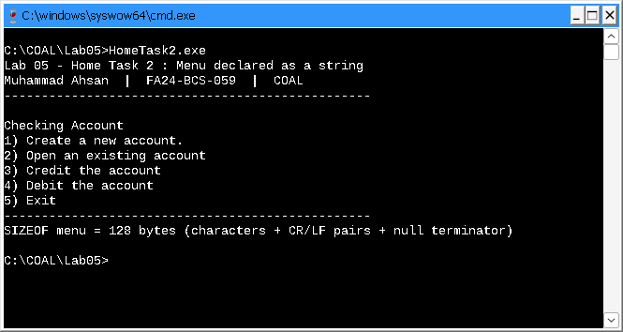
Figure 2: Output of HomeTask2.exe

Observations
- The whole menu is one variable, menu. A comma at the end of a line continues the same BYTE declaration onto the next line.
- 0Dh, 0Ah (carriage return and line feed) after each line moves the cursor to the start of the next line, so a single WriteString call prints the complete menu.
- The final 0 is the null terminator that WriteString needs to know where the string ends.
- SIZEOF menu = 128 bytes: 115 visible characters + 6 CR/LF pairs (12 bytes) + 1 null byte.

Home Task 3: Arrays

Task statement
Create the following arrays in Assembly Language.
1) Array of ten integers.
2) Array of 100 characters.
3) Arrays of 4x3 integers
4) Array of 4x3x2 integers.

Declarations (answer)
# | Array | Declaration | Elements | Bytes
1 | intArray | DWORD 10 DUP(?) | 10 | 40
2 | charArray | BYTE 100 DUP(?) | 100 | 100
3 | array2D | DWORD 4 DUP(3 DUP(?)) | 4 x 3 = 12 | 48
4 | array3D | DWORD 4 DUP(3 DUP(2 DUP(?))) | 4 x 3 x 2 = 24 | 96

Source code: HomeTask3.asm
1 TITLE Lab 05 - Home Task 3 : Arrays (HomeTask3.asm)
2
3 ;--------------------------------------------------------------------
4 ; Name : Muhammad Ahsan
5 ; Reg. No. : FA24-BCS-059
6 ; Subject : COAL
7 ; Submitted to : Sir Taimur Shahzad
8 ; Lab 05 : Stage v (verify) - Home Activities
9 ;
10 ; Home Task 3 : Create the following arrays in assembly language
11 ; 1) array of ten integers
12 ; 2) array of 100 characters
13 ; 3) array of 4 x 3 integers
14 ; 4) array of 4 x 3 x 2 integers
15 ; The program shows TYPE / LENGTHOF / SIZEOF of every
16 ; array, fills the arrays and prints their contents.
17 ;--------------------------------------------------------------------
18
19 INCLUDE Irvine32.inc
20
21 .data
22 ;------------------ Home Task 3 : array declarations ------------------
23 intArray DWORD 10 DUP(?) ; 1) ten integers
24 charArray BYTE 100 DUP(?) ; 2) 100 characters
25 array2D DWORD 4 DUP(3 DUP(?)) ; 3) 4 x 3 integers
26 array3D DWORD 4 DUP(3 DUP(2 DUP(?))) ; 4) 4 x 3 x 2 integers
27
28 ;---------------------- strings for the output ----------------------
29 banner1 BYTE "Lab 05 - Home Task 3 : Arrays in Assembly",0
30 banner2 BYTE "Muhammad Ahsan | FA24-BCS-059 | COAL",0
31 dashes BYTE "-------------------------------------------------------------------",0
32 header BYTE " Array Declaration TYPE LENGTHOF SIZEOF",0
33 hdrLine BYTE " --------- ------------------------------ ---- -------- ------",0
34
35 dInt BYTE "1) intArray DWORD 10 DUP(?) ",0
36 dChar BYTE "2) charArray BYTE 100 DUP(?) ",0
37 d2D BYTE "3) array2D DWORD 4 DUP(3 DUP(?)) ",0
38 d3D BYTE "4) array3D DWORD 4 DUP(3 DUP(2 DUP(?))) ",0
39
40 tInt BYTE "1) intArray : ten integers (filled with 10, 20, ... 100)",0
41 tChar BYTE "2) charArray : 100 characters (4 rows x 25 characters)",0
42 t2D BYTE "3) array2D : 4 rows x 3 columns (filled with 1 .. 12)",0
43 t3D BYTE "4) array3D : 4 x 3 x 2 (filled with 1 .. 24)",0
44 n3D BYTE " each line is one 3 x 2 block, '|' separates its 3 rows",0
45 sRow BYTE " row ",0
46 sColon BYTE " :",0
47 sBlock BYTE " [",0
48 sBlock2 BYTE "] :",0
49 sBar BYTE " |",0
50 sIndent BYTE " ",0
51 sDump BYTE "Memory of array2D (12 doublewords stored row after row):",0
52
53 .code
54 main PROC
55 ; ---------------- title ----------------
56 mov edx, OFFSET banner1
57 call WriteString
58 call Crlf
59 mov edx, OFFSET banner2
60 call WriteString
61 call Crlf
62 mov edx, OFFSET dashes
63 call WriteString
64 call Crlf
65
66 ; ------- TYPE, LENGTHOF and SIZEOF of every array -------
67 mov edx, OFFSET header
68 call WriteString
69 call Crlf
70 mov edx, OFFSET hdrLine
71 call WriteString
72 call Crlf
73
74 mov edx, OFFSET dInt
75 mov eax, TYPE intArray
76 mov ebx, LENGTHOF intArray
77 mov ecx, SIZEOF intArray
78 call ShowSizes
79
80 mov edx, OFFSET dChar
81 mov eax, TYPE charArray
82 mov ebx, LENGTHOF charArray
83 mov ecx, SIZEOF charArray
84 call ShowSizes
85
86 mov edx, OFFSET d2D
87 mov eax, TYPE array2D
88 mov ebx, LENGTHOF array2D
89 mov ecx, SIZEOF array2D
90 call ShowSizes
91
92 mov edx, OFFSET d3D
93 mov eax, TYPE array3D
94 mov ebx, LENGTHOF array3D
95 mov ecx, SIZEOF array3D
96 call ShowSizes
97
98 ; ======== 1) intArray : store 10, 20, ... 100 and print ========
99 mov esi, OFFSET intArray
100 mov ecx, LENGTHOF intArray
101 mov eax, 10
102 F1: mov [esi], eax
103 add eax, 10
104 add esi, TYPE intArray
105 loop F1
106
107 call Crlf
108 mov edx, OFFSET tInt
109 call WriteString
110 call Crlf
111 mov edx, OFFSET sIndent
112 call WriteString
113 mov esi, OFFSET intArray
114 mov ecx, LENGTHOF intArray
115 P1: mov eax, [esi]
116 push ecx
117 mov ecx, 5 ; field width
118 call WriteDecRight
119 pop ecx
120 add esi, TYPE intArray
121 loop P1
122 call Crlf
123
124 ; ===== 2) charArray : 4 rows of 'A' .. 'Y' (25 characters each) =====
125 mov esi, OFFSET charArray
126 mov ecx, 4 ; rows
127 F2: push ecx
128 mov al, 'A'
129 mov ecx, 25 ; characters per row
130 F2c:mov [esi], al
131 inc al
132 inc esi
133 loop F2c
134 pop ecx
135 loop F2
136
137 call Crlf
138 mov edx, OFFSET tChar
139 call WriteString
140 call Crlf
141 mov esi, OFFSET charArray
142 mov ecx, 4
143 P2: push ecx
144 mov edx, OFFSET sIndent
145 call WriteString
146 mov ecx, 25
147 P2c:mov al, [esi]
148 call WriteChar
149 inc esi
150 loop P2c
151 call Crlf
152 pop ecx
153 loop P2
154
155 ; ===== 3) array2D : fill with 1 .. 12 and print as 4 x 3 =====
156 mov esi, OFFSET array2D
157 mov ecx, LENGTHOF array2D ; 12 elements
158 mov eax, 1
159 F3: mov [esi], eax
160 inc eax
161 add esi, TYPE array2D
162 loop F3
163
164 call Crlf
165 mov edx, OFFSET t2D
166 call WriteString
167 call Crlf
168 mov esi, OFFSET array2D
169 mov ebx, 0 ; row number
170 mov ecx, 4 ; 4 rows
171 P3: push ecx
172 mov edx, OFFSET sRow
173 call WriteString
174 mov eax, ebx
175 call WriteDec
176 mov edx, OFFSET sColon
177 call WriteString
178 mov ecx, 3 ; 3 columns
179 P3c:mov eax, [esi]
180 push ecx
181 mov ecx, 5
182 call WriteDecRight
183 pop ecx
184 add esi, TYPE array2D
185 loop P3c
186 call Crlf
187 inc ebx
188 pop ecx
189 loop P3
190
191 ; ===== 4) array3D : fill with 1 .. 24 and print as 4 x (3 x 2) =====
192 mov esi, OFFSET array3D
193 mov ecx, LENGTHOF array3D ; 24 elements
194 mov eax, 1
195 F4: mov [esi], eax
196 inc eax
197 add esi, TYPE array3D
198 loop F4
199
200 call Crlf
201 mov edx, OFFSET t3D
202 call WriteString
203 call Crlf
204 mov edx, OFFSET n3D
205 call WriteString
206 call Crlf
207 mov esi, OFFSET array3D
208 mov ebx, 0 ; block number
209 mov ecx, 4 ; 4 blocks
210 P4: push ecx
211 mov edx, OFFSET sBlock
212 call WriteString
213 mov eax, ebx
214 call WriteDec
215 mov edx, OFFSET sBlock2
216 call WriteString
217 mov ecx, 3 ; 3 rows in a block
218 P4r:push ecx
219 mov ecx, 2 ; 2 columns in a row
220 P4c:mov eax, [esi]
221 push ecx
222 mov ecx, 4
223 call WriteDecRight
224 pop ecx
225 add esi, TYPE array3D
226 loop P4c
227 pop ecx
228 cmp ecx, 1 ; no bar after the last row
229 je P4n
230 mov edx, OFFSET sBar
231 call WriteString
232 P4n:loop P4r
233 call Crlf
234 inc ebx
235 pop ecx
236 loop P4
237
238 ; ===== memory layout of array2D (row-major order) =====
239 call Crlf
240 mov edx, OFFSET sDump
241 call WriteString
242 call Crlf
243 mov esi, OFFSET array2D
244 mov ecx, LENGTHOF array2D
245 mov ebx, TYPE array2D
246 call DumpMem
247
248 exit
249 main ENDP
250
251 ;--------------------------------------------------------------------
252 ShowSizes PROC
253 ;
254 ; Prints one row of the TYPE / LENGTHOF / SIZEOF table.
255 ; Receives: EDX = OFFSET of the row label, EAX = TYPE,
256 ; EBX = LENGTHOF, ECX = SIZEOF
257 ; Returns: nothing
258 ;--------------------------------------------------------------------
259 pushad
260 call WriteString ; label + declaration
261 push ecx
262 mov ecx, 4
263 call WriteDecRight ; TYPE
264 mov eax, ebx
265 mov ecx, 10
266 call WriteDecRight ; LENGTHOF
267 pop eax
268 mov ecx, 8
269 call WriteDecRight ; SIZEOF
270 call Crlf
271 popad
272 ret
273 ShowSizes ENDP
274
275 ;--------------------------------------------------------------------
276 WriteDecRight PROC
277 ;
278 ; Writes the unsigned value in EAX right-aligned in a field that is
279 ; ECX characters wide (leading spaces, then the digits).
280 ; Receives: EAX = value, ECX = field width
281 ; Returns: nothing (all registers preserved)
282 ;--------------------------------------------------------------------
283 pushad
284 mov edi, ecx ; field width
285 mov ebx, eax ; keep the value
286 mov esi, 10
287 mov ecx, 0 ; digit counter
288 WD1:mov edx, 0
289 div esi ; EAX = EAX / 10
290 inc ecx
291 cmp eax, 0
292 jne WD1
293 sub edi, ecx ; spaces = width - digits
294 jle WD3
295 mov ecx, edi
296 mov al, ' '
297 WD2:call WriteChar
298 loop WD2
299 WD3:mov eax, ebx
300 call WriteDec
301 popad
302 ret
303 WriteDecRight ENDP
304
305 END main

Output
Console window after running HomeTask3.exe:
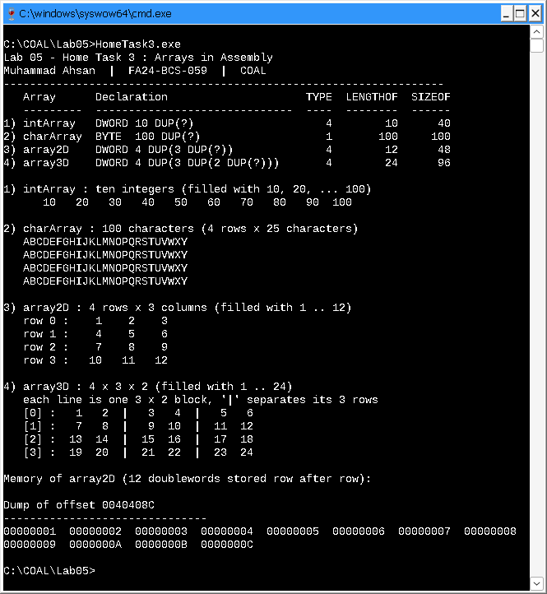
Figure 3: Output of HomeTask3.exe

Assembler listing (data section)
Offset of each variable (left) and the bytes the assembler stored for it. This listing is part of the build output (HomeTask3.lst).
00000000 000000000000000000 intArray DWORD 10 DUP(?)
00000028 000000000000000000 charArray BYTE 100 DUP(?)
0000008C 000000000000000000 array2D DWORD 4 DUP(3 DUP(?))
000000BC 000000000000000000 array3D DWORD 4 DUP(3 DUP(2 DUP(?)))

Observations
- An integer is a 32-bit DWORD (TYPE = 4 bytes) and a character is a BYTE (TYPE = 1 byte).
- DUP repeats an initializer. Nesting it (4 DUP(3 DUP(?))) makes the 4 x 3 and 4 x 3 x 2 dimensions visible in the declaration, and LENGTHOF counts every element (12 and 24).
- Memory is one-dimensional, so multi-dimensional arrays are stored row by row (row-major order). Element [i][j] of the 4 x 3 array is at byte offset (i x 3 + j) x 4; element [i][j][k] of the 4 x 3 x 2 array is at ((i x 3 + j) x 2 + k) x 4. The memory dump of array2D (1, 2, 3, ... 12) shows this order.
- The listing shows the arrays placed one after another: intArray at 0, charArray at 28h (40), array2D at 8Ch (140) and array3D at BCh (188), which matches their SIZEOF values 40, 100, 48 and 96.
- The arrays are declared with ? (no initial values). The program fills them at run time (10 ... 100, 'A' ... 'Y', 1 ... 12 and 1 ... 24) only so that their contents can be displayed.

Home Task 4: C++ Declarations in Assembly

Task statement
Implement each of the following declarations in assembly language:
1) char initial;
2) char grade = 'B';
3) char x = 'P', y = 'Q';
4) int amount;
5) int count = 0;
6) int number = -396;

Declarations (answer)
# | C++ declaration | Assembly (MASM) | Size | Bytes in memory
1 | char initial; | initial BYTE ? | 1 byte | 00
2 | char grade = 'B'; | grade BYTE 'B' | 1 byte | 42
3 | char x = 'P', y = 'Q'; | x BYTE 'P'  y BYTE 'Q' | 1 + 1 bytes | 50 51
4 | int amount; | amount SDWORD ? | 4 bytes | 00 00 00 00
5 | int count = 0; | count SDWORD 0 | 4 bytes | 00 00 00 00
6 | int number = -396; | number SDWORD -396 | 4 bytes | 74 FE FF FF

Source code: HomeTask4.asm
1 TITLE Lab 05 - Home Task 4 : C++ Declarations in MASM (HomeTask4.asm)
2
3 ;--------------------------------------------------------------------
4 ; Name : Muhammad Ahsan
5 ; Reg. No. : FA24-BCS-059
6 ; Subject : COAL
7 ; Submitted to : Sir Taimur Shahzad
8 ; Lab 05 : Stage v (verify) - Home Activities
9 ;
10 ; Home Task 4 : Implement the given C/C++ declarations in assembly
11 ; language. A char is 1 byte (BYTE) and an int is a
12 ; 32-bit signed integer (SDWORD).
13 ;--------------------------------------------------------------------
14
15 INCLUDE Irvine32.inc
16
17 .data
18 ;----------------- Home Task 4 : the declarations -----------------
19 initial BYTE ? ; 1) char initial;
20 grade BYTE 'B' ; 2) char grade = 'B';
21 x BYTE 'P' ; 3) char x = 'P', y = 'Q';
22 y BYTE 'Q' ; (two separate char variables)
23 amount SDWORD ? ; 4) int amount;
24 count SDWORD 0 ; 5) int count = 0;
25 number SDWORD -396 ; 6) int number = -396;
26
27 DataSize = ($ - initial) ; bytes used by the declarations above
28
29 ;---------------------- strings for the output ----------------------
30 banner1 BYTE "Lab 05 - Home Task 4 : C++ declarations in Assembly",0
31 banner2 BYTE "Muhammad Ahsan | FA24-BCS-059 | COAL",0
32 dashes BYTE "------------------------------------------------------------------------------",0
33 header BYTE " C++ declaration Assembly Hex Value",0
34 hdrLine BYTE " ---------------------- ------------------- --------- -----------------",0
35
36 lInit BYTE "1) char initial; initial BYTE ? ",0
37 lGrade BYTE "2) char grade = 'B'; grade BYTE 'B' ",0
38 lX BYTE "3) char x = 'P', y = 'Q'; x BYTE 'P' ",0
39 lY BYTE " y BYTE 'Q' ",0
40 lAmount BYTE "4) int amount; amount SDWORD ? ",0
41 lCount BYTE "5) int count = 0; count SDWORD 0 ",0
42 lNumber BYTE "6) int number = -396; number SDWORD -396 ",0
43
44 sOpen BYTE "'",0
45 sAscii BYTE "' (ASCII ",0
46 sClose BYTE ")",0
47 sUninit BYTE " (uninitialized)",0
48 sDump BYTE "Memory dump of the declarations (",0
49 sDump2 BYTE " bytes, little-endian):",0
50
51 .code
52 main PROC
53 ; ---- title ----
54 mov edx, OFFSET banner1
55 call WriteString
56 call Crlf
57 mov edx, OFFSET banner2
58 call WriteString
59 call Crlf
60 mov edx, OFFSET dashes
61 call WriteString
62 call Crlf
63 mov edx, OFFSET header
64 call WriteString
65 call Crlf
66 mov edx, OFFSET hdrLine
67 call WriteString
68 call Crlf
69
70 ; ---- 1) char initial; ----
71 mov edx, OFFSET lInit
72 call WriteString
73 movzx eax, initial
74 mov ebx, TYPE initial
75 call ShowHex
76 call WriteDec
77 mov edx, OFFSET sUninit
78 call WriteString
79 call Crlf
80
81 ; ---- 2) char grade = 'B'; ----
82 mov edx, OFFSET lGrade
83 call WriteString
84 movzx eax, grade
85 mov ebx, TYPE grade
86 call ShowHex
87 call ShowChar
88 call Crlf
89
90 ; ---- 3) char x = 'P', y = 'Q'; ----
91 mov edx, OFFSET lX
92 call WriteString
93 movzx eax, x
94 mov ebx, TYPE x
95 call ShowHex
96 call ShowChar
97 call Crlf
98
99 mov edx, OFFSET lY
100 call WriteString
101 movzx eax, y
102 mov ebx, TYPE y
103 call ShowHex
104 call ShowChar
105 call Crlf
106
107 ; ---- 4) int amount; ----
108 mov edx, OFFSET lAmount
109 call WriteString
110 mov eax, amount
111 mov ebx, TYPE amount
112 call ShowHex
113 call WriteInt
114 mov edx, OFFSET sUninit
115 call WriteString
116 call Crlf
117
118 ; ---- 5) int count = 0; ----
119 mov edx, OFFSET lCount
120 call WriteString
121 mov eax, count
122 mov ebx, TYPE count
123 call ShowHex
124 call WriteInt
125 call Crlf
126
127 ; ---- 6) int number = -396; ----
128 mov edx, OFFSET lNumber
129 call WriteString
130 mov eax, number
131 mov ebx, TYPE number
132 call ShowHex
133 call WriteInt ; -396
134 call Crlf
135
136 ; ---- memory dump of all the declarations ----
137 call Crlf
138 mov edx, OFFSET sDump
139 call WriteString
140 mov eax, DataSize
141 call WriteDec
142 mov edx, OFFSET sDump2
143 call WriteString
144 call Crlf
145 mov esi, OFFSET initial ; starting address
146 mov ecx, DataSize ; number of units
147 mov ebx, TYPE BYTE ; unit size = 1 byte
148 call DumpMem
149
150 exit
151 main ENDP
152
153 ;--------------------------------------------------------------------
154 ShowHex PROC
155 ;
156 ; Writes EAX in hexadecimal using EBX bytes (1, 2 or 4), adds the
157 ; suffix 'h' and pads with spaces so that the next column always
158 ; starts at the same position.
159 ; Receives: EAX = value, EBX = size of the value in bytes
160 ; Returns: nothing (EAX, EBX and ECX are preserved)
161 ;--------------------------------------------------------------------
162 push eax
163 push ecx
164 call WriteHexB ; 2, 4 or 8 hex digits
165 mov al, 'h'
166 call WriteChar
167 mov ecx, 10 ; spaces = 10 - 2 * size
168 sub ecx, ebx
169 sub ecx, ebx
170 mov al, ' '
171 SH1:call WriteChar
172 loop SH1
173 pop ecx
174 pop eax
175 ret
176 ShowHex ENDP
177
178 ;--------------------------------------------------------------------
179 ShowChar PROC
180 ;
181 ; Writes the character in AL as 'C' (ASCII nn)
182 ; Receives: EAX = character code (0..255)
183 ; Returns: nothing
184 ;--------------------------------------------------------------------
185 push edx
186 push eax
187 mov edx, OFFSET sOpen
188 call WriteString
189 call WriteChar ; the character itself
190 mov edx, OFFSET sAscii
191 call WriteString
192 call WriteDec ; its ASCII code
193 mov edx, OFFSET sClose
194 call WriteString
195 pop eax
196 pop edx
197 ret
198 ShowChar ENDP
199
200 END main

Output
Console window after running HomeTask4.exe:
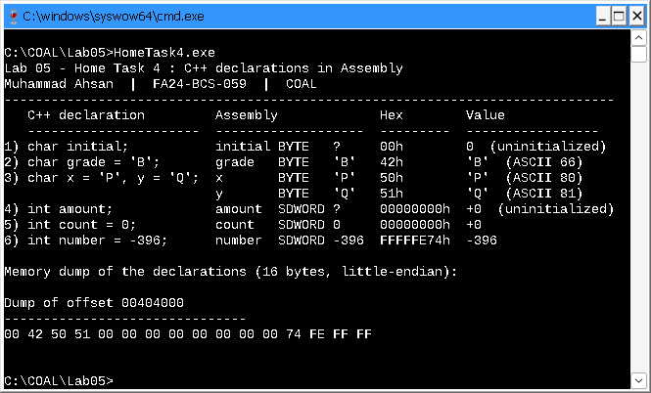
Figure 4: Output of HomeTask4.exe

Assembler listing (data section)
Offset of each variable (left) and the bytes the assembler stored for it. This listing is part of the build output (HomeTask4.lst).
00000000 00 initial BYTE ?
00000001 42 grade BYTE 'B'
00000002 50 x BYTE 'P'
00000003 51 y BYTE 'Q'
00000004 00000000 amount SDWORD ?
00000008 00000000 count SDWORD 0
0000000C 74FEFFFF number SDWORD -396
= 10 DataSize = ($ - initial)

Observations
- A C++ char is one byte, so it becomes BYTE. A C++ int is a 32-bit signed integer in Visual C++, so it becomes SDWORD.
- A declaration with no initial value (char initial;, int amount;) uses ? in MASM. It reserves the space without a value, and in the .data segment it shows up as 0.
- char x = 'P', y = 'Q'; declares two variables, so it needs two labels: x (50h) and y (51h).
- -396 in 32-bit two's complement is FFFFFE74h, stored little-endian as 74 FE FF FF; WriteInt prints it back as -396.
- All the declarations together use 16 bytes (DataSize = 10h).

