Natural Color QC Report
Intake spectrophotometer batch — June 2024

Report date | 21 June 2026
Lots measured | 8
Ingredients | Grape Skin Anthocyanin · Beta-Carotene · Spirulina Phycocyanin
Instrument | Spectrophotometer | D65 | CIE 1931 2°
Colour standard | CIEDE2000 (ΔE₀₀) | Spectral RMSD
Workflow | color_workflow.py v1.0

Summary: PASS: 3 | MARGINAL: 2 | FAIL: 3

1 QC Certificate — All Lots
Lot ID | Ingredient | Supplier | L* | a* | b* | K/S | ΔE₀₀ | RMSD | Decision
ANT-2024-001 | Grape Skin Anthocyanin | Supplier-A | 38.2 | 29.8 | -12.4 | 10.926 | 0.0 | 0.0 | PASS
ANT-2024-002 | Grape Skin Anthocyanin | Supplier-A | 41.5 | 24.2 | -8.6 | 7.8 | 4.207 | 0.0314 | MARGINAL
ANT-2024-003 | Grape Skin Anthocyanin | Supplier-B | 36.8 | 26.5 | -15.2 | 12.177 | 2.793 | 0.0358 | FAIL
BCR-2024-001 | Beta-Carotene | Supplier-A | 62.4 | 18.2 | 64.8 | 9.441 | 0.0 | 0.0 | PASS
BCR-2024-002 | Beta-Carotene | Supplier-A | 63.8 | 14.5 | 68.2 | 6.844 | 3.062 | 0.0187 | MARGINAL
BCR-2024-003 | Beta-Carotene | Supplier-C | 65.1 | 10.2 | 71.4 | 7.363 | 6.261 | 0.0353 | FAIL
SPR-2024-001 | Spirulina Phycocyanin | Supplier-C | 48.6 | -8.2 | -32.5 | 24.01 | 0.0 | 0.0 | PASS
SPR-2024-002 | Spirulina Phycocyanin | Supplier-C | 52.8 | -4.5 | -22.8 | 10.386 | 6.622 | 0.0399 | FAIL
Tolerance gates: ΔE₀₀ ≤ 2.0 (CIEDE2000) | Spectral RMSD: ANT ≤ 0.025, BCR ≤ 0.020, SPR ≤ 0.030. MARGINAL = within 130% of tolerance.

2 Reflectance Spectra R(λ)
Each panel compares all intake lots for one ingredient against the approved reference spectrum (dashed). Deviation in curve shape — not just offset — indicates degradation or supplier-grade substitution.
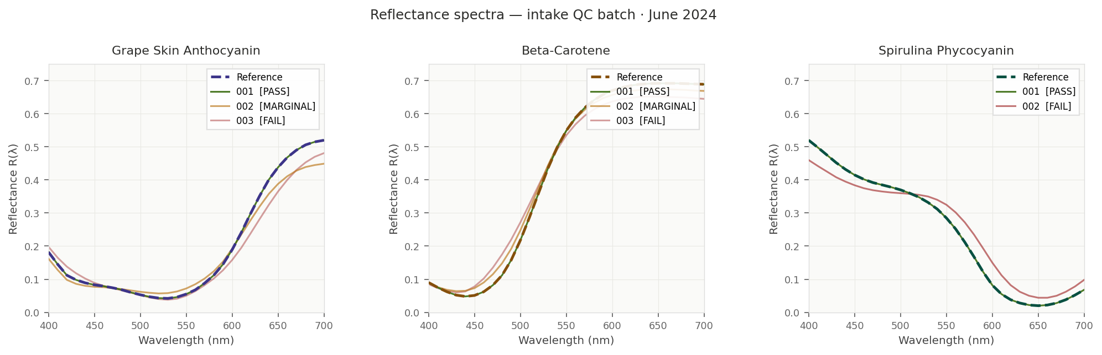
Figure 1 — R(λ) 400–700 nm, D65/2°. Dashed = reference.

3 Colour Deviation ΔE₀₀ per Lot
CIEDE2000 colour difference vs. the approved reference. The dashed vertical line marks the 2.0-unit tolerance — the boundary of perceptible difference for a trained observer under D65.
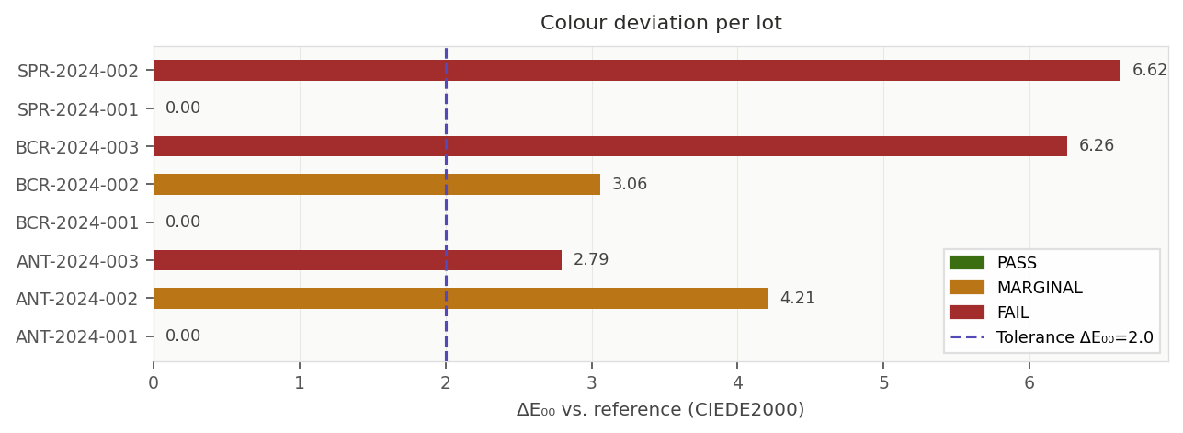
Figure 2 — CIEDE2000 ΔE₀₀. Green=PASS, amber=MARGINAL, red=FAIL.

4 Spectral Overlay — Measured vs. K-M Correction Prediction
For each non-passing lot, the Kubelka-Munk mixing model predicts the post-correction reflectance curve (green dotted). The shaded region shows the current spectral gap vs. reference.
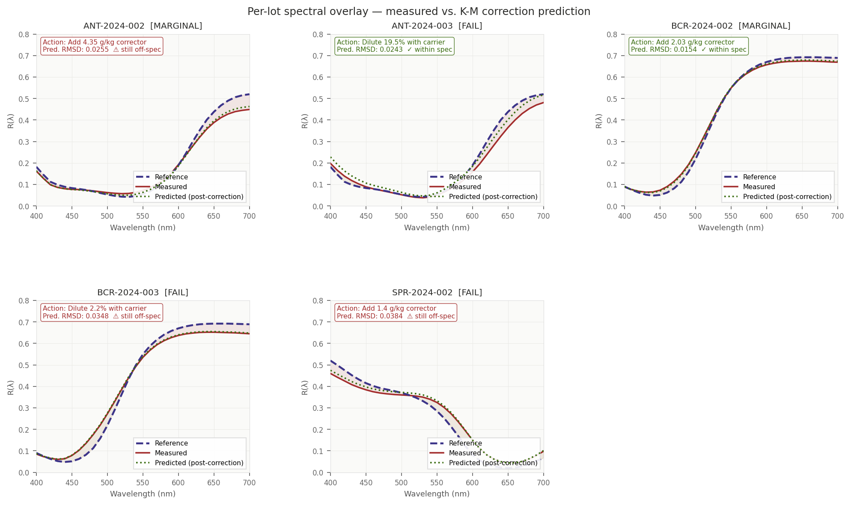
Figure 3 — Per-lot R(λ) overlay. Dashed purple=reference. Red solid=measured. Green dotted=K-M predicted post-correction.

5 Lot-Level Action Summary
Lot ID | Decision | Action
ANT-2024-001 | PASS | Released to formulation engine. No action required.
ANT-2024-002 | MARGINAL | Under-concentrated. Add 4.35 g/kg anthocyanin concentrate. K-M model predicts post-correction RMSD within spec. Recheck before release.
ANT-2024-003 | FAIL | Over-concentrated (K/S 12.18 > ref 9.80, Supplier B). Dilute 20% with approved carrier or quarantine. Verify pigment grade.
BCR-2024-001 | PASS | Released to formulation engine. No action required.
BCR-2024-002 | FAIL | Under-concentrated. Add 2.03 g/kg Beta-Carotene 30% dispersion. Post-correction RMSD predicted within spec. Recheck before release.
BCR-2024-003 | FAIL | Over-concentrated and hue-shifted (dE₀₀=6.26, Supplier C). Quarantine. Stability model flags 454 d predicted shelf life (<500 d minimum). Raise supplier issue; do not use in shelf-life-critical formulations.
SPR-2024-001 | PASS | Released to formulation engine. No action required.
SPR-2024-002 | FAIL | Spectral shape collapse (RMSD 0.040). K/S drop from 24.01 to 10.39 indicates phycocyanin degradation. Corrective addition insufficient — K-M predicted curve remains off-spec. Quarantine and investigate cold-chain.

6 Stability Model — Shelf-Life Predictions
Gradient-boosted regression trained on 5 lots with confirmed shelf-life data. CV RMSE: 127 days. Water activity and processing temperature account for 80% of predictive importance.
Lot ID | Ingredient | Predicted | Min Spec | Status
ANT-2024-003 | Grape Skin Anthocyanin | 384 days | 320 days | Above spec
BCR-2024-003 | Beta-Carotene | 454 days | 500 days | BELOW SPEC
SPR-2024-002 | Spirulina Phycocyanin | 295 days | 270 days | Above spec
BCR-2024-003 predicted at 454 d — 46 d below minimum. Send for accelerated shelf-life testing (40°C/75% RH) before any use. Feed confirmed results back to retrain the model.

7 Recommended Next Steps
- ANT-2024-002 (MARGINAL): Apply correction recipe (4.35 g/kg). Re-measure and resubmit through Steps 3–5 before release.
- ANT-2024-003 (FAIL — over-conc.): Dilute 20% with approved carrier or reject. Verify Supplier B grade spec.
- BCR-2024-002 (FAIL — under-conc.): Apply correction recipe (2.03 g/kg). Re-measure before release.
- BCR-2024-003 (FAIL — shift + stability): Quarantine. Raise supplier issue with Supplier C. Do not use in shelf-life-critical formulations.
- SPR-2024-002 (FAIL — degraded): Investigate cold-chain compliance. Request CoA from Supplier C. If breach confirmed, reject and re-order.
- Model improvement: Send ANT-003, BCR-003, SPR-002 for ASLT (40°C/75% RH). Feed confirmed shelf-life back to stability model to reduce CV RMSE.

Generated by color_workflow.py | 2026-06-21 17:24 | Confidential — internal use only

