We used 2 data set for this study, Ontario weather and Ontario fire reports.

Our weather dataset has 1980 obs. of 12 variables:,

|  |  |
| --- | --- |
| $ Date/Time : POSIXct  $ Difference : num  $ Year : num  $ Month : num  $ Day : num  $ Mean Temp (C) : num  $ Max Temp (C) : num  $ Min Temp (C) : num  $ Total Rain (mm) : num  $ Total Snow (cm) : num  $ Total Precip (mm): num  $ season : chr | $ Year : num  $ Month : num  $ Cause : chr  $ Data qualifier : chr  $ Number : num  $ Protection zone : chr  $ Response category: chr |

|  |  |
| --- | --- |
| Weather Dataset | Fire Dataset |

And our fire dataset has 1516 obs. of 7 variables

table(Toronto.data$Toronto.Season,Toronto.data$Toronto.Year)

2013 2014 2015 2016 2017 2018

Fall 91 91 91 91 91 75

Spring 0 92 92 92 92 92

Summer 79 92 92 92 92 92

Winter 31 90 90 91 90 59

My data start from "2013-06-14 UTC" to "2018-11-14 UTC"

In this analysis I did study the Toronto weather elements and monitored the weather for 6 years .

We would like to see any relationship between the temperature study and

We use the Ontario open data to get the data for Snow , Rain , Temperature for each day,

First we cleaned the data and removed unwanted data , after that I analysis the data based on 3 factors

And in each part, I checked the analysis of the fire report for these period

1. Yearly analysis

let’s monitor data for each year

first we look at the rain for each year

Rain

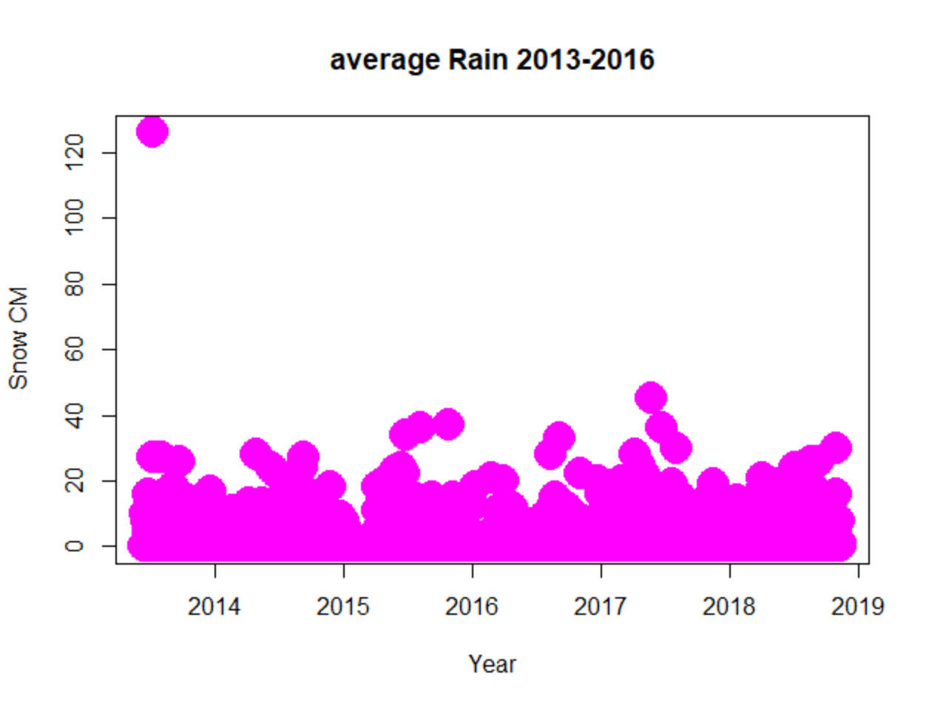

2013`

Min. 1st Qu. Median Mean 3rd Qu. Max. NA's

0.000 0.000 0.000 2.523 1.000 126.000 8

$`2014`

Min. 1st Qu. Median Mean 3rd Qu. Max.

0.000 0.000 0.000 1.658 1.000 28.000

$`2015`

Min. 1st Qu. Median Mean 3rd Qu. Max. NA's

0.000 0.000 0.000 1.707 0.000 37.000 7

$`2016`

Min. 1st Qu. Median Mean 3rd Qu. Max. NA's

0.000 0.000 0.000 1.421 0.500 33.000 3

$`2017`

Min. 1st Qu. Median Mean 3rd Qu. Max. NA's

0.000 0.000 0.000 2.118 1.000 45.000 2

$`2018`

Min. 1st Qu. Median Mean 3rd Qu. Max. NA's

0.000 0.000 0.000 2.146 1.000 30.000 2

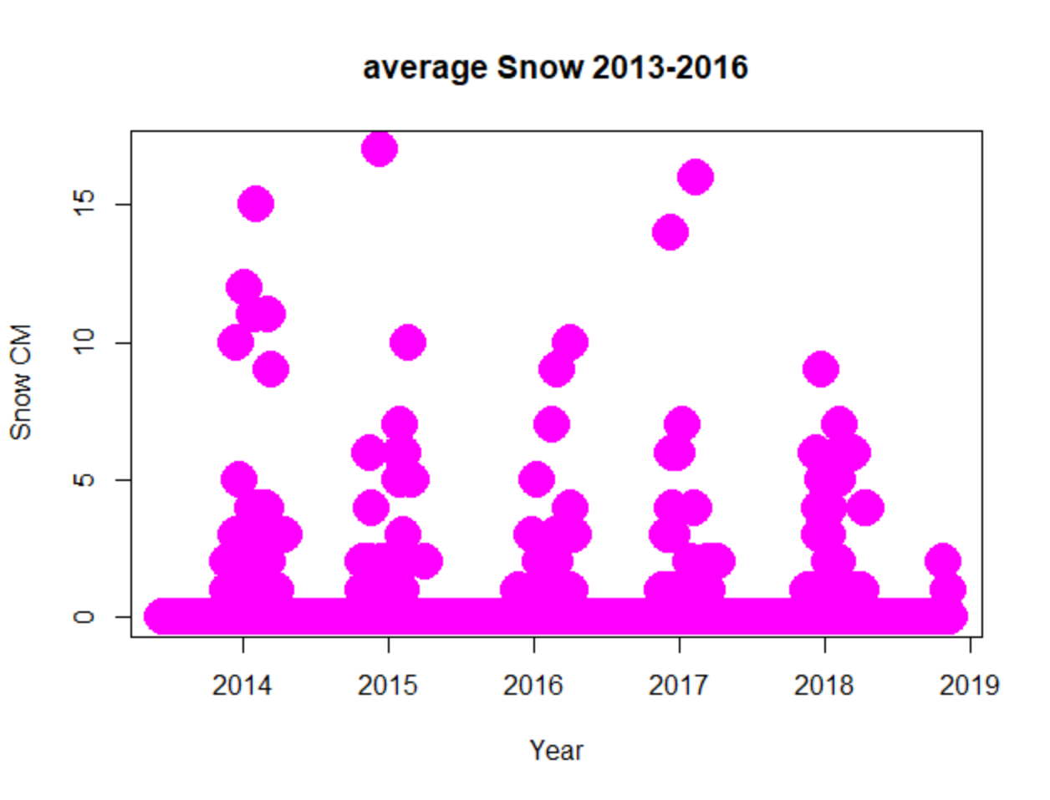

$`2013`

Min. 1st Qu. Median Mean 3rd Qu. Max. NA's

0.0000 0.0000 0.0000 0.1701 0.0000 10.0000 7

$`2014`

Min. 1st Qu. Median Mean 3rd Qu. Max.

0.0000 0.0000 0.0000 0.3781 0.0000 17.0000

$`2015`

Min. 1st Qu. Median Mean 3rd Qu. Max. NA's

0.0000 0.0000 0.0000 0.1768 0.0000 10.0000 3

$`2016`

Min. 1st Qu. Median Mean 3rd Qu. Max.

0.0000 0.0000 0.0000 0.2842 0.0000 14.0000

$`2017`

Min. 1st Qu. Median Mean 3rd Qu. Max. NA's

0.0000 0.0000 0.0000 0.2176 0.0000 16.0000 2

$`2018`

Min. 1st Qu. Median Mean 3rd Qu. Max. NA's

0.0000 0.0000 0.0000 0.2152 0.0000 7.0000 2

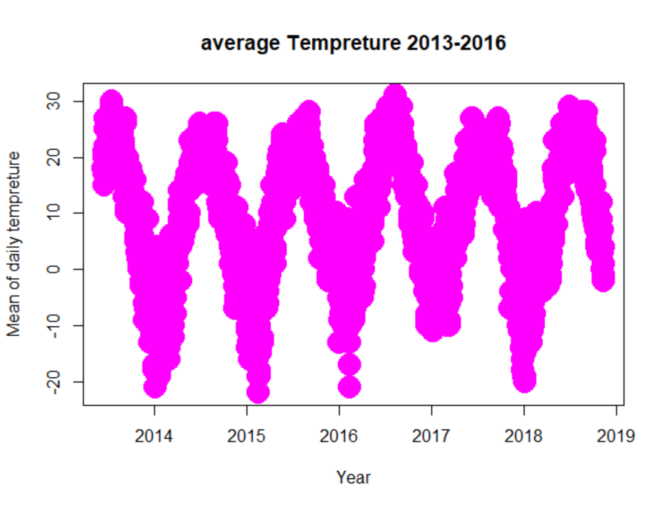

$`2013`

Min. 1st Qu. Median Mean 3rd Qu. Max. NA's

-13.00 4.00 15.00 11.99 20.00 30.00 6

$`2014`

Min. 1st Qu. Median Mean 3rd Qu. Max.

-21.00 -1.00 9.00 7.54 18.00 26.00

$`2015`

Min. 1st Qu. Median Mean 3rd Qu. Max.

-22.000 1.000 10.000 8.679 19.000 28.000

$`2016`

Min. 1st Qu. Median Mean 3rd Qu. Max.

-21.00 1.00 9.00 10.12 20.00 31.00

$`2017`

Min. 1st Qu. Median Mean 3rd Qu. Max. NA's

-19.000 2.000 10.000 9.354 18.000 27.000 1

$`2018`

Min. 1st Qu. Median Mean 3rd Qu. Max. NA's

-20.00 1.00 12.00 10.54 21.00 29.00 2

Toronto.dat

tapply(Toronto.Rain,list(Toronto.Year,Toronto.Season),mean,na.rm=T)

tapply(Toronto.Snow,list(Toronto.Year,Toronto.Season),mean,na.rm=T)

tapply(Toronto.Temp.Mean,list(Toronto.Year,Toronto.Season),mean,na.rm=T)

tapply(Toronto.Temp.Max,list(Toronto.Year,Toronto.Season),mean,na.rm=T)

tapply(Toronto.Temp.Min,list(Toronto.Year,Toronto.Season),mean,na.rm=T)

1. Season analysis
2. Monthly analysis
3. Outlier analysis
4. Study the relationship between weather conditions and fire