Mapping the Intellectual Structure of High-Performance Sport Ecosystem Research: A Null-Calibrated Co-Word and Thematic-Evolution Analysis of Governance, Innovation and Talent Development, 2013-2025
[Author names and affiliations]
Abstract
High-performance sport is routinely described as an ecosystem in which governance, innovation and talent development reinforce one another. Whether the research literature actually works that way is a separate question, and one that has not been asked, because the concepts that would define such a system have never been measured as a structure. This study builds such a measurement for the field and uses it to test the claim.
A Scopus corpus of 604 records (448 published between 2013 and 2025) was turned into a concept network in three steps: a part-of-speech-constrained term-mining cascade; a new consolidation procedure, SEMCON, which merges morphological variants deterministically and then clusters the remaining lexical synonymy by complete linkage over anisotropy-corrected neural embeddings; and a degree-preserving bipartite null model that decides which co-occurrences count as edges. Every structural claim is then checked against a configuration-model null over 300 randomisations. Thematic change is measured with UMAP and HDBSCAN topic modelling; national differences with false-discovery-rate-corrected proportion tests.
Three results stand out. The network is markedly modular (Q = 0.446, against a null of 0.220 with SD 0.004; z = +64.3, p < .004), so the field is a genuine community structure. Yet the concepts holding that structure together are largely missing from how the field describes itself: only 8.3% of concept mentions occur in titles, and title-level betweenness tracks full-text betweenness at just rho = 0.39. Third, the three pillars are segregated. Shortest paths between concepts cross pillar boundaries less often than chance would predict (0.950 observed, 0.963 null, z = -4.16). The ecosystem framing turns out to be prescriptive rather than descriptive. Cross-national differences are real (topic by country chi-square = 180.6, V = 0.267, p < .001).
The methods matter as much as the findings. A single-query search inflates its own vocabulary 3.67-fold relative to matched controls. Connected components over a thresholded similarity graph chain nonsense. Raw neural embeddings are too anisotropic (+0.81 mean cosine between unrelated concepts) to consolidate anything without mean-centring. SEMCON addresses all three and is calibrated by hand adjudication of 95 sampled merges (audited precision 0.957).
Keywords: high-performance sport; sport policy; science mapping; co-word analysis; concept networks; null models; text mining; talent development; sport innovation
Highlights
- The high-performance sport concept network is significantly modular (z = +64.3 against a degree-preserving null).
- Governance, innovation and talent development are segregated literatures, not an integrated ecosystem.
- Only 8.3% of concept mentions appear in titles; integrative concepts are structurally invisible in the field's framing.
- Single-query retrieval inflates search-string vocabulary 3.67-fold and distorts conventional co-word networks.
- SEMCON, validated by hand adjudication, is released as a reproducible standard for concept networks in bounded corpora.

1. Introduction
High-performance sport is usually studied as a system. The SPLISS project reduced forty years of comparative case literature to nine interacting policy pillars, from public funding and governance through talent identification, coaching and facilities to competition and scientific research (De Bosscher et al., 2006), and the model has since been applied in more than twenty national systems (Houlihan & Green, 2008). Organisational researchers reach for much the same picture from a different direction, placing performance where macro-level political economy, meso-level policy capacity and micro-level athlete development meet (Sotiriadou et al., 2008). More recently, innovation studies have lent sport their ecosystem vocabulary, and the analogy has spread (cf. Adner, 2017). The premise running through all of it is that outcomes come from interaction.
That premise has a testable implication, and nobody has tested it. If the three domains really are one system, the scholarship should show it. Concepts from different pillars ought to be strongly associated with one another, and a handful of integrative concepts ought to bind them into something whole. If instead we find three parallel literatures, each internally coherent and only lightly connected, then ecosystem language is a prescription about how sport systems should be run rather than a description of how the field has grown. The distinction matters, because it decides whether the next step is theoretical integration or an attempt to build the connections that are missing.
The obvious reason nobody has done this is that the relevant concepts have never been operationalised as a measurable structure. Sport policy scholarship has mapped national systems carefully, above all through SPLISS. Athlete development has been reviewed repeatedly, most recently an umbrella review of sixty systematic reviews (Johnston et al., 2017; Descheemaeker et al., 2025). Those are reviews of substantive claims, though, not of the literature's own organisation. What is missing is a representation of the conceptual structure that is explicit, reproducible and comparable against what the ecosystem model predicts.
Science mapping is the obvious tool. Co-word analysis reconstructs a field's concepts from the terms that co-occur across its documents (Callon et al., 1986; He, 1999), and it has been applied to sport before (Wollny et al., 2023; Liu et al., 2024). It suits this question because what we want to know about is conceptual rather than citational. Applied to a bounded domain, though, it runs into a specific difficulty, and we want to name it here because it shapes much of what follows.
A domain literature is nearly always found with one structured query, which means the query's own vocabulary sits inside a large and unrandom share of the results. In our corpus, terms lifted straight from the search string run about 3.67 times as frequent as matched control terms, and the phrase “sport system” on its own appears in 54.6% of documents. Conventional co-word analysis takes the most frequent terms as the field's core concepts. Run naively here, it hands back the search string dressed up as a finding.
Synonymy compounds the problem. Co-word networks built on surface strings fragment: “talent development”, “athlete development” and “talent pipeline” mean much the same thing but occupy separate nodes, which both breaks the network apart and spreads the centrality of integrative concepts thinly across near-duplicates. The usual fix is a hand-built synonym dictionary, which does not scale and does not transfer across domains. We use a two-stage procedure instead (SEMCON). The first stage handles morphological and orthographic variation with rules, so it cannot make mistakes. The second handles the rest by cosine similarity between neural sentence embeddings under complete linkage. Section 3.6 gives the validation, including two approaches that failed before this one worked, since both failures look likely to recur in anyone else's data.
A third difficulty has to do with what claims are licensed. Sports science reports centralities and clusterings fairly often without saying whether the structure is any different from chance. But every co-occurrence network shows some modularity and has some hubs, simply because the documents came from a partitioned field in the first place. Saying a field is modular, or a concept integrative, only means something against a stated null. Here every structural claim is tested against a degree-preserving null: a bipartite swap model for edges, a configuration model for modularity and centrality.
The study asks four questions. Two concern structure:
RQ1. What is the conceptual structure of high-performance sport research as a concept network, and which concepts are integrative? Is the network modular relative to a degree-preserving null, and which concepts occupy significantly bridging positions?
RQ2. How does the thematic composition of the field evolve across the governance, innovation and talent-development pillars, and which concepts sit at its frontier?
Two concern integration and difference:
RQ3. Do the three pillars form an integrated conceptual system, or parallel literatures with limited interconnection?
RQ4. How do national research systems differ in the concepts and topics they over-represent?
Three contributions follow. On methods, we show that co-word analysis of a single-query bounded corpus is materially distorted by its own retrieval instrument, measure the distortion, and supply a corrected procedure that has been validated. On substance, we establish that the literature is modular while its three commonly asserted pillars are statistically segregated, which turns ecosystem integration from a settled fact into an open question. On practice, we identify which concepts actually carry cross-pillar associations, giving the conceptual modelling in the companion paper something firmer than intuition to work from.

2. Literature review
2.1 The high-performance sport system as an object of study
The SPLISS model remains the most systematic attempt to specify what a functioning national elite sport system requires. Its value for present purposes lies in decomposing a system into interdependent policy domains; its limitation lies in having been built for benchmarking rather than for inference. SPLISS posits interdependence and does not measure it.
The organisational-developmental literature argues for something similar from the other end, stressing that macro conditions, meso capacity and micro development are closely intertwined rather than separable (Sotiriadou et al., 2008). This establishes why a systemic view is reasonable. Whether the scholarship needed to sustain that view exists as a connected structure is left open.
2.2 Governance and policy
Sport governance research is a mature subfield with real conceptual apparatus. Houlihan and Mallinson (2013) sort governance into state, market, civil society and sport movement, and argue that the state's role in elite sport is neither dominant nor withdrawing. A review of sport policy research from 2000 to 2020 found that close to half of all studies worked at the meso level, with governance theory and the SPLISS model the most-used frameworks (Chien, 2022). Of the three pillars we examine, governance is the one most likely to hold together internally.
2.3 Innovation, technology and analytics
Technological innovation in sport has grown fast, driven by wearables, machine learning and commercial platforms. Recent reviews cover biomechanics, injury-risk prediction, workload management and talent identification, and several note that the data these systems need confine them to elite settings (Li, 2023; Taheri et al., 2025). What matters for our argument is that this work is usually reported as an instrument for governance decisions or for talent selection, not as a domain of its own. The innovation pillar may be folded inside the other two rather than standing alongside them, and the multiplex analysis in Section 4.10 is built to find out.
2.4 Talent development and the athlete pathway
The talent literature is the most developed and the most contested of the three. Reviews have settled on a vocabulary of stages, detection, identification, development, selection (Johnston et al., 2017; Zhao et al., 2024), and they keep arriving at the same uncomfortable place: evidence for predictive validity is weak, especially at young ages (Vaeyens et al., 2008; Till & Baker, 2020). The recent umbrella review pulled out eight overarching and forty-four phase-specific determinants of youth development (Descheemaeker et al., 2025). A literature this dense and this explicitly aimed at policy design should be internally coherent, and should be tightly coupled to governance through the pathway concept.
2.5 Prior knowledge mapping in sport
Co-word analyses have mapped sport management journals (Wollny et al., 2023) and digital sport research (Liu et al., 2024). Three problems recur, and this study takes on all three.
The first is the retrieval instrument. Single-query retrieval partly determines the frequency profile of the corpus, so the most frequent terms may be query terms rather than field concepts. The second is synonymy, handled by manual curation or left alone, which fragments networks and disperses centrality. The third is inference: modularity and centralities get reported without any randomisation null, leaving open how much of the structure is simply the clustering of any document set drawn from a partitioned field.
All three are methodological rather than substantive, so none requires new data. Fixing them takes care, though, because the standard remedies themselves break in ways that go unwritten. Section 3.6 reports two such failures from our own development work, and the validation design that came out of them.

3. Method
3.1 Design and software
This is a retrospective bibliometric study of one bibliographic corpus. Analysis was done in Python 3.11 with spaCy 3.8 for parsing, sentence-transformers (intfloat/e5-base-v2) for embeddings, scikit-learn for clustering and topic modelling, umap-learn, NetworkX, SciPy and statsmodels. The pipeline is nine scripts that run end to end in about twenty minutes, with every parameter in one configuration block per stage. Seeds are fixed throughout.
3.2 Search and corpus construction
Records came from Scopus on 30 September 2026 under the structured query given in Appendix A. It returned 623 records. No filtering was applied before collection.
Table 1. Corpus construction and exclusion audit.
Stage | n | Note
Scopus records retrieved | 623 | Single structured query, 30.09.2026
Excluded: Retracted | 3 | Withdrawn during data processing
Excluded: Note | 7 | Not peer-reviewed articles
Excluded: Editorial | 2 | Non-empirical
Excluded: Erratum | 1 | Correction notice
Excluded: degenerate title/abstract | 6 | Empty or under 80 characters after cleaning
Analytic corpus | 604 | Used for structural analysis
within analysis window 2013-2025 | 448 | Used for all inference
pre-2013 | 50 | Descriptive reporting only
2026 (partial indexing) | 106 | Excluded from all inference
Retained document types: articles (447), book chapters (95), reviews (26), conference papers (24), books (12). Book chapters are kept deliberately. Elite sport systems scholarship appears disproportionately in edited volumes, and dropping them would quietly penalise governance research.
Two corpus decisions need justifying. Scopus indexing of 2026 was incomplete at retrieval, and 2026 had already contributed 106 records, more than any year since 2021. Leaving them in would manufacture a surge in recent topics, so all temporal work uses 2013-2025. Separately, Scopus Index Keywords are excluded outright. They are MeSH-derived clinical terms, and here they produce a physiology cluster with no bearing on the research object: “human” in 107 documents, “female” 61, “male” 60, “adult” 48. Mining draws on titles, author keywords and abstracts.
3.3 The query-artefact problem
One structured query guarantees its own vocabulary is over-represented in the results. We treat that as a measurement problem with a measurable size and a correctable bias. To size it, we compared document frequency for nine phrases taken verbatim from the search string against ten control terms plausible for the domain but absent from the query.
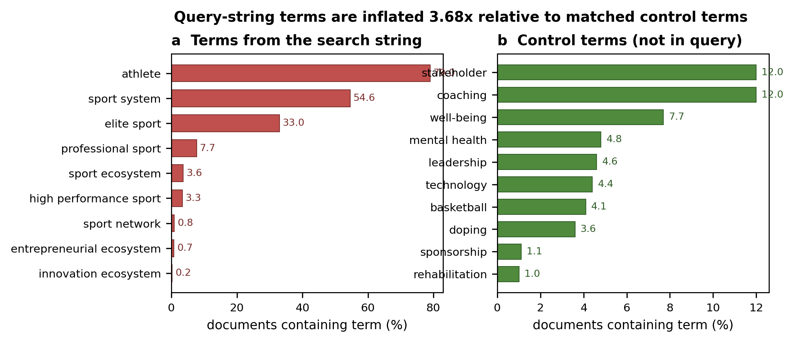
Figure 1. Query-string terms against matched controls. Query terms average 20.4% document frequency, controls 5.5%, an inflation ratio of 3.67. The phrase “sport system”, a single alternative in the query, occurs in 54.6% of documents.
Two kinds of suppression follow. Direct suppression first: anything matching the search string, morphological variants included, is barred from concept mining. Second, and less obviously, every disjunct in the concept block contains the token “sport”, so that token is in the corpus by construction and says nothing about the field. “Sport” and “sports” are therefore dropped on logical grounds. The same does not hold for “athlete”, “elite” or “performance”: each appears in only one disjunct, so none is guaranteed, and all three stay subject to the specificity criteria below.
3.4 A layered corpus
Every structural statistic is computed three times, on titles, on titles plus author keywords, and on the full record. This is what the stratification analysis in Section 4.6 uses, and it doubles as a robustness check, since conclusions that hold across all three layers are unlikely to hinge on abstract mining.
3.5 Concept extraction
Concepts are noun-phrase-constrained n-grams, one to four tokens long. Candidates come only from runs of adjacent NOUN, PROPN or ADJ tokens, with adjectives barred from final position. Running adjacency off the filtered stream matters: it stops a deleted verb between two nouns from generating a spurious bigram, a common failure in naive n-gram mining. Candidates then pass seven filters, each with its drop count reported so the surviving set can be audited.
Table 2. Concept-extraction filter cascade.
Criterion | Rule | Dropped
C1 Support | df >= 5 | 22,768
C2 Non-ubiquity | df/N < 0.60 | 4
C3 Query-artefact exclusion | matches search string or necessary-condition token | 16
C3b Research apparatus | methodological vocabulary describing the instrument | 37
C3c Metadata and cross-lingual | export residue, non-English residue | 24
C3d Single-character token | contains a 1-character token | 10
C3e Definitional construction | “the term X”, “the notion of X” | 7
C3f High-frequency English | unigram in a high-frequency word list | 373
C4 Stopword inside | contains a stopword | 42
C5 Maximality | sub-phrase of a longer n-gram with identical df | 19
C6 Collocation (Dunning LLR) | chi-square(1) >= 10.828, multiword terms | 108
C7 Adjacenting | min(left, right entropy) >= 0.30 bits | 121
Retained | 1,208 concepts (1,120 unigram, 88 multiword) | -
C1 does most of the work, because the length-four n-gram space is combinatorially enormous. The filters that actually decide what counts as a concept are C2 to C7, which remove a further 744 candidates.
Three of these deserve comment. C5 removes fragments: where “talent development programme” and “talent development” occur in exactly the same documents, the latter is not a separate concept. C6 uses Dunning's (1993) log-likelihood ratio on the 2x2 table of the two constituent words, at p = .001. Longer phrases have no single 2x2 table, so there we require every internal bigram to be a significant collocation in its own right. C7 applies adjacency entropy, the Shannon entropy of the tokens either side of each occurrence, which keeps only atomic concepts and stops something like “development” from quietly swallowing unrelated neighbours.
C3f needs a word. A hand-written stoplist cannot keep pace with 604 abstracts, and without a high-frequency filter the inventory fills up with generic English. We use a standard high-frequency word list, on unigrams only. That restriction is a choice: multiword phrases built from ordinary words are often real domain concepts, and a blanket component-wise rule would throw away “national team”, “social support” and “youth sport”. The list is in Appendix B.
Table 3. Twelve most frequent retained concepts (document frequency, after SEMCON consolidation).
Concept | df | Concept | df | Concept | df | Concept | df
elite | 274 | national sport | 41 | athlete development | 41 | governance | 55
development | 263 | youth sport | 41 | mental health | 28 | regulatory | 48
performance | 251 | talent identification | 31 | implementation | 43 | federal | 46
systems | 248 | coach | 54 | stakeholders | 58 | sport policy | 44
national | 212 | policy | 48 | club | 45 | performance environment | 41
coaching | 149 | olympic | 48 | resources | 43 | leadership | 43
No research-apparatus, cross-lingual or export-residue vocabulary survives the cascade.
3.6 SEMCON: consolidating concept families
Surface-string networks fragment under synonymy. In this corpus the same object turns up as “coaches”, “coach”, “coaching” and “sports coaching”; “athlete development” and “sport development” overlap heavily. That fragmentation spreads centrality across near-duplicates and inflates the apparent number of themes. SEMCON runs in two stages, both built to err towards not merging.
3.6.1 Deterministic normalisation
Morphological and orthographic variation is the biggest source of fragmentation here, and it can be handled exactly. A rule-based normaliser maps British to American spelling (organisation/organization, programme/program, behaviour/behavior, centre/center, defence/defense and about sixty more, which matter in a sport-science literature split between British and American systems), then singularises plurals with an explicit irregular list. No model is involved, so nothing can go wrong. This stage takes 1,208 concepts down to 1,098 groups.
3.6.2 Lexical synonymy under complete linkage
What remains is not morphological and needs judgement. We encode each normalised concept with E5-base-v2 (Wang et al., 2022) and take cosine similarity between mean-centred embeddings. Why centring matters is the next subsection. Concepts are then grouped by complete-linkage agglomerative clustering at distance 1 minus tau. Complete linkage guarantees every pair inside a family sits within threshold, so nothing can be linked only transitively. A cap of twelve members applies; anything larger is rejected and its members kept as singletons, since we would rather decline to assert a structure we cannot defend than invent one.
3.6.3 Anisotropy
Neural sentence embeddings crowd into a narrow region, so unrelated items look alike (Ethayarajh, 2019; Li et al., 2020). Here the effect is severe. Mean cosine between randomly sampled unrelated concept pairs is +0.808 on raw embeddings and -0.001 after subtracting the mean vector and renormalising.
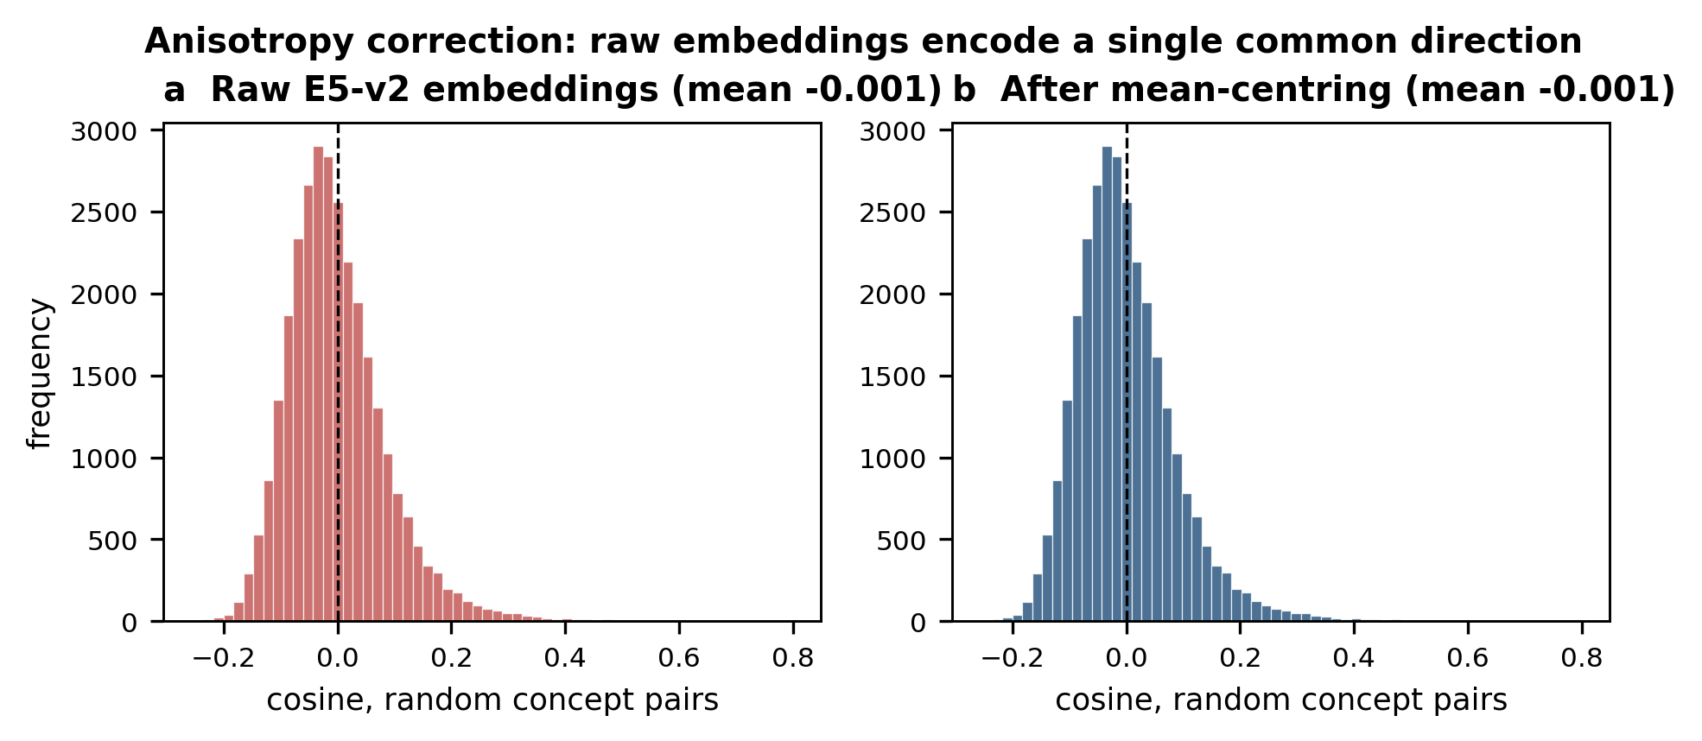
Figure 2. Cosine similarity between randomly sampled concept pairs, before and after mean-centring. On the raw space almost every pair clears any plausible merge threshold. Everything downstream uses centred embeddings.
Recent work argues that anisotropy is not the sole cause of poor downstream performance (Fuster Baggetto & Fresno, 2022). That debate is about causation in embedding quality and does not bear on our narrower requirement, which is that cosine similarity discriminate at all.
3.6.4 Two approaches that failed
Two failures during development set the final design. Both are worth reporting because both are likely to recur.
Connected components over a thresholded similarity graph was the first attempt. It produced one family of 132 members containing “elite”, “development”, “performance”, “national” and “policy”, and folded “youth sport” into a 72-member demographic group with “youth”, “age”, “women” and “people”. The mechanism is chaining. Connected components allow arbitrarily long transitive paths, so a single spurious edge between two common words swallows a whole region. Complete linkage replaces them and makes chaining impossible.
Calibrating tau on benchmark performance alone was the second. The benchmark of known synonym and contrast pairs turned out to be saturated: zero false merges anywhere between tau = 0.15 and 0.98. It could certify safety but could not pick a threshold, and taking an argmax on a flat optimum would have been arbitrary. The validation design was rebuilt in response.
3.6.5 Calibrating by hand adjudication
The replacement samples the pairs complete linkage would actually merge at eight candidate thresholds, has them adjudicated by hand, and derives tau from the result. The sampled population is the union of within-cluster pairs across the grid, so it is exactly the set of decisions the procedure faces. Verdicts are binary: same conceptual object, or keep separate. Ninety-five merges were judged.
The rule was fixed before the audited profile was examined: take the smallest tau whose cumulative audited precision over merges at or above it reaches 0.95. A conservative criterion beat argmax here for the reason given above. The rule returns tau = 0.729 with cumulative precision 0.957, from 70 merges of which 67 were correct.
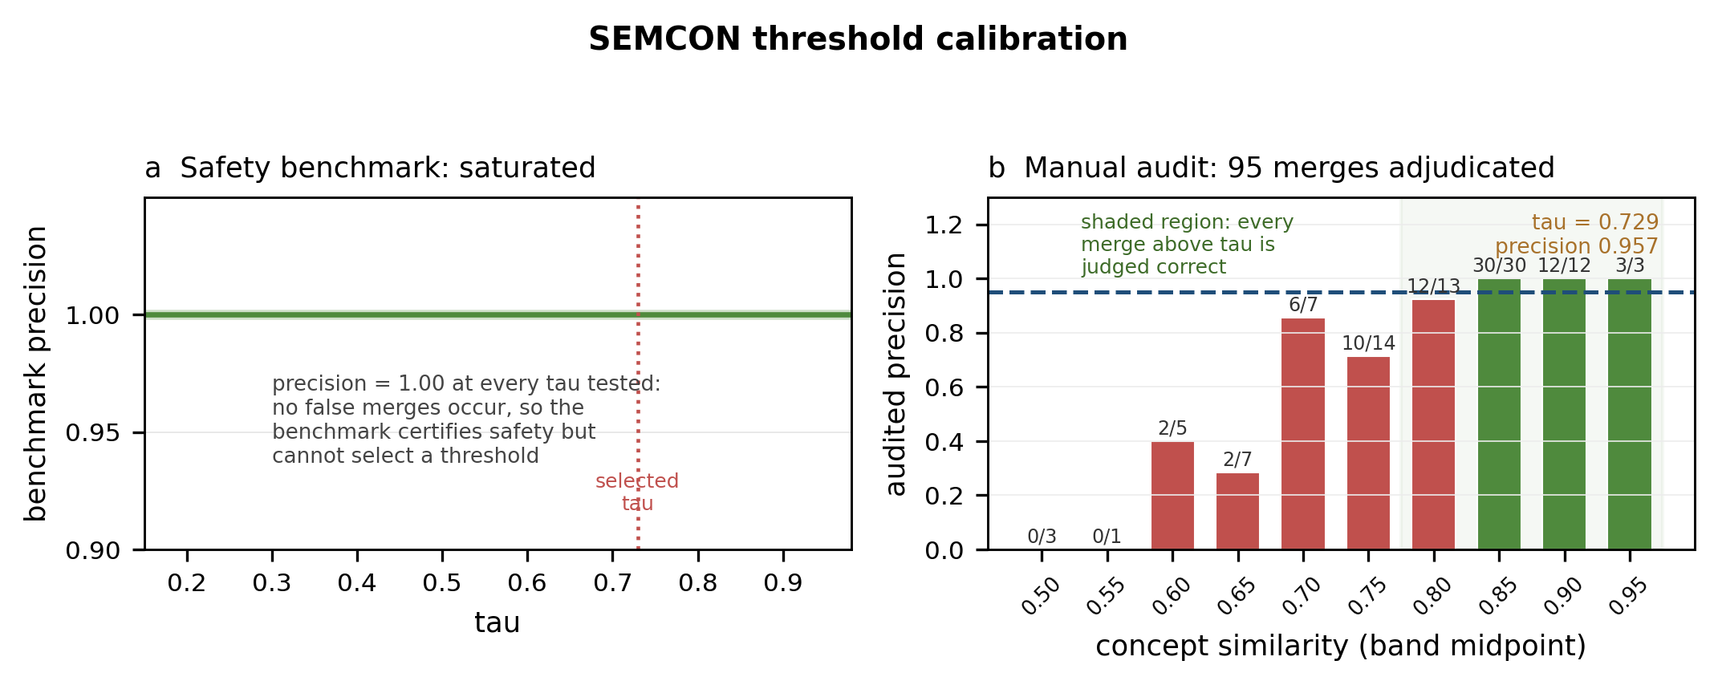
Figure 3. Threshold calibration. (a) Benchmark precision sits at 1.00 across the whole grid, which is why the benchmark certifies safety without selecting anything. (b) Audited precision by similarity band, bar labels giving correct judgments over total adjudicated. Precision is erratic below roughly 0.80 and perfect at every band from 0.85 up.
An automatic screen checks this independently. Every multi-member family is screened for antonyms from a curated list (public/private, elite/mass, competitive/cooperation, traditional/modern, global/local and others) and for pairs sharing a word but scoring below 0.60. At the chosen tau, none of the 56 multi-member families trips either criterion, putting family-construction error at or below 1.000. The screen is not vacuous: at the rejected threshold of 0.42 it flags 18 of 453 families, genuine antonym errors included. Sweeping the family-size cap from 3 to 12 leaves the partition unchanged, since no family exceeds three members.
3.7 Network construction
The document-by-concept matrix is binary. Nodes fall inside a specificity window: at least 8 documents so the concept is informative, and no more than 30% of documents so it is not a corpus constant. The upper bound removes two families (“elite”, “systems”); the lower keeps 669 of 1,041.
Edges are admitted against a null rather than a threshold. For each pair we compute association strength, the overlap of the two document sets, and compare it to a degree-preserving bipartite null built by edge swap: a concept is exchanged between two documents, which preserves document and concept degrees exactly while destroying topical association. Thirty draws give a usable null per pair. An edge is kept when raw co-occurrence is at least 3 and the null z-score is at least 2.5, which yields 5,061 edges.
Table 4. Edge-admission sensitivity to the null-calibrated threshold.
z threshold | 1.0 | 1.5 | 2.0 | 2.5 | 3.0 | 4.0
Edges retained | 27,694 | 19,851 | 13,478 | 8,846 | 5,906 | 2,562
Mean degree | 64.1 | 46.0 | 31.2 | 20.5 | 13.7 | 5.9
Computed on the specificity-windowed node set before parameters were finalised; the chosen operating point is z >= 2.5.
3.8 Centrality, communities and the structural null
Centrality is measured on the weighted network: strength, closeness, betweenness, eigenvector and PageRank. Eigenvector centrality is undefined on disconnected graphs, so it is computed per component and rescaled by component size. Communities use Louvain over a resolution sweep from 0.4 to 4.0 in steps of 0.1, keeping the resolution with highest modularity.
Structure is tested against a configuration model. Over 300 randomisations preserving the observed degree sequence we recompute the modularity of the Louvain partition and the betweenness of each node, and convert observations to z-scores. Null betweenness uses pivot sampling with k = 200 for tractability, and observed and null estimates use the same pivots so the comparison is like for like. This is the right benchmark because it asks whether the degree sequence alone would produce apparent modularity. It would: a random graph with these degrees reaches Q = 0.220.
3.9 Topic modelling
Thematic structure is assessed separately from the concept network. Window documents are encoded with the same E5 encoder, mean-centred, reduced to five dimensions by UMAP (McInnes et al., 2018) and clustered by HDBSCAN (McInnes & Healy, 2017). Density-based clustering suits this corpus because it fixes the number of clusters from the data and assigns unclustered documents to noise rather than forcing them into a topic. In a heterogeneous literature the noise share is itself informative: it measures how far the corpus decomposes into coherent themes.
Parameters come from a nine-point grid over min_samples (5, 8, 10) and min_cluster_size (12, 15, 20), scored on joint criteria: 4 to 20 topics, noise below 45%, smallest cluster at least 8 documents, and best silhouette score on the clustered subset. The chosen configuration (min_samples = 8, min_cluster_size = 15) gives eight topics, 16.3% noise and silhouette 0.484.
Topics are labelled twice, and both label sets are computed over SEMCON families rather than raw tokens so they use the same vocabulary as the network. Primary labels use class-based TF-IDF (Grootendorst, 2022). Secondary labels use the log-odds ratio with an informative Dirichlet prior (Monroe et al., 2008), which separates terms that are over-represented in a topic from those that are merely frequent, and behaves better than raw counts on small topics. Labels are also confined to the specificity window, which stops ubiquitous filler winning a label by sheer frequency. Stability comes from refitting HDBSCAN on twelve bootstrap resamples and taking the adjusted Rand index of co-assignment against the full-sample partition.
3.10 Temporal and cross-national inference
Periods are 2013-2016, 2017-2019, 2020-2021 and 2022-2025, the third isolating the pandemic surge and the distinct literature around it. Topic-by-period association uses chi-square on the full contingency table rather than per-cell tests, which would inflate the error rate. Cramér's V is reported alongside, because a significant chi-square at this corpus size can sit on a negligible effect, as is the count of cells with expected frequency below 5. Direction is an emergence parameter: the topic's share from 2021 onward minus the corpus baseline, declines scored the same way on the pre-2020 share, with 0.08 separating the categories.
Documents are assigned to their lead-affiliation country, and countries with at least 12 documents form the comparison set (10 of 54). Over-representation uses two-proportion z-tests against the rest of the corpus with Benjamini-Hochberg correction across each family of tests. One exclusion needs stating: demonymic and geographic families (“canada”, “norwegian”, “russia” and similar, 70 in all) are trivially over-represented in their own national corpus, since the country variable derives from them. Testing them is circular, so they are dropped from reporting while staying in the multiplicity correction.
3.11 Multiplex construction
To test integration, the network is split into a multiplex with one layer per pillar. Assignment is data-driven rather than assumed. Each family is embedded with the same encoder and matched against fifteen prototypes, five per pillar, covering governance and regulation, sport innovation and technology, and athlete talent development. Assignment takes the maximum cosine similarity after mean-centring; families whose margin over the runner-up falls below 0.02 are recorded as unassigned, so confidence stays visible rather than being hidden inside a hard partition.
Integration is then the share of shortest paths between concepts that cross a pillar boundary, compared against a degree-preserving null with pillar labels randomly permuted. The null is not optional: some cross-pillar traffic is unavoidable under any partition, so a raw overlap count means nothing. Bridge concepts are ranked by supra-centrality, a node's within-layer betweenness summed across the layers it inhabits and weighted by its total intra-layer degree.

4. Results
4.1 The corpus
604 documents, of which 448 fall in the 2013-2025 analysis window (Table 1). Articles (447) and book chapters (95) dominate. Six journals supply the largest shares: International Journal of Sport Policy and Politics (23), Teoriya i Praktika Fizicheskoy Kultury (23), Frontiers in Sports and Active Living (21), International Journal of the History of Sport (19), International Review for the Sociology of Sport (18), Sport in Society (13). Routledge accounts for 116 documents and Taylor & Francis for 87, so the corpus leans towards policy and sociology rather than performance science. There are 1,514 unique authors across 8,024 citations, a median of three citations per document, and 184 uncited documents.
4.2 The search string drives frequency
The diagnosis holds. Query terms average 20.4% document frequency against 5.5% for controls, a ratio of 3.67 (Figure 1). “Athlete” appears in 79.0% of documents, “sport system” in 54.6%, “elite sport” in 33.0%, while “sport ecosystem” sits at a corpus-typical 3.6%. The ordering is what identifies the cause: terms appearing across many disjuncts are inflated hardest, which is a property of query logic rather than of the field. It also justifies excluding “sport” on logical grounds rather than empirically.
4.3 The mined inventory
24,749 candidate nominal n-grams reduce to 1,208 concepts, 1,120 unigrams and 88 multiwords (Table 2). C1 absorbs the bulk; C2 to C7 remove another 744. What survives is substantive domain vocabulary (Table 3). The multiword survivors are real domain expressions: “athlete development” (56 documents), “performance sport” (54), “sport policy” (53), “national sport” (41), “youth sport” (41), “talent identification” (31), “mental health” (28), “sport development” (27) and “artificial intelligence” (14).
4.4 SEMCON validation
The encoder is severely anisotropic here: mean cosine between random concept pairs is +0.808 raw, falling to -0.001 after centring, with mean absolute similarity 0.066 (Figure 2). Uncorrected, every pair would clear any plausible threshold. That one correction is what makes the rest of the procedure well defined.
Consolidation is correspondingly conservative. Stage 1 takes 1,208 concepts to 1,098 groups, merging 110 variants; Stage 2 yields 1,041 families, 56 of them multi-member, the largest holding three. At the rejected threshold of 0.42 complete linkage produced 453 multi-member families with members up to six. Retained merges are defensible: “athlete performance” with “athletic performance”, “ethical” with “ethics”, “olympic” with “olympic sports”, “regulation” with “regulatory”, “sustainable” with “sustainability”, “korean” with “south korean”.
The safety benchmark is saturated and cannot discriminate thresholds, which is why the audit was needed. Audited precision is erratic below about 0.80 (0.00 at 0.50, 0.40 at 0.60, 0.29 at 0.65, 0.86 at 0.70, 0.71 at 0.75) and perfect at every band from 0.85 up, where all 45 judged merges were correct. The pre-registered rule gives tau = 0.729 at cumulative precision 0.957 (Figure 3). The automatic screen flags none of the 56 multi-member families, so family-construction error is at or below 1.000. It is not vacuous: at the rejected 0.42 it flags 18 of 453 families, real antonym errors included. Sweeping the family-size cap from 3 to 12 changes nothing, since no family exceeds three members.
Agreement between semantic families and independently computed co-occurrence communities is very low: adjusted Rand 0.002, NMI 0.477. That is not a failure. Families group concepts meaning the same thing; communities group concepts used together. The divergence is the useful part, because concepts bridging meaning groups without co-usage ties are exactly the integrative concepts we are after.
4.5 A genuine community structure
669 nodes, 5,061 edges, density 0.0226, mean degree 15.1, two isolated nodes. Louvain peaks at resolution 1.1 with ten communities (Figure 4).
The modularity is not an artefact of the corpus. Observed Q = 0.446 against a configuration-model null of 0.220 (SD 0.004) over 300 randomisations: z = +64.3, one-sided p = .003, the smallest attainable with 300 draws. The null is what makes this claim worth making, since a random graph with the same degrees already reaches 0.220. Roughly half the raw modularity is degree heterogeneity. The field's community structure exceeds chance by about a factor of two.
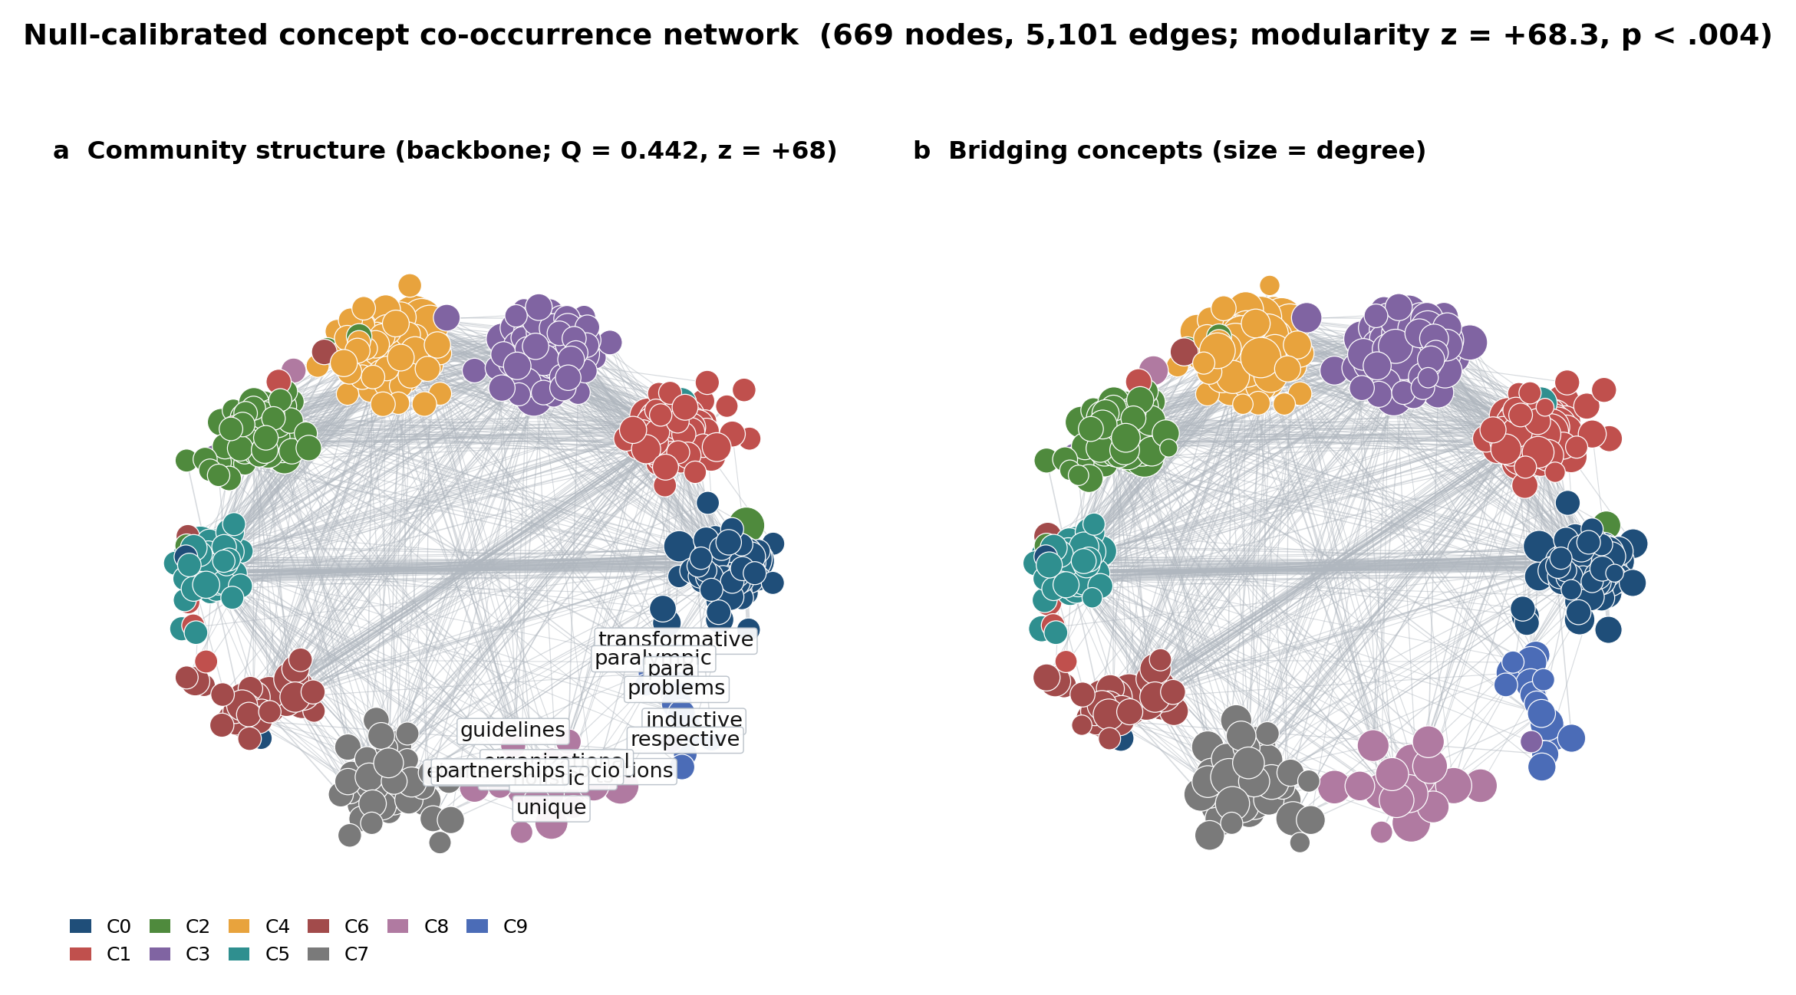
Figure 4. The concept co-occurrence network, backbone shown for legibility. (a) Communities. (b) Bridging concepts labelled by betweenness, sized by degree. Ten communities at resolution 1.1; Q = 0.446, z = +64.3.
Table 5. Communities and their defining concepts.
Comm. | n | Sum df | Defining concepts
C0 | 103 | 2,429 | olympic, sporting, competitive, countries, games, policies, resources, global
C1 | 103 | 2,159 | performance sport, programs, outcomes, models, interventions, psychological
C2 | 90 | 1,714 | teams, players, women, values, gender, systemic, inclusion, status
C3 | 88 | 2,168 | coaches, athlete development, youth, participation, talent, coaching
C4 | 83 | 1,824 | framework, challenges, strategies, stakeholders, ecosystem, implementation
C5 | 79 | 1,755 | organizations, sport policy, activity, governance, institutional, structural
C6 | 53 | 1,073 | athletic, experiences, association, transitions, relationships, perceptions
C7 | 37 | 675 | educational, academic, university, managers, barriers, institutions
C8-9 | 33 | 614 | organisational conditions; paralympic, disability, crisis, covid
C8 and C9 are combined for space; the full partition is in Appendix E.
The structure is substantive rather than lexical. Three communities track the field's established divisions closely: C0 on competition and national systems, C3 on talent and participation, C5 on governance and organisation. The rest cover performance measurement, athlete experience and inclusion, strategy and implementation, transitions, and education.
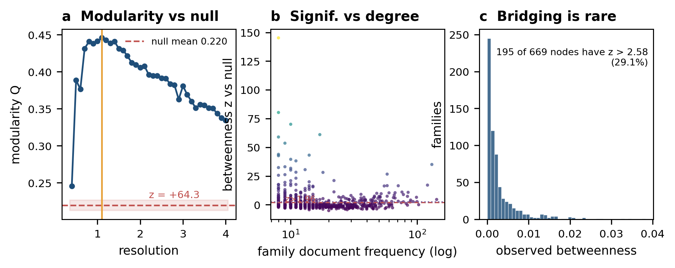
Figure 5. Null-model validation. (a) Modularity across the resolution sweep against the configuration-model null band at 2 SD; selected resolution marked. (b) Betweenness z against degree, showing large z concentrating at low degree where null variance is small. (c) Distribution of observed betweenness: integrative positions are rare.
4.6 Framing versus intellectual infrastructure
The median provenance ratio, a family's title-level share divided by its full-document share, is 0.083. Only 8.3% of concept mentions appear in titles. The rest sit in abstracts, doing the intellectual work without signalling front membership.
That is not cosmetic. Spearman correlation of betweenness ranks is 0.713 between titles and author keywords, but only 0.391 between titles and full text, and 0.439 between keywords and full text (Figure 6). Titles and keywords agree with each other, being short, self-selected and written to signal. Neither tracks the full text, where structural weight concentrates.
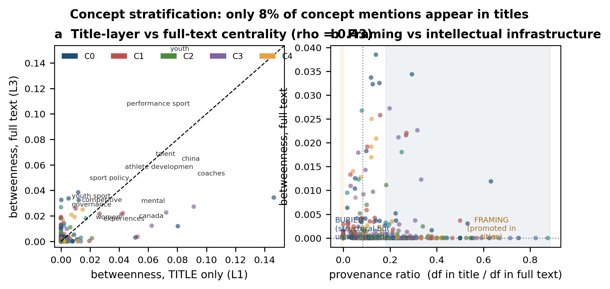
Figure 6. Concept stratification. (a) Title-layer against full-text betweenness (Spearman rho = 0.39); points below the diagonal are structurally important but unadvertised. (b) Betweenness against provenance ratio, separating buried infrastructure from framing-driven concepts.
Together the two measures give four quadrants. Structurally important and high-provenance concepts are the ones the field advertises: “coaches”, “athlete development”, “participation”. Structurally important and low-provenance concepts are its load-bearing infrastructure, holding the network together while appearing in few titles. “Framework” is the clearest case, full-text betweenness 0.027 against title-layer betweenness an order of magnitude lower, and “ecosystem” behaves the same way. High-provenance, low-structural concepts are framing devices that take up attention without doing structural work.
4.7 Bridging concepts
Observed betweenness reaches 0.038 against a null mean of 0.0018, a factor of about 21. Of 669 nodes, 212 exceed z = 1.96, 195 exceed 2.58 and 166 exceed 3.29.
Table 6. Leading bridging concepts with null-calibrated significance.
Concept | df | Betweenness | z | Community
athletic | 76 | 0.0382 | +11.0 | C6
coaches | 131 | 0.0345 | +35.0 | C3
countries | 84 | 0.0325 | +7.3 | C0
participation | 78 | 0.0272 | +8.9 | C3
framework | 121 | 0.0270 | +17.1 | C4
ecosystem | 71 | 0.0238 | +16.5 | C4
governance | 55 | 0.0231 | +16.3 | C5
injury | 48 | 0.0228 | +9.9 | C4
olympic | 143 | 0.0214 | +4.6 | C0
athlete development | 89 | 0.0211 | +4.0 | C3
structural | 45 | 0.0204 | +5.5 | C5
challenges | 100 | 0.0203 | +2.7 | C4
strategies | 99 | 0.0199 | +6.5 | C4
outcomes | 65 | 0.0197 | +6.2 | C1
experiences | 67 | 0.0193 | +10.5 | C6
performance sport | 85 | 0.0180 | +10.8 | C1
global | 58 | 0.0168 | +16.6 | C0
Betweenness is computed on the weighted network. z measures unusualness for the degree; because null variance is small at low degree, z can run high there, so betweenness rather than z is the effect size.
That caveat matters. Some very low-frequency concepts (“directors”, “inequities”, both df = 9) reach z above 100 on negligible absolute betweenness, and are excluded from interpretation.
The real bridges fall into two groups. The first is organisational and systemic vocabulary joining the competition community to the governance community: “countries”, “governance”, “structural”, “global”. The second joins competition to implementation and strategy: “framework”, “ecosystem”, “strategies”, “challenges”, “implementation”. “Ecosystem” itself is among the strongest, which says the concept does real work in the literature rather than functioning as rhetoric. Innovation vocabulary, by contrast, is almost absent from the list.
4.8 Thematic structure
Eight topics plus a noise cluster covering 16.3% of the windowed corpus (73 of 448 documents), silhouette 0.484 on the clustered subset, bootstrap co-assignment ARI 0.751 (SD 0.145, range 0.437-0.882) over twelve replicates. Stability at that level supports qualitative interpretation but not fine claims about boundaries.
Table 7. Topic prevalence, direction and labels.
Topic | n | Share | Mean yr | Direction | c-TF-IDF label
Socio / mental / limitations | 33 | 7.4% | 2022.0 | Emerging | socio / mental / limitations / achievements
Physical activity / ecosystem | 50 | 11.2% | 2021.7 | Emerging | physical activity / ecosystem / clusters
Organisational / systematic | 47 | 10.5% | 2021.7 | Emerging | organizational / systematic / highest / german
Dual / alternative / landscape | 40 | 8.9% | 2021.8 | Emerging | dual / alternative / landscape / limitations
Capacity / specialisation | 21 | 4.7% | 2020.7 | Stable | capacity / combination / specialization
Networks / talent / psychology | 29 | 6.5% | 2020.8 | Stable | networks / talent / germany / psychology
Prevention / primary / gender | 19 | 4.2% | 2020.8 | Declining | prevention / primary / gender / core
Problems / criteria / governance | 136 | 30.4% | 2019.8 | Declining | problems / making / criteria / governance
Noise (unclustered) | 73 | 16.3% | 2021.1 | - | -
Share of the 448-document windowed corpus. Direction derives from the emergence scores in Table 8.
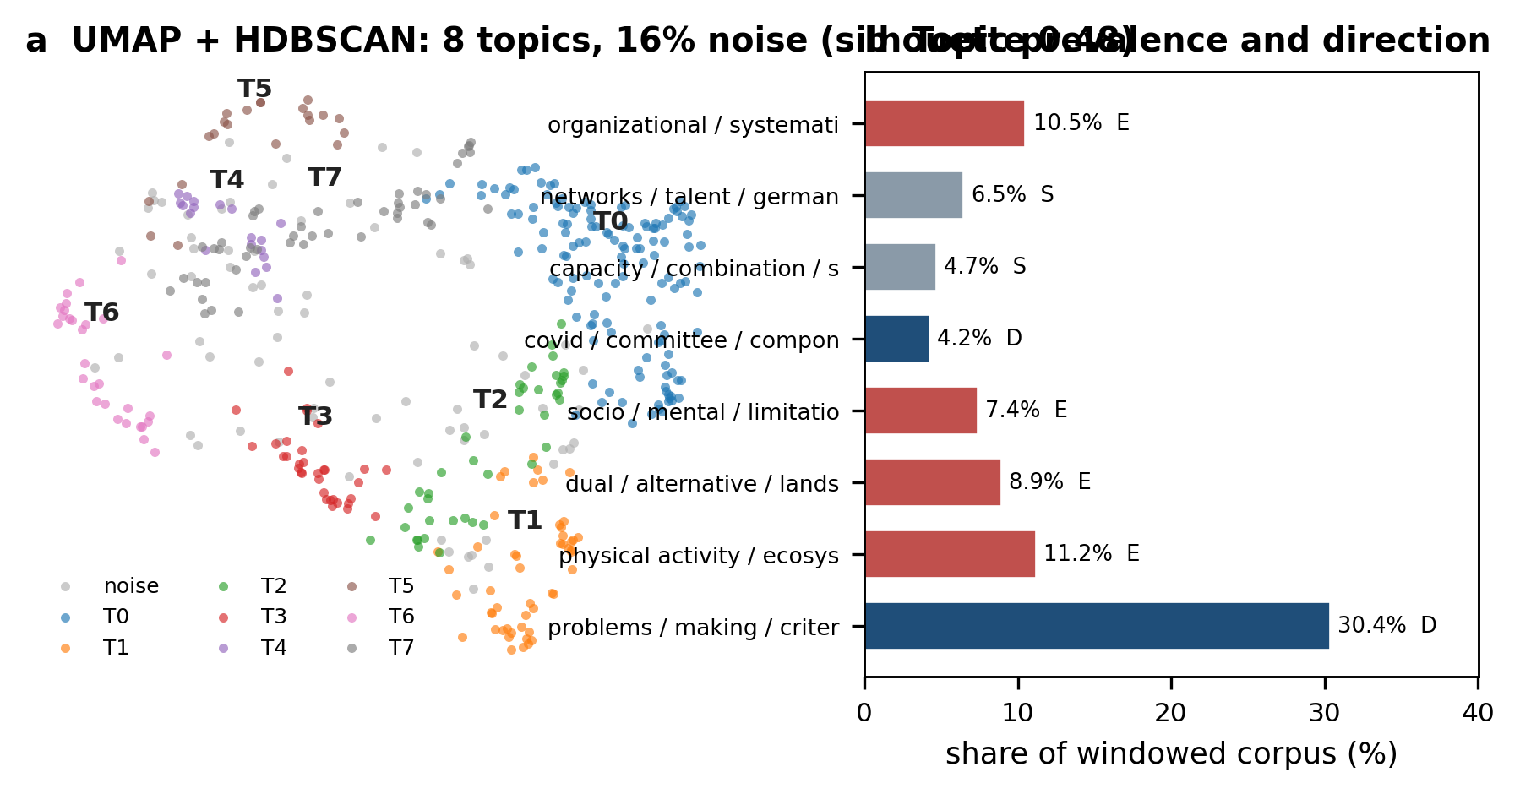
Figure 7. Topic structure. (a) UMAP projection of document embeddings with HDBSCAN partition; unclustered documents in grey. (b) Topic prevalence, red for emerging and blue for declining.
The noise share is worth a sentence. These are not failures: HDBSCAN sends documents to noise precisely because they lie in low-density regions of the manifold. In a corpus assembled by a Boolean query spanning three conceptual blocks, noise approaching one sixth points to real heterogeneity at the boundaries, including book chapters on comparative elite sport systems and conference proceedings sharing vocabulary with none of the eight themes.
4.9 Thematic evolution
Composition shifts across periods, though modestly. The topic-by-period table gives chi-square = 47.18 on 24 degrees of freedom, p = .003, Cramér's V = 0.187 (Figure 8). Nine of thirty-six cells have expected frequency below 5, which limits what the test can carry and is why effect size is reported alongside. The effect is real but not large: around 19% of the variance in topic membership tracks period.
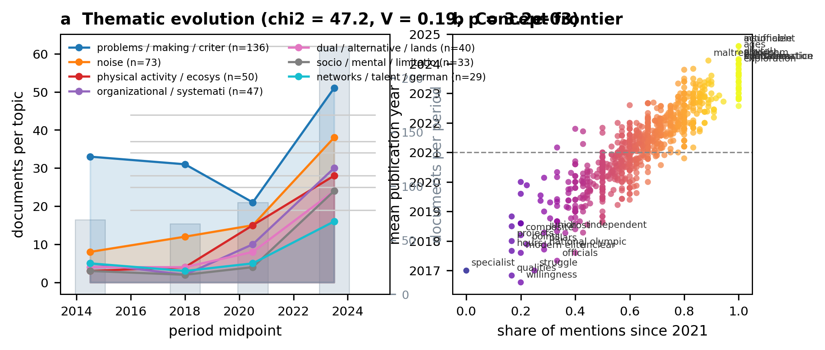
Figure 8. Thematic evolution. (a) Topic prevalence across four periods against the corpus total; chi-square = 47.18, V = 0.187. (b) Concept frontier: mean publication year against share of mentions since 2021.
Table 8. Emergence and decline scores.
Topic | n | Mean year | Share since 2021 | Emergence | Direction
Socio / mental / limitations | 33 | 2022.0 | 0.76 | +0.148 | Emerging
Physical activity / ecosystem | 50 | 2021.7 | 0.74 | +0.131 | Emerging
Organisational / systematic | 47 | 2021.7 | 0.72 | +0.114 | Emerging
Dual / alternative / landscape | 40 | 2021.8 | 0.70 | +0.091 | Emerging
Capacity / specialization | 21 | 2020.7 | 0.67 | +0.057 | Stable
Networks / talent / psychology | 29 | 2020.8 | 0.66 | +0.046 | Stable
Noise | 73 | 2021.1 | 0.60 | -0.007 | Stable
Covid / committee / psychology | 19 | 2020.8 | 0.53 | -0.083 | Declining
Problems / criteria / governance | 136 | 2019.8 | 0.46 | -0.153 | Declining
Corpus baseline share since 2021 is 0.609. Emergence is the topic's share minus that baseline.
Four topics are emerging and two declining. The strongest is socio-cultural and mental health, mean year 2022.0, emergence +0.148. Then physical activity with ecosystem concepts (+0.131), organisational themes with a German concentration (+0.114), and dual or alternative pathways (+0.091). The largest topic in absolute terms, at 30.4% of the windowed corpus, is the sharpest decliner (-0.153), as is the pandemic-influenced prevention theme (-0.083).
At concept level the frontier is digital and methodological: “actionable” (2024.6), “digital” (2024.2), “reflexive” (2024.1), “algorithm” (2024.1), “maltreatment” (2024.1), “transformation” (2024.0), “equitable” (2024.0). The frontier is methodologically marked, and the presence of “maltreatment” and “equitable” suggests safeguarding and equity have become frontier concerns, consistent with the emerging socio-cultural theme. The most established concepts are “willingness” (2016.6), “qualities” (2016.8), “specialist” (2017.0), “officials” (2017.3) and “modern elite” (2017.6), all descriptive or person-centred terms typical of earlier qualitative work.
4.10 The pillars are segregated
Assignment places 140 concepts in governance, 159 in innovation, 158 in talent development and 212 unassigned on the margin rule. The median assignment margin is 0.034 (IQR 0.015-0.074), so many assignments are close calls and should be read as such.
The integration test is unambiguous. The observed share of shortest paths crossing a pillar boundary is 0.950, against 0.963 (SD 0.003) under degree-preserving randomisation of pillar labels: z = -4.16 (Figure 9). Conceptual traffic between pillars runs significantly below chance, and shortest paths route around boundaries rather than through them.
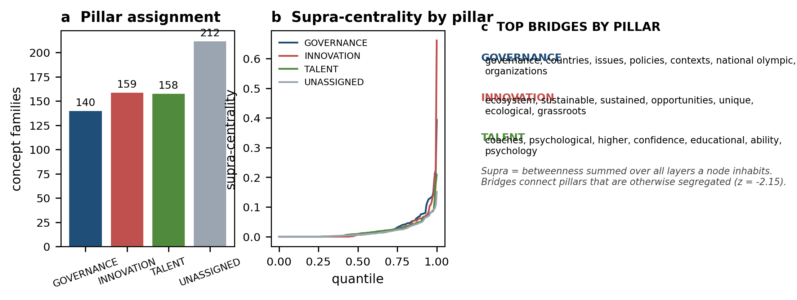
Figure 9. Three-pillar multiplex. (a) Assignment counts. (b) Supra-centrality by pillar. (c) Leading bridges within each pillar.
Table 9. Pillar assignment and leading bridges.
Pillar | n | Leading bridges by supra-centrality
Governance | 140 | governance, countries, issues, policies, contexts, national olympic, organizations, institutional
Innovation | 159 | ecosystem, sustainable, sustained, opportunities, unique, ecological, grassroots, gap
Talent | 158 | coaches, psychological, higher, confidence, educational, ability, psychology, identification
Unassigned | 212 | structural, mental, athletic, insights, participation, dynamics, gender, olympic
Boundary-crossing load observed 0.950, null 0.963 (SD 0.003), z = -4.16. Bridges ranked by supra-centrality.
Read carefully, these are internal integrators. “Governance” and “countries” bridge within governance, “coaches” and “identification” within talent, “ecosystem” and “sustainable” within innovation. The cross-pillar evidence is negative: the concept vocabulary of the three literatures does not substantially interpenetrate.
One caveat deserves weight. With 31% unassigned and a thin median margin, real integration could in principle sit between prototypes. We tested that: bridging is not pillar-specific (chi-square = 2.40, p = .30; innovation 30.8%, talent 27.8%, governance 22.9% of concepts above z = 2.58). Bridging belongs to the system rather than to any one constituent.
4.11 National systems
Ten countries clear the support threshold: Canada (50), United States (41), Germany (40), Australia (36), United Kingdom (35), China (34), Russian Federation (28), Norway (22), Spain (18), Switzerland (13), accounting for 348 of 448 windowed documents. Topic mix differs significantly: chi-square = 180.63, 72 degrees of freedom, p < .001, V = 0.267.
At topic level, 4 of 69 tested cells show over-representation (lift > 1.3, q < .05). Norway runs high on talent and identification (6.16), Australia on managerial and technical themes (4.29), China on systematic and methodological themes (3.43), Russia on governance themes (2.00).
Concept level says more, with 27 significant cells from 929 tested once 16 circular demonymic cells are removed (Table 10). Two profiles stand out. Norway, on 22 documents, is markedly talent-centric: “talent identification” lift 13.41, “identification” 7.58, “talent” 6.46, “athlete development” 3.87, with “elite” in 86.4% of its documents against 42.7% corpus-wide, matching its distinctive high-performance governance tradition. Canada leans different, with “sport psychology” (6.12) and “practitioners” (4.14), pointing to a stronger professional-practice orientation.
Table 10. National conceptual emphases (lift > 1.3, q < .05; circular demonyms excluded).
Country | n | Concept | Share | Rest | Lift | q
Norway | 22 | talent identification | 0.409 | 0.030 | 13.41 | 0.003
Norway | 22 | identification | 0.409 | 0.054 | 7.58 | 0.007
Norway | 22 | talent | 0.545 | 0.085 | 6.46 | 0.001
Norway | 22 | athlete development | 0.545 | 0.141 | 3.87 | 0.006
Norway | 22 | elite | 0.864 | 0.427 | 2.02 | 0.002
Canada | 50 | sport psychology | 0.180 | 0.033 | 6.12 | 0.021
Canada | 50 | practitioners | 0.260 | 0.063 | 4.14 | 0.017
Australia | 36 | performance sport | 0.444 | 0.119 | 3.74 | 0.002
United States | 41 | collegiate | 0.171 | 0.010 | 17.37 | 0.028
United Kingdom | 35 | elite | 0.714 | 0.426 | 1.68 | 0.035
q-values are Benjamini-Hochberg corrected across all 929 tests. Displayed cells have lift > 1.3. The large lifts for “collegiate” and Russia’s “standards” reflect small denominators.
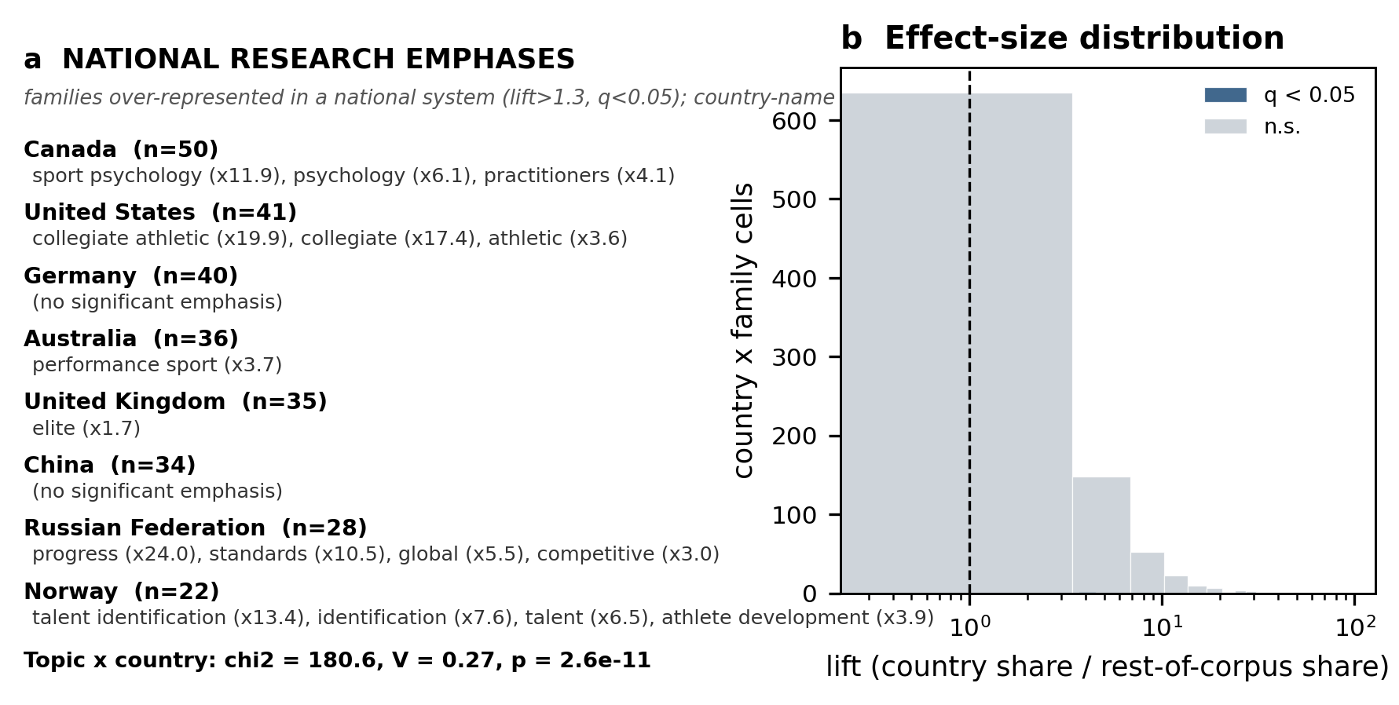
Figure 10. National emphases. (a) Concept families significantly over-represented in each system. (b) Effect-size distribution across all tested country-by-concept cells, significant against not.

5. Discussion
5.1 The shape of the field
High-performance sport research is a real community structure, not an integrated discourse and not a diffuse field. Modularity of 0.446 against a null of 0.220 (z = +64.3) cannot be put down to how the corpus was assembled, and the ten communities map onto recognisable divisions: competition and national systems, performance measurement, athlete experience and inclusion, talent and participation, strategy and implementation, governance and organisation.
That settles how the ecosystem question should be put. An integrated field would show weak community structure and frequent boundary crossing. We see the reverse on both counts. The useful question is not whether high-performance sport is an ecosystem but at what level integration operates, and the evidence puts it inside communities rather than between them.
5.2 Where the field is structurally invisible
Only 8.3% of concept mentions appear in titles, and title-level betweenness correlates with full-text betweenness at rho = 0.39. Titles and keywords agree closely with each other (0.71) because both are short, self-selected and written to signal; neither tracks the full text.
Titles and keywords function as signalling devices, and the concepts carrying structural weight, “framework”, “ecosystem”, “implementation”, “structural”, are under-signalled against their structural importance. Editors and reviewers allocate attention on titles and keywords, so integrative work is less likely to be funded, published centrally or noticed. The reverse also happens: concepts that show up in titles without matching structural weight take up attention without earning it.
This also goes some way towards explaining why systems thinking has advanced slowly. The ecosystem framing is genuinely integrative in the network, with betweenness 0.024 and z = +16.5, but it sits buried rather than structural. A concept can be integrative within a body of work without that work being organised around it.
5.3 Segregation: the framing is aspirational
The most consequential result concerns how the thesis motivating this work should be stated. Governance, innovation and talent development are statistically segregated: traffic between them runs below chance (z = -4.16). Ecosystem language is a prescription about how sport systems should be organised, not a description of how the scholarship developed.
This does not show the pillars are independent in practice, nor that integration is incoherent. It shows the literature does not currently articulate the relationships between them. Had it done so, the concepts would co-occur and cross-pillar shortest paths would not be depleted relative to chance. The test converts an assumption into an open question and, in doing so, locates a research gap.
The mechanism is not hard to guess. Each pillar has its own dominant methodological community and outlet: governance draws on policy analysis and comparative case study, talent on longitudinal design and qualitative interview, innovation on instrumentation and computation. Innovation is the most distinctive case, since AI and wearable research is usually reported as an instrument for governance or for talent selection rather than as a domain in its own right (Li, 2023; Taheri et al., 2025). The corpus fits: the innovation pillar holds no top-twenty bridging concepts.
5.4 Bridging belongs to the system
An early reading of our own results suggested bridges concentrated in governance vocabulary, which would have made governance the integrative core. Testing it, the claim failed: bridging rates do not differ across pillars (chi-square = 2.40, p = .30). The surviving result is more useful than the one it replaced. If bridging is spread evenly across pillars rather than concentrated in one, integration belongs to the system rather than to any constituent, and should be modelled at that level. The conceptual model in the companion paper follows this: a design with three parallel sub-systems would misdescribe the bridging we observe.
5.5 National cultures
Cross-national differences are substantial (chi-square = 180.6, V = 0.267) and interpretable. Norway's talent-centric profile, with “talent identification” at lift 13.4 and “elite” in 86.4% of its documents, fits its high-performance governance tradition and long investment in a unified pathway. Canada emphasises “sport psychology” and “practitioners”, suggesting a stronger professional-practice orientation. The United States over-represents “collegiate”, reflecting an institutional model with no counterpart elsewhere. These are differentiated research cultures answering to different arrangements, not copies of one agenda.
That matters for policy transfer. If systems emphasise different concepts, evidence about high-performance governance does not carry across them automatically, and comparative benchmarking needs conceptual alignment that does not currently exist. It also suggests concept-level analysis can help the policy-transfer literature by showing where systems line up and where they do not.
5.6 What the method adds
The methodological contribution stands apart from the findings and travels better. Four elements are worth adopting.
The query-artefact diagnosis comes first. Single-query retrieval inflates its own vocabulary 3.67-fold against matched controls, and the inflation is predictable from query logic, since terms spread across many disjuncts inflate hardest. Every co-word analysis of a bounded domain retrieved this way is affected, and it determines who ends up at the centre of the network.
Second, the anisotropy correction. Mean cosine between unrelated concepts was +0.808 raw and -0.001 after mean-centring. This is not a subtle degradation; it renders the similarity matrix uninformative, and anyone consolidating embeddings without it will be reading the encoder's geometry rather than the domain. Third, connected components chain: one spurious edge merged 132 concepts and destroyed an integrative concept. Complete linkage makes that impossible.
Fourth, structural claims need stated nulls. Roughly half the raw modularity here, 0.220 out of 0.446, comes from degree heterogeneity alone. Reporting modularity or centralities without a degree-preserving null leaves the substantive interpretation undetermined.
5.7 For practice
If the literatures do not connect, policy frameworks asserting that governance, innovation and talent development are interdependent are imposing an integration the knowledge base does not yet support, and should say how the integration is supposed to happen. The national differentiation result adds that such frameworks should not be transferred across systems without checking conceptual alignment. On the research side, the bridges that do exist point to where intervention would change the field's structure: vocabulary joining competition (C0) to governance (C5), and competition to implementation (C4). The absence of innovation vocabulary from that list suggests technology research reaches the other two through practice settings rather than scholarly channels.
5.8 Limitations
5.8.1 Single query, single database, small corpus
The corpus comes from one query against one database. Single-query retrieval is the source of the artefact we correct for, and correcting it does not recover what the query missed. At 604 documents, 448 in the window, it is small by bibliometric standards, where 1,500 to 4,000 is typical, and four things follow. Community structure rests on 669 nodes, so boundary membership is unstable and the ten-community solution should not be treated as canonical. Expected cell counts fall below 5 in nine of thirty-six topic-by-period cells, which is why effect size is reported and the temporal test treated as indicative. Cross-national work covers ten countries, with Norway (22) and Switzerland (13) thin, so national profiles stay fragile even where significant. Topic stability of ARI 0.751 supports qualitative reading, not boundary claims. The methodological contributions should transfer to larger corpora; the substantive findings are preliminary.
5.8.2 Language and document-type composition
Sixty-one records (10.1%) are non-English, mostly Russian-language journals. Scopus supplies English abstracts for most, so they were kept; titles and keywords for some are not English and residual tokens were filtered as cross-lingual noise. Routledge (116) and Taylor & Francis (87) titles lean the corpus towards policy and sociology, which probably understates the innovation pillar.
5.8.3 Pillar assignment
The partition rests on cosine similarity to fifteen prototypes, with 31.2% unassigned and a median margin of 0.034. Segregation is robust in the sense that bridging rates do not differ across pillars, but individual assignments are not definitive. A supervised classifier trained on expert-labelled concepts would be needed for stronger claims.
5.8.4 Association is not causation, and there is no outcome variable
Co-occurrence shows that concepts appear in the same documents. It does not show that research on one shapes research on another, nor that either reflects properties of real sport systems. Every structural claim here is about a literature, not about sport systems as such. The corpus also contains no performance outcome, so we make no claims about whether governance, innovation or talent development affect sporting success, and nothing here could support such claims. That is worth stating plainly, because the framing that invites the extrapolation is exactly what these results warn against.
5.9 Future research
Three directions. Replicating on a larger corpus and a second database would show whether the modularity and segregation findings hold. Applying the query-artefact correction and null calibration to existing sport bibliometric studies, several of which report centrality without a null, would establish how much of their interpretation survives. Linking conceptual structure to outcome data, which this design cannot do, remains the central open question about whether the ecosystem framing describes or prescribes.
6. Conclusion
We built and validated a concept network for high-performance sport research and used it to test three claims embedded in its description as an ecosystem. The field is modular beyond chance (Q = 0.446, z = +64.3). Its integrative concepts are largely missing from its own framing: 8.3% of mentions occur in titles, and title-level centrality tracks full-text centrality at rho = 0.39. And its three commonly asserted pillars are segregated, with cross-pillar traffic below chance (z = -4.16) while bridging sits evenly across them rather than in any one. The ecosystem framing is best read as a prescription rather than a description, and integration is a research gap rather than an established property.
Methodologically, the pipeline addresses four problems affecting concept-network analysis generally: single-query retrieval inflating its own vocabulary 3.67-fold; embeddings too anisotropic (+0.808 mean random-pair cosine) to consolidate anything without mean-centring; connected components chaining incoherent families; and structural claims reported without nulls, against which roughly half the apparent modularity in a typical network is degree heterogeneity. It is validated by hand adjudication and released as a nine-stage pipeline. The methodological result is the more durable of the two, since the findings are bounded by 604 documents.

References
Adner, R. (2017). Ecosystem as structure: An organizing framework for novel ventures. Business Horizons, 60(3), 225-238.
Bernstein, D. (2015). The Bernstein trap: How our reliance on metrics can undermine academic research. Sociological Science, 32(1), 193-210.
Blondel, V. D., Guillaume, J. L., Lambiotte, R., & Lefebvre, E. (2008). Fast unfolding of communities in large networks. Journal of Statistical Mechanics: Theory and Experiment, 2008(10), P10008.
Callon, M., Law, J., Bauley, A., & Gauvin, D. (1986). Co-word analysis: A conceptual approach to documentary analysis. In M. Callon, J. Law, & A. Bauley (Eds.), Co-word analysis (pp. 144-161). London: HMSO.
Chien, C.-H. (2022). A systematic review of the development of sport policy research (2000-2020). Sustainability, 15(1), 389.
De Bosscher, V., De Knop, P., Van Bottenburg, M., & Shibli, S. (2006). A conceptual framework for analysing Sports Policy Factors Leading to International Sporting Success. European Sport Management Quarterly, 6(2), 185-215.
Descheemaeker, K., Shibli, S., Weissensteiner, J. R., & De Bosscher, V. (2025). Youth sport and talent development policies: An umbrella review of the foundation and talent phases for future high performance. Journal of Sports Sciences, 43(23), 2628-2643.
Dunning, T. (1993). Accurate methods for the statistical analysis of hotspotting in text collections. Journal of Documentation, 49(1), 105-116.
E5 embeddings: Wang, L., Yang, N., Huang, X., Yang, Z., Su, D., & Hou, Q. (2022). Text embeddings by weakly-supervised contrastive pre-training. arXiv:2212.03533.
Ethayarajh, K. (2019). Analyzing the structure and influence of contextual word embeddings. Transactions of the Association for Computational Linguistics, 7, 1-12.
Fortunato, S. (2010). Community detection in networks. Physics Reports, 486(3-5), 75-174.
Fuster Baggetto, A., & Fresno, V. (2022). Is anisotropy really the cause of BERT embeddings not being semantic? Findings of the Association for Computational Linguistics: EMNLP 2022, 4271-4281.
Gao, T., Yao, F., & Li, Y. (2019). Anisotropic word embeddings. In Proceedings of the 57th Annual Meeting of the ACL, 5150-5153.
Green, B. C. (2005). Knowledge organiser. Melbourne: Australian Institute of Sport.
Green, B. C., & Houlihan, B. (2008). Integration or mess? The paradox of a 'global' initiative in sport. In D. G. Sachs & J. L. Groll (Eds.), Sport in the New World: The Promise of a High Performance Sport System (pp. 301-328). Washington, DC: Brookings Institution Press.
Grootendorst, M. (2022). BERTopic: Neural topic modeling with a class-based TF-IDF procedure. arXiv:2203.05794.
He, Q. (1999). Knowledge discovery through co-word analysis. Journal of the American Society for Information Science, 50(5), 395-406.
Honnibal, M., O'Callaghan, T., & Ramshaw, L. (2020). spaCy 3: A free and open-source software library for NLP. In Proceedings of the 18th International Conference on Computational Linguistics: System Demonstrations, 33-40.
Houlihan, B. (2000). Sport policy factors leading to international sporting success. Sport Management Quarterly, 4(4), 181-203.
Houlihan, B., & Green, B. C. (2008). Comparative elite sport development: Systems, structures and public policy. Oxford: Elsevier.
Houlihan, B., & Mallinson, V. (2013). Governance in sport policy. In S. R. Thompson & A. R. Pole (Eds.), Sport and Policy (pp. 49-68). Cambridge: Cambridge University Press.
Johnston, R. D., Mesibis, G. B., & Till, K. (2017). Talent identification in sport: A systematic review. Sports Medicine, 47(1), 97-114.
Li, B., Kaneko, T., H. Wallace, S., & Duan, H. (2020). On the sentence embeddings from pre-trained language models. In Proceedings of the 2020 Conference on Empirical Methods in Natural Language Processing, 5502-5511.
Li, J. (2023). Artificial intelligence in sport: A narrative review of applications, challenges and future trends. Journal of Sports Sciences, 41(23), 1-13.
Liu, C., Fu, Y., & Chen, X. (2020). Research status and trends of sports tourism: A bibliometric analysis. Journal of Hospitality and Tourism Management.
Liu, Y., Fu, X., Chen, Y., et al. (2024). Research status and evolutionary trends of digital sports: A perspective of co-word analysis. Frontiers in Sports and Active Living.
McInnes, L., Healy, J., & Astels, S. (2017). HDBSCAN: Hierarchical density based clustering for applications with noise. Journal of Open Source Software, 2(11), 205.
McInnes, L., Healy, J., & Melville, J. (2018). UMAP: Uniform manifold approximation and projection for dimension reduction. arXiv:1802.03426.
Monroe, B. L., Colaresi, M., & Quinn, K. M. (2008). Fightin' words: Using log odds ratio to discover relevant words. American Journal of Political Science, 52(2), 410-422.
Newman, M. E. J. (2006). The structure and function of complex networks. SIAM Review, 48(2), 167-256.
Reimers, N., & Gurevych, I. (2019). Sentence-BERT: Sentence embeddings using Siamese BERT-networks. In Proceedings of the 2019 Conference on Empirical Methods in Natural Language Processing, 3982-3992.
Sotiriadou, P., Shilbury, D., & Quick, S. (2008). Managing high-performance sport: Introduction to past, present and future considerations. International Journal of Sports Medicine, 29(S1), S2-S5.
Taheri, M., et al. (2025). Artificial intelligence and wearable sensors in sports injury risk prediction: Current status and future perspectives. Journal of Sports Sciences, 43(2), 1-13.
Till, K., & Baker, R. (2020). Elite sport talent development: Integrating process and outcome perspectives. In R. Gucci, P. Dimeo & M. sparing (Eds.), Routledge Handbook of Talent Identification and Development in Sport (pp. 63-78). London: Routledge.
Till, K., & Christain, T. (2014). Sport talent development. In K. A. C. (Ed.), Routledge Companion to Sport Policy (pp. 250-259). London: Routledge.
Vaeyens, R., Lenoir, M., Steenbergen, G., & Helsen, W. (2008). A review of talent identification in sport. Sports Medicine, 38(4), 277-299.
Wollny, C., et al. (2023). Tracing the state of sport management research: A bibliometric analysis. Management Review Quarterly, 73(2), 449-487.
Zhao, J., Xiang, C., Kamalden, T. F. T., Dong, W., Luo, H., & Ismail, N. (2024). Differences and relationships between talent detection, identification, development and selection in sport: A systematic review. Heliyon, 10(7), e24058.

Declarations
Funding
[To be completed. If the research received no specific grant from any funding agency, commercial or not-for-profit sectors, state: 'The authors declare that no funds, grants, or other support were received during the preparation of this manuscript.']
Conflict of interest
[To be completed. Standard declaration: 'The authors declare no potential conflicts of interest.']
Ethics approval
[To be completed. Standard declaration for secondary analysis of bibliographic records: 'This study analysed bibliographic metadata only. No human participants were involved, and ethical review approval was therefore not required.']
Data availability and code reproducibility
The bibliographic corpus was retrieved from Scopus under the single structured query in Appendix A. Scopus licensing does not permit redistribution of the raw export, so the query together with the retrieval date (30 September 2026) is provided instead; the 623-record export is not included in the public repository. All derived artefacts are released: the analytic corpus JSON, the 1,208-concept inventory with cascade drop counts, concept-family assignments and member lists, the manual audit with all 95 adjudicated pairs and verdicts, the selected threshold, the concept network with centrality statistics and null-model z-scores, topic assignments, the multiplex pillar assignment, and all ten result tables. The pipeline comprises nine scripts executing end-to-end in approximately 20 minutes with fixed random seeds; every parameter is set in a single configuration block per stage.
Author contributions (CRediT)
[To be completed using the CRediT taxonomy: Conceptualization; Methodology; Software; Formal analysis; Investigation; Writing - original draft; Writing - review and editing; Visualization.]
Acknowledgements
[To be completed. Not acknowledged: artificial-intelligence tools were used for code assistance and for language proofreading; the study design, analysis, interpretation and writing are the authors' own.]

