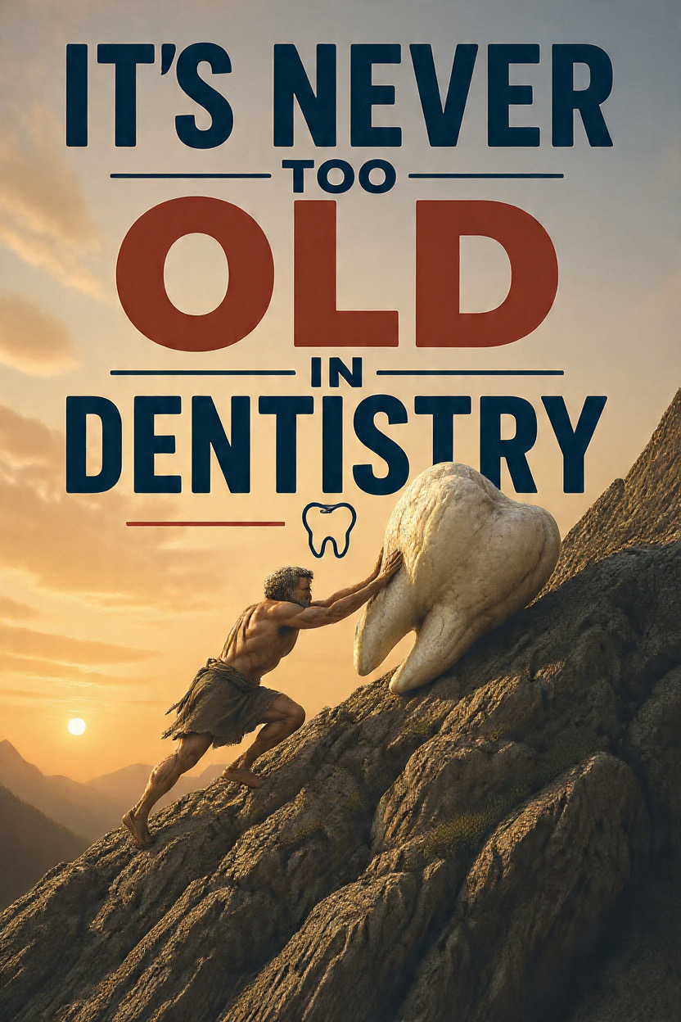
In the 69th episode of “Dental CEO Podcast,” Dr Scott Leune interviews Dr Ramin Tabib and Dr Elisa Mello, a dental team couple who have worked together for over 32 years in New Yok City. Instead of slowing and preparing for retirement, this couple chose to completely reinvent their practice at the age 61. They relocated to a larger facility and rebranded their practice as The Smile Code.

Reinventing instead of retiring:

Although financially stable and successful, the couple felt their old 700-square-foot clinic was no longer reflecting the quality of the care they provide. Rather than becoming comfortable with the status quo, they chose to make significant changes by relocating. They invested in a new 2,500-square-foot practice to create a better patient experience and renew their passion for dentistry. They explained that the new practice allowed them to work in an environment that better represented their professional values and clinical standards.

The importance of branding:
The podcast emphasises that successful branding extends far beyond a logo or a practice name. They stress that a dental practice brand, office, design, website, and patient must all align. Patients often judge quality before treatment begins, so the environment should reflect the level of dentistry being delivered. Their rebranding effort included changing the practice’s name, redesigning the office, improving their marketing, and creating an identity that reflected the type of dentistry they wanted to provide. Further, they argue that consistent branding helps establish trust and communicates the quality-of-care patients can expect. Also, they believe that patients start evaluating a dental practice before the treatment even starts, oft based on its appearance.

Commitment to fee-for-service dentistry:

Throughout the podcast, Dr. Tabib and Dr. Mello discuss their long-standing commitment to a fee-for-service. They intentionally chose not to participate in insurance PPO networks, even when doing so would have made it easier for them to increase patient volume. They believed that remaining independent would allow them to prioritise patients’ need instead of insurance. Although this decision created financial challenges early in their careers, they remained committed to their philosophy. They explained that fee-for-service requires patents to recognise the value of exceptional care, which is why they focused heavily on building trust, delivering outstanding patient experience, and providing a high-quality patient experience.

Working as spouse:

The podcast also explores the challenges and advantages of operating a dental practice as a married couple for managing work and relationship at the same time has always been a complex task for couples. However, this couple was able to delightfully manage that task. Dr. Tabib describes himself as the visionary and risk-taker, while Dr. Mello is more cautious and detail oriented. In other words, one partner is more entrepreneurial, optimistic, and willing to take risks, while the other is more cautious, analytical, and detail-oriented. Rather than allowing these personality differences to create conflict, they learned to view them as strengths when making business decisions. They emphasised that open communication, mutual respect, and shared long-term goal have enabled them to successfully manage both their marriage and their dental practice for more than three decades.

Continuous improvement:

A recurring message throughout the episode is the importance of lifelong learning. The couple believes dentists should never stop improving their clinical skills or business knowledge regardless of their experience. Throughout their career, this couple has continually, updated their clinical techniques, invested in new technology, refreshed their website and marketing, and adapted to changing patient expectations. They stress that a successful dental practice must continue evolving rather than staying stagnant.

Main lesson:

The central message of this podcast is that professional growth does not have an expiration date. Dr. Tabi and Mello demonstrate that dentists can successfully reinvent themselves even after decades in practice. Instead of viewing their 60’s as the end of their careers, the couple saw it as an opportunity to create the practice they had always envisioned. Their journey shows that investing in branding, modern facilities, patient experience, and continuous education can revitalize both a practice and a career. They encourage dentist not to fear change or assume that innovation is only for excellence. Their story reinforces the idea that dedication, adaptability, and commitment to quality can lead to a long-term success.

Reference:

Dental CEO Podcast Ep.62: The husband-and-Wife Dentists Reinventing themselves at 6

