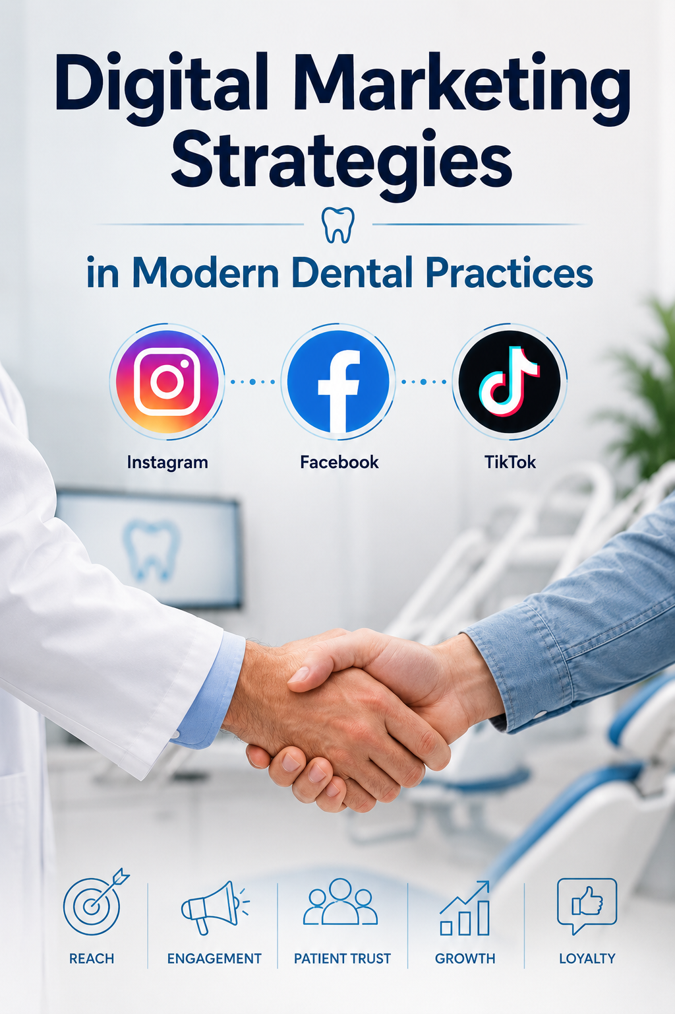Digital Marketing Strategies in Modern Dental Practices

Social Media Marketing in Dentistry

One of the most powerful tools for available clinics now days is social media marketing. In recent years, dental clinics have increasingly used social media platforms in order to promote and advertise their services, educate the public, and attract new patients. Platforms such as Instagram, Facebook, TikTok have become essential communication channels between dental professionals and their communities. As Oral Health suggest, “Facebook remains the to-go social platform for dental practises.” However, Instagram and TikTok have also widespread significantly enough among Canadines, especially among younger people. These platforms allow dental clinics to create visually engaging content, such as before-and-after treatment results, educational videos, and demonstrations of dental procedures.

Ethical Issues Surrounding Social Media in Dentistry:

The main problem with social media in Dentistry is patient’s privacy. It is superbly important for patients to consent the use of their face, smile, and/or medical details. For if not, their right to privacy is violated and they can pursue with legal actions. Moreover, misrepresentation and alteration, meaning enhancing and/or exaggerating photos to make final result look more dramatic or flawless, stands at the 2nd degree of most ethical issues around the use of social media for advertising in dentistry. dental professionals have responsibility to ensure that their online consent accurately represents their services and treatment results.

Search Engine Optimization (SEO) and Online Reviews and Reputation Management for Dental Clinics:

Local SEO is the most critical digital marketing strategy, as patients usually look for clinic in or near their neighbourhood. Google Business Profile for instance, holds a very important key to a successful advertisement, for clients rely very much on Google’s ratings. Furthermore, On-page SEO also plays a bold role for clinics. On-page SEO means to structure your website’s content in a way that your services and location is easily understood by search engines. By being accessible and offering spotless services, clinics can gain immense patient acquisition. As for keeping a good reputation, clinics must respond promptly (aim to reply within a few days), express genuine gratitude (thanking the patient for their time to comment), and personalized response (referring to the patient without revealing any health information).

Content Marketing:

Content marketing is another effective strategy used by modern dental practices. Creating educational contents, such as blogs, articles, and videos explaining dental procedures immensely serves to attract more people. by doing so, people get to see and learn about dentistry and its procedures. This approach helps patients become more informed and comfortable with dental treatments. When individuals understand procedures and their benefits, they might feel more confident and at ease. Additionally, providing reliable educational resources helps establish dental practice as trustworthy sources of information and strengthens the relationship between patients and dental professionals.

Patient Relationship Management:

Beyond attracting new patients, maintaining strong relationships with existing patients is a crucial aspect of successful dental marketing. Patient relationship management focuses on creating positive experiences and building long-term trust between the clinic and its patients. Patients satisfaction remain one of the most important factors in success of any healthcare practice. By providing excellent service, communicating effectively, and demonstrating genuine care, dental clinics can create lasting relationships with their patients. A satisfied patient is more likely return for future treatment and recommend the clinic to family members, friends, and colleagues. In modern dentistry, digital marketing is not only about advertisement services; it is about building trust, education patients, and creating meaningful connections. By combining social media marketing, ethical online practices, SEO strategies, valuable consent creation, and strong patient relationship, dental practices can successfully adapt to the digital age while maintaining professional integrity.

