**CREDIT CARD MANAGEMENT SYSTEM**

Mahshooq K

2061693

**CREATING THE FACT AND DIMENSION TABLE**

1. **Move the data files to cloudera folder using WinSCP**
2. **Creating tables for storing data using hive**

**//create database for the project**

CREATE DATABASE PROJECT;

USE PROJECT;

**//Create command for customer table**

CREATE EXTERNAL TABLE CDW_SAPP_CUSTOMER_2061693 (

CUST_ID BIGINT,CUST_F_NAME STRING, CUST_M_NAME STRING,CUST_L_NAME STRING,CUST_CC_NO BIGINT,CARD_TYPE STRING,CARD_LIMIT INT,CARD_END_DATE STRING,CUST_SSN BIGINT,CUST_STREET STRING,CUST_CITY STRING,CUST_STATE STRING,CUST_COUNTRY STRING,CUST_ZIP INT,CUST_PHONE STRING,CUST_EMAIL STRING)

ROW FORMAT DELIMITED FIELDS TERMINATED BY ','

STORED AS TEXTFILE

TBLPROPERTIES("SKIP.HEADER.LINE.COUNT"="1");

**//loading data from local folder to hive cdw_sapp_customer_2061693 table**

LOAD DATA LOCAL INPATH 'Customer.csv' overwrite into table CDW_SAPP_CUSTOMER_2061693;

// **showing cdw_sapp_customer_2061693 table**

SELECT * FROM CDW_SAPP_CUSTOMER_2061693;

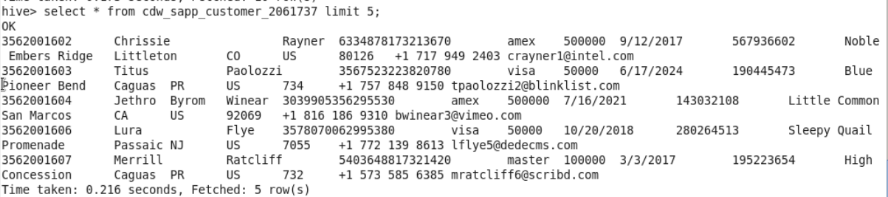

**//Create command for branch table**

CREATE EXTERNAL TABLE CDW_SAPP_BRANCH_2061693 (

BRANCH_CODE INT,

BRANCH_NAME STRING,

BRANCH_STREET STRING,

BRANCH_CITY STRING,

BRANCH_STATE STRING,

BRANCH_ZIP INT,

BRANCH_PHONE STRING)

ROW FORMAT DELIMITED FIELDS TERMINATED BY ',' STORED AS TEXTFILE TBLPROPERTIES("SKIP.HEADER.LINE.COUNT"="1");

**//loading data from local folder to hive table**

LOAD DATA LOCAL INPATH 'BRANCH.CSV' OVERWRITE INTO TABLE CDW_SAPP_BRANCH_2061693;

// **showing cdw_sapp_branch_2061693 table**

SELECT * FROM CDW_SAPP_BRANCH_2061693;

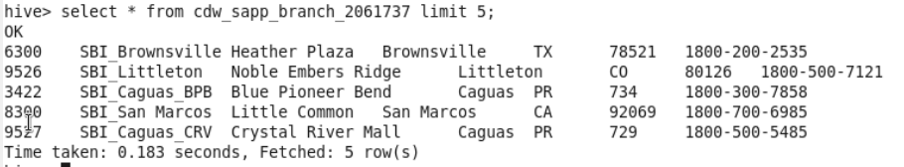

**//Create command for creditcard fact table**

CREATE EXTERNAL TABLE CDW_SAPP_CREDITCARD_2061693 (

TRAN_ID INT,

TRAN_DATE STRING,

CUST_ID BIGINT,

CUST_CC_NO BIGINT,

CUST_SSN BIGINT,

BRANCH_CODE INT,

TRAN_TYPE STRING,

TRAN_VALUE INT)

ROW FORMAT DELIMITED FIELDS TERMINATED BY ',' STORED AS TEXTFILE TBLPROPERTIES("SKIP.HEADER.LINE.COUNT"="1");

**//loading data from local folder to hive table**

LOAD DATA LOCAL INPATH 'Tran_creditcard.csv' overwrite into table CDW_SAPP_creditcard_2061693;

// **showing cdw_sapp_creditcard_2061693 table**

SELECT * FROM CDW_SAPP_CREDITCARD_2061693;

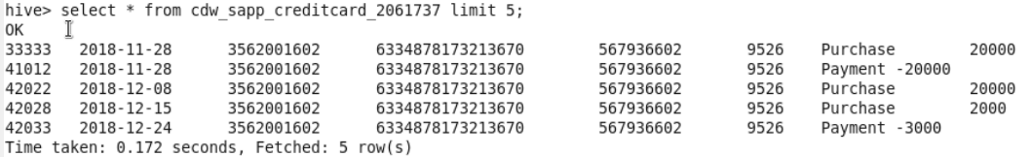

**//Create command for time table**

CREATE EXTERNAL TABLE CDW_SAPP_TIME_2061693 (

TIME_ID STRING,

DAY INT,

MONTH INT,

QUARTER INT,

YEAR INT)

ROW FORMAT DELIMITED

FIELDS TERMINATED BY ','

STORED AS TEXTFILE;

**//creating data file ‘Time’ for time table using data from cdw_sapp_creditcard_2061693**

INSERT OVERWRITE LOCAL DIRECTORY '/HOME/CLOUDERA/TIME' ROW FORMAT DELIMITED FIELDS TERMINATED BY ','

SELECT DISTINCT TRAN_DATE AS TIMEID,

SUBSTR(TRAN_DATE,9,2) AS DAY,

SUBSTR(TRAN_DATE,6,2) AS MONTH,

(CASE

WHEN SUBSTR(TRAN_DATE,6,2) >= 1 AND SUBSTR(TRAN_DATE,6,2) <= 3 THEN 1

WHEN SUBSTR(TRAN_DATE,6,2) >= 4 AND SUBSTR(TRAN_DATE,6,2) <= 6 THEN 2

WHEN SUBSTR(TRAN_DATE,6,2) >= 7 AND SUBSTR(TRAN_DATE,6,2) <= 9 THEN 3

WHEN SUBSTR(TRAN_DATE,6,2) >= 10 AND SUBSTR(TRAN_DATE,6,2) <= 12 THEN 4

END) AS QUARTER,

SUBSTR(TRAN_DATE,1,4) AS YEAR FROM CDW_SAPP_CREDITCARD_2061693;

**//loading data from local folder to hive table**

LOAD DATA LOCAL INPATH 'Time' overwrite into table CDW_SAPP_time_2061693;

// **showing cdw_sapp_time_2061693 table**

SELECT * FROM CDW_SAPP_TIME_2061693;

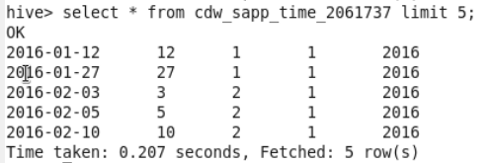

**FUNCTIONAL REQUIREMENTS**

CUSTOMER MODULE

1. **To store credit card details of customers.**

**//in spark shell**

**//to store data in a RDD**

val cc_details = sqlContext.sql(" select t.cust_id, t.cust_f_name, t.cust_m_name, t.cust_l_name, t.cust_cc_no, t.card_type, t.card_limit, t.card_end_date, t.cust_ssn, c.tran_type, c.tran_value from project.cdw_sapp_creditcard_2061693 c, project.cdw_sapp_customer_2061693 t where c.cust_id=t.cust_id")

**//to save output back to hive**

cc_details.write.mode("overwrite").saveAsTable("project.credit_card_details");

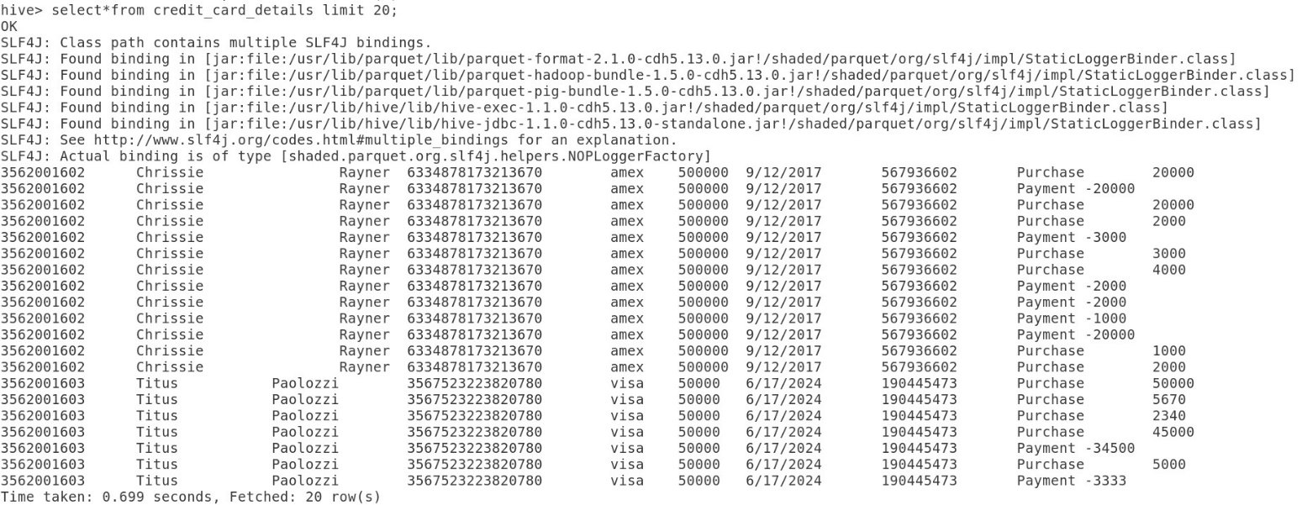

1. **To fetch the card details of a customer.**

**//to store data in a RDD**

val cust_ccdetails = sqlContext.sql(" select*from project.credit_card_details where cust_id=3562001611");

**//to save output as textfile in the local system**

val op= cust_ccdetails.rdd.map(_.toString().replace("[","").replace("]", "")).saveAsTextFile("file:/home/cloudera/creditcard_3562001611_details")

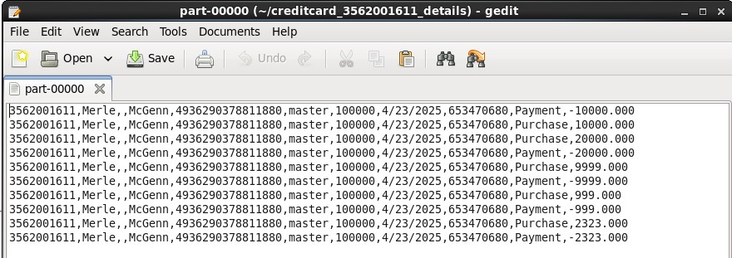

**//Creating temporary table in RDD using data in hive table**

**//customer table**

val customers = sqlContext.sql("select * from project.cdw_sapp_customer_2061693")

customers.registerTempTable("customer")

**//creditcard table**

val creditcard = sqlContext.sql("select * from project.cdw_sapp_creditcard_2061693")

creditcard.registerTempTable("credit_card")

**//time table**

val time= sqlContext.sql("select * from project.cdw_sapp_time_2061693")

time.registerTempTable("time")

**//branch table**

val branch = sqlContext.sql("select * from project.cdw_sapp_branch_2061693")

branch.registerTempTable("branch")

1. **To generate monthly bill for a credit card number.**

**//to store data in a RDD**

val bill = sqlContext.sql("select c.cust_id customer_id,name,year,month,sum(tran_value) bill from credit_card c join time t on c.tran_date=t.time_id join (select cust_id,concat(cust_f_name,' ',cust_l_name) as name from customer) as cs1 on c.cust_id=cs1.cust_id group by c.cust_id,name,year,month order by customer_id,year,month")

**//to save output back to hive**

bill.write.mode("overwrite").saveAsTable("project.monthly_bill");

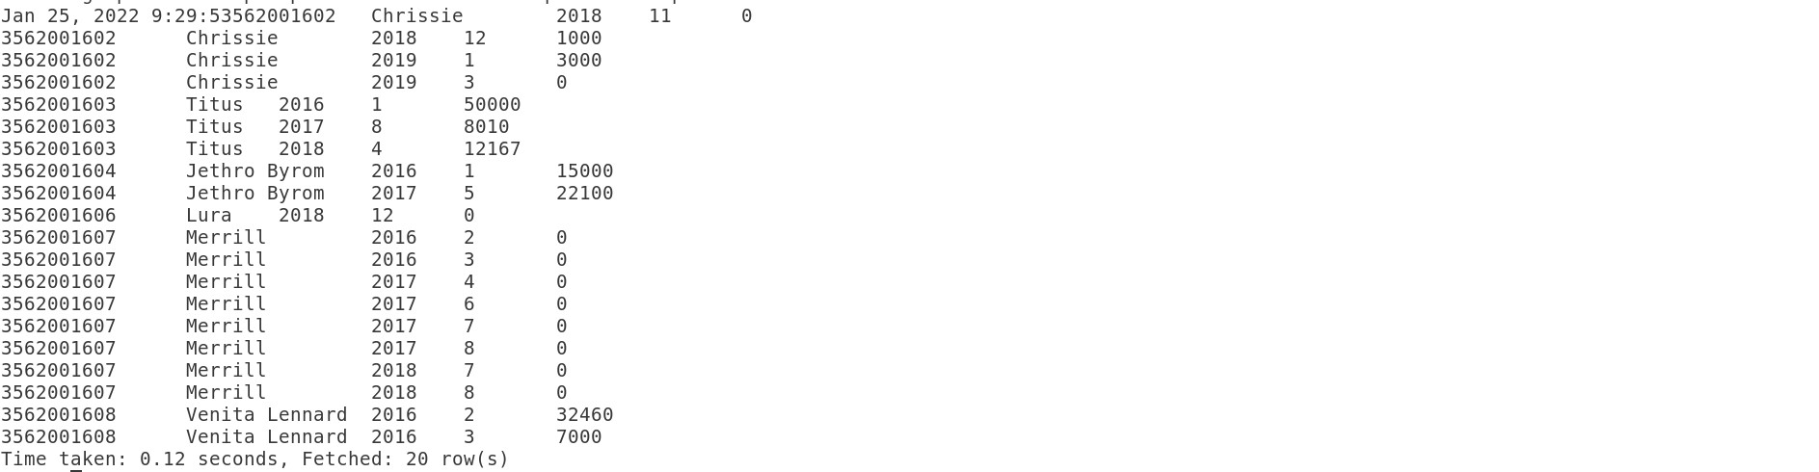

**//to save output as textfile in the local system**

val billoutput= bill.rdd.map(_.toString().replace("[","").replace("]", "")).coalesce(1).saveAsTextFile("file:/home/cloudera/creditcard_monthly_bill")

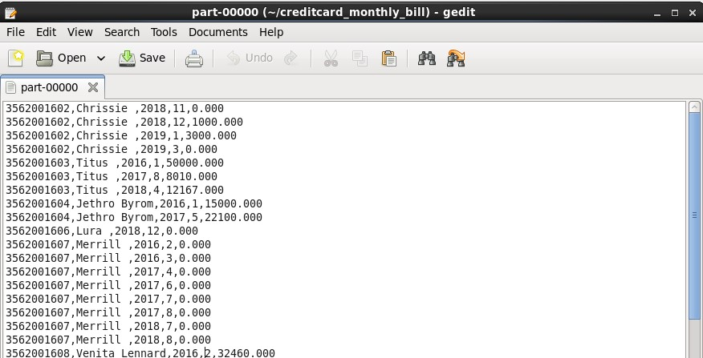

1. **To display the transactions made by a customer (daily, weekly, monthly basis).**

**//transaction on daily basis**

VAL DAILY= SQLCONTEXT.SQL("SELECT C.CUST_ID, CONCAT(C.CUST_F_NAME,' ', C.CUST_M_NAME,' ', C.CUST_L_NAME) AS NAME, T.CUST_CC_NO, T.TRAN_DATE, SUM(T.TRAN_VALUE) AS TOTAL_AMOUNT FROM CUSTOMER C, CREDIT_CARD T WHERE T.CUST_CC_NO=C.CUST_CC_NO GROUP BY C.CUST_ID, T.CUST_CC_NO, T.TRAN_DATE, C.CUST_F_NAME, C.CUST_M_NAME, C.CUST_L_NAME ORDER BY C.CUST_ID, T.TRAN_DATE")

**//to save output back to hive**

daily.write.mode("overwrite").saveAsTable("project.daily_transaction");

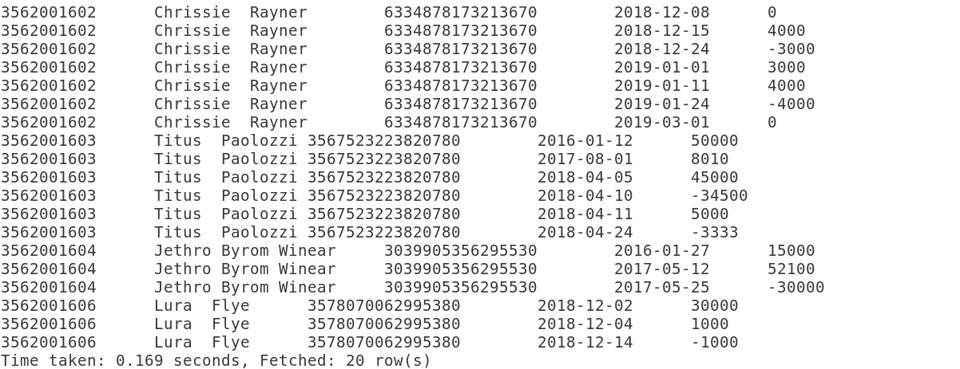

**//to save output as textfile in the local system**

val sa= daily.rdd.map(_.toString().replace("[","").replace("]", "")).coalesce(1).saveAsTextFile("file:/home/cloudera/daily_transaction")

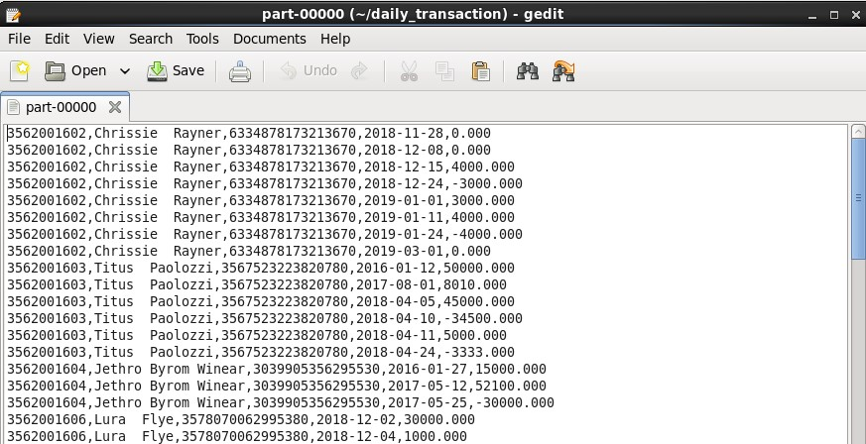

**//transaction on weekly basis**

val week= sqlContext.sql("select c.cust_id, concat(c.CUST_F_NAME,' ', c.CUST_M_NAME,' ', c.CUST_L_NAME) as NAME, t.CUST_CC_NO, weekofyear(t.tran_date) as week, year(t.tran_date) as year, sum(t.TRAN_VALUE) as TOTAL_AMOUNT from customer c, credit_card t where t.cust_cc_no=c.cust_cc_no group by c.cust_id, t.CUST_CC_NO, weekofyear(t.tran_date), year(tran_date), c.CUST_F_NAME, c.CUST_M_NAME, c.CUST_L_NAME order by c.cust_id, weekofyear(t.tran_date), year(t.tran_date)")

**//to save output back to hive**

week.write.mode("overwrite").saveAsTable("project.weekly_transaction");

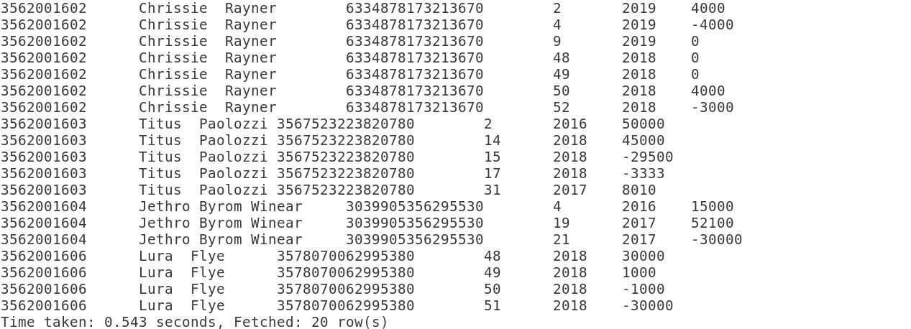

**//to save output as textfile in the local system**

val sa= week.rdd.map(_.toString().replace("[","").replace("]", "")).coalesce(1).saveAsTextFile("file:/home/cloudera/weekly_transaction")

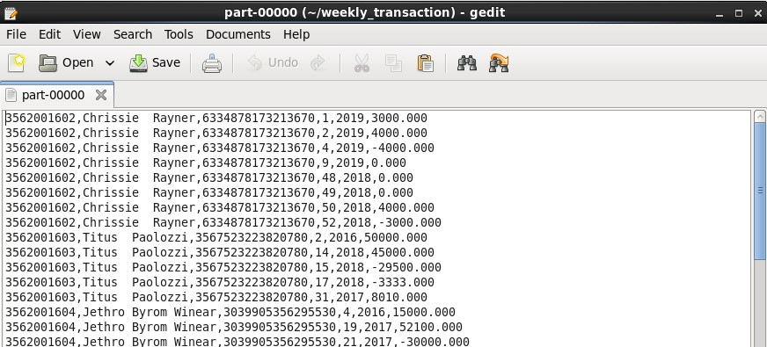

**//transaction on monthly basis**

val month= sqlContext.sql("select c.cust_id, concat(c.CUST_F_NAME,' ', c.CUST_M_NAME,' ', c.CUST_L_NAME) as NAME, t.CUST_CC_NO, month(t.tran_date) as month, year(t.tran_date) as year, sum(t.tran_VALUE) as TOTAL_AMOUNT from customer c, credit_card t where t.cust_cc_no=c.cust_cc_no group by c.cust_id, t.CUST_CC_NO, month(t.tran_date), year(tran_date), c.CUST_F_NAME, c.CUST_M_NAME, c.CUST_L_NAME order by c.cust_id, month(t.tran_date), year(t.tran_date)")

**//to save output back to hive**

month.write.mode("overwrite").saveAsTable("project.monthly_transaction");

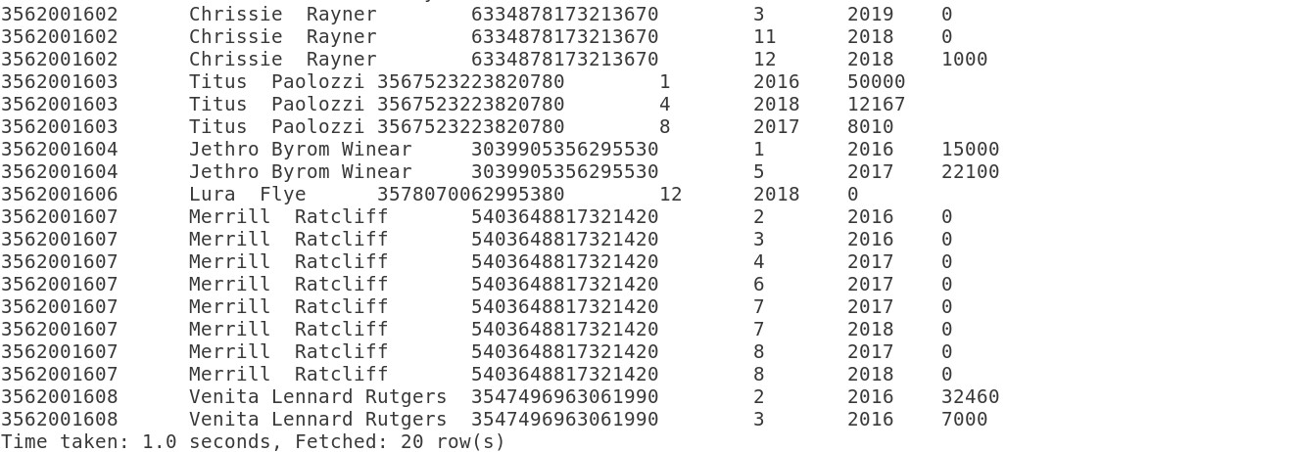

**//to save output as textfile in the local system**

val sa= month.rdd.map(_.toString().replace("[","").replace("]", "")).coalesce(1).saveAsTextFile("file:/home/cloudera/monthly_transaction")

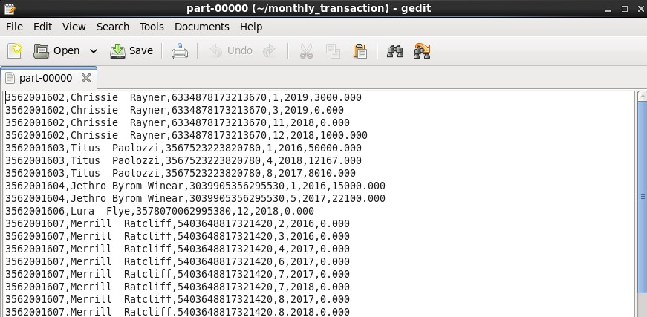

1. **To fetch customer details who have overdue.**

val overdue= sqlContext.sql("select id,name,mon,year,tot from (select cr.cust_id as id,cust_f_name as name,mon,year,sum(tran_value) as tot from credit_card cr join customer cs on cr.cust_id=cs.cust_id join time tm on cr.tran_date=tm.tran_date group by cr.cust_id,cust_f_name,mon,year order by id,year,mon) as sample where tot < 0")

**//to save output back to hive**

overdue.write.mode("overwrite").saveAsTable("project.customer_overdue");



**//to save output as textfile in the local system**

val sa= overdue.rdd.map(_.toString().replace("[","").replace("]", "")).coalesce(1).saveAsTextFile("file:/home/cloudera/customer_overdue")

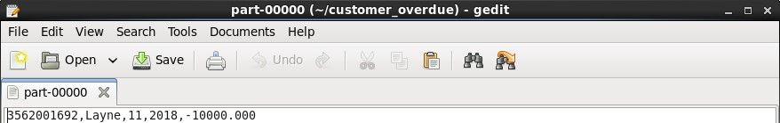

1. **To display customer details based on**

* **Card type**

val card_type= sqlContext.sql("select cust_id,concat(cust_f_name,' ',cust_m_name,' ',cust_L_name) as NAME, cust_cc_no, cust_ssn, cust_street, cust_email from customer where card_type like 'visa'")

**//to save output back to hive**

card_type.write.mode("overwrite").saveAsTable("project.cardtype_visa");

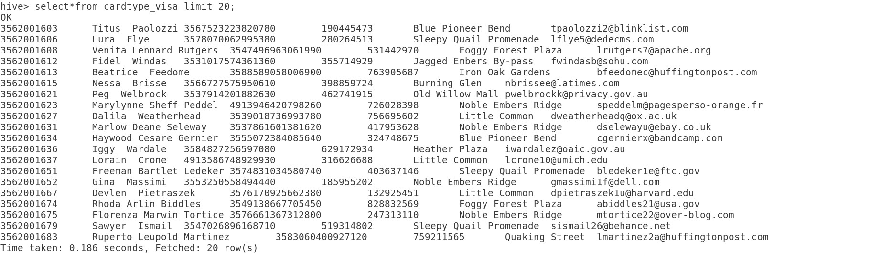

**//to save output as textfile in the local system**

val sa= card_type.rdd.map(_.toString().replace("[","").replace("]", "")).coalesce(1).saveAsTextFile("file:/home/cloudera/cardtype_visa")

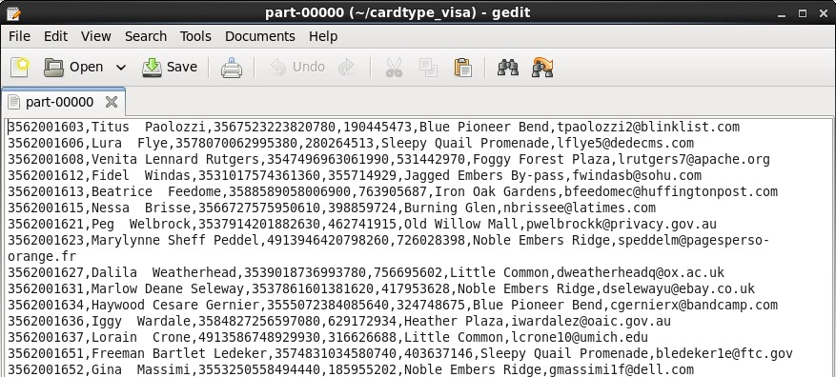

* **Credit limit range**

val card_limit= sqlContext.sql("select cust_id,concat(cust_f_name,' ',cust_m_name,' ',cust_L_name) as NAME, cust_cc_no, cust_ssn, cust_street, cust_email from customer where card_limit <= 50000")

**//to save output back to hive**

card_limit.write.mode("overwrite").saveAsTable("project.cardlimit");

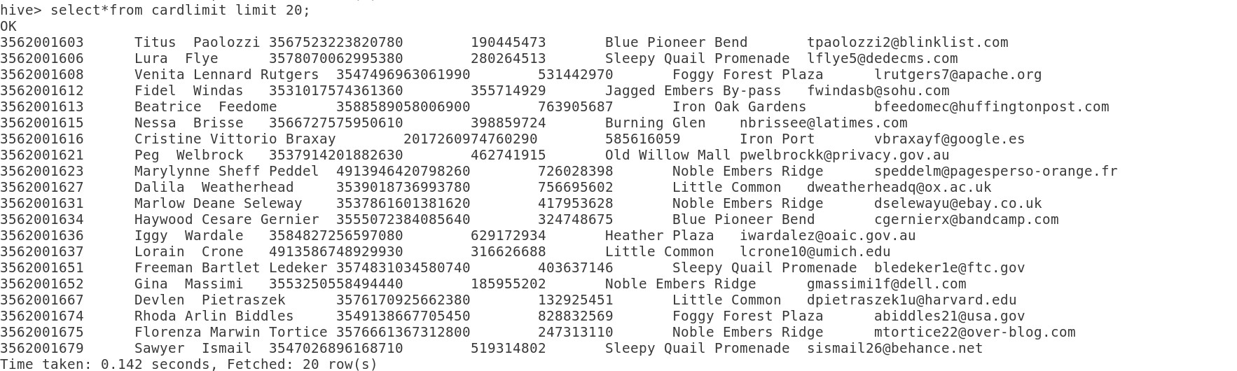

1. **To check the credit card validity.**

val validity =sqlContext.sql("select id,name,cc,concat(yr,' years ',mn,' months ',dy,' days') from (select cust_id as id,concat(cust_f_name,' ',cust_m_name,' ',cust_L_name) as name,cust_cc_no as cc, (cast(year(from_unixtime(unix_timestamp(card_end_date, 'mm/dd/yyyy'),'yyyy-mm-dd')) as int)-cast(year('2016-01-01') as int)) as yr, (cast(month(from_unixtime(unix_timestamp(card_end_date, 'mm/dd/yyyy'),'yyyy-mm-dd')) as int)-cast(month('2016-01-01') as int)) as mn, (cast(day(from_unixtime(unix_timestamp(card_end_date, 'mm/dd/yyyy'),'yyyy-mm-dd')) as int)-cast(day('2016-01-01') as int)) as dy from customer) as enddate")

**//to save output back to hive**

validity.write.mode("overwrite").saveAsTable("project.cardvalidity");

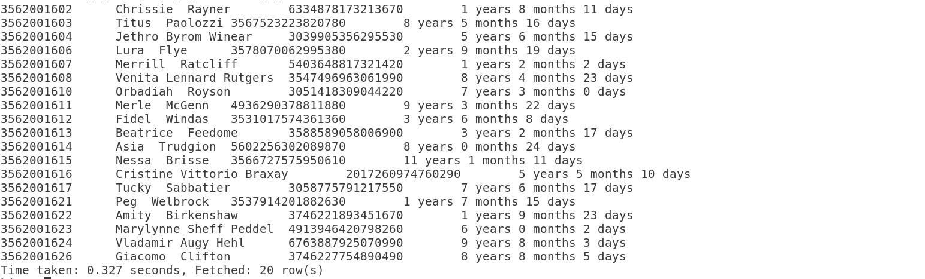

**//to save output as textfile in the local system**

val sa= validity.rdd.map(_.toString().replace("[","").replace("]", "")).coalesce(1).saveAsTextFile("file:/home/cloudera/cardvalidity")

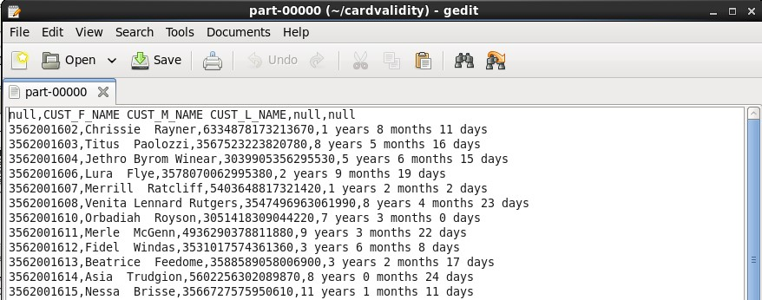

BANK MODULE

1. **To check for existing account details of a customer.**

val existing_acc=sqlContext.sql("select cust_id,concat(cust_f_name,' ',cust_m_name,' ',cust_L_name) as cust_name,CUST_CC_NO,card_type,card_limit,CARD_END_DATE,CUST_SSN,CUST_STREET,CUST_CITY,CUST_STATE,CUST_COUNTRY,CUST_ZIP,CUST_PHONE,CUST_EMAIL from customer where cust_ssn=195223654 order by cust_id")

**//to save output back to hive**

existing_acc.write.mode("overwrite").saveAsTable("project.customer_existing_acc")



**//to save output as textfile in the local system**

val sa= existing_acc.rdd.map(_.toString().replace("[","").replace("]", "")).coalesce(1).saveAsTextFile("file:/home/cloudera/customer_existing_acc")

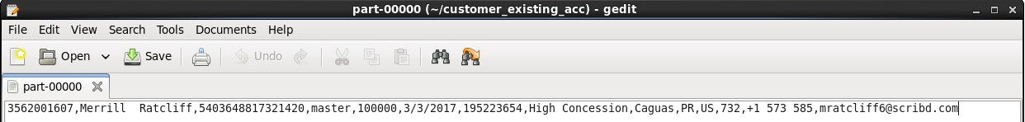

1. **To display Account Information for a customer.**

val acc=sqlContext.sql("select cs.cust_id,concat(cust_f_name,' ',cust_m_name,' ',cust_L_name) as cust_name,cs.CUST_CC_NO,card_type,card_limit,CARD_END_DATE,cr.branch_code,br.branch_name from credit_card cr join customer cs on cr.cust_id=cs.cust_id join branch br on br.branch_code=cr.branch_code order by cs.cust_id").distinct

**//to save output back to hive**

acc.write.mode("overwrite").saveAsTable("project.customer_account_info")

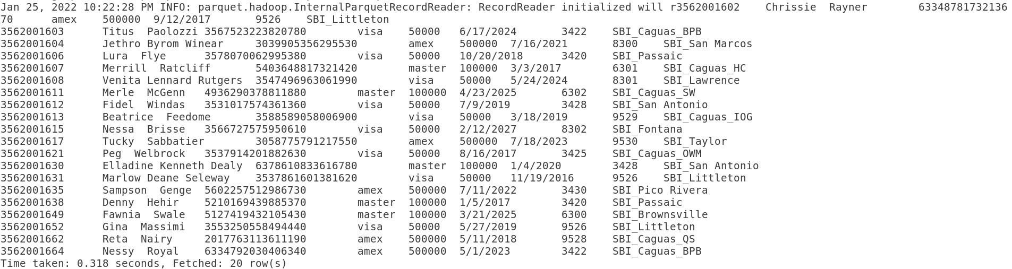

**//to save output as textfile in the local system**

val sa=acc.rdd.map(_.toString().replace("[","").replace("]","")).coalesce(1).saveAsTextFile("file:/home/cloudera/customer_account_info")

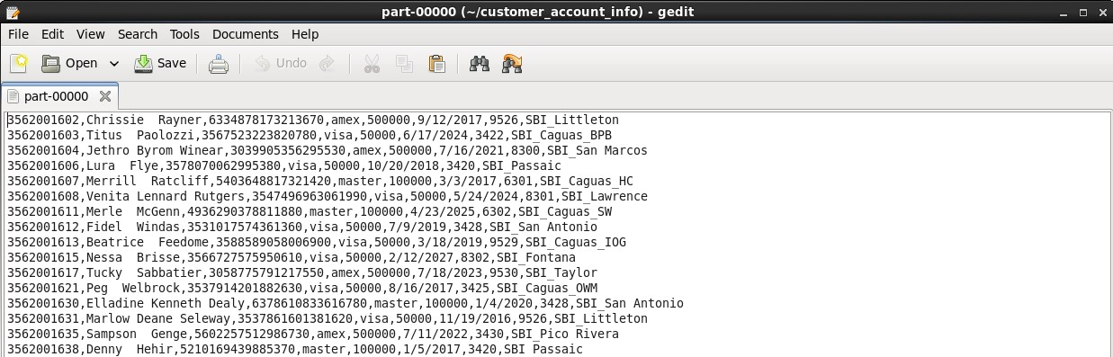

**EXTRAS**

1. **Total credit limit for each customer**

val cr_limit= sqlContext.sql("SELECT CUST_ID, CONCAT(CUST_F_NAME,' ', C.CUST_M_NAME,' ', C.CUST_L_NAME) AS NAME,card_limit from project.cdw_sapp_customer_2061693”)

cr_limit.show()

1. **Available credit limit for each customer**

val overdue= sqlContext.sql("select id,name,os from (select cr.cust_id as id,cust_f_name as name,

sum(tran_value) as os from project.cdw_sapp_creditcard_2061693 cr join project.cdw_sapp_customer_2061693 cs on cr.cust_id=cs.cust_id group by cr.cust_id,cust_f_name) as sample")

overdue.registerTempTable("overdue");

cr_limit.registerTempTable("cr_limit");

overdue.write.mode("overwrite").saveAsTable("project.customer_overdue");

cr_limit.write.mode("overwrite").saveAsTable("project.customer_cr_limit");

val avl_limit= sqlContext.sql("select o.id, l.NAME, (l.card_limit-o.os) as AVL_LIMIT from overdue o join cr_limit l on o.id = l.CUST_ID")

**//to save output back to hive**

avl_limit.write.mode("overwrite").saveAsTable("project.cardvalidity");

**3.How many customers have invalid or null email id**

val invalid_cnt=sqlContext.sql("select count (cust_email) as count from project.cdw_sapp_customer_2061693 where cust_email not like '%_@_%._%' or cust_email is null")

invalid_cnt.show()

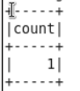

**4. Total customers who do average 1L transaction/purchase per month**

val mon_avg= sqlContext.sql("select id, avg(myavg) as monavg from (select cust_id as id, month(tran_date), year(tran_date), avg(abs(tran_value)) as myavg from project.cdw_sapp_creditcard_2061693 group by cust_id, month(tran_date), year(tran_date)) s group by id having monavg >= 100000")

mon_avg.count()

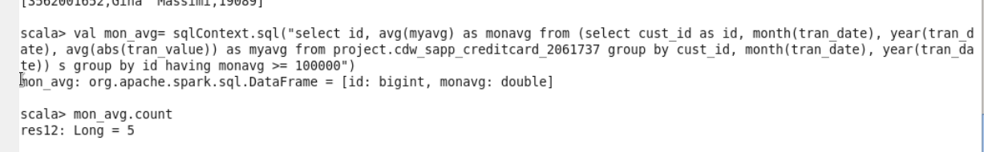

**5. Fetch top 10 customers who is doing more transactions**

val toptencust = sqlContext.sql("select c.cust_id, concat(c.CUST_F_NAME,' ', c.CUST_M_NAME,' ', c.CUST_L_NAME) as NAME, sum(t.TRAN_VALUE) as TOTAL_AMOUNT from project.cdw_sapp_customer_2061693 c, project.cdw_sapp_creditcard_2061693 t where t.cust_cc_no=c.cust_cc_no group by c.cust_id, t.CUST_CC_NO, c.CUST_F_NAME, c.CUST_M_NAME, c.CUST_L_NAME order by sum(t.tran_value) desc limit 10")

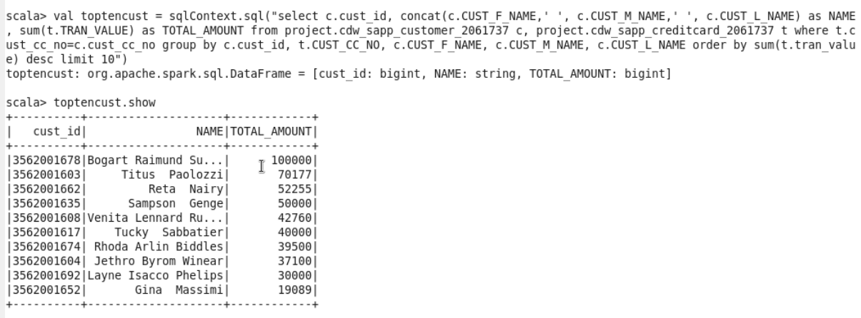

**//to save output back to hive**

toptencust.write.mode("overwrite").saveAsTable("project.cardvalidity");

**6. List of customers whose credit card needs to be renewed within next 1 year**

val wthnxtyr = sqlContext.sql("select id,name from (select cust_id as id,concat(cust_f_name,' ',cust_m_name,' ',cust_L_name) as name,datediff(add_months(current_date,12),from_unixtime(unix_timestamp(card_end_date, 'mm/dd/yyyy'),'yyyy-mm-dd')) as end_date from project.cdw_sapp_customer_2061693) as enddate where end_date < 365 and end_date>0");

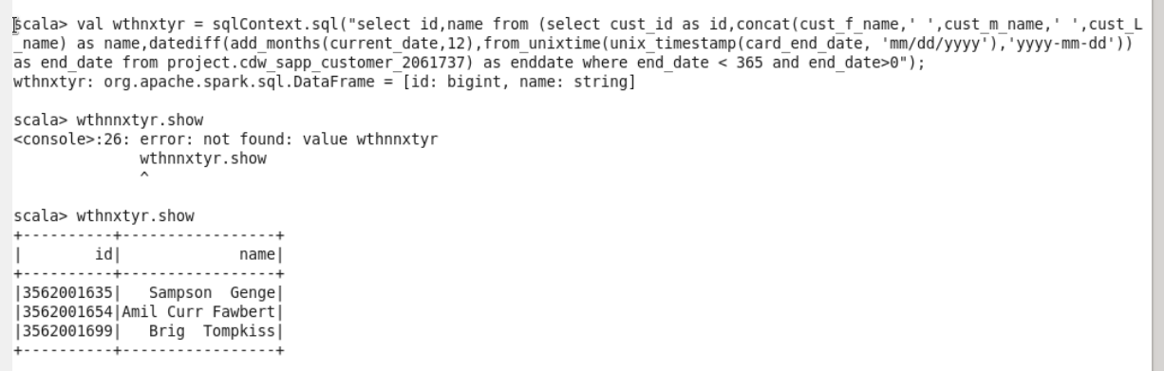

**//to save output back to hive**

wthnxtyr.write.mode("overwrite").saveAsTable("project.cardvalidity");