**List of contents**

**Stages for conducting a data warehouse 1**

Analysis 1

Create Table OLAP 1

Proses ETL dimension 2

ETL Time Dimension 13

Proses ETL fact tables 16

Create CUBE and Pivot table 19

Pivot Table Creation 27

# 

# Stages for conducting a data warehouse

## Analysis

1. Make a measurement analysis of the fact table you want to create.
2. Make analysis of the dimensions needed for the data warehouse.
3. Create fact analysis required for the data warehouse.

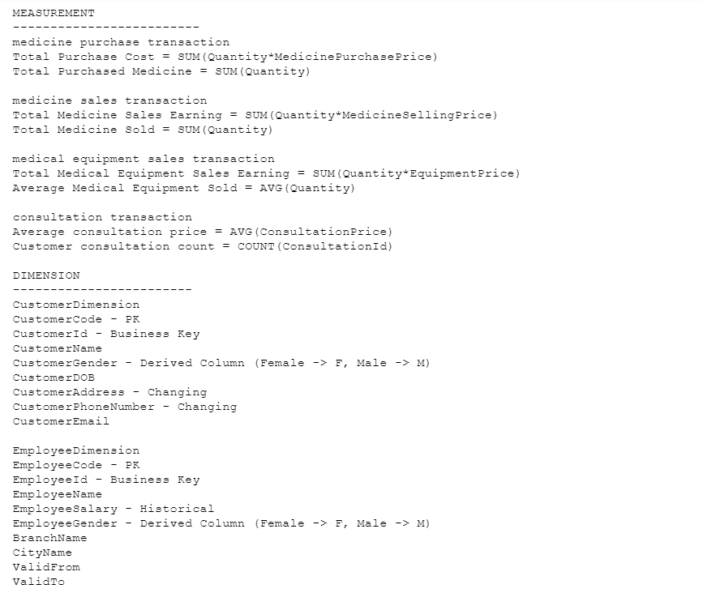

* Further analysis can be found in the txt file "ANALYSIS PROJECT"

## Create Table OLAP

1. Create predetermined dimension and fact tables analyzed using the DDL language.

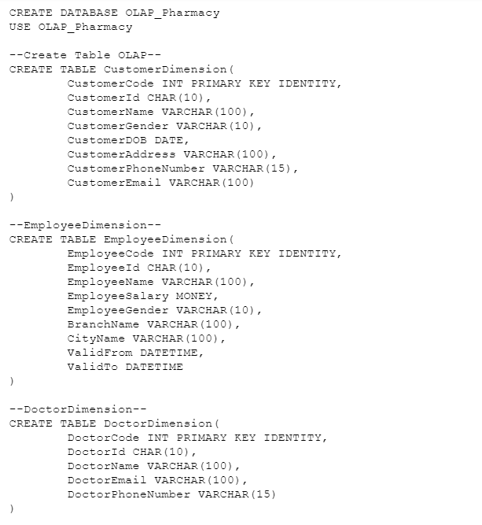

* The query extension can be found in the sql file "CREATE TABLE OLAP"

## Proses ETL dimension

1. Create a SELECT query for the ETL process against all dimensions and a query for the timestamp filter.

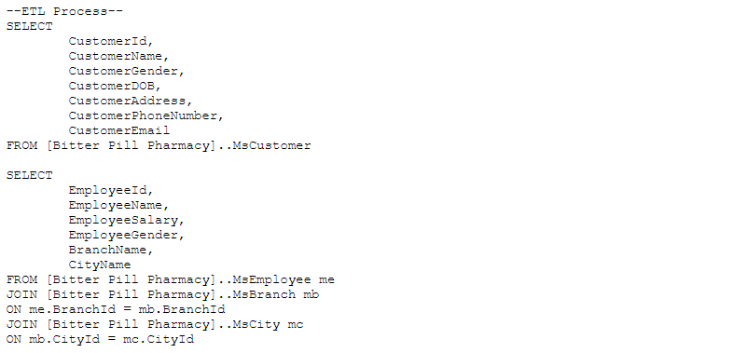

* The query extension can be found in the sql file "SELECT ETL"

1. Open Visual Studio 2019. Then, click Create a new project.

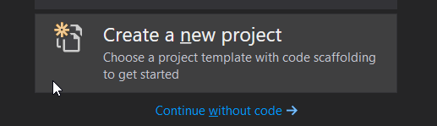

1. Gunakan template Integration Services Project.

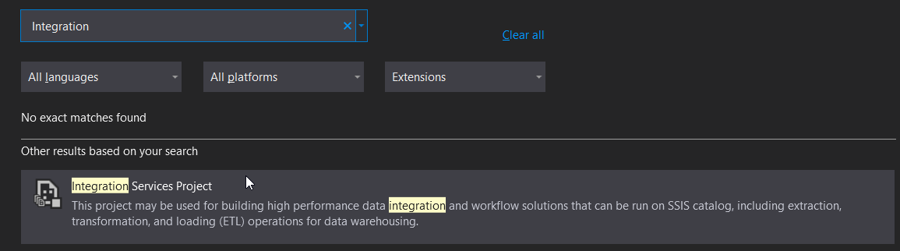

1. Fill in the project name and location. Then, click Create.

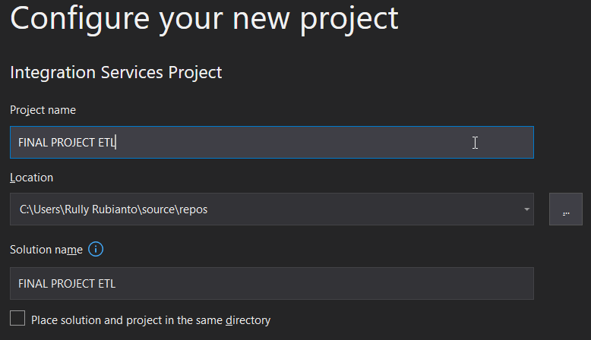

1. Right click on “Connections Managers”

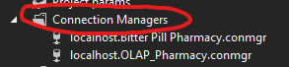

1. Select and Click "New Connection Manager"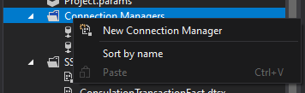
2. Look for a connection called OLEDB then click the “Add…” button.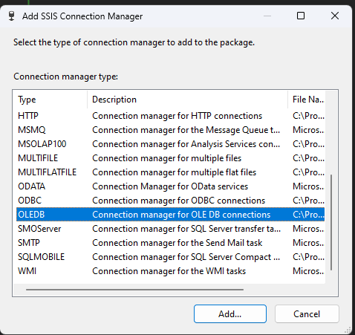
3. After that, press the "New..." button

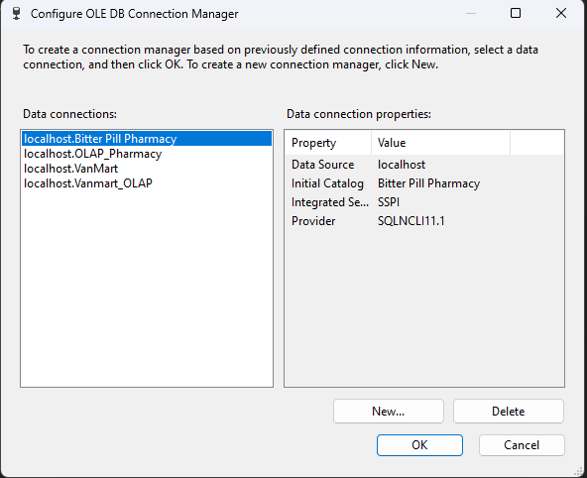

1. Enter the Server Name according to the existing SSMS. Then enter "Select or enter a database name" according to the required database. There are two databases that need to be entered, namely the OLTP and OLAP databases for the data warehouse. First of all we enter OLAP. After that, click OK.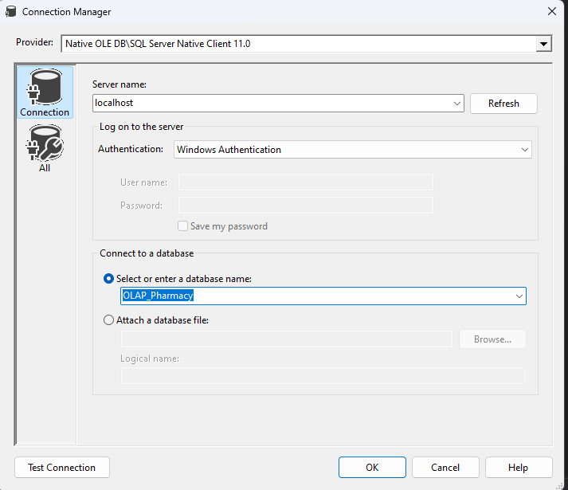
2. Then we click OK. Then, an OLE DB Connection can be created.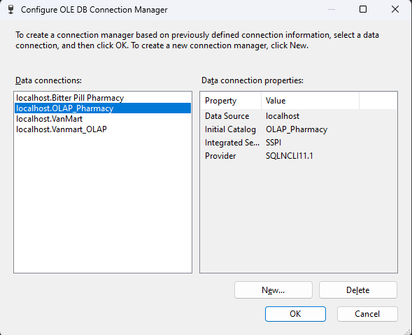
3. Next, we do the same as before to connect to the OLTP Pharmacy database.

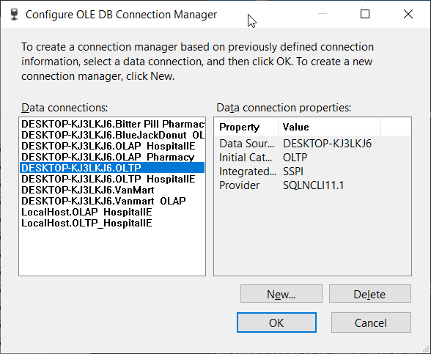

1. After that, we select and left click "SSIS Packages" then right click "New SSIS Package"

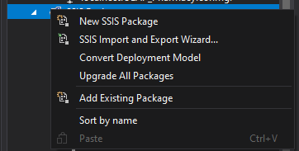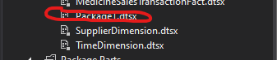

1. Right click Package1.dtsx then we "Rename" according to the analysis we made previously. There are facts and dimensions.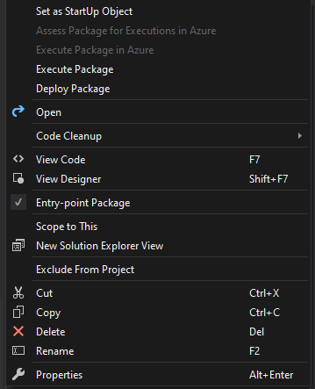
2. Search for “Data Flow Task” in the SSIS Toolbox. Then, enter the “Data Flow Task” on the left into the project.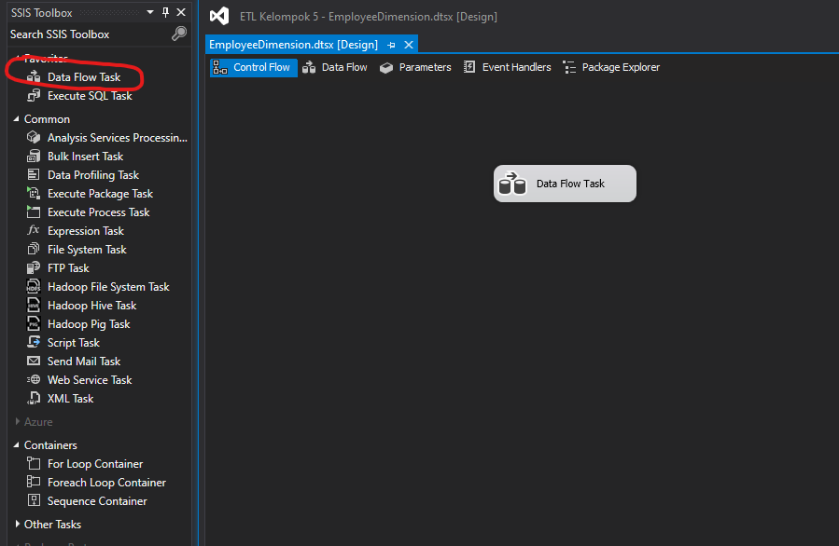
3. Then, double click on the Data Flow Task that has been entered.

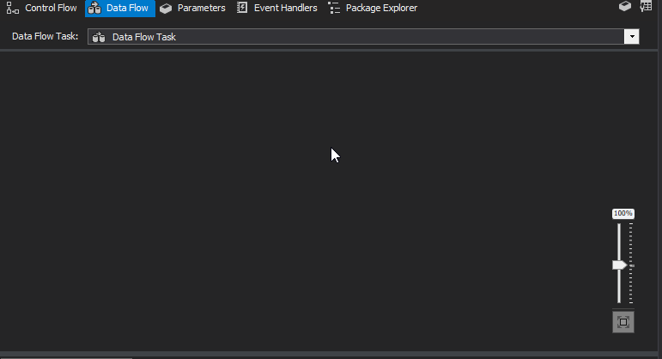

1. Then we enter “OLE DB Source”. Then, double click on OLE DB Source.

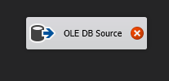

1. Enter the SELECT Query that we created previously to use the attributes required for the ETL dimension process. After that, click OK.

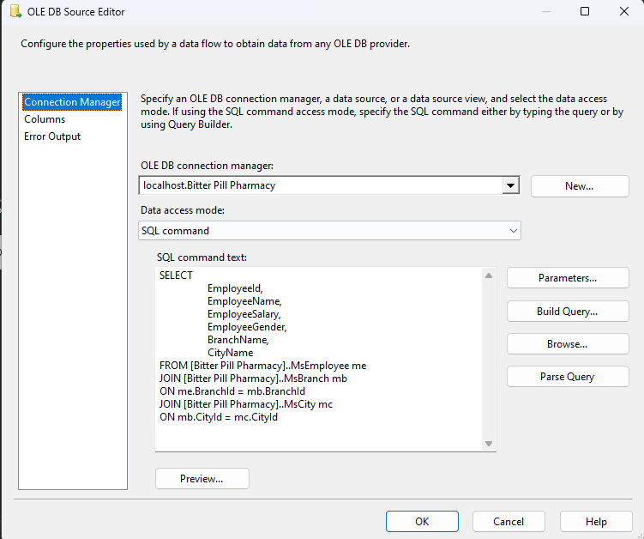

1. Then, we select the derived column in the SSIS Toolbox if there is a column we want to derive (such as male or female).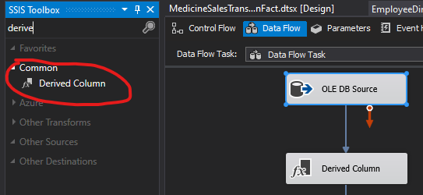
2. Then we have to add a “Slowly Changing Dimension” to determine the key type and change type for each attribute.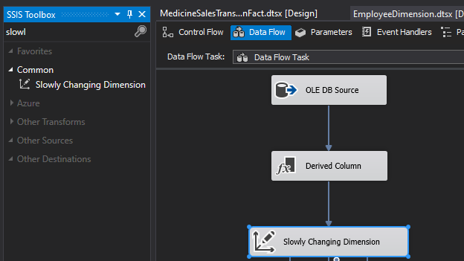
3. Select next to proceed to the next stage.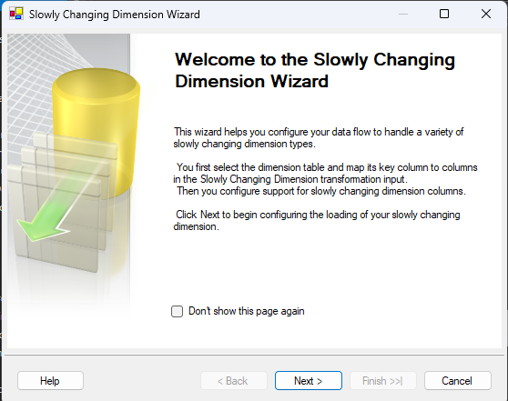
4. Determine the Id to be a "Business Key" in "Key Type" and then click next.

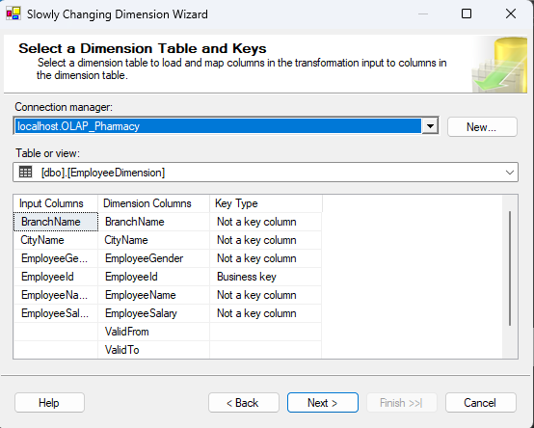

1. Determine each attribute, whether it is a fixed attribute, historical attribute, or changing attribute. Then click Next.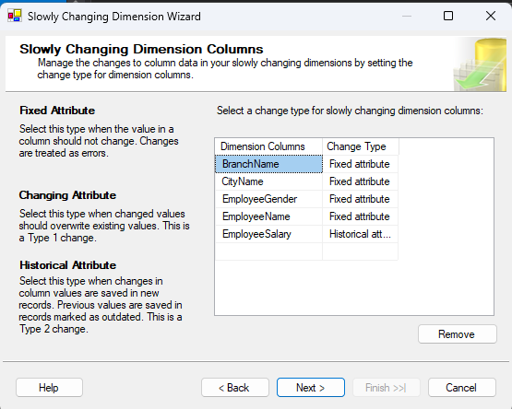
2. Click next.

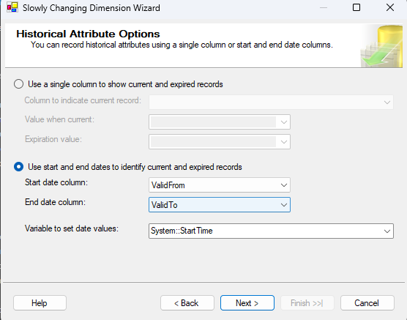

1. Click next.

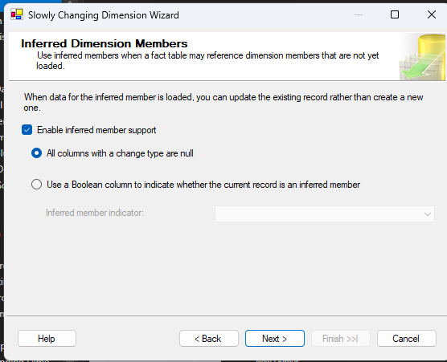

1. Click finish.

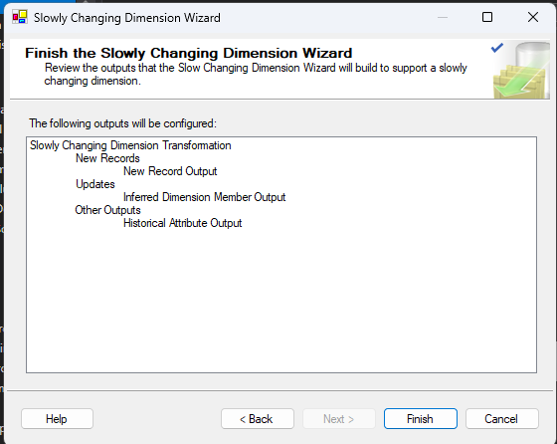

1. Then, after everything is successful, it will look like in the image below, and then we can run the etl.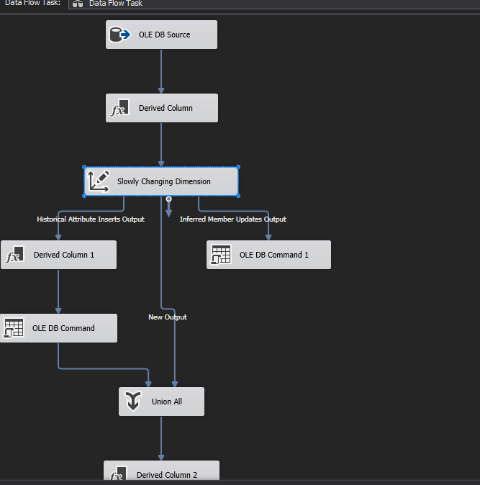

## ETL Time Dimension

1. Enter as usual, namely "Data Flow Task", then we enter "Execute SQL task". Then, we double click on "Data Flow Task".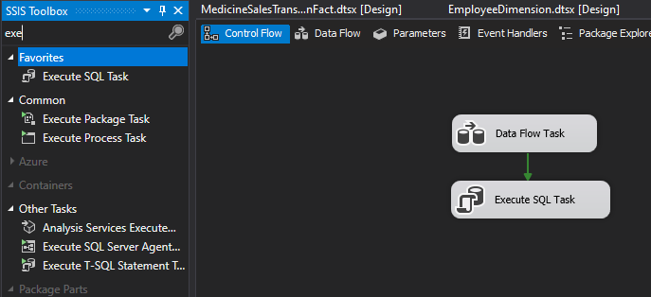
2. We enter the OLE DB source then we double click.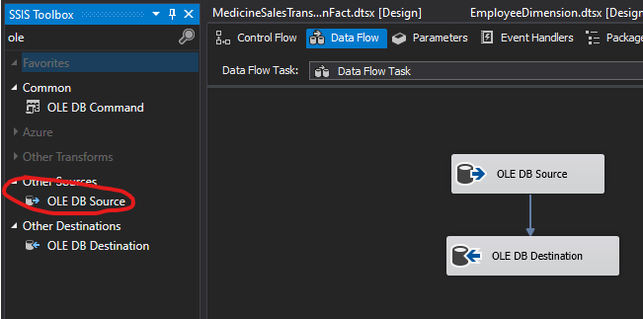
3. Then we enter the SELECT Query that has been created for TimeDimension. Then we click the "OK" button

.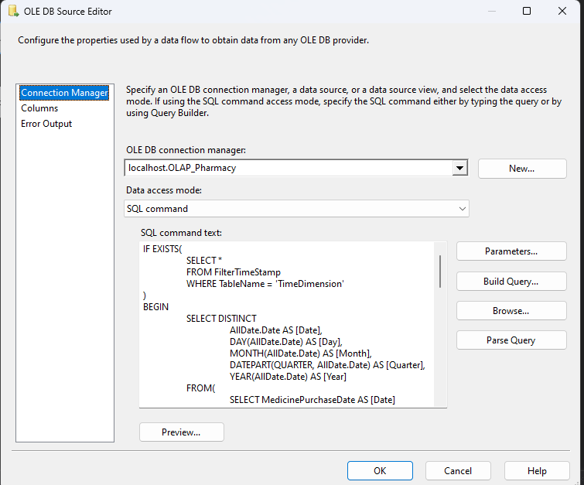

1. We enter "OLE DB Destination" into the project. Then we double click.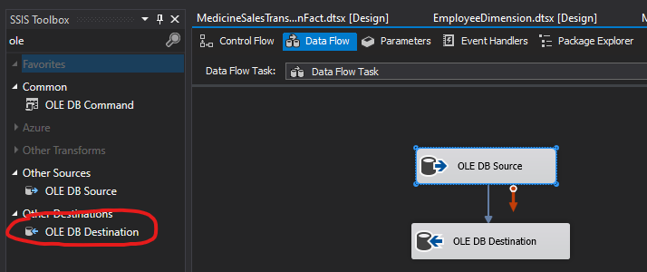
2. Select "Data Access mode:" then we select "Table or view". Then, we select "Name of table of the view:" is "TimeDimension". After that, we click OK.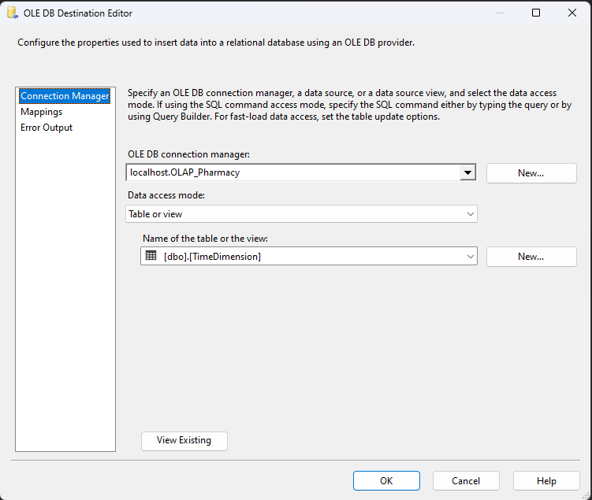
3. Once finished, we return to "Control Flow" then we double click "Execute SQL Task"
4. We select the "OLAP" connection, then we enter the SQLStatement that we created for the SELECT QUERY. Then we change "BypassPrepare" to False and we test the query by pressing the "Parse Query" button. Change “BypassPrepare” again to True. Once finished, we click OK.

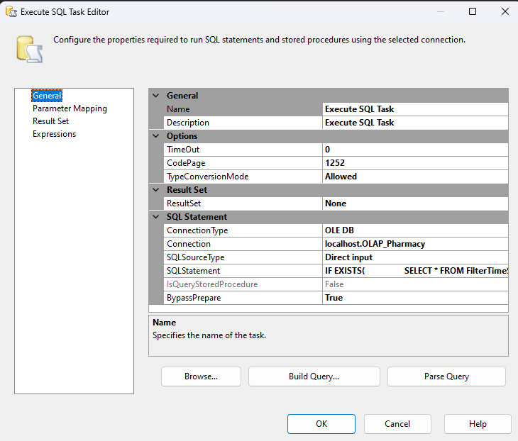

## Proses ETL fact tables

1. Enter the Data Flow Task on the project. Then, double click “Data Flow Task” to enter Data Flow.

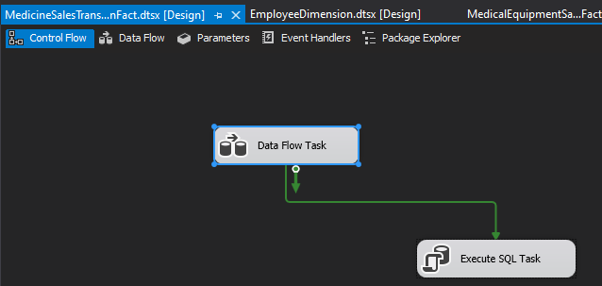

1. Then, enter OLE DB Source and OLE DB Destination in Data Flow. Then, double click on OLE DB Source.

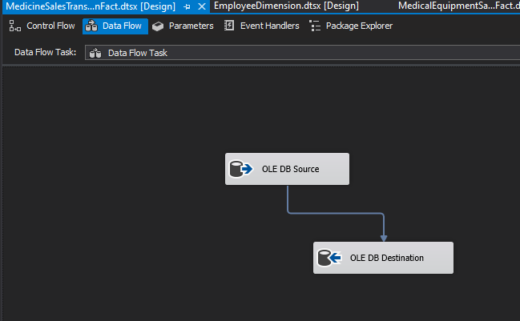

1. We enter the SELECT query that we have created for the desired fact table. Then we click "OK"

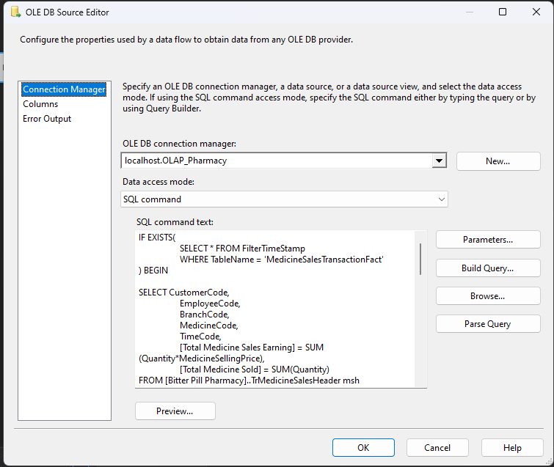

1. Then double click “OLE DB Destination”. Then, change “Data Access Mode” to “Table or view”. Then we select the fact table that we want to ETL. Next, click OK.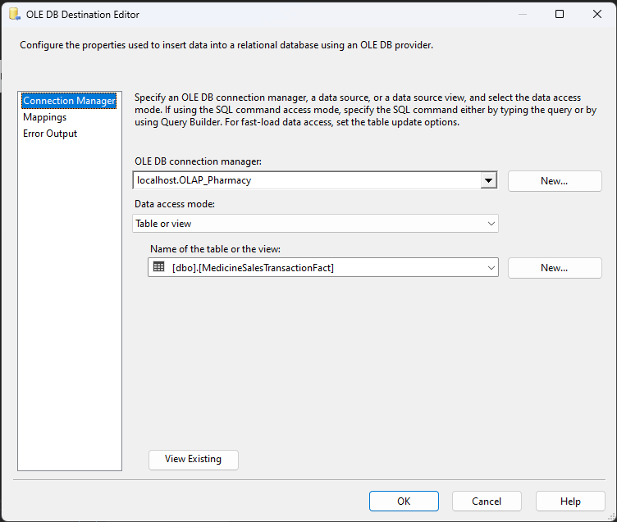
2. Return to control flow, double click “Execute SQL Task”. Then, we select the OLAP database. Then, we enter the SELECT Query that we have created for the Fact Table. After that, we set "BypassPrepare" to False and we test the query by clicking the "Parse Query" button. Change “BypassPrepare” again to True. Once finished, we click the “OK” button.

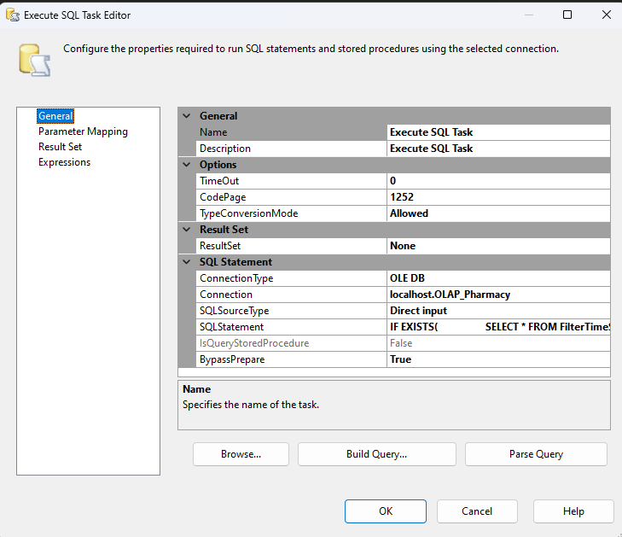

1. After all the dimensions and facts, the packages are created. We start everything 1 by 1 to carry out the ETL stage and enter the data into the OLAP data warehouse server that we have created.

## Create CUBE and Pivot table

1. First of all, create a new project. Use the “Analysis Services Multidimensional and Data Mining Project” template. Then, click Next.

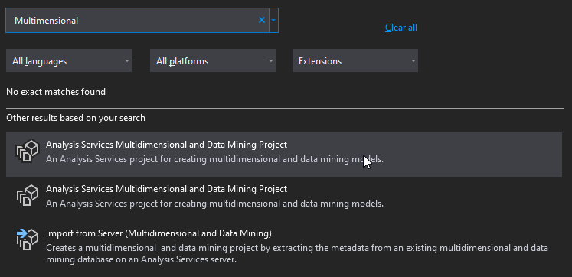

1. Enter the project name and location. Then, click Create.

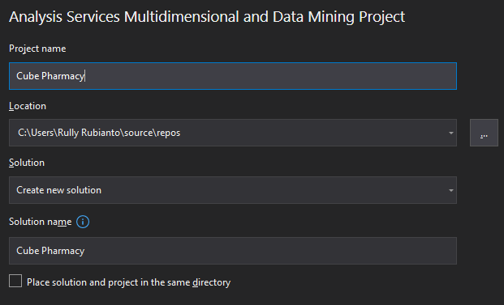

1. Right click on "Data Sources" and select new connection.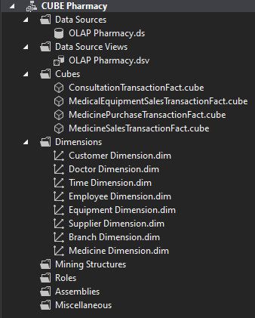
2. Click the "Next" button.

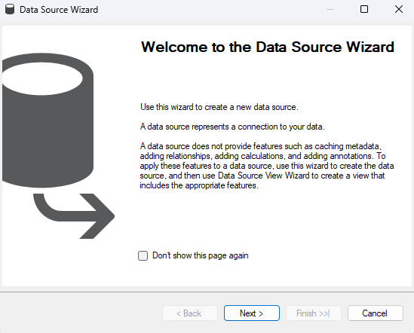

1. Enter a new server by pressing new and selecting the OLAP server.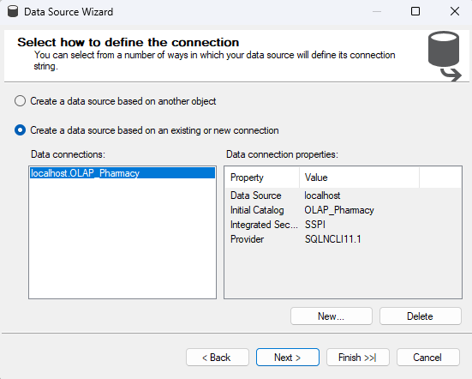
2. After we enter, we click the "Next" button. Then, we enter the Username and Password of our computer/laptop. The username can be obtained from cmd by running the whoami command. The password is our computer/laptop password. After that we click the "Next" button.

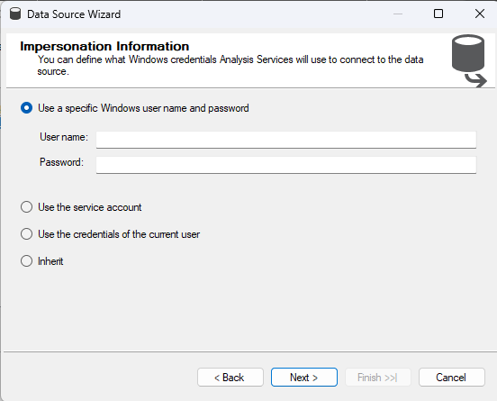

1. Determine the data source that we want to create then click "Finish".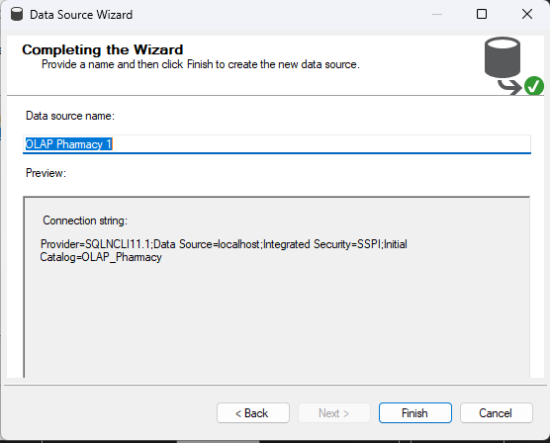
2. After creating the data source, it's time for us to create a CUBE. In Solution Explorer, right click on Cubes. Then, click New Cube.

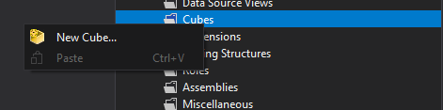

1. In the Cube Wizard, we click the “Next” button.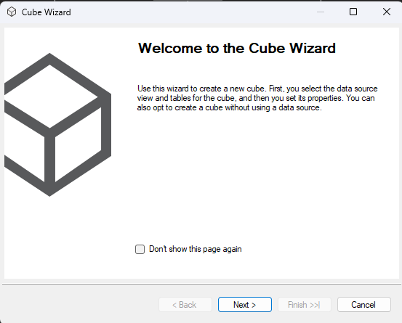
2. Select “Use Existing Tables”, and we select the “Next” button.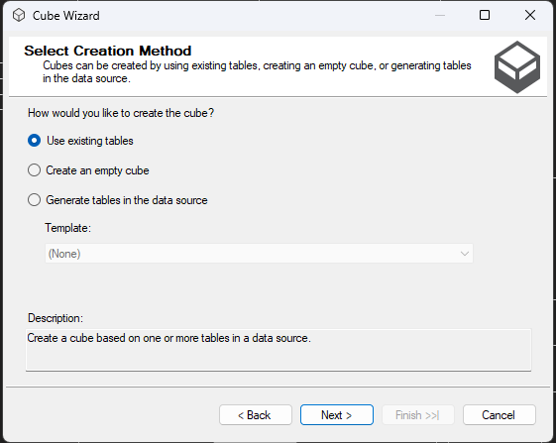
3. Here we enter one of the fact tables that we want to enter into the CUBE.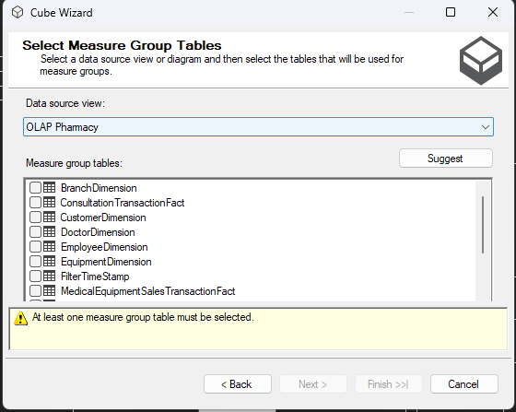
4. After that, we click the "Next" button.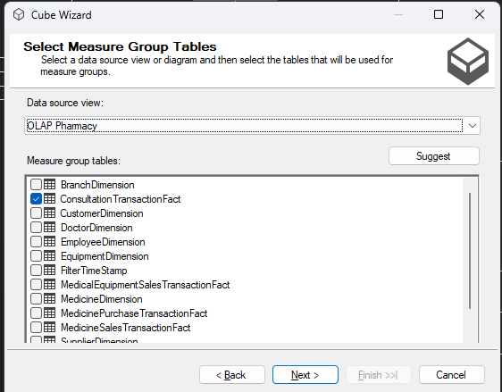
5. Here we check everything and we click the "Next" button.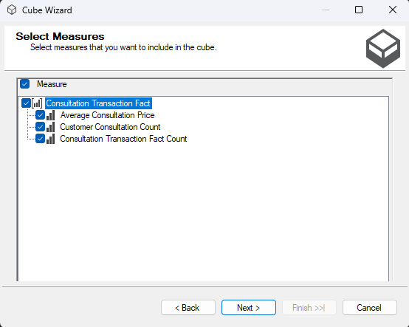
6. After that, we click the check all button and click the “Next” button.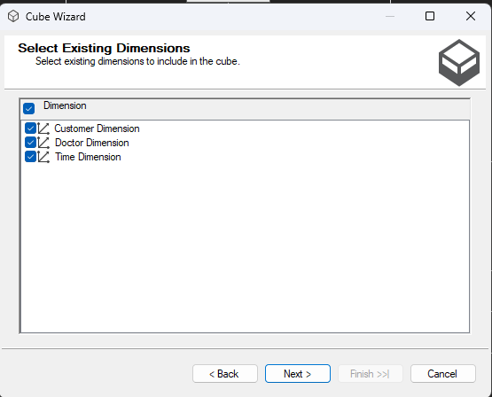
7. Once finished, we change the name of the cube we want and we click finish.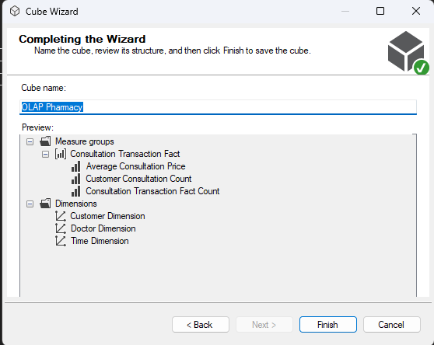
8. We repeat the stage until all the fact cubes have been made.

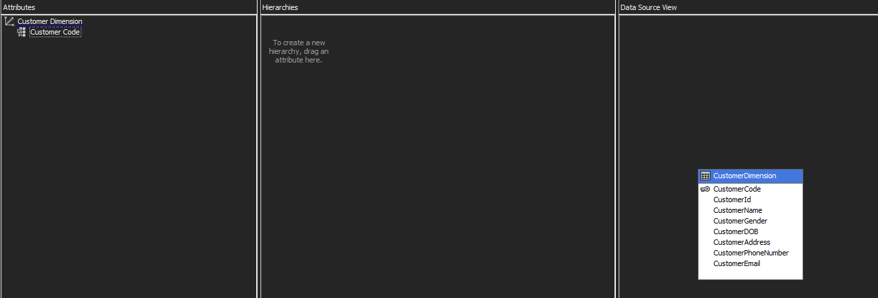

1. Here we double click on the dimension we want. For example, selecting a customer dimension to enter its attributes into a cube. Select all the attributes in the Data Source View and drag them to the Attributes section on the left.

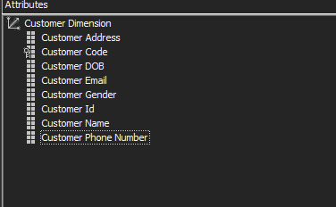

1. We do it all in all dimensions.
2. After we have done all that, we click the "Start" button or we right-click the "Data Source" section then we click "Deploy".

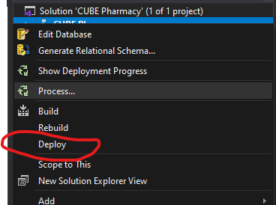

1. After we have created it, it's time to create a pivot table.

## Pivot Table Creation

1. To create a pivot table, open Microsoft Excel and create a new workbook. Then we click on the "Data" ribbon, then we click "Get Data" > "From Database" > "From Analysis Services".

.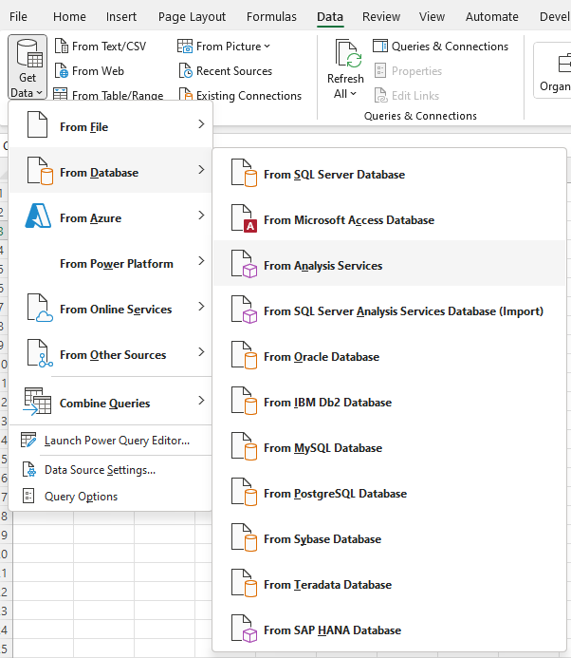

1. Then we enter the required "Username" and "Password". “Username” and “Password” are the same as in Visual Studio.

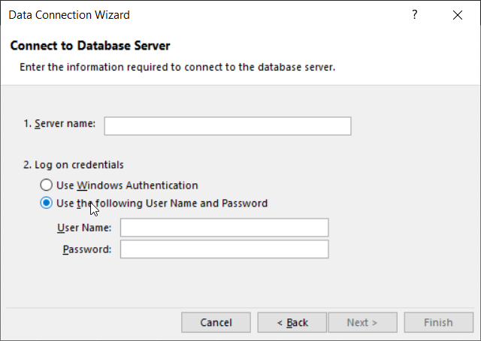

1. We select the “CUBE Pharmacy” dropdown and select the cubes one by one to create the pivot table we want.

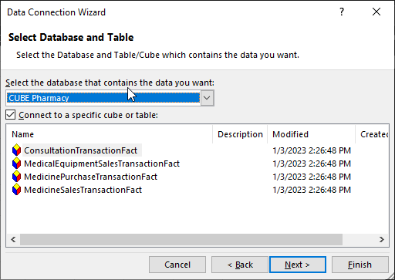

1. Once finished, we select the CUBE fact that we want, we click the "Finish" button.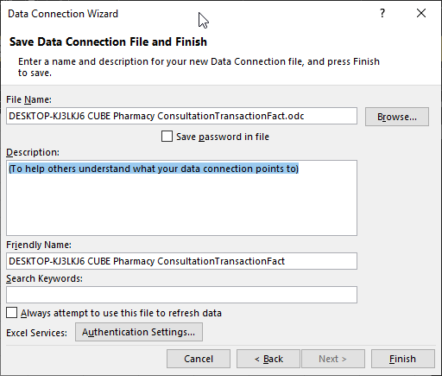
2. We choose the Pivot table location that we want to position in the cells we have selected.

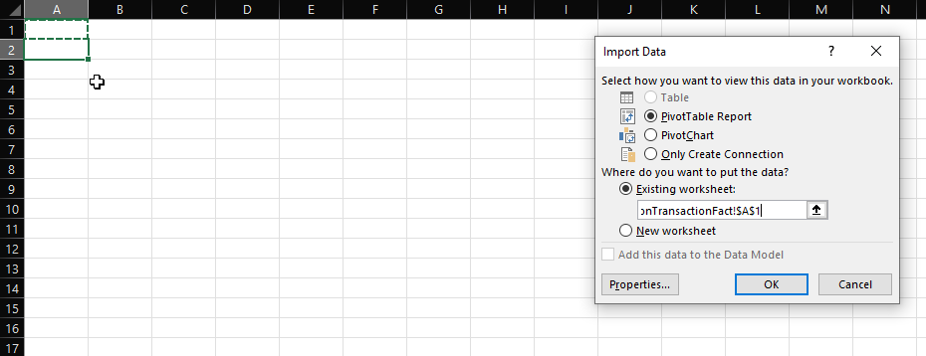

1. After that, we adjust the attributes and nominal required in the pivottable that we want to show.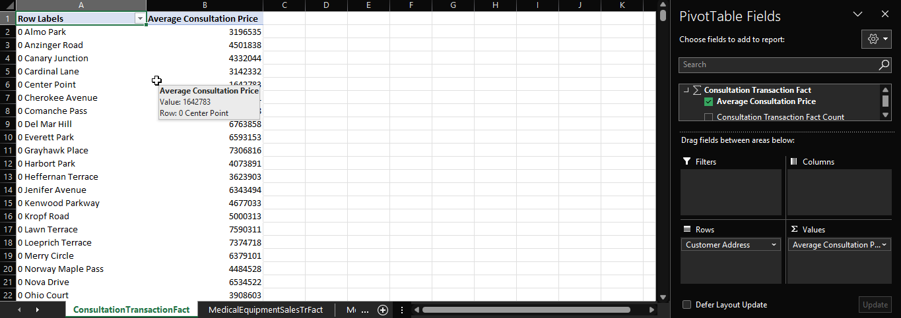
2. Pivot Table and Cube creation is complete.