Introduction

What is an operating system?

An operating system is the layer of software that manages a computer’s resources for its users and their applications.

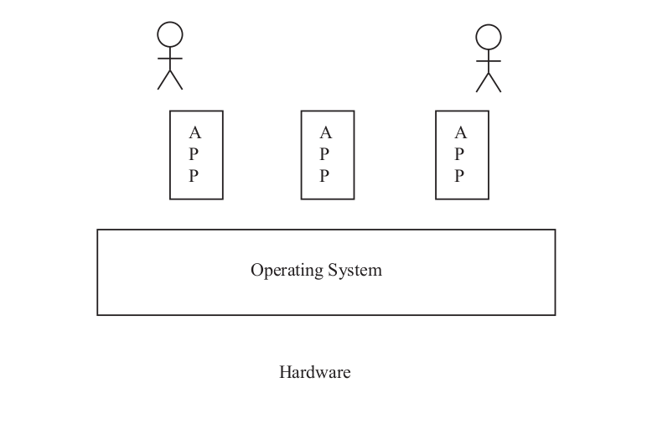

Operating systems run in a wide range of computer systems.

Operating systems are also an essential component of more general-purpose systems such as smart phones, desktop
computers, and servers.

For example, early mobile phones had simple operating systems to manage the hardware and to run a handful of
primitive applications. Today, smart phones phones capable of running independent third party applications are the
fastest growing part of the mobile phone business.
These new devices require much more complete operating systems, with sophisticated resource management,
multi-tasking, security and failure isolation.

