## MY B.sc. thesis,

**"The role of SLAM capable robots in chemical and**  
**Petroleum industrial pipelines"**

An Intro:

This project of mine was a SLAM feature  
implemented on my 2- wheeled robot, which I had designed for this specific matter.

The robot was initially designed in Solid Works 2019, converted to urdf format, and simulated in Rviz + Gazebo environment using  
Robot operating system (ROS). After successfully  
parsing the robot's model, LDS (laser distance sensor), differential drive plugins, etc. were added to the urdf file. The simulation was then tested using a pre-made maze, in gazebo, for evaluation of localization + generated map  
accuracy.

In a brief, my project is divided into: 1) 30% simulation

* + - * 1. 70% built and Real-world testing.

As it may be obvious, designing both the robot and the maze was such a challenge to overcome under my room's circumstances, available materials, etc.  
I had many limitations such as not being able to attach any encoder to the wheels because of the chassis I was given (and I had no other choice!)

so in a sense> it's safe to say that I almost covered  
the flaws by combining Kalman filter, AMCI, and Kinect ✗ Box -560 depth images (which were ultimately converted to 2d laser data) and Imu raw data in a way that satisfied the goal.

This is a picture captured from the latest mapping  
output considering the hard work mentioned above.

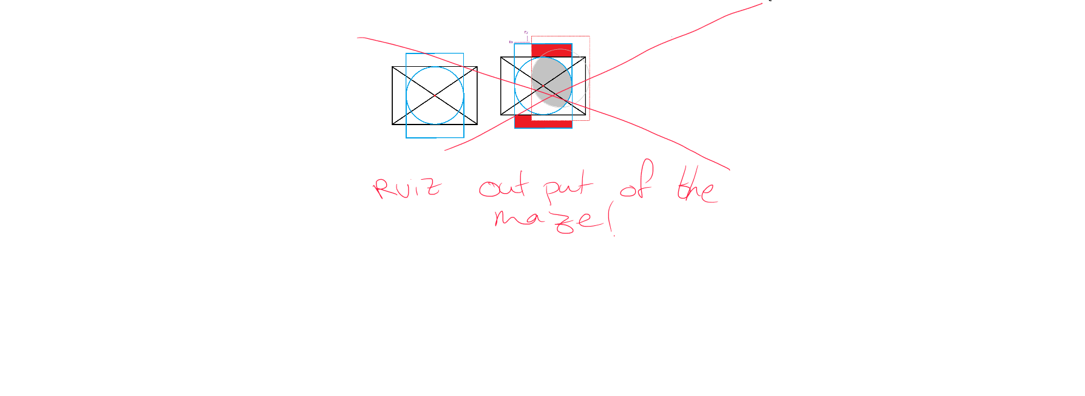

Feel free to read my work using the provided link below

It is worth mentioning that this is only an unofficial translation of my fall-marked, university official full-text thesis, thus it may have differences from the original. However, the fundamentals are the same.

