Assignment 2
(this document is one of my exercises for image processing course)
Mahta zarei

1)
Sobel: 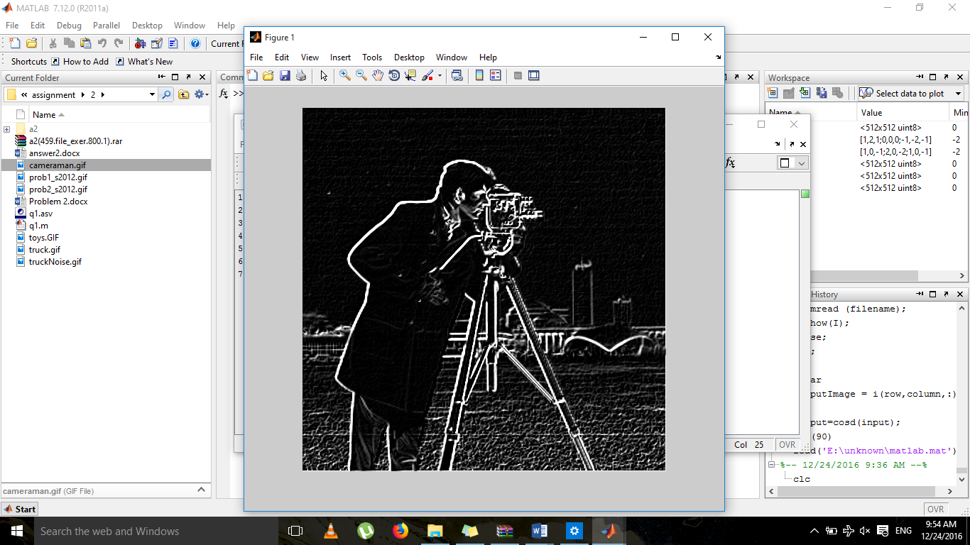
i=imread('cameraman.gif');
sb1=[1,2,1;0,0,0;-1,-2,-1];
sb2=[1,0,-1;2,0,-2;1,0,-1];
sba1= imfilter(i,sb1);
sba2= imfilter(i,sb2);
sba=abs(sba1)+abs(sba2);
imshow(sba);

Robert:
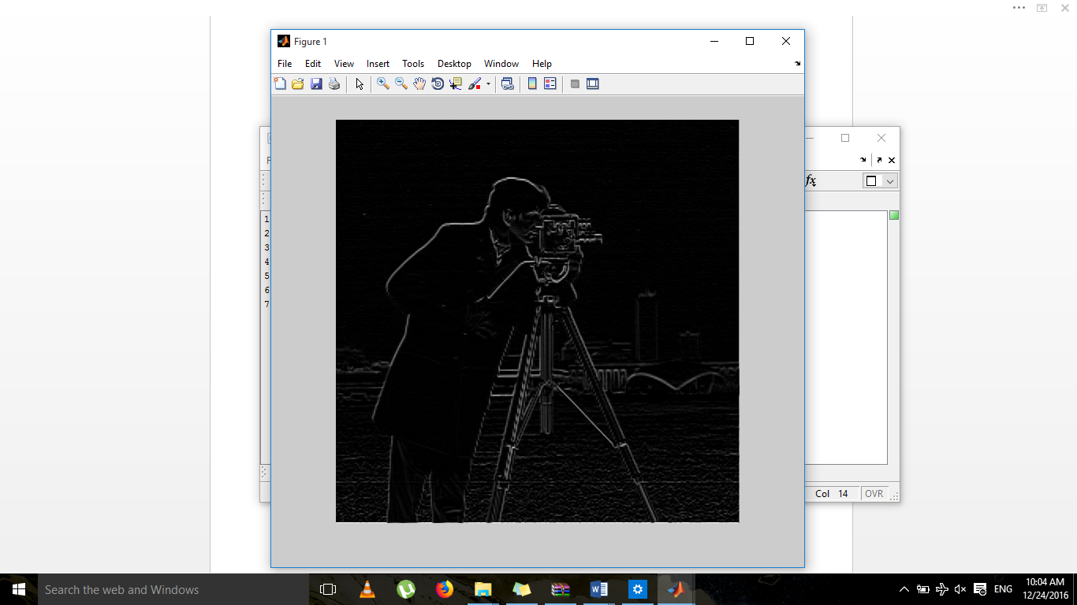
i=imread('cameraman.gif');
rb1=[0,0,0;0,1,0;0,0,1];
rb2=[0,0,0;0,0,1;0,-1,0];
rba1= imfilter(i,rb1);
rba2= imfilter(i,rb2);
rba3=(rba1)+(rba2);
imshow(rba3);

robert’s histogram:
rba3=im2double(rba);
hist(rba3)
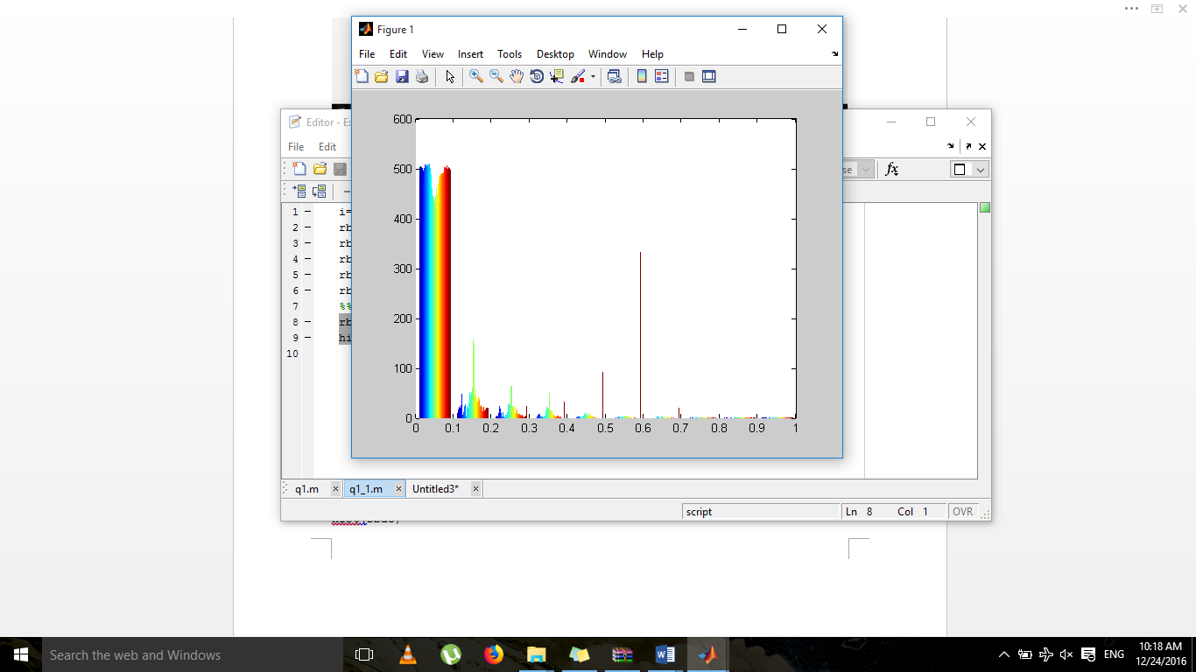

sobel’s histogram:

sba3=im2double(sba);
hist(sba3)
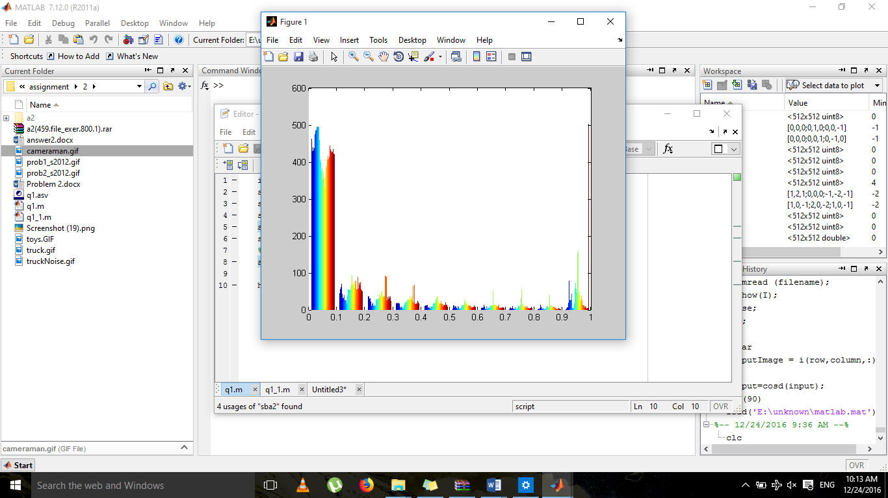
by comparing the two histograms it is obvious that these are not the same
diff=imabsdiff(sba,rba);
diff=im2double(diff);
hist(diff)
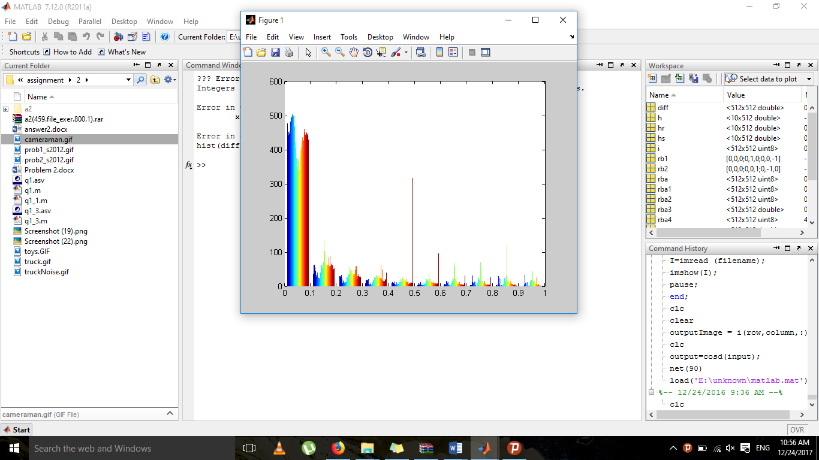

The function above performs pixel by pixel measurement. There are some differences between these two images. We can conclude that the results aren’t the same either.

2)
i=imread('toys.gif');
imshow(i);

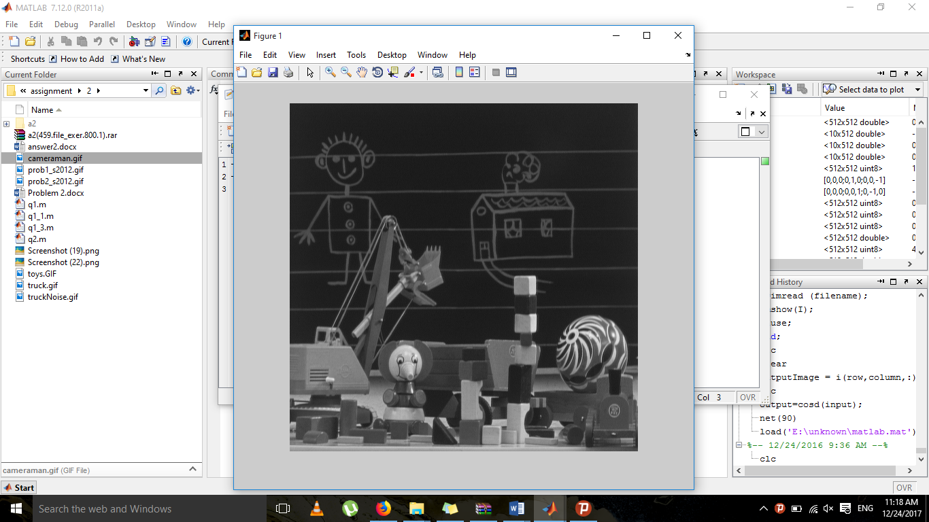
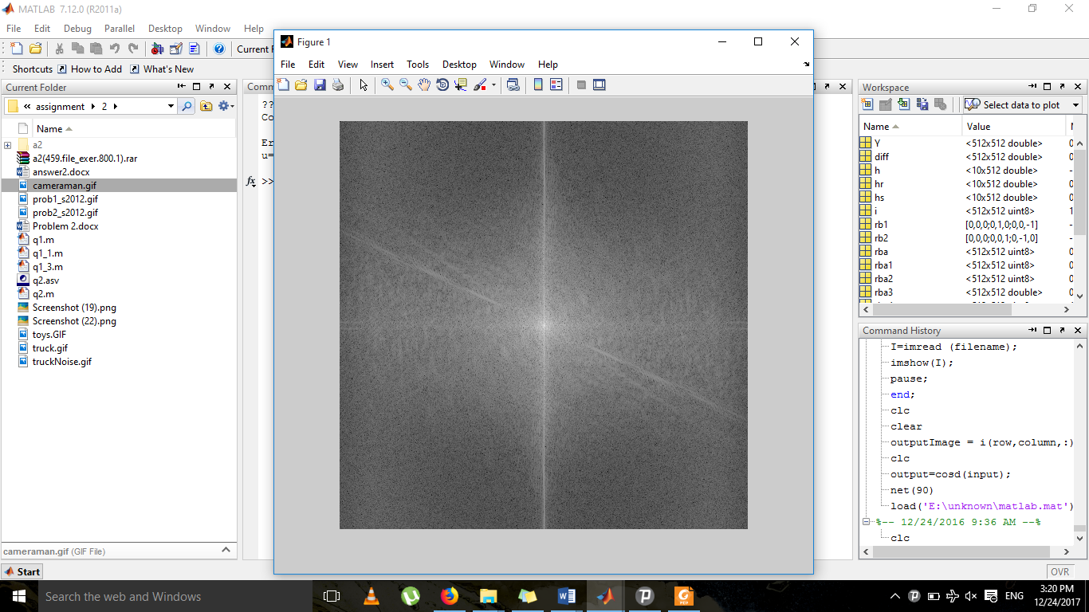
i=imread('toys.gif');
%imshow(i);
Y = fft2(i);
Y = fftshift(Y);
Y = abs(Y);
Y = log(Y+1); for brighten the image
Y = mat2gray(Y);
imshow(Y);
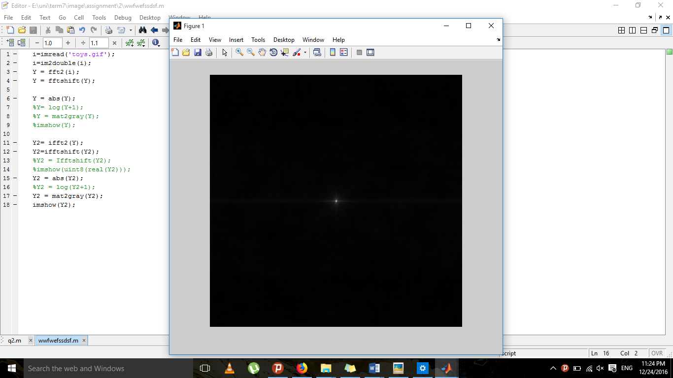

i=imread(‘toys.gif’);
i=im2double(i);
Y = fft2(i);
Y = fftshift(Y);

Y = abs(Y);
Y2= ifft2(Y);
Y2=ifftshift(Y2);
Y2 = abs(Y2);
Y2 = mat2gray(Y2);
imshow(Y2);

3)
function [out]=butterlp(image,a,b)
out=1-butterlp(image,a,b);
end

i=imread('prob1_s2012.gif');
[M N] = size(img);
filter=zeros(M,N);
img = uint8(img);
imshow(img);
fftI = fft2(img);
fftI = fftshift(fftI);
d0=50; %Cutoff Frequency
n=1; %Order of butterworth filter

for i=1:M
for j=1:N
dist=(i-M/2)^2 + (j-N/2)^2;
filter(i,j)= 1/(1 + (dist/d0)^(2*n));
%filter(i,j)=1.0 - filter(i,j);

end
end

figure;imshow(filter);
filtered_image =filter.*fftI;
figure;imshow(filtered_image,[]);
filtered_image = ifftshift(filtered_image);
filtered_image = ifft2(filtered_image,2*M-1,2*N-1);
filtered_image = real(filtered_image(1:M,1:N));
filtered_image = uint8(filtered_image);
filtered_image1 =img - filtered_image ;
figure;imshow(filtered_image,[]);
figure;imshow(filtered_image1,[]);

Order=1 & Cutoff Frequency=50 :

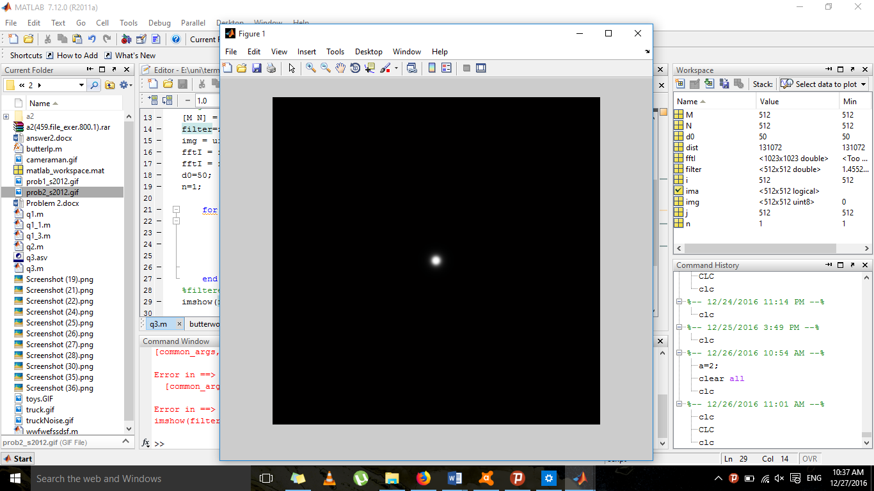

On the left side we have sum of signals and points that have been passed through the low-pass filter. On the right side we have the have the removal of the desired signals from the image.

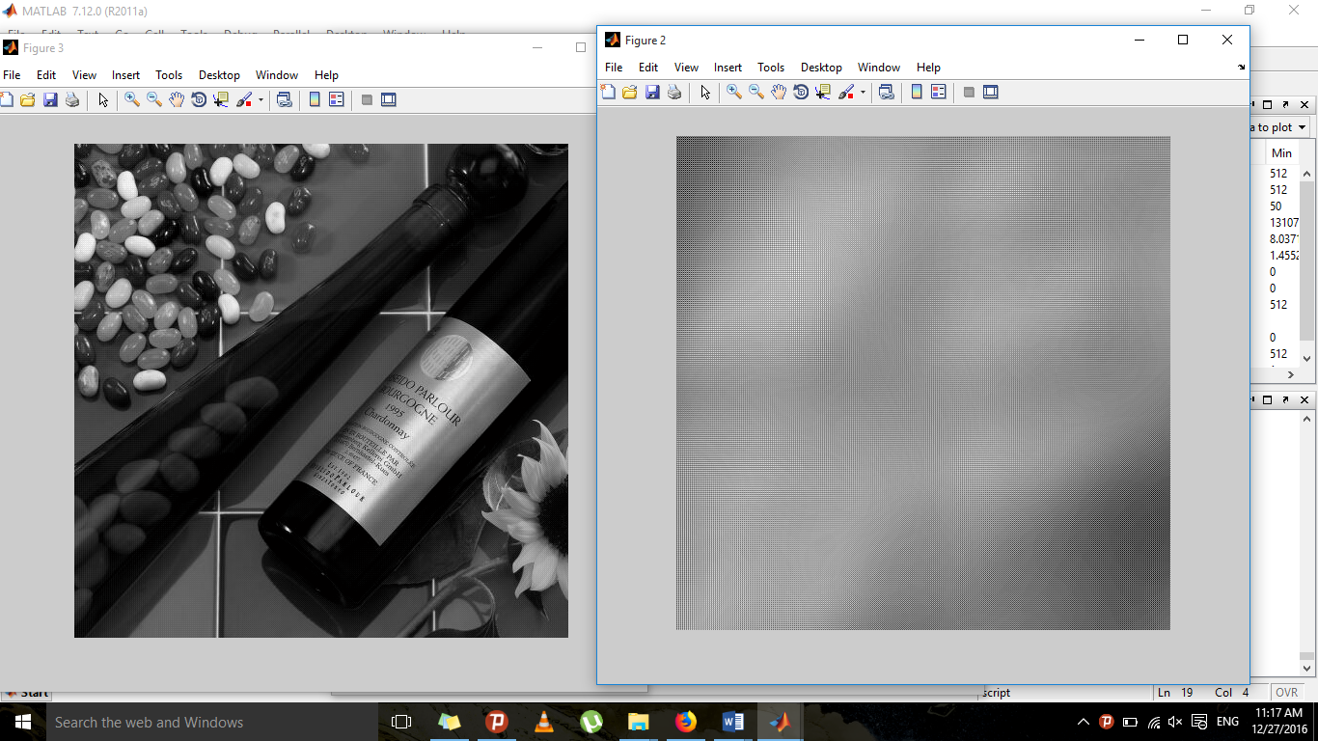

Order=1 & Cutoff Frequency=150 :
more signals have been passed compared to the previous state
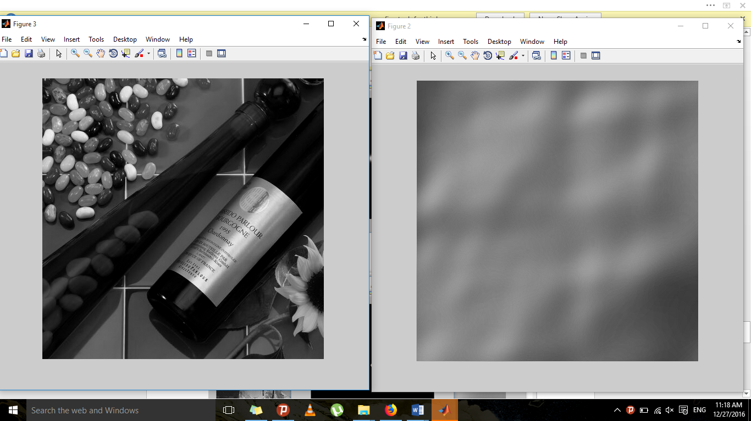
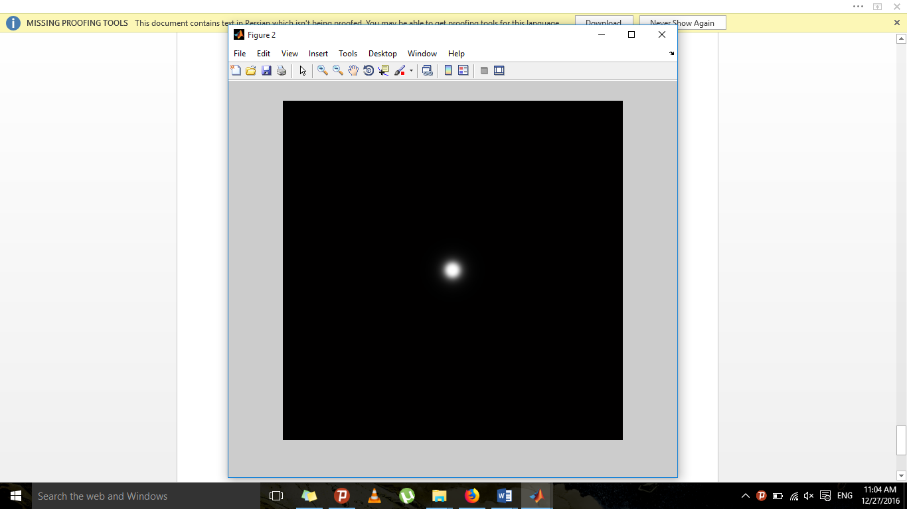

Order=5 & Cutoff Frequency=50 :

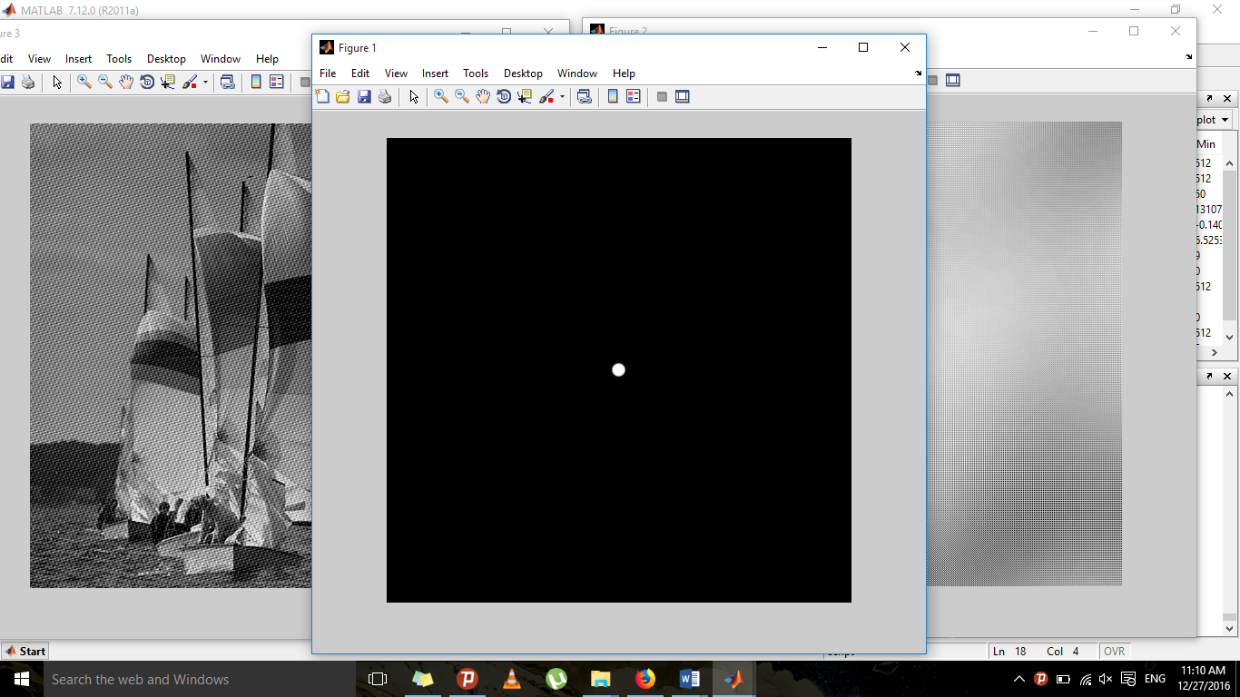

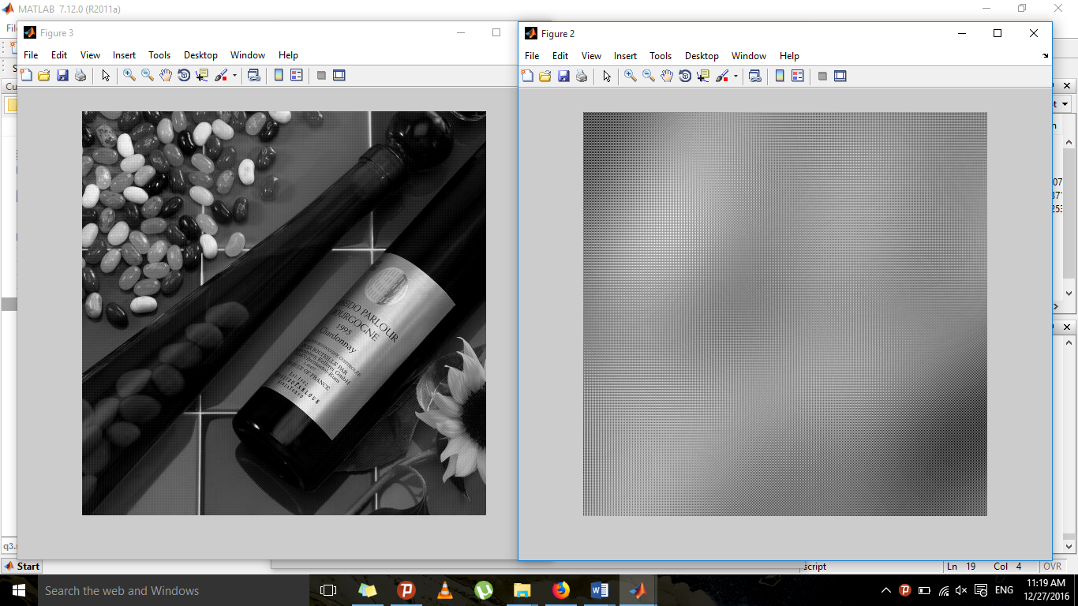
Order=5 & Cutoff Frequency=150 : 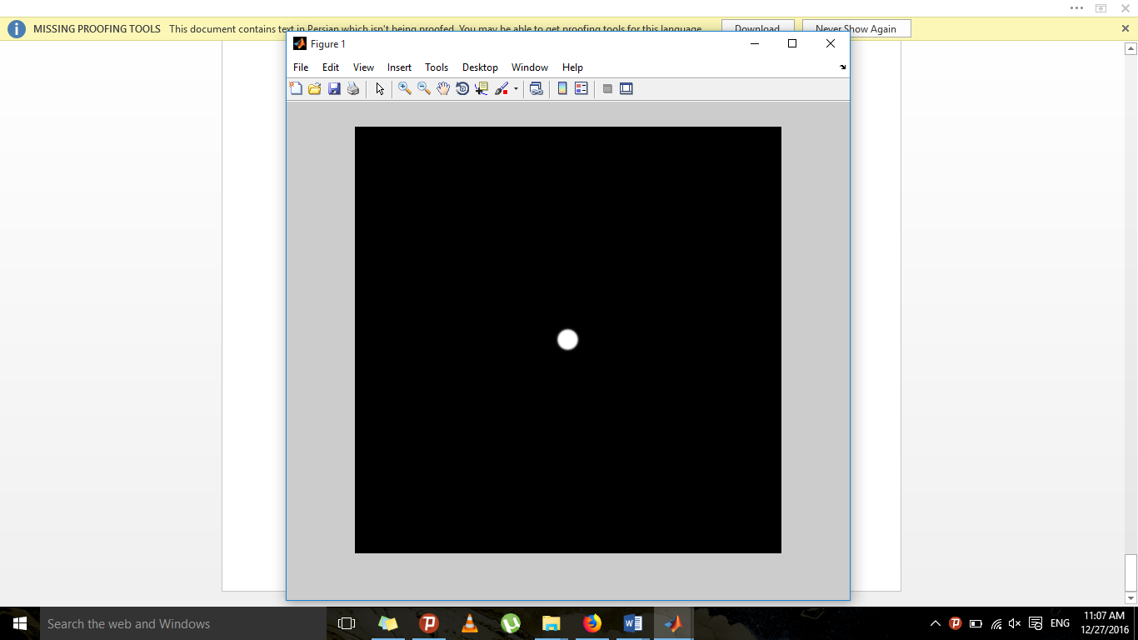

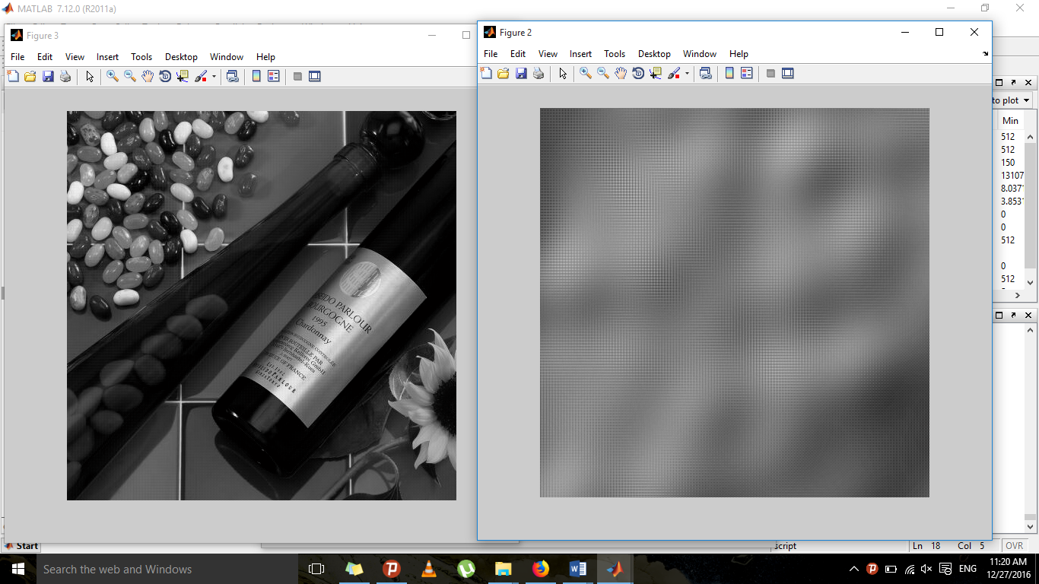

4)
The original image:
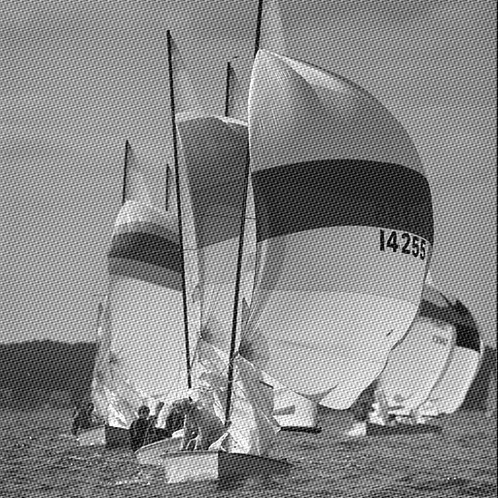
i=imread('prob2_s2012.gif ');
fftA = fft2(double(i));
figure, imshow(abs(fftshift(fftA)),[1 100000]);

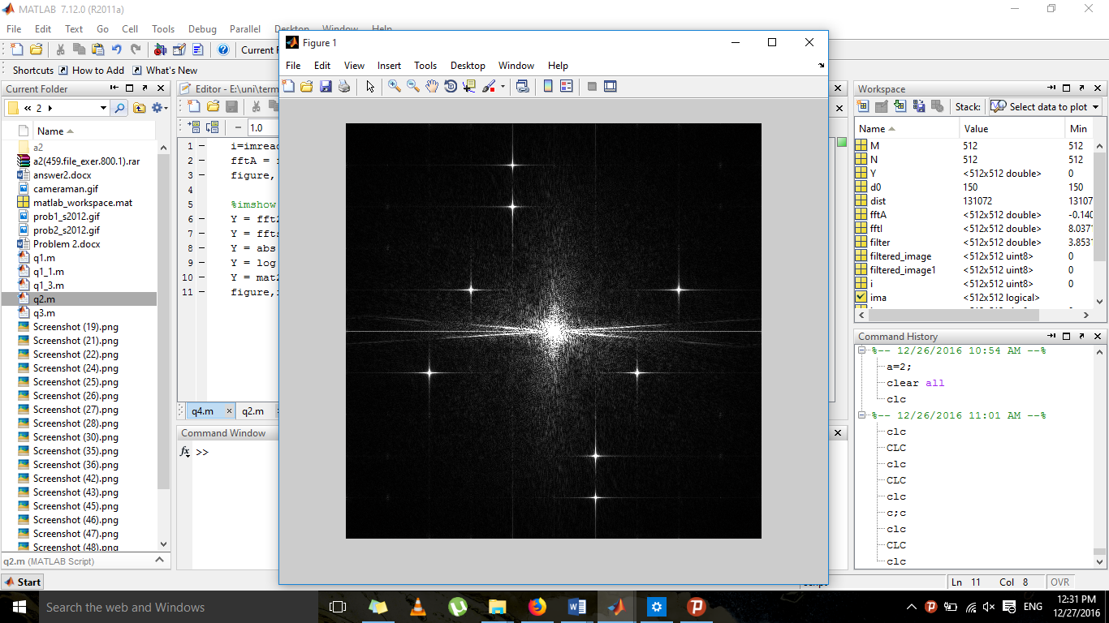
Spatial domain:
1) Smoothing filter_ averaging masks:
h = ones(3,3) / 9;
i2 = imfilter(i,h);
imshow(i2);

As observed, this filter has improved the image. It reduces pixel differences and diminishes edges. Therefore, it can be concluded that the image contains noise, specifically Gaussian noise. Low-pass filters enhance salt and pepper noise.
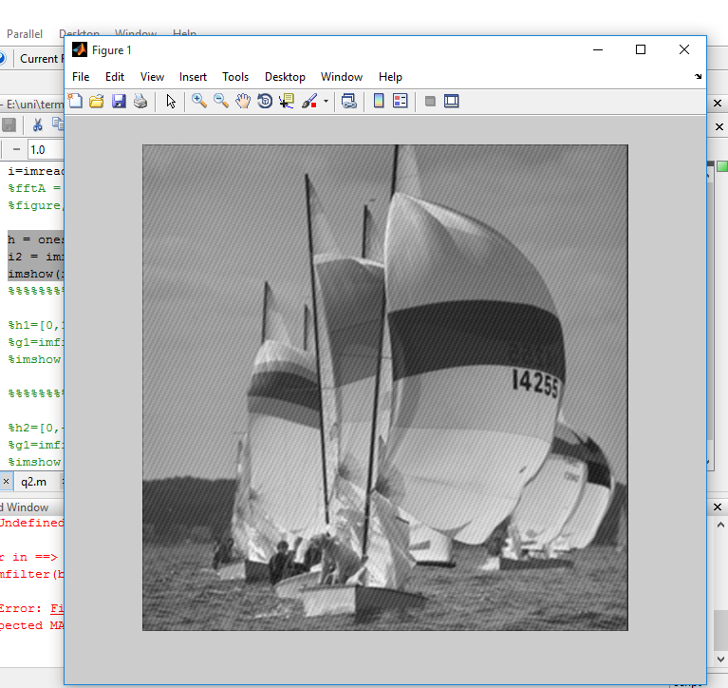
2)median filter
The median filter is suitable for salt and pepper noise.

i2 = medfilt2(i);
imshow(i2);

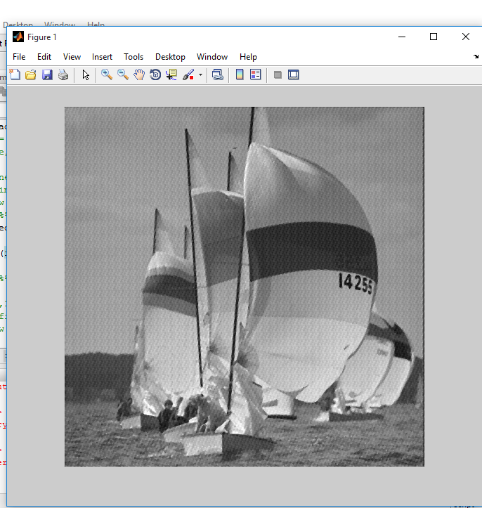

We have an improvement compared to the original image, but the previous filter yielded better results.

3) Sharpening filter:
High-pass filter: Derivative.

Laplace :
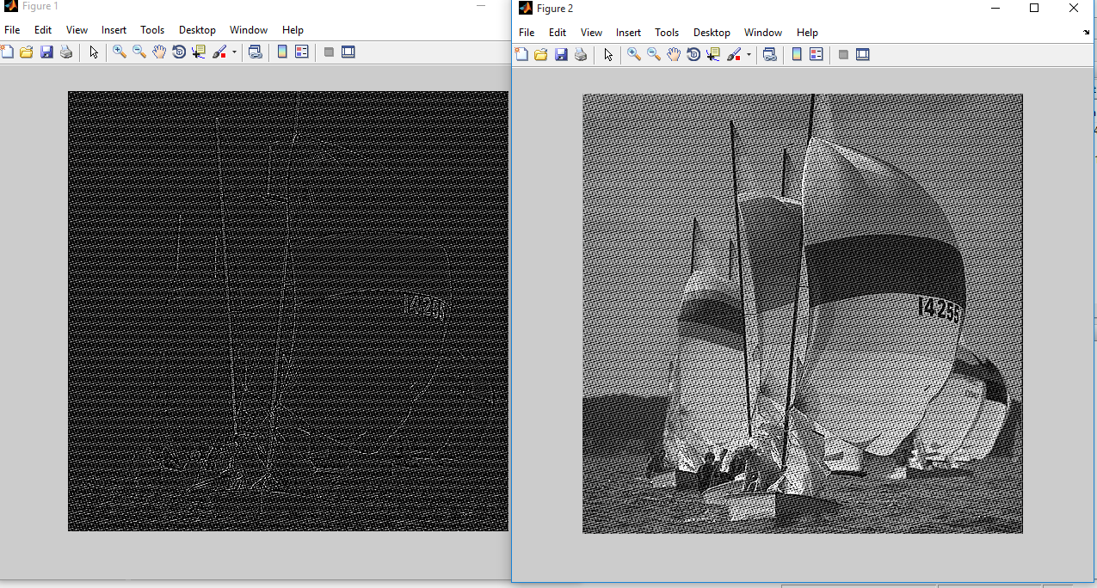
h1=[0,1,0;1,-4,1;0,1,0];
g1=imfilter(i,h1);
imshow(g1);
figure,imshow(i-g1);
sobel:
sb1=[1,2,1;0,0,0;-1,-2,-1];
sb2=[1,0,-1;2,0,-2;1,0,-1];
sba1= imfilter(i,sb1);
sba2= imfilter(i,sb2);
sba=abs(sba1)+abs(sba2);
imshow(sba);
figure,imshow(i-sba);

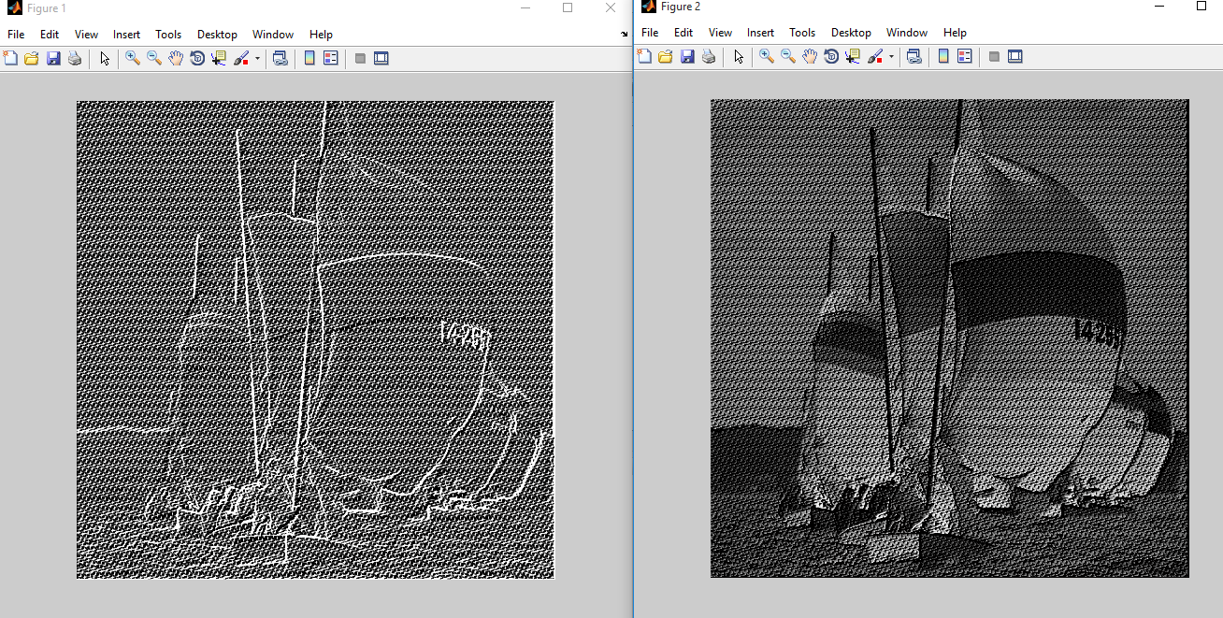
As seen, sharpening filters are not suitable here.

frequency domain:
Ideal:
The images result of low pass Ideal :
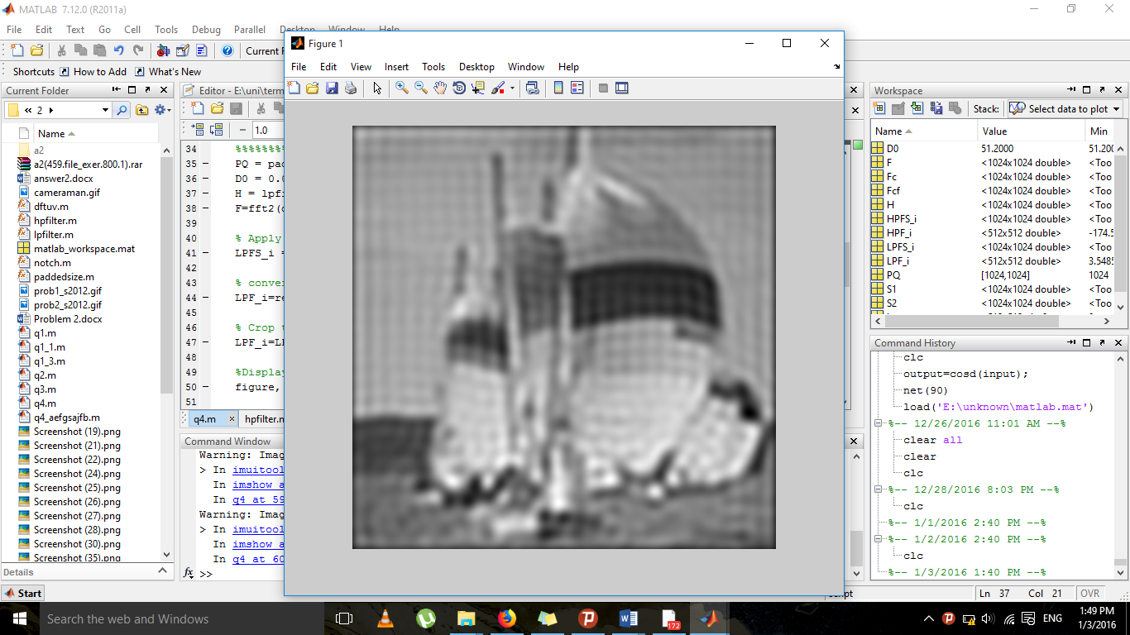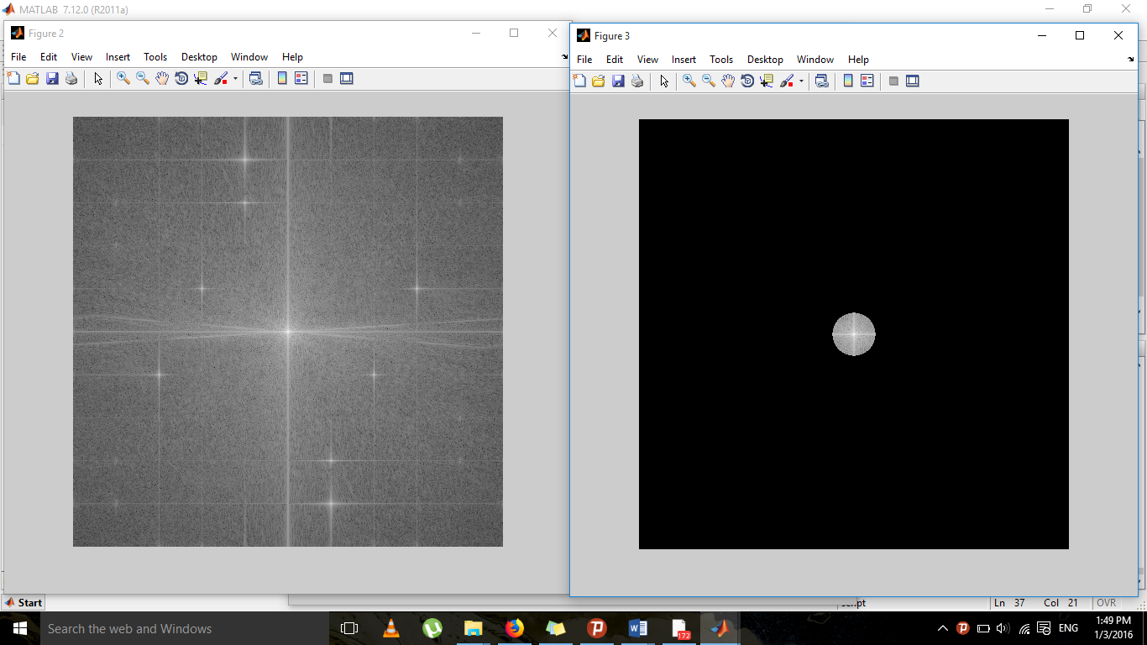

The images result of high pass Ideal:
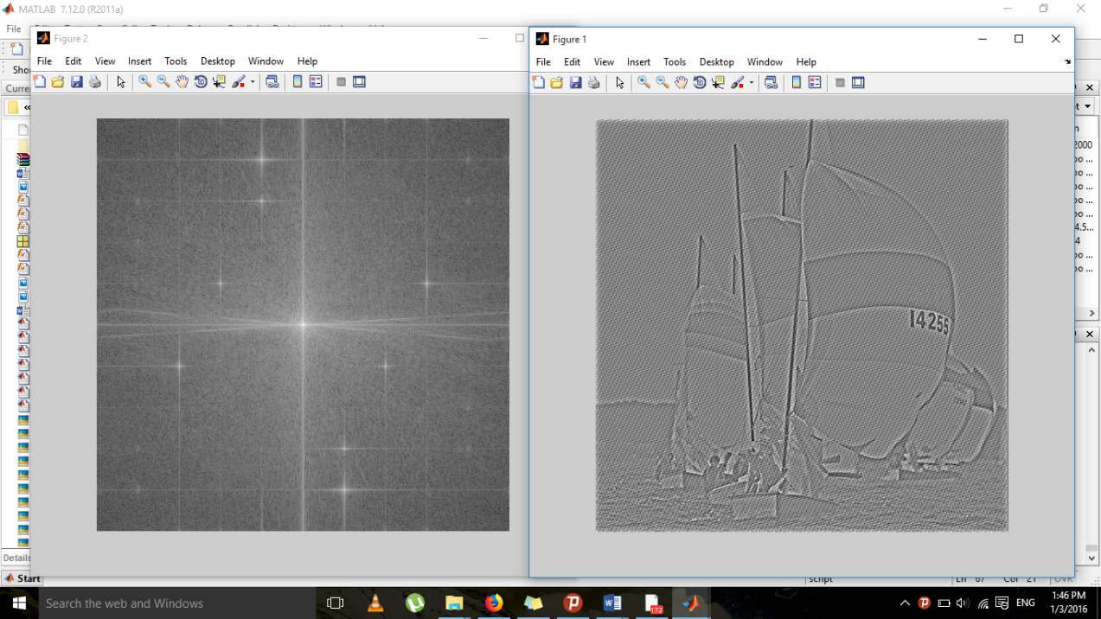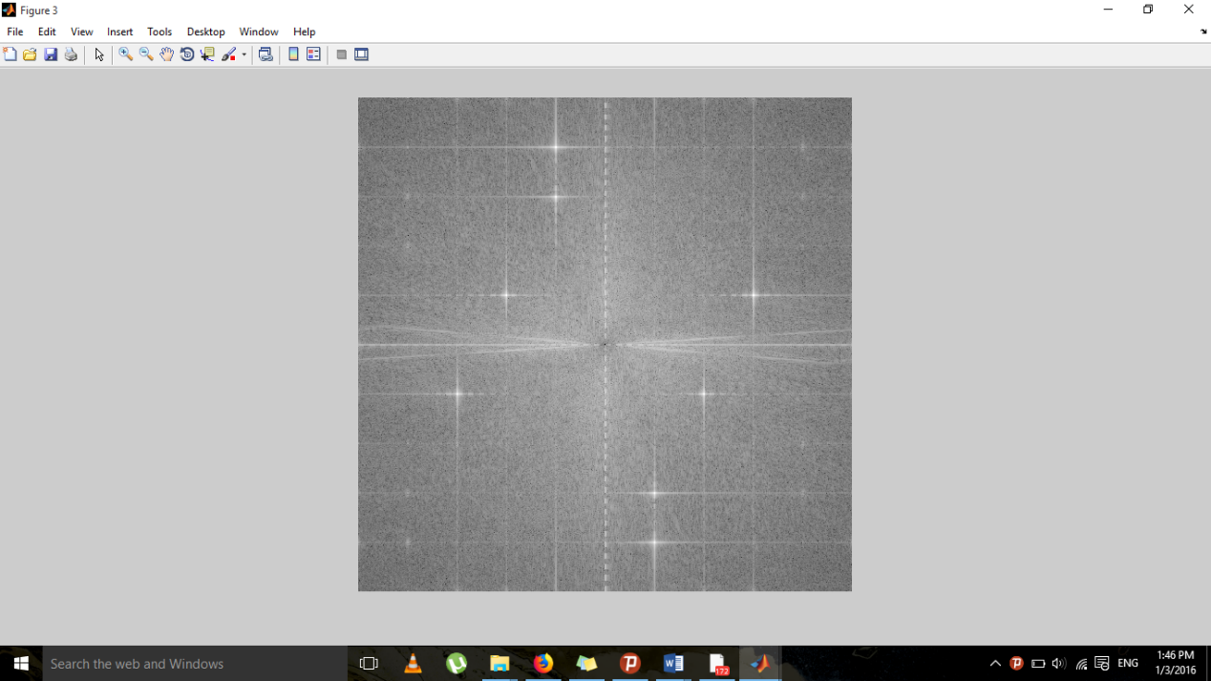

Butterworth:

The images result of low pass Butterworth: 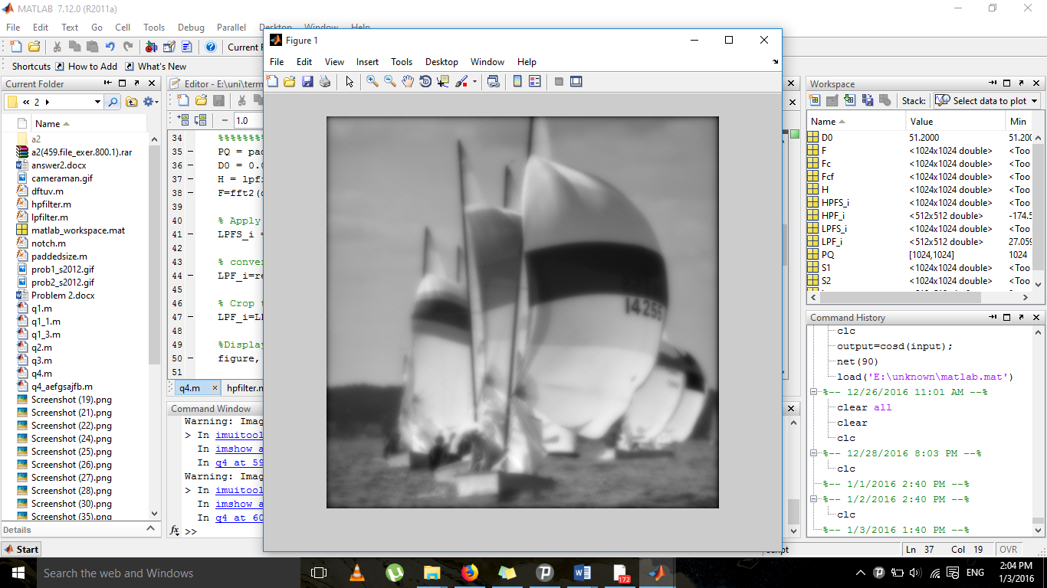 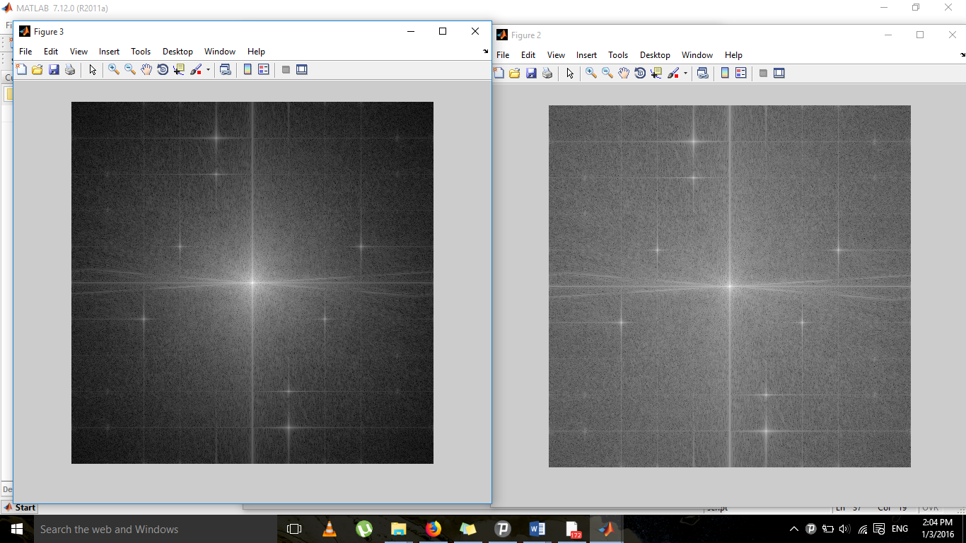
The images result of high pass Butterworth: 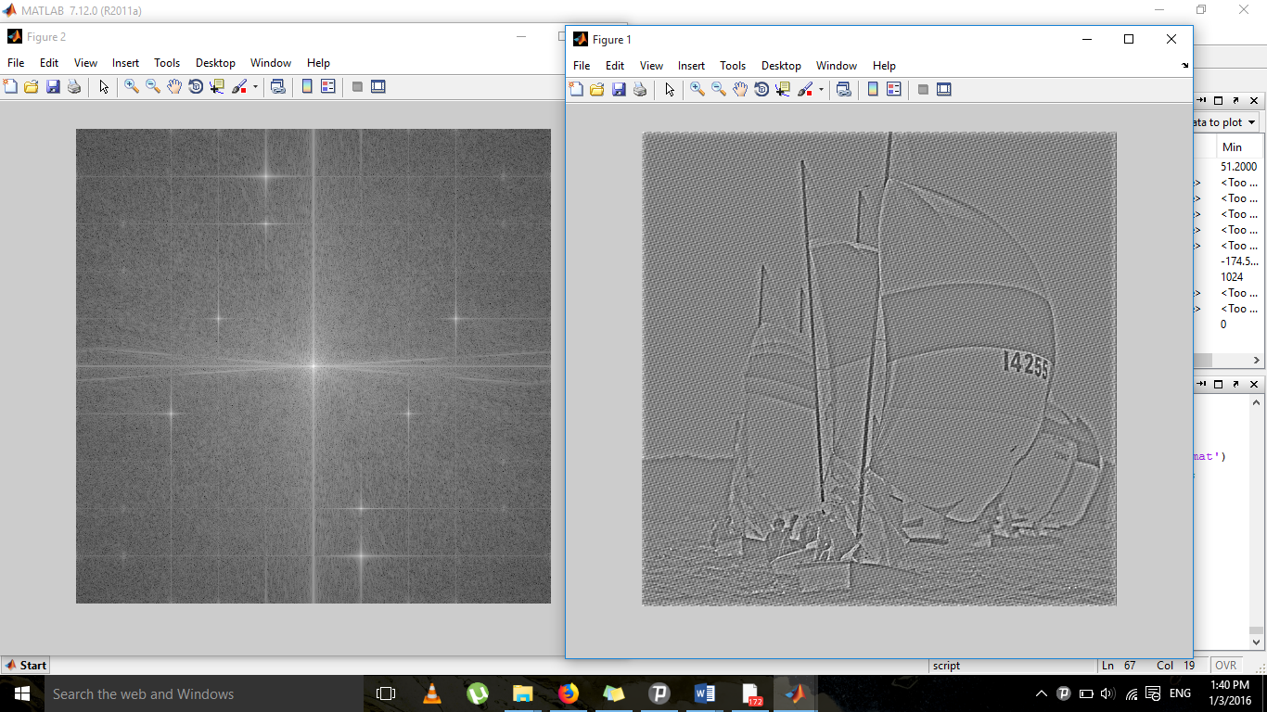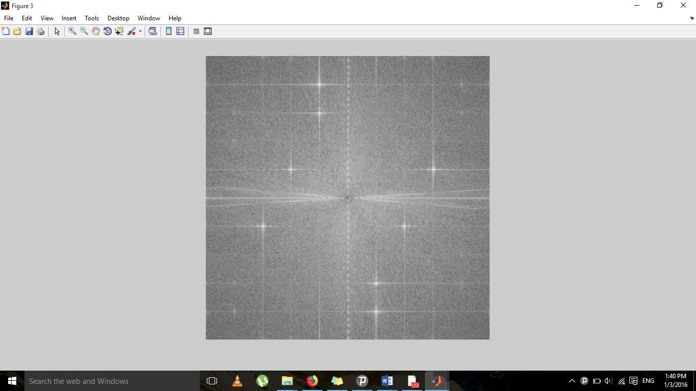

Gaussian:
Note: In the section where the filter type is expressed in purple, three types can be used: 'gaussian,' 'btw,' and 'ideal.'

.
Lowpass:
PQ = paddedsize(size(i));
D0 = 0.05*PQ(1);
H = lpfilter('gaussian', PQ(1), PQ(2), D0);
F=fft2(double(i),size(H,1),size(H,2));
LPFS_i = H.*F;
LPF_i=real(ifft2(LPFS_i));
LPF_i=LPF_i(1:size(i,1), 1:size(i,2));
figure, imshow(LPF_i, [])
Fc=fftshift(F);
Fcf=fftshift(LPFS_i);
S1=log(1+abs(Fc));
S2=log(1+abs(Fcf));
figure, imshow(S1,[])
figure, imshow(S2,[])

highpass:
footBall=rgb2gray(footBall);
imshow(footBall)
PQ = paddedsize(size(footBall));
D0 = 0.05*PQ(1);
H = hpfilter('gaussian', PQ(1), PQ(2), D0);
F=fft2(double(footBall),size(H,1),size(H,2));
HPFS_football = H.*F;
HPF_football=real(ifft2(HPFS_football));
HPF_football=HPF_football(1:size(footBall,1), 1:size(footBall,2));
figure, imshow(HPF_football, [])
Fc=fftshift(F);
Fcf=fftshift(HPFS_football);
S1=log(1+abs(Fc));
S2=log(1+abs(Fcf));
figure, imshow(S1,[])
figure, imshow(S2,[])

The images result of low pass guassian:

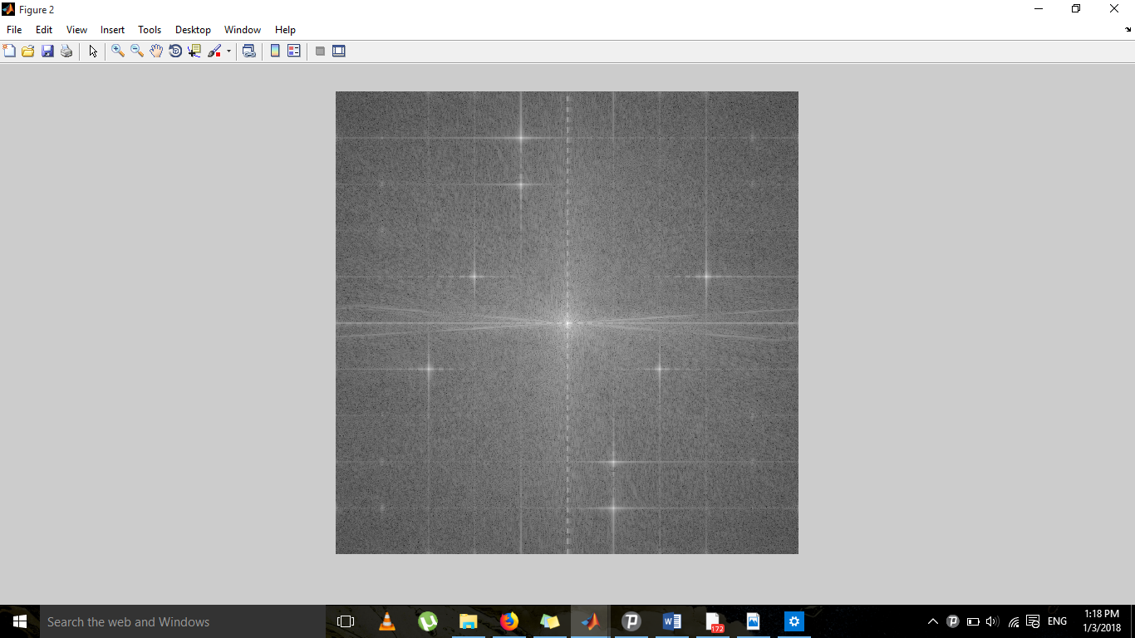این تصویر حاصل تبدیل فوریه میباشد
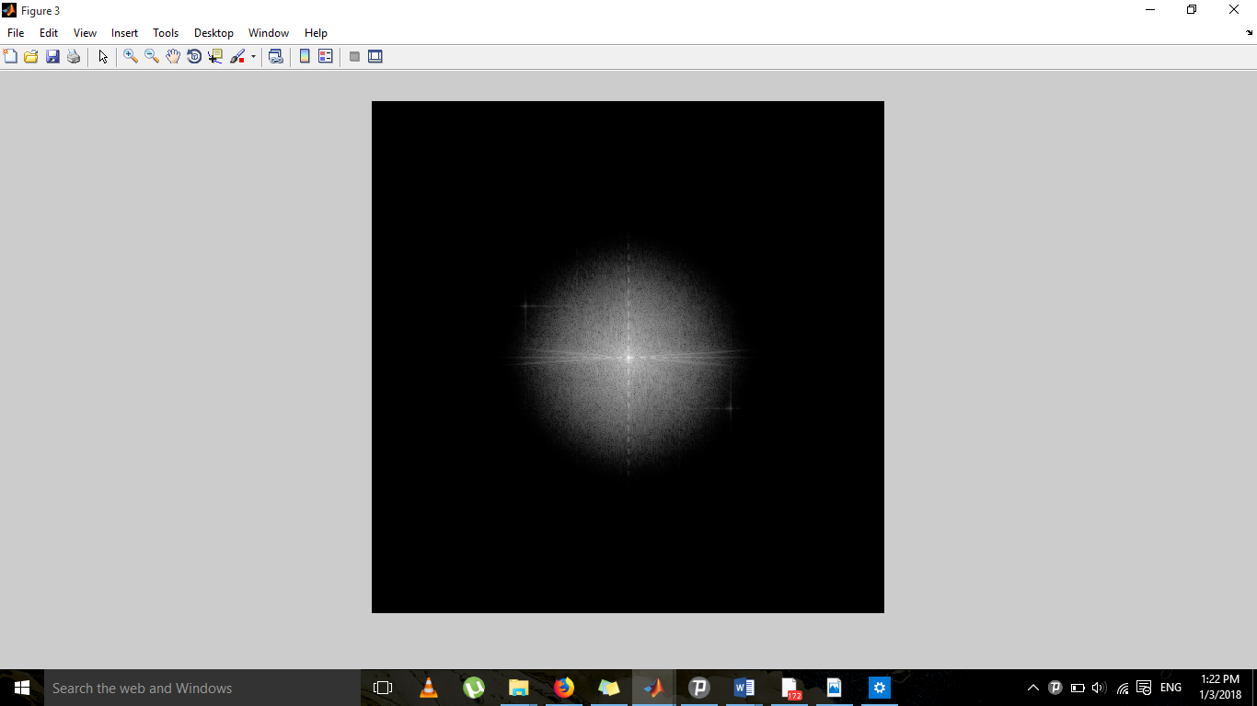

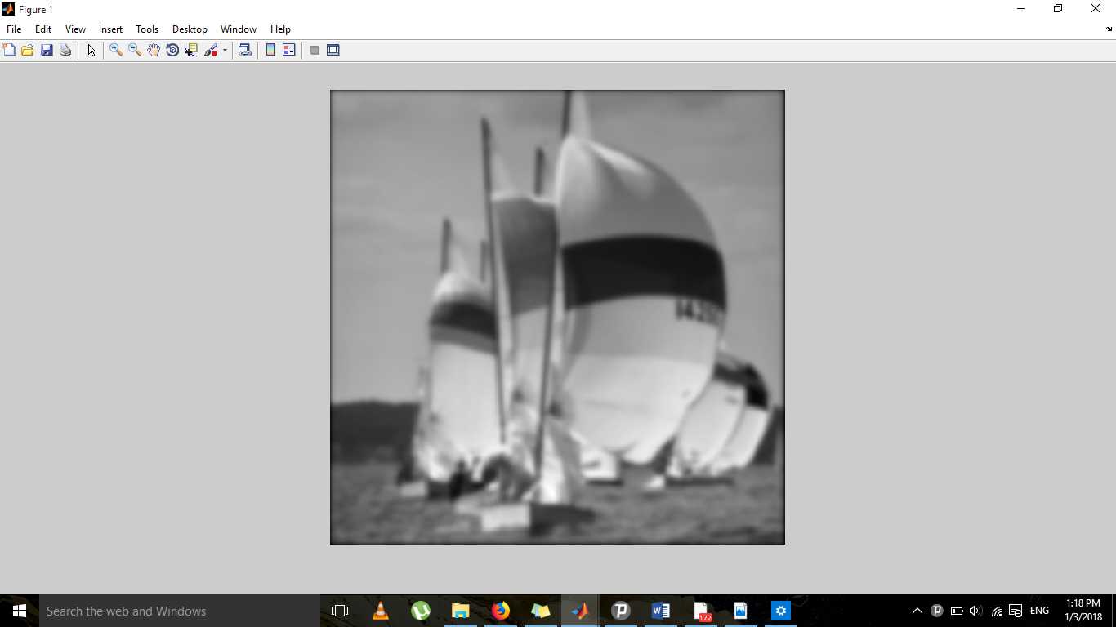
The images result of high pass guassian: 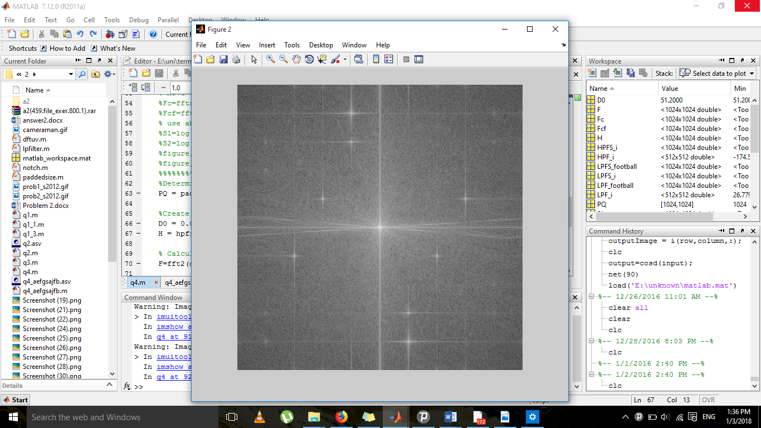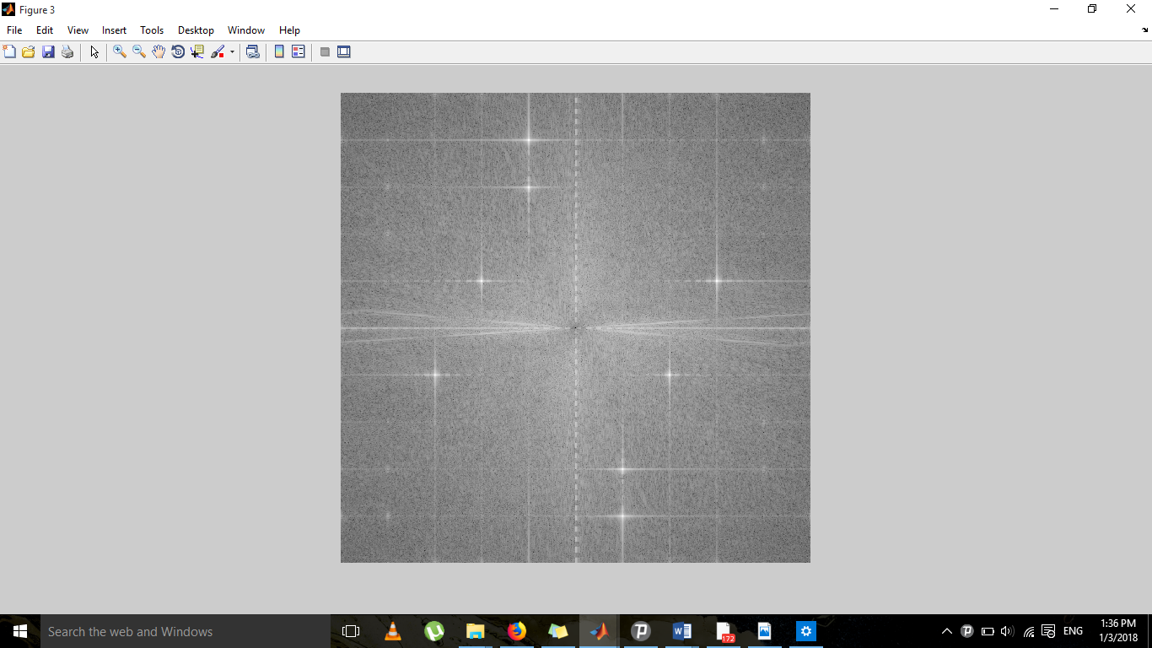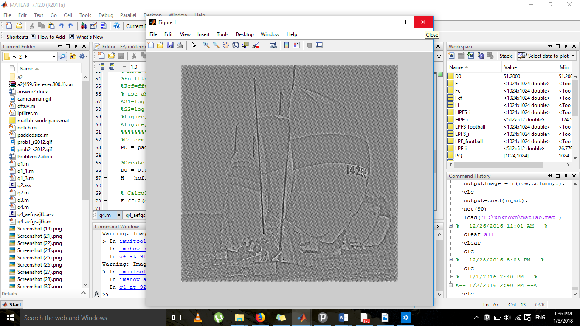

Conclusion: Low-pass filters are more suitable.

Functions:

function H = hpfilter(type, M, N, D0, n)
if nargin == 4
n = 1; % Default value of n.
end

% Generate highpass filter.
Hlp = lpfilter(type, M, N, D0, n);
H = 1 - Hlp;

function [U, V] = dftuv(M, N)
u = 0:(M-1);
v = 0:(N-1);
idx = find(u > M/2);
u(idx) = u(idx) - M;
idy = find(v > N/2);
v(idy) = v(idy) - N;
[V, U] = meshgrid(v, u);

function H = lpfilter(type, M, N, D0, n)
[U, V] = dftuv(M, N);
D = sqrt(U.^2 + V.^2);
switch type
case 'ideal'
H = double(D <=D0);
case 'btw'
if nargin == 4
n = 1;
end
H = 1./(1 + (D./D0).^(2*n));
case 'gaussian'
H = exp(-(D.^2)./(2*(D0^2)));
otherwise
error('Unknown filter type.')
end

function H = notch(type, M, N, D0, x, y, n)
if nargin == 6
n = 1
end
Hlp = lpfilter(type, M, N, D0, n);
H = 1 - Hlp;
H = circshift(H, [y-1 x-1]);

function PQ = paddedsize(AB, CD, PARAM)
if nargin == 1
PQ = 2*AB;
elseif nargin == 2 & ~ischar(CD)
PQ = AB + CD - 1;
PQ = 2 * ceil(PQ / 2);
elseif nargin == 2
m = max(AB);
P = 2^nextpow2(2*m);
PQ = [P, P];
elseif nargin == 3
m = max([AB CD]);
P = 2^nextpow2(2*m);
PQ = [P, P];
else
error('Wrong number of inputs.')
end

5)
magnitude spectrum :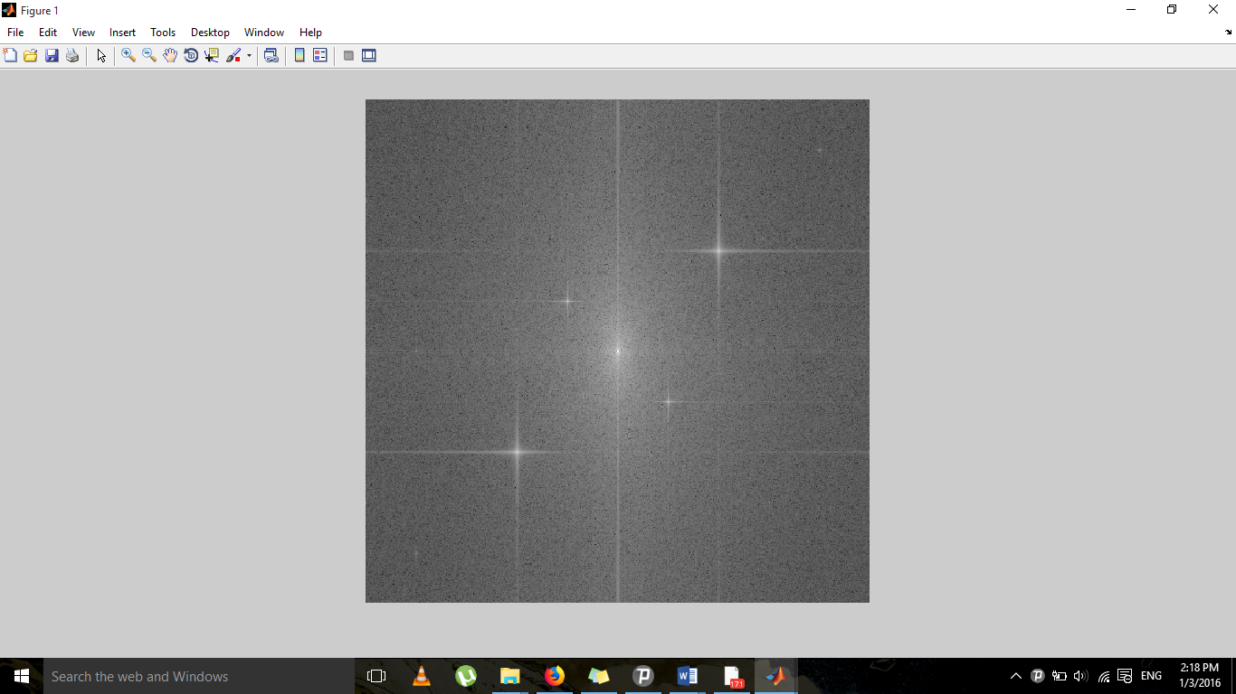

low pass Butterworth: 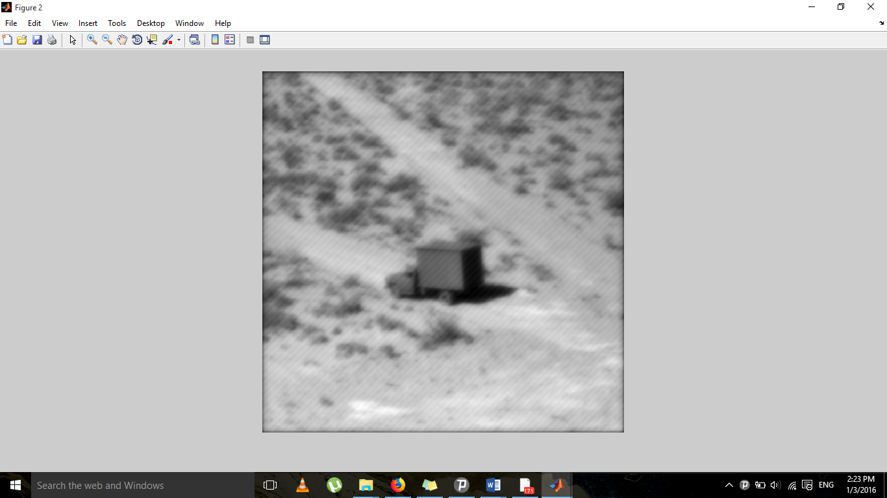
high pass Butterworth: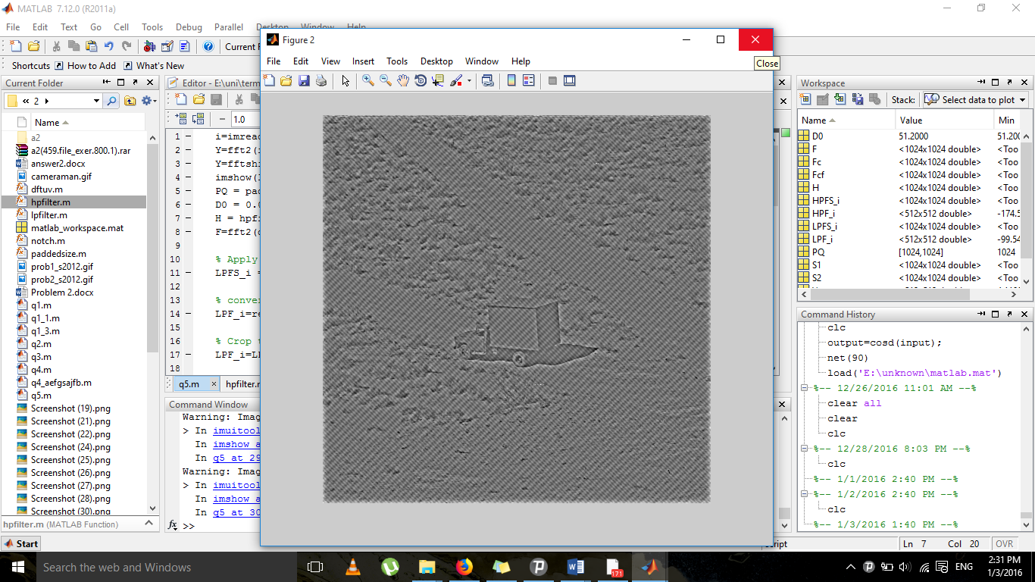
low pass guassian: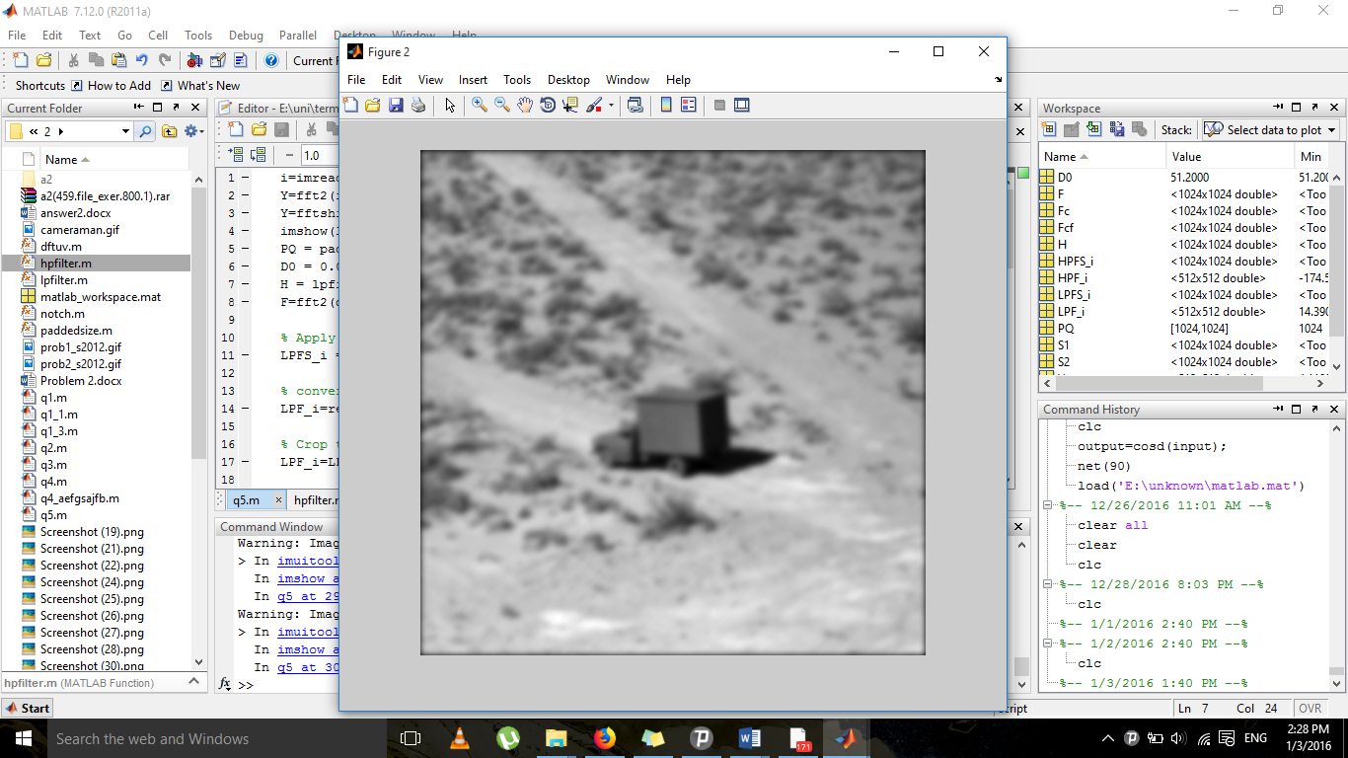
Of all, the Gaussian filter is the most appropriate.

high pass guassian: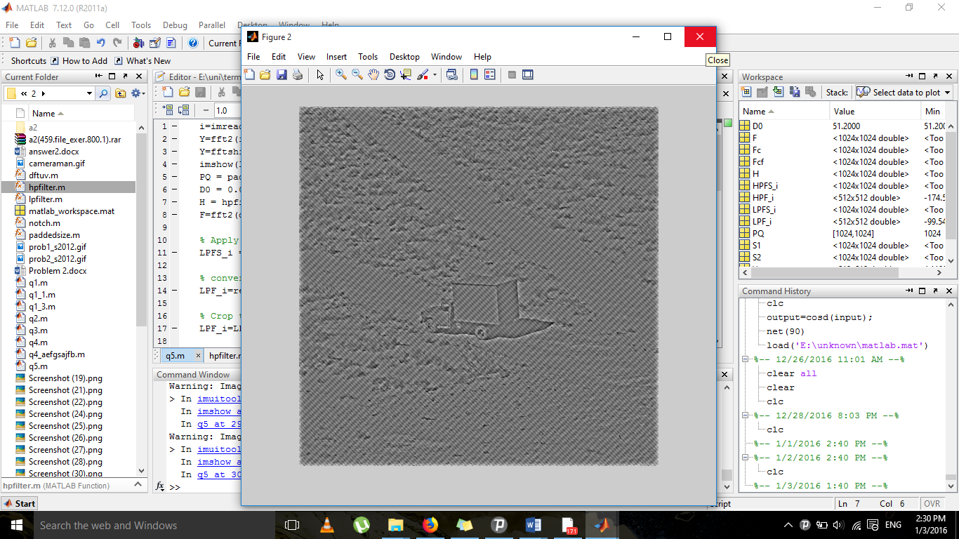

low pass Ideal: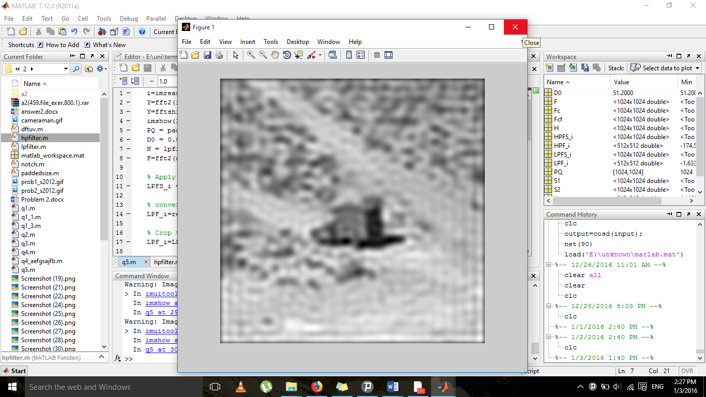
this isn’t ideal at all
high pass Ideal: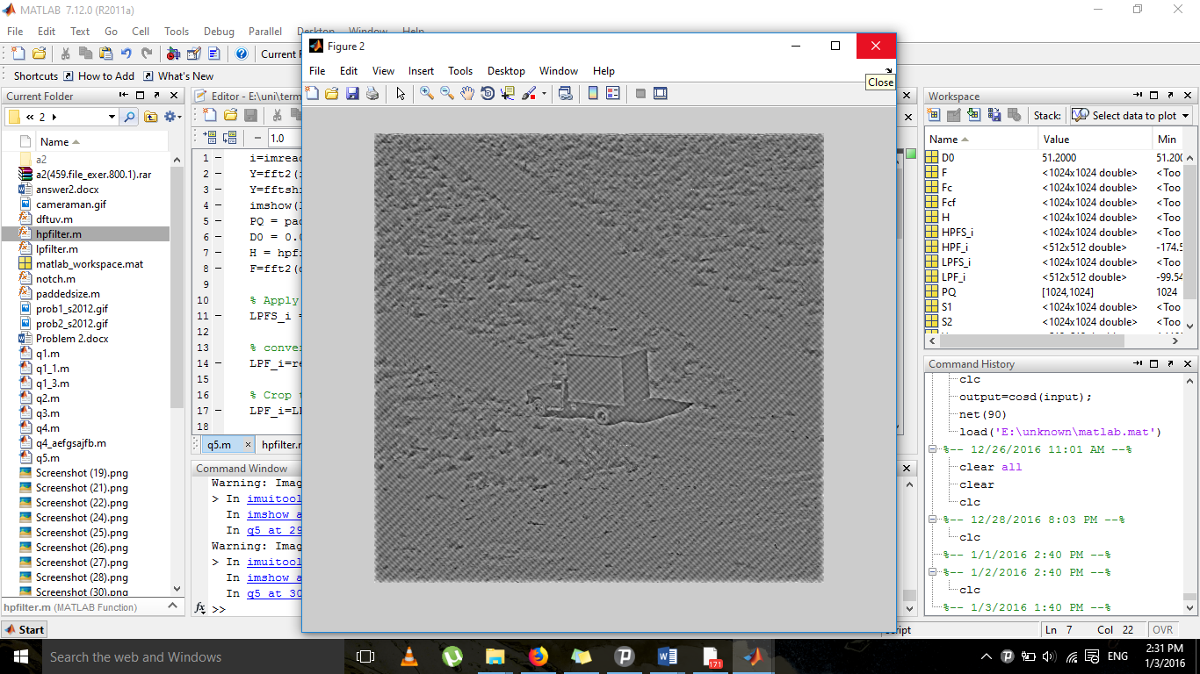

n=size(i);
M=n(1);
N=n(2);
MSE = sum(sum((i-i2).^2))/(M*N);
PSNR = 10*log10(256*256/MSE);
fprintf('\nPSNR: %9.7f dB', PSNR);
MSE: 64.93
PSNR: 30.0400388

