CO2 Indoor Air Quality Prediction
Multi-Horizon LSTM Neural Network — Technical Report
PyTorch · 200,000 Training Samples
1. Project Overview
This project develops a multi-horizon Long Short-Term Memory (LSTM) neural network to predict indoor CO₂ concentration levels at three future time horizons: 15, 45, and 60 minutes ahead. Proactive CO₂ forecasting enables HVAC systems to pre-emptively adjust ventilation before air quality degrades, shifting building management from reactive threshold alerts to intelligent anticipatory control.

Primary Objectives: Achieve prediction accuracy above 90% at all horizons; design a single multi-output architecture that predicts all three horizons simultaneously; enable CO₂ spike detection for early HVAC triggering.
2. Dataset & Preprocessing
Source File: co2_dataset_200k.csv — 200,000 timestamped sensor readings from a single indoor room.

2.1 Raw Features
- CO₂ concentration (ppm), Temperature (°C), Humidity (%), Occupancy , Timestamp
- 3 engineered time features extracted from timestamp: hour, day_of_week, minute
- Total input dimensionality: 7 features per timestep

2.2 Sequence Construction & Normalization
- Lookback window: 30 timesteps (~2.5 hours at 5-min intervals) → predicts 3 future horizons
- Train / Test split: 80 / 20 sequential (159,928 train / 39,982 test)
- Normalization: MinMaxScaler [0, 1]. Separate scalers for input features and output targets prevent data leakage. MinMaxScaler preferred over StandardScaler because CO₂ and occupancy have bounded, non-Gaussian distributions.
3. Model Architecture
The model is implemented as CO2LSTMModel in PyTorch, using a unidirectional (causal) LSTM stack — a deliberate design choice ensuring the model processes only past information and is therefore compatible with real-time deployment.

- Input shape: [Batch × 30 timesteps × 7 features]
- LSTM: 3 stacked layers, 256 hidden units per layer, dropout = 0.2 applied between layers
- Fully-connected head: Linear(256 to 32, ReLU activation) to Linear(32 to 3, no activation)
- Output: 3 values simultaneously, one per prediction horizon (15, 45, 60 min)
- Total parameters: 1,332,355 (~5.2 MB on disk)

Why LSTM over standard RNN: Standard RNNs suffer from the vanishing gradient problem ,gradients shrink exponentially during backpropagation through time (BPTT), preventing the model from learning long range dependencies. LSTM solves this with three learnable gates: the forget gate (decides what to discard from cell state), the input gate (controls new information flow), and the output gate (filters what cell state to expose as hidden state). This gating mechanism allows the model to retain CO₂ trends spanning tens of minutes, capture occupancy-driven step-changes, and learn daily and weekly periodicity.
Why multi-output (single model): A shared LSTM encoder for all three horizons is more computationally efficient than 3 separate models, reduces total parameters, and forces the hidden representation to capture features useful across all prediction windows — acting as implicit cross-horizon regularization.
4. Training Configuration & Results
Parameter | Value | Parameter | Value
Hardware | RTX 4050 (CUDA) | Batch Size | 64
Max Epochs | 200 (stopped: 103) | Early Stop Patience | 20 epochs
Loss Function | MSE | Optimizer | Adam (lr=0.001)
Weight Decay | 1e-4 (L2 reg.) | LR Scheduler | ReduceLROnPlateau
Gradient Clipping | max_norm = 1.0 | Best Test Loss | 0.015190 (MSE)

Regularization strategy: Dropout (0.2) randomly zeroes LSTM outputs during training, preventing co-adaptation of neurons. Weight decay (L2 = 1e-4) penalizes large weights, encouraging distributed representations. Gradient clipping (max_norm = 1.0) prevents exploding gradients during BPTT across 30 timesteps × 3 LSTM layers. Together these three mechanisms explain the absence of overfitting divergence despite 200-epoch training.
Learning rate scheduling: ReduceLROnPlateau halves the learning rate after 5 consecutive epochs with no test loss improvement. This adaptive scheduling accounts for loss plateau regions common in deep RNN training, allowing the optimizer to take finer steps near convergence.

Figure 1 below shows the training and test loss curves over 103 epochs:
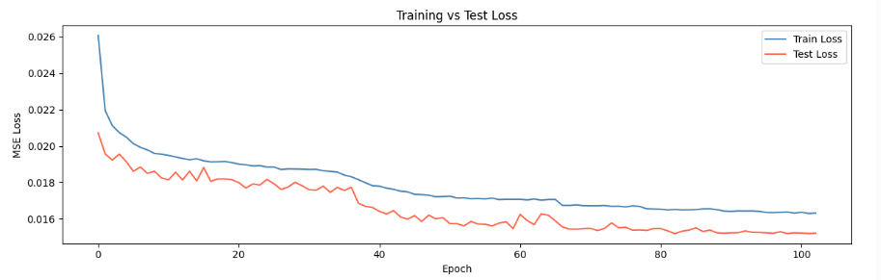

5. Performance Results
The model was evaluated on the held-out test set (39,982 samples) using three metrics: Mean Absolute Error (MAE) in raw ppm, Root Mean Squared Error (RMSE), and Accuracy defined as the percentage of predictions within ±10% of the true CO₂ value.

Horizon | MAE (ppm) | RMSE (ppm) | Accuracy (±10%)
15 min | 65.65 | 103.80 | 92.6%
45 min | 84.47 | 130.01 | 90.2%
60 min | 84.37 | 128.67 | 90.1%

Interpretation: The 15-min horizon achieves the highest accuracy (92.6%) because near-future CO₂ is most predictable from recent sensor history. The 45-min and 60-min horizons converge closely (90.2% vs. 90.1%), indicating that predictability beyond ~30 minutes is governed primarily by structural occupancy and ventilation cycle patterns rather than moment-to-moment dynamics. The absolute error range of 65–85 ppm represents approximately 4–5% of the operational CO₂ range (400–2000 ppm) — operationally acceptable for HVAC pre-triggering.
Spike Detection: A binary alert is generated when any predicted horizon exceeds a configurable threshold (1000–1200 ppm). This enables pre-emptive HVAC activation, facility alerts, and occupancy analytics logging.

Figure 2 shows actual vs. predicted CO₂ for each horizon over 200 test samples:

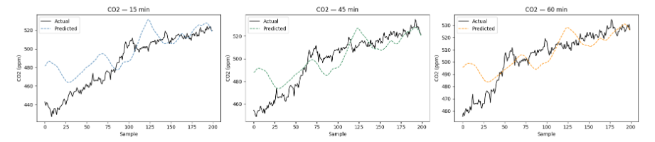

6. Key Design Decisions
- Sequence length = 30 steps: Sequence length = 30 steps:
Captures 2.5 hours of sensor history at 5 minute intervals. This window is long enough to cover occupancy transitions, HVAC response lags, and sub daily CO₂ trends, yet short enough to avoid injecting noise from distant irrelevant past states. Shorter windows miss multi-hour trends; longer windows increase model complexity without proportional accuracy gain.

- Unidirectional LSTM (causal):
Processes time in past to present direction only. Bidirectional LSTMs use future context to improve accuracy but are incompatible with real-time inference where future sensor readings are unavailable.

- MinMaxScaler [0, 1]:
CO₂, occupancy, and humidity are bounded variables with non-Gaussian distributions, making MinMaxScaler more appropriate than StandardScaler. The [0, 1] output range aligns naturally with LSTM gate activation ranges (sigmoid). Separate scalers for features and targets prevent cross-contamination.
7. Deployment & Inference Pipeline
Saved Artifacts: co2_lstm_130k.pth (model weights), model_config_130k.json (architecture config), feature_scaler_130k.pkl, target_scaler_130k.pkl.

Seven-step inference pipeline:
- Load model_config_200k.json and reconstruct CO2LSTMModel with identical architecture
- Load weights: model.load_state_dict(torch.load('co2_lstm_200k.pth')) then model.eval()
- Load feature and target scalers from .pkl files using pickle.load()
- Collect the 30 most recent sensor readings: CO₂, Temperature, Humidity, Occupancy + 3 time features
- Apply feature_scaler.transform() to the [30 × 7] input matrix
- Run forward pass through model (no_grad context) , outputs 3 normalized predictions
- Apply target_scaler.inverse_transform() to convert normalized outputs back to ppm

Critical constraint: Preprocessing must exactly replicate training-time transformations. Never refit scalers on new data , always load the saved, training-fitted scaler objects.
8. Limitations & Future Work
8.1 Current Limitations
- Static model: No online adaptation. Requires full retraining if sensor calibration drifts or occupancy patterns shift significantly.
- Point predictions only: No uncertainty quantification. Outputs are deterministic; there are no confidence intervals around predictions.
- Fixed lookback window: The 30 step window weights all past timesteps equally. The model cannot dynamically focus on the most informative past moments.
- Single-room scope: Trained on one sensor stream. Generalization to other rooms or building types is not validated and may require transfer learning.

8.2 Recommended Future Work
- Transformer / Attention architecture: Self-attention layers can dynamically weight relevant past timesteps and may outperform LSTM for longer sequence dependencies.
- Uncertainty quantification: Conformal prediction or Monte Carlo Dropout (MC-Dropout) can produce calibrated prediction intervals, increasing reliability for safety-critical HVAC decisions.
- Online / continual learning: Continuous fine tuning on a rolling window of recent data would allow the model to adapt to sensor drift and evolving occupancy patterns without full retraining.
- Edge deployment: At ~5.2 MB, the model is a viable candidate for quantization and deployment on embedded targets (ESP32) for latency-free on-device inference.
- Cross-domain validation: Testing across building types (office, classroom, hospital, industrial) would establish generalizability bounds and guide transfer learning strategies.
9. Glossary
LSTM Long Short-Term Memory, a recurrent neural network variant using gating mechanisms to retain long-range temporal dependencies.
BPTT Backpropagation Through Time, the training algorithm for RNNs/LSTMs; computes gradients by unrolling the network over all timesteps.
Vanishing Gradient A training failure mode where gradients shrink exponentially during BPTT, preventing learning of long-range patterns. LSTM gates mitigate this.
MinMaxScaler A normalization transform mapping raw feature values to [0, 1] using the training-set minimum and maximum.
MSE / MAE / RMSE Mean Squared Error / Mean Absolute Error / Root Mean Squared Error, regression loss and evaluation metrics measured in ppm.
Dropout A regularization technique that randomly zeroes neural network outputs during training to prevent co-adaptation and overfitting.
Adam Adaptive Moment Estimation, an optimizer combining momentum and adaptive learning rates per parameter.
Early Stopping Training termination when validation loss fails to improve for a set number of epochs (patience), preventing overfitting.
ppm Parts per million CO₂ concentration unit. Normal outdoor air ≈ 420 ppm; indoor thresholds typically flagged above 1000 ppm.
HVAC Heating, Ventilation, and Air Conditioning the target control system for CO₂-based predictive regulation.

