Windows 11 Troubleshooting Lab
IT Support Portfolio Project
Prepared by: Mahule Frejus Sasse
Houston, Texas | IT Support / Help Desk / Desktop Support

Project Overview
This portfolio project documents practical Windows 11 troubleshooting tasks commonly performed by entry-level IT support technicians. The project includes system information review, performance troubleshooting, network diagnostics, Windows Update review, and Device Manager hardware checks. Each lab includes the objective, tools used, steps completed, findings, analysis, result, and sample help desk ticket notes.
Target Roles | Skills Demonstrated
IT Support Technician / Help Desk Technician / Desktop Support Technician / Computer Technician | Windows Support, Troubleshooting, Technical Documentation, Hardware Review, Networking Basics
Web Support Specialist / Technical Support Specialist | DNS, Connectivity Testing, User Support, Problem Solving, Help Desk Ticket Notes

Lab 1: System Information Review

Objective
Review the basic system information of a Windows 11 computer before troubleshooting. In IT support, checking system information helps identify the operating system version, device model, hardware specifications, processor, RAM, BIOS mode, and security settings.

Tools Used
- Windows 11 Pro
- System Information tool
- Screenshot documentation

System Details Found
Item | Finding
Operating System | Microsoft Windows 11 Pro
Version | 10.0.26100 Build 26100
Computer Model | Dell Latitude 5320
System Type | x64-based PC
Processor | 11th Gen Intel Core i7-1185G7
Installed Memory | 32 GB RAM
BIOS Mode | UEFI
Secure Boot | On
Virtualization-based Security | Running

Steps Completed
- Opened the Run window using Windows + R.
- Typed msinfo32 and pressed Enter.
- Opened the System Information tool.
- Reviewed the System Summary section.
- Identified the operating system, system model, processor, RAM, BIOS mode, and security settings.
- Took screenshots to document the lab.

Result
The system information was successfully reviewed and documented. The device is running Windows 11 Pro on a Dell Latitude 5320 with an Intel Core i7 processor and 32 GB of RAM. The system is using UEFI BIOS mode with Secure Boot enabled, which is good for modern Windows security.

Sample Help Desk Ticket Note
Issue: User needs basic system information reviewed before troubleshooting performance or software issues.
Resolution: System information was documented successfully. The device has strong hardware specifications and appears ready for further troubleshooting steps such as performance checks, Windows updates, Device Manager review, and network diagnostics.
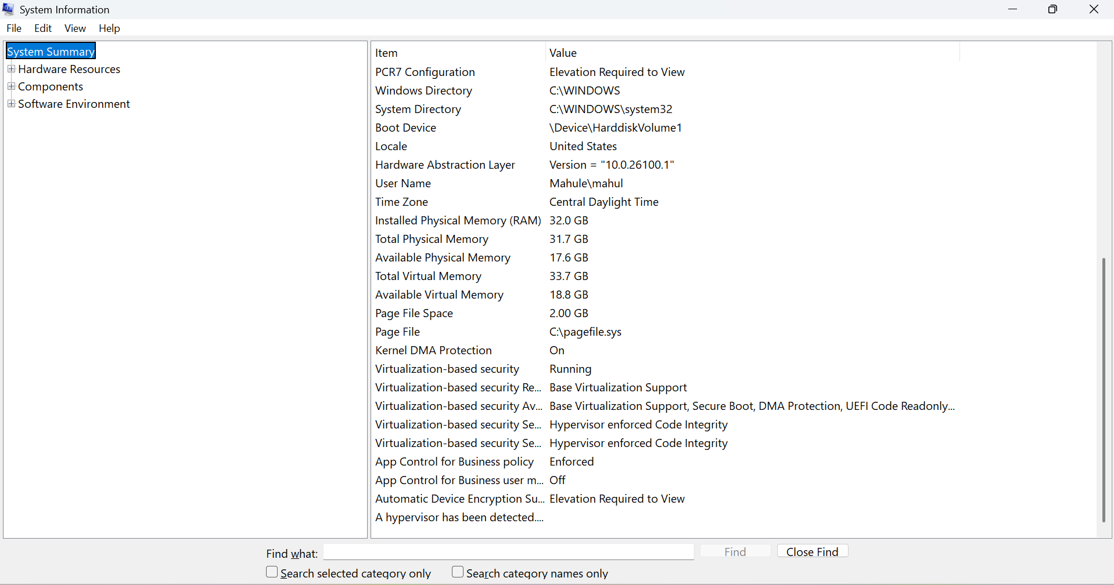
Screenshot 1: System Information - operating system, model, processor, and BIOS/security details
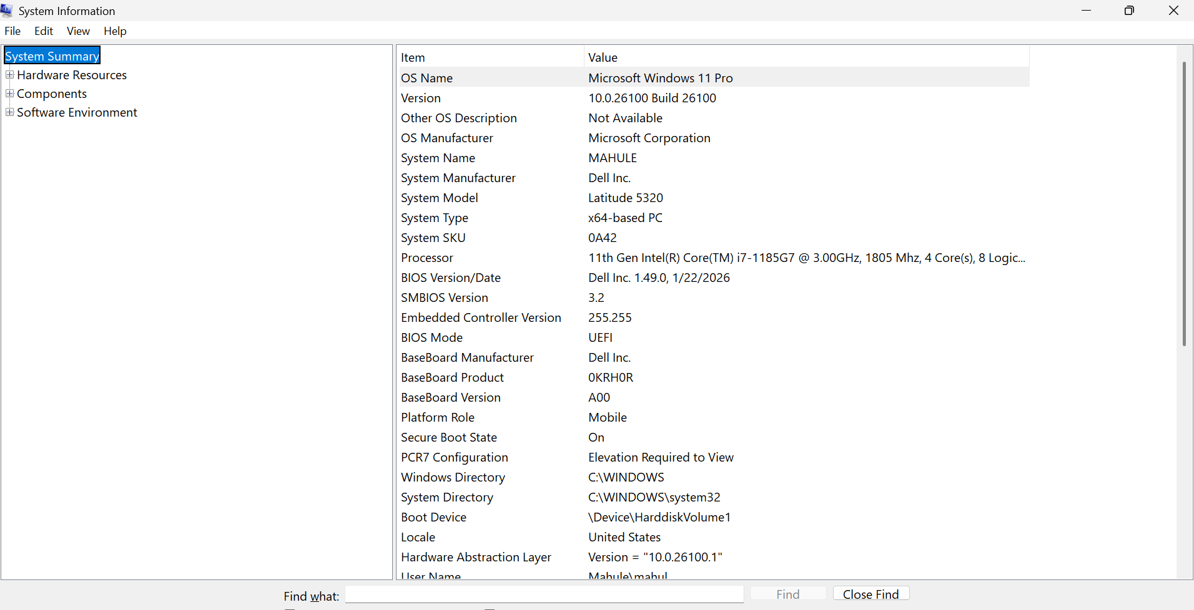
Screenshot 2: System Information - memory, security, and virtualization details

Lab 2: Slow Computer Troubleshooting

Objective
Review system performance and startup applications to identify possible causes of a slow computer. In IT support, Task Manager is commonly used to check CPU, memory, disk, network, GPU usage, startup apps, and uptime.

Tools Used
- Windows 11 Pro
- Task Manager
- Performance tab
- Startup Apps tab
- Screenshot documentation

Performance Findings
Metric | Finding
CPU Usage | 20%
Memory Usage | 14.8 GB / 31.7 GB (47%)
Disk Usage | 2%
GPU Usage | 6%
Processes Running | 283
System Uptime | 2 days, 14 hours
Last BIOS Time | 8.0 seconds

Startup Apps Reviewed
Enabled startup apps included AdobeCollabSync, DuckDuckGo Startup Boost, Microsoft 365 Copilot, Mobile Devices, OneDrive, Realtek Audio Service, Windows Security notification icon, Waves audio service, and WebexHost. Disabled startup apps included Calendar, Files, Firefox, Intel Graphics Command Center, iTunes Helper, iTunes Mobile Device Helper, Microsoft Teams, Phone Link, Terminal, and Xbox.

Analysis
The system did not show signs of heavy CPU or disk usage at the time of review. However, the system had been running for more than 2 days and had 283 processes running. Several startup applications were enabled, which could contribute to slower startup or background resource use.

Recommended Troubleshooting Actions
- Restart the computer to clear temporary memory and refresh running processes.
- Review enabled startup apps and disable nonessential programs with user approval.
- Keep security-related startup apps enabled, such as Windows Security.
- Keep required audio and driver-related services enabled unless there is a known issue.
- Monitor CPU, memory, and disk usage after restart.
- Ask the user when slowness happens: at startup, during browsing, while opening apps, or all the time.

Sample Help Desk Ticket Note
Issue: User reports that the computer feels slow.
Resolution: No major resource issue was found at the time of review. Recommended restarting the computer, reviewing startup apps, and disabling unnecessary startup programs with user approval. Also recommended monitoring performance after restart.
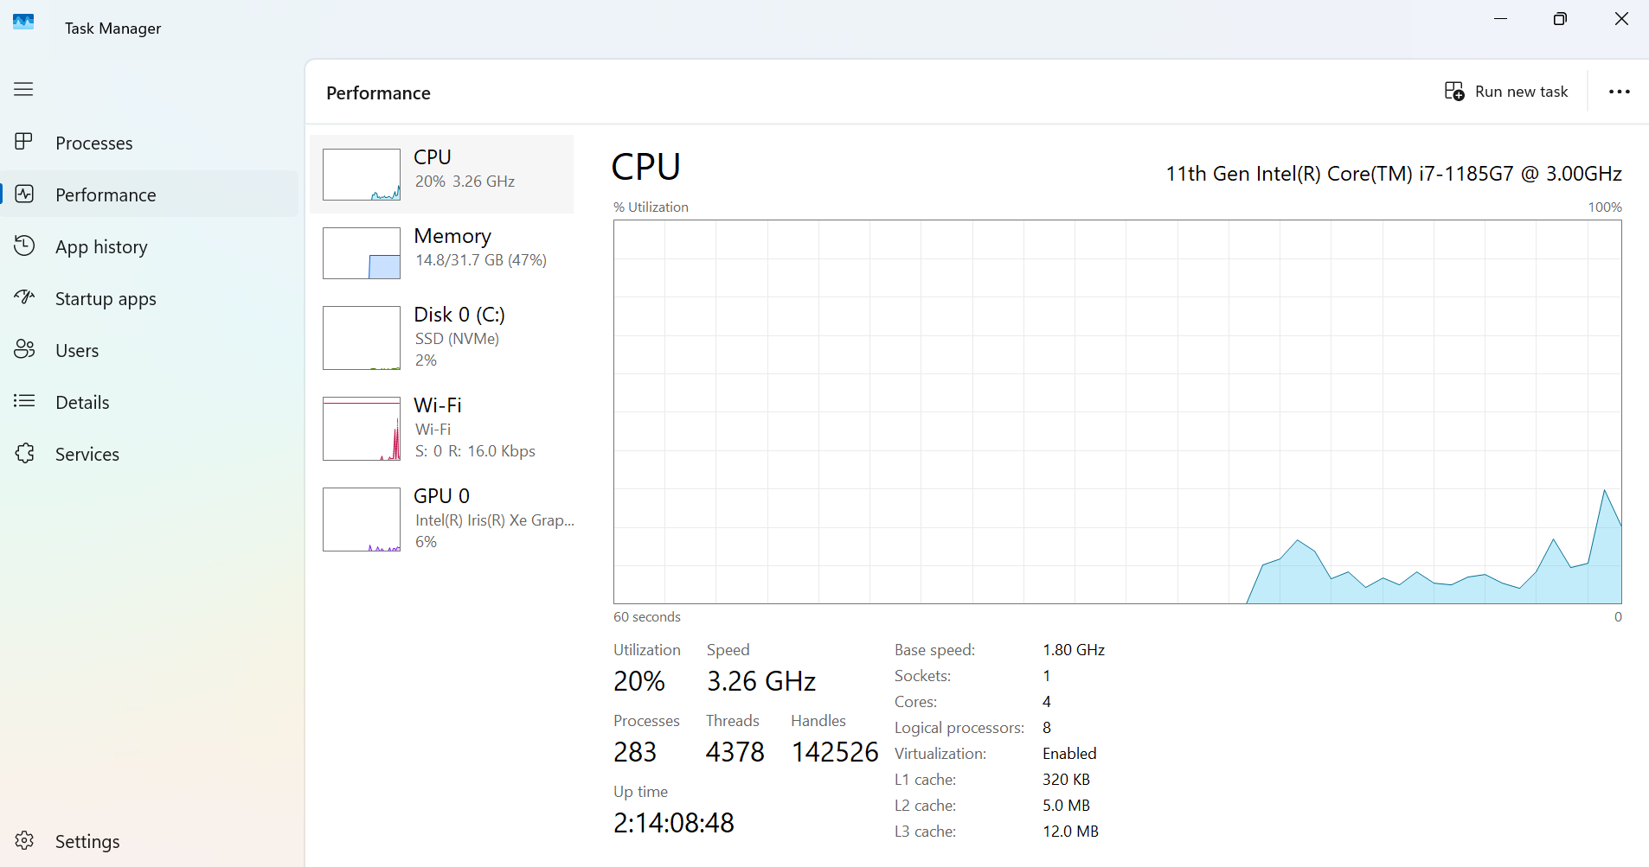
Screenshot 3: Task Manager Performance tab showing CPU, memory, disk, Wi-Fi, and GPU usage
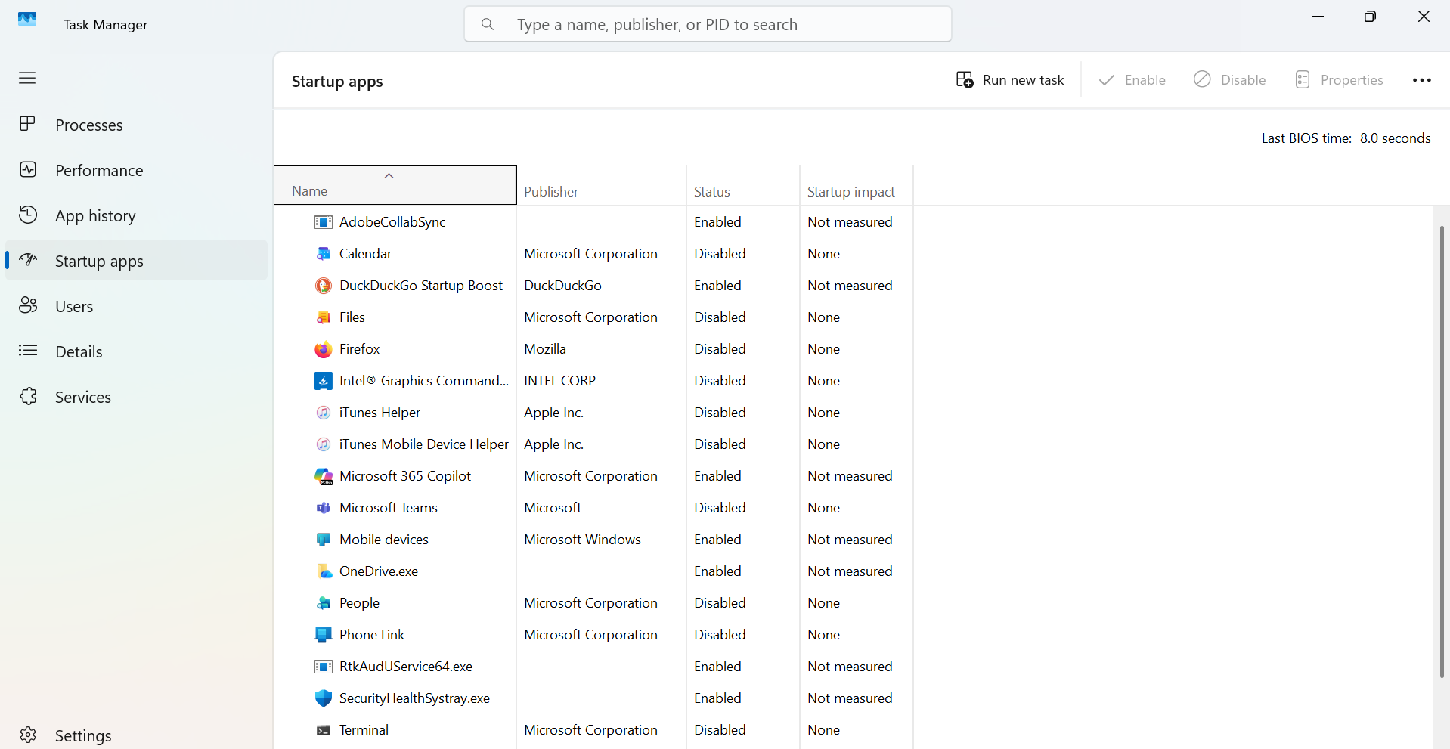
Screenshot 4: Startup Apps review showing enabled and disabled startup programs
Screenshot 5: Startup Apps review continued

Lab 3: Network Troubleshooting

Objective
Test local network configuration, internet connectivity, DNS resolution, and route tracing using Command Prompt tools commonly used in IT support.

Tools Used
- Windows 11 Pro
- Command Prompt
- ipconfig
- ping
- tracert
- Screenshot documentation

Network Details Found
Item | Finding
Connection Type | Wi-Fi
DNS Suffix | attlocal.net
IPv4 Address | 192.168.1.72
Subnet Mask | 255.255.255.0
Default Gateway | 192.168.1.254

Tests Performed and Findings
- ipconfig confirmed the device had a valid IPv4 address, subnet mask, and default gateway.
- ping 8.8.8.8 confirmed raw internet connectivity with 4 packets sent, 4 received, 0 lost, and an average response time of 9 ms.
- ping google.com confirmed DNS resolution and internet connectivity with 0% packet loss and an average response time of 34 ms.
- tracert google.com completed successfully in 23 hops. Some intermediate hops timed out, which can be normal because some routers do not respond to ICMP trace requests.

Analysis
The computer is properly connected to the Wi-Fi network and received a valid private IPv4 address from the local network. The default gateway was present, confirming basic local network configuration. The successful ping to 8.8.8.8 confirmed working internet access. The successful ping to google.com confirmed that DNS resolution was also functioning correctly.

Sample Help Desk Ticket Note
Issue: User reports possible internet or network issue and requests connectivity verification.
Resolution: No active network issue was found at the time of testing. Local network connection, internet access, and DNS resolution were working correctly.
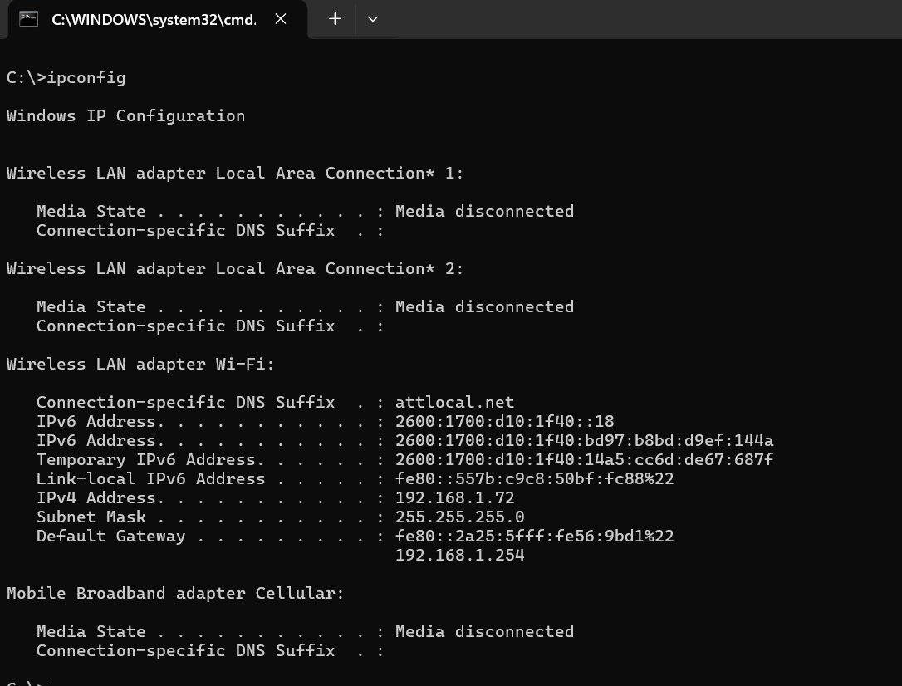
Screenshot 6: ipconfig output showing Wi-Fi network configuration
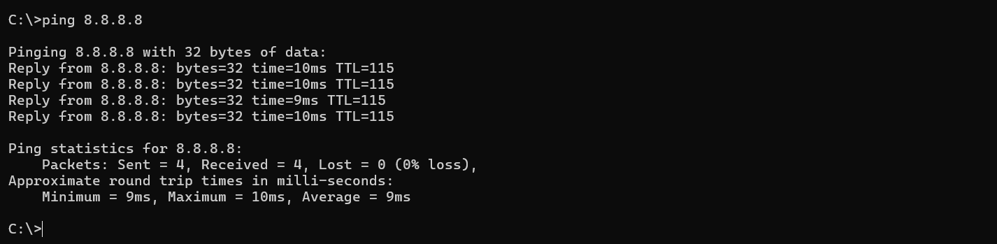
Screenshot 7: ping 8.8.8.8 showing 0% packet loss and low latency
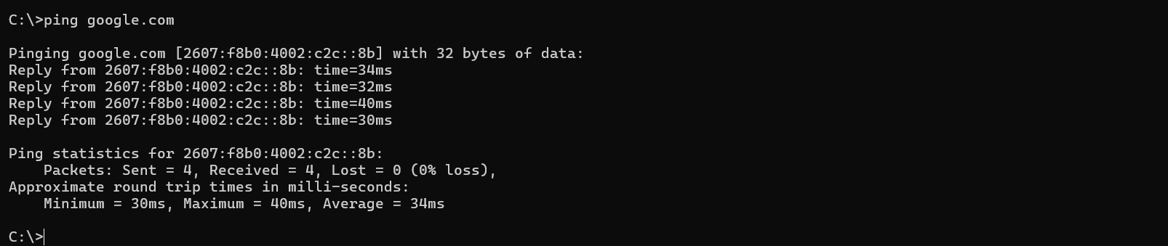
Screenshot 8: ping google.com showing DNS resolution and successful replies
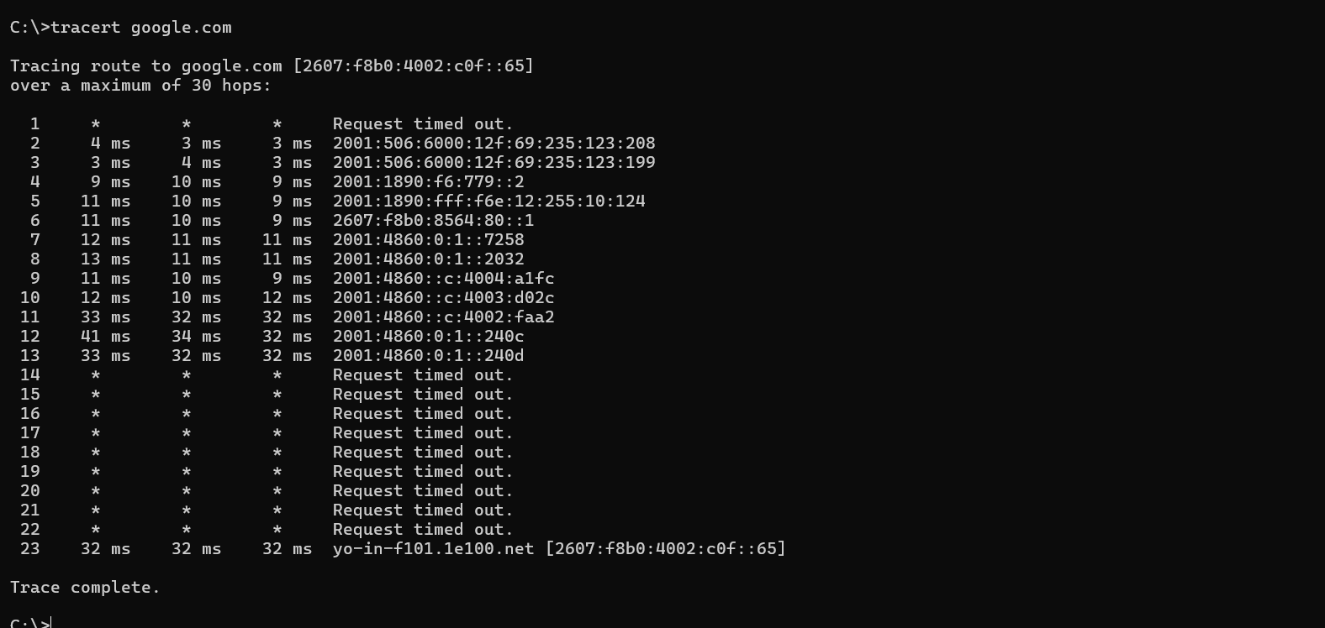
Screenshot 9: tracert google.com showing completed network path trace

Lab 4: Windows Update Review & Troubleshooting

Objective
Review Windows Update status, update history, advanced update settings, and optional updates. In IT support, Windows Update review is important for security, performance, system stability, and troubleshooting driver or software-related issues.

Tools Used
- Windows 11 Pro
- Windows Settings
- Windows Update
- Update History
- Advanced Options
- Screenshot documentation

Windows Update Findings
Item | Finding
Update Status | You're up to date
Last Checked | Today, 1:15 PM
Optional Updates | 6 available
Recent Quality Updates | Successfully installed
Recent Security Updates | Successfully installed

Settings Reviewed
- Windows Update main page
- Check for updates option
- Pause updates option
- Update history
- Advanced options
- Optional updates
- Delivery Optimization
- Recovery
- Restart apps
- Configured update policies

Analysis
The system was up to date at the time of review. Recent quality and security updates were successfully installed, which helps protect the computer from security risks and improves stability. Optional updates were available and should be reviewed carefully before installation because they may include driver or feature updates. In a professional IT support environment, optional driver updates are normally installed only when troubleshooting a specific issue or after confirming compatibility.

Sample Help Desk Ticket Note
Issue: User wants to confirm whether their Windows computer is fully updated and secure.
Resolution: Confirmed that the system was up to date. Recommended continuing regular update checks and reviewing optional updates only when needed for driver, feature, or hardware troubleshooting.
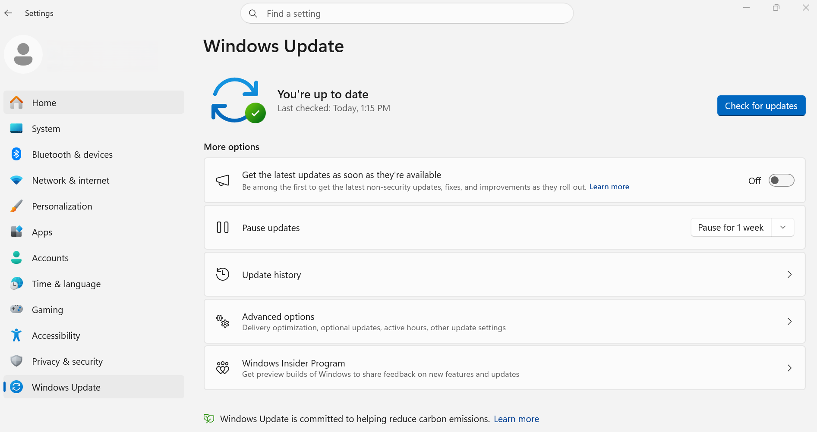
Screenshot 10: Windows Update main page showing system is up to date
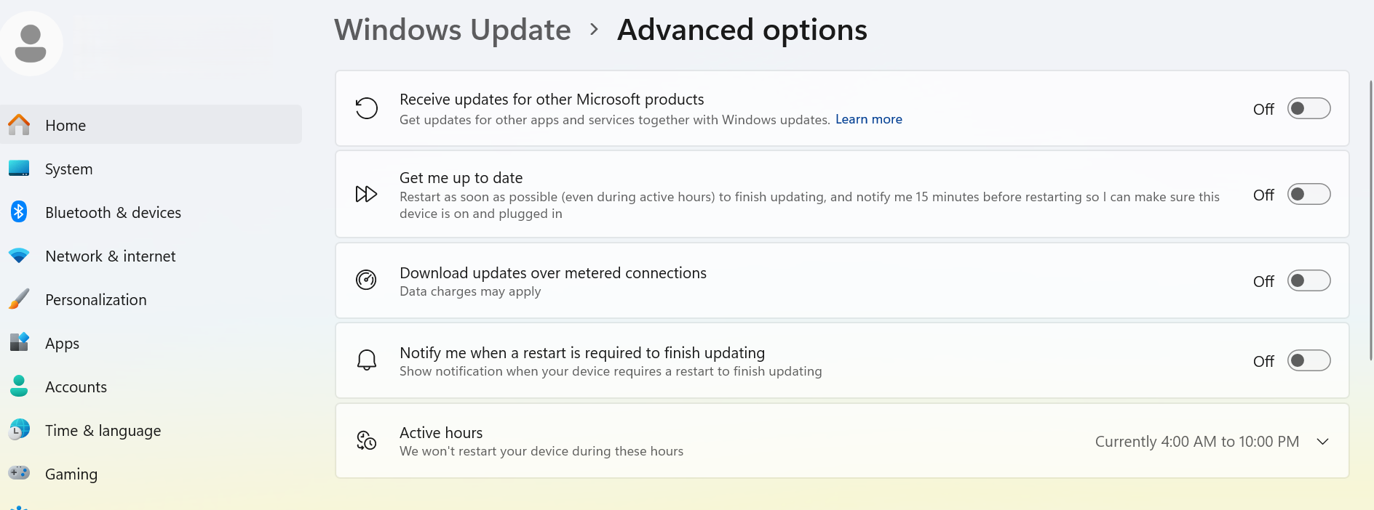
Screenshot 11: Windows Update advanced options showing update preferences
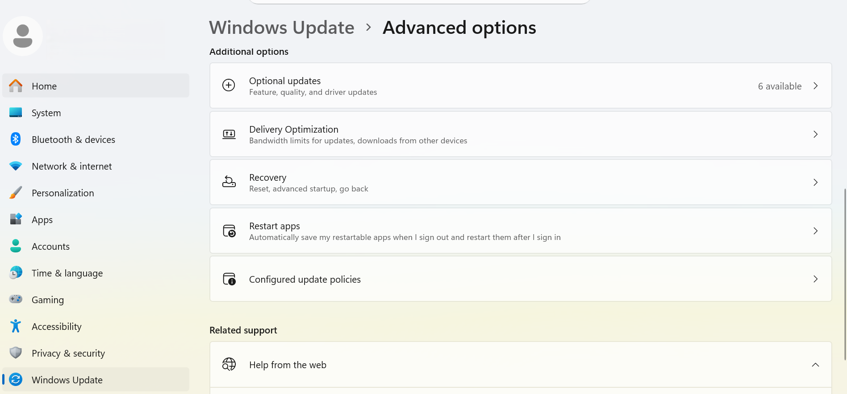
Screenshot 12: Additional Windows Update advanced options and optional updates
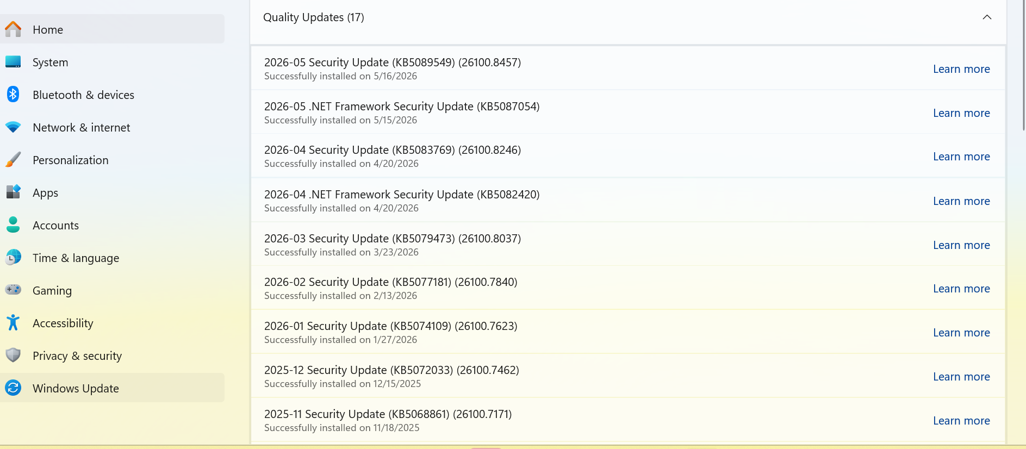
Screenshot 13: Update history showing recent security and quality updates

Lab 5: Device Manager Hardware Review

Objective
Review hardware devices in Windows Device Manager and verify whether key device categories are properly detected. In IT support, Device Manager is commonly used to check drivers, identify missing devices, troubleshoot hardware problems, and look for warning icons.

Tools Used
- Windows 11 Pro
- Device Manager
- Screenshot documentation

Devices Reviewed
Category | Device / Finding
Disk Drive | Samsung SSD 970 EVO Plus 500GB
Display Adapter | Intel Iris Xe Graphics
Network Adapter | Intel Wi-Fi 6 AX201 160MHz
Mobile Broadband Adapter | DW5820e Intel 7360 LTE-A
Audio Devices | Intel Smart Sound Technology for USB Audio and Realtek Audio
WAN Miniport Adapters | IKEv2, IP, IPv6, L2TP, Network Monitor, PPPOE, PPTP, SSTP

Findings and Analysis
Device Manager showed the main hardware devices properly detected by Windows. No yellow warning signs were visible in the reviewed sections, meaning there were no obvious driver or hardware detection problems at the time of review. In a real IT support environment, if a user reported audio, display, storage, or network issues, Device Manager would be one of the first tools used to check for missing drivers, disabled devices, or hardware errors.

Sample Help Desk Ticket Note
Issue: User reports possible hardware or driver issue and requests a device check.
Resolution: No obvious hardware or driver issue was detected in Device Manager. Recommended checking device drivers, Windows Update optional driver updates, and manufacturer support tools if the user continues to experience hardware-related issues.
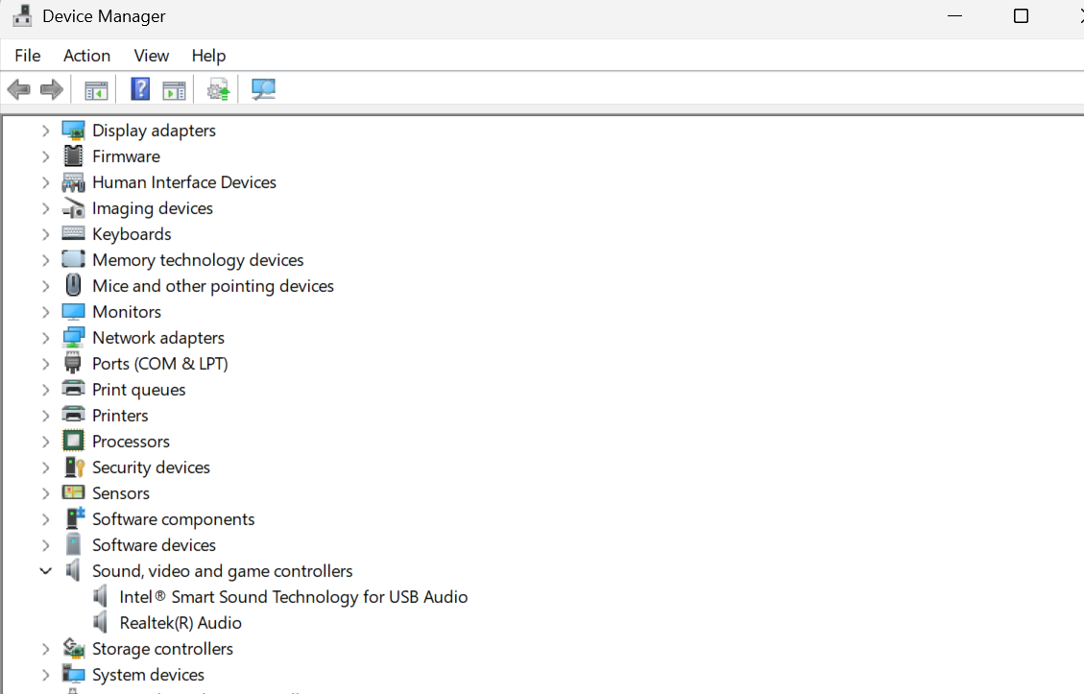
Screenshot 14: Device Manager main hardware categories
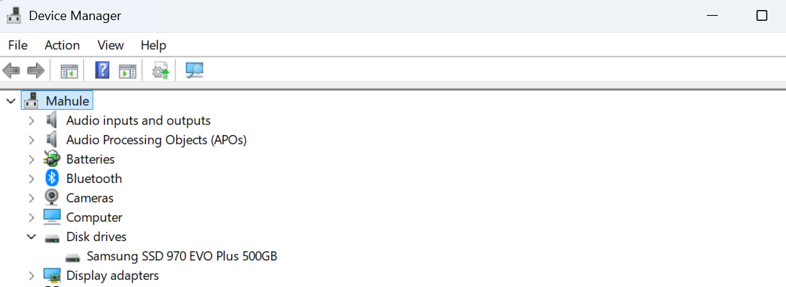
Screenshot 15: Disk Drives showing Samsung SSD 970 EVO Plus 500GB
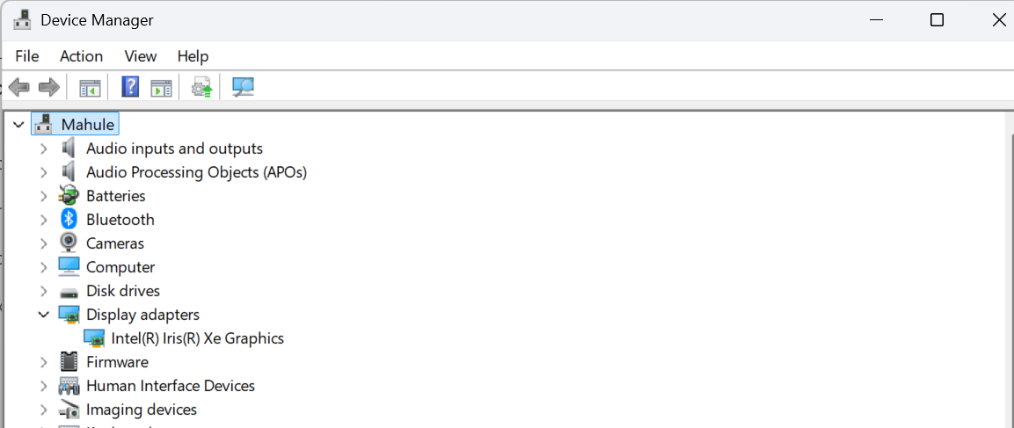
Screenshot 16: Display Adapters showing Intel Iris Xe Graphics
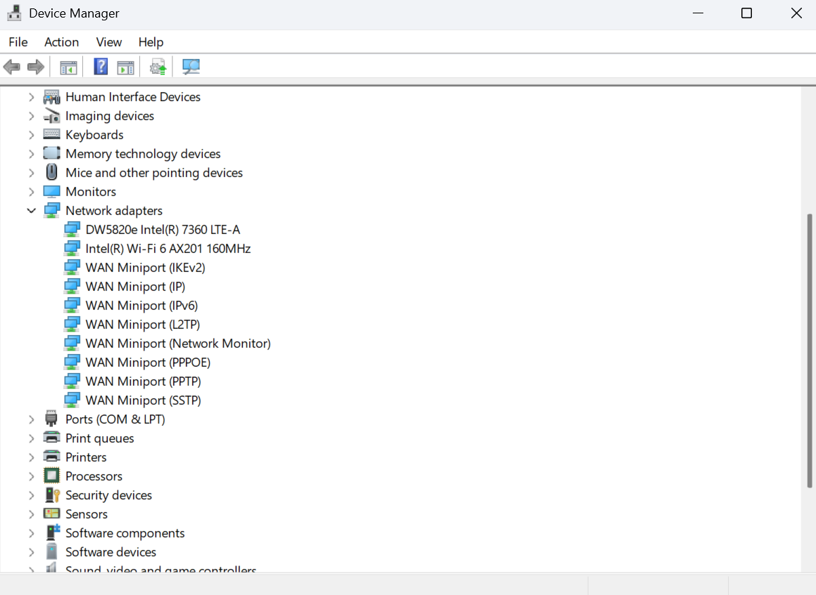
Screenshot 17: Network Adapters showing Wi-Fi, mobile broadband, and WAN miniport adapters
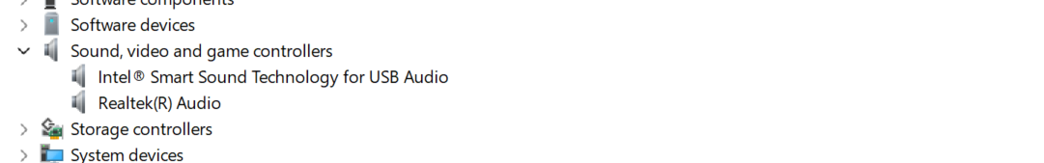
Screenshot 18: Sound devices showing Intel Smart Sound and Realtek Audio

Final Project Summary
This Windows 11 Troubleshooting Lab demonstrates practical entry-level IT support skills. The labs show that I can review system information, analyze performance issues, test network connectivity, verify Windows Update status, and inspect hardware devices in Device Manager. The project also demonstrates my ability to document troubleshooting steps clearly, write help desk ticket notes, and communicate technical findings in a professional way.

Skills Demonstrated Across the Project
- Windows Support
- Hardware and Software Troubleshooting
- Task Manager Performance Review
- Startup App Review
- Network Troubleshooting
- IP Configuration Review
- Ping and DNS Testing
- Traceroute Analysis
- Windows Update Review
- Patch Management Basics
- Device Manager Review
- Driver Troubleshooting Basics
- Technical Documentation
- Help Desk Ticket Writing
- Customer/User Support

