**A. After downloading data, save them to the mongodb manually.**

**(capture one sample of adding your data to your answer(PDF))**

**Note: Capture your insert code and it’s result. If you have many things, capture just one**

**sample of insertion.**

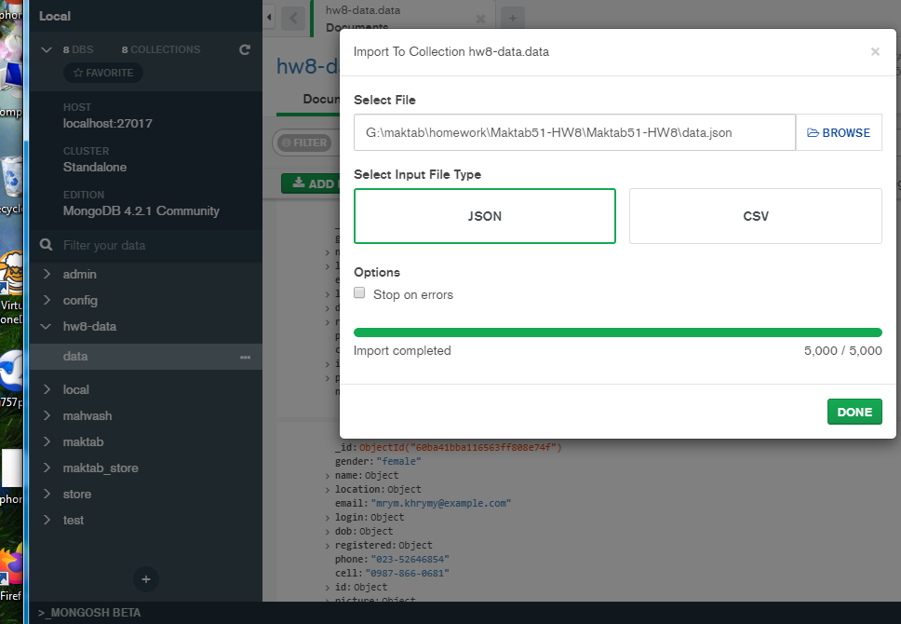

**B. Make the following queries. Capture the results and paste them to your answer(PDF).**

**Note: Capture the queries and its results.**

1-Find the firstname and lastname of all users that have more than 50 years and reside on

(their city = ‘ (’گلستان)

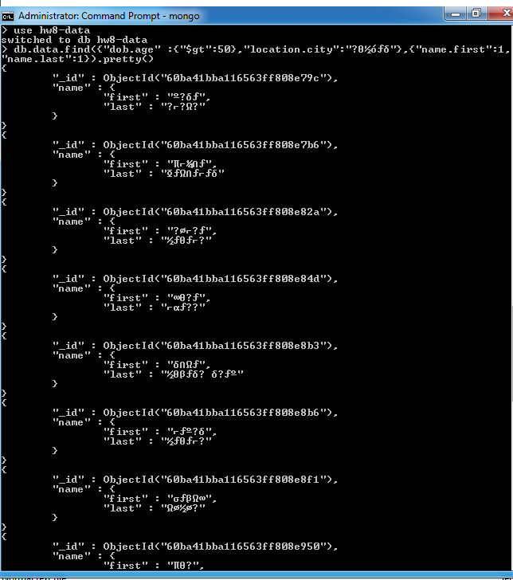

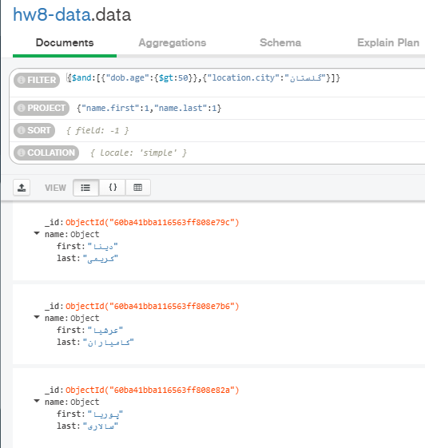

2--We want to reward those users who have registered on our site for more than 20 years. Find

their last name, phone and address.

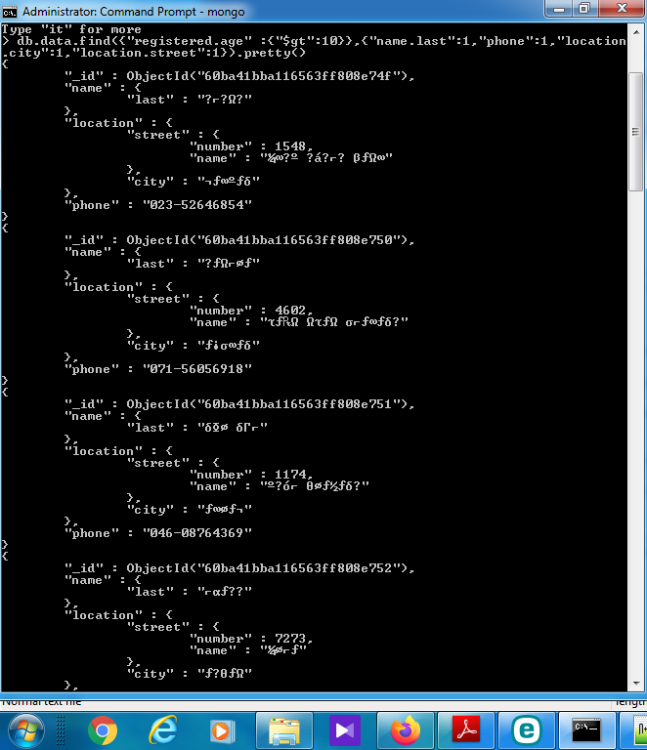

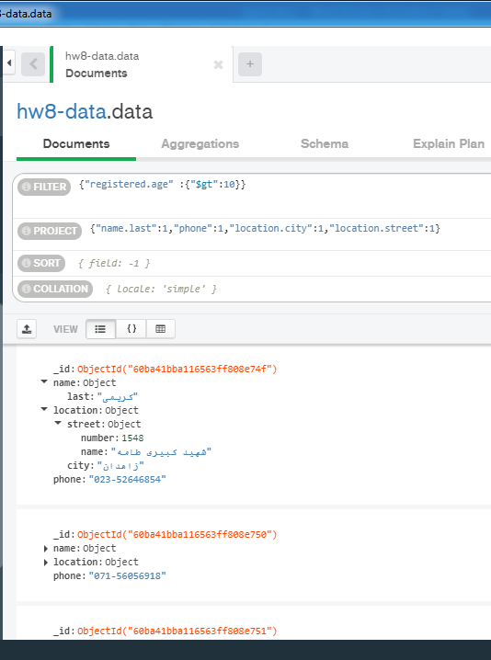

3-At the end of each day, we want to grant a discount code or a gift to those whose birthday is

today and send them a “Happy Birthday” email. Find the full name and email address of these

guys.(By running the query we can have the info of those users which their birthday is today)

"$expr": {

"$and": [

{ "$eq": [ { "$dayOfMonth": "$dob.date" }, { "$dayOfMonth": new Date() } ] },

{ "$eq": [ { "$month" : "$dob.date" }, { "$month" : new Date() } ] }

]

}

4-Find the number of users based on their province(=state). For example Isfahan, 30

Tehran, 50

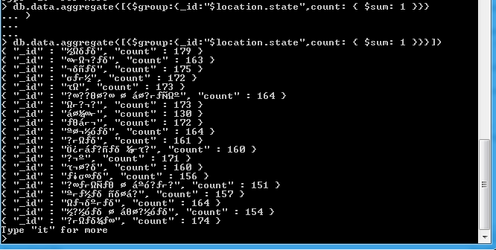

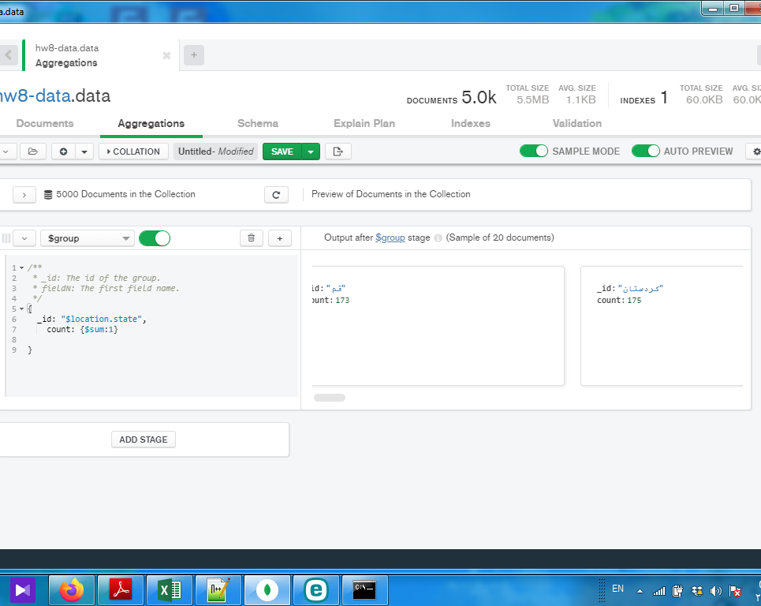

5-Which city has the most number of users and which one has the least number of users?

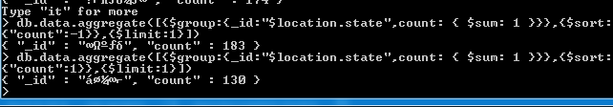

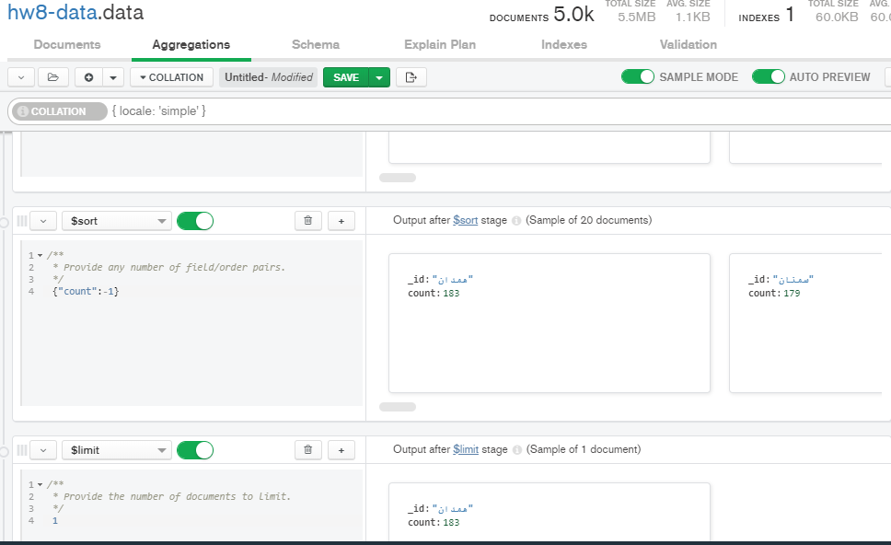

6-Compare the average of users’ age in Tehran with the average of users’ age in other cities.

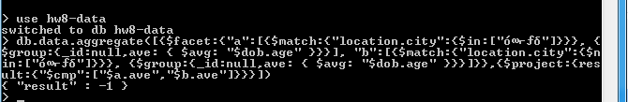

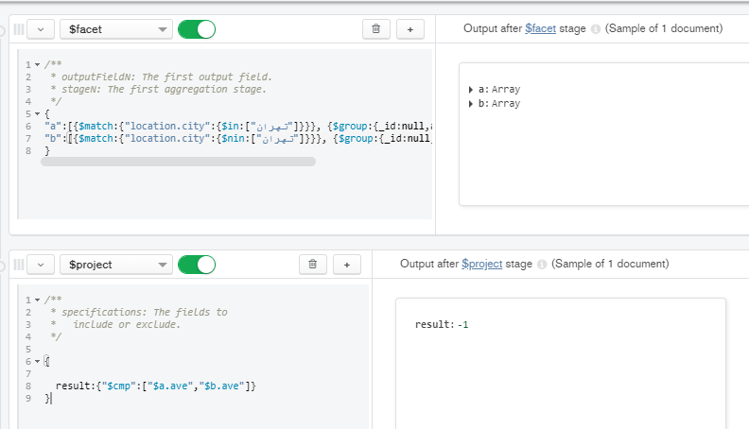

7-For an advertisement, we want to categorize users based on their age. Write a query to

categorize them into three groups 1)youth 2)middle-aged 3)old:

Youth for ages < 16

Middle-aged for 16 < ages <40

Old for ages >40

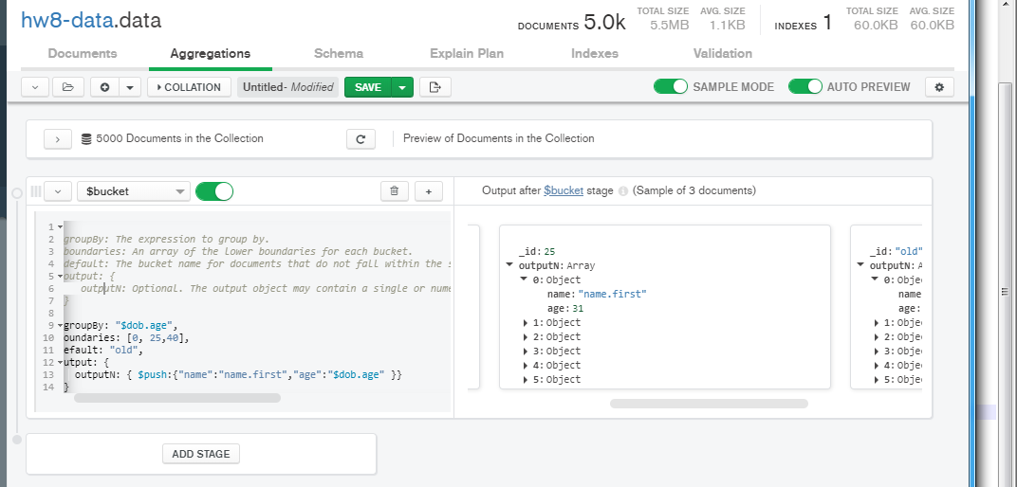

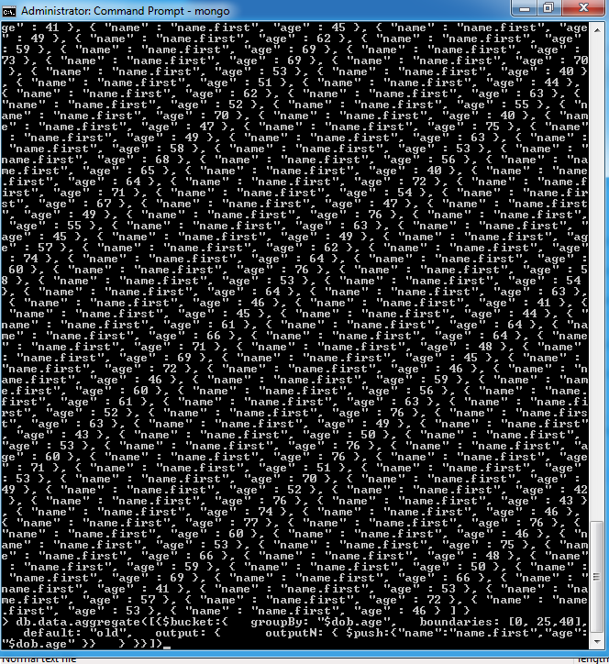

**By using pymongo, save the information of these users to a new collection and make sure that the info of all users is saved to your collection using “count”.**

**Note: Capture your code and it’s result. Do not forget to append your python file to your document.**

