**CSCS351: Software Quality Assurance**

**Assignment 2**

**Submitted By:**

**Mahwish Seemi 241576854**

**Submitted To:**

**Dr. Saad Bin Saleem**

**Screenshots**

In windows, in vs code using the ‘pip install selenium’ and ‘pip install webdriver-manager’ commands, selenium was installed. The testing was done on moodle as well as empower. The screenshots for both the successful and failed test( using correct and wrong login credetianals)

1. **For automated test on FCCU Empower Module using Selenium Webdriver**

**For correct login credetianals:**

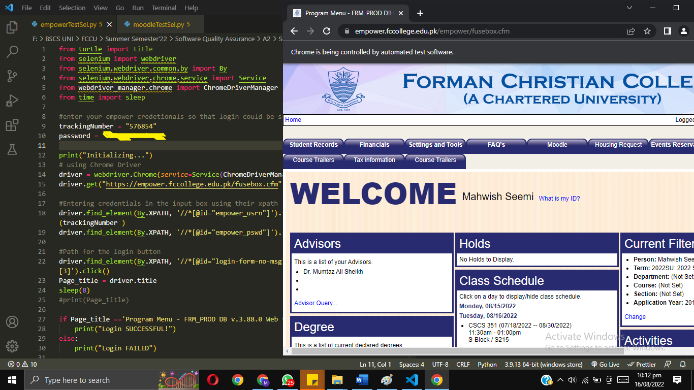

**For wrong login credentials so that the test fails:**

1. **For automated test on FCCU MOODLE PAGE using Selenium Webdriver**

**For correct login credetianals:**

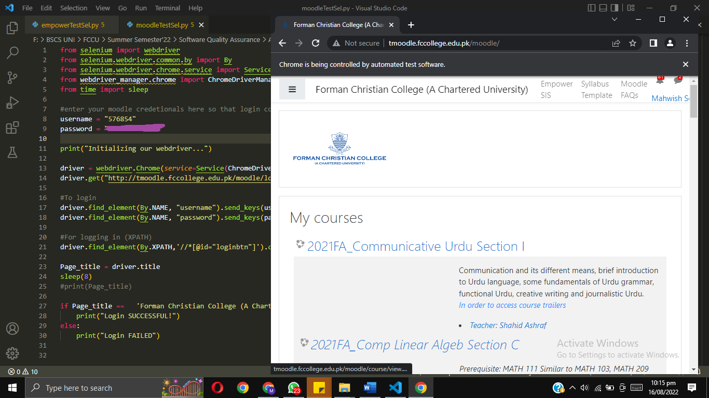

**For wrong login credentials so that the test fails:**

