**CSCS351: Software Quality Assurance**

**Assignment 1**

**Submitted By:**

**Mahwish Seemi 241576854**

**Submitted To:**

**Dr. Saad Bin Saleem**

In this assignment, I used python unit testing framework. The five programs for which I generated the test cases for were:

1. the palindrome
2. even odd
3. Fibonacci series
4. leap year calculation
5. identifying prime number program.

For this purpose, the python’s unittest module was used. All the programs are written in python.

The screenshots of the five programs along with their test cases for both the pass and fail scenarios have been shown.

In the end, all the tests were combined into test suite.

**Screenshots:**

1. **Prime Numbers**

**primeNum.py**

**Test_prime.py**

1. **Test Pass**

1. **Test Fail Scenario:**

1. **Fibonacci Series**

**Fibonacci.py**

**Test_fib.py**

1. **Test Pass Case**

1. **Test Fail Case:**

1. **Leap Year Calculation**

**Leapyear.py**

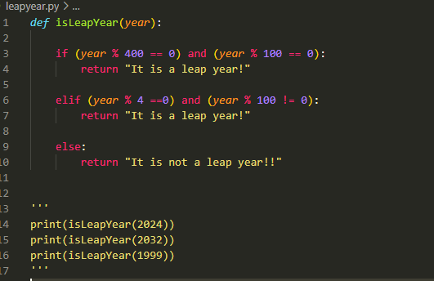

**Test_leapyear.py**

1. **Test Pass**

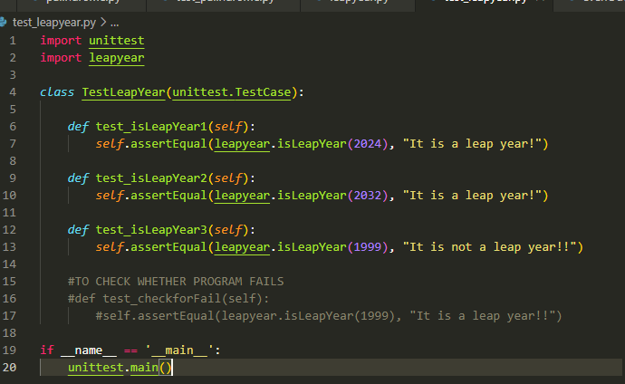

1. **Test Fail Case**

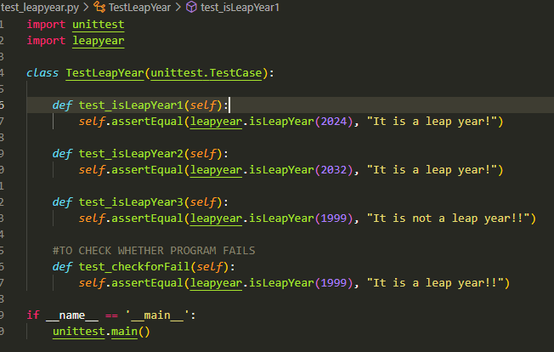

1. **Even Odd**

**evenOdd.py**

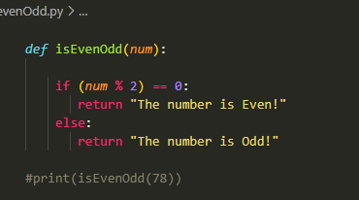

**Test_evenodd.py**

1. **Test Pass**

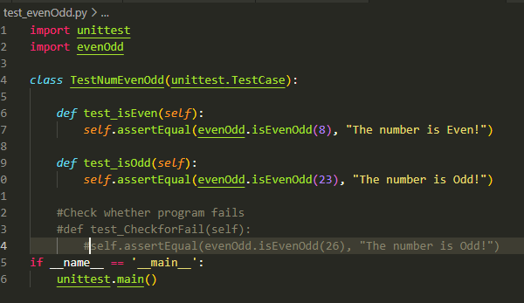

1. **Test Fail Scenario**

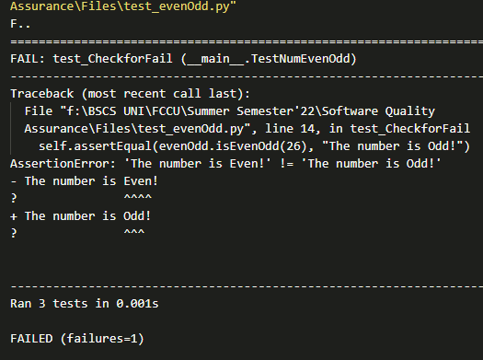

1. **Palindrome**

**Palindrome.py**

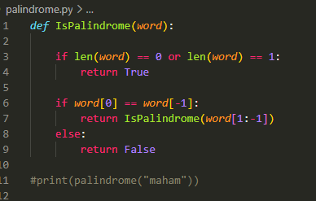

**Test_palindrome.py:**

1. **Test Pass**

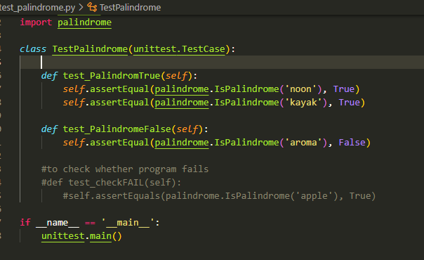

1. **Test Fail**

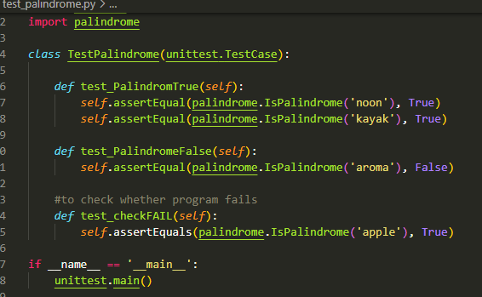

**.**

**And finally:**

**The Test Suite**

