**4170207**

Software Engineering Theory

**Topic 4**: Fitness club Management System

**Final Project**

**November 2020**

Team

|  |  |  |  |
| --- | --- | --- | --- |
| ID | Name | Email | Mobile |
| 203106 | Mahy Moustafa Aly | Sim.mahymostafa3106@alexu.edu.eg | 01110609949 |
| 203138 | Mariam Tareq Ibrahim | Sim.mariamtarek3138@alexu.edu.eg | 01021865504 |
| 203053 | Zeyad Walid Yehia | Sim.ziadwalid3058@alexu.edu.eg | 01272507445 |

Document purpose and audience

* This software targets health enthusiasts and gymaholics.
* It’s purpose is to alter gymnasium, fitness admission strategies and provide the best service to customers.
* Make admission process easier and less time consuming for customers.
* Allows members to book class of their choice from the comfort of their own homes and pay fees by electronic cash transfer/card details.
* This fitness club system includes: Admin, member and trainer.

Audience

* CEO
* Project manager
* Member
* Trainers
* Admin

System Models

1. Class diagrams

|  |  |  |
| --- | --- | --- |
| Class name | Subsystem | description |
| Users | Member, Admin ,trainer | Users in the software system are the subsystems of the main class |
| Member | PackagePaymetntDetails , card | The member has two subsystems which are the payment details and the card information |

2.Sequence diagram

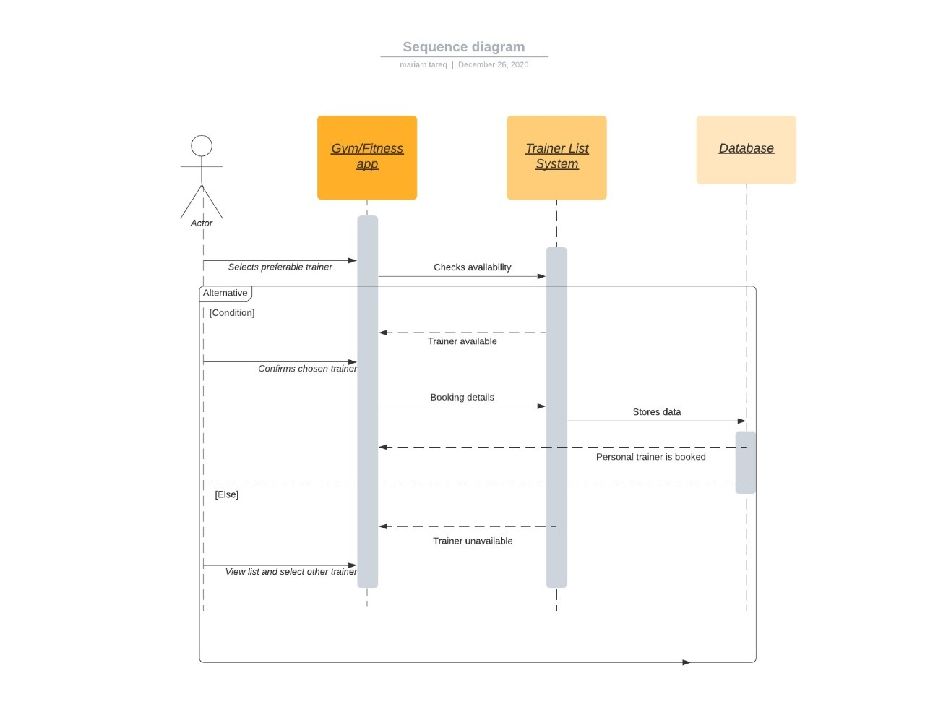

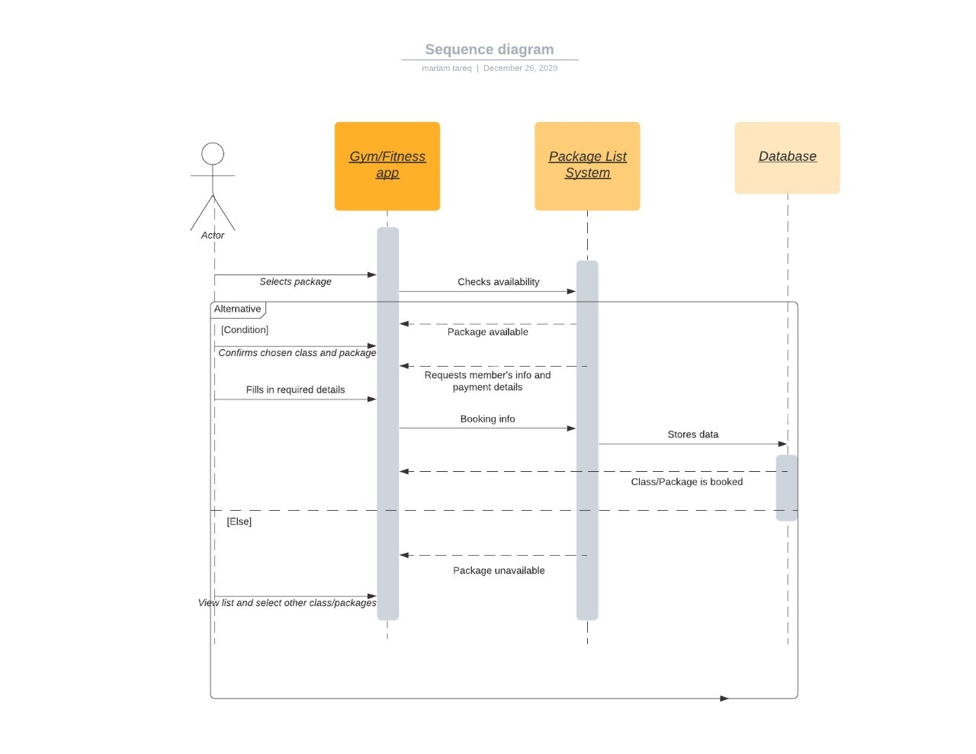

3.Physical Entity-Relationship Diagram

User interface design

application icon

The login page appearing for member

.Enter username

Enter password

.Registration page

Choose perferred package

.Choose payment method and fill card details

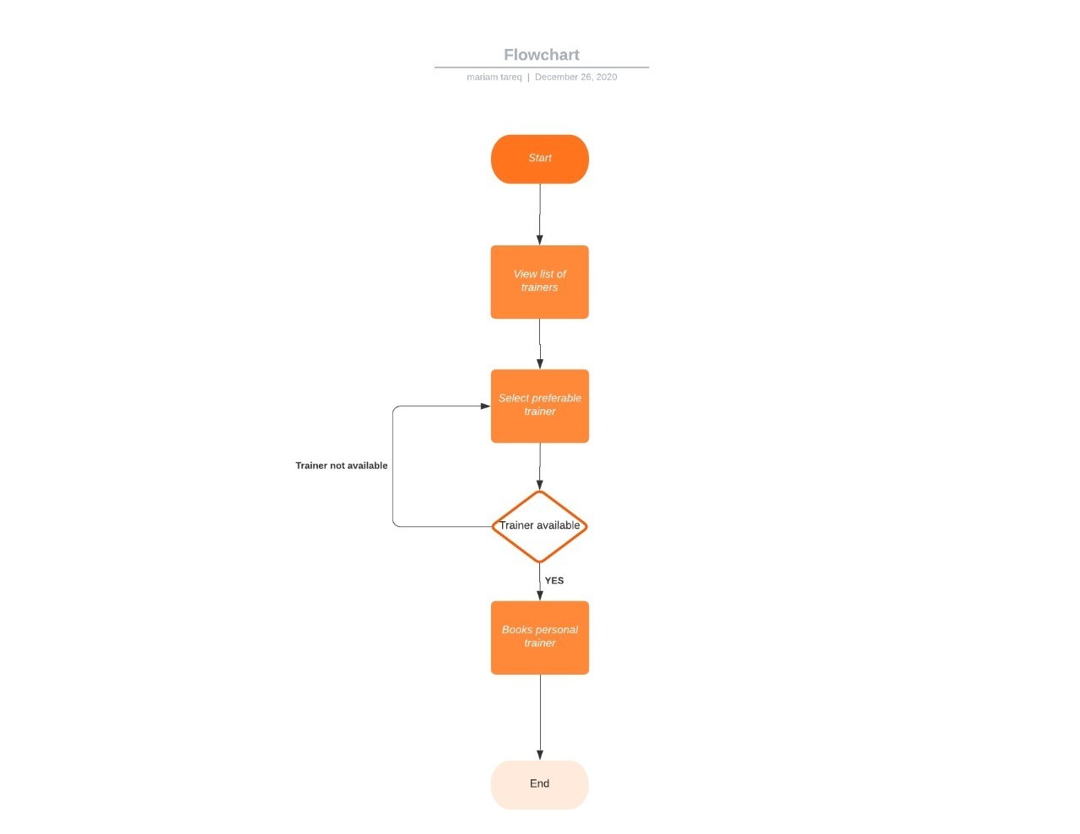

Resources and links used

[www.luicidchart.com](http://www.luicidchart.com)

[www.clearly.com](http://www.clearly.com)

**Owner ship report**

|  |  |
| --- | --- |
| Item | Owners |
|  |  |

Policy Regarding Plagiarism:

Students have collective ownership and responsibility of their project.Any violation of academic honesty will have severe consequences and punishment for ALL team members.

فى حالة ثبوت الغش سيأخذ الطالب سالب درجة المسألة ،و فى حالة تكرار الغش سيرسب الطالب فى المقرر.1

.تشجع الكليةعلى مناقشة الأفكار و تبادل المعلومات و مناقشات الطلاب حيث يعتبر هذا جوهريا لعملية تعليمية سليمة2

.ساعد زملاءك على قدر ما تستطيع و حل لهم مشاكلهم فى الكود و لكن تبادل الحلول غير مقبول و يعتبر غشا.3

.أى حل يتشابه مع أى حل آخر بدرجة تقطع بأنهما منقولان من نفس المصدر سيعتبر أن صاحبيهما قد قاما بالغش.4

.قد توجد على النت برامج مشابهة لما نكتبه هنا أى نسخ من على النت يعتبر غشا يحاسب عليه صاحبه.5

.إذا لم تكن متأكدا أن فعلا ما يعد غشا فلتسأل المعيد أو أستاذ المادة.6

.