**DATA VISUALIZATION**





**DATA INGESTION**



MusicBrainz

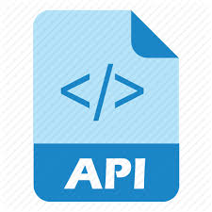

Spotify



Songkick

**DATA**

**SOURCE**

Batch Processing

**DATA PROCESSING & ANALYSIS**



Batch Processing

**DATA STORAGE**



