Title

Author

2021-05-05

Outline

Header 1 1

Header 2 1

Header 3 1

References 3

# Header 1

## Header 2

### Header 3

#### Header 4

##### Header 5

###### Header 6

First paragraph

Body text.[1]

This is a citation (Layton 2015).

This is a block quote.

This is an unordered list:

* Item 1
* Item 2

This is an ordered list:

1. Item 1
2. Item 2

This is an inline equation: $1+2$.

This is a display equation.

$$1+2$$

This is a codeblock.

x <- 1 + 2  
x

## [1] 3

This is kable, Table 1.

Table 1: Table caption

|  |  |  |  |  |  |  |
| --- | --- | --- | --- | --- | --- | --- |
|  | mpg | cyl | disp | hp | drat | wt |
| Mazda RX4 | 21.0 | 6 | 160 | 110 | 3.90 | 2.620 |
| Mazda RX4 Wag | 21.0 | 6 | 160 | 110 | 3.90 | 2.875 |
| Datsun 710 | 22.8 | 4 | 108 | 93 | 3.85 | 2.320 |
| Hornet 4 Drive | 21.4 | 6 | 258 | 110 | 3.08 | 3.215 |
| Hornet Sportabout | 18.7 | 8 | 360 | 175 | 3.15 | 3.440 |
| Valiant | 18.1 | 6 | 225 | 105 | 2.76 | 3.460 |

This is pander, Table ??.

Table caption

|  |  |  |  |  |  |  |
| --- | --- | --- | --- | --- | --- | --- |
|  | mpg | cyl | disp | hp | drat | wt |
| **Mazda RX4** | 21 | 6 | 160 | 110 | 3.9 | 2.62 |
| **Mazda RX4 Wag** | 21 | 6 | 160 | 110 | 3.9 | 2.875 |
| **Datsun 710** | 22.8 | 4 | 108 | 93 | 3.85 | 2.32 |
| **Hornet 4 Drive** | 21.4 | 6 | 258 | 110 | 3.08 | 3.215 |
| **Hornet Sportabout** | 18.7 | 8 | 360 | 175 | 3.15 | 3.44 |
| **Valiant** | 18.1 | 6 | 225 | 105 | 2.76 | 3.46 |

This is `flextable`, Table 2.

Table 2: Table caption

| mpg | cyl | disp | hp | drat | wt |
| --- | --- | --- | --- | --- | --- |
| 21.0 | 6 | 160 | 110 | 3.90 | 2.620 |
| 21.0 | 6 | 160 | 110 | 3.90 | 2.875 |
| 22.8 | 4 | 108 | 93 | 3.85 | 2.320 |
| 21.4 | 6 | 258 | 110 | 3.08 | 3.215 |
| 18.7 | 8 | 360 | 175 | 3.15 | 3.440 |
| 18.1 | 6 | 225 | 105 | 2.76 | 3.460 |

This is Figure 1.

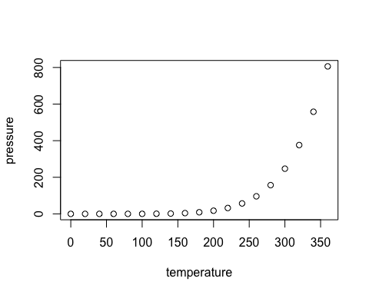

Figure 1: Image caption

# References

Layton, Richard. 2015. “Happy Collaboration with Rmd to Docx.” <https://rmarkdown.rstudio.com/articles_docx.html>.

1. This is a footnote.