**A Twist of Freight**

Freight is the backbone of our economy. As such, there is an endless supply of data on this subject and companies are constantly using this data to identify past, present, and future trends to identify supply chain transportation opportunities. We are interested in analyzing the movement of freight into, within, and outside of each state in terms of tonnage, specific commodities, and value.

**Project Requirements:**

Visualization must include:

* Python Flask RESTful API, HTML, CSS, and JavaScript; and
* At least one database (MongoDB, SQLite, etc.); and
* Powered by a dataset with at least 100 records; and
* At least one JS Library that we did not cover; and
* Some level of user-driven interaction (e.g. menus, dropdowns, textboxes); and
* At least 3 views in final presentation.

Project must fall into one of the following 3 tracks:

* A custom creative D3.js project (nonstandard graph or chart)
* A combination of web scraping and Leaflet or Plotly
* A dashboard page with multiple charts that update from the same data

**Source Data:**

Bureau of Transportation Statistics

* <https://www.bts.gov/topics/freight-transportation/freight-shipments-value>
* Value of Freight Shipments by State: 2017

Economic Census

* <https://data.census.gov/cedsci/table?q=cf1700&tid=CFSPRELIM2017.CF1700P6&vintage=2017&layer=VT_2017_040_00_PP_D1>
* CFS Preliminary Report 2017
* Shipment Characteristics by Mode of Transportation: 2017
  + Table: CFSPRELIM2017.CF1700P1
* Shipment Characteristics by Total Modal Activity: 2017
  + Table: CFSPRELIM2017.CF1700P2
* Shipment Characteristics by 2-digit Commodity
  + Table: CFSPRELIM2017.CF1700P6

Data Set Up Tools:

* Python, SQL Alchemy, SQLite

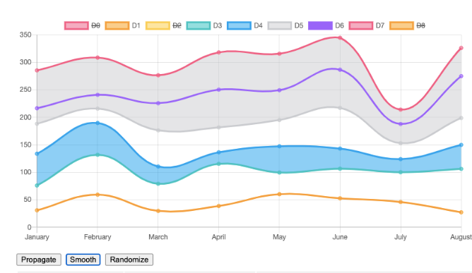

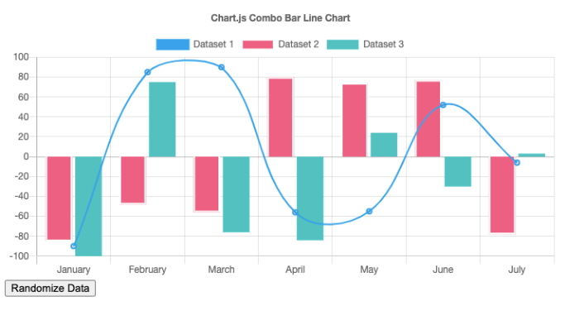

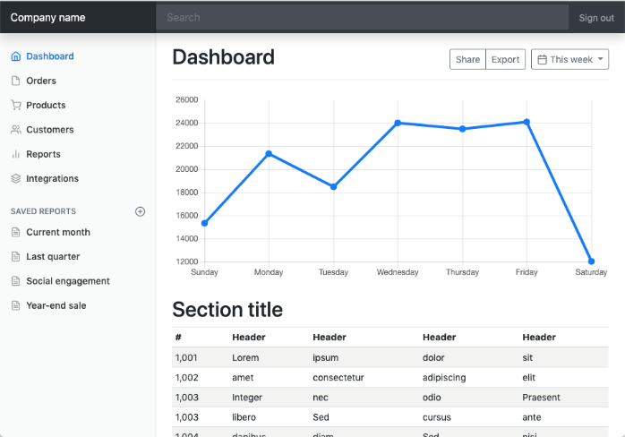

You will need to create a 1-page proposal that includes:

* A brief articulation of your chosen topic and rationale
* A link to your data set(s) and a screenshot of the metadata if it exists.
* 3 or 4 screenshots of relevant, “inspiring” visualizations that frame your creative fodder
* A sketch of the final design
* A link to the primary GitHub repository you’ll be housing your work in