Weak Prompts:
- Regression is the prediction of one thing based on another. Think of it as the more sleep you get during the night, the less tired you’ll feel in the morning. Regression can assist in predicting trends and making predictions themselves. For example, the more someone practices driving a car with an instructor, the more skilled and confident they become driving within their own time.
  - The reason in which I feel as if my explanation is a little bit stronger is because I related it to a trend that I can relate to such as driving. 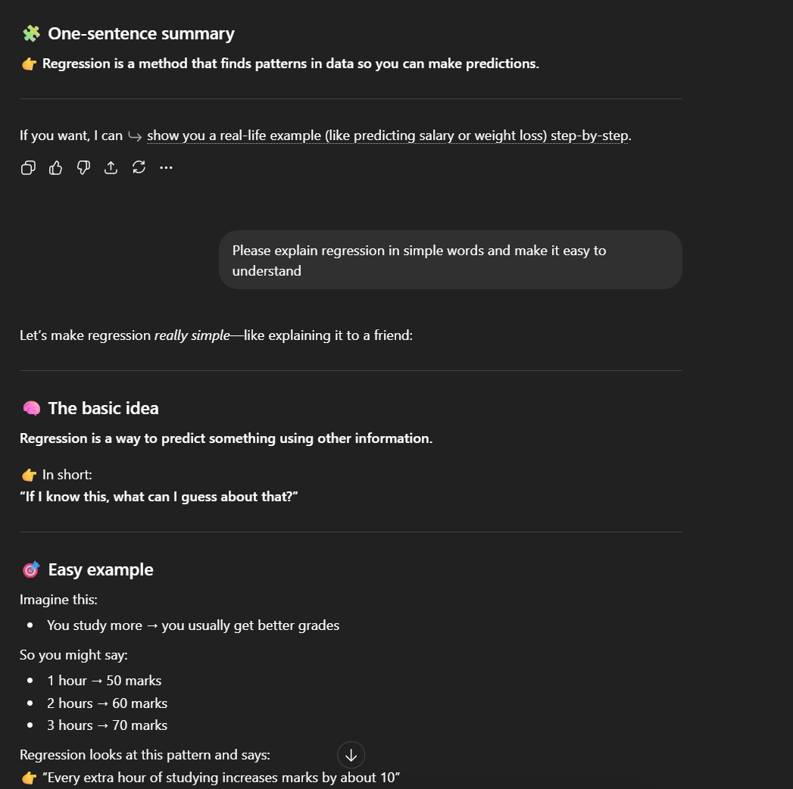
- SQL is the way to speak to a database and it’s a simple language used to ask questions as well. SQL is useful because it gathers information from apps or websites, analyzes that same data, and provides an answer quickly.
  - My explanation is a little bit stronger because it pulls all the information together and words it a little bit differently than what was provided. 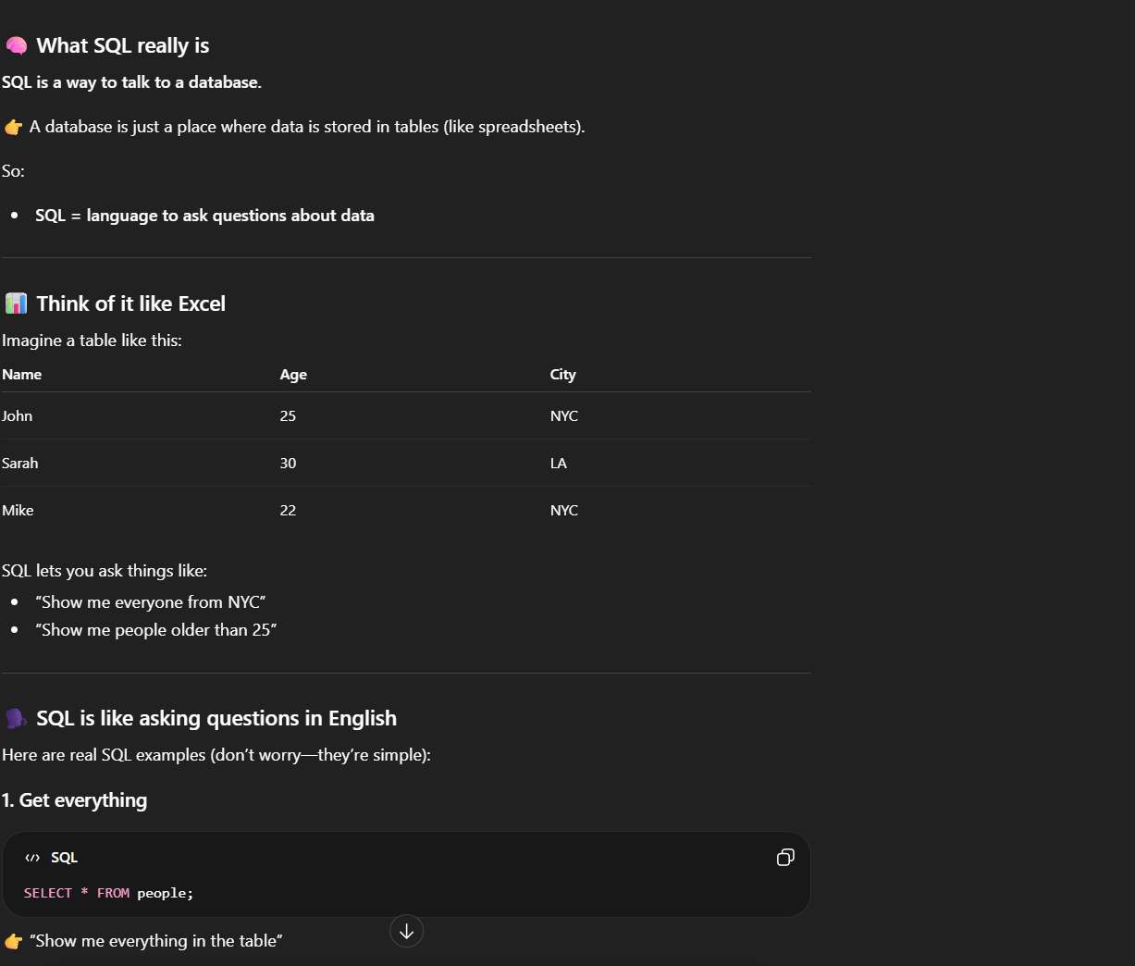
- This dataset is a little bit more stronger for me because it shows which class has the highest and/or lowest number of books checked out from the library and helps me to understand the data a little better in the sheet as well.
  - 