Missing Italian Translations — Screenshot Issue Brief
Source: Italian Localization and Translation Deficit Analysis. Feedback collected from Italian Property Managers and internal sales communications.

1. Unified Inbox and Messaging
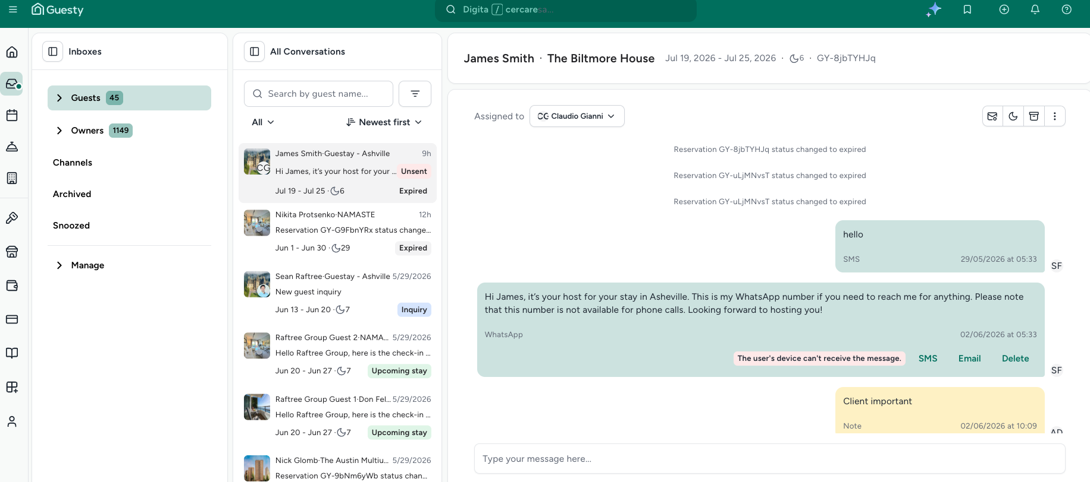
Issue: Unified Inbox lacks integrated real-time message translation. Inbox system/error strings remain in English (e.g. “The user's device can't receive the message.”, “Unsent”) even when the user is operating in an Italian context. Italian clients report falling back to Airbnb/Booking.com native apps to communicate with guests.
Expected outcome: Inbox supports real-time guest message translation into Italian, and all inbox UI/status/error strings are fully localized so users can manage guest communication entirely inside Guesty.
Account that reported: Reported via Italian Property Managers / internal sales. Screenshot shows conversation assigned to Claudio Gianni (CC).

2. Guest Communication and Quote Modules
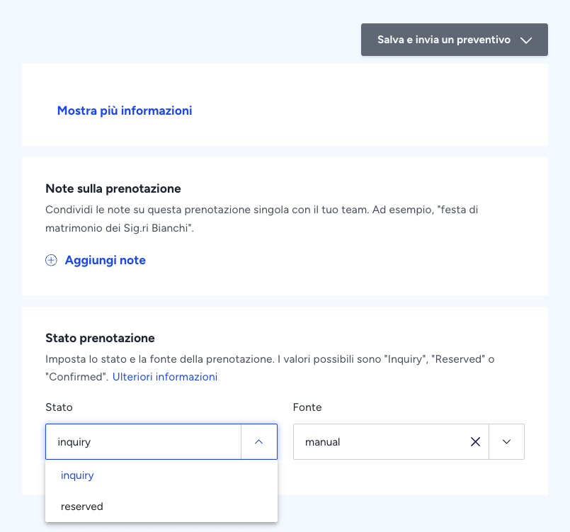
Issue: Quote/booking UI is partially Italian, but key field values stay in English (Status: inquiry / reserved; Source: manual). Quotes sent to Italian clients are often generated entirely in English; email templates may show raw variables; quote links can fail or spin indefinitely on localized browsers.
Expected outcome: Quotes, email templates, and related dropdown/status values render fully in Italian; template variables resolve correctly; quote links open reliably on Italian-locale browsers.
Account that reported: Italian Property Managers / Italian clients (account name not shown on screenshot).

3. Analytics and Financial Reporting
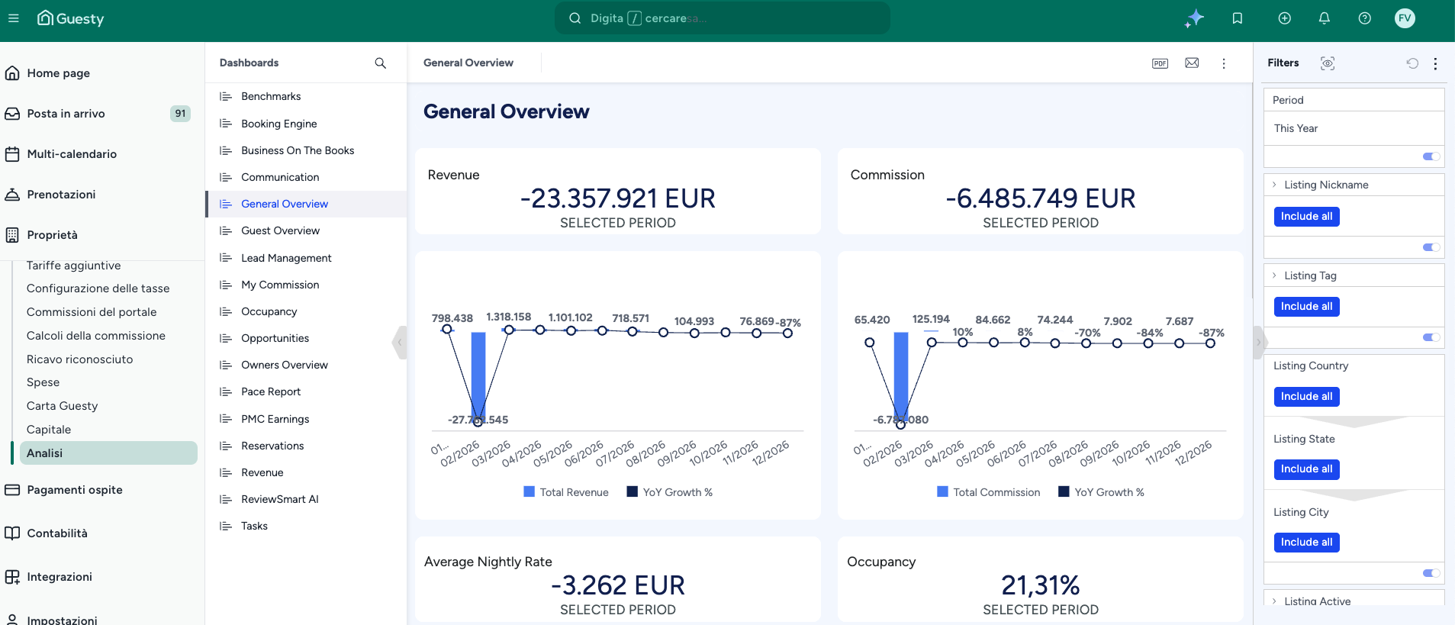
Issue: Analytics is only partially localized. Sidebar is Italian (Analisi), but dashboard title, metric labels, and filters remain English (General Overview, Revenue, Listing Nickname / Tag / Country / State / City). Italian PMCs struggle with untranslated billing/accounting terms.
Expected outcome: Analytics dashboards, filters, and financial terminology are fully translated to Italian so owners and PMCs can review performance and reconciliations in their language.
Account that reported: Flavio (user initials FV on screenshot).

4. Owner Portal — Reports / Settings
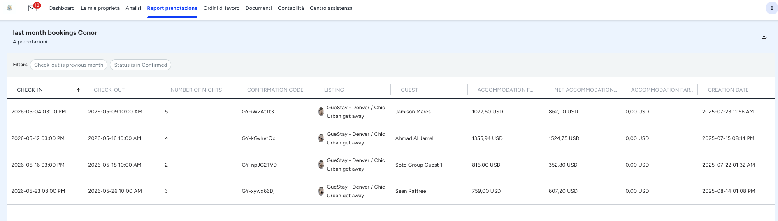
Issue: Owner Portal retains untranslated English strings in reports and customization menus (e.g. report title “last month bookings Conor”, English column headers such as CHECK-IN, CONFIRMATION CODE, ACCOMMODATION FARE), while surrounding navigation is Italian. This confuses Italian owners and forces PMCs to explain the UI manually.
Expected outcome: Owner Portal report titles, column headers, settings, and customization menus are fully Italian when the account language is set to Italian.
Account that reported: Visible in screenshot as report for Conor (GueStay); portal user avatar “B”. Captured from Italian PM / owner portal feedback.

5. Reservations UI (mixed localization)
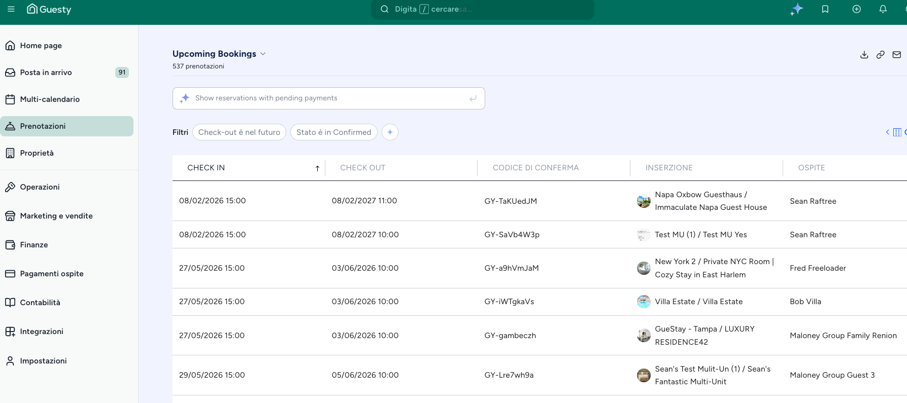
Issue: With Italian language enabled, primary page chrome stays English: “Upcoming Bookings”, “Show reservations with pending payments”, while sidebar and some table headers are Italian. Inconsistent localization reduces trust and usability.
Expected outcome: All reservation list titles, helper links, filters, and table chrome match the Italian locale consistently.
Account that reported: Italian Property Manager session (same Italian-locale account family as other screenshots; specific account name not labeled on this frame).

6. Guesty Co-Pilot and AI search bars
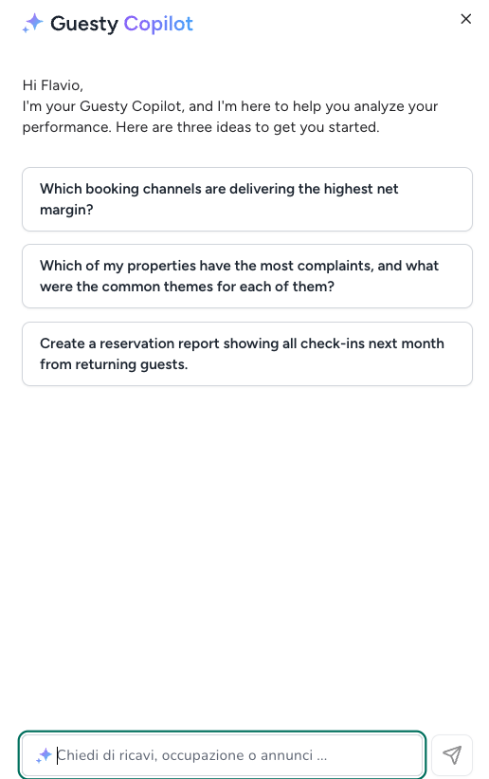
Issue: Co-Pilot greeting and suggested prompts remain English (“Which booking channels…”, “Which of my properties…”, “Create a reservation report…”) while the input placeholder is Italian (“Chiedi di ricavi, occupazione o annunci…”). Suggestions and sentences are still in English.
Expected outcome: Co-Pilot greeting, suggestion chips, and AI search/suggestion text all appear in Italian when the user’s language is Italian.
Account that reported: Flavio (Copilot greets “Hi Flavio”).

Additional gaps (no screenshot in source PDF)

7. Help Center
Issue: Italian Help Center was recently released, but technical guides still gap out and often redirect to English for complex troubleshooting.
Expected outcome: Italian Help Center articles fully cover advanced troubleshooting without forcing English redirects.
Account that reported: Italian Property Managers (early feedback after Italian Help Center launch).

8. Localized data fields (compliance)
Issue: No native UI field for Italian fiscal “Codice Fiscale” (Tax Code). Custom fields are a workaround only, complicating automated check-in and fiscal reporting.
Expected outcome: Standardized native Codice Fiscale field available for Italian guest data and compliance flows.
Account that reported: Italian Property Managers (compliance / fiscal requirement feedback).

Reporting summary: Named users/accounts visible in the source screenshots are Flavio (FV) for Analytics and Co-Pilot, Claudio Gianni (CC assignee) on the Inbox example, and Conor / GueStay on the Owner Portal report. The PDF overall attributes the feedback set to Italian Property Managers and internal sales communications.

