**OpenCV Tasks- Milestone 2**

**TASK 1:**

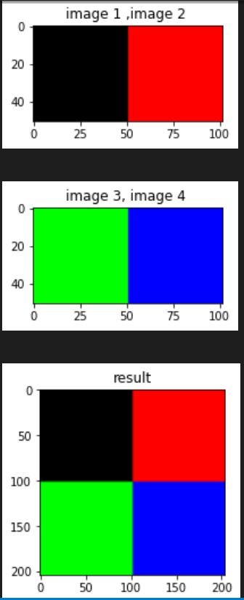Create 4 images, each image has a dimension of 50x50 and a distinct color. After creating the image attach them together to make an image of dimension 200x200.

no input create image by code --- do not read the image from your laptop

**Task2**

Read frames from any camera. Press Q to terminate the code, R to rotate the frame 90 degrees, C to save the frame on your device, S to save a video stream using OpenCV. G to convert the frame to grayscale, H to convert the frame to HSV space, and X to show (grayscale, HSV, rotated and original frames) together, Z to show only the original frame.

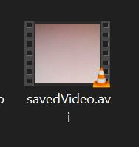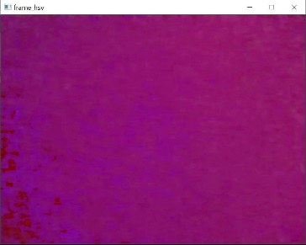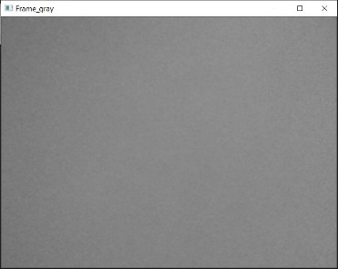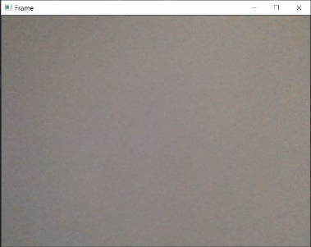output G h s

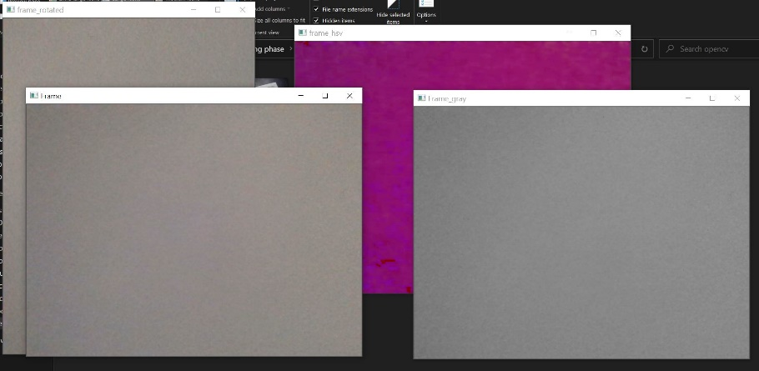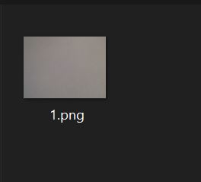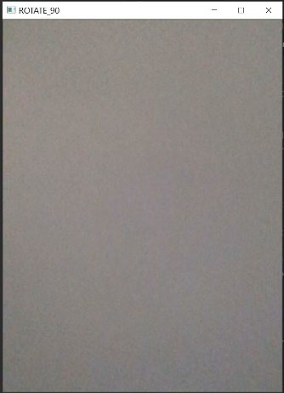 r c x

z 🡪 return to output stream

**Task 3**

Read task 3.1 (Determining the location where the float will next surface) written in mate’s 2022 manual. After reading the manual draw the map using OpenCV and solve the problem. Assume that the co-pilot is going to enter the problem’s numbers manually using the terminal.

Inputs 🡪 angle = 103 degree

Speed = 0.143

Time = 144

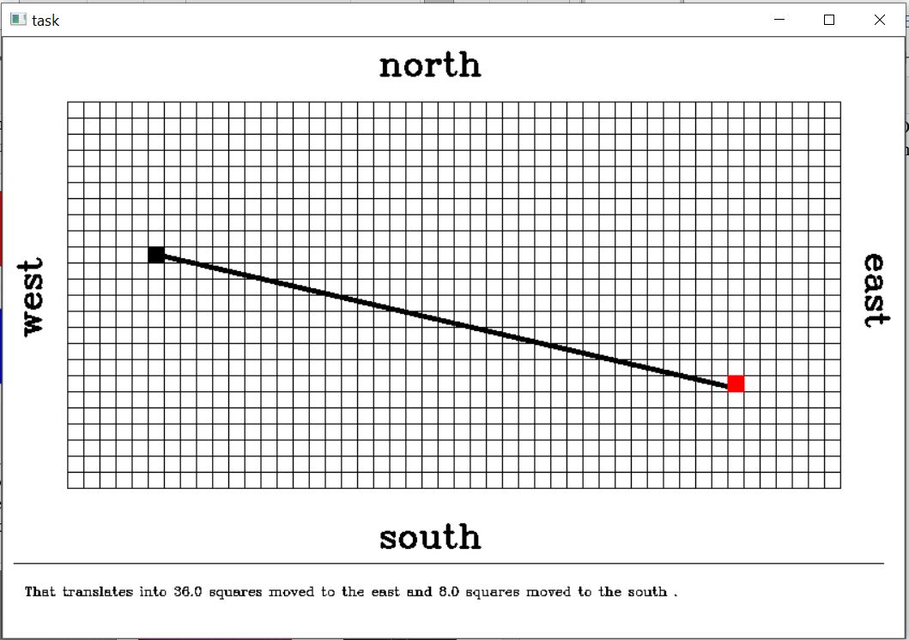Output

**Task4:**

Use OpenCV’s Callback Function to code a script that can draw circles and delete them. The deletion feature should allow the user to delete the last drawn circle or all of them.

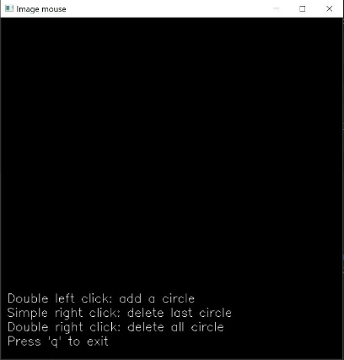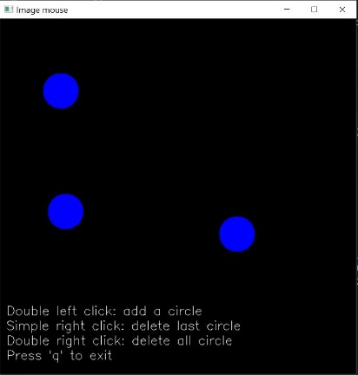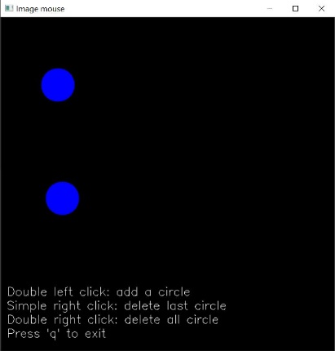Output double left click 3 times simple right click one time double right click

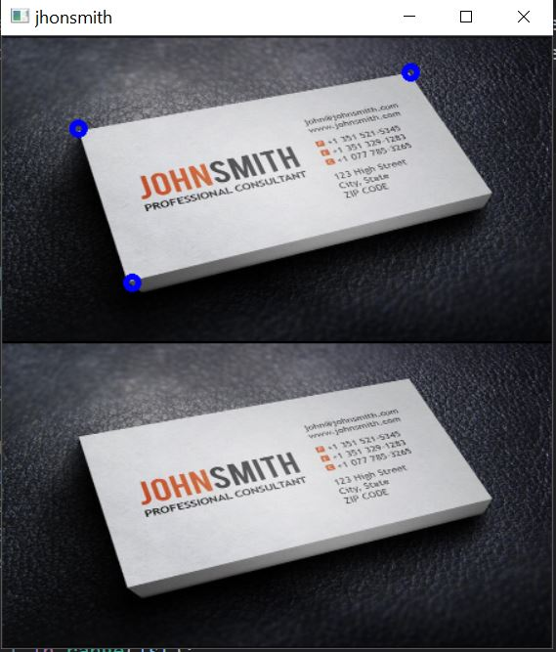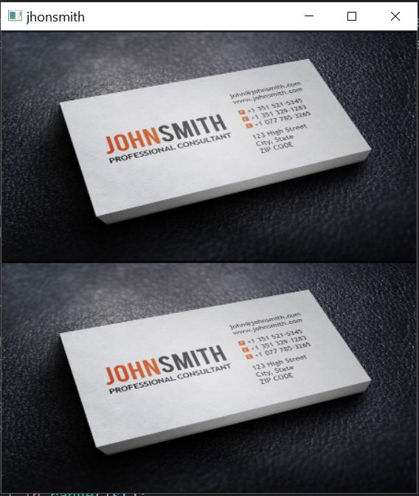**Task5**:The given image has a book, your task is to define some points on the book using OpenCV’s Callback Function those points should help represent the book in bird’s eye view.

Output detect the point result

**Task6:**

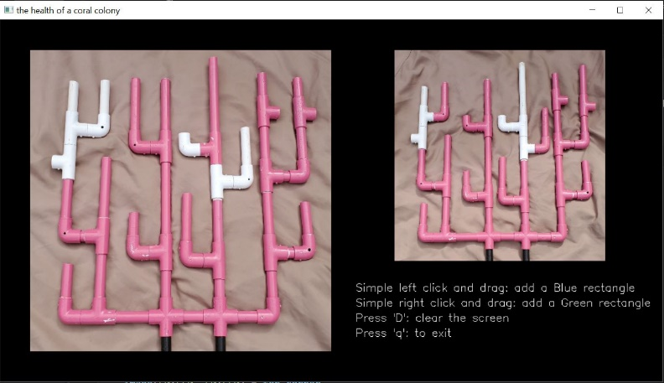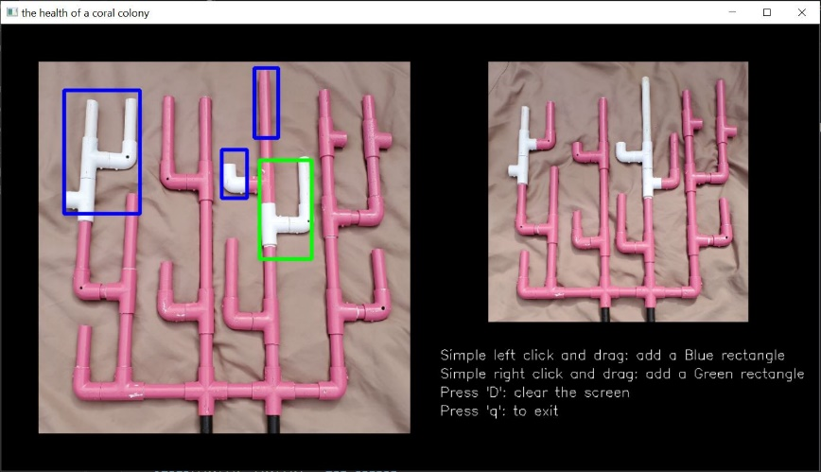Read task 2.2 (Using image recognition to determine the health of a coral colony by comparing its current condition to past data) written in mate’s 2021 manual and attempt the task manually using OpenCV’s Callback Function. Your code should work on all of the given images.

output

The layout doesn’t have to be the same

Using the mouse clicks you can draw the

boxes