Class Diagram

CardFace

CardSuit
4
52
13
CardImage

1 1 1

Card

52

1

DeckOfCard

1

1
Game

Use Case Diagram

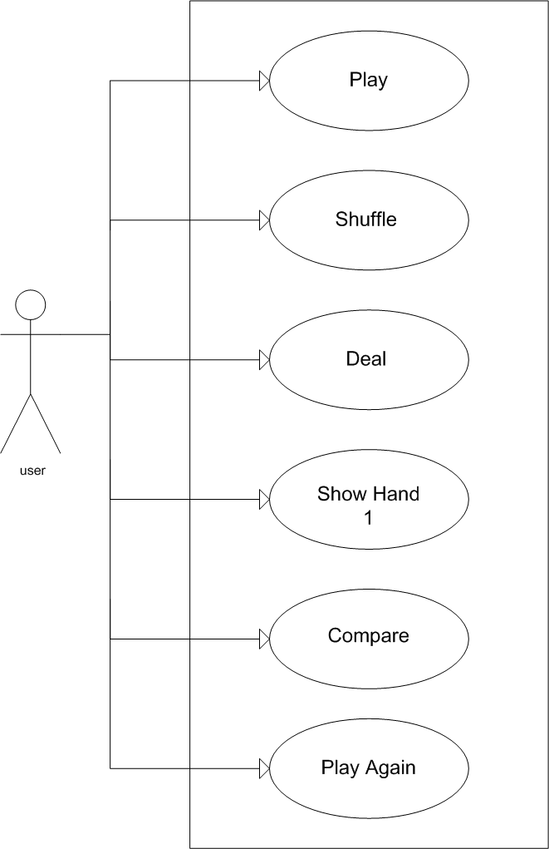

Scenario Description
Use case: Play
- Precondition(s):
- Steps: Enter the name, and access the game.
- Post-condition(s): Shuffle the cards.

Use case: Shuffle
- Precondition(s): The cards must be in the deck.
- Steps: Shuffle the cards.
- Post-condition(s): Deal (distribute) the cards

Use case: Deal
- Precondition(s): The cards must be shuffled.
- Steps: Deals only 5 cards, not less or not more for both hands.
- Post-condition(s): Show the hands.

Use case: Show Hand
- Precondition(s): The deal must be done.
- Steps: Display player’s card.
- Post-condition(s): Compare both user and computer hands.

Use case: Compare Hands
- Pre-condition: The user’s cards must be shown.
- Steps:
The first Step when comparing the hands is to identify the type of hands of each player. If it is one pair, or two pairs and so on.
Check better for better and. Where a Hand of Two Pairs wins a Hand of One Pair for example.
In case of both hands has only one Pair or only two Pairs; see which face is bigger than the other.
In case there is a tie on the pairs, it will be decided on the Higher Rank card that each hand holds.
If there’s a tie in everything, the game will have to start over again.
Post-Condition: Display the Winner, and then give the adequate points on the winner player.

Use case: Play Again
- Precondition(s): Result of the previous game need to be displayed.
- Steps: Play game.
- Post-condition(s): Shuffle the cards.

Activity Diagram

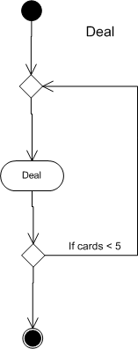
Figure 1 Play Game

Figure 2 Deal (distribute) Cards



Figure 4 Shuffle the Cards
Figure 3 Show Player Hand

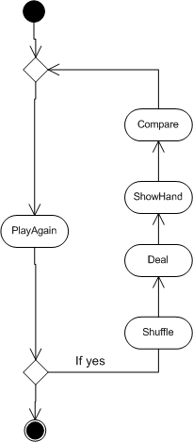
Figure 5 Compare Hands
Figure 6 Play Again

CardFace
- cardFace : int
+ getCardFace() : int
+ getFace() :
End of class
CardSuit
- cardSuit : int
+ getCardSuit() : int
+ getSuit() : CardSuit
End of class
CardImages
- cardImage : String
+ getCardImages() : String
End of class
Cards
- cardFace : CardFace
- cardSuit : CardSuit
- cardImage : String
+ getCardFace() : CardFace
+ getCardSuit() : CardSuit
+ getCardImage() : String
End of class
Attributes of the classes

DeckOfCards
# deckofCards : ArrayList<Card>
# myCards : Card
face : CardFace
- hand1 : int
- hand2 : int
+ getDeckofCards() : Card
+ isOnePair() : boolean
+ isTwoPair() : boolean
+ isThreeOfAKind() : boolean
+ isStraight() : boolean
+ isFlush() : boolean
+ isStraightFlush() : boolean
+ isRoyalFlush() : boolean
+ isFourOfKind() : boolean
+ isOnePair2() : boolean
+ isTwoPair2() : boolean
+ isThreeOfAKind2() : boolean
+ isStraight2() : boolean
+ isFlush2() : boolean
+ isStraightFlush2() : boolean
+ isRoyalFlush2() : boolean
+ isFourOfKind2() : boolean
End of class

