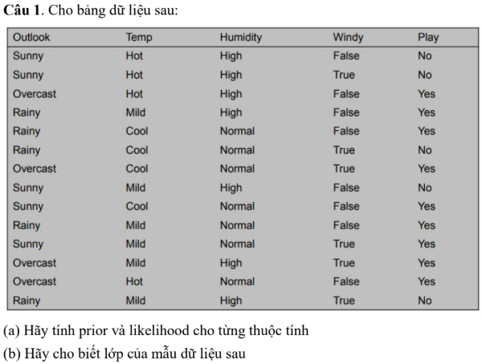

(a) Prior (P lớp) và likelihood (P(attr | class))
- Prior:
  - $P(\text{Play}=Yes)=\frac{9}{14}≈0.6429$
  - $P(\text{Play}=No)=\frac{5}{14}≈0.3571$
- Likelihood cho các thuộc tính (đếm tần suất, không smoothing):
  - Outlook
    - $P(\text{Sunny}∣Yes)=2/9≈0.2222$
    - $P(\text{Overcast}∣Yes)=4/9≈0.4444$
    - $P(\text{Rainy}∣Yes)=3/9≈0.3333$
    - $P(\text{Sunny}∣No)=3/5=0.6$
    - $P(\text{Overcast}∣No)=0/5=0$
    - $P(\text{Rainy}∣No)=2/5=0.4$
  - Temperature
    - Yes: Hot=2/9 ≈0.2222, Mild=4/9 ≈0.4444, Cool=3/9 ≈0.3333
    - No: Hot=2/5 =0.4, Mild=2/5 =0.4, Cool=1/5 =0.2
  - Humidity
    - Yes: High=3/9≈0.3333, Normal=6/9≈0.6667
    - No: High=4/5=0.8, Normal=1/5=0.2
  - Windy
    - Yes: False=6/9≈0.6667, True=3/9≈0.3333
    - No: False=2/5=0.4, True=3/5=0.6
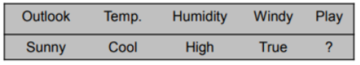
(b) Phân lớp mẫu: Outlook=Sunny, Temp=Cool, Humidity=High, Windy=True
Tính (Naive Bayes, giả thiết độc lập có điều kiện):
- Tích cho lớp Yes:
$$\begin{matrix}{\text{score}}_{Yes} & =P(Yes)⋅P(Sunny∣Yes)⋅P(Cool∣Yes)⋅P(High∣Yes)⋅P(True∣Yes) \\ & =\frac{9}{14}⋅\frac{2}{9}⋅\frac{3}{9}⋅\frac{3}{9}⋅\frac{3}{9}≈0.0052910053\end{matrix}$$
- Tích cho lớp No:
$$\begin{matrix}{\text{score}}_{No} & =P(No)⋅P(Sunny∣No)⋅P(Cool∣No)⋅P(High∣No)⋅P(True∣No) \\ & =\frac{5}{14}⋅\frac{3}{5}⋅\frac{1}{5}⋅\frac{4}{5}⋅\frac{3}{5}≈0.0205714286\end{matrix}$$
Kết luận: ${\text{score}}_{No}>{\text{score}}_{Yes}$→ phân lớp Play = No.
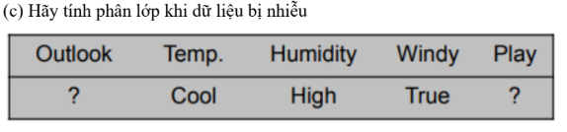
(c) Phân lớp khi thiếu thuộc tính Outlook (bỏ Outlook)
Chỉ dùng Temp=Cool, Humidity=High, Windy=True:
- Score Yes:
$${\text{score}}_{Yes}^{(\text{no Outlook})}=P(Yes)⋅P(Cool∣Yes)⋅P(High∣Yes)⋅P(True∣Yes)=\frac{9}{14}⋅\frac{3}{9}⋅\frac{3}{9}⋅\frac{3}{9}≈0.0238095238$$
- Score No:
$${\text{score}}_{No}^{(\text{no Outlook})}=P(No)⋅P(Cool∣No)⋅P(High∣No)⋅P(True∣No)=\frac{5}{14}⋅\frac{1}{5}⋅\frac{4}{5}⋅\frac{3}{5}≈0.0342857143$$
Kết luận (không có Outlook): ${\text{score}}_{No}>{\text{score}}_{Yes}$→ Play = No.
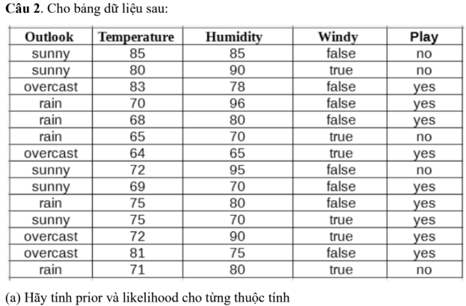
(a) Tính prior và tham số Gaussian (mean, variance) cho Temperature và Humidity theo từng lớp
- Số mẫu: tổng = 14, Yes = 9, No = 5
- Priors:
  - $P(Yes)=9/14≈0.6429$
  - $P(No)=5/14≈0.3571$
- Tập nhiệt độ (Temperature) theo lớp:
  - Yes temperatures: $[83,70,68,64,69,75,72,81,75]$→ $n_{Yes}=9$
    - Mean: $μ_{T∣Yes}=73.0$
    - Variance (population): $σ_{T∣Yes}^{2}≈33.7777778$
  - No temperatures: $[85,80,65,72,71]$→ $n_{No}=5$
    - Mean: $μ_{T∣No}=74.6$
    - Variance: $σ_{T∣No}^{2}≈49.84$
- Tập độ ẩm (Humidity) theo lớp:
  - Yes humidities: $[78,96,80,65,70,80,90,75,70]$
    - Mean: $μ_{H∣Yes}≈78.2222222$
    - Variance: $σ_{H∣Yes}^{2}≈86.8395062$
  - No humidities: $[85,90,70,95,80]$
    - Mean: $μ_{H∣No}=84.0$
    - Variance: $σ_{H∣No}^{2}=74.0$
- Windy conditional (Bernoulli estimate):
  - $P(Windy=True∣Yes)=\frac{\#(Windy=True∧Yes)}{9}=\frac{3}{9}=0.3333$
  - $P(Windy=True∣No)=\frac{\#(Windy=True∧No)}{5}=\frac{3}{5}=0.6$
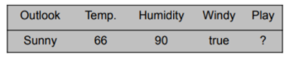
(b) Phân lớp mẫu: Outlook=Sunny, Temperature=66, Humidity=90, Windy=True
Gaussian likelihood cho biến thực $x$(với mean $μ$, var $σ^{2}$):
$$N(x∣μ,σ^{2})=\frac{1}{\sqrt{2πσ^{2}}}exp⁡\text{,}(-\frac{(x-μ)^{2}}{2σ^{2}})$$
- Tính likelihoods:
  - For class Yes:
    - $p(T=66∣Yes)=N(66;μ_{T∣Yes}=73.0,σ^{2}=33.7778)≈0.0012226$
    - $p(H=90∣Yes)=N(90;μ_{H∣Yes}=78.2222,σ^{2}=86.8395)≈0.0551634$
    - $P(Windy=True∣Yes)=0.3333$
    - Product likelihood ≈ $0.0012226×0.0551634×0.3333≈0.0002133785$
    - Multiply prior $P(Yes)=9/14$→ posterior unnormalized:
$${\text{score}}_{Yes}≈0.0001371719$$
  - For class No:
    - $p(T=66∣No)=N(66;μ_{T∣No}=74.6,σ^{2}=49.84)≈0.0015660$
    - $p(H=90∣No)=N(90;μ_{H∣No}=84.0,σ^{2}=74.0)≈0.3749$
    - $P(Windy=True∣No)=0.6$
    - Product likelihood ≈ $0.0015660×0.3749×0.6≈0.0005870728$
    - Multiply prior $P(No)=5/14$→ posterior unnormalized:
$${\text{score}}_{No}≈0.0002096689$$
So sánh: ${\text{score}}_{No}≈2.0967×{10}^{-4}>{\text{score}}_{Yes}≈1.3717×{10}^{-4}$
Kết luận: mẫu được phân lớp No.
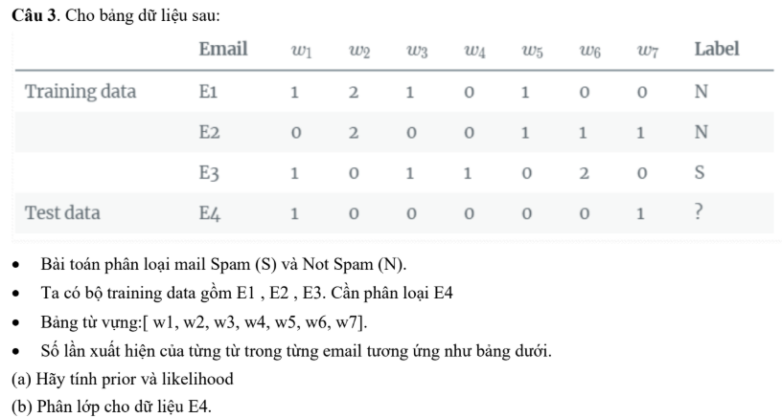
(a) Prior và likelihood (Laplace smoothing)
- Priors:
  - $P(N)=\frac{2}{3}$(E1,E2), $P(S)=\frac{1}{3}$(E3)
- Word counts per class (sum over training emails of that class):
  - Class N: counts N = E1 + E2 = $[1,4,1,0,2,1,1]$, total N = 10
  - Class S: counts S = E3 = $[1,0,1,1,0,2,0]$, total S = 5
  - Vocabulary size $V=7$
- Áp Laplace smoothing (α = 1):
$$P(w_{i}∣class)=\frac{\text{count}(w_{i},class)+α}{\text{total_words_in_class}+V}$$
  - Với class N (totalN=10):
    - $P(w1∣N)=(1+1)/(10+7)=2/17≈0.1176471$
    - $P(w2∣N)=(4+1)/17=5/17≈0.2941176$
    - $P(w3∣N)=2/17≈0.1176471$
    - $P(w4∣N)=1/17≈0.0588235$
    - $P(w5∣N)=3/17≈0.1764706$
    - $P(w6∣N)=2/17≈0.1176471$
    - $P(w7∣N)=2/17≈0.1176471$
  - Với class S (totalS=5):
    - $P(w1∣S)=(1+1)/(5+7)=2/12≈0.1666667$
    - $P(w2∣S)=(0+1)/12=1/12≈0.0833333$
    - $P(w3∣S)=2/12≈0.1666667$
    - $P(w4∣S)=2/12≈0.1666667$
    - $P(w5∣S)=1/12≈0.0833333$
    - $P(w6∣S)=(2+1)/12=3/12=0.25$
    - $P(w7∣S)=1/12≈0.0833333$
(b) Phân lớp E4 = $[1,0,0,0,0,0,1]$
- Multinomial likelihood (product of $P(w_{i}∣class)^{count_{i}}$):
  - For class N:
$$L(E4∣N)=P(w1∣N)^{1}⋅P(w7∣N)^{1}=0.1176471×0.1176471≈0.01384083045$$
Posterior unnormalized: $P(N)⋅L≈\frac{2}{3}×0.0138408≈0.00922722$
  - For class S:
$$L(E4∣S)=P(w1∣S)^{1}⋅P(w7∣S)^{1}=0.1666667×0.0833333≈0.0138888889$$
Posterior unnormalized: $P(S)⋅L≈\frac{1}{3}×0.0138889≈0.00462963$
Kết luận: posterior unnormalized của class N lớn hơn của S, nên E4 được phân loại là Not Spam (N).

