GED Tutor Administrator Guide
  - Create accounts and math templates and build GED practice sets
This guide is for new administrators at https://gedtutor.org. Learn how to add students, use ChatGPT or Claude to generate math templates with answers, import a file, check templates, create practice sets, and review each attempt.
The example is GED Demo Guide LCM and Decimal, with five LCM questions and five decimal multiplication questions. It was published in the GED course. Button names in this guide match the English website interface.

Sign in and open administration
1. Open https://gedtutor.org and select Log in.
2. Enter your administrator email and assigned password, then select Log in. The example account is dummyadmin@gedtutor.org.
3. From the learning area, click your username or Go to the admin page to open administration.
4. Use Users for accounts, Math templates for question templates, Practice sets to build exercises, and Reports to review progress.
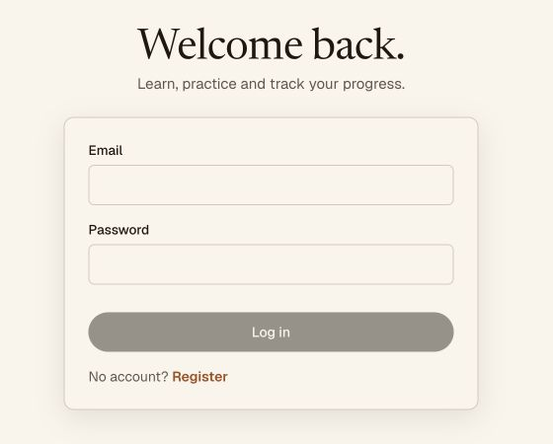
Figure 1 The login form with no password displayed
Use your assigned password. Keep passwords out of AI prompts, import files, and shared guides. Select Log out when you finish on a shared computer.

Add and find students
1. Open Users and select New account.
2. Enter Email and Full name. Set Initial password according to the displayed requirement of at least eight characters.
3. Select Student for a learner. Select Administrator only when the person needs administrator access.
4. Optionally enter comma-separated Tags to group students, such as GED or a class name.
5. Check the email, name, and role, then select Create account. Give the login details directly to the student.
6. Use Search email or Search name to find an account. Click the email to view its profile, Practice access, and Practice history.
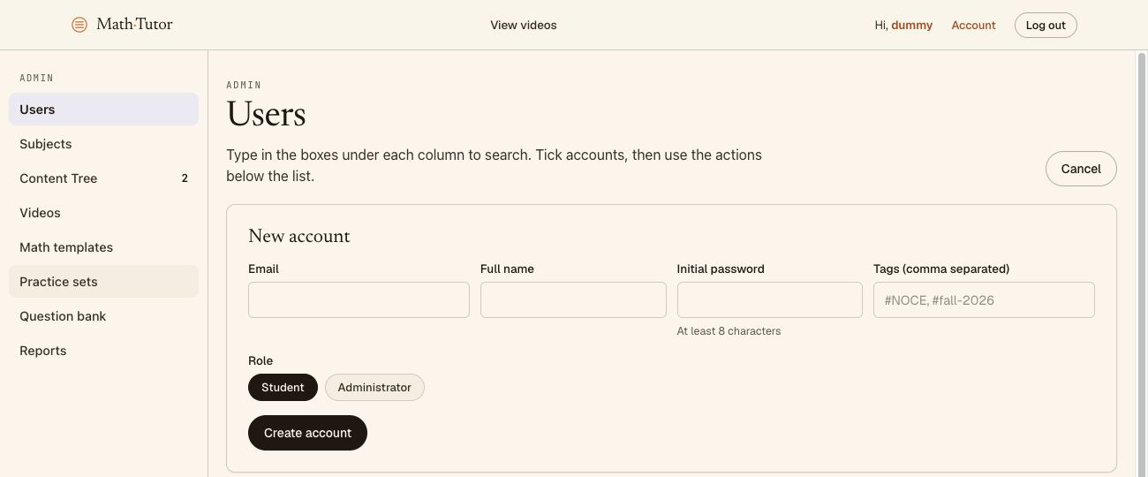
Figure 2 The New account form and its required fields
The account student1@gedtutor.org already exists, so there is no need to create a duplicate. The screenshot shows the form only; no additional account was created for this guide.

Generate math templates with ChatGPT or Claude
A math template is a family of questions. Variables such as a and b receive random values during practice, and answer_formula calculates the answer from those values. A single fixed answer cannot cover the entire family.
Open ChatGPT or Claude, attach ged-demo-templates.json, and use the following prompt. The AI needs the question structure and file format, without student lists or passwords.
Create a UTF-8 JSON file for GED Tutor using the exact
structure of the attached ged-demo-templates.json.
Create two question families under subject GED:
1. LCM of two integers from 2 to 20.
2. Multiply decimals from 1.1 to 9.9 with scale 1.
Use new labels and IDs that do not duplicate existing ones.
Include a LaTeX template, variables, answer_formula,
numeric answer_mode, constraints, and a worked example.
Use lcm(a,b) for LCM and a*b for decimal multiplication.
Keep template and template_latex consistent.
Set tolerance to 0 and use exact answers without rounding.
Keep key names unchanged and avoid unsupported features.
Check at least five variable combinations per template.
Return valid JSON only, without Markdown in the file.

Two examples for a quick check
Template | Example question | Formula | Answer
LCM | LCM of 12 and 18 | lcm(a,b) | 36
Decimal product | 1.2 × 2.5 | a*b | 3
In JSON, escape LaTeX backslashes: \times in a question is stored as \\times in a JSON string. Use one backslash in the website LaTeX field. A placeholder such as {a} needs a matching a entry in variables.
AI may produce incorrect formulas or syntax. Check example answers by hand and use Preview before publishing. The accompanying file contains two examples generated by ChatGPT, rather than a complete GED question bank.

Import a file and confirm the result
1. Save the AI output as ged-demo-templates.json in UTF-8. Avoid saving it as .docx or .txt, and remove any ```json code fences.
2. Open Math templates and select Import file….
3. Choose the .json file on your computer and click Upload or Open in the file picker.
4. Wait for processing. Check messages and the template count, then look for Demo Guide LCM or Demo Guide Decimal multiplication.
5. Open each new template and check its subject, variables, LaTeX, and answer formula. Confirm import only after the new templates appear and can be opened.
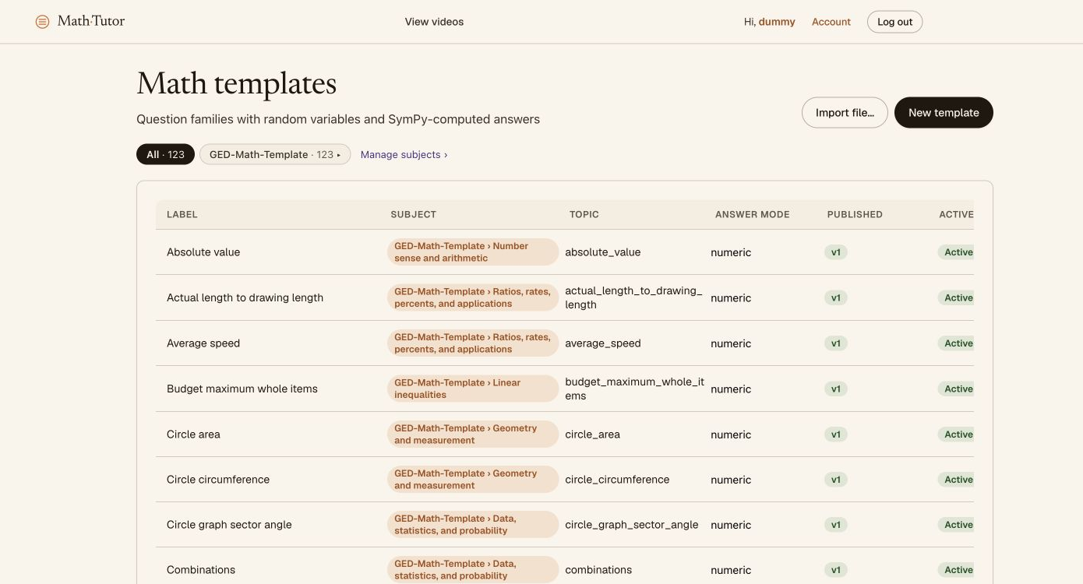
Figure 3 The Import file button in Math templates
Selecting a file alone does not confirm import. If no new template or message appears, reload and check again. If it is still missing, keep the file and report the issue to the site administrator. Avoid repeated imports until you know whether they create duplicates.
During the check on October 5, 2026, selecting the file in Safari produced no success message and the count remained 123. Import of the two accompanying templates was not confirmed. Use New template for manual entry while the import issue is being investigated.

Check and publish a math template
1. Open New template or an imported template. Enter Label and Topic and select the appropriate Subject.
2. Fill in Question template (LaTeX) and Answer formula. For LCM, use placeholders {a:2–20} and {b:2–20} with the formula lcm(a,b).
3. Choose Numeric for typed answers, Multiple choice for options, or Display only for content that is not graded.
4. For decimals, set Variables (JSON) to type decimal with scale 1. Add Constraints when necessary to prevent division by zero or invalid combinations.
5. Click Preview to inspect questions and answers. Check random values, fraction rendering, and calculated results.
6. Use Create draft, then Validate and Publish if those buttons appear for the draft. Confirm that its version is published before adding it to a practice set.
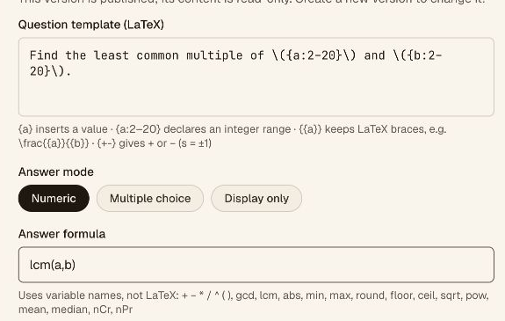
Figure 4 The LaTeX question and answer formula fields
A published version is read-only. Use + New version to change its content. Active allows the template to be used for new attempts. After editing, check Preview and the version status again before using it.

Create a practice set in the GED course
1. Open Practice sets and select New practice set.
2. Select GED. On this website, the GED course is under the Math subject; a template subject label may differ from the course name.
3. Enter a Title, such as GED Demo Guide LCM and Decimal. Set Pass threshold (%) to 60.
4. Leave Time limit blank for no time limit and Max attempts blank for unlimited attempts, as indicated by the current placeholders.
5. Select Create draft to open the content editor.
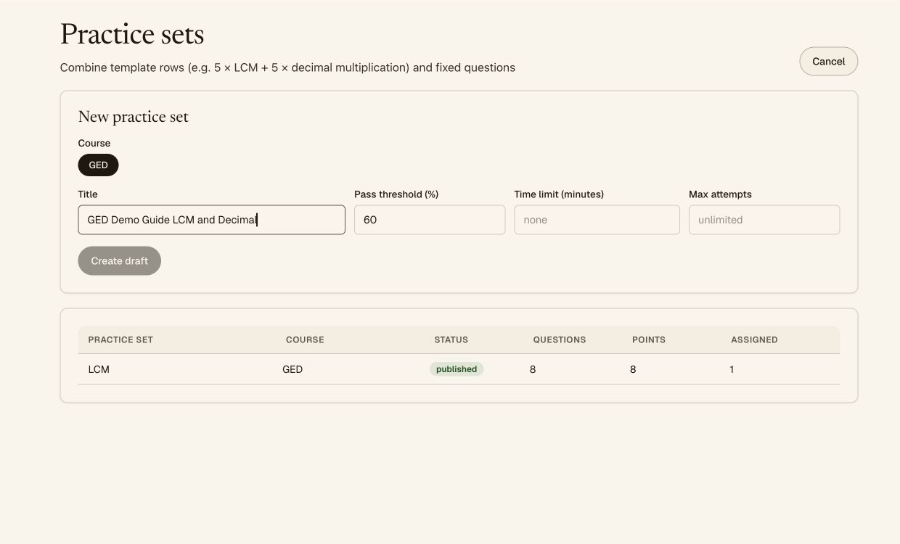
Figure 5 Selecting GED and configuring the practice set
A descriptive title helps administrators and students identify the content. If you need time or attempt limits, enter them before publishing and explain them to students.

Combine five LCM and five decimal questions
1. In Add templates, search for LCM using Search templates. Set Questions to 5 and click + Add.
2. Search for Decimal multiplication, set Questions to 5, and click + Add.
3. In Template rows, select Fill in or Multiple choice for each row. Set Points per question to 1.
4. Confirm a total of 10 questions and 10 points. Row order determines the order of question groups; values inside questions are generated randomly.
5. Click Save draft, then Preview questions. Check answers from both groups. Preview does not create a student attempt.
6. When the content is correct, select Publish and confirm the published status. Students still need access assigned to this set.
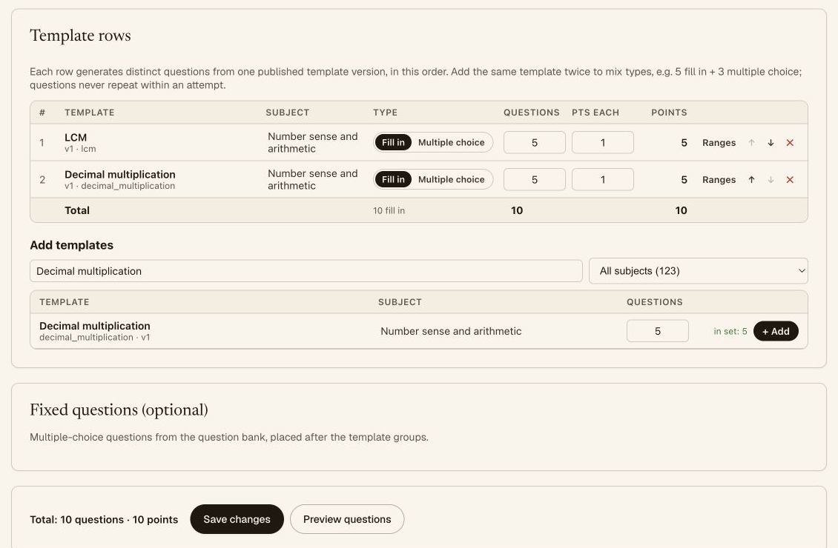
Figure 6 Two template rows totaling ten questions and ten points
The example set was published. Each student attempt receives its own questions. The website states that Save changes on a published set affects new attempts, while earlier attempts retain their original questions.

Assign practice and review individual attempts
1. Open Users, find the student email, and open the profile.
2. In Practice access, find the published set. When Assign is enabled, click it and confirm that Access changes to Assigned.
3. The student signs in and opens Practice to see assigned sets. If the set is missing, check the account, set status, and Assigned access.
4. In Practice history, review the set name, attempt number, status, Score, Passed result, and attempt times.
5. Review Accuracy by skill to identify weak topics. Reports summarizes attempts, average scores, and accuracy by topic.
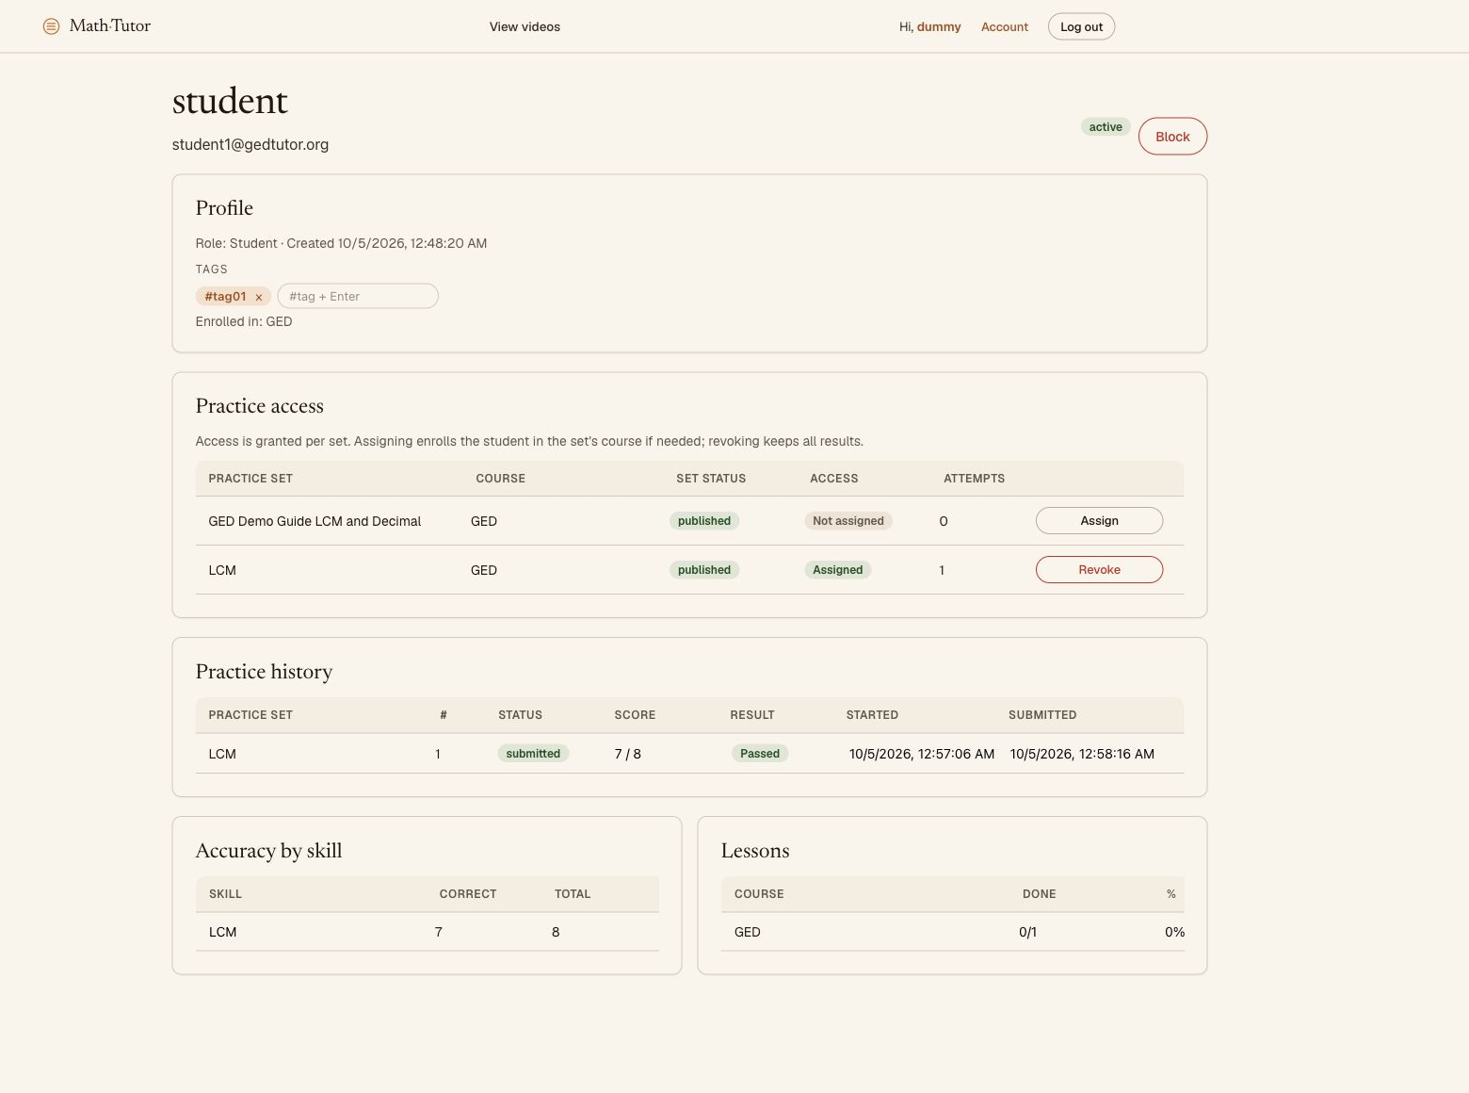
Figure 7 A student profile with practice access and score history
During this demonstration, Assign and Revoke were disabled for dummyadmin. The new demo set could not be assigned to student1 with this account. If you encounter this, ask an administrator to check permissions. Publishing alone does not confirm student access.
The existing LCM set was already Assigned to student1. The new demonstration was attempt 2 and scored 8/8; the earlier attempt scored 7/8. These are practice records used to illustrate the guide.

Read reports and resolve common issues
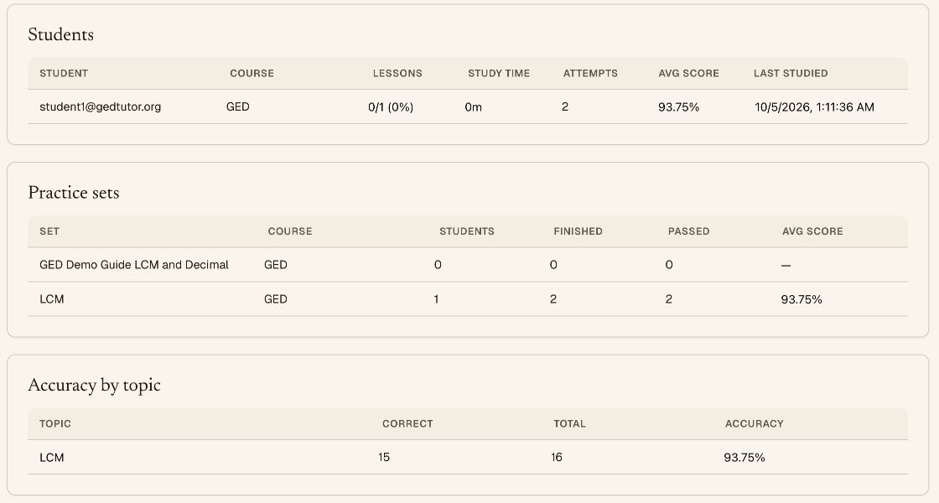
Figure 8 Reports showing attempts and scores by student course and topic
1. Open Reports and select GED to focus on that course.
2. Attempts counts attempts, and Avg score shows the average score of completed attempts. For example, 7/8 and 8/8 average 93.75%.
3. If a template is missing when building a set, check Active and whether its version is published.
4. If a student cannot see a practice set, check Assigned. Course enrollment and practice assignment are separate actions.
5. If the student sees Page not found after login, select Practice or Courses to continue and report the Dashboard issue.
6. If a lesson shows Video not available yet or Nothing here yet, its content is not ready. Add content before directing students to study that lesson.
Screenshots show the interface on October 5, 2026. Labels and layouts may change with site updates. Changing a configuration password does not confirm that an existing account password has been reset.

