GED Tutor Student Guide
  - Sign in study lessons complete practice and track results
This guide is for first-time users of https://gedtutor.org. Learn how to open the GED course, complete assigned practice, submit answers, and review each attempt. The example account is student1@gedtutor.org; use the password provided by your teacher.

Sign in and find assigned practice
1. Open https://gedtutor.org, click Log in, and enter your email and password.
2. Select Practice from the menu to see the sets assigned by an administrator.
3. Read the set name, question count, pass mark, time limit, and attempt limit before starting.
4. Select Start new attempt. If you have an unfinished attempt, use the displayed resume option instead of creating another one.
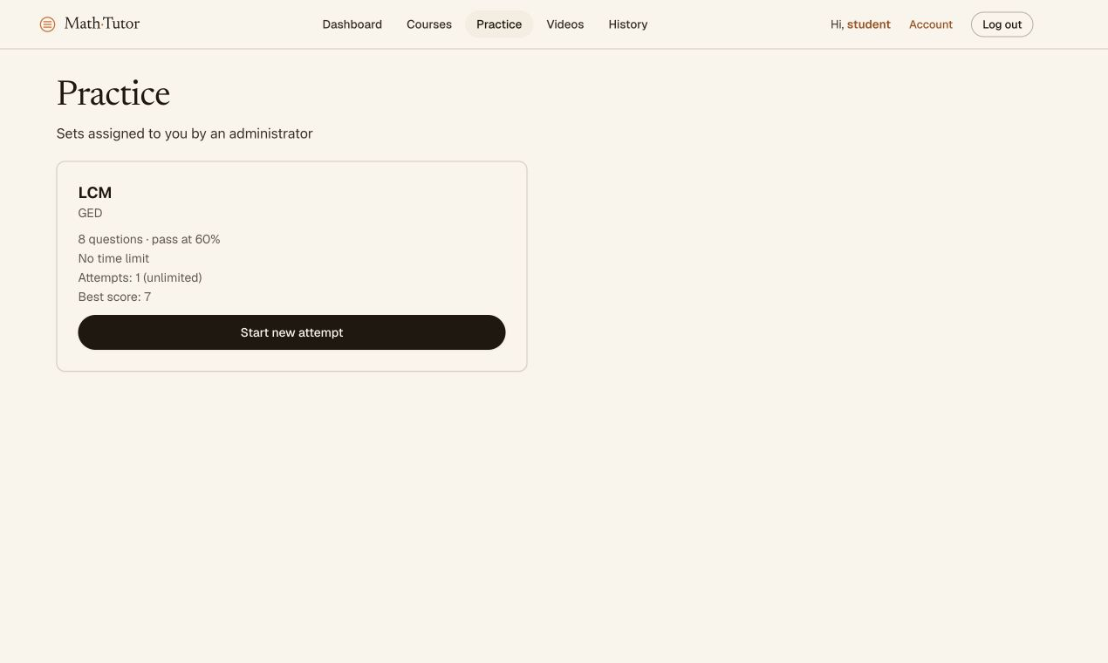
Figure 1 Practice showing the assigned LCM set and best score
Course enrollment does not grant access to every practice set. If the list is empty, ask your teacher to assign a set. If login leads to Page not found, select Practice or open https://gedtutor.org/#/practice directly.

Open the GED course and its lessons
1. Select Courses. GED appears under Your courses for the example account.
2. Click GED or Continue → to view chapters and lessons.
3. Select a lesson to open its content. Use Course outline on the left to move between lessons.
4. Read Explanation and watch the video when available. Once you have studied the lesson, select Mark as completed to record completion.
5. Return to Courses to see your completion percentage. Practice is a separate area for exercises assigned by your teacher.
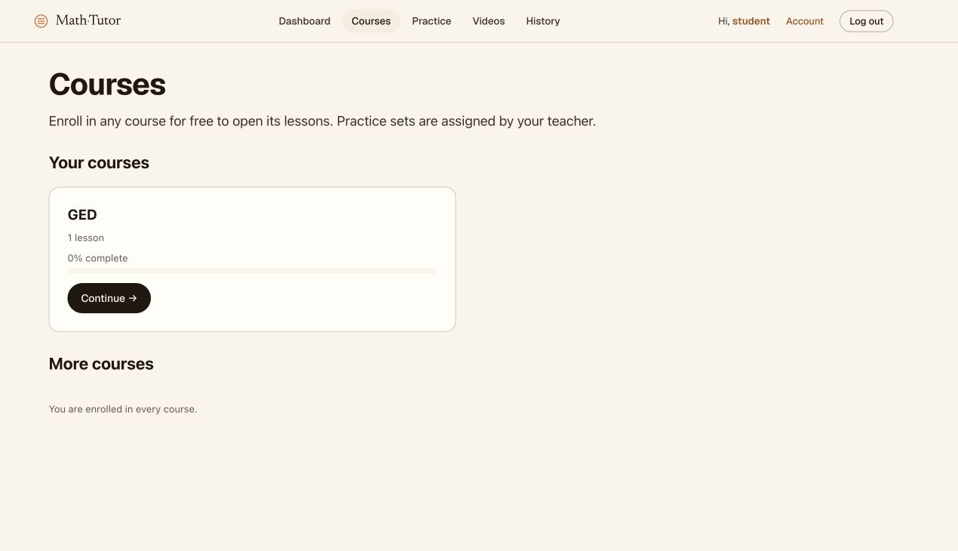
Figure 2 The GED course and completion percentage
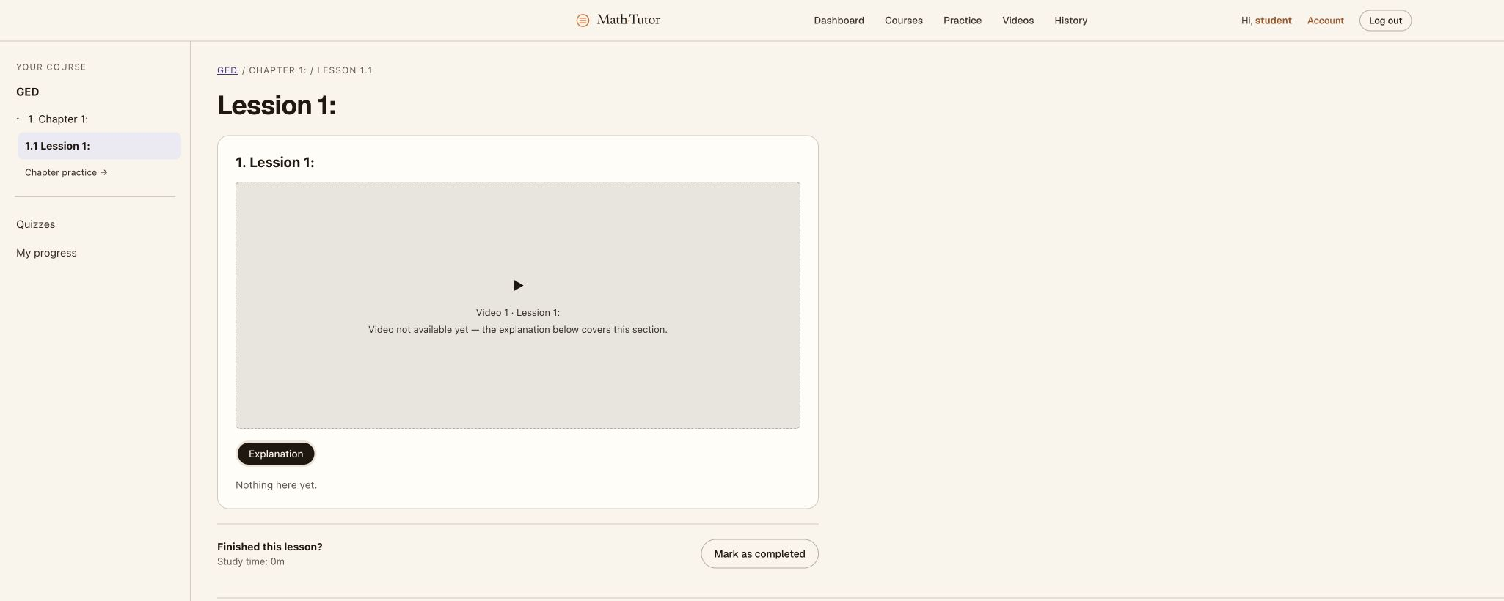
Figure 3 A lesson with Explanation and Mark as completed
If you see Video not available yet or Nothing here yet, tell your teacher that the lesson has no content. Mark a lesson complete only after you have studied it.

Answer questions and check automatic saving
1. After Start new attempt, read the set name and Attempt number. The example is Attempt 2 of LCM.
2. For a typed answer, enter an integer, decimal, or fraction in Your answer. For example, the LCM of 12 and 2 is 12.
3. The displayed instructions allow decimals such as 3.6 or 3,6 and fractions such as 18/5. Enter the numerical answer without a written explanation.
4. For multiple choice, select A, B, C, or D. Read the value of each option because their order can change.
5. Wait for ✓ Saved. If Saving… remains visible or an error appears, check your connection before submitting.
6. Check the answered-question count at the bottom of the page. Answer every question before submitting.
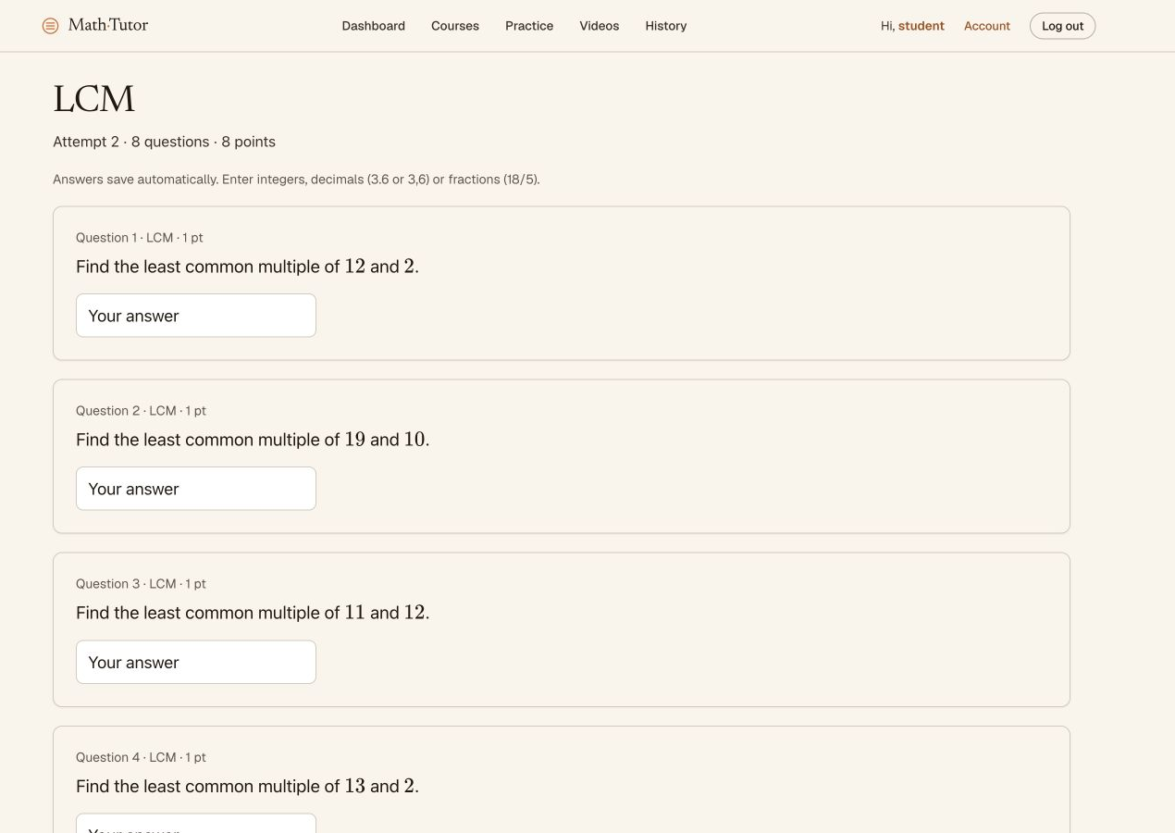
Figure 4 Answer fields for randomly generated questions
Each attempt can have different values, so answers in these screenshots may not apply to your attempt. Saved confirms storage of your answer, without indicating whether it is correct.

Submit an attempt and read the results
1. Scroll to the bottom and check the answered-question count, such as 8 of 8 questions answered.
2. Click Submit attempt. The confirmation says Submit now? You cannot change answers afterwards.
3. Select Keep working to revise, or Yes, submit when you are ready. You cannot change answers for that attempt after submitting.
4. Review Score, the percentage, and Passed. The example scored 8/8, or 100%, above the 60% pass mark.
5. Scroll to Results by skill and Questions. Compare Your answer with Correct answer and note incorrect questions for review.
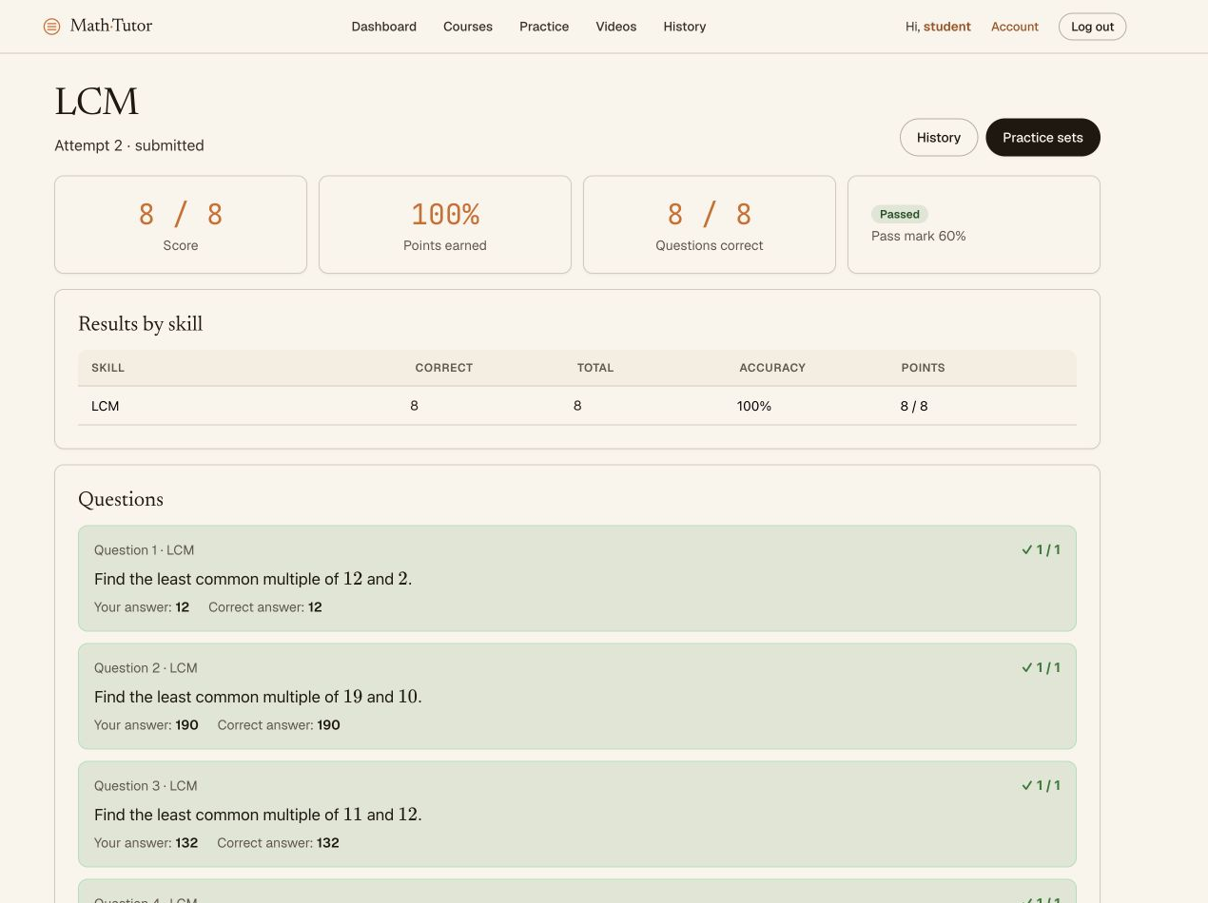
Figure 5 The practice result with the score and individual answers
The score shown is a demonstration attempt completed while preparing this guide. Your result depends on your answers and the set scoring rules. When questions have different point values, the score percentage can differ from the percentage of questions answered correctly.

Review history and continue practicing
1. Select History from the menu or from the results page.
2. Each row is a separate attempt showing the set name, attempt number, status, score, result, and start time.
3. Select an attempt to review its questions and answers. Demonstration attempt 2 scored 8/8; attempt 1 still shows 7/8.
4. Return to Practice to start again if you still have access and attempts remaining. Random values may differ in the new attempt.
5. Review skills with lower accuracy and study related lessons before trying again.
6. Click Log out when finished, especially on a shared computer.
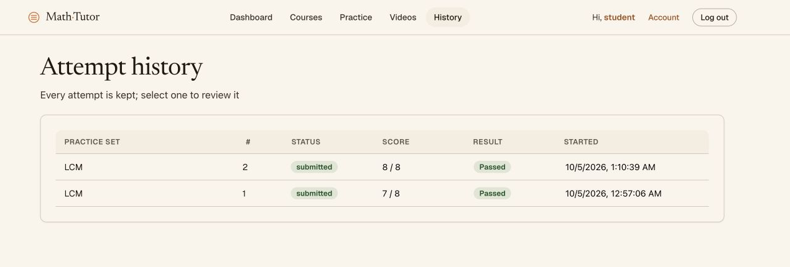
Figure 6 History retaining separate scores for two attempts

Get help when something goes wrong
Cannot sign in: check your email and ask your teacher for password help. No practice sets: ask an administrator to check Assigned access. Page not found on Dashboard: open Practice or Courses. No ✓ Saved: check your connection. Attempt or time limit reached: contact your teacher about the set rules.
This guide contains no passwords. Screenshots show the interface on October 5, 2026; content and labels may change with future updates.

