Smart Urban Cooling and Green Living Assistant Using AI

Student Name: Vijay M Segunasi
Siva Sai Kumar
H C Vinod
Gayathri Priya JM
College Name: Alliance University
BTech CSE Data Analytics 7th Sem.
Program: AI for Sustainability Virtual Internship
Organization: 1M1B – IBM SkillsBuild & AICTE

Based on the Topic:-
Primary SDG: SDG 11 – Sustainable Cities and Communities
Supporting SDGs: SDG 13 – Climate Action, SDG 15 – Life on Land.

Urban areas are becoming hotter due to dense construction, concrete surfaces, and the loss of trees and green spaces. This creates the Urban Heat Island effect, where cities remain warmer than nearby rural areas and air quality also decreases due to pollution and reduced vegetation. Higher temperatures increase energy usage and worsen climate change.
This project promotes small-scale green solutions such as balcony plants, rooftop gardens, and indoor greenery to reduce heat and improve living conditions. By providing local heat awareness and personalized plant recommendations, the system helps citizens take practical actions that support climate adaptation, urban biodiversity, and sustainable city development.

Problem Description: -
Cities are becoming increasingly hotter due to rapid construction, loss of trees, and large concrete surfaces. This phenomenon, known as the Urban Heat Island effect, causes discomfort, higher electricity consumption, and health risks, especially for children and elderly people.
Although many eco-friendly solutions exist such as terrace gardens, balcony plants, and rooftop greenery most people do not know:
- How severe the heat problem is in their area
- Which plants are suitable for their home environment
- How small actions can contribute to climate resilience
There is currently no simple, personalized, and accessible digital platform that connects local heat awareness with practical green solutions for common households.

Problem Statement
How might we use AI to help urban residents understand heat risks in their locality and guide them with personalized green solutions so that cities can become more climate-resilient and environmentally friendly?
Target Users
- Urban households
- Students and working professionals
- Apartment residents with limited green space
- Community gardening groups

These users need easy-to-use tools that translate climate information into simple actions they can take at home.

Proposed AI-Based Solution
The Smart Urban Cooling and Green Living Assistant is a web-based decision support system that helps users take climate-positive actions using personalized recommendations.
System Features:
1. Urban Heat Visualization -Heat-prone areas are shown using maps and charts.
2. User Profiling- Age and interests are used to personalize recommendations.
3. AI-Driven Plant Recommendation System -Uses season, sunlight, and space type.
4. Image Upload (Future Scope) -For AI-based space classification.
5. Multilingual Accessibility -Supports multiple languages

FLOWCHART EXPLANATION
The flowchart represents the complete operational flow of the system from user entry to report generation and exit. It explains how user input is processed and how AI-based recommendations are generated.
Step 1: Start
The process begins when the user opens the web application in a browser. The Flask server loads the application interface.

Step 3: User Login
The user enters:
- Name
- Password
If the user is new, their details are stored in the users.csv file.
The system then creates a session and redirects the user to the dashboard.

Step 4: Display
After successful login, the dashboard is displayed with navigation options:
- Heat Analysis
- Plant Recommendation
- Image Upload
- Community Page

Step 5: Feature Selection Decision
The user selects one of the available modules.
This step is represented as a decision node in the flowchart.

Step 6A: Heat Analysis Module
When Heat Analysis is selected:
- The user selects a city.
- The system generates a heat map using Folium.
- A bar chart showing area-wise temperature is generated using Plotly.
- Both map and chart are displayed to the user.
This helps users understand local heat patterns.

Step 6B: Plant Recommendation Module
When Plant Recommendation is selected:
- The user selects season, sunlight level, and space type.
- The system filters plant data from plant.csv using Pandas.
- Matching plants are displayed in a table format.
This module provides AI-based decision support using dataset filtering.

Step 6C: Image Upload Module
When Image Upload is selected:
- The user uploads an image of their home area.
- The system validates file type and saves the image to the server.
- The uploaded image is displayed to the user.
Future versions will apply AI image analysis to detect space type.

Step 6D: Community Module
When Community is selected:
- A community information page is displayed.
- Future enhancements may include user posts and shared green practices using a
Database

Flow art flow
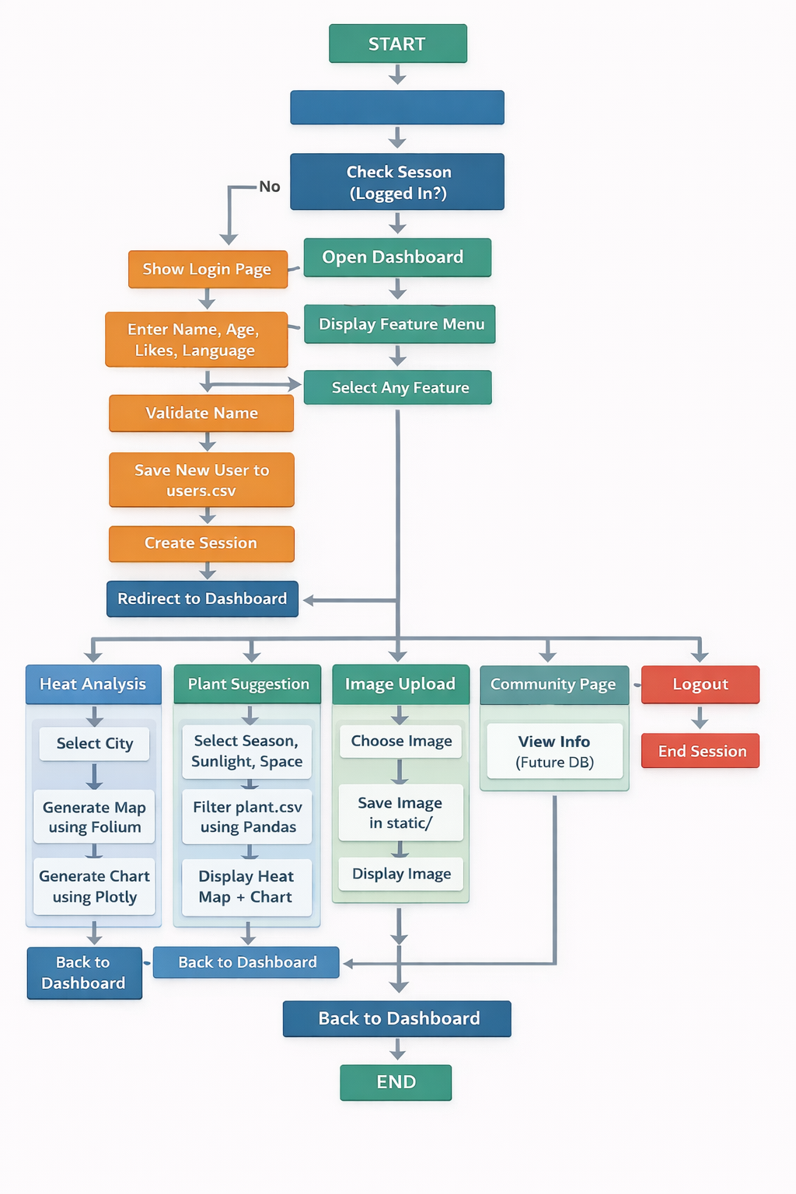

Tools used:
Plotly& Folium)
Python, Session Management
Data Handling: Pandas, CSV datasets
Visualization: Folium Maps, Plotly Charts
AI Logic: Rule-based dataset filtering for recommendations
Tools: VS Code, Localhost Server, GitHub

Role of Artificial Intelligence
- Intelligent filtering of plant datasets based on environmental conditions
- Personalized decision support instead of generic advice
- Future computer vision integration
- Scalable guidance delivery

Design Thinking Approach
- Empathize: Urban residents face increasing heat stress.
- Define: Need localized heat awareness and green solutions.
- Ideate: Use AI for sustainability guidance.
- Prototype: Develop web platform with maps and recommendations.
- Test & Improve: Feedback improves accuracy and usability.

Responsible AI Considerations
- Fairness: Equal guidance for all users
- Transparency: Explainable recommendations
- Privacy: No sensitive personal data collected
- Ethical Use: No harmful environmental or medical claims

Expected Impact
- Improved climate awareness
- Increased rooftop and balcony gardening
- Reduced cooling energy demand
- Better urban air quality
- Higher citizen participation in sustainability

Conclusion
This project demonstrates how artificial intelligence can be applied responsibly to solve everyday sustainability challenges. By focusing on awareness, personalization, and accessibility, the solution encourages citizens to actively participate in climate adaptation efforts. The project reflects practical AI usage aligned with sustainable development goals and ethical design principles.

