AirHockey
Final version for course “Introduction to Game Programming 2013”

Contents
Introduction 3
Goal 3
Controls 4
Features 4
3 gamemod 4
Multitasking 4
Speed 4
Sounds 4
Building from source 5
Structure 5
General structure 5
Multiplayer 5
Basic idea of multiplayer 5
Server-client communication 5
AI principle, tips and hints 6
Local multiplayer 7
Contacts 7

Introduction
AirHockey is a fast-paced multitasking game, which will provide a pleasure challenge for few minutes. You may play against the AI, against another player on the same computer or over the Internet. Push your multitasking skills to the limits by controlling two paddles at the same time and crush your opponents!

Goal
The purpose of the game is to push the black puck into the other player's goal. One player controls the two red hockey paddles, and the other controls the two blue paddles.


Controls
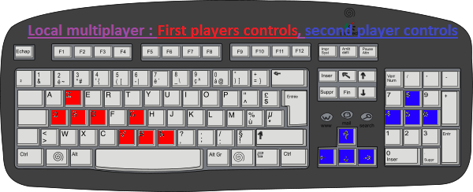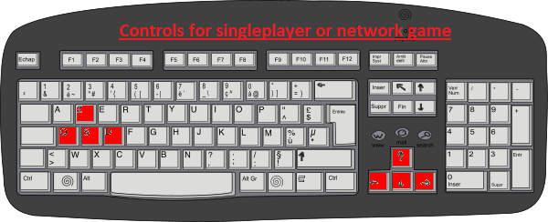

Features

3 gamemod
- Network game
- Local Multiplayer
- Singleplayer vs AI

Multitasking
- 2 paddles to control
- Powerups

Speed
Your opponent will barely sleep, so hurry up!

Sounds
Not required for successful gaming, but might help. (whistle at the start.)

How to start

Python-version
Execute __init__.py
(Cocos2d library required)

Exe -version

Structure

General structure

Multiplayer

Basic idea of multiplayer
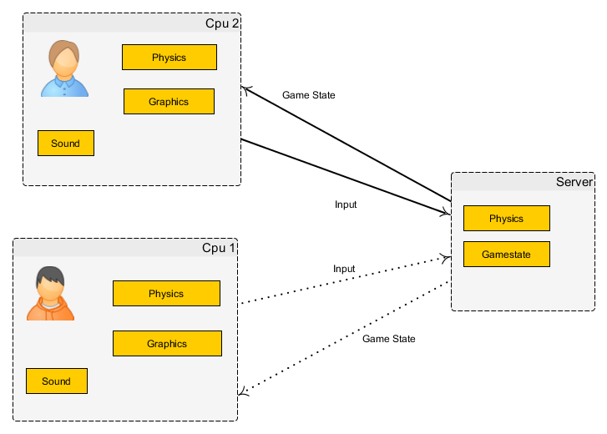

Server-client communication
Each client side takes inside an input and generate gamestate, which has all information of this game inside. However, this client side has no information about opponent’s actions, so all input is sent to server, who calculates the real situation and forwards it back to players.
There is a small delay, so following picture demonstrates how we handle it.
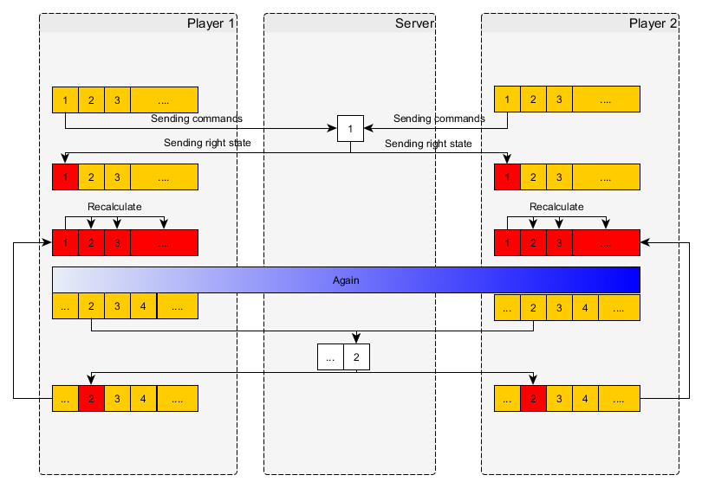
Each computer calculates on constant speed coming frame number. Then for example we send information from state 1 to server. At moment when we receive the response of real situation at state 1, we are already at later state, so we recalculate all basing on the fixed situation of state 1. Then we select next state, and repeat all this operation.

AI principle, tips and hints
Compared to previous in case of singleplayer mode, we don’t start any server communication. Player’s commands are recorded to gamestate and are modified by adding AI actions.
AI has 3 difficulty levels 0-2
- Level 0 is just going after the ball
- Level 1 will put 1 ball to be a goalkeeper, while second one chases the ball.
- Level 2 is clever aggression.

Due to fact that few found it rather hard to beat even Level 0 AI, we provide a spoiler, of how to win AI.
Best working strategy is just to stop the ball, and push it behind AI balls. This is not necessary a win, but most likely at least vs lvl 0 AI. Lvl 2 AI can be beaten even with 1 ball, just go to the middle and then straightly top.

Local multiplayer
Similarly to singleplayer mode, here is no communication with server. Input from both players are taken, resulting in gamestate, which is showed at the screen.

Contacts
Nyholm, Niklas email@gmail.com
Rautiainen, Mikko email@gmail.com
Skudnov, Rostislav email@gmail.com
Sofiev, Alexey alexey.sofiev@helsinki.fi

Extra

Building executable from source
If you don’t want to use prebuilt option or python version, then here is our guide of how to compile:

1. copy src/ to new folder compile/
2. comment compile/__init__.py lines 3-7
3. comment compile/server.py lines 5-7
4. copy libs:
autobahn-0.6.4/autobahn -> compile/autobahn/
cocos2d-0.5.5/cocos -> compile/cocos/
pyglet-1.1.4/pyglet -> compile/pyglet/
twisted-13.1.0/twisted -> compile/twisted/
zope.interface-3.8.0/src/zope -> compile/zope/
5. copy files:
compile/autobahn/resource.py -> compile/resource.py
6. uncomment compile/setup.py line 4 '__init__.py'
7. in compile folder: python setup.py py2exe
8. copy resources:
compile/res/ -> compile/dist/res/
9. rename compile/__init__.exe -> compile/AirHockey.exe
10. copy compile/dist/ -> dist/
11. comment compile/setup.py line 4 '__init__.py', uncomment line 5 'server.py'
12. in compile folder: python setup.py py2exe
13. copy compile/dist/server.exe to dist/server.exe

Now dist/ has distribution version.

"access denied" on py2exe running: try again

