Mini-Java Compiler

Code generation course
.5.2014
Mikko Rautiainen

Building and running the program

The program can be built by opening it in Visual Studio and selecting Build -> Build Solution. The program is run from the command line by using "cgen2014minijava.exe inputFile outputFile", where inputFile is a file containing Mini-Java source code, and outputFile is the name of the output file, including the file extension ".exe". For example, "cgen2014minijava.exe factorial.minijava factorial.exe"

Architecture

The program is divided into roughly three parts: syntactic analyzer, semantic analyzer / AST builder, and code generator. The syntax analyzer is taken from compiler course's project with minor modifications. The semantic analyzer takes the parse tree from syntactic analysis and builds an AST from it. Finally, the code generator takes the AST and outputs CIL bytecode and builds an executable file.

Syntax analysis

The syntax analyzer is taken from the compiler course's project. The analyzer is a recursive top-down parser that recognizes an LL-grammar. Three modifications were made to use the parser for minijava. First, the grammar has been replaced with Mini-Java grammar. Second, special parsing was built for if statements because the dangling else problem can't be solved with minor changes to the grammar. Third, special parsing was built for expressions because they can't be parsed with an LL-grammar. The expression parsing is also used to parse local variable declarations and method calls. Both of the special parsing steps are handwritten ad-hoc methods instead of recognizing a more powerful grammar.

Semantic analysis

The semantic analyzer transforms a parse tree into an AST. The analysis is divided into two parts, building the AST and validating the tree. Figure 1 shows all AST node types, their inheritances and their members.

Building the AST works in three passes. On the first pass, the parse nodes are transformed into corresponding AST nodes, and references to other AST nodes are left unbounded. Second and third passes bind the names of identifiers. On the second pass, references to classes are bound to the correct AST nodes. On the third pass, all other references, such as references to member variables or methods, are bound to the correct AST nodes. Expression types are also bound in the third pass.

During the name binding passes, the analyzer checks for some errors and reports them if it finds them. All names must refer to something. Operators must have compatible types as their operands. A return statement must return an expression with the same type as the method or a subclass of it. Assignments must have compatible types, either the same type or assigning a subclass to a superclass.

Validation of the AST works in third passes. First, classes are ordered by their inheritance so that superclasses are ordered before subclasses. This part also checks that the inheritance is ordered like a tree, so a class cannot be its own super-super-...-class. Second, local variable names must be unique. A local variable may shadow a member variable but all locals must have unique names. Third, all statements which are also expressions must be function calls, so statements such as "printNumber(5);" are fine but statements such as "1+1;" are not.

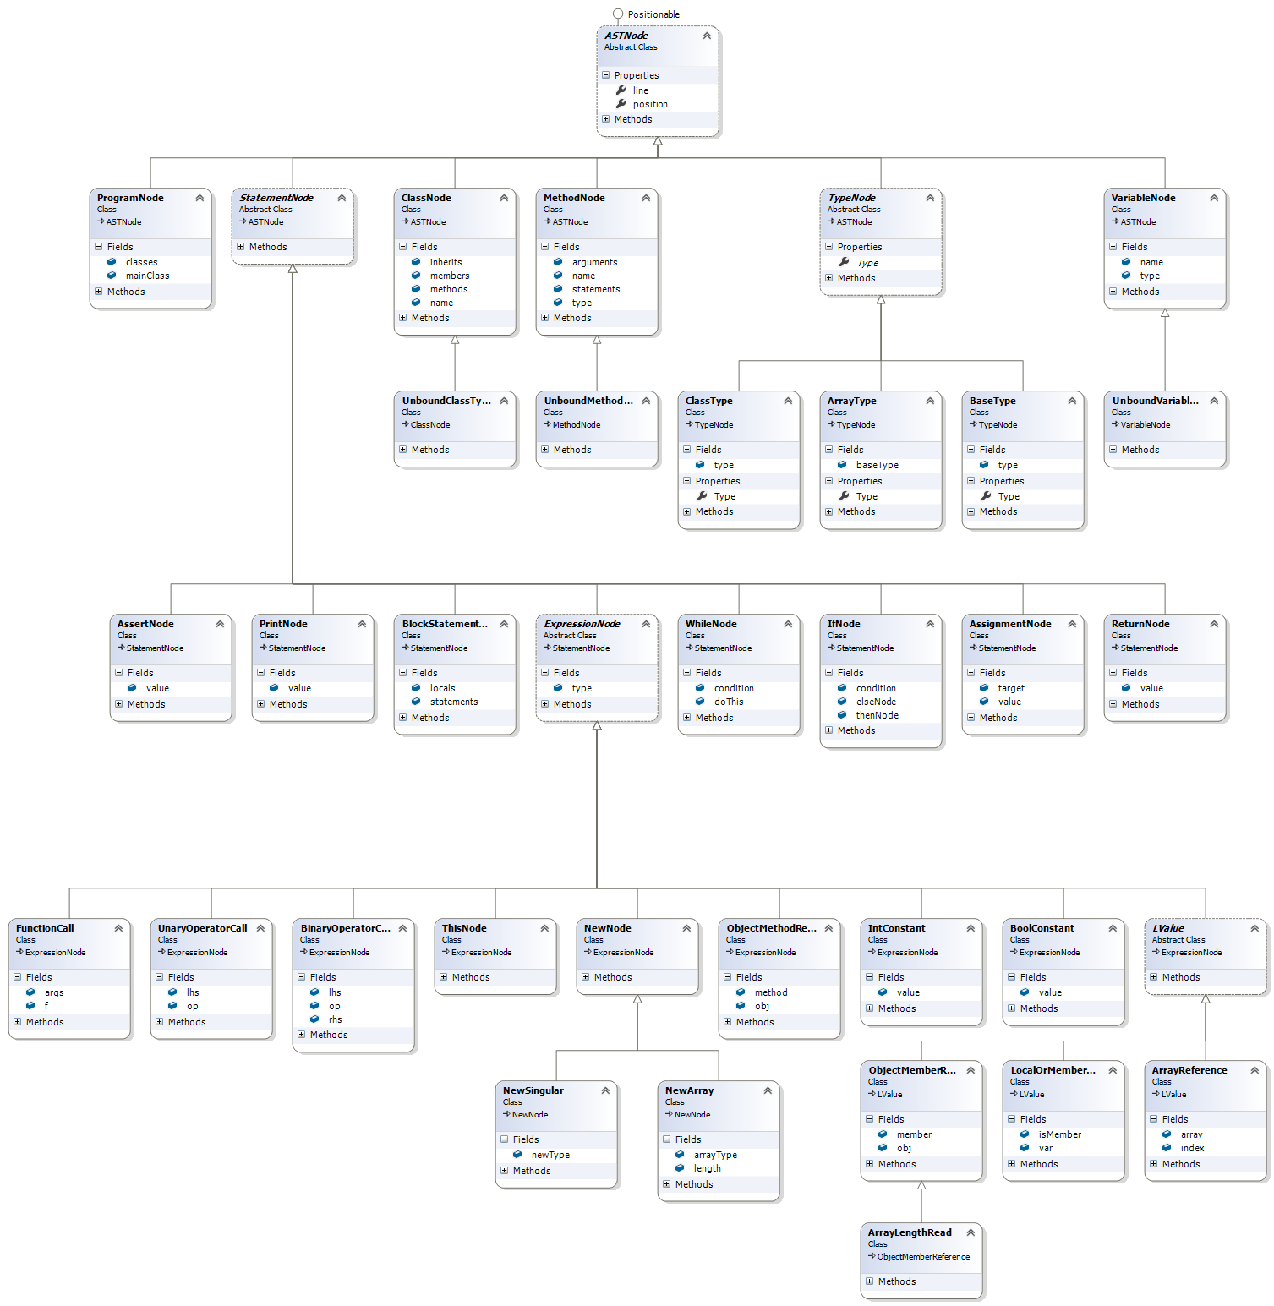
Figure 1: Class diagram of the AST nodes

Code generation

The code generator takes an AST and outputs an executable file that represents the program. There are no error checks for correctness of the input program because those errors are assumed to be caught in either syntactic or semantic analysis. The executable file is built using System.Reflection to emit CIL bytecode. The base types, booleans and integers, are both treated as integers in the generated code. Class types have a new type built for them.

Tests

The automated tests can be run by opening the solution in Visual Studio and selecting Test -> Run -> All Tests. When running the tests, one test will create a window saying something like "temp20.exe has stopped working", this is the intended result of a test on the assertion statement. There are three areas of tests. The grammar tests test the expression parsing. There are no other tests for syntax analysis because the syntax analyzer was tested in compiler course project. The AST tests test the construction of the AST from Mini-Java source code. There are also tests for error checking in the AST tests part, which verify that errors are reported on malformed programs. The most important tests are in the compiler tests. The tests take the source code of a Mini-Java program, compile it into an executable file, run the executable and verify that the output is correct. There is a wide amount of tests, testing each type of statement, arithmetic and comparison operator. Features of object-oriented programming are tested, including method overriding, polymorphism and inheritance.

