Mini-PL Interpreter

Compilers course, spring 2014
Mikko Rautiainen

Architecture

The interpreter is roughly divided into two parts: the front-end parses a string representing a program and outputs an abstract syntax tree for the program, and the interpreter runs the AST. The front-end is further divided into scanner, parser and syntax tree builder. Scanner (Scanner.cs) reads a string and outputs a list of tokens. The parser (Parser.cs) takes a list of tokens from the scanner and outputs a parse tree. The syntax tree builder (AST.cs) takes the parse tree and outputs an abstract syntax tree. Finally the interpreter takes the abstract syntax tree and runs it. All three phases in the front end make a complete pass over the program. The interpreter makes only one pass when interpreting the program.

Scanner

The scanner uses a custom regex implementation (Regex.cs, NFA.cs) because regex libraries were specifically forbidden. In retrospect, this was a bit of an overkill. The scanner starts reading the input string from the start. Each possible token regex is matched against the string starting from the current position, and the longest match is taken, and the position is advanced by the size of the match. When a substring matches both a keyword and an identifier, the keyword is taken instead of the identifier. For all other token types, matching two different tokens with same length is not possible. The scanner was specifically built to be reusable.

Keywords' regex patterns are the keywords themselves. Integer pattern is "(0|[1-9][0-9]*)", which matches 0 and all positive numbers. Negative numbers are handled separately by outputting the token '-' and the number, which is then treated as an unary operator '-' on the integer. This was done because otherwise the scanner would treat the expression "1-1" as two number tokens instead of a number, operator and number. String pattern is "\"([^\"]|\\.)*\"", a quotation mark followed by any number of non-quotation marks or special characters, ending with a quotation mark. Boolean patterns are "true" and "false". Whitespace pattern is "[ \n\t\r]*", any number of spaces, tabs and line endings. Identifier pattern is "[a-zA-Z_][0-9a-zA-Z_]*", a letter or underscore followed by any number of numbers, letters or underscores.

Parser

The parser is a top-down recursive descent parser recognizing an LL(1)-grammar. The parser first takes a starting symbol and any number of production rules and figures out from them the tokens and the terminals of the language. Then the parser calculates the predict set from the rules. Then the parser may be used to build a parse tree from a list of tokens. The parser was specifically built to be reusable, so it doesn't contain the grammar definition.

The grammar definition is located in file MiniPLGrammar.cs. The differences between the grammar definition in the specs and the grammar used in the program are:
- <prog> ::= <stmts> is replaced by <prog> ::= <stmt> ";" <stmts>
- <stmts> ::= <stmt> ";" ( <stmt> ";" )* is replaced by <stmts> ::== <stmt> ";" <stmts> and <stmts> ::= nothing
- expression's production rule is replaced by <expr> ::= <expr2> and <expr> ::= <unary_op> <opnd> and <expr2> ::= <opnd> <expr3> and <expr3> ::= <op> <opnd> and <expr3> ::= nothing
- for statement's production rule is modified so <stmts> is replaced by <stmt> ";" <stmts>
- all <var_ident> are replaced with <ident>

These modifications don't change the accepted language. The original stmts produces at least one statement, but the new stmts can produce zero, so all instances of stmts on the right side need to be changed to <stmt> ";" <stmts>. The only places where stmts is produced are the first <prog> ::= <stmts> and the for statement. The original expr can produce three different things: <opnd> <op> <opnd>, <unary_op> <opnd> and <opnd>. The modified expr first handles the case <unary_op> separately. Then the other two cases are produced by expr2, which starts with the <opnd> and expr3 optionally adds <op> <opnd>. Thus they both produce the same expressions. <var_ident>'s replacement obviously doesn't change the language.

Abstract syntax tree

The abstract syntax tree's nodes are represented by class ASTNode. Expressions and statements are further subclassed. All ASTNodes have a list of children, which the subclasses treat in their own specific way. An ASTNode that isn't subclassed is treated as a block statement that groups actual statements as its children. The picture below describes the class diagram. The picture is missing a type attribute for Expression.
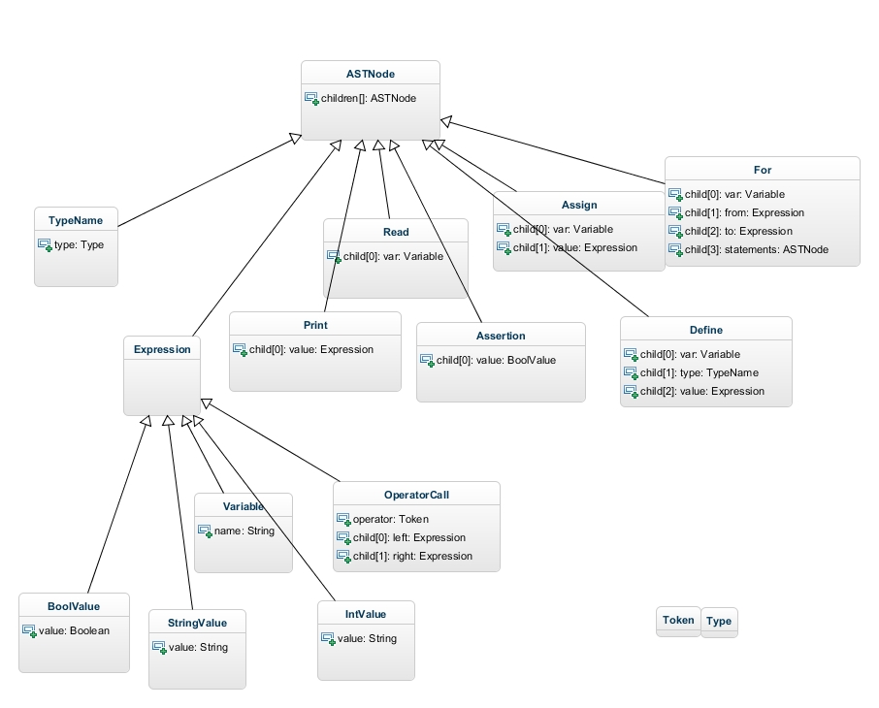
Semantic checks are done on the AST while it is being built. All operator calls are checked to see if applying the operator to its data types makes sense, variables must be defined before using and must not be defined twice and loop variables can't be assigned inside the loop.

