ABU

Asia-Pacific Robot Contest 2025 Ulaanbaatar, Mongolia



Theme & Rules

“ROBOT BASKETBALL”

August, 2024

ABU Asia-Pacific Robot Contest 2025 Ulaanbaatar, Mongolia

Organizing Committee

[http://aburobocon2025.mnb.mn](http://aburobocon2025.mnb.mn/)

Concept and flow of the game

Inspired by the game of basketball, ABU Robocon 2025 Ulaanbaatar aims to promote the idea of achieving tasks through teamwork. Under the motto "Team Effort, Ultimate Success" robots will compete in basketball as teams (Figure 1).

In the robot basketball game, the red and blue teams, each consisting of two robots, compete to score points by shooting the ball into the opponents' basket while defending their own.

Teams alternate possession, with each possession limited to a 20-second shot clock.

The offensive team aims to score points within the shot clock duration by dribbling or passing the ball to teammate robot on their offensive side. Normal shots score 3 or 2 points, depending on the shooting location, while dunk shots are worth 7 points.

The defensive team aims to prevent the offensive from scoring by blocking shots, intercepting passes, or causing turnovers. If the offensive team loses control of the ball due to defensive pressure or an unsuccessful shot, the defensive team gains possession and begins their offensive play.

This exciting and strategic game combines elements of teamwork, precision, and strategy as robots compete to outmaneuver their opponents and emerge victorious on the game field.

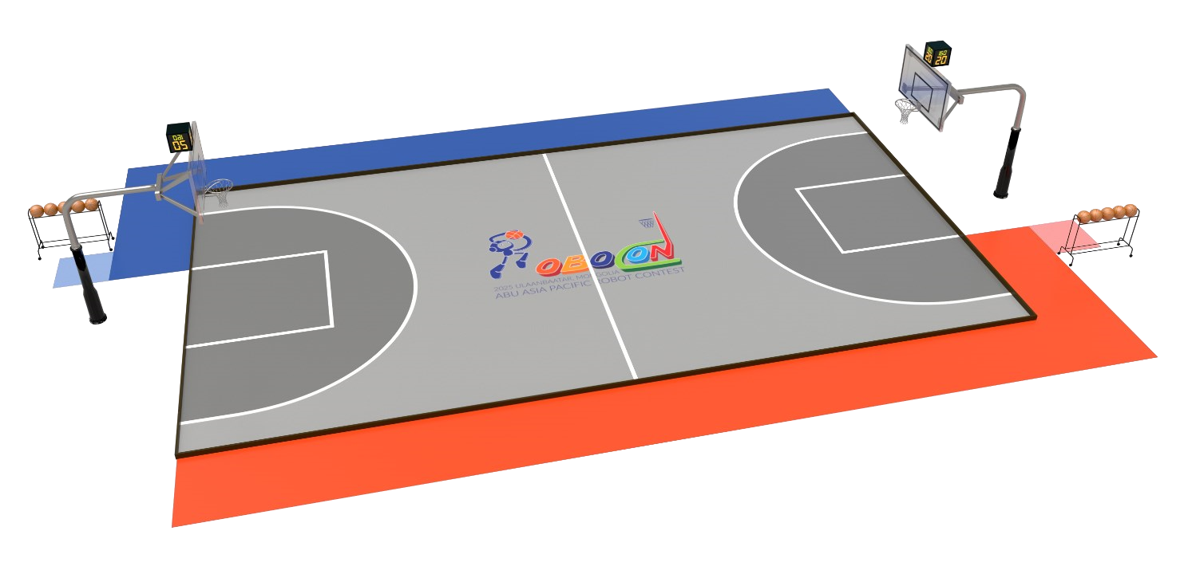

Figure 1. The game field – Isometric view.

The importance of safety

In ABU Robocon, safety is a top priority. Participants shall give safety precedence over everything at all times, from the robot designing and manufacturing stages to taking part in the actual contest. Teams are always required to cooperate fully with the organizer in order to ensure the safety of the Robocon competition for all participants, including team members, spectators, officials and staff, as well as for the surrounding environment.

Domestic contest

All domestic competitions to select the representative teams for the ABU Robocon 2025 Ulaanbaatar, Mongolia should adhere to the rules laid out in this rulebook.

However, it is understood that if material(s) is/are not available, organizers are to employ the best possible replacement(s) available in their country/region.

Team composition

One (1) representing team selected from each country or region will participate in ABU Robocon 2025. As the host country, Mongolia will be represented by two (2) teams.

A team consists of three (3) undergraduate students and one instructor from the same university.

A maximum of 3 undergraduates from the same university can be registered as Pit Crews. Pit Crews can assist in the work in the pit area, in carrying the robot from the pit area to the game field. They can assist team members during the setting time.

Schedule

22/8/2025 (Fri.): Arrival

23/8/2025 (Sat.): Test- run and Rehearsal

24/8/2025 (Sun.): Contest Day

25/8/2025 (Mon.): ABU General Meeting, Producers Workshop Friendship Exchange Program.

26/8/2025 (Tue.): Departure.

Contest Venue: AIC Steppe Arena (Ulaanbaatar, Mongolia)

THE RULES

|  |  |  |  |  |
| --- | --- | --- | --- | --- |
| # | Update date | Section | Detail | Approved by |
| 1 | 2024/08/25 |  | Initial release | Organizing Committee |
| 2 | 2024/10/03 | Sec.1 Table [#2]  Table [#8]  Figure 2  Sec.15.1.13    Sec.18.2 | Additional information for the foam rubber protective bar.  Additional information for the backboard.  Clarification of the baselines.  The maximum permitted extension of the robot's height has been updated.  The specification of the transportation box has been updated. | Organizing Committee |

1. Terms and definitions

The terms and definitions used in the rules of ABU Robocon 2025 Ulaanbaatar are provided in the following table.

|  |  |  |
| --- | --- | --- |
| # | Terms | Definitions |
| 1 | Robots | Each team must have 2 robots for gameplay. Robots can be fully autonomous, semi-automatic or manually controlled. |
| 2 | Base perimeter | The base perimeter is a cylindrical frame equipped with a foam rubber protective bar. It has a height of 300 mm and an outside diameter of 800 mm, surrounding the base of the robot.  The base perimeter must be positioned vertical to and no more than 50 mm above the game field surface.  All robots are required to have a base perimeter made by the team. The outside color of the base perimeter must be red or blue, depending on the team's assigned side of play. Teams must change the color of the base perimeter accordingly before each game.  To change the color, teams may either replace the foam rubber protective bar or use a red or blue fabric cover to wrap its surface (refer to the color code of the Operating areas for the specific colors). |
| 3 | Spare mechanism | A spare mechanism is a component designed for specialized tasks. Each robot may have one spare mechanism, which may include actuators and power sources. However, after equipping the robot with the spare mechanism, it must continue to comply with the specifications outlined in Section 15. |
| 4 | Game Field | The game field consists of a playing area, operating area, spare mechanism zone and equipment (Figure 2). |
| 5 | Playing area | The playing area is the grey ground, measuring 15 meters in length and 8 meters in width. It is surrounded by a fence with a height of 10 cm and a width of 5 cm. The playing area includes the backboard and the baskets. However, the outside of the fence and the back side of the backboard are not considered part of the playing area. |
| 6 | Operating area | The operating area is a designated space beside the playing area where team members control their robots during the game and reconfigure them if needed (Figure 2). |
| 7 | Reconfiguration | Reconfiguration is the process in which a team restarts a malfunctioning robot or replaces a robot's spare mechanism. |

|  |  |  |
| --- | --- | --- |
| 8 | Equipment | Backstop units and basketballs, following the specifications of the International Basketball Federation (FIBA) for men's games, are used in ABU Robocon 2025.  Backstop Units:  Backstop units are installed at each end of the game field and consist of:   1. Backboards (1800 mm length and 1050 mm width).   The backboard is transparent, but the inner rectangle is covered with a white, non-reflective sticker featuring the simplified contest logo. The logo, which includes only the letter "R" symbolizing a jumping robot, is 30 cm high and displayed in the center of the sticker. You can download the simplified contest logo from the contest’s official webpage.   1. Baskets, comprising rings and nets (an inside diameter of a minimum of 450 mm and a maximum of 459 mm). The height of the basket is 2.43m. 2. Backboard support structures.   Basketballs and ball rack:   1. Regulation-sized Size 7 (Circumstance 750–770 mm, Weight 580–620 g) basketballs, are used in ABU Robocon 2025. 2. A ball rack, capable of holding up to five (Figure 2) basketballs simultaneously, will be provided by the organizer (shape and size free). 3. The ball rack must be positioned in the outside of the operating areas as shown in the Figure 1 throughout the duration of the game.   Timing Equipment:  A game clock (measures the overall duration of the game) and shot clock (indicates the time remaining for a team to attempt a shot after gaining possession) are positioned visibly from the operating areas to track the passage of time during gameplay. |
| 9 | Possession | A possession is the status of a team when it is on offense. A possession ends either with a successful shot, foul or a violation. |
| 10 | Control of the ball | Control of the ball is a situation where a robot has physical contact with the ball and can maneuver it. A robot is considered to have control of the ball when it is holding, dribbling, or passing the ball, and the team maintains possession. |
| 11 | Offensive team | The team in possession is considered the offensive team. |
| 12 | Defensive team | The team not in possession is considered the defensive team. |
| 13 | Possession change | Possession change is a process in that the current offensive team transfers control of the ball to the opposing team, which then becomes the new defensive team. |
| 14 | Dribbling | Dribbling is the act of robot bouncing the ball on the surface of the playing area’s ground. |
| 15 | Passing | Passing is the act of a robot transferring control of the ball to a teammate robot. |
| 16 | Shooting | Shooting is the act of attempting to throw the ball into the opposing team's basket to score points. |
| 17 | Dunk shooting | Dunk shooting is a form of shooting where a robot propels the ball into the basket by jumping and directly placing the ball through the basket while in the air. |

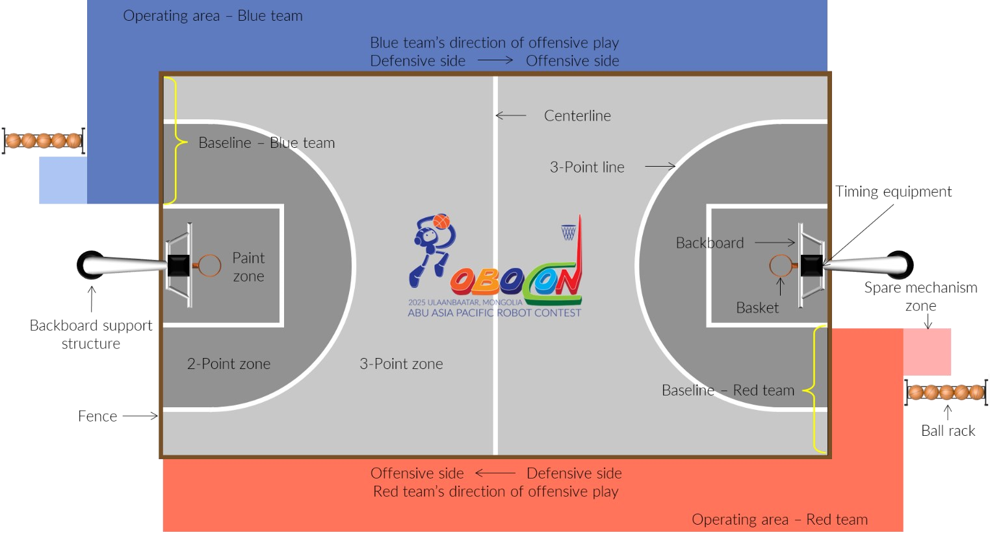

Figure 2. The game field - Structure and equipment.

1. Game time
   1. ABU ROBOCON 2025 Contest: Each game consists of a single period lasting 120 seconds in the preliminary round and 160 seconds in the knockout round.
   2. Domestic Contest Organizer Variation: domestic contest organizers have the flexibility to set the game duration at 160 seconds for a single period in the preliminary round.
   3. Each possession within the game is allotted a 20-second shot clock.
   4. The game clock will be suspended for specific instances, including:
      1. Possession change
      2. Fouls
      3. Violations
      4. Other stoppages determined by the referees.
2. First possession
   1. A robot basketball game begins with a coin toss to determine which team will have first possession. The organizer will provide a coin with red and blue sides.
   2. After deciding the first possessing team, chief referee initiate the ‘setting time’ period for setting the robots for teams.
3. Setting of robots
   1. A one-minute 'setting-time' period is allocated for teams to prepare their robots for a game.
   2. In the ‘setting-time’ period, each team must set up and place their robots within their defensive side.
   3. A robot to control the ball for the team in possession must be positioned immediately behind the designated baseline for ball loading.
   4. If a team fails to complete setting up their robots within the 'setting-time' period, the team must place and leave their robots on the defensive side to start the game.
   5. Following the start of the game, the team that fails to complete setting up can reconfigure their robots by adhering to the reconfiguration rules outlined in Section 11.

1. Start of game
   1. After the setting time expires, count-down time (5-0 second) will be initiated by the chief referee permission.
   2. In the end of the count-down time, the game begins with the referee's whistle or buzzer sound. Once the game starts, the team in possession can load the ball onto the robot positioned immediately behind the designated baseline.
2. Offensive team
   1. The primary objective of the offensive team is to score points by shooting the ball into the opposing team's basket from their offensive side within the shot clock duration.
   2. The offensive team can advance to their offensive side of the playing area through either dribbling or passing to another robot on their offensive side.
      1. If the offensive team opts to dribble, a robot that controls the ball must dribble the ball at least once on the offensive side (the ball is in contact with the surface of the offensive side) before its base perimeter fully enters the offensive side.
      2. If the offensive team opts to pass, the receiving robot must be fully within the offensive side by surface contact area, including space above the offensive side.
   3. If the offensive team’s robots lose control of the ball, either on its own, due to a defensive play by the defending team (i.e., steal, block, or interception) or unsuccessful shooting, the offensive team can pick up or rebounds the ball to retains possession, however, the shot clock will not reset.
   4. Dribbling
      1. Both dropping and picking up the ball must be performed from a height of at least 700 mm above the surface of the playing area’s ground (it will be measured from the lowermost of the ball).
      2. Dribbling robots must not cover or surround the ball except for dribbling hand above 700 mm.

* 1. Passing
     1. To be valid, the ball must be thrown to the teammate robot from a distance of at least 1000 mm, measured from the nearest points of the robots.
  2. Shooting
     1. Shooting robot must perform at least one dribble at any point but before a shot for each instance of gaining control of the ball. However, a robot may shoot without dribbling if it shoots immediately upon gaining control of the ball without changing its location or while in the air.
     2. Dunk shooting:
        1. A robot must jump independently when performing a dunk shooting.
        2. If the jumping robot controls the ball and is within the space of the paint zone, it is considered the robot performing a dunk shoot.
        3. The ball must follow the direction of its fall after released by the robot.
        4. Dunk shooting robot can hold onto the basket after released the ball.
  3. Scoring
     1. Points will be awarded for successful shots based on the shooting zone and shooting types as follows:
        1. Three (3) points for a shot made from the 3-point zone. The robot's base perimeter must be fully within the 3-point zone before, during and after the shot including space above the zone.
        2. Two (2) points for a shot that are neither a 3-point shot nor a dunk shot.
        3. Seven (7) points for a dunk shot.
     2. A shot made after the expiration of the shot clock, game time, or a referee's signal will not be awarded any points.
     3. A shot from the own defensive side will not be awarded any points.
     4. A shot is defined as the ball is fully released from any part of the robot.

1. Possession change
   1. Upon the chief referee's signal to possession change, the shot clock will stop, and a referee removes the ball from the game field, all robots must come to a complete stop at their current positions.
   2. After a referee removes the ball from the game field, a both teams must immediately move to their defensive side within a 10-second time frame as the chief referee signals.
   3. A robot to control the ball for the team gaining possession must move immediately behind the designated baseline for ball loading.
   4. Upon the expiration of the 10-second time frame or both teams are ready for the game, the referee will signal to resume the game. The shot clock will start counting down 20 seconds.
   5. Once the game starts, the team in possession is allowed to load the ball onto their robot positioned immediately behind the designated baseline.
2. Defensive team
   1. The defensive team's primary objective is to prevent the offensive team from scoring by blocking shots, stealing the ball, or disrupting passing lanes.
   2. If the offensive team’s robots lose control of the ball, either on its own, due to a defensive play by the defending team (i.e., steal, block, or interception) or unsuccessful shooting, the defensive team can pick up or rebound the ball to gain possession.
      1. If the defensive team picks up or rebounds the ball, possession immediately transfers to them. They can start their attack without waiting for a referee's signal.
      2. If the defensive team picks up or rebounds the ball and wants to setup for their possession, they may request the referee to initiate the possession change.
   3. The defensive team must defend only within their designated defensive side of the playing area.
   4. If the defensive team fails to transition to their defensive side within a time frame that given by referee, they are prohibited from taking any defensive actions until they complete the transition.
3. Fouls
   1. If a robot enters the opposing robot's base perimeter and touches anything other than the base perimeter, it will be considered a foul.
   2. A robot can touch the opposing robots with its base perimeter. However, if a robot pushes the opposing team’s robots, it is considered a foul.
   3. If the offensive team commits a foul, a possession change will be implemented.
   4. If the defensive team commits a foul, the following actions will be taken:
      1. Upon the referee's signal, the shot clock will stop, and the defensive team’s robot must immediately disengage from contact with the opposing robot and create a distance of at least 1 meter (the satisfaction of which will be determined by the referee).
      2. If the defensive robot is unable to move itself, team members are allowed to disengage the robots from contact but are prohibited from taking any other action with the robot.
      3. The offensive team will be awarded points from the designated zone where the foul occurred. These points will not count as a successful shot attempt.
         1. If the fouled robot’s base perimeter is fully within the 3-point zone including space above, or the robot’s base perimeter is on the centerline, the offensive team will be awarded three (3) points.
         2. If the fouled robot’s base perimeter is in the 2-point zone, the offensive team will be awarded two (2) points.
         3. If the fouled robot is performing a dunk shoot, the offensive team will be awarded seven (7) points.
      4. If the offensive robot remains standing after the foul, the referee will resume the game, and the remaining shot clock will continue.

* + 1. If the offensive robot falls, 10 seconds will be given for the team members to return it to its position. Once the 10-second time has expired, the team members must leave the playing area immediately. The referee will resume the game, and the remaining shot clock will continue.
  1. If a robot momentary enters the opposing robot’s base perimeter without touching, followed by an immediate exit, it will not be considered a foul.
  2. If the offensive team’s robot enters the opposing robot’s base perimeter and touches it while performing a dunk shot, it will not be considered a foul.

1. End and winner of a game
   1. The game will end when the 120 or 160-second duration has passed, as specified in Section 2.
   2. At the end of the game, the team with the higher score will be declared the winner.
   3. In the event of a tied score at the end of regulation time:
      1. The team with less successful shots.
      2. The team with the shortest successful shot time of all the possessions.
      3. The winner will be decided by the Judges.
2. Reconfiguration
   1. Teams can bring their robots to their own operating area for reconfiguration only during possession changes.
   2. Teams can place robots back into the playing area during possession changes or while the game is in progress.
   3. If teams place robots back into the playing area during possession changes, they must follow the rules outlined in Section 7.
   4. If teams place robots back into the playing area while the game is in progress, the robot must enter from the defensive side of the offensive team when remaining robots of the offensive team are on the offensive team’s offensive side.
   5. Team members are allowed to enter the playing area to bring their robots but are prohibited from entering the playing area to place their robots back.
3. Violations
   1. If the offensive team fails to advance to their offensive side within 8 seconds.
   2. If the offensive team fails to shoot the ball within the shot clock duration.
   3. If the offensive team’s robot advances to the offensive side without properly dribbling or passing.
   4. If an offensive team’s robot shoots the ball without adhering to the rules for shooting.
   5. If an offensive team’s robot dribbles or passes without adhering to the rules for dribbling or passing, respectively.
   6. If an offensive team’s robot that is controlling the ball, returns to their defensive zone.
   7. If the offensive team’s robots lose control of the ball, either on its own or due to a defensive play by the defensive team (i.e., steal, block, or interception) or unsuccessful shooting, resulting the ball to touch outside the playing area.
   8. Any defensive action performed by the defensive team while in their offensive side.
   9. Any robot found holding onto the basket or backboard, except after a dunk shot.
   10. Any team member touching any part of any robot, except in situations explicitly permitted by this rulebook.
   11. Any team member entering the playing area, except in situations explicitly permitted by this rulebook.
   12. Other actions that violate the rules but are not specifically listed in the fouls and violations sections.
   13. If the offensive team commits a violation, possession will change to the defensive team.
   14. If the defensive team commits a violation, the following actions will be taken:
       1. Upon the chief referee's signal, the shot clock will stop, and the defensive team must immediately correct the violation (the satisfaction of which will be determined by the referee).

* + 1. After the defensive team corrects the violation, the chief referee will resume the game, with offensive team retaining possession. The remaining shot clock will be extended by 10 seconds. If the remaining game clock is less than the extension time, the offensive team will be awarded points equivalent to the remaining seconds of the extension time (up to 5 points).

1. Disqualification

A team may face disqualification under the following circumstances:

13.1 The team performs any acts that are not in the spirit of fair play.

13.2 The team fails to obey instructions or warnings issued by referees.

13.3 The team intentionally damages or attempts to damage the field, facilities, equipment, or opponent’s robots.

1. Robot Control
   1. Remote controllers used for manual operation must be wireless.
   2. For radio frequency communication, teams can use only Wi-Fi (IEEE 802.11), Zigbee (IEEE 802.15), and Bluetooth for the communications between controller and robot.
   3. The organizer will not control the environment of Wi-Fi, Zigbee or Bluetooth.
2. Specifications of the robots
   1. Dimensions of the robots
      1. Each robot must fit within a cylinder with dimensions of 800 mm (diameter) x 1500 mm (height) before a game starts.
      2. Each robot's base perimeter must not exceed the diameter of 800 mm at all times.
      3. During the game, robots can extend up to height of 2400 mm, including the ball if the robot is in control of it, and up to diameter of 1200 mm above their base perimeter, excluding the ball.
      4. Robots must not separate while in the playing area.

* 1. Weight of the robots
     1. The total weight of both robots, including batteries, controllers, cables, spare mechanisms, the foam rubber protective bars and equipment, must not exceed 50kg.
     2. Any other equipment that the team brings for setup purposes, tools, air containers, and backup batteries (of the same type as that initially installed in the robot are exempt.
  2. Power source of the robots
     1. Each team must have their own power source for their robots.
     2. Teams can use only batteries, compressed air, and/or elastic force as power sources.
     3. The nominal voltage of any battery used in the robot, controller, and any other devices during the game shall not exceed 24V. When connecting batteries in series, the total voltage must be 24V or less.
     4. Power circuits of Robots should be designed so that any actual voltages in the circuits should be 42V or less. If the power supply system includes multiple isolated circuits, voltage in each system must be 42V or less.
     5. Teams using compressed air must use either a container made for the purpose or a plastic bottle in pristine condition prepared appropriately. Air pressure must not exceed 600 kPa.

1. Safety
   1. The design and build of robots should not pose any kind of danger to any person at the competition scene.
   2. All robots must have a red emergency “STOP” button.
   3. Robots must be designed and manufactured to ensure the safety of team members, opposing teams, surrounding people and the game field.
   4. Team members must wear running shoes, and helmets, and safety goggles during the games and test runs.
   5. The following devices are not permitted to be used:
      1. Lead-acid batteries, adhesive-sealed batteries, explosive and high temperature energy sources, and any items that can damage the game field or hinder the competition.
      2. When using lasers, the teams must use Class 1 or 2 products that comply with IEC 60825-1 and must take safety measures based on the standards.
   6. Team should design fail safe systems.
   7. When teams have multiple power supply systems, teams must design the circuits and mechanisms not to go out of control or move dangerously no matter which power supply is lost or regardless of the order of turning on the power.
   8. To avoid starting a fire or smoking by the overload of a motor stall and so on, proper current limiting devices such as a circuit breaker must be installed to power supply circuits. Use wires, connectors, terminals, etc., with a rated current equal to or higher than the assumed maximum current.
2. Others
   1. Situations not mentioned in this rulebook shall be subject to the decisions of the Referee and the Organizing Committee.
   2. The dimensions, weight, etc. of the game field described in this rulebook may have a tolerance of ± 5% unless otherwise specified.
   3. All inquiries should be directed to the official website of ABU Robocon 2025 at [http://www.aburobocon2025.mnb.mn](http://www.aburobocon2025.mnb.mn/) . The FAQ section will be provided on the website of the contest.
   4. Any changes to the competition rules will be updated on the official website of the ABU Robocon 2025 Organizing Committee at [http://www.aburobocon2025.mnb.mn](http://www.aburobocon2025.mnb.mn/) .
   5. Teams must comply with the instructions of the Organizing Committee and the referees to ensure the safety of the robots and/or humans involved.

1. Robot transportation
   1. The Organizing Committee will arrange for the transportation of robots for teams participating in the ABU Robocon 2025. Details regarding this transportation will be communicated specifically to each team.
   2. The robots must fit within a single transport box with external dimensions of 1000 mm in width, 1800 mm in length, and 800 mm in height. The total weight of the box, including the robots, must not exceed 240 kg.
   3. As for ABU Robocon 2025, the robot pick-up time will be mid-July. Please keep it in mind when planning your domestic contest.
2. Materials and colours of the contest tools

|  |  |  |  |
| --- | --- | --- | --- |
| Items | Colours | R-G-B | Materials |
| Operating area | Red | 255-110-90 | Plywood Water Paint |
| Blue | 90-110-200 |
| 3-point zone | Grey | 200-200-200 | Plywood Water Paint |
| 2-point and Paint zone | Dark Grey | 145-145-145 | Plywood Water Paint |
| Spare mechanism zone | Light Red | 255-175-175 | Plywood Water Paint |
| Light Blue | 175-175-255 |
| Fence | Dark Brown | 120-80-40 | Wood  Oil Paint |
| Lines | White | 255-255-255 | Non-Shiny Vinyl Tape |