Answers to the lessons

Note: when running the programs, one should set the “Maximum errors before halting” option to a high number (such as 100). The reason for this is the presence of error-producing statements, which simplify the programs with no harm to the process.

For instance, before creating the model, we destroy any previous version using delete. If no such element is present in the Work file, Eviews will produce an error. But there is no statement asking to delete an item only if it exists.

Lesson 1 : Preparing the model : answers
The following answers can be run using the procedure pdon_a.prg.

Questions 1 and 2 :

We shall use the “wfcreate” statement :

close pic_q
wfcreate(wf=pic_q,page=oecd) q 1962Q1 2010Q4

Question 3
We import the date into the “oecd” sheet :

smpl 1962Q1 2010Q4
read(t=xls,t) fra_q.xls 72

Question 4
We shall now produce the model sheet :

pagecreate(page=pic_a) q 1962Q1 2010Q4

Question 5
We have now on one side a set of original data, on the other a set of precise constraints on the specification of the model, especially on identities. One of our first tasks is to adjust this set to the needs of the model. But to locate the necessary elements, and identify the data transformations needed on the original data, we first need to specify completely the identities.

Let us first produce the identities.

There can be several reasons for introducing an identity in a model:

- defining a variable which relays influences between other variables (FD transmits the influence of each demand element to imports).
- enforcing constraints (such as the equilibrium between supply and demand).
- improving the description of the solution (computing the trade balance).

For a given model, the number of identities can vary. It can be increased by breaking up a computation, or decreased by replacing an element by its formula. Adding identities to a model will generally make its specifications clearer, and will make the interpretation of forecast results easier. Substracting identities will only decrease the number of equations and symbols in the model, without generally simplifying computations.

Our specifications lead us implicitly to introduce:
- a link between firms employment and household consumption through total employment and household real income (3 equations)
- an equation defining domestic demand as a sum of its components, already defined elsewhere.
- an equation enforcing the equilibrium between supply (added value and imports) and demand (domestic demand and exports). As the other variables are already assigned equations, this equation will give added value. This equation is not without some theoretical meaning.
- an equation describing the evolution of capital.
We could have increased the number of equations by defining explicitly wage revenue, or decreased it by replacing domestic demand by its elements. But let us see what would happen in this last case : we would have suppressed interesting information, and actually increased the number of computations, as the same formula would now have to be applied twice.

We shall now specify these seven equations, leaving for Question 6 the data transformations they request.

Note : to make the text clearer, the endogenous will use capital letters.

Defining total employment

Firms’ employment is already a variable of the model. We just need to add state employment, lg (government employment), which leads to:
(1) LT = LE + lg
No other computation is necessary.

Defining real household revenue.

The equation reads as:

Real revenue = (real wage) x (total employment) + (ratio of other revenue to GDP) x GDP

Using the required names, we have:
(2) RHI = wr * LT + r_rhiq * Q

Household consumption
Consumption must conform to:
(3) CO = RHI * (1 - sr)

Housing investment
Consumption must conform to:
(4) IH = r_ih* RHI

Total domestic demand
The equation gives:
(5) FD = CO + I + IH + IC + gd

Supply-demand equilibrium
In this equation, the only endogenous variable yet undefined is Q.
(6) Q = DF + X - M

Capital
Capital at the end of the period sums the non-scrapped share of initial capital, and investment made during the period.
(7) Kt = Kt-1 (1 - drt) + It

Establishing the behavioral equations will be easier, as they do not have to be fully defined yet.

The five behavioral equations will define in turn firms employment, productive investment, change in inventories, imports and exports. Their formulation is not fully established, but we know that they will take into account added value, domestic demand and a world demand index.

One can question the reasons for introducing partially defined equations. Actually this can be used to
- present to other persons the state of the present reflection on the model framework (or remember it after a long break).
- ask Eviews to test the model structure (in particular the loops), which allows to better understand the future model and check for some error types (such as the presence of accurate loops).
- prepare the model statements for the insertion of estimated equations, and allow the definition of associated groups
- check that all equations in the model can be computed, thus that the data base is complete.
The necessary data seems indeed to be available.

Without going further, we shall write these equations as:

(8) LE = f *(Q)

(9) I = f* (Q)

(10) IC = f * (Q)

(11) M = f * (FD)

(12) X = f * (WD)

Summary

We have shown that the whole set of necessary variables is available, either directly or by computation. The present form of the model is
(1) LT = LE + LG

(2) RHI = wr * LT + r_rhiq * Q

(3) IH = r_ih * RHI

(4) HCO = (1 - sr) * RHI

(5) FD = HCO + I + IC + GD + rfdx * Q

(6) Q = FD + X - M

(7) Kt = Kt-1 (1 - drt) + It

(8) LE = f *(Q)

(9) I = f*(Q)

(10) IC = f * (Q)

(11) M = f * (FD)

(12) X = f * (WD)

Question 6 : computing the variables

There are several solutions to produce the model data, keeping in mind that we do not want to lose the original “OECD” sheet through erroneous transformations.

We have to compute:
- The endogenous (12) : co fd i ic ih k le lt m q rhi x

- The exogenous (10) : dr gd lg r_ih r_rhiq sr t wd wr

More than half of them (13) are already present in the OECD sheet, under a different name. We create a link :

pageselect pic_a

CO.linkto oecd::fra_cpv
FD.linkto oecd::fra_tddv
Q.linkto oecd::fra_gdpv
I.linkto oecd::fra_ibv
IH.linkto oecd::fra_ihv
IC.linkto oecd::fra_iskv
K.linkto oecd::fra_kbv
LG.linkto oecd::fra_eg
LT.linkto oecd::fra_et
M.linkto oecd::fra_mgsv
X.linkto oecd::fra_xgsv
RHI.linkto oecd::fra_ydrh
WD.linkto oecd::fra_xgvmkt

This leaves 8.

Generating T is simple. One sets a value of 1962 for the first quarter of 196é, then computes T dynamically:

smpl 1962Q1 1962Q1
genr T=1962
smpl 1960S2 2001S2
genr T=t(-1)+0.5

gd is the sum of government investment and consumption:

gd=fra_igv+fra_cgv

LE is obtained by substraction :

genr LE=LT-lg

The ratio of “other household revenue” r_rhiq to GDP is obtained by inverting the equation for RHI:

genr r_rhiq=(rhi-wr*lt)/q

The savings rate applies the definition to original variables:

genr sr=(RHI-CO)/RHI

Computing the ratio of investment to real household income is done through :

genr r_ih=IH/RHI

To get the wage rate in purchasing power, we first get the individual wage in nominal terms by dividing total wages by the number of workers. Then we divide it by the consumption price index to get the real individual wage.

genr wr=fra_wsss/fra_et/fra_pcp

The depreciation rate of capital is obtained by inverting the equation for capital :

genr dr=(I+K(-1)-K)/K(-1)

One can also consider that depreciation is the difference between the capital level we would have reached without depreciation, and the one we actually obtained.

However, the above statements will only work if the current sheet has access to the requested OECD series:

fra_igv, fra_cgv, fra_wsss, fra_pcp, fra_et.

To accomplish this, the simplest and cleanest way is perhaps to create link elements in the pic_a work file, using the same name as in the OECD file.

smpl 1962Q1 2010Q4
for %1 igv cgv wsss pcp et
link fra_{%1}
fra_{%1}.linkto oecd::fra_{%1}
next

Of course, these statements must be placed before the computations.

Question 7 : Defining the groups

This could not be done before, as group can only contain existing series.

We shall use the following statements, which need only to know the names of the behavioral variables.

pic_a.makegroup(a,n) g_vendo @endog
group g_vbeha ic i m le x
pic_a.makegroup(a,n) g_viden @endog
g_viden.drop ic i m le x
pic_a.makegroup(a,n) g_vexog @exog
group g_varia g_vendo g_vexog

This will define the following groups :

g_vbeha Estimated variables ic i m le x
g_viden Identity variables co fd ih k lt q rhi
g_vexog Exogenous variables dr gd lg r_ih r_rhiq sr t wd wr
g_vendo Endogenous variables g_vbeha g_viden
g_varia Variables g_vendo g_vexog

The program shows an automatic technique, which relies on the presence of the “f” parameter in the future estimated equations.

Question 8: Consistency of identities, and availability of all elements

We just have to check that the value computed by the equation is equal to the historical one. For this we shall perform a special model simulation, in which all equations are solved separately (just as if we had as many models as equations). As these simulations are also static, computations will use historical values in all cases. As convergence is obtained immediately by definition, the other options are not important. Before that we associated to the solution values the suffix “_c”.

This is obtained through the option “d=f”. The other options are not relevant, and can be set at any value, except for the mandatory use of the Gauss algorithm.

smpl 1974Q1 2004Q4
pic_a.append assign @all _c
solve(d=f) pic_a

Then we compute the absolute and relative differences, using a loop on the group of identity variables variables g_viden:

for !i=1 to g_viden.@count
%1=g_viden.@seriesname(!i)
series dc_{%1}={%1}-{%1}_c
series pc_{%1}=100*dc_{%1}/({%1}+({%1}=0))
next

The comparison can be numerical or graphical.

The values obtained for the “estimated” variables are not used. However, being able to compute the associated equations shows that estimation can be performed, and on which sample.

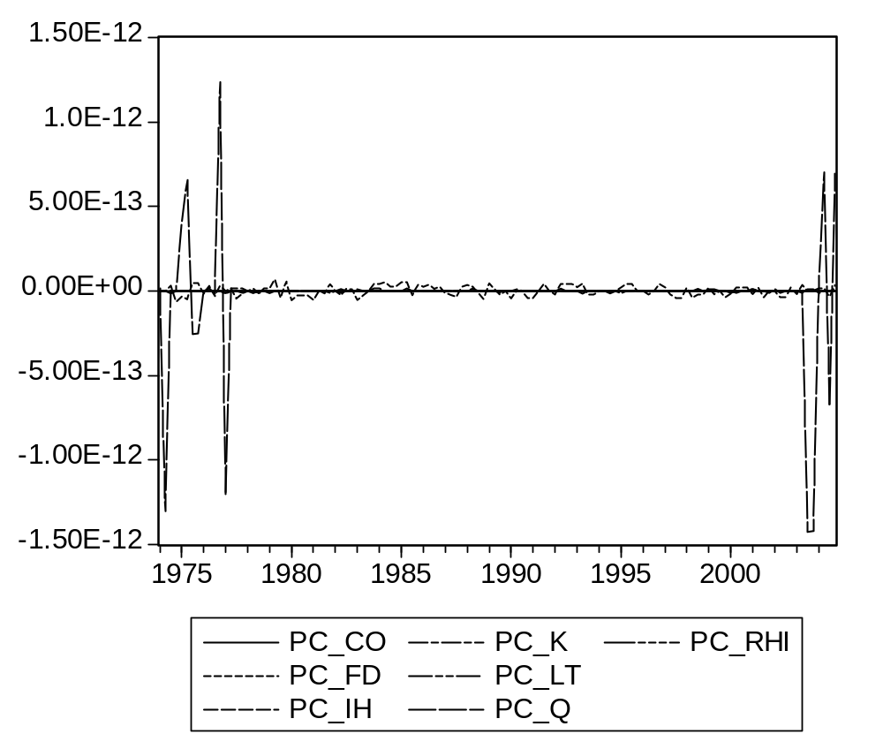

Question 9 : Model architecture

The above list of equations did not take into account causal sequences. Let us produce a more logical ordering.

- We start from a given level of value added.

- From this information, firms set levels for production factors: productive investment and employment.

- Adding the exogenous component of employment gives total employment. Adding wage and non-wage elements gives household revenue and consumption.

- By adding to investment and consumption the exogenous demand elements we get total demand.

- Exports are determined by world demand

- Correcting by imports and exports give a new value of GDP, and the process can be reinitiated until it converges.

- Once equilibrium is reached, investment gives end-of-period capital, which will affect the next period.

This causal sequence allows to produce the following graph.

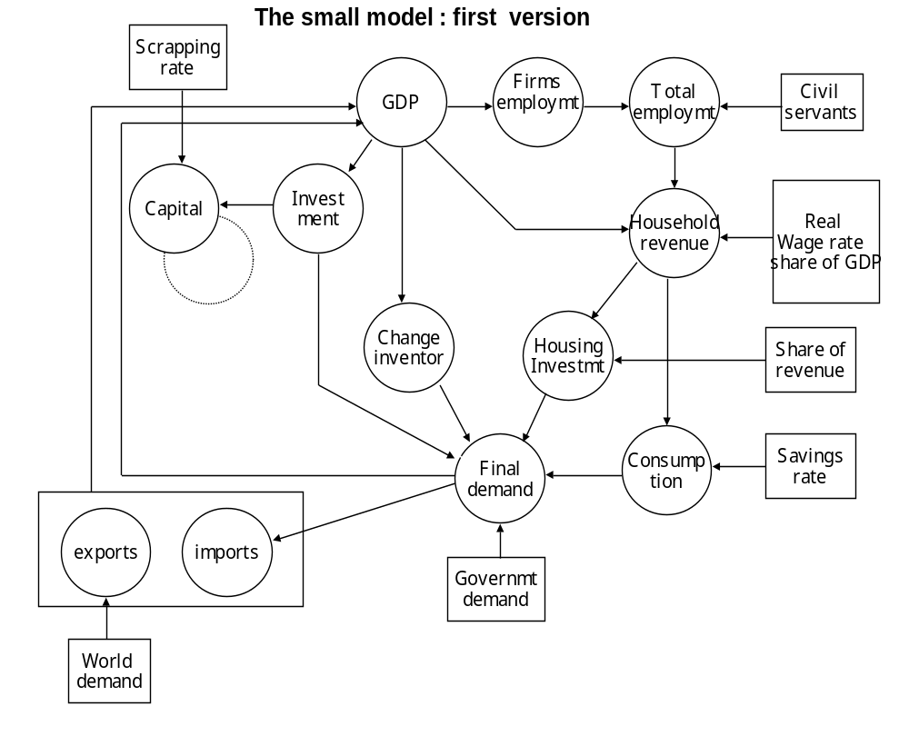
Which associates with the sequence of equations:

(1) X = f * (wd)

(2) Q = DF + X - M

(3) LE = f *(Q)

(4) IH= r_ih * RHI

(5) I= f* (Q)

(6) IC = f * (Q)

(7) LT = LE + lg

(8) RHI = wr * LT + r_rhiq * Q

(9) HCO = RHI * (1 - sr)

(10) FD = HCO + I + IH + IC + gd

(11) M = f * (FD)

(12) Kt = Kt-1 (1 - drt) + It

We use :
wfsave pic_q

Lesson 2 : Estimating the behavioral equations : answers

The following answers can be run using the Eviews program preg_a.prg.

Question 1 : Imports
1. The assumption is :

ΔM/M / (ΔFD/FD) = constant

or

ΔM/M = a (ΔFD/FD)

which by integration gives :
Log(M) = a Log(FD) + b

2. Results are uneven :
- The T-statistics are good (but it would have been strange not to see this link validated).
- The global error is rather high (6.(%).
- The Durbin-Watson test value is extremely bad, which in fact invalidates the whole process. We can see that indeed the residual only changes sign twice (a minimum as the sum is zero and minimizing the sum of squares makes the trend more or less the same).
Dependent Variable: LOG(M)
Method: Least Squares
Date: 06/25/07 Time: 16:31
Sample (adjusted): 1963Q1 2004Q4
Included observations: 168 after adjustments
Variable | Coefficient | Std. Error | t-Statistic | Prob.
LOG(FD) | 2.084255 | 0.016289 | 127.9509 | 0.0000
C | -31.68185 | 0.448425 | -70.65144 | 0.0000
R-squared | 0.989962 | Mean dependent var |  | 25.69074
Adjusted R-squared | 0.989902 | S.D. dependent var |  | 0.660169
S.E. of regression | 0.066341 | Akaike info criterion |  | -2.576196
Sum squared resid | 0.730579 | Schwarz criterion |  | -2.539006
Log likelihood | 218.4004 | F-statistic |  | 16371.42
Durbin-Watson stat | 0.053138 | Prob(F-statistic) |  | 0.000000

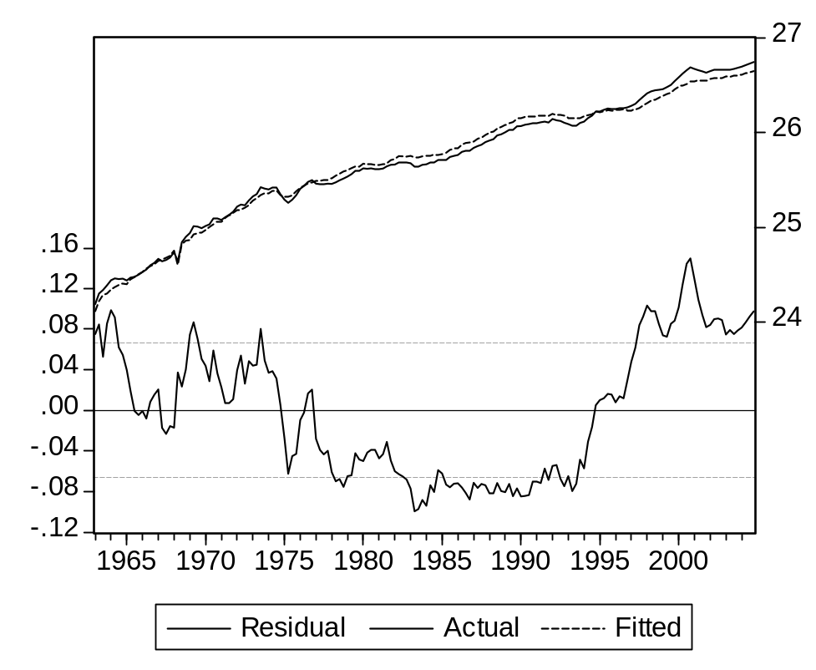

3. Reducing auto-correlation improves the results : the test value, becomes acceptable, the global error decreases to 2.0%, the T-statistic is still high.

Dependent Variable: LOG(M)
Method: Least Squares
Date: 06/25/07 Time: 16:31
Sample (adjusted): 1963Q2 2004Q4
Included observations: 167 after adjustments
Convergence achieved after 14 iterations
Variable | Coefficient | Std. Error | t-Statistic | Prob.
LOG(FD) | 1.964132 | 0.097352 | 20.17562 | 0.0000
C | -28.24967 | 2.805615 | -10.06898 | 0.0000
AR(1) | 0.992035 | 0.015758 | 62.95474 | 0.0000
R-squared | 0.999458 | Mean dependent var |  | 25.69972
Adjusted R-squared | 0.999451 | S.D. dependent var |  | 0.651772
S.E. of regression | 0.015268 | Akaike info criterion |  | -5.508377
Sum squared resid | 0.038228 | Schwarz criterion |  | -5.452365
Log likelihood | 462.9495 | F-statistic |  | 151180.6
Durbin-Watson stat | 1.725276 | Prob(F-statistic) |  | 0.000000
Inverted AR Roots | .99
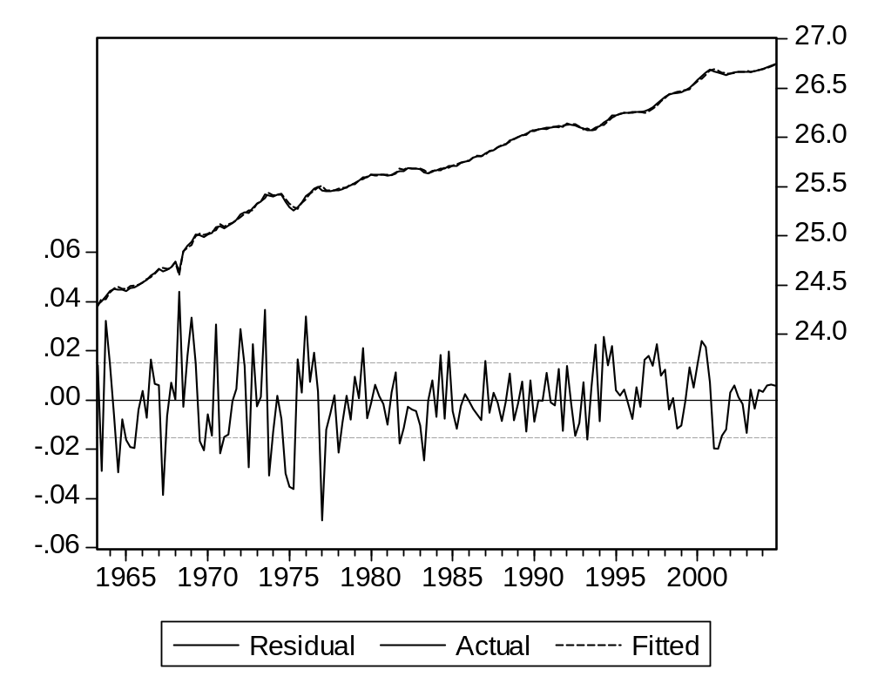
ΔM / M = a ΔFD/FD = 1.96 ΔFD/FD = 1.96 ΔFD/FD

ΔM = 1.96 M/FD ΔFD

If the share of imports in demand grows over 1/1.96 = 0.52, a given increase in local demand will lead to an even higher increase in imports, and a negative change in local production. However, such a situation will not happen so soon : the present share in France is 0.25, and it has grown by 0.06 over the last ten years. But a share of 0.40 would associate to additional imports a share of more than 80%.
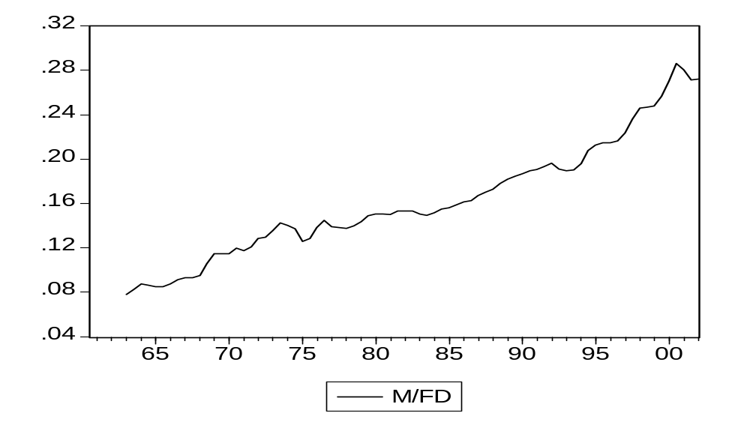

5. We shall now try to introduce this effect. The simplest solution is to use a constant time trend

Log(M) = a Log(FD) + b t + c

The first results are promising: the demand coefficient decreases, and the trend is positive and significant. But the autocorrelation remains, which was to be expected as an unbroken trend us not the best tool to remove it.

Dependent Variable: LOG(M)
Method: Least Squares
Date: 06/25/07 Time: 16:38
Sample (adjusted): 1963Q1 2004Q4
Included observations: 168 after adjustments
LOG(M)=C_M(1)*LOG(FD)+C_M(2)*T+C_M(3)
 | Coefficient | Std. Error | t-Statistic | Prob.
C_M(1) | 1.541307 | 0.063100 | 24.42631 | 0.0000
C_M(2) | 0.014403 | 0.001635 | 8.807698 | 0.0000
C_M(3) | -45.31053 | 1.591204 | -28.47562 | 0.0000
R-squared | 0.993172 | Mean dependent var |  | 25.69074
Adjusted R-squared | 0.993089 | S.D. dependent var |  | 0.660169
S.E. of regression | 0.054879 | Akaike info criterion |  | -2.949659
Sum squared resid | 0.496940 | Schwarz criterion |  | -2.893874
Log likelihood | 250.7713 | Durbin-Watson stat |  | 0.085776
Using an AR process again, the results are slightly better, even if the trend is not significant (and small).

Dependent Variable: LOG(M)
Method: Least Squares
Date: 06/25/07 Time: 16:41
Sample (adjusted): 1963Q2 2004Q4
Included observations: 167 after adjustments
Convergence achieved after 7 iterations
LOG(M)=C_M(1)*LOG(FD)+C_M(2)*T+C_M(3)+[AR(1)=C_M(4)]
 | Coefficient | Std. Error | t-Statistic | Prob.
C_M(1) | 1.970077 | 0.098760 | 19.94807 | 0.0000
C_M(2) | 0.007681 | 0.004791 | 1.603002 | 0.1109
C_M(3) | -43.80955 | 8.842943 | -4.954182 | 0.0000
C_M(4) | 0.971351 | 0.019182 | 50.63891 | 0.0000
R-squared | 0.999469 | Mean dependent var |  | 25.69972
Adjusted R-squared | 0.999459 | S.D. dependent var |  | 0.651772
S.E. of regression | 0.015153 | Akaike info criterion |  | -5.517554
Sum squared resid | 0.037428 | Schwarz criterion |  | -5.442871
Log likelihood | 464.7158 | Durbin-Watson stat |  | 1.730778
Inverted AR Roots | .97
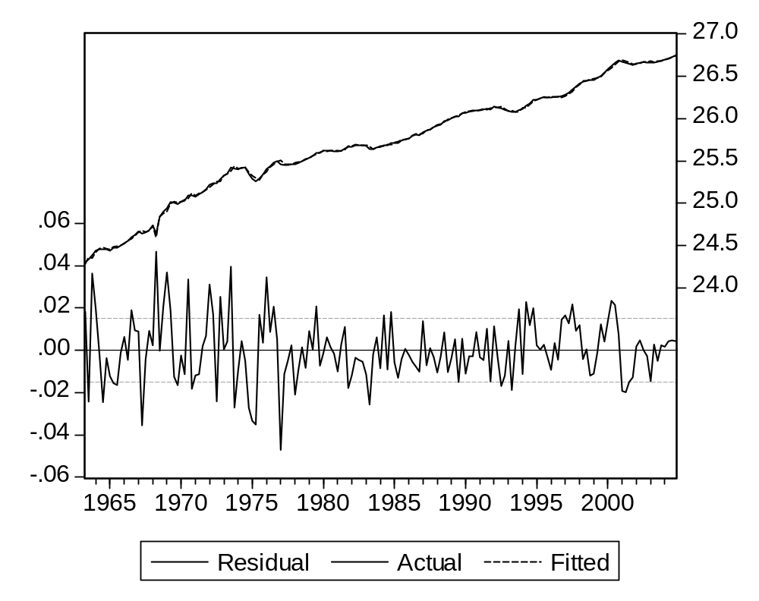
It is clear that we must make further research, studying the causes of the growth of French imports during the sample period, and looking for other explanations. We shall come back to this problem later, and accept for now the simple auto-correlation reducing estimation.

6. We shall use :

equation eq_m.ls(p) log(m)=c_m(1)*log(fd)+c_m(2)*t+c_m(3)+[ar(1)=c_m(4)]+ec_m

Question 2 : Exports

We now have to estimate

Log(X) = a Log(WD) + b

The above objection is not justified here, as the explanatory variable represents demand on the international market, and includes the natural expansion of world trade. The estimated coefficient should be close to unity.

Dependent Variable: LOG(X)
Method: Least Squares
Date: 06/25/07 Time: 17:55
Sample (adjusted): 1974Q1 2004Q4
Included observations: 124 after adjustments
LOG(X)=C_X(1)*LOG(WD)+C_X(2)
 | Coefficient | Std. Error | t-Statistic | Prob.
C_X(1) | 0.887012 | 0.004704 | 188.5550 | 0.0000
C_X(2) | 3.097530 | 0.121671 | 25.45817 | 0.0000
R-squared | 0.996580 | Mean dependent var |  | 26.03497
Adjusted R-squared | 0.996552 | S.D. dependent var |  | 0.446469
S.E. of regression | 0.026216 | Akaike info criterion |  | -4.428916
Sum squared resid | 0.083846 | Schwarz criterion |  | -4.383427
Log likelihood | 276.5928 | Durbin-Watson stat |  | 0.480527
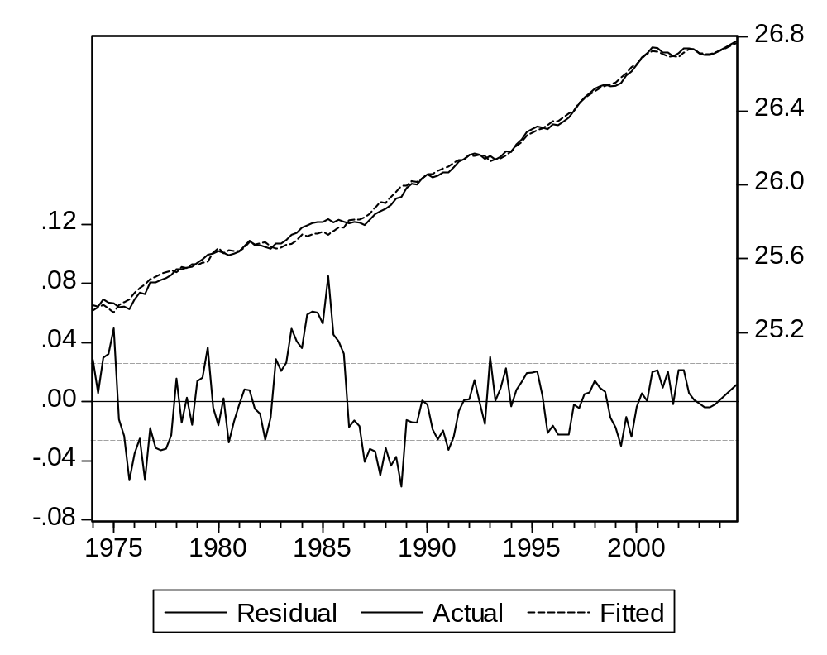
The coefficient is close to 1, but significantly different. In any case, the Durbin-Watson test invalidates the formulation.

2. Let us try to eliminate auto-correlation.

Dependent Variable: LOG(X)
Method: Least Squares
Date: 06/25/07 Time: 17:46
Sample (adjusted): 1974Q2 2004Q4
Included observations: 123 after adjustments
Convergence achieved after 4 iterations
LOG(X)=C_X(1)*LOG(WD)+C_X(2)+[AR(1)=C_X(3)]+EC_X
 | Coefficient | Std. Error | t-Statistic | Prob.
C_X(1) | 0.884420 | 0.012696 | 69.65941 | 0.0000
C_X(2) | 3.164011 | 0.328984 | 9.617535 | 0.0000
C_X(3) | 0.757248 | 0.059233 | 12.78431 | 0.0000
R-squared | 0.998533 | Mean dependent var |  | 26.04055
Adjusted R-squared | 0.998509 | S.D. dependent var |  | 0.443924
S.E. of regression | 0.017142 | Akaike info criterion |  | -5.270440
Sum squared resid | 0.035263 | Schwarz criterion |  | -5.201850
Log likelihood | 327.1320 | Durbin-Watson stat |  | 2.304654
Inverted AR Roots | .76

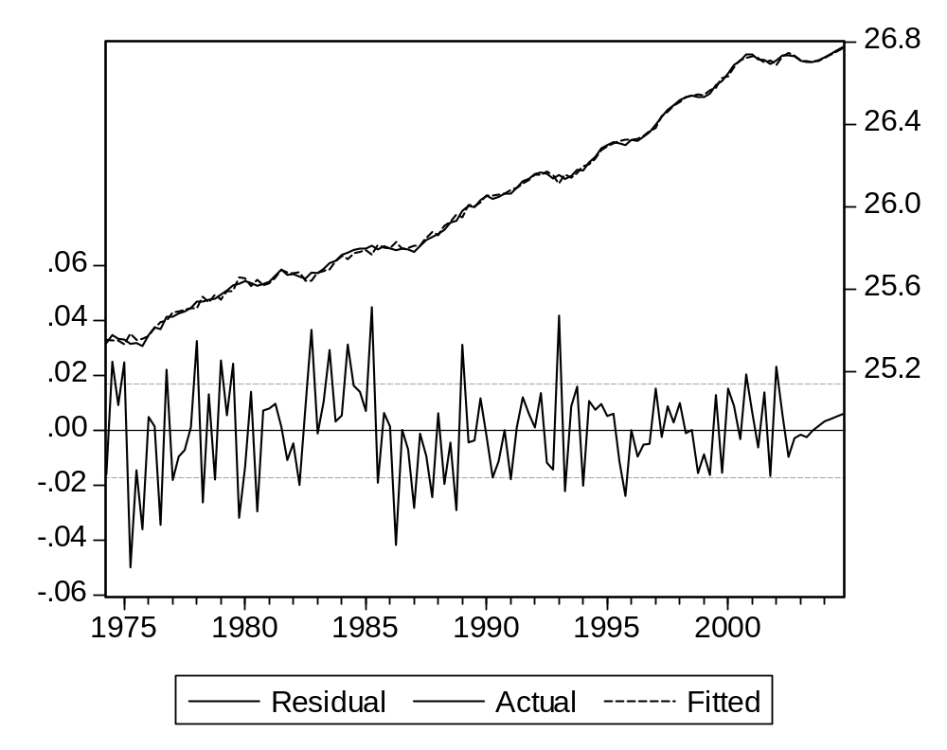

This improves the global results significantly. The error is reduced, and the auto-correlation almost disappears, as the Durbin-Watson test value is now acceptable. The coefficient of World trade is still significantly different from 1, which means we should check how world demand is computed.
This is done by:
equation eq_x.ls(p) log(x)=c_x(1)*log(wd)+c_x(2)+[ar(1)=c_x(3)]+ec_x
genr ec_x=resid

Question 3: Change in inventories
For a particular good, this type of behavior come from its producers (a car manufacturer will set an average target between the production and the inventories of each car) but also from its users : if the time is constant between buying the necessary steel and using it, the quantity of steel in inventories will be proportional to production.

If firms have achieved, at the previous period, an inventory level STOC representing a number of quarters of production :
ILt-1 = a Qt-1
They want to maintain this share at the present period:
IL*t = a Qt

And they manage to do it :
ILt = IL*t
Then the change in inventory will represent :
ICt = (ILt-ILt-1) = a (Qt-Qt-1)
This means the equation should not include a constant term.
We just have to eliminate its dimension by dividing each term in the equation by a stable element, growing with the local economy. The simplest idea is to use Q itself.
ICt/ Qt-1 = a (Qt-Qt-1)/ Qt-1
Estimating the basic equation shows a mixed result.
- The T-statistic is quite significant.

- The R-Squared is not too bad considering the volatility of the explained series.

- The Durbin-Watson test (dubious as there is no constant term) is quite bad.

- As the explained variable is measured in GDP points, the standard error shows an average of 0.6 points, a rather high figure.

- And the graph of residuals shows the limits of the explanation.

Dependent Variable: IC/Q(-1)
Method: Least Squares
Date: 06/25/07 Time: 12:26
Sample (adjusted): 1964Q1 2004Q4
Included observations: 164 after adjustments
Variable | Coefficient | Std. Error | t-Statistic | Prob.
@PCHY(Q) | 0.106681 | 0.012802 | 8.333409 | 0.0000
R-squared | 0.220521 | Mean dependent var |  | 0.002259
Adjusted R-squared | 0.220521 | S.D. dependent var |  | 0.006784
S.E. of regression | 0.005990 | Akaike info criterion |  | -7.391487
Sum squared resid | 0.005848 | Schwarz criterion |  | -7.372585
Log likelihood | 607.1019 | Durbin-Watson stat |  | 0.958799

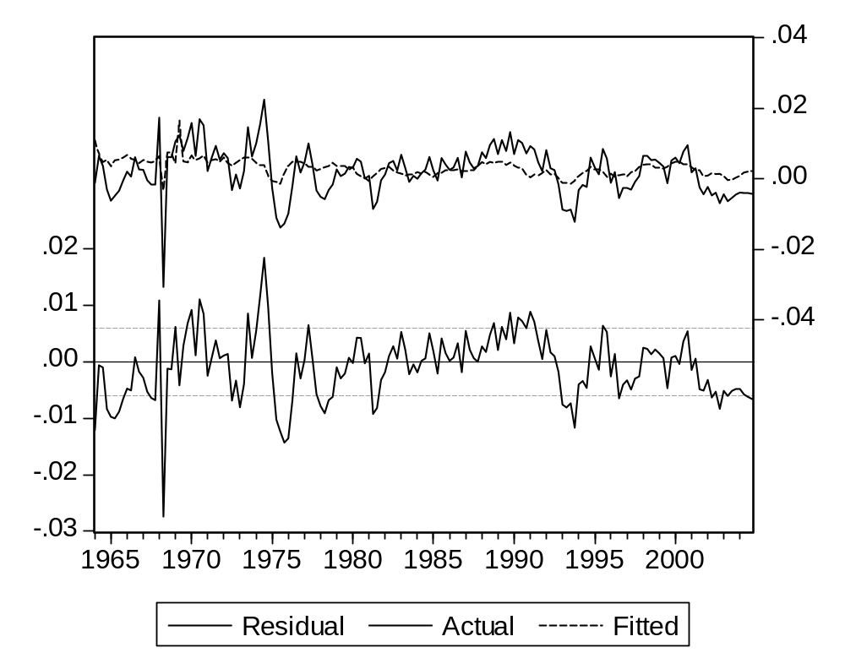

As production was much more reduced than demand, in an unexpected way, satisfying it had to call for inventories, and even a lower production needed intermediate goods (in particular oil and coal) which were not available due to transportation problems. Thus stocks decreased more than normally.

In equation terms,

ILt < IL*t

This period has to be dropped from the sample, as the economic conditions made firms adopt a different behavior. This would not be the case if the drop in production was demand driven.

Not doing it would introduce an alien behavior, just for one point admittedly, but with a very high value. As it will work through its square, the influence on the global statistics will not be negligible.

The results are slightly improved (R-squared, standard error).

Dependent Variable: IC/Q(-1)
Method: Least Squares
Date: 06/25/07 Time: 12:24
Sample (adjusted): 1964Q1 2004Q4
Included observations: 164 after adjustments
Variable | Coefficient | Std. Error | t-Statistic | Prob.
@PCHY(Q) | 0.102852 | 0.012011 | 8.563486 | 0.0000
T=1968.25 | -0.027511 | 0.005620 | -4.895526 | 0.0000
R-squared | 0.320976 | Mean dependent var |  | 0.002259
Adjusted R-squared | 0.316784 | S.D. dependent var |  | 0.006784
S.E. of regression | 0.005608 | Akaike info criterion |  | -7.517260
Sum squared resid | 0.005094 | Schwarz criterion |  | -7.479457
Log likelihood | 618.4153 | Durbin-Watson stat |  | 0.700490

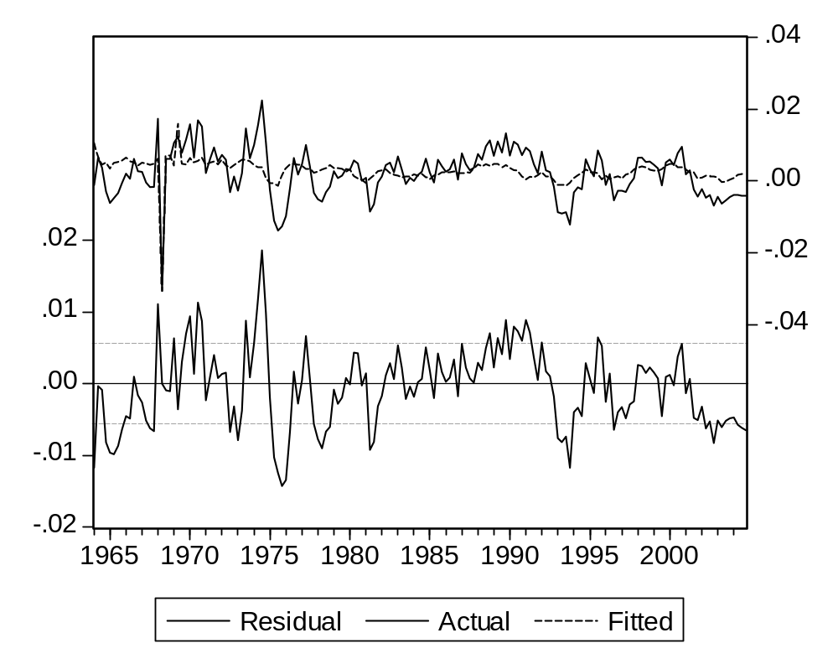

We can consider for instance:
- The last five quarterly changes. The coefficient for the first quarter is negligible (and negative…).

Dependent Variable: IC/Q(-1)
Method: Least Squares
Date: 06/22/07 Time: 14:51
Sample (adjusted): 1964Q2 2004Q4
Included observations: 163 after adjustments
Variable | Coefficient | Std. Error | t-Statistic | Prob.
@PCH(Q) | -0.015392 | 0.043290 | -0.355545 | 0.7227
@PCH(Q(-1)) | 0.058955 | 0.036838 | 1.600411 | 0.1115
@PCH(Q(-2)) | 0.166449 | 0.034885 | 4.771425 | 0.0000
@PCH(Q(-3)) | 0.177331 | 0.037380 | 4.743971 | 0.0000
@PCH(Q(-4)) | 0.073800 | 0.035119 | 2.101456 | 0.0372
T=1968.25 | -0.037652 | 0.006491 | -5.801017 | 0.0000
R-squared | 0.386670 | Mean dependent var |  | 0.002280
Adjusted R-squared | 0.367137 | S.D. dependent var |  | 0.006800
S.E. of regression | 0.005409 | Akaike info criterion |  | -7.565217
Sum squared resid | 0.004594 | Schwarz criterion |  | -7.451337
Log likelihood | 622.5652 | Durbin-Watson stat |  | 0.753603
A constant term is associated with a trend in the inventories-GDP ratio. The results improve, the graphic explanation in particular.
Dependent Variable: IC/Q(-1)
Method: Least Squares
Date: 06/25/07 Time: 14:29
Sample (adjusted): 1964Q2 2004Q4
Included observations: 163 after adjustments
Variable | Coefficient | Std. Error | t-Statistic | Prob.
@PCH(Q) | 0.036382 | 0.044148 | 0.824093 | 0.4111
@PCH(Q(-1)) | 0.118228 | 0.039153 | 3.019643 | 0.0030
@PCH(Q(-2)) | 0.228844 | 0.037844 | 6.047082 | 0.0000
@PCH(Q(-3)) | 0.226765 | 0.038570 | 5.879299 | 0.0000
@PCH(Q(-4)) | 0.105445 | 0.034981 | 3.014321 | 0.0030
T=1968.25 | -0.034226 | 0.006329 | -5.407465 | 0.0000
C | -0.002653 | 0.000738 | -3.595542 | 0.0004
R-squared | 0.433608 | Mean dependent var |  | 0.002280
Adjusted R-squared | 0.411823 | S.D. dependent var |  | 0.006800
S.E. of regression | 0.005215 | Akaike info criterion |  | -7.632563
Sum squared resid | 0.004243 | Schwarz criterion |  | -7.499703
Log likelihood | 629.0539 | F-statistic |  | 19.90457
Durbin-Watson stat | 0.794762 | Prob(F-statistic) |  | 0.000000

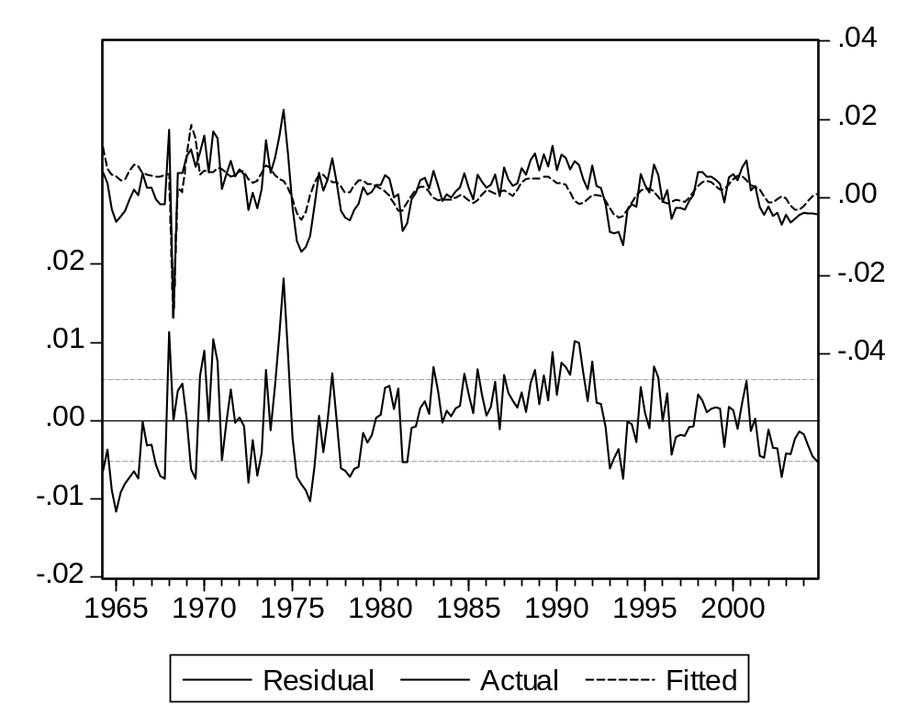
To make the set of lagged coefficients smoother, we can constraint them using a polynomial distributed lags (PDL):

The syntax for this element is :

PDL(variable, number of lags, degree of the polynomial, conditions).

Here we shall use :

PDL(@pch(Q),4,3,2)

Which implies

- A maximum lag of 4.
- A polynomial of degree 3.
- A zero value for the last coefficient (just beyond the last lag).

Dependent Variable: IC/Q(-1)
Method: Least Squares
Date: 06/25/07 Time: 14:52
Sample (adjusted): 1964Q2 2004Q4
Included observations: 163 after adjustments
Variable | Coefficient |  | Std. Error | t-Statistic | Prob.
T=1968.25 | -0.026807 |  | 0.005099 | -5.256900 | 0.0000
IC(-1)/Q(-2) | 0.612895 |  | 0.063632 | 9.631865 | 0.0000
C | -0.002149 |  | 0.000591 | -3.636950 | 0.0004
PDL01 | 0.054922 |  | 0.027450 | 2.000823 | 0.0471
PDL02 | -0.028519 |  | 0.022629 | -1.260305 | 0.2094
PDL03 | 0.017477 |  | 0.009394 | 1.860457 | 0.0647
R-squared | 0.636943 |  | Mean dependent var |  | 0.002280
Adjusted R-squared | 0.625380 |  | S.D. dependent var |  | 0.006800
S.E. of regression | 0.004162 |  | Akaike info criterion |  | -8.089560
Sum squared resid | 0.002720 |  | Schwarz criterion |  | -7.975679
Log likelihood | 665.2991 |  | F-statistic |  | 55.08772
Durbin-Watson stat | 2.022998 |  | Prob(F-statistic) |  | 0.000000
Lag Distribution of @PCH(Q) |  | i | Coefficient | Std. Error | t-Statistic
. *| |  | 0 | 0.21940 | 0.03934 | 5.57655
. * | |  | 1 | 0.10561 | 0.02824 | 3.73939
. * | |  | 2 | 0.05492 | 0.02745 | 2.00082
. * | |  | 3 | 0.03919 | 0.02780 | 1.40989
. * | |  | 4 | 0.03026 | 0.02738 | 1.10538
 | Sum of Lags |  | 0.44938 | 0.07327 | 6.13293
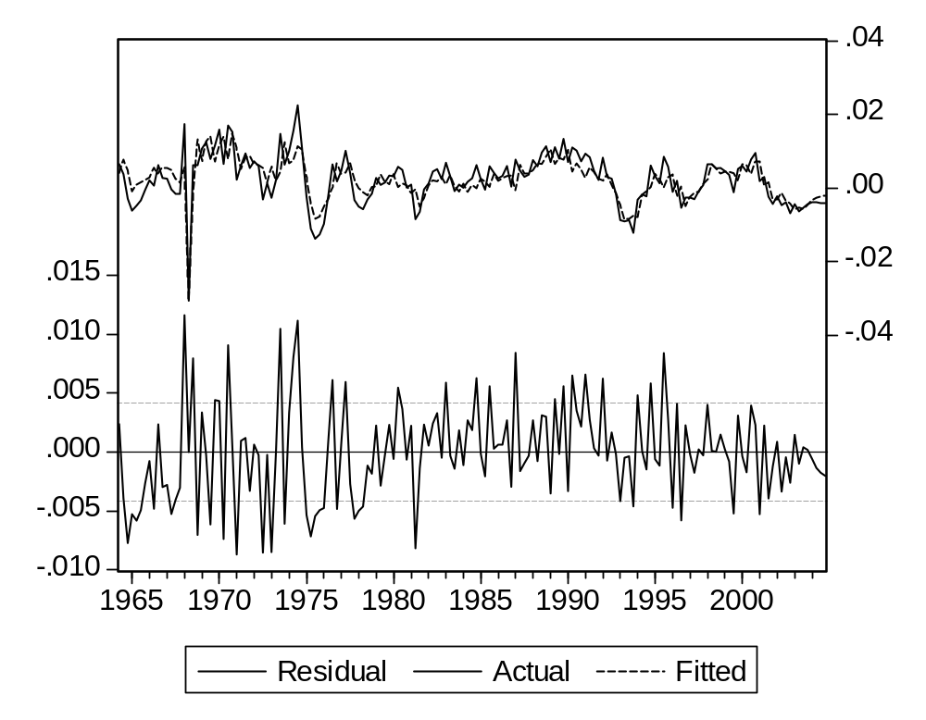
Introducing a PDL expression in our framework is not so easy, as Eviews does not allow them in equations with a non-linear format (even if they are linear in practice).

So we must :

- estimate the equation using the linear format
- store the coefficients into a vector of parameters
- estimate a “non-linear” formula including the set parameters.

The sequence is :

ls(p) ic/q(-1) (t=1968.25) ic(-1)/q(-2) c PDL(@pch(Q),4,3,2)

vector(12) p_ic

p_ic(7)=c(7)
p_ic(8)=c(8)
p_ic(9)=c(9)
p_ic(10)=c(10)
p_ic(11)=c(11)

genr ec_ic=0
equation eq_ic.ls(p) ic/q(-1)=c_ic(1)*(t=1968.25)+c_ic(2)*ic(-1)/q(-2)+c_ic(3) +p_ic(7)*@pch(q)+p_ic(8)*@pch(q(-1))+p_ic(9)*@pch(q(-2))+p_ic(10)*@pch(q(-3))+p_ic(11)*@pch(q(-4))+ec_ic
genr ec_ic=resid

Question 4 : Firms employment

First, we compute actual labor productivity
PROD = Q / LE

And regress it on time:
Log(PROD) = a + b t
To get the structural productivity trend.

Dependent Variable: LOG(Q/LE)
Method: Least Squares
Date: 06/26/07 Time: 19:30
Sample (adjusted): 1963Q1 2004Q4
Included observations: 168 after adjustments
LOG(Q/LE)=C(1)+C(2)*T
 | Coefficient | Std. Error | t-Statistic | Prob.
C(1) | -39.40435 | 0.874206 | -45.07445 | 0.0000
C(2) | 0.024634 | 0.000441 | 55.90400 | 0.0000
R-squared | 0.949563 | Mean dependent var |  | 9.466339
Adjusted R-squared | 0.949260 | S.D. dependent var |  | 0.307411
S.E. of regression | 0.069246 | Akaike info criterion |  | -2.490459
Sum squared resid | 0.795980 | Schwarz criterion |  | -2.453269
Log likelihood | 211.1986 | Durbin-Watson stat |  | 0.030638

Results are quite bad. Of course productivity shows a significant growth, but the standard error is quite high (more than 5 %). More important, the graph of residuals and the auto-correlation test show that we are not meeting the condition we have set : that observed productivity fluctuates around a desired value growing at a constant rate.
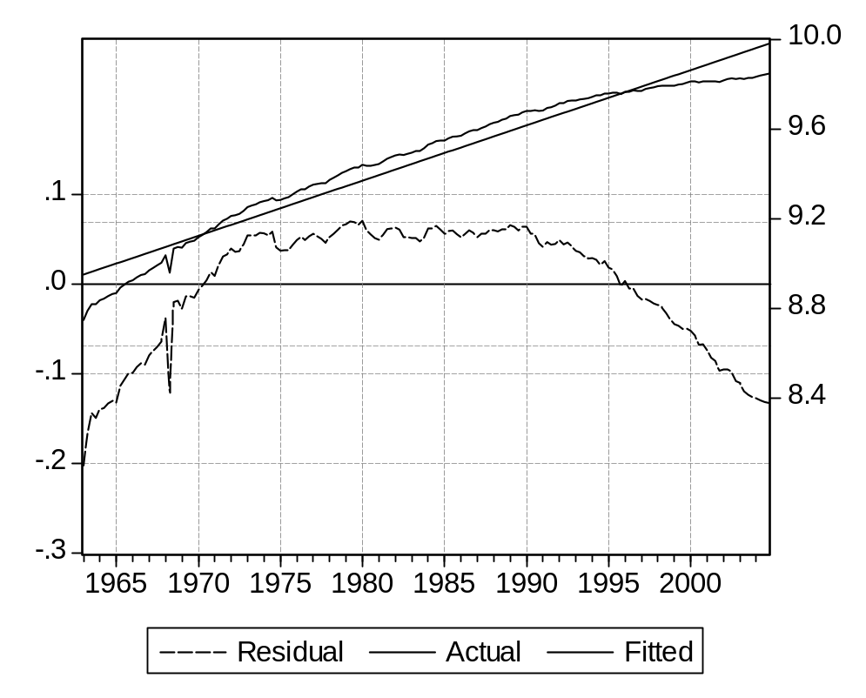

The problem apparently lies in the fact that the average growth rate is consistently higher in the first part of the period, and lower later. Seen individually, each sub-period might seem to meet the above condition.

From the graph above, we clearly need two breaks. The best result seems to correspond to 1972 and 1992.

To confirm this, we can make a series of Chow tests, and use the one with the highest likelihood. The couple of periods is 1972Q4 and 1992Q2, with a value of 651.777, a local maximum as shown by the following results.

Chow Breakpoint Test: 1972Q2 1992Q1
F-statistic | 1989.069 | Probability |  | 0.000000
Log likelihood ratio | 648.8789 | Probability |  | 0.000000

Chow Breakpoint Test: 1972Q2 1992Q2
F-statistic | 1991.204 | Probability |  | 0.000000
Log likelihood ratio | 649.0524 | Probability |  | 0.000000

Chow Breakpoint Test: 1972Q2 1992Q3
F-statistic | 1985.497 | Probability |  | 0.000000
Log likelihood ratio | 648.5881 | Probability |  | 0.000000

Chow Breakpoint Test: 1972Q4 1992Q1
F-statistic | 2020.779 | Probability |  | 0.000000
Log likelihood ratio | 651.4379 | Probability |  | 0.000000

Chow Breakpoint Test: 1972Q4 1992Q2
F-statistic | 2025.027 | Probability |  | 0.000000
Log likelihood ratio | 651.7777 | Probability |  | 0.000000

Chow Breakpoint Test: 1972Q4 1992Q3
F-statistic | 2022.195 | Probability |  | 0.000000
Log likelihood ratio | 651.5512 | Probability |  | 0.000000

Chow Breakpoint Test: 1973Q1 1992Q1
F-statistic | 2016.841 | Probability |  | 0.000000
Log likelihood ratio | 651.1222 | Probability |  | 0.000000

Chow Breakpoint Test: 1973Q1 1992Q2
F-statistic | 2021.640 | Probability |  | 0.000000
Log likelihood ratio | 651.5068 | Probability |  | 0.000000

Chow Breakpoint Test: 1973Q1 1992Q3
F-statistic | 2019.697 | Probability |  | 0.000000
Log likelihood ratio | 651.3512 | Probability |  | 0.000000

The breaks are accepted with a very high probability. However, any break would be actually accepted, and we should chose the one with the highest log likelihood ratio (this criterion works only because the sample and the number of breaks remain the same).

One will of course observe that the first period follows the first oil shock, and the beginning of a lasting world economic crisis. The reason for the second break is less clear (some countries like the US and Scandinavia show a break in the opposite direction).

The equation for structural productivity is

log(prle_t)=c_prle(1)+c_prle(2)*(t-2002)+c_prle(3)*(t-t1)*(t<t1)+c_prle(4)*(t-t2)*(t<t2)

The results look acceptable, as to the validation of coefficients and the graphs.

Dependent Variable: LOG(PRLE)
Method: Least Squares
Date: 06/26/07 Time: 18:42
Sample (adjusted): 1963Q1 2004Q4
Included observations: 168 after adjustments
LOG(PRLE)=C_PRLE(1)+C_PRLE(2)*(T-2002)+C_PRLE(3)*(T-T1)
*(T<T1)+C_PRLE(4)*(T-T2)*(T<T2)
 | Coefficient | Std. Error | t-Statistic | Prob.
C_PRLE(1) | 9.821081 | 0.001777 | 5527.924 | 0.0000
C_PRLE(2) | 0.009382 | 0.000262 | 35.76099 | 0.0000
C_PRLE(3) | 0.022782 | 0.000457 | 49.89498 | 0.0000
C_PRLE(4) | 0.015405 | 0.000361 | 42.64593 | 0.0000
R-squared | 0.999093 | Mean dependent var |  | 9.466339
Adjusted R-squared | 0.999077 | S.D. dependent var |  | 0.307411
S.E. of regression | 0.009341 | Akaike info criterion |  | -6.485251
Sum squared resid | 0.014310 | Schwarz criterion |  | -6.410871
Log likelihood | 548.7611 | Durbin-Watson stat |  | 1.553017

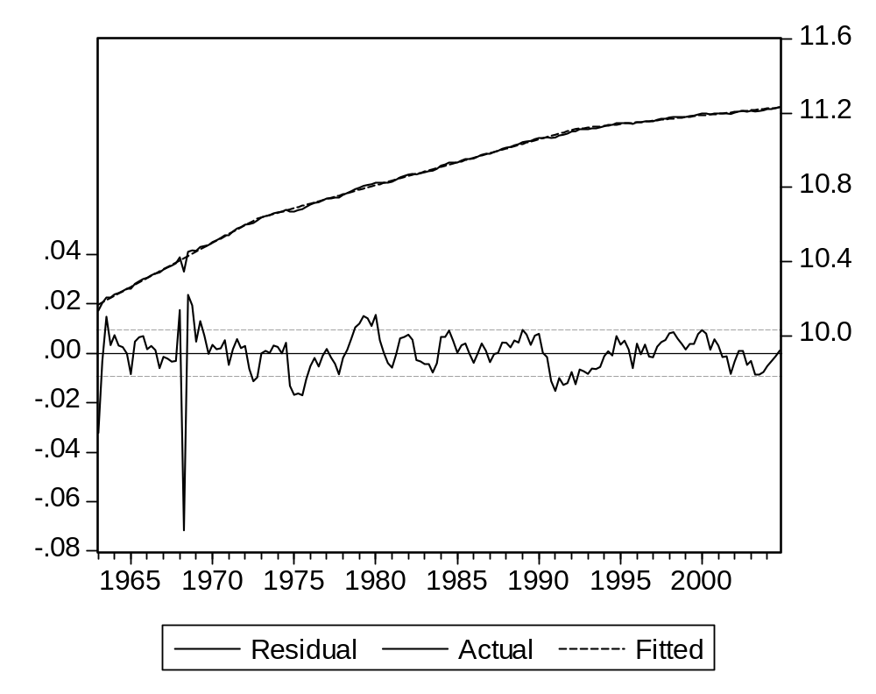
The stationarity of the residual is tested by :

genr res_prle=resid
uroot(1,p) res_prle
uroot(h,p) res_prle

Null Hypothesis: RES_PRLE has a unit root
Exogenous: Constant
Lag Length: 1 (Fixed)
 |  |  | t-Statistic | Prob.*
Augmented Dickey-Fuller test statistic |  |  | -7.019929 | 0.0000
Test critical values: | 1% level |  | -3.469933
 | 5% level |  | -2.878829
 | 10% level |  | -2.576067
*MacKinnon (1996) one-sided p-values.
Augmented Dickey-Fuller Test Equation
Dependent Variable: D(RES_PRLE)
Method: Least Squares
Date: 06/25/07 Time: 18:10
Sample (adjusted): 1963Q3 2004Q4
Included observations: 166 after adjustments
Variable | Coefficient | Std. Error | t-Statistic | Prob.
RES_PRLE(-1) | -0.673535 | 0.095946 | -7.019929 | 0.0000
D(RES_PRLE(-1)) | -0.163495 | 0.074277 | -2.201161 | 0.0291
C | 0.000182 | 0.000677 | 0.268461 | 0.7887
R-squared | 0.419235 | Mean dependent var |  | 2.02E-05
Adjusted R-squared | 0.412109 | S.D. dependent var |  | 0.011377
S.E. of regression | 0.008723 | Akaike info criterion |  | -6.627792
Sum squared resid | 0.012403 | Schwarz criterion |  | -6.571551
Log likelihood | 553.1068 | F-statistic |  | 58.83221
Durbin-Watson stat | 2.024407 | Prob(F-statistic) |  | 0.000000

Null Hypothesis: RES_PRLE has a unit root
Exogenous: Constant
Bandwidth: 6 (Newey-West using Bartlett kernel)
 |  |  | Adj. t-Stat | Prob.*
Phillips-Perron test statistic |  |  | -11.42296 | 0.0000
Test critical values: | 1% level |  | -3.469691
 | 5% level |  | -2.878723
 | 10% level |  | -2.576010
*MacKinnon (1996) one-sided p-values.
Residual variance (no correction) |  |  |  | 7.65E-05
HAC corrected variance (Bartlett kernel) |  |  |  | 0.000110
Phillips-Perron Test Equation
Dependent Variable: D(RES_PRLE)
Method: Least Squares
Date: 06/25/07 Time: 18:10
Sample (adjusted): 1963Q2 2004Q4
Included observations: 167 after adjustments
Variable | Coefficient | Std. Error | t-Statistic | Prob.
RES_PRLE(-1) | -0.809764 | 0.073443 | -11.02581 | 0.0000
C | 0.000194 | 0.000681 | 0.285333 | 0.7757
R-squared | 0.424222 | Mean dependent var |  | 0.000194
Adjusted R-squared | 0.420732 | S.D. dependent var |  | 0.011563
S.E. of regression | 0.008800 | Akaike info criterion |  | -6.616138
Sum squared resid | 0.012779 | Schwarz criterion |  | -6.578797
Log likelihood | 554.4475 | F-statistic |  | 121.5686
Durbin-Watson stat | 2.054001 | Prob(F-statistic) |  | 0.000000

Both tests conclude very strongly to the stationarity of the residual.

The values of target productivity and desired employment are given by:
genr prle_t=exp(c_prle(1)+c_prle(2)*t+c_prle(3)*(t-1972.75)*(t<1972.75)+c_prle(4)*(t-1992.25)*(t<1992.25))
genr led=q/prle_t

LE will be estimated by :
ΔLog(LEt)= a ΔLog(LEDt) + b Log(LEDt-1 / LEt-1) + c

The results are rather significant, including the c coefficient.

Dependent Variable: DLOG(LE)
Method: Least Squares
Date: 06/25/07 Time: 18:59
Sample (adjusted): 1963Q2 2004Q4
Included observations: 167 after adjustments
DLOG(LE)=C_LE(1)*DLOG(LED)+C_LE(2)*LOG(LED(-1)/LE(-1))
+C_LE(3)
 | Coefficient | Std. Error | t-Statistic | Prob.
C_LE(1) | 0.166334 | 0.020297 | 8.195005 | 0.0000
C_LE(2) | 0.216267 | 0.026322 | 8.216159 | 0.0000
C_LE(3) | 0.000598 | 0.000204 | 2.931151 | 0.0039
R-squared | 0.346046 | Mean dependent var |  | 0.000756
Adjusted R-squared | 0.338071 | S.D. dependent var |  | 0.003228
S.E. of regression | 0.002626 | Akaike info criterion |  | -9.028889
Sum squared resid | 0.001131 | Schwarz criterion |  | -8.972877
Log likelihood | 756.9122 | Durbin-Watson stat |  | 0.894407
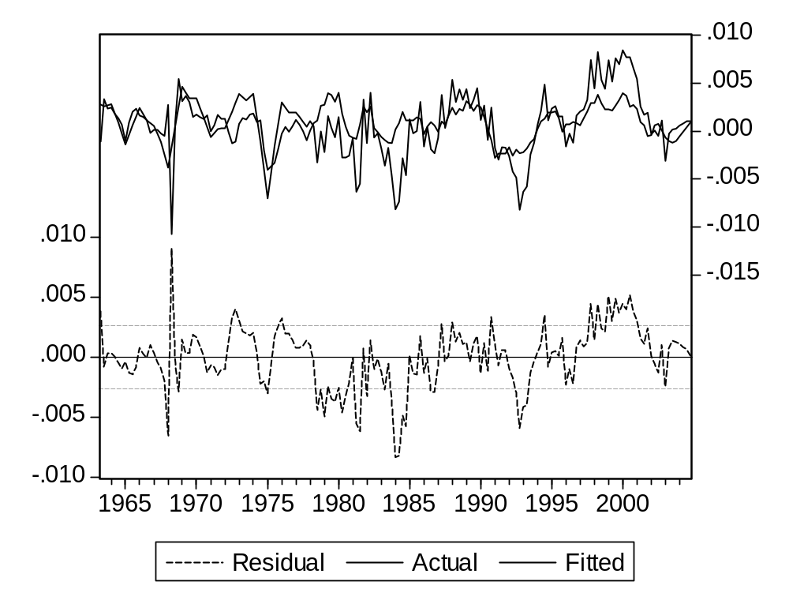
The results are rather satisfactory, with a relatively low adaptation speed.

However, we observe a large residual in 1968, in particular in the second quarter.
Again, the behavior of firms did not follow normal lines. They believed (rightly) that the decrease in production they were facing was quite temporary. For them, laying out the corresponding number of workers was not reasonable, as it would cost severance payments, and when things went back to normal there was no reason they would find as efficient and firm-knowledgeable workers as before.

This means labor productivity decreased, then increased to get back to normal.

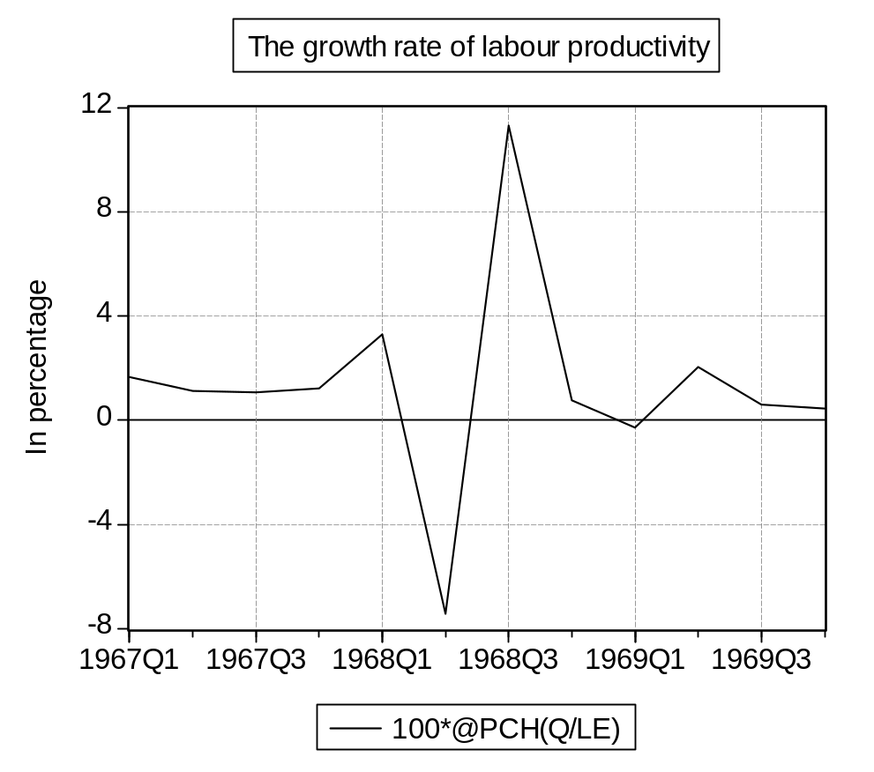
This calls for a dummy variable in the corresponding period. But not only, as this temporary over employment allowed firms to manage the backswing in production with limited job creation.

The simplest idea is to introduce a symmetric dummy, with the value 1 in the second quarter and -1 in the third.

Dependent Variable: DLOG(LE)
Method: Least Squares
Date: 06/25/07 Time: 19:36
Sample (adjusted): 1963Q2 2004Q4
Included observations: 167 after adjustments
DLOG(LE)=C_LE(1)*DLOG(LED)+C_LE(2)*LOG(LED(-1)/LE(-1))
+C_LE(3)+C_LE(4)*((T=1968.25)-(T=1968.50))
 | Coefficient | Std. Error | t-Statistic | Prob.
C_LE(1) | 0.295420 | 0.030602 | 9.653533 | 0.0000
C_LE(2) | 0.199058 | 0.024568 | 8.102254 | 0.0000
C_LE(3) | 0.000475 | 0.000190 | 2.495656 | 0.0136
C_LE(4) | 0.017596 | 0.003294 | 5.342659 | 0.0000
R-squared | 0.443499 | Mean dependent var |  | 0.000756
Adjusted R-squared | 0.433257 | S.D. dependent var |  | 0.003228
S.E. of regression | 0.002430 | Akaike info criterion |  | -9.178280
Sum squared resid | 0.000962 | Schwarz criterion |  | -9.103598
Log likelihood | 770.3864 | Durbin-Watson stat |  | 1.087096
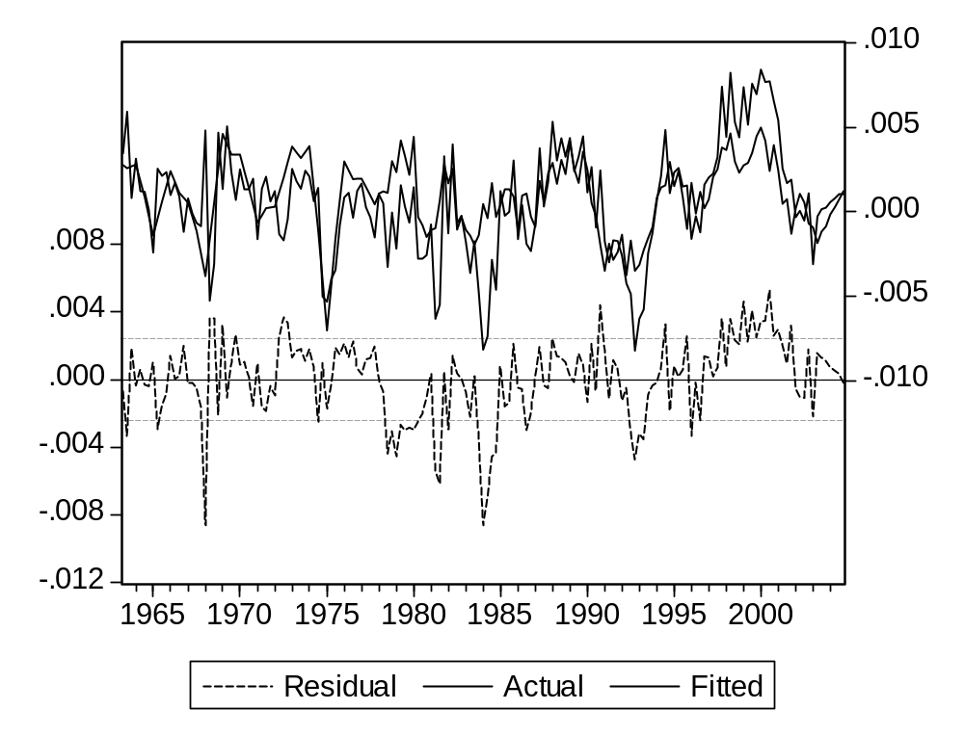
It is quite significant. However, a strong residual remains for the first quarter of 1968. In the absence of economic explanation, we shall not try to correct it.

Following the reasoning made earlier, c should correspond to the logarithm of the long term gap between the target employment and the level reached. This gap will be significant if both:
- A difference between the growths of GDP and target productivity is not compensated immediately (the value of a is different from one)

- Employment shows a trend (the target is moving), which means that GDP and target productivity show different trends.

The first condition is obviously met. As to the second, we can see that employment increases globally over the period, even if this increase is concentrated in the last ten years.
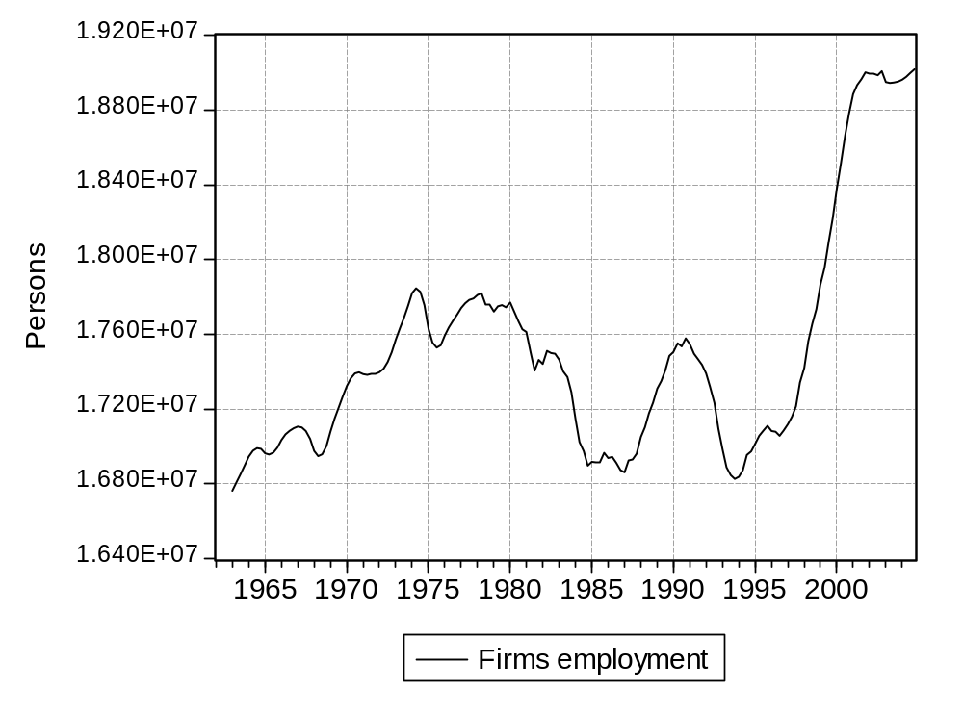

It is interesting to observe that dropping these ten years from the sample makes the constant non-significant:
Dependent Variable: DLOG(LE)
Method: Least Squares
Date: 06/26/07 Time: 10:04
Sample (adjusted): 1963Q2 1994Q4
Included observations: 127 after adjustments
DLOG(LE)=C_LE(1)*DLOG(LED)+C_LE(2)*LOG(LED(-1)/LE(-1))
+C_LE(3)+C_LE(4)*((T=1968.25)-(T=1968.5))
 | Coefficient | Std. Error | t-Statistic | Prob.
C_LE(1) | 0.248523 | 0.033377 | 7.445868 | 0.0000
C_LE(2) | 0.156582 | 0.026062 | 6.008141 | 0.0000
C_LE(3) | 5.28E-05 | 0.000213 | 0.247768 | 0.8047
C_LE(4) | 0.015114 | 0.003425 | 4.412703 | 0.0000
R-squared | 0.367503 | Mean dependent var |  | 9.83E-05
Adjusted R-squared | 0.352076 | S.D. dependent var |  | 0.002974
S.E. of regression | 0.002394 | Akaike info criterion |  | -9.200592
Sum squared resid | 0.000705 | Schwarz criterion |  | -9.111011
Log likelihood | 588.2376 | Durbin-Watson stat |  | 1.057623

As to a and b, they look significantly different. The first is more significant, and also higher: this could mean that it is easier (and more desirable) to close the first part of the gap between desired and actual employment.

We shall use (with t1=1972.75 and t2=1992)::

smpl 1962Q1 2004Q4
equation eq_prle.ls(p) log(prle)=c_prle(1)+c_prle(2)*(t-2002)+c_prle(3)*(t-t1)*(t<t1)+c_prle(4)*(t-t2)*(t<t2)

coef(10) c_le
genr ec_le=0
genr log(prle_t)=c_prle(1)+c_prle(2)*(t-2002)+c_prle(3)*(t-t1)*(t<t1)+c_prle(4)*(t-t2)*(t<t2)
genr led=q/prle_t
equation eq_le.ls(p) dlog(le)=c_le(1)*dlog(led)+c_le(2)*log(led(-1)/le(-1))+c_le(3)+c_le(4)*((t=1968.25)-(t=1968.50))+ec_le
genr ec_le=resid

g_vendo.drop led prle_t
g_vendo.add led prle_t

Question 3 : Productive investment

The first equation to estimate is
It = a (Qt - Qt-1) + b
The results are :

Dependent Variable: I
Method: Least Squares
Date: 06/26/07 Time: 18:41
Sample (adjusted): 1964Q1 2004Q4
Included observations: 164 after adjustments
I=C_I(1)*(Q-Q(-4))+C_I(2)
 | Coefficient | Std. Error | t-Statistic | Prob.
C_I(1) | 0.091625 | 0.190586 | 0.480755 | 0.6313
C_I(2) | 2.63E+10 | 1.35E+09 | 19.48366 | 0.0000
R-squared | 0.001425 | Mean dependent var |  | 2.69E+10
Adjusted R-squared | -0.004739 | S.D. dependent var |  | 9.26E+09
S.E. of regression | 9.28E+09 | Akaike info criterion |  | 48.75249
Sum squared resid | 1.40E+22 | Schwarz criterion |  | 48.79029
Log likelihood | -3995.704 | Durbin-Watson stat |  | 0.003293
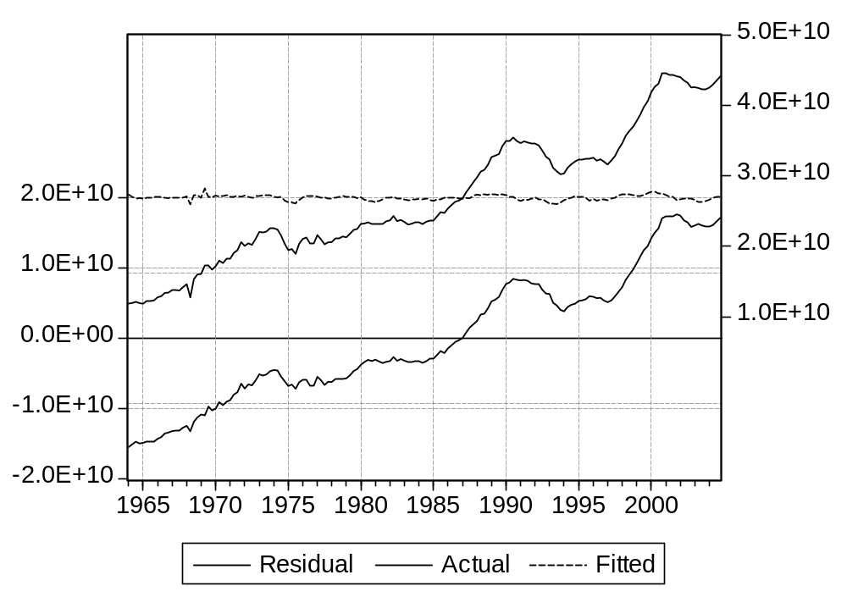

No statistic is satisfactory. Global quality: T-Stat, R2, standard error of residual, are quite bad, and the auto-correlation of residuals obvious. The graph shows there is no true link between the two elements.

This equation might look a little more acceptable, as depreciation should be proportional to capital, and now the equation is homogenous, all terms having the dimension of a value at constant prices. The individual results are improved, both terms providing a significant explanation. But the coefficients ar far from theoretical values: to produce one more unit of GDP, about 2 units of capital are needed, and the quarterly depreciation rate (associated with capital) is closer to 1 or 1.5%.

But the message provides by the graph is less favorable. One can even question if a trend would not give an explanation with a similar quality And anyway, the clear autocorrelation disqualifies the whole estimation..

Dependent Variable: I
Method: Least Squares
Date: 06/26/07 Time: 18:41
Sample (adjusted): 1964Q1 2004Q4
Included observations: 164 after adjustments
I=C_I(1)*(Q-Q(-4))+C_I(2)*K(-1)
 | Coefficient | Std. Error | t-Statistic | Prob.
C_I(1) | 0.710653 | 0.058391 | 12.17054 | 0.0000
C_I(2) | 0.017823 | 0.000304 | 58.64543 | 0.0000
R-squared | 0.849820 | Mean dependent var |  | 2.69E+10
Adjusted R-squared | 0.848893 | S.D. dependent var |  | 9.26E+09
S.E. of regression | 3.60E+09 | Akaike info criterion |  | 46.85799
Sum squared resid | 2.10E+21 | Schwarz criterion |  | 46.89580
Log likelihood | -3840.355 | Durbin-Watson stat |  | 0.248323

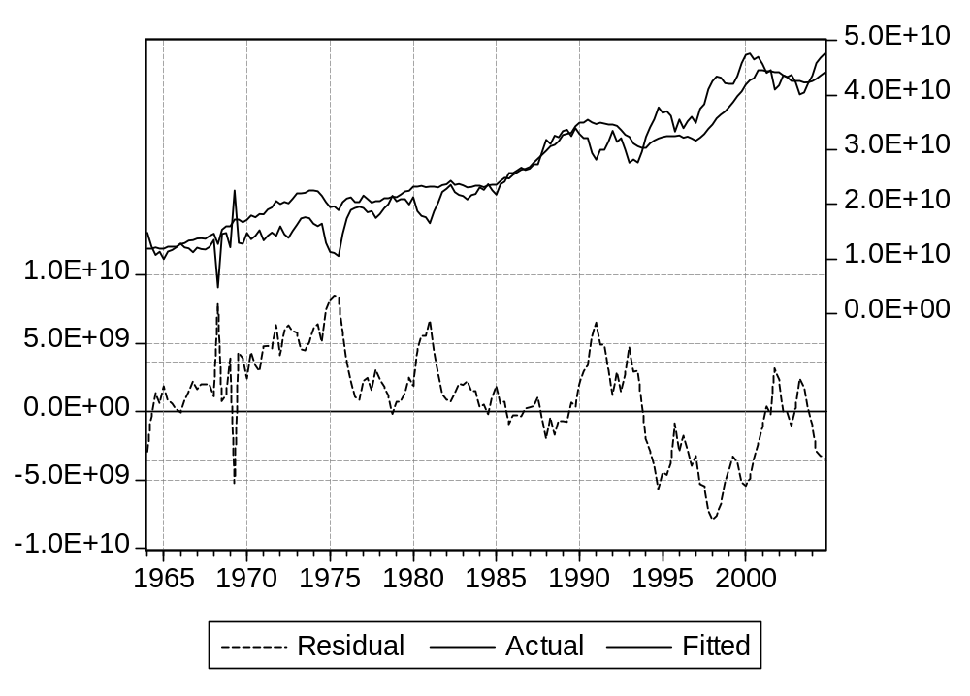

As for the change in inventories, the terms in the equation are measured at constant prices. They should grow with time, and the error too, while the estimation method requires a constant standard error.

To eliminate heteroskedaticity, we can divide all elements by a term of the same nature. In our case one can think of capital or GDP. Let us take capital. We shall use its lagged value (at the end of the previous period) and not the present level which includes present investment, the variable we want to explain.

We estimate :

I/K(-1)=C_I(1)*D(Q)/K(-1)+C_I(2)

And we get :

Dependent Variable: I/K(-1)
Method: Least Squares
Date: 06/26/07 Time: 18:41
Sample (adjusted): 1964Q1 2004Q4
Included observations: 164 after adjustments
I/K(-1)=C_I(1)*(Q-Q(-4))/K(-1)+C_I(2)
 | Coefficient | Std. Error | t-Statistic | Prob.
C_I(1) | 0.761420 | 0.049367 | 15.42371 | 0.0000
C_I(2) | 0.019615 | 0.000489 | 40.14171 | 0.0000
R-squared | 0.594889 | Mean dependent var |  | 0.025065
Adjusted R-squared | 0.592389 | S.D. dependent var |  | 0.006769
S.E. of regression | 0.004321 | Akaike info criterion |  | -8.038371
Sum squared resid | 0.003025 | Schwarz criterion |  | -8.000568
Log likelihood | 661.1464 | Durbin-Watson stat |  | 0.677091
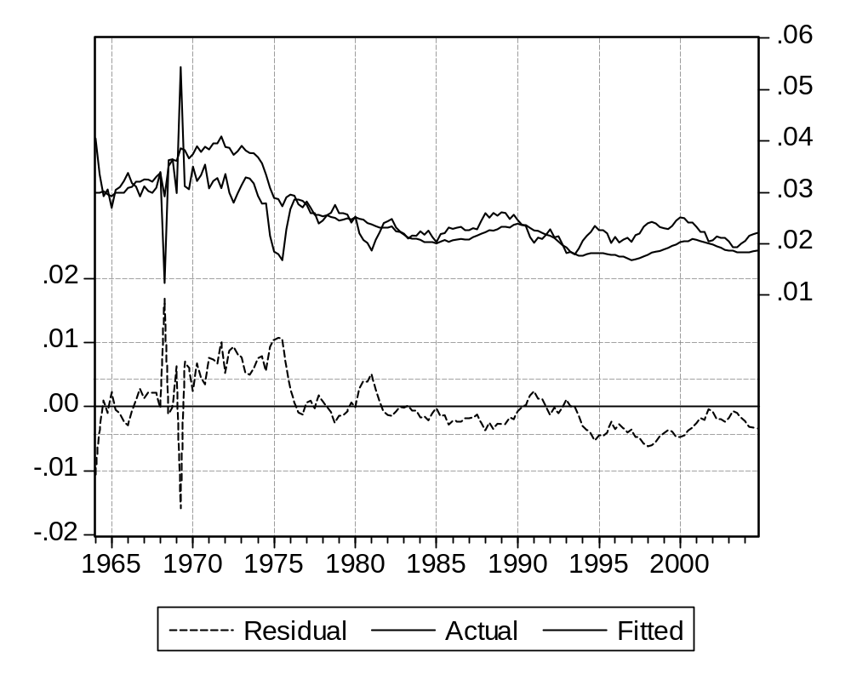
One could consider that the quality has decreased, in particular as the R2 statistic has changed from .85 to .59. However this is due to the elimination of a trend, present in both the explained an explanatory variables, and present in most macroeconomic series. This trend is the main element in the variance of the explained variable (through the deviation from the mean, close to the middle-of-sample value). And as the explanatory variables show a similar evolution, they are able to account for a large part of this variance,which would actually be the case for any growing variable, for instance the Australian GDP (or time itself)

We should rather consider the fact that the T-Statistics have the same average quality.

4. One can guess that although linking investment (a change in capital) to the change in production seems a natural idea, supposing the link to be linear (with a sensitivity constant with time) was going a little too fast. Moreover, the estimated equation contains a constant with a dimension, making it non-homogenous.

We shall have first to assess the actual equation to estimate. The framework described in the presentation gives the starting point.

We have
CAP*_{t+1} = pk _{t+1}K_{t} = a Qª _{t+1}

CAP _{t}= pk _{t} K _{t-1} = a Q _{t}
Dividing each term by its correspondent we get:
CAP*_{t+1} / CAP _{t} = (pk _{t+1} / pk _{t} ) (K_{t} / K _{t-1}) = (Qª _{t+1}/Q _{t})
Or
(pk _{t+1} / pk _{t} ) (K_{t} / K _{t-1}) = (Qª _{t+1}/Q _{t})
Or in growth rates, which we shall note as tx():
tx(pk _{t+1}) + tx(K _{t}) = txª (Q) _{t+1}
The desired growth rate of K is (logically enough) the difference between the expected growth rate of production Q and the growth rate of capital productivity pk.

Now we shall use the definition.

(11) Kt = Kt-1 (1 - drt) + It
can be written as
(11') tx(K _{t}) = I_{t} / Kt-1 - drt
giving the growth rate of capital as the difference between the “accumulation ratio” (investment as a share of initial capital) and the depreciation rate.

Combining both equations we get:
It / Kt-1 = drt - tx(pk) _{t+1} + txª (Q) _{t+1}
In other words, the determinants of investment, measured as a share of initial capital, are:
- The need to replace scrapped capital.
- The need to adapt to a change in expected production
- The evolution of capital productivity.

The depreciation rate follows :

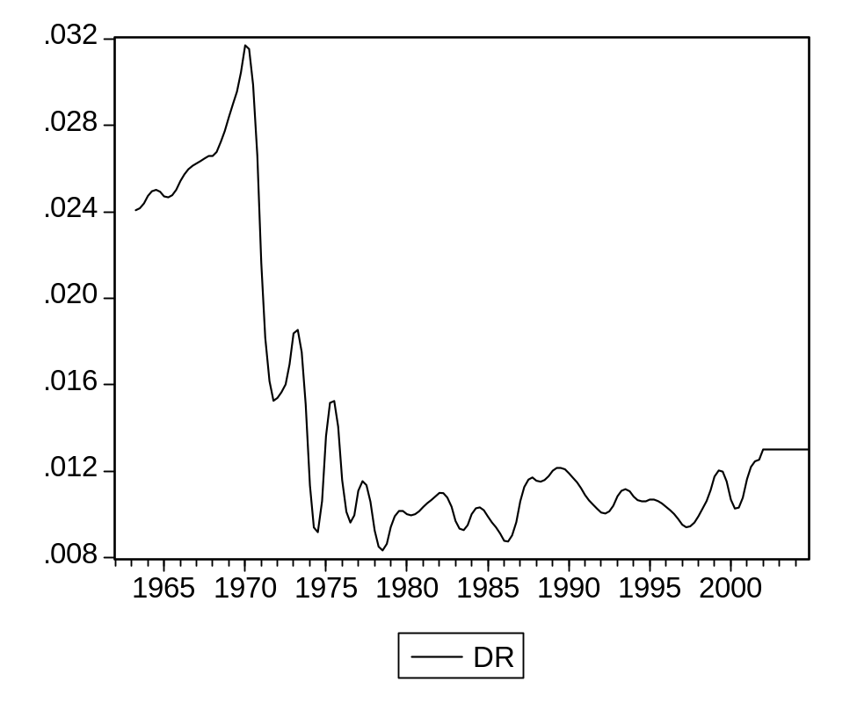
It looks constant, but only after the 1970-1975 period. Let us assume this assumption nonetheless.

As to the productivity of capital, it follows:

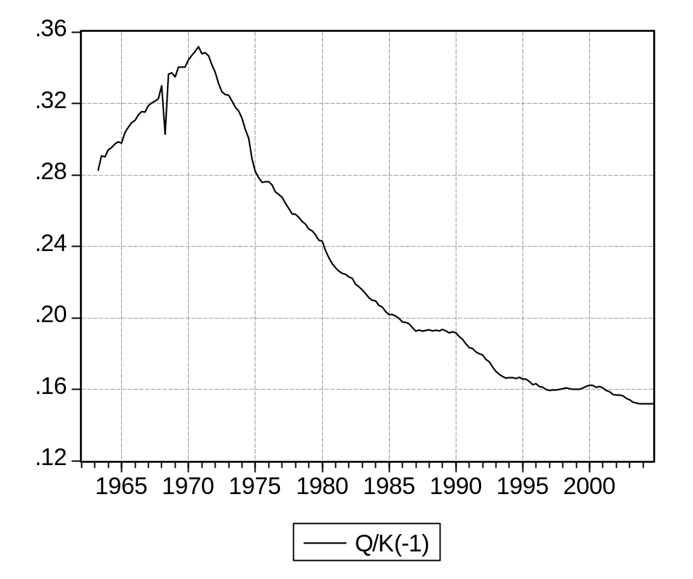

Again, the productivity of capital shows a stable trend, but only after 1972.

One can be surprised to see capital productivity decrease: machinery should be more and more effeicient with time. The explanation can be decomposed in two elements.
- First, there is no reason for productivity to increase: capital is measured at constant prices, and the price (or deflator) of capital is computed at a given quality level, which for capital means efficiency. When the current value of capital is decomposed into a deflator and a value at constant prices, any increase in quality is affected to the volume, not the deflator. If production follows capital productivity, the ratio of GDP to capital will not change.

- Second, we are considering the accounting notion of productivity, the number of units of output obtained by each unit of capital. True, we are using a complementary factors production function. But the evolution of technology in the last decades has gradually increased the role of capital, introducing a de facto substitution.
Let us take an example: if to produce the same good we replace a machine and ten men by two equivalent (as efficient) machines and one man, capital productivity is divided by 2, and labor productivity is multiplied by 10. The value of the machine at constant prices will stay the same, and the remaining worker can very well be less qualified than any of the previous ones (maybe he just has to control that all lights on a panel remain green, and call security otherwise).

Let us suppose that:

- production growth expectations are identical to the present annual rate
- the depreciation rate is constant, as well as the rate of growth of capital productivity

It / Kt-1 = a + (Qt - Qt-1 )/Qt-1

In which way does this formulation differ from the previous one? The first can be written as:

It / Kt-1= a tx(Qt) . (Kt-1 /Qt-1) + b
The two formulas would be identical if Q/K, the apparent capital productivity, was constant. But a graph shows that this productivity has been decreasing significantly for most of the the period, with the growing role of capital in the productive process.

We shall estimate the equation with an additional coefficient:
It / Kt-1 = a + b tx (Q) _{t}
Dependent Variable: I/K(-1)
Method: Least Squares
Date: 06/27/07 Time: 15:29
Sample (adjusted): 1964Q1 2004Q4
Included observations: 164 after adjustments
I/K(-1)=C_I(1)*1/4*@PCHY(Q)+C_I(2)
 | Coefficient | Std. Error | t-Statistic | Prob.
C_I(1) | 0.755018 | 0.075325 | 10.02350 | 0.0000
C_I(2) | 0.019576 | 0.000688 | 28.45363 | 0.0000
R-squared | 0.382788 | Mean dependent var |  | 0.025065
Adjusted R-squared | 0.378978 | S.D. dependent var |  | 0.006769
S.E. of regression | 0.005334 | Akaike info criterion |  | -7.617319
Sum squared resid | 0.004609 | Schwarz criterion |  | -7.579516
Log likelihood | 626.6202 | Durbin-Watson stat |  | 0.328203
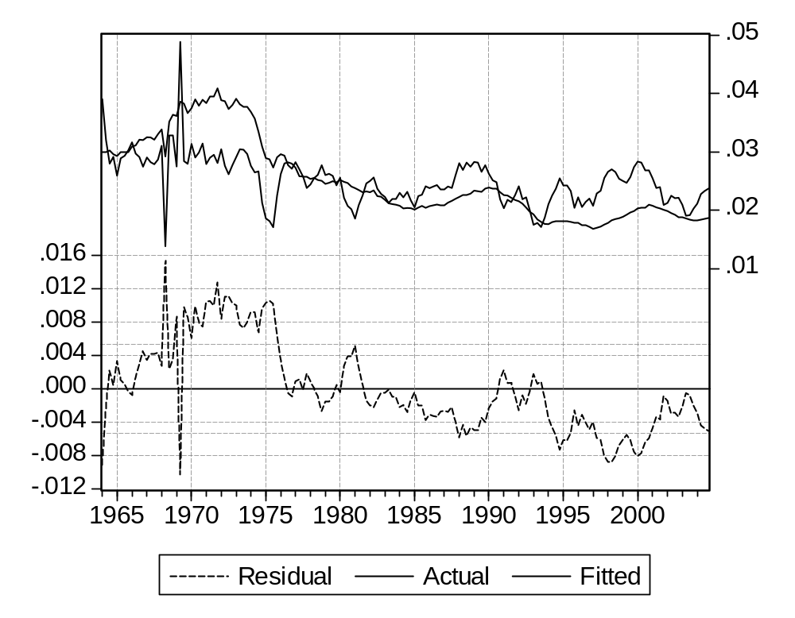

The results are similar, but actually a little worse. Let us try to improve the explanation.
The results are much improved in terms of significance and error, but the autocorrelation is still extremely high. The graph evidences also a better adjustment.

Dependent Variable: I/K(-1)
Method: Least Squares
Date: 06/26/07 Time: 19:19
Sample (adjusted): 1965Q1 2004Q4
Included observations: 160 after adjustments
I/K(-1)=C_I(1)*1/8*(Q-Q(-8))/Q(-8)+C_I(2)
 | Coefficient | Std. Error | t-Statistic | Prob.
C_I(1) | 1.178215 | 0.076454 | 15.41071 | 0.0000
C_I(2) | 0.016328 | 0.000655 | 24.92563 | 0.0000
R-squared | 0.600496 | Mean dependent var |  | 0.024944
Adjusted R-squared | 0.597967 | S.D. dependent var |  | 0.006809
S.E. of regression | 0.004317 | Akaike info criterion |  | -8.039970
Sum squared resid | 0.002945 | Schwarz criterion |  | -8.001530
Log likelihood | 645.1976 | Durbin-Watson stat |  | 0.282740
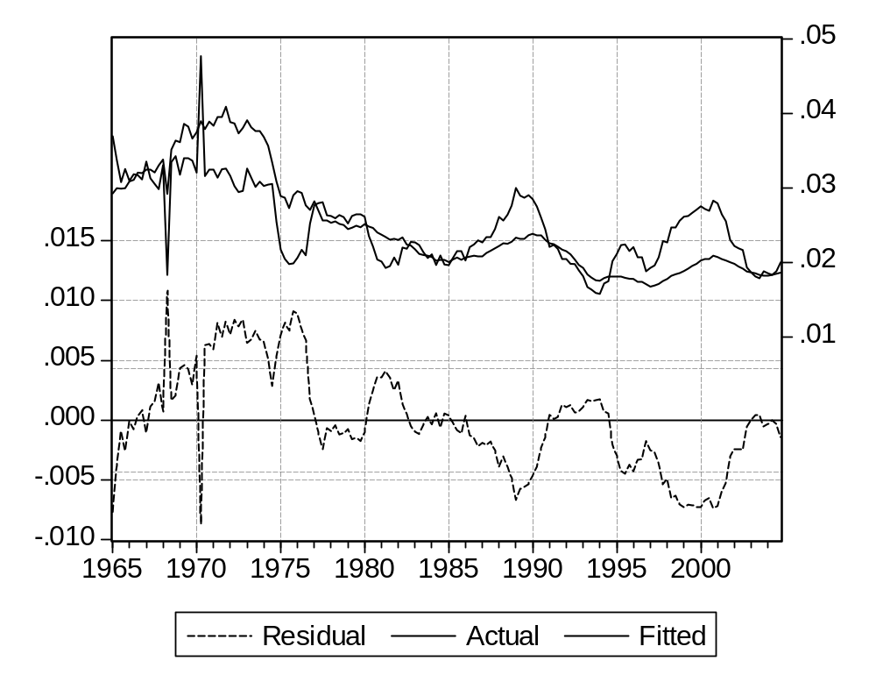

Finally, we can suppose, as for employment in question 2, that the desired growth of capital productivity is only partially reached in practice, either because firms react cautiously to fluctuations of demand, or because they are constrained by investment programs covering more than one year.

This leads us to estimate
It / Kt-1 = a It-1 / Kt-2 + 1/8 *. (Qt - Qt-8) / Qt-8 + c
Results improve very much (especially the residual auto-correlation test), with an inertia coefficient both high and significant.

However, one can stress the fact that now most of the explanation comes from the lagged value (which is natural as the series show strong autocorrelation) and the T-statistic for GDP has actually decreased, even if it remains at a high value.

Dependent Variable: I/K(-1)
Method: Least Squares
Date: 06/26/07 Time: 19:14
Sample (adjusted): 1965Q1 2004Q4
Included observations: 160 after adjustments
I/K(-1)=C_I(1)*I(-1)/K(-2)+C_I(2)*1/8*(Q-Q(-8))/Q(-8)+C_I(3)
 | Coefficient | Std. Error | t-Statistic | Prob.
C_I(1) | 0.924962 | 0.013910 | 66.49851 | 0.0000
C_I(2) | 0.138565 | 0.021122 | 6.560377 | 0.0000
C_I(3) | 0.000795 | 0.000263 | 3.019854 | 0.0030
R-squared | 0.986302 | Mean dependent var |  | 0.024944
Adjusted R-squared | 0.986128 | S.D. dependent var |  | 0.006809
S.E. of regression | 0.000802 | Akaike info criterion |  | -11.40047
Sum squared resid | 0.000101 | Schwarz criterion |  | -11.34281
Log likelihood | 915.0377 | Durbin-Watson stat |  | 2.053162
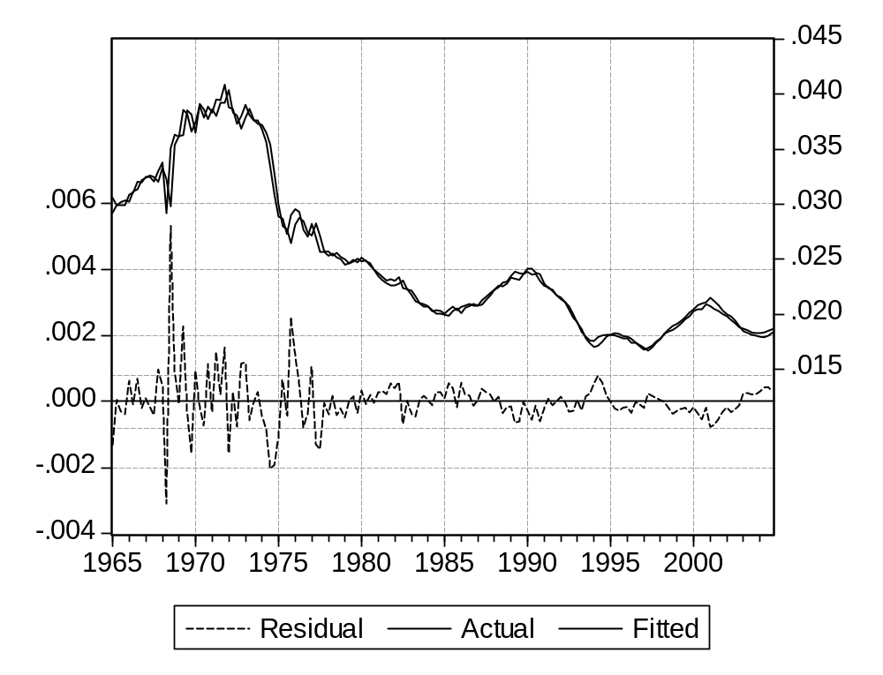

And if on the short period the role of the accelerator decreases, the lagged term will sustain its influence, leading to a larger long term value.

0.14 x (1 + 0.92 + 0. 92 x 0. 92 + .... = 0.14 / (1 - 0. 92) # 1.7. The coefficient is quite higher than its theoretical value (and probably significantly too).

We shall accept this formulation for now.

equation eq_i.ls(p) i/k(-1)=c_i(1)*i(-1)/k(-2)+c_i(2)*1/8*(q-q(-8))/q(-8)+c_i(3)+ec_i
genr ec_i=resid

Lesson 3 : Building the model and analyzing its properties : answers

The following answers can be run using the procedure psim_a.prg.

Question 1 : Gathering the elements and analyzing the structure.

The framework we had produced in the first lesson still applies, except for :

- 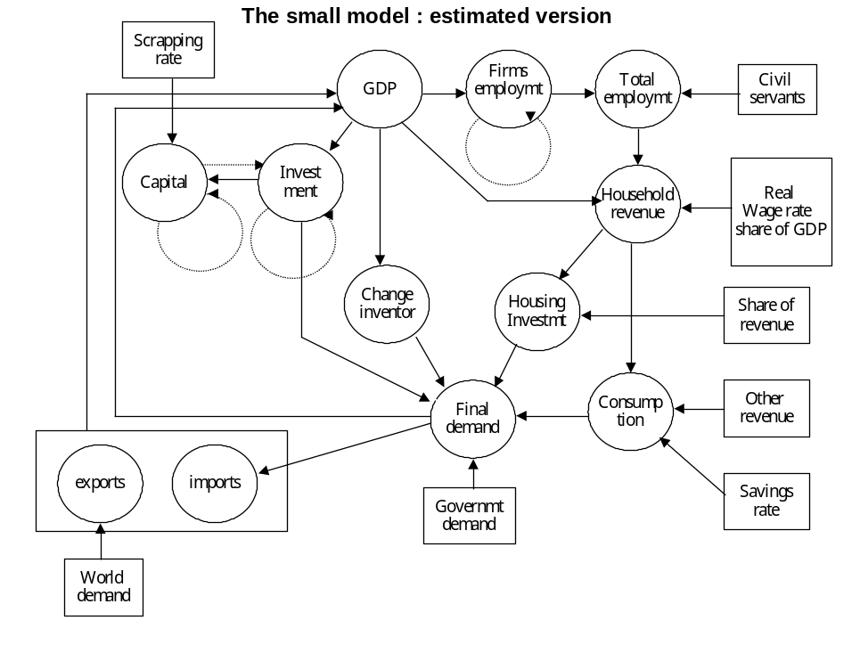Two new identities giving structural productivity and desired employment

- Lagged influences, coming either

- From economic mechanisms: investment (I), value addded (Q), Capital (K), and firms employment (LE).
- From the use of autocorrelation reduction : imports (M), final demand (FD), Exports (X), World demand (WD).
The statement append introduces identities as a text, the statement merge the estimated equations as items.

delete pic_a
model pic_a
pic_a.append assign @all _c
pic_a.append q=0.5*(fd+x-m)+0.5*Q
pic_a.merge eq_i
pic_a.append log(prle_t)=c_prle(1)+c_prle(2)*(t-2002)+c_prle(3)*(t-t1)*(t<t1)+c_prle(4)*(t-t2)*(t<t2)
pic_a.append led=q/prle_t
pic_a.merge eq_le
pic_a.append lt=le+lg
pic_a.append rhi=wr*lt+r_rhiq*q
pic_a.append ih=r_ih*rhi
pic_a.append co=rhi*(1-sr)
pic_a.merge eq_ic
pic_a.append fd=co+i+gd+ic+ih
pic_a.merge eq_m
pic_a.merge eq_x
pic_a.append k=k(-1)*(1-dr)+i

This framework calls for two remarks concerning the computing process.
- If an equation uses only exogenous or lagged elements, the associated variable can be computed once and for all. This property extends to equations using variables of this type, along with exogenous and lagged ones. We shall group them in a set which can be solved in one pass, at the start of the solving process (we shall call this set "prologue").
This applies in our case to X, which uses only exogenous world demand, and to PRLE_T, which depends only on time.
- if current values of a variable are not used in any equation, computing it can wait until the rest of the model has been solved, and it will be also done in one pass. This property extends to equations computing variables which only influence variables of this type. We can also group them (in reverse order) in a set which can be solved in one pass (the "epilogue").

This applies here to K (capital at end of period) which only show lagged influences. It can be noted that if K was defined as the capital at beginning of period, its place would be in the prologue.

The rest of the model will have to be solved simultaneously, using an iterative process. But these remarks have helped to reduce computations.

This structure can be obtained by accessing the model, then using in sequence the “View” and “Block structure” options. This gives the following text:

Number of equations: 14
Number of independent blocks: 3
Number of simultaneous blocks: 1
Number of recursive blocks: 2

Block 1: 2 Recursive Equations

x(13) prle_t(3)

Block 2: 11 Simultaneous Equations

q(1) i(2) led(4) le(5) lt(6) rhi(7) ih(8) co(9) ic(10) fd(11) m(12)

Block 3: 1 Recursive Equations

k(14)

These elements will show clearly if we have built an incidence matrix.3

Note: one might be surprised that prle_t, an estimated variable, is computed through an identity. This is because the equation is supposed to give the actual value of the productivity trend. True, we did not succeed completely, but only from lack of information.

Let us take two non-economic examples:
- The logical process for the trajectory of a comet is known exactly. But if we measure its position a finite number of times with an imperfect telescope, we will have to use an imperfect formula.

- On the contrary, we shall never be able to forecast the weather (say the temperature at a given place), because its potential determinants are too correlated to be separated if they become too numerous. Only the precision of the error will increase.

Question 2 : Residual check.

We shall use the same technique as in Question 8 of Lesson 1.

smpl 1975q2 2004Q4
pic_a.append assign @all _c
solve(d=f) pic_a
for !i=1 to g_vendo.@count
%1=g_vendo.@seriesname(!i)
genr dc_{%1}={%1}-{%1}_c
genr pc_{%1}=100*dc_{%1}/({%1}+({%1}=0))
next

But now the difference between computed and historical values must be zero all equations, as they should hold true,
- by definition for the identities.
- thanks to the residual for the behavioral equations.

Question 3 : Ex-post simulation.

To simulate the model, we shall use the largest period for which it can be computed. This will be the intersection of periods allowing to compute each single equation (taking into account lagged influences). It practice, this corresponds again to the 1975Q2-2004Q4 period.

We shall first create zero residuals with the suffix “_s”.

for !i=1 to g_vbeha.@count
%1=g_vbeha.@seriesname(!i)
genr ec_{%1}_s=0
next

Then we shall call for a scenario called for instance « Scenario 1 ». This scenario has to be defined previously using the menus. To this scenario we shall associate the “_s” suffix, and state that we are overriding the residuals. The solution will be carried on using the alternate (zero) values.

One can observe that to replace dynamically the values of exogenous variables, two actions are needed :

- Create the values with a specific suffix.
- At simulation time, state which variables have to be overriden.
This looks tedious, but will allow:
- To avoid overriding by mistake, if a variable has been inadvertently created with the given suffix.
- To select the overriden variables in a pool.

pic_a.scenario "scenario 1"
pic_a.append assign @all _s
pic_a.override ec_i ec_ic ec_le ec_m ec_x
solve(d=d) pic_a

Then we shall solve the model.

pic_a.append assign @all _s
pic_a.solveopt(n=t m=1000,c=1e-6,o=n,d=d)
solve(n=t m=1000 c=1e-6 o=g d=d) pic_a

The previous statements indicate that results will have the suffix “_c” and we shall solve the model dynamically (d=d), using the Gauss-Seidel algorithm(o=g), accepting initial “Not available” values (n=t), a maximum of 1000 iterations(m=1000), and using a convergence criterion of 10⁻⁶ (c=1e-6).

The model should converge without problem (the textbook provides techniques to solve entual problems).

The program for determining the errors might look esoteric. Actually it computes for each variable the relative average of the error, and the level of the error on its growth rate. Both elements are important, as our goal is to determine if the model can be used for presentation of economic results. If we take GDP for instance, it is important to know if we predict well both its level and its growth rate.

matrix(14,2) v_psm_a
for !i=1 to g_vendo.@count
%st1=g_vendo.@seriesname(!i)
%st2=g_vendo.@seriesname(!i)+"_s"
series psa_{%st1}=100*({%st2}-{%st1})/({%st1}+({%st1}=0))
series tc_{%st2}=100*({%st2}-{%st2}(-1))/({%st2}(-1)+({%st2}(-1)=0))
series tc_{%st1}=100*({%st1}-{%st1}(-1))/({%st1}(-1)+({%st1}(-1)=0))
series psd_{%st1}=tc_{%st2}-tc_{%st1}
v_psm_a(!i,1)=(@mean(@abs(psa_{%st1})))
v_psm_a(!i,2)=(@mean(@abs(psd_{%st1})))
next

We get the following simulation errors:

Variable | Percentage error on the  level | Error on the  growth rate
CO | 1.292 | 0.184
FD | 1.980 | 0.418
IH | 1.292 | 0.183
K | 2.160 | 0.158
LT | 1.199 | 0.165
Q | 1.937 | 0.369
RHI | 1.292 | 0.184
LED | 1.937 | 0.367
PRLE_T | - | -
I | 8.525 | 1.376
M | 2.976 | 1.281
LE | 1.5432 | 0.211
X | 2.004 | 1.316

The errors look large on the levels, but much smaller on the growth rates.

100*(fd_s-fd)/fd 100*(m_s-m)/m 100*(q_s-q)/q
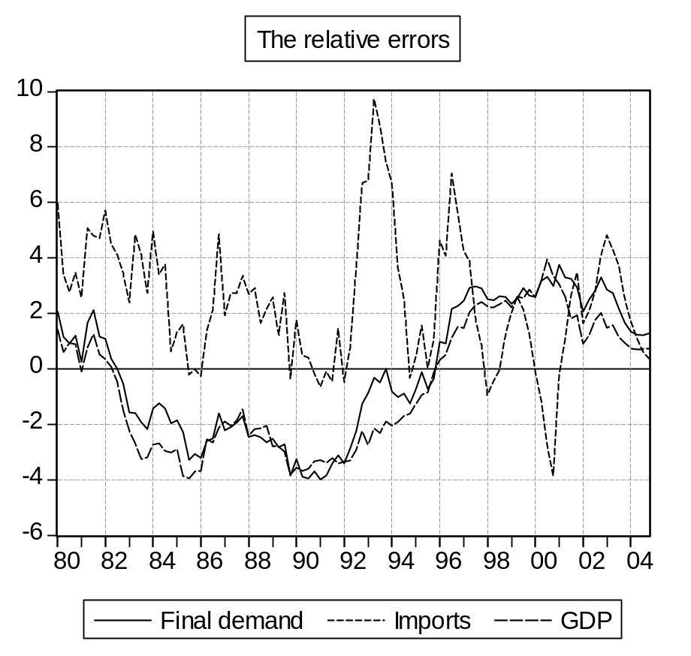

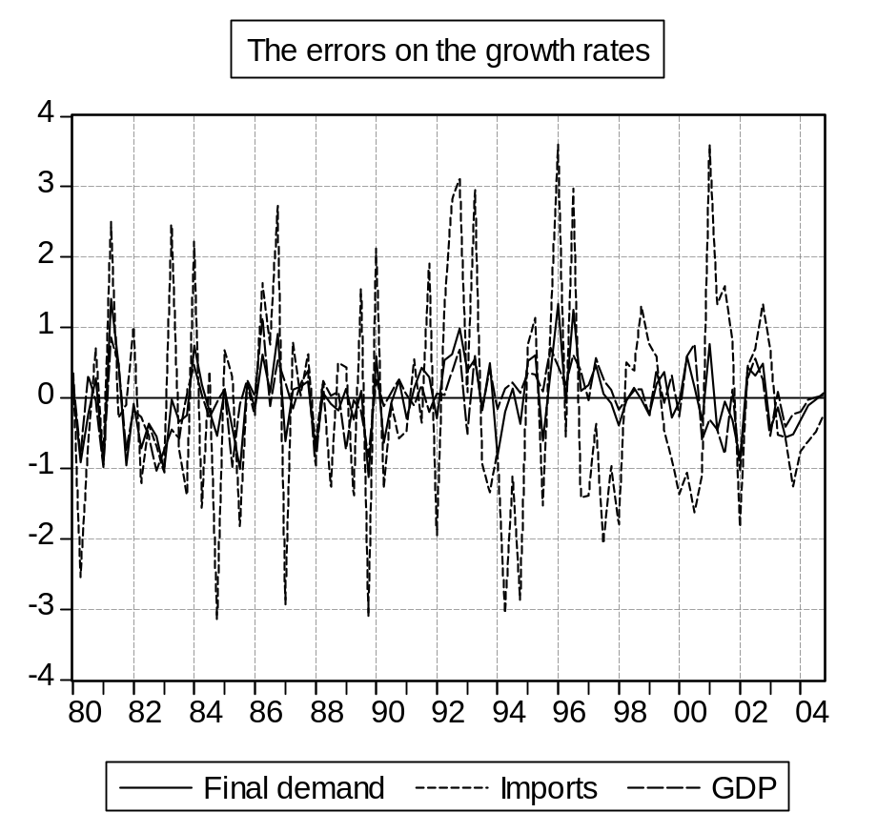

Trying to understand the origin of errors, we can see that imports play an important role, for both types.

We can see also that the errors seem to cancel out in the end. This can be associated with the fact that most equations are quite autoregressive, so the residuals add up with time, and their sum is zero.

QUESTION 4 : COMPUTING THE MULTIPLIER
1. For a dynamic model, the solution path depends on the starting year. But to interpret the results in terms of economic mechanisms, the differences between the two solutions must originate only in the change in assumptions, and not to a different starting date. Thus we have to start from the same year (1980) as the base simulation.

' We produce a shock

' First, an unshocked simulation

smpl 1980Q1 2004Q4
pic_a.scenario "scenario 1"
pic_a.append assign @all _b
pic_a.override ‘a blank list to make sure that no element is overridden at present
pic_a.solveopt(n=t,m=1001,o=g,d=d)
solve pic_a

' The shocked simulation

smpl 1980Q1 2004Q4
genr dv_gd=.01*q_b*(t>=1981)
genr gd_v=gd+dv_gd

pic_a.solveopt(n=t,m=1002,o=g,d=d)
pic_a.scenario "scenario 1"
pic_a.append assign @all _v
pic_a.override gd
solve pic_a

' We compute the differences
' in absolute and relative terms

for !i=1 to g_vendo.@count
%1=g_vendo.@seriesname(!i)
series dv_{%1}={%1}_v-{%1}_b
series pv_{%1}=100*dv_{%1}/({%1}_b+({%1}_b=0))
next

The results are easily interpreted.
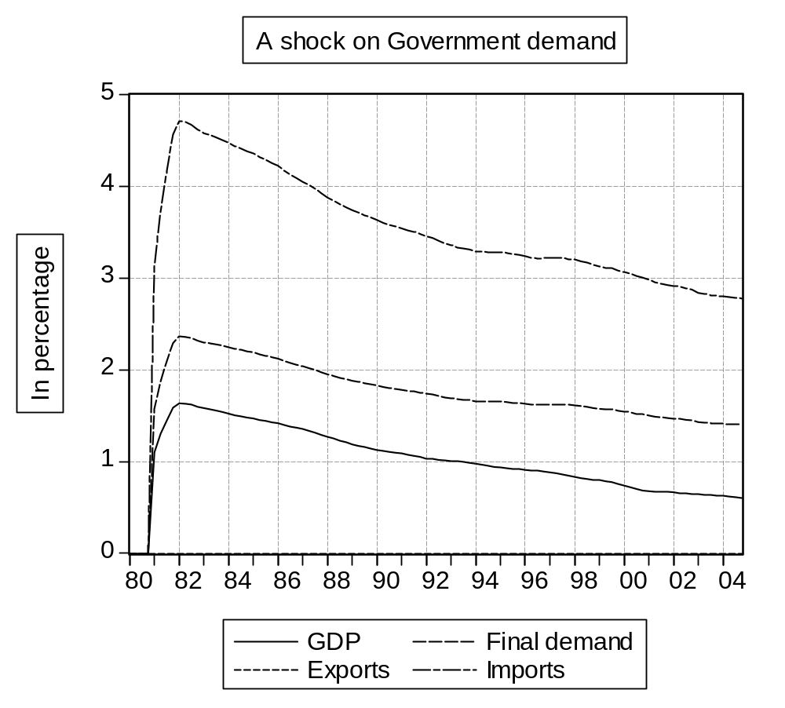
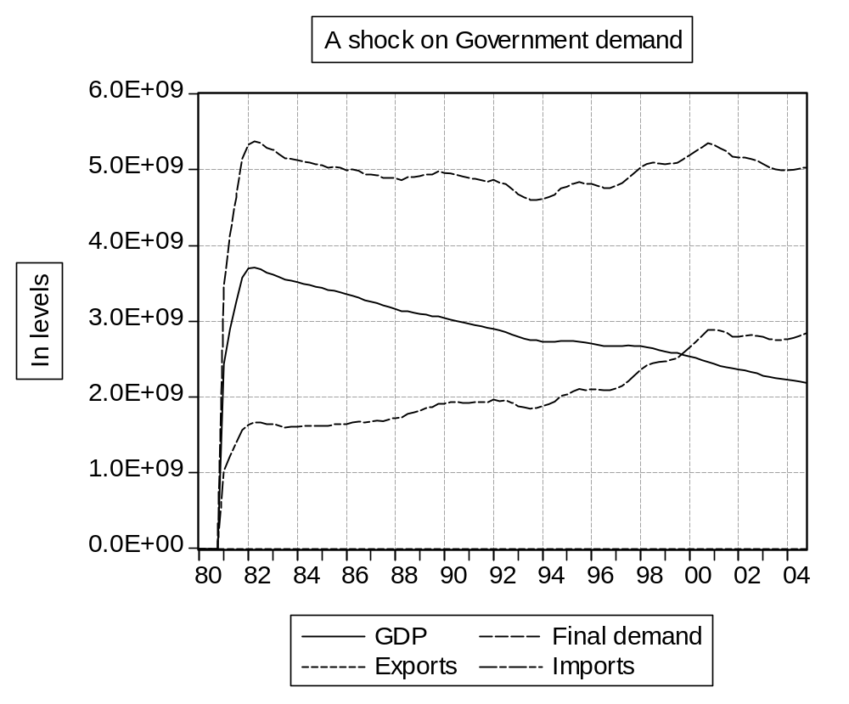
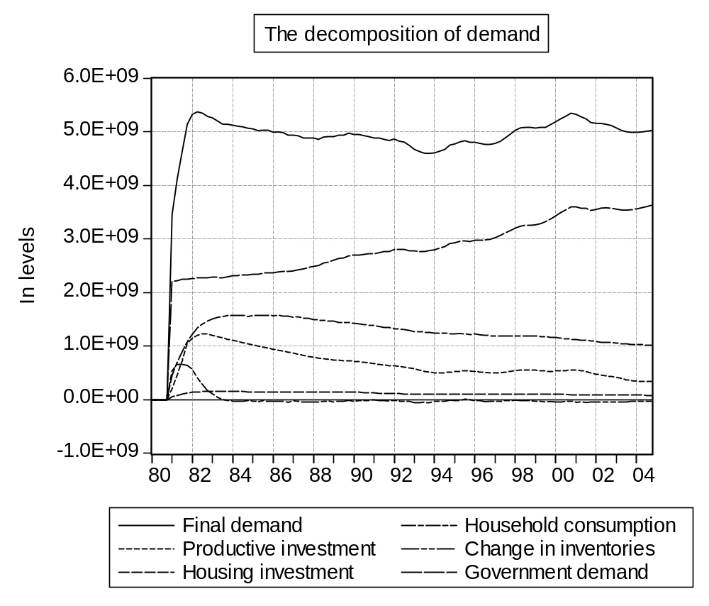

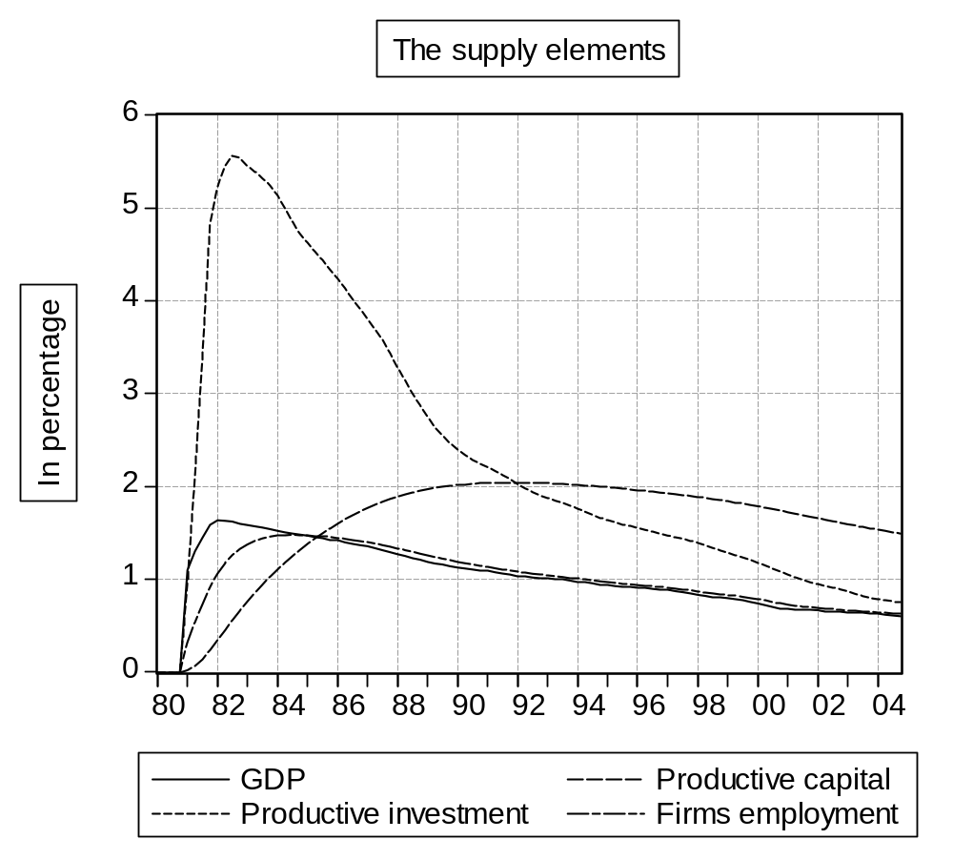
The ex-ante demand variation is amplified by the increase in production factors (investment and employment), the latter affecting household revenue and consumption. These two elements keep increasing for a while, with a higher inertia on investment and less on consumption (revenue comes from the faster adapting employment and GDP itself). Later, both changes become proportional to GDP. But while households obtain as revenue a high share of the increase, the motivation for investment decreases as capital adapts to GDP. In the long run, the only incentive left is the replacement of a higher level of discarded capital.

Actually, the evolution of capital confirms the mathematical diagnosis of its elasticity to GDP : the overshooting appears quickly, and is maintained afterwards.

As to the short run oscillation, it is clearly due to the change in inventories. The increase is no longer needed in the second period, reducing demand and production. This is amplified by negative effect on inventories themselves of the decrease in production growth.

External trade plays a simple role. Exports do not change, depending only on world demand, but imports take a large and increasing share in the additional demand. In the short run, they already compensate the ex post demand increase, reducing the multiplier value to unity. In subsequent periods, the effect keeps growing, and the multiplier decreases regularly. This model gives to demand policies a rather low efficiency.

But the formulations used by the model can be questioned on several points, most of which could not be treated without conflicting with its primary goal of simplicity. For instance, introducing price competitiveness in the trade equations would call for a full formalization of the price system.

There is however a serious fault which could be treated at relatively low cost.

During both the estimation of the model and the study of its properties we have often used the notion of productive capacity, without taking it into account. Capital is computed, but has no influence on the rest of the model, except for being a scaling factor of the investment of the next period.

On the contrary, it can be argued that the way productive capacity fits production, in other terms the rate of use of productive capacity, has a strong influence on the economic equilibrium. It should influence in particular

on external trade (the more capacities remain available, the easier it will be easier to counter foreign producers both on foreign and domestic markets),
on productive investment (facing a given growth of demand, the firms will react differently whether their capacities are under or over-utilized).

One of the above features looks particularly unacceptable: as local producers build up their capacities, they keep losing shares on the local market.

Retaining a complementary factors production function, the introduction of a productive capacity equation should prove quite cheap compared to the expected improvements in terms of model properties. We shall use this idea in the 4th lesson.

Lesson 4 : Looking for a better specification : answers

The following answers can be run using the procedures preg_b.prg and psim_b.prg

Question 1 : Improving the investment equation
We shall use the statements:

pagedelete pic_b
pageselect pic_a
pagecopy(page=pic_b)
smpl 1963Q1 2004q4
link cap
cap.linkto oecd::fra_caps
genr pk=CAP/K(-1)
genr UR=Q/CAP

The main reason is that expected future production (or GDP) is only the average of a distribution of potential productions. Firms might feel (maybe with the help of an optimization technique) that potential sales associated with a slightly higher level of capacity are still profitable, even considering their lower (and decreasing) probability. And in any case, investing more than necessary for the next period can be considered a too early decision, not as a wrong one, if the economy is growing.

In the previous model, the target growth of capacity followed the expected growth in production, without taking into account the present rate of use:
It / Kt-1 = drt - tx(pk) _{t+1} + txª (Q) _{t+1}
Let us suppose firms actually want to reach a constant target utilization rate UR**. Then by definition:
CAP*t+1 / UR** = Qªt₊₁ and CAPt / URt = Qt or
With UR* computed as the average of UR over the estimation period.
CAP*t+1 / CAPt = (Qªt+1 / UR**) / (Qt / URt)

= (Qªt+1 / Qt ) . ( UR** / URt+1)
In other words if firms expect a growth rate of 1%, but feel their capacities are under-used by 0.3%, their desired capacity will only increase by 0.7%

If we suppose firms expect an unchanged growth, we have

CAP*t+1 / CAPt = (Qt / Qt-1 ) / ( URt / UR*)
thus finally
It / Kt-1 = a It-1 / Kt-2 + b (Qt / Qt-1 ) / ( URt / UR**) + c
The results are rather satisfactory, with the right sign and acceptable statistics for all explanatory elements. The global statistics are improved also.

The only issue could be the slightly reduced quality of the T statistic, in particular for Q. Actually each of the explanatory elements: accelerator and rate if use, are extremely significant if used alone. But their strong correlation (both use Q in the numerator) makes it difficult for the estimation process to separate their role, if taken together.

Also, it might look surprising that the R-squared has decreased, while the standard error has decreased too. In the reduced sample, due to the unavailability of UR at the beginning, the variable shows a much lower variance (3 times), and is easier to explain.
Dependent Variable: I/K(-1)
Method: Least Squares
Date: 06/28/07 Time: 17:20
Sample: 1980Q1 2004Q4
Included observations: 100
I/K(-1)=C_I(1)*I(-1)/K(-2)+C_I(2)*(UR_STAR-UR)/UR+C_I(3)*.125*Q/Q(
-8)+C_I(4)+EC_I
 | Coefficient | Std. Error | t-Statistic | Prob.
C_I(1) | 0.944504 | 0.013304 | 70.99251 | 0.0000
C_I(2) | -0.002560 | 0.000898 | -2.849573 | 0.0054
C_I(3) | 0.042822 | 0.013585 | 3.152157 | 0.0022
C_I(4) | -0.004488 | 0.001676 | -2.678488 | 0.0087
R-squared | 0.985646 | Mean dependent var |  | 0.020449
Adjusted R-squared | 0.985198 | S.D. dependent var |  | 0.002141
S.E. of regression | 0.000260 | Akaike info criterion |  | -13.62895
Sum squared resid | 6.51E-06 | Schwarz criterion |  | -13.52474
Log likelihood | 685.4474 | Durbin-Watson stat |  | 1.514157
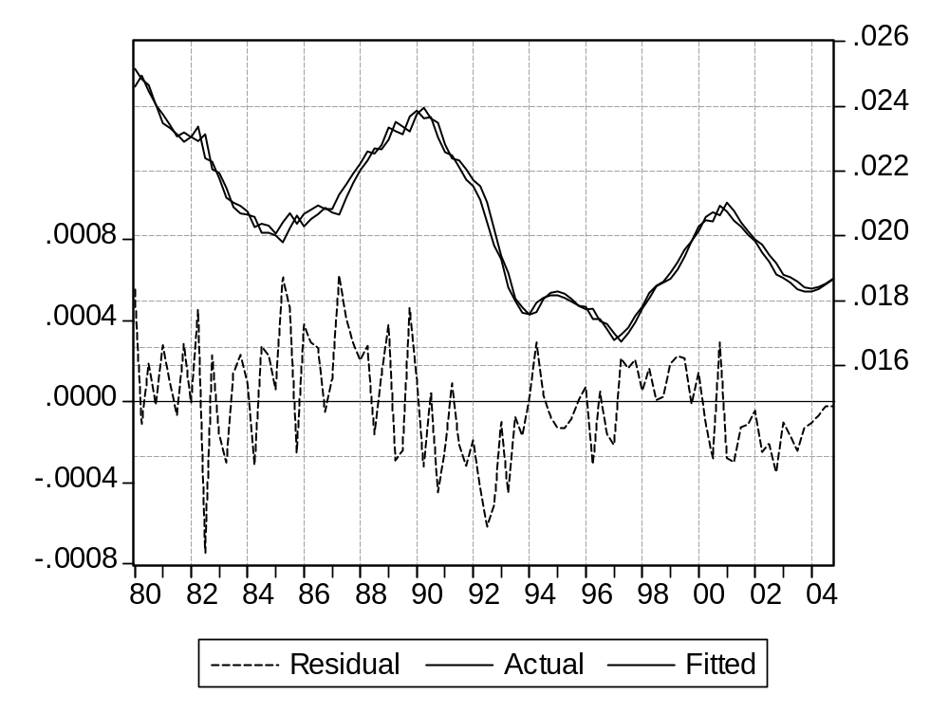

The elasticity of capital to production is now unitary by construction. Starting from a base simulation, a 1% permanent shock on Q will leave UR unchanged. This gives the same relative variations to production, capacity and (with a constant capital productivity) capital.

The coefficients determine only the dynamics of the convergence to this target.

Actually we have estimated a kind of error-correction equation, in which the error is the gap between actual and target capacity (or rate of use).

Question 2: improving the exports equation
The first tests show that both UR and the ratio of exports to world demand cannot be considered stationary, even if we consider a trend. Of course, without a trend the conclusion would be even stronger.

Null Hypothesis: LOG(X/WD) has a unit root
Exogenous: Constant, Linear Trend
Lag Length: 1 (Automatic based on SIC, MAXLAG=12)
 |  |  | t-Statistic | Prob.*
Augmented Dickey-Fuller test statistic |  |  | -2.515780 | 0.3201
Test critical values: | 1% level |  | -4.046072
 | 5% level |  | -3.452358
 | 10% level |  | -3.151673
*MacKinnon (1996) one-sided p-values.
Augmented Dickey-Fuller Test Equation
Dependent Variable: D(LOG(X/WD))
Method: Least Squares
Date: 06/28/07 Time: 17:10
Sample: 1978Q2 2004Q4
Included observations: 107
Variable | Coefficient | Std. Error | t-Statistic | Prob.
LOG(X(-1)/WD(-1)) | -0.157329 | 0.062537 | -2.515780 | 0.0134
D(LOG(X(-1)/WD(-1))) | -0.265307 | 0.092520 | -2.867562 | 0.0050
C | 0.038142 | 0.016339 | 2.334424 | 0.0215
@TREND(1978Q2) | -0.000260 | 0.000117 | -2.217517 | 0.0288
R-squared | 0.172932 | Mean dependent var |  | -0.001515
Adjusted R-squared | 0.148842 | S.D. dependent var |  | 0.017713
S.E. of regression | 0.016341 | Akaike info criterion |  | -5.353556
Sum squared resid | 0.027505 | Schwarz criterion |  | -5.253637
Log likelihood | 290.4152 | F-statistic |  | 7.178750
Durbin-Watson stat | 1.937887 | Prob(F-statistic) |  | 0.000201

Null Hypothesis: LOG(UR) has a unit root
Exogenous: Constant, Linear Trend
Lag Length: 10 (Automatic based on SIC, MAXLAG=12)
 |  |  | t-Statistic | Prob.*
Augmented Dickey-Fuller test statistic |  |  | -2.399050 | 0.3778
Test critical values: | 1% level |  | -4.054393
 | 5% level |  | -3.456319
 | 10% level |  | -3.153989
*MacKinnon (1996) one-sided p-values.
Augmented Dickey-Fuller Test Equation
Dependent Variable: D(LOG(UR))
Method: Least Squares
Date: 06/28/07 Time: 17:10
Sample (adjusted): 1980Q3 2004Q4
Included observations: 98 after adjustments
Variable | Coefficient | Std. Error | t-Statistic | Prob.
LOG(UR(-1)) | -0.091478 | 0.038131 | -2.399050 | 0.0186
D(LOG(UR(-1))) | 1.464814 | 0.094658 | 15.47473 | 0.0000
D(LOG(UR(-2))) | -1.665424 | 0.170251 | -9.782189 | 0.0000
D(LOG(UR(-3))) | 1.785757 | 0.212274 | 8.412515 | 0.0000
D(LOG(UR(-4))) | -1.737132 | 0.246525 | -7.046472 | 0.0000
D(LOG(UR(-5))) | 1.618277 | 0.251123 | 6.444148 | 0.0000
D(LOG(UR(-6))) | -1.586227 | 0.255319 | -6.212736 | 0.0000
D(LOG(UR(-7))) | 1.412498 | 0.236345 | 5.976417 | 0.0000
D(LOG(UR(-8))) | -1.047248 | 0.214050 | -4.892542 | 0.0000
D(LOG(UR(-9))) | 0.719400 | 0.157728 | 4.561021 | 0.0000
D(LOG(UR(-10))) | -0.292147 | 0.096418 | -3.030009 | 0.0032
C | -0.019947 | 0.008365 | -2.384508 | 0.0193
@TREND(1978Q2) | 3.72E-05 | 3.38E-05 | 1.101800 | 0.2737
R-squared | 0.793872 | Mean dependent var |  | 0.000238
Adjusted R-squared | 0.764772 | S.D. dependent var |  | 0.018172
S.E. of regression | 0.008813 | Akaike info criterion |  | -6.502075
Sum squared resid | 0.006603 | Schwarz criterion |  | -6.159171
Log likelihood | 331.6017 | F-statistic |  | 27.28050
Durbin-Watson stat | 2.006954 | Prob(F-statistic) |  | 0.000000

Then we show that the two elements are co integrated, using the Johansen test.

Date: 06/28/07 Time: 17:10
Sample (adjusted): 1978Q4 2004Q4
Included observations: 105 after adjustments
Trend assumption: Linear deterministic trend (restricted)
Series: LOG(X/WD) LOG(UR)
Lags interval (in first differences): 1 to 3
Unrestricted Cointegration Rank Test (Trace)
Hypothesized |  | Trace | 0.05
No. of CE(s) | Eigenvalue | Statistic | Critical Value | Prob.**
None * | 0.243048 | 37.98054 | 25.87211 | 0.0010
At most 1 | 0.079892 | 8.742767 | 12.51798 | 0.1968
Trace test indicates 1 cointegrating eqn(s) at the 0.05 level
* denotes rejection of the hypothesis at the 0.05 level
**MacKinnon-Haug-Michelis (1999) p-values
Unrestricted Cointegration Rank Test (Maximum Eigenvalue)
Hypothesized |  | Max-Eigen | 0.05
No. of CE(s) | Eigenvalue | Statistic | Critical Value | Prob.**
None * | 0.243048 | 29.23777 | 19.38704 | 0.0014
At most 1 | 0.079892 | 8.742767 | 12.51798 | 0.1968
Max-eigenvalue test indicates 1 cointegrating eqn(s) at the 0.05 level
* denotes rejection of the hypothesis at the 0.05 level
**MacKinnon-Haug-Michelis (1999) p-values
Unrestricted Cointegrating Coefficients (normalized by b'*S11*b=I):
LOG(X/WD) | LOG(UR) | @TREND(62Q2)
35.26598 | 34.61357 | 0.050828
-34.99684 | 7.763491 | -0.062448
Unrestricted Adjustment Coefficients (alpha):
D(LOG(X/WD)) | -0.003095 | 0.004179
D(LOG(UR)) | -0.005249 | -0.001177
1 Cointegrating Equation(s): |  | Log likelihood | 619.9411
Normalized cointegrating coefficients (standard error in parentheses)
LOG(X/WD) | LOG(UR) | @TREND(62Q2)
1.000000 | 0.981500 | 0.001441
 | (0.15305) | (0.00017)
Adjustment coefficients (standard error in parentheses)
D(LOG(X/WD)) | -0.109154
 | (0.05644)
D(LOG(UR)) | -0.185116
 | (0.03637)

Vector Error Correction Estimates
Date: 06/28/07 Time: 17:10
Sample (adjusted): 1978Q4 2004Q4
Included observations: 105 after adjustments
Standard errors in ( ) & t-statistics in [ ]
Cointegrating Eq: | CointEq1
LOG(X(-1)/WD(-1)) | 1.000000
LOG(UR(-1)) | 0.981500
 | (0.15305)
 | [ 6.41295]
@TREND(62Q1) | 0.001441
 | (0.00017)
 | [ 8.48841]
C | -0.146033
Error Correction: | D(LOG(X/WD)) | D(LOG(UR))
CointEq1 | -0.109154 | -0.185116
 | (0.05644) | (0.03637)
 | [-1.93394] | [-5.08992]
D(LOG(X(-1)/WD(-1))) | -0.247121 | 0.117794
 | (0.10651) | (0.06863)
 | [-2.32021] | [ 1.71634]
D(LOG(X(-2)/WD(-2))) | 0.063406 | 0.149096
 | (0.10786) | (0.06950)
 | [ 0.58786] | [ 2.14525]
D(LOG(X(-3)/WD(-3))) | 0.224571 | 0.104327
 | (0.09611) | (0.06193)
 | [ 2.33667] | [ 1.68463]
D(LOG(UR(-1))) | 0.042820 | 1.086597
 | (0.13590) | (0.08757)
 | [ 0.31508] | [ 12.4080]
D(LOG(UR(-2))) | -0.085847 | -0.669400
 | (0.17299) | (0.11147)
 | [-0.49625] | [-6.00521]
D(LOG(UR(-3))) | 0.082884 | 0.377947
 | (0.14018) | (0.09033)
 | [ 0.59127] | [ 4.18415]
C | -0.001345 | 0.000348
 | (0.00163) | (0.00105)
 | [-0.82564] | [ 0.33189]
R-squared | 0.181420 | 0.667693
Adj. R-squared | 0.122347 | 0.643712
Sum sq. resids | 0.026088 | 0.010832
S.E. equation | 0.016400 | 0.010567
F-statistic | 3.071129 | 27.84269
Log likelihood | 286.7738 | 332.9193
Akaike AIC | -5.309978 | -6.188939
Schwarz SC | -5.107772 | -5.986732
Mean dependent | -0.001394 | -0.000243
S.D. dependent | 0.017505 | 0.017704
Determinant resid covariance (dof adj.) |  | 2.99E-08
Determinant resid covariance |  | 2.55E-08
Log likelihood |  | 619.9411
Akaike information criterion |  | -11.44650
Schwarz criterion |  | -10.96626
We shall use :

genr res_x = p_x(1) * log(x / wd) + p_x(2) * log(ur) + p_x(3) * (@trend(60:1) * (t<=2004) + @elem(@trend(60:1) , "2004q4") * (t>2004))

pic_b.append res_x = p_x(1) * log(x / wd) + p_x(2) * log(ur) + p_x(3) * (@trend(60:1) * (t<=2004) + @elem(@trend(60:1) , "2004q4") * (t>2004))

with

p_x(1)=1
p_x(2)= 0.981500
p_x(3)= 0.001441

The estimation works, but only with a dynamic influence of World demand. If we try to introduce the change in the rate of use, we get a non significant coefficient with the wrong sign.

Dependent Variable: DLOG(X)
Method: Least Squares
Date: 06/28/07 Time: 17:30
Sample (adjusted): 1978Q3 2004Q4
Included observations: 106 after adjustments
DLOG(X)=C_X(4)*DLOG(WD)+C_X(6)+C_X(7)*RES_X(-1)
 | Coefficient | Std. Error | t-Statistic | Prob.
C_X(4) | 0.494017 | 0.084894 | 5.819245 | 0.0000
C_X(6) | 0.019601 | 0.006141 | 3.191585 | 0.0019
C_X(7) | -0.091424 | 0.038151 | -2.396342 | 0.0184
R-squared | 0.266535 | Mean dependent var |  | 0.011661
Adjusted R-squared | 0.252293 | S.D. dependent var |  | 0.017116
S.E. of regression | 0.014800 | Akaike info criterion |  | -5.560452
Sum squared resid | 0.022562 | Schwarz criterion |  | -5.485071
Log likelihood | 297.7039 | Durbin-Watson stat |  | 2.032482
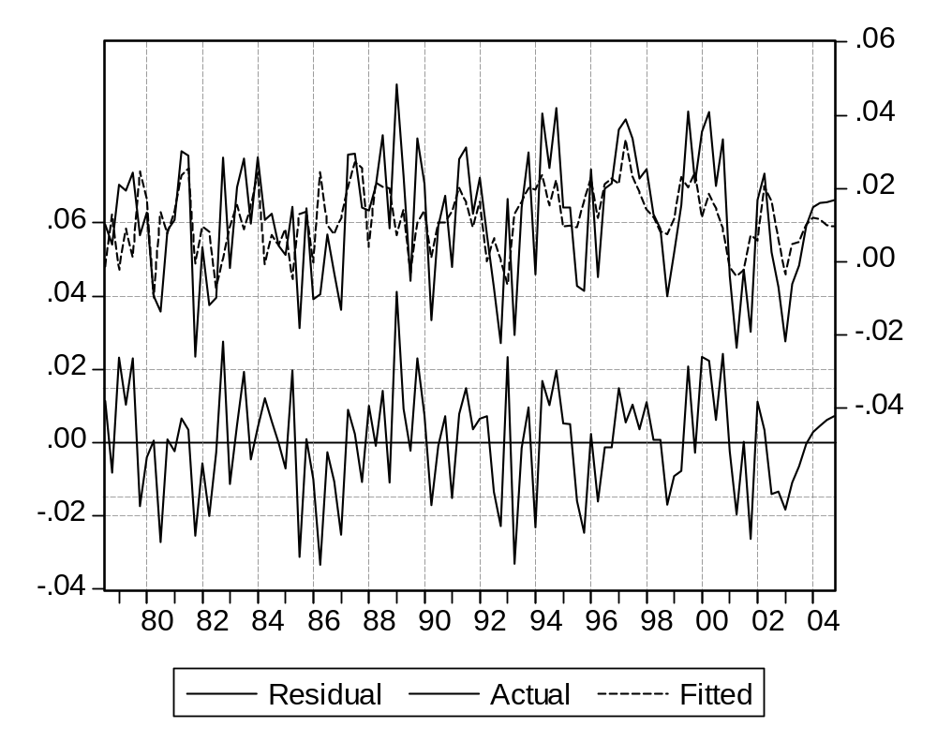

Question 3: Improving the imports equation

The tests show us again that neither variable is stationary. Of course, we will not replicate the one on Log(UR).

Null Hypothesis: LOG(M/(FD+CT*Q)) has a unit root
Exogenous: Constant, Linear Trend
Lag Length: 2 (Automatic based on SIC, MAXLAG=12)
 |  |  | t-Statistic | Prob.*
Augmented Dickey-Fuller test statistic |  |  | -2.619373 | 0.2728
Test critical values: | 1% level |  | -4.046925
 | 5% level |  | -3.452764
 | 10% level |  | -3.151911
*MacKinnon (1996) one-sided p-values.
Augmented Dickey-Fuller Test Equation
Dependent Variable: D(LOG(M/(FD+CT*Q)))
Method: Least Squares
Date: 06/28/07 Time: 17:10
Sample: 1978Q3 2004Q4
Included observations: 106
Variable | Coefficient | Std. Error | t-Statistic | Prob.
LOG(M(-1)/(FD(-1)+CT(-1)*Q(-1))) | -0.072387 | 0.027635 | -2.619373 | 0.0102
D(LOG(M(-1)/(FD(-1)+CT(-1)*Q(-1)))) | 0.213484 | 0.093888 | 2.273817 | 0.0251
D(LOG(M(-2)/(FD(-2)+CT(-2)*Q(-2)))) | 0.278797 | 0.093966 | 2.967003 | 0.0038
C | -0.193141 | 0.075098 | -2.571872 | 0.0116
@TREND(1978Q3) | 0.000530 | 0.000202 | 2.631365 | 0.0098
R-squared | 0.173796 | Mean dependent var |  | 0.006993
Adjusted R-squared | 0.141075 | S.D. dependent var |  | 0.012856
S.E. of regression | 0.011915 | Akaike info criterion |  | -5.976017
Sum squared resid | 0.014339 | Schwarz criterion |  | -5.850384
Log likelihood | 321.7289 | F-statistic |  | 5.311456
Durbin-Watson stat | 2.030375 | Prob(F-statistic) |  | 0.000635

The test gives no evidence of cointegration.
Date: 06/28/07 Time: 17:10
Sample (adjusted): 1978Q4 2004Q4
Included observations: 105 after adjustments
Trend assumption: Linear deterministic trend (restricted)
Series: LOG(M/(FD+CT*Q)) LOG(UR)
Lags interval (in first differences): 1 to 3
Unrestricted Cointegration Rank Test (Trace)
Hypothesized |  | Trace | 0.05
No. of CE(s) | Eigenvalue | Statistic | Critical Value | Prob.**
None | 0.153528 | 22.69123 | 25.87211 | 0.1184
At most 1 | 0.048227 | 5.190051 | 12.51798 | 0.5693
Trace test indicates no cointegration at the 0.05 level
* denotes rejection of the hypothesis at the 0.05 level
**MacKinnon-Haug-Michelis (1999) p-values
Unrestricted Cointegration Rank Test (Maximum Eigenvalue)
Hypothesized |  | Max-Eigen | 0.05
No. of CE(s) | Eigenvalue | Statistic | Critical Value | Prob.**
None | 0.153528 | 17.50118 | 19.38704 | 0.0920
At most 1 | 0.048227 | 5.190051 | 12.51798 | 0.5693
Max-eigenvalue test indicates no cointegration at the 0.05 level
* denotes rejection of the hypothesis at the 0.05 level
**MacKinnon-Haug-Michelis (1999) p-values
Unrestricted Cointegrating Coefficients (normalized by b'*S11*b=I):
LOG(M/(FD+CT*Q)) | LOG(UR) | @TREND(62Q2)
-4.234446 | 34.85577 | 0.020477
29.92624 | -17.15759 | -0.215936
Unrestricted Adjustment Coefficients (alpha):
D(LOG(M/(FD+CT*Q))) | -0.000312 | -0.002432
D(LOG(UR)) | -0.004268 | -0.000549
1 Cointegrating Equation(s): |  | Log likelihood | 659.9199
Normalized cointegrating coefficients (standard error in parentheses)
LOG(M/(FD+CT*Q)) | LOG(UR) | @TREND(62Q2)
1.000000 | -8.231483 | -0.004836
 | (1.84126) | (0.00188)
Adjustment coefficients (standard error in parentheses)
D(LOG(M/(FD+CT*Q))) | 0.001322
 | (0.00477)
D(LOG(UR)) | 0.018072
 | (0.00444)
3. The test refuses to reject the non-stationarity of competitiveness.

Null Hypothesis: LOG(COMPM) has a unit root
Exogenous: Constant, Linear Trend
Lag Length: 9 (Automatic based on SIC, MAXLAG=12)
 |  |  | t-Statistic | Prob.*
Augmented Dickey-Fuller test statistic |  |  | -2.872123 | 0.1762
Test critical values: | 1% level |  | -4.056461
 | 5% level |  | -3.457301
 | 10% level |  | -3.154562
*MacKinnon (1996) one-sided p-values.
Augmented Dickey-Fuller Test Equation
Dependent Variable: D(LOG(COMPM))
Method: Least Squares
Date: 06/28/07 Time: 17:10
Sample (adjusted): 1981Q1 2004Q4
Included observations: 96 after adjustments
Variable | Coefficient | Std. Error | t-Statistic | Prob.
LOG(COMPM(-1)) | -0.040995 | 0.014273 | -2.872123 | 0.0052
D(LOG(COMPM(-1))) | 0.994263 | 0.099510 | 9.991565 | 0.0000
D(LOG(COMPM(-2))) | -0.921765 | 0.135921 | -6.781614 | 0.0000
D(LOG(COMPM(-3))) | 0.888253 | 0.165238 | 5.375581 | 0.0000
D(LOG(COMPM(-4))) | -0.775795 | 0.181338 | -4.278166 | 0.0000
D(LOG(COMPM(-5))) | 0.649700 | 0.186406 | 3.485397 | 0.0008
D(LOG(COMPM(-6))) | -0.363465 | 0.179159 | -2.028721 | 0.0457
D(LOG(COMPM(-7))) | 0.232402 | 0.159644 | 1.455749 | 0.1492
D(LOG(COMPM(-8))) | -0.429083 | 0.132227 | -3.245037 | 0.0017
D(LOG(COMPM(-9))) | 0.304932 | 0.092621 | 3.292260 | 0.0015
C | 0.012045 | 0.003778 | 3.188248 | 0.0020
@TREND(1978Q3) | -0.000154 | 4.62E-05 | -3.329639 | 0.0013
R-squared | 0.700585 | Mean dependent var |  | -0.001000
Adjusted R-squared | 0.661376 | S.D. dependent var |  | 0.012816
S.E. of regression | 0.007458 | Akaike info criterion |  | -6.842588
Sum squared resid | 0.004672 | Schwarz criterion |  | -6.522044
Log likelihood | 340.4442 | F-statistic |  | 17.86791
Durbin-Watson stat | 1.852318 | Prob(F-statistic) |  | 0.000000

Or the cointegration between the sole ratio of import to demand, and competitiveness.

Date: 06/28/07 Time: 17:10
Sample (adjusted): 1979Q3 2004Q4
Included observations: 102 after adjustments
Trend assumption: Linear deterministic trend (restricted)
Series: LOG(M/(FD+CT*Q)) LOG(COMPM)
Lags interval (in first differences): 1 to 3
Unrestricted Cointegration Rank Test (Trace)
Hypothesized |  | Trace | 0.05
No. of CE(s) | Eigenvalue | Statistic | Critical Value | Prob.**
None | 0.125169 | 17.89101 | 25.87211 | 0.3513
At most 1 | 0.040821 | 4.251111 | 12.51798 | 0.7055
Trace test indicates no cointegration at the 0.05 level
* denotes rejection of the hypothesis at the 0.05 level
**MacKinnon-Haug-Michelis (1999) p-values
Unrestricted Cointegration Rank Test (Maximum Eigenvalue)
Hypothesized |  | Max-Eigen | 0.05
No. of CE(s) | Eigenvalue | Statistic | Critical Value | Prob.**
None | 0.125169 | 13.63990 | 19.38704 | 0.2792
At most 1 | 0.040821 | 4.251111 | 12.51798 | 0.7055
Max-eigenvalue test indicates no cointegration at the 0.05 level
* denotes rejection of the hypothesis at the 0.05 level
**MacKinnon-Haug-Michelis (1999) p-values
Unrestricted Cointegrating Coefficients (normalized by b'*S11*b=I):
LOG(M/(FD+CT*Q)) | LOG(COMPM) | @TREND(62Q2)
-29.88412 | -10.42776 | 0.205084
-4.157687 | -16.48583 | -0.015243
Unrestricted Adjustment Coefficients (alpha):
D(LOG(M/(FD+CT*Q))) | 0.004225 | -0.000141
D(LOG(COMPM)) | -0.000260 | 0.001877
1 Cointegrating Equation(s): |  | Log likelihood | 646.7039
Normalized cointegrating coefficients (standard error in parentheses)
LOG(M/(FD+CT*Q)) | LOG(COMPM) | @TREND(62Q2)
1.000000 | 0.348940 | -0.006863
 | (0.14906) | (0.00043)
Adjustment coefficients (standard error in parentheses)
D(LOG(M/(FD+CT*Q))) | -0.126247
 | (0.03449)
D(LOG(COMPM)) | 0.007766
 | (0.02871)

Or the cointegration between the rate of use and competitiveness.
Date: 06/28/07 Time: 17:10
Sample (adjusted): 1979Q3 2004Q4
Included observations: 102 after adjustments
Trend assumption: Linear deterministic trend (restricted)
Series: LOG(COMPM) LOG(UR)
Lags interval (in first differences): 1 to 3
Unrestricted Cointegration Rank Test (Trace)
Hypothesized |  | Trace | 0.05
No. of CE(s) | Eigenvalue | Statistic | Critical Value | Prob.**
None | 0.169741 | 23.14745 | 25.87211 | 0.1052
At most 1 | 0.040093 | 4.173678 | 12.51798 | 0.7169
Trace test indicates no cointegration at the 0.05 level
* denotes rejection of the hypothesis at the 0.05 level
**MacKinnon-Haug-Michelis (1999) p-values
Unrestricted Cointegration Rank Test (Maximum Eigenvalue)
Hypothesized |  | Max-Eigen | 0.05
No. of CE(s) | Eigenvalue | Statistic | Critical Value | Prob.**
None | 0.169741 | 18.97377 | 19.38704 | 0.0573
At most 1 | 0.040093 | 4.173678 | 12.51798 | 0.7169
Max-eigenvalue test indicates no cointegration at the 0.05 level
* denotes rejection of the hypothesis at the 0.05 level
**MacKinnon-Haug-Michelis (1999) p-values
Unrestricted Cointegrating Coefficients (normalized by b'*S11*b=I):
LOG(COMPM) | LOG(UR) | @TREND(62Q2)
2.953957 | -30.06430 | 0.019106
-14.27547 | -4.282803 | -0.042767
Unrestricted Adjustment Coefficients (alpha):
D(LOG(COMPM)) | 9.05E-05 | 0.001887
D(LOG(UR)) | 0.004738 | -9.84E-05
1 Cointegrating Equation(s): |  | Log likelihood | 651.1849
Normalized cointegrating coefficients (standard error in parentheses)
LOG(COMPM) | LOG(UR) | @TREND(62Q2)
1.000000 | -10.17763 | 0.006468
 | (2.35691) | (0.00277)
Adjustment coefficients (standard error in parentheses)
D(LOG(COMPM)) | 0.000267
 | (0.00287)
D(LOG(UR)) | 0.013995
 | (0.00320)

However, the cointegration of the three elements is accepted, with a rather higher probability level.
Date: 06/28/07 Time: 17:10
Sample (adjusted): 1979Q3 2004Q4
Included observations: 102 after adjustments
Trend assumption: Linear deterministic trend (restricted)
Series: LOG(M/(FD+CT*Q)) LOG(UR) LOG(COMPM)
Lags interval (in first differences): 1 to 3
Unrestricted Cointegration Rank Test (Trace)
Hypothesized |  | Trace | 0.05
No. of CE(s) | Eigenvalue | Statistic | Critical Value | Prob.**
None * | 0.240307 | 46.08716 | 42.91525 | 0.0233
At most 1 | 0.122323 | 18.05342 | 25.87211 | 0.3403
At most 2 | 0.045452 | 4.744804 | 12.51798 | 0.6333
Trace test indicates 1 cointegrating eqn(s) at the 0.05 level
* denotes rejection of the hypothesis at the 0.05 level
**MacKinnon-Haug-Michelis (1999) p-values
Unrestricted Cointegration Rank Test (Maximum Eigenvalue)
Hypothesized |  | Max-Eigen | 0.05
No. of CE(s) | Eigenvalue | Statistic | Critical Value | Prob.**
None * | 0.240307 | 28.03374 | 25.82321 | 0.0252
At most 1 | 0.122323 | 13.30861 | 19.38704 | 0.3038
At most 2 | 0.045452 | 4.744804 | 12.51798 | 0.6333
Max-eigenvalue test indicates 1 cointegrating eqn(s) at the 0.05 level
* denotes rejection of the hypothesis at the 0.05 level
**MacKinnon-Haug-Michelis (1999) p-values
Unrestricted Cointegrating Coefficients (normalized by b'*S11*b=I):
LOG(M/(FD+CT*Q)) | LOG(UR) | LOG(COMPM) | @TREND(62Q2)
-38.34645 | 58.18449 | -21.17524 | 0.221992
40.54223 | -13.27895 | 14.45687 | -0.274847
2.500665 | 4.998751 | 15.34349 | 0.024427
Unrestricted Adjustment Coefficients (alpha):
D(LOG(M/(FD+CT*Q))) | 0.002033 | -0.003559 | -0.000202
D(LOG(UR)) | -0.004216 | -0.002450 | -0.000251
D(LOG(COMPM)) | -0.000361 | 0.000809 | -0.001906
1 Cointegrating Equation(s): |  | Log likelihood | 982.2613
Normalized cointegrating coefficients (standard error in parentheses)
LOG(M/(FD+CT*Q)) | LOG(UR) | LOG(COMPM) | @TREND(62Q2)
1.000000 | -1.517337 | 0.552209 | -0.005789
 | (0.16825) | (0.08279) | (0.00025)
Adjustment coefficients (standard error in parentheses)
D(LOG(M/(FD+CT*Q))) | -0.077941
 | (0.04357)
D(LOG(UR)) | 0.161669
 | (0.04152)
D(LOG(COMPM)) | 0.013852
 | (0.03721)
2 Cointegrating Equation(s): |  | Log likelihood | 988.9156
Normalized cointegrating coefficients (standard error in parentheses)
LOG(M/(FD+CT*Q)) | LOG(UR) | LOG(COMPM) | @TREND(62Q2)
1.000000 | 0.000000 | 0.302737 | -0.007052
 |  | (0.14837) | (0.00043)
0.000000 | 1.000000 | -0.164414 | -0.000832
 |  | (0.11811) | (0.00035)
Adjustment coefficients (standard error in parentheses)
D(LOG(M/(FD+CT*Q))) | -0.222221 | 0.165519
 | (0.05989) | (0.06405)
D(LOG(UR)) | 0.062329 | -0.212769
 | (0.05869) | (0.06277)
D(LOG(COMPM)) | 0.046648 | -0.031760
 | (0.05395) | (0.05770)

Vector Error Correction Estimates
Date: 06/28/07 Time: 17:10
Sample (adjusted): 1979Q3 2004Q4
Included observations: 102 after adjustments
Standard errors in ( ) & t-statistics in [ ]
Cointegrating Eq: | CointEq1
LOG(M(-1)/(FD(-1)+CT(-1)*Q(-1))) | 1.000000
LOG(UR(-1)) | -1.517337
 | (0.16825)
 | [-9.01857]
LOG(COMPM(-1)) | 0.552209
 | (0.08279)
 | [ 6.66991]
@TREND(62Q1) | -0.005789
 | (0.00025)
 | [-23.4135]
C | 2.672401
Error Correction: | D(LOG(M/(FD+CT*Q))) | D(LOG(UR)) | D(LOG(COMPM))
CointEq1 | -0.077941 | 0.161669 | 0.013852
 | (0.04357) | (0.04152) | (0.03721)
 | [-1.78880] | [ 3.89414] | [ 0.37221]
D(LOG(M(-1)/(FD(-1)+CT(-1)*Q(-1)))) | 0.068502 | 0.178791 | -0.151276
 | (0.10842) | (0.10331) | (0.09260)
 | [ 0.63181] | [ 1.73069] | [-1.63359]
D(LOG(M(-2)/(FD(-2)+CT(-2)*Q(-2)))) | 0.150218 | 0.076480 | 0.055773
 | (0.10545) | (0.10047) | (0.09006)
 | [ 1.42460] | [ 0.76121] | [ 0.61927]
D(LOG(M(-3)/(FD(-3)+CT(-3)*Q(-3)))) | -0.062853 | -0.081506 | -0.005600
 | (0.10186) | (0.09706) | (0.08700)
 | [-0.61704] | [-0.83979] | [-0.06437]

We shall introduce in our program :

genr res_m = p_m(1) * log(m / (fd + ct * q)) + p_m(2) * log(ur) + p_m(3) * log(compm) + p_m(4) * (@trend(60:1) * (t<=2004) + @elem(@trend(60:1) , "2004q4") * (t>2004))
pic_b.append res_m = p_m(1) * log(m / (fd + ct * q)) + p_m(2) * log(ur) + p_m(3) * log(compm) + p_m(4) * (@trend(60:1) * (t<=2004) + @elem(@trend(60:1) , "2004q4") * (t>2004))

With

p_m(1)=1
p_m(2)= -1.517337
p_m(3)= 0.552209
p_m(4)= -0.005789

The free estimation of the dynamic equation gives a large value to the demand variable, and leaves the role of tensions on capacities very limited and unsignificant. We can assume the strong correlation between the two terms (0.47) makes it difficult for the estimation process to identify the role of each.

Dependent Variable: DLOG(M)
Method: Least Squares
Date: 06/28/07 Time: 17:49
Sample (adjusted): 1978Q4 2004Q4
Included observations: 105 after adjustments
DLOG(M)=C_M(1)*DLOG(FD+CT*Q)+C_M(2)*DLOG(UR)+C_M(3)
*DLOG(COMPM)+C_M(4)*RES_M(-1)+C_M(5)
 | Coefficient | Std. Error | t-Statistic | Prob.
C_M(1) | 1.676415 | 0.236019 | 7.102896 | 0.0000
C_M(2) | 0.213352 | 0.065300 | 3.267272 | 0.0015
C_M(3) | -0.105752 | 0.078397 | -1.348931 | 0.1804
C_M(4) | -0.102809 | 0.025468 | -4.036803 | 0.0001
C_M(5) | -0.275761 | 0.068639 | -4.017567 | 0.0001
R-squared | 0.614643 | Mean dependent var |  | 0.011899
Adjusted R-squared | 0.599229 | S.D. dependent var |  | 0.016169
S.E. of regression | 0.010236 | Akaike info criterion |  | -6.279400
Sum squared resid | 0.010477 | Schwarz criterion |  | -6.153021
Log likelihood | 334.6685 | Durbin-Watson stat |  | 2.059633

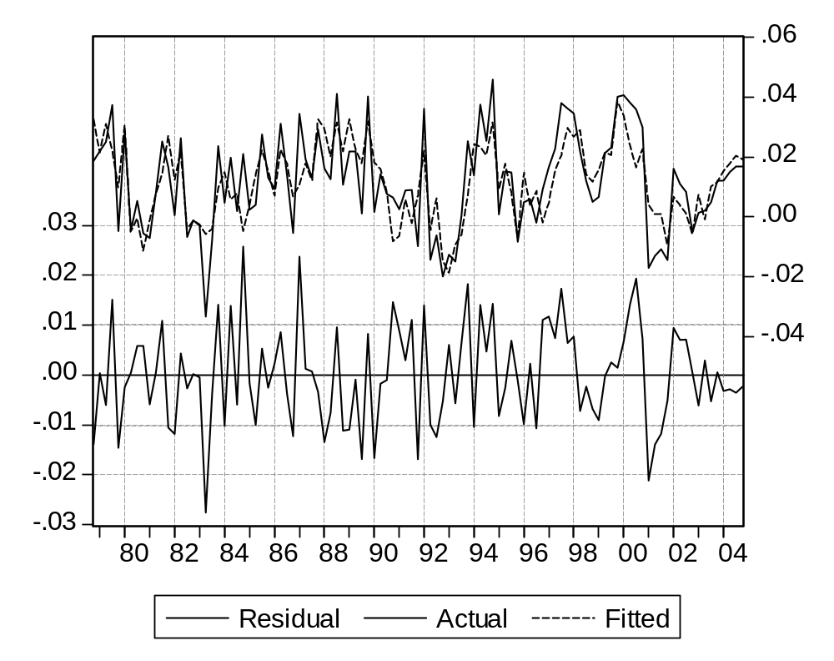
We can consider lowering the first coefficient to unity which might give to the model better properties, without decreasing too much the global quality of the equation.

Dependent Variable: DLOG(M)
Method: Least Squares
Date: 06/28/07 Time: 17:52
Sample (adjusted): 1978Q4 2004Q4
Included observations: 105 after adjustments
DLOG(M)=1*DLOG(FD+CT*Q)+C_M(2)*DLOG(UR)+C_M(3)
*DLOG(COMPM)+C_M(4)*RES_M(-1)+C_M(5)
 | Coefficient | Std. Error | t-Statistic | Prob.
C_M(2) | 0.302616 | 0.059407 | 5.093959 | 0.0000
C_M(3) | -0.076308 | 0.080448 | -0.948531 | 0.3451
C_M(4) | -0.136011 | 0.023476 | -5.793510 | 0.0000
C_M(5) | -0.362521 | 0.063764 | -5.685333 | 0.0000
R-squared | 0.582991 | Mean dependent var |  | 0.011899
Adjusted R-squared | 0.570605 | S.D. dependent var |  | 0.016169
S.E. of regression | 0.010595 | Akaike info criterion |  | -6.219511
Sum squared resid | 0.011338 | Schwarz criterion |  | -6.118408
Log likelihood | 330.5243 | Durbin-Watson stat |  | 2.061970
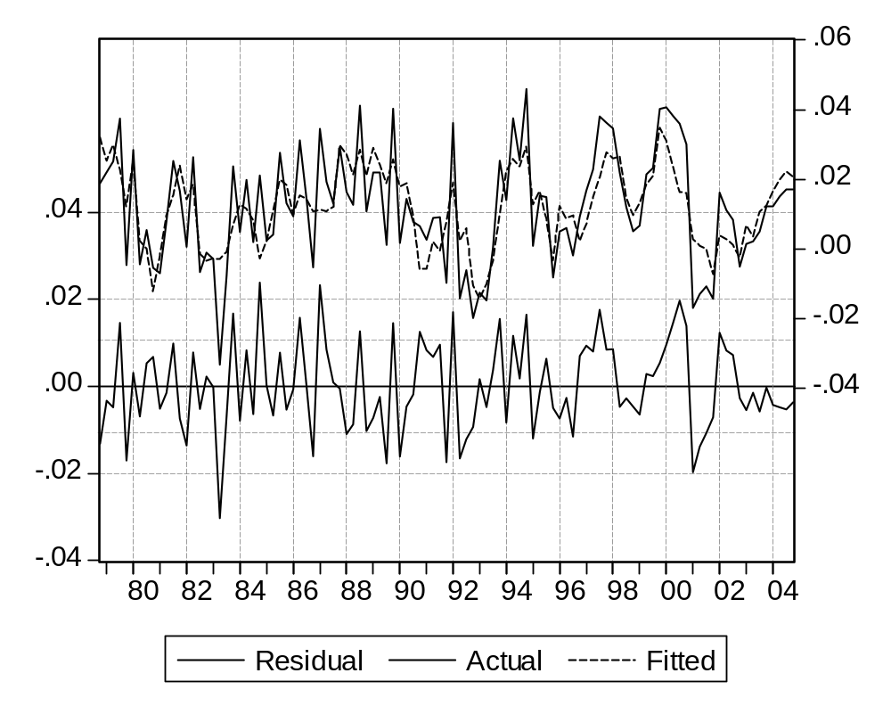

Question 4 : the new equations

Up to now we have modified three behavioral equations, introduced an identity and three new variables: res_m, res_x and ur.

But of course we must not keep UR exogenous, if we want this variable to convey the relative fluctuations of production and productive capacity. Thus UR must depend on Q, and also on the production factors: K and LE.

Using a complementary factors production function simplifies the problem. The rate of use is naturally defined as the ratio between added value Q and productive capacity, which depend then only on capital (we suppose that the level of employment if high enough). Supposing that capital productivity is constant for a given period, we get:
CAP = pk * K(-1)

UT = Q / CAP
(note that we have defined capacity at the beginning of a period)

We also have two new variables, CAP and pk, for which the historical values will be obtained by:
CAP = Q / UT
pk = CAP / K(-1)
The intermediary variable CAP has been retained for its descriptive power in simulation results.

The organization of the model is now slightly modified. Among the new endogenous variables, CAP can be computed in the prologue, as it only depends on lagged K and exogenous pk. But UR belongs to the iterative process, as depends on added value and influences demand and external trade. And in particular X, which enters the simultaneous block.

The new model is :

CAP = pk * K(-1)

UR = Q / CAP

Q + M = FD + X

I/K( - 1) = 0.944*I( - 1)/K( - 2) - 0.00256027580185569*(UR_STAR - UR)/UR + 0.0428*.125*Q/Q( - 8) - 0.00448 + EC_I

log(PRLE_T) = c_prle(1) + c_prle(2) * (t - 2002) + c_prle(3) * (t - t1) * (t<t1) + c_prle(4) * (t - t2) * (t<t2)

LED= Q / PRLE_T

DLOG(LE) = 0.295*DLOG(LED) + 0.199*LOG(LED( - 1)/LE( - 1)) + 0.000474+ 0.01759*((T = 1968.25) - (T = 1968.50)) + EC_LE

LT = LE + lg

RHI = wr * LT +r_rhiq * Q

CO= RHI * (1 - sr)

IH= r_ih * RHI

IC/Q( - 1) = -0.0268*(T = 1968.25) + 0.612*IC( - 1)/Q( - 2) - 0.00214 + 0.219*@PCH(Q) + 0.1056*@PCH(Q( - 1)) + 0.0549*@PCH(Q( - 2)) + 0.0391*@PCH(Q( - 3)) + 0.0302*@PCH(Q( - 4)) + EC_IC

FD = CO + I + gd + IC + IH

RES_M = p_m(1) * log(M / (FD + ct * Q)) + p_m(2) * log(UR) + p_m(3) * log(compm) + p_m(4) * (@trend(60:1) * (t<=2004) + @elem(@trend(60:1) , "2004q4") * (t>2004))

DLOG(M) = 1.676*DLOG(FD + ct*Q) + 0.213*DLOG(UR) - 0.1057*DLOG(COMPM) - 0.1028*RES_M( - 1) - 0.275 + EC_M

RES_X = p_x(1) * log(X / wd) + p_x(2) * log(UR) + p_x(3) * (@trend(60:1) * (t<=2004) + @elem(@trend(60:1) , "2004q4") * (t>2004))

DLOG(X) = 0.494*DLOG(WD) - 0.0914*RES_X( - 1) + 0.01960 + EC_X
K = K(-1) * (1 - dr) + I

We can establish the new graph (we have not repeated the lagged influences):

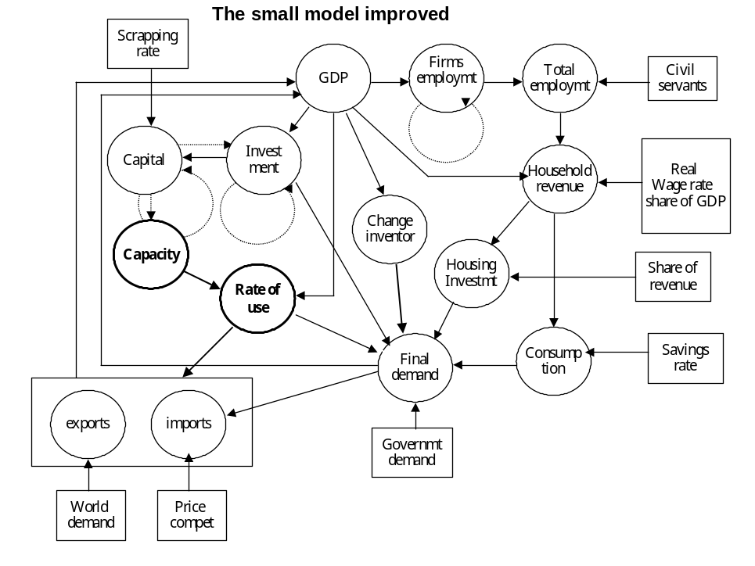

Question 5 : residual check.
It works, using the same statements as before on the 1980Q1- 2004Q4 period.

Question 6 : ex-post simulation.
We shall now simulate the model with residuals set to zero, on the 1980Q1- 2004Q4 period.

The precision of the model improves a little on the whole. Looking more precisely at the results, we can see that much of the improvement comes from imports. This could be expected from the error correction format, which makes the consequences of each single period error disappear with time, often at a rather high rate.
 | First model |  | Second model
 | Percentage error on the  level | Error on the  growth rate | Percentage error on the  level | Error on the  growth rate
CAP | - | - | 0.456 | 0.040
CO | 1.292 | 0.184 | 0.880 | 0.198
FD | 1.980 | 0.418 | 0.874 | 0.388
I | 8.525 | 1.376 | 1.979 | 0.5466
IH | 1.292 | 0.183 | 0.880 | 0.198
K | 2.160 | 0.158 | 0.452 | 0.045
LE | 1.5432 | 0.211 | 1.147 | 0.246
LED | 1.937 | 0.367 | 0.876 | 0.314
LT | 1.199 | 0.165 | 0.890 | 0.191
M | 2.976 | 1.281 | 1.999 | 1.146
PRLE_T | - | - | - | -
Q | 1.937 | 0.369 | 0.876 | 0.315
RHI | 1.292 | 0.184 | 0.880 | 0.198
UR | - | - | 1.729 | 1.300
X | 2.004 | 1.316 | 2.249 | 1.192
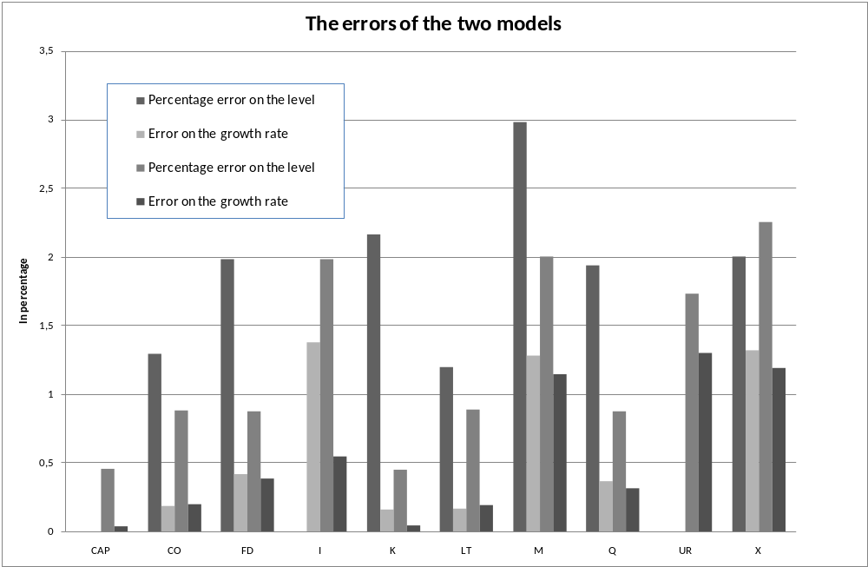

(To improve the presentation of the other elements, the high percentage error on I has been suppressed for the first model).

The results are closely associated to the generalization of the error correction framework, to three new equations (investment, exports and imports). Almost all estimated equations define growth rates (or Dlogs) and their residuals are not much improved compared to the previous formulations, leading to a comparable simulation error. But now any residual appearing at a given period is corrected with time, sometimes very fast. The variance of the global error will grow, but converge in the long run to a bounded value

Question 7 : the multiplier.

We shall base our commentary on fours graphs showing : the decomposition of final demand, the evolution of the supply-demand equilibrium both in absolute and relative terms, and the evolution of elements linked to production.
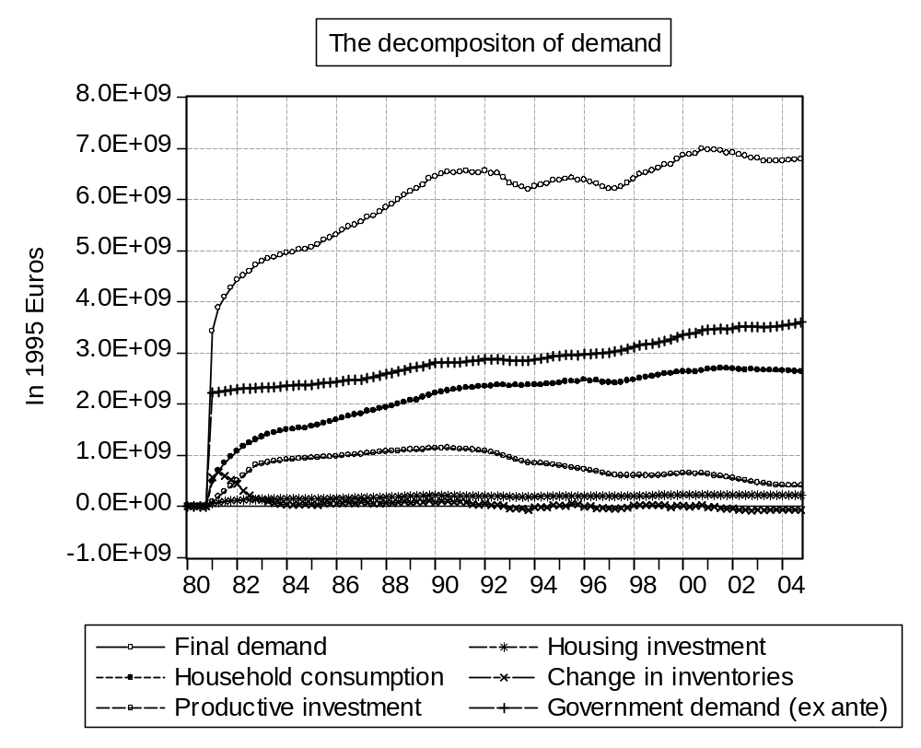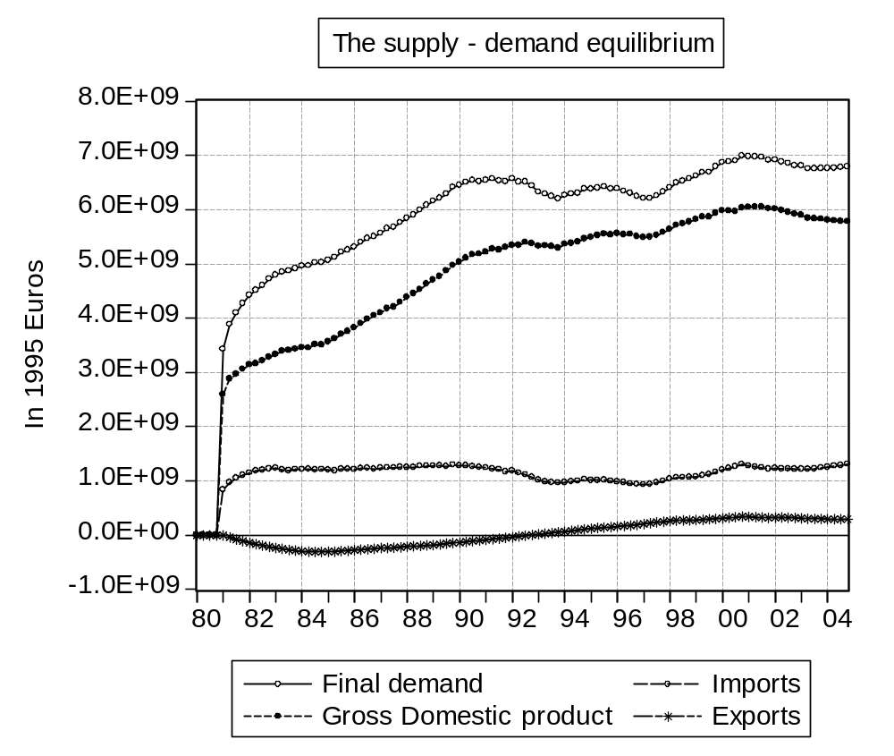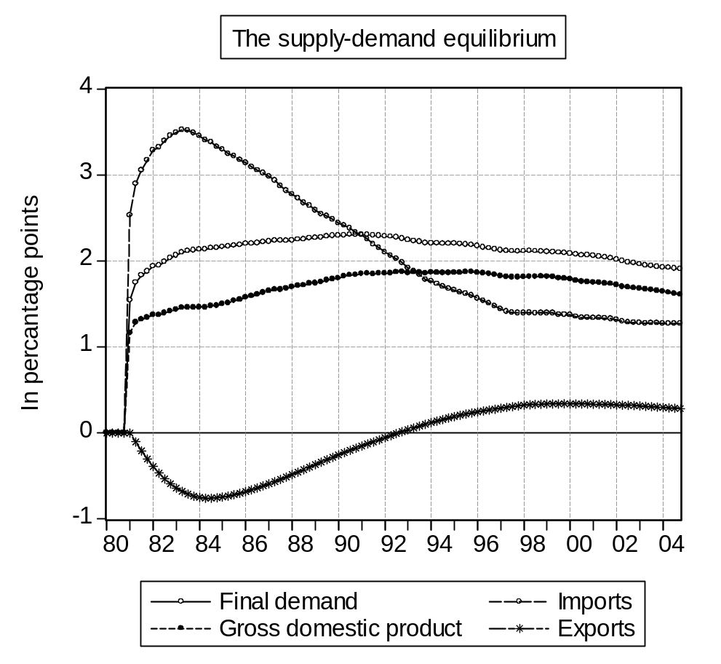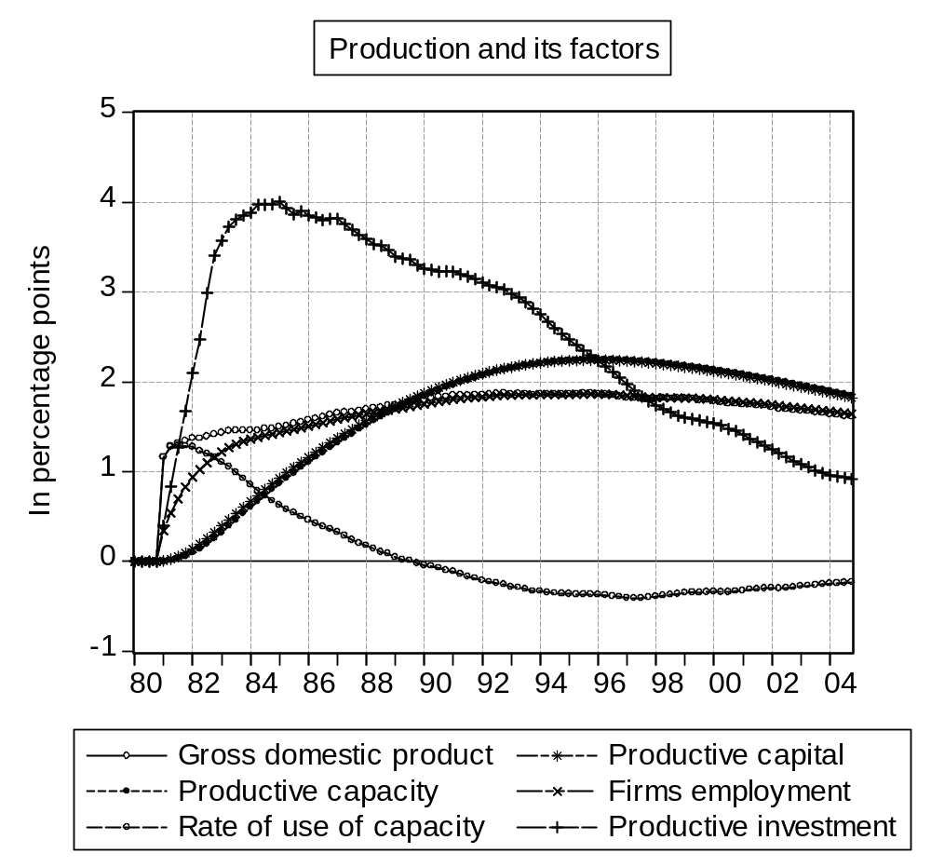

Most of the conclusions associated to the previous model remain valid. But the present version presents indeed some improvements, in terms of economic links and stability. Now the evolution of productive factors and the adaptation of capacities to their target is fully described, and we see that the change in the rate of use converges to zero in the long run.

External trade is also better described:

The change in exports follows the rate of use, with a negative evolution limited to the first periods.
The change in imports is higher in the beginning, when tensions have not adapted, and (in relative terms) converges to a value a little lower than demand, as the exports variation has disappeared.

On the whole, although this model remains overly simplistic, it looks rather sound if we consider its size.

Lesson 5 : Producing a forecast : answers
.
The following answers can be run using the procedure pfor_b.prg.

Note : please do not consider the errors :

Log of non positive number - Missing data generated in "GENR TC_IC=100*LOG((IC_P+(IC_P=0))/(IC_P(-1)+(IC_P(-1)=0)))"

As we compute the growth rates as Δlogs, computation fails when the variable changes signs from one period to the other (for the change in inventories here).

Question 1 : Creating a new page
We shall use :

wfsave pic_p.wf1
pageselect pic_b
pagecopy(page=pic_p)
pagestruct(end=2100Q4) *

The last element allows creating or modifying variables u to 2100.

Question 2 : Computing the assumptions
The needed statements are the following:

Setting the long term growth rates :

scalar txq=exp(0.006)-1
scalar txn=exp(0.0005)-1

Exogenous

smpl 2005Q1 2100Q4
genr T=t(-1)+0.25

for %1 gd wd
genr {%1}={%1}(-1)*(1+txq)
next

for %1 r_rhiq dr sr pk compm ec_i ec_le ec_m ec_x ec_ic ct r_ih
genr {%1}={%1}(-1)
next

for %1 lg
genr {%1}={%1}(-1)*(1+txn)
next

for %1 wr
genr {%1}={%1}(-1)*(1+txq)/(1+txn)
next

Endogenous (useful for providing starting values to the solving process)

for %1 ic i m x co fd k rhi q cap ih
genr {%1}={%1}(-1)*(1+txq)
next

for %1 ur res_m res_x
genr {%1}={%1}(-1)
next

for %1 le lt led
genr {%1}={%1}(-1)*(1+txn)
next

for %1 prle_t
genr {%1}={%1}(-1)*(1+txq)/(1+txn)
next

Parameters

c_prle(2)=4*log((1+txq)/(1+txn))

Question 3 : The simulation
In the proposed solution, results look rather satisfying.
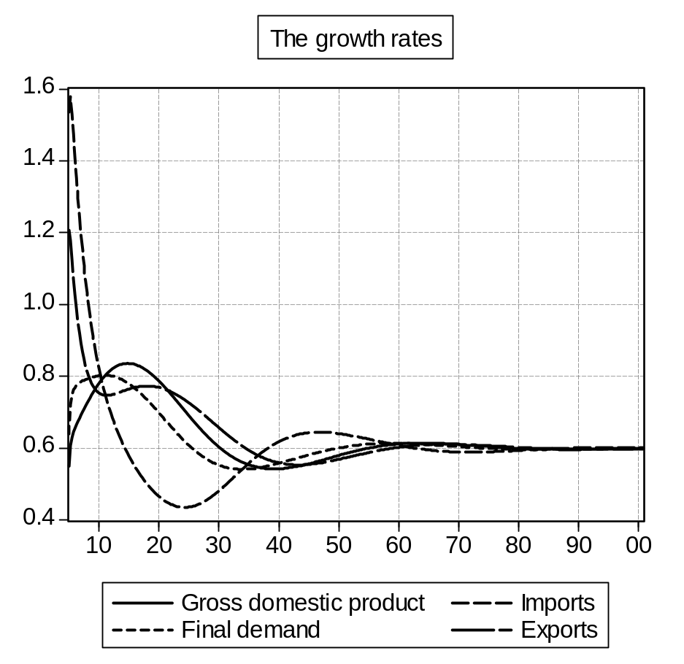

Converging cycles appear in the first decades, mostly due to the trade elements, which start with higher (historical) growth rates than the long term values.

Question 3 : A shock

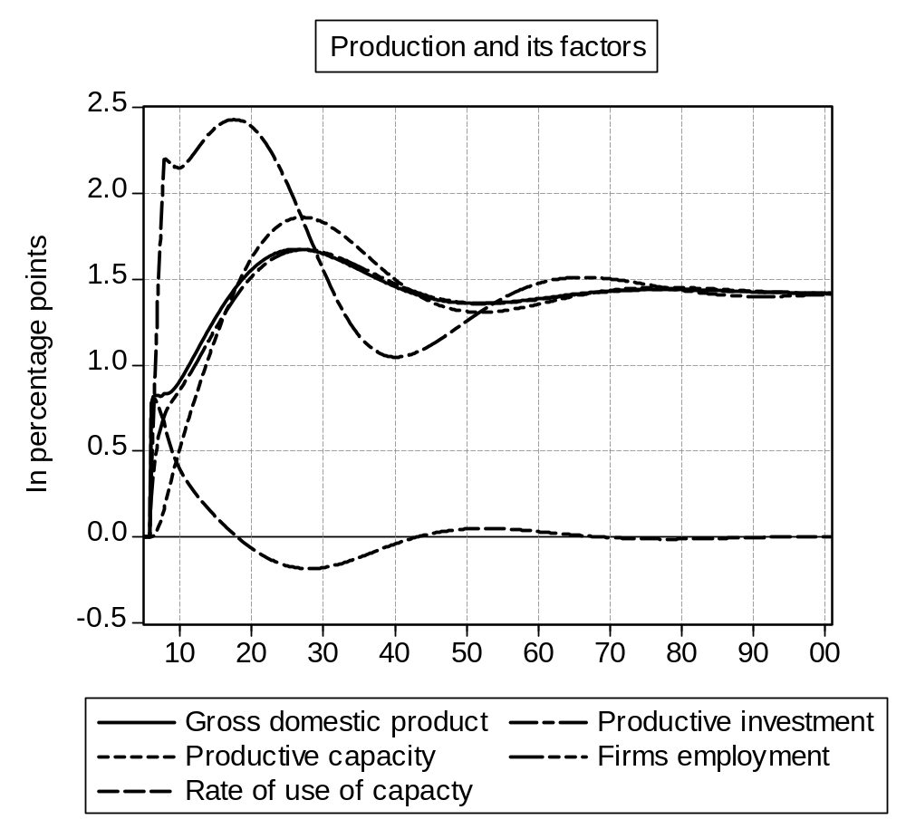

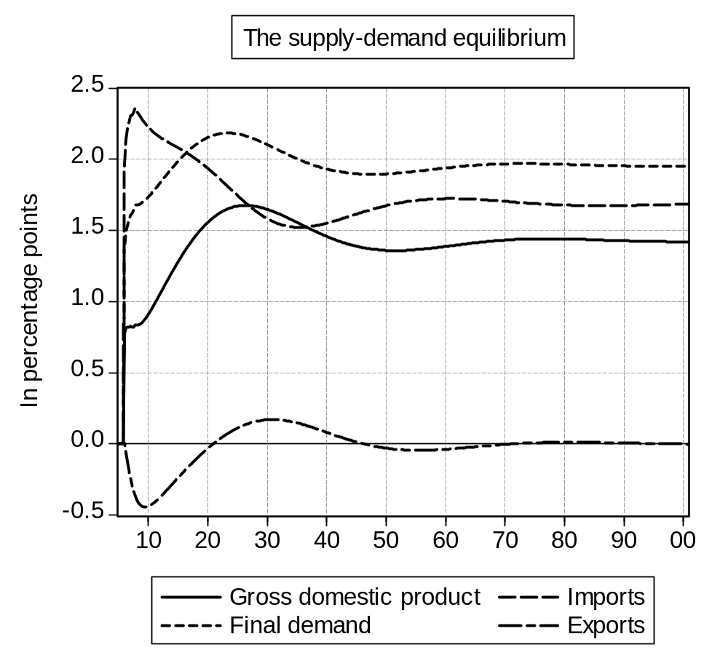
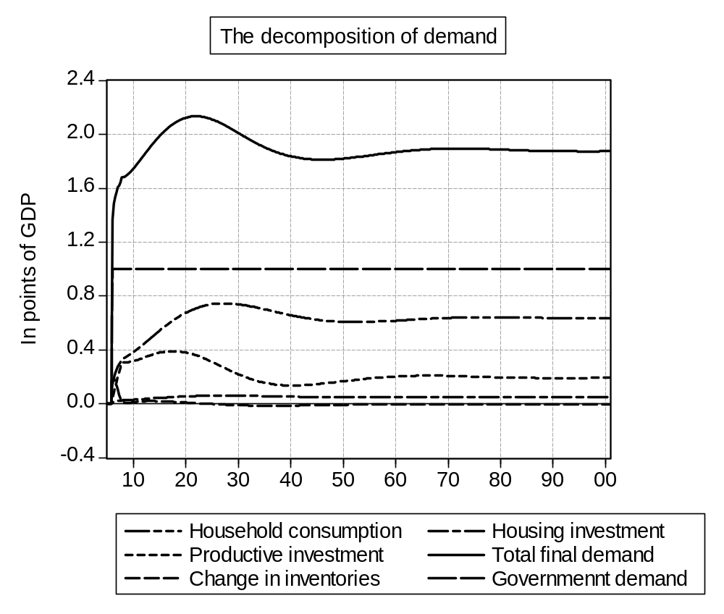

The results look rather similar to the previous shock. We can only observe that with a more recent period, the role of the trade variables increases, leading to a lower multiplier. The main observation is that now the smooth evolutions make the results much clearer.

In the long run, the value of the multiplier is about 1.4, a somewhat high value. But we do not take into account the loss in competitiveness which could come through inflation.

We can observe that the rate of use of capacities gets back to its base value. This leads exports to do the same.

The addition of investment and consumption to the ex ante change in Government demand makes the global variation grow to 2 %. Imports grow less as they depend also on the unchanged exports. And GDP even less, as it depend even more on exports (twice more actually, which is consistent with the graph).

The stability of the rate of use gives investment and capital on one side, and GDP and capacity on the other, a constant ratio, and thus the same relative change. As productivity of capital is fixed, all these variables change in the same proportion. And as productivity of labor is also fixed, firms employment follow. The change in inventories also, although with more sustained fluctuations.

But government employment does not change. Thus total employment and wages grow less, as well as household income and consumption, which depend also on GDP

This ends the course. We could proceed further:
- by making more complex simulations of the same model

- Stochastic simulations, in which the error term is not set to zero, but rather drawn according to its estimated law, using a random number generator. Repeating the process a large number of times will give a better estimate of the average solution, and a measure of its reliability.
- Forward-looking simulations, in which agents are supposed to know elements of the future, or at least the future model.
These two elements will be addressed in a separate document, using the present model.
- by introducing additional elements :

- Simple ones, such as estimating an equation for the real wage rate, or for household consumption.
- More complex ones, such as defining a full price system (estimating a single price would make the model inconsistent) or introducing a financial block.
- Going even farther, we could produce the long term model, computing the sensitivity of the long term equilibrium to assumptions and parameters, or interpret the dynamics through an eigenvalues analysis of the linearized model.

In a rather large proportion for this compact model, but it decreases with the size of the model. In operational cases it is closer to 15-20%.
The coefficients 1 to 6 correspond to the 3 explanatory variables and the 3 original polynomial coefficients.
This assumption will be made more acceptable later, when we have to restrict the sample to the constancy period.
Let us just hope he is not Homer Simpson.
Again, restricting the prriod will make the assumption more acceptable later.
3 Incidence matrix: each line of the matrix is associated with one equation, following a specific order, and each column to the variable the equation with the same rank is supposed to compute (in our case the variable on the left hand side). Then for matrix M: Mij = 1 if variable j appears in equation i, 0 otherwise. In particular we have Mii = 1
As the left hand side represents the (fixed) long term growth rate of capital.

