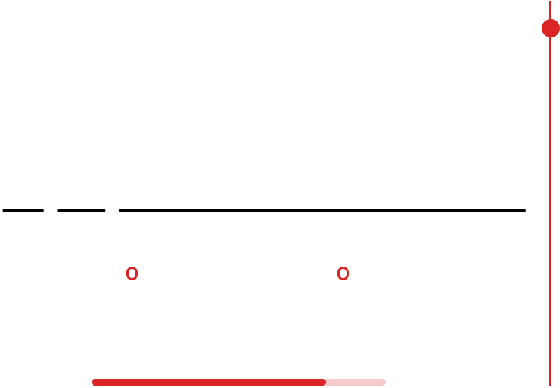

**Maedeh Narouei**

|  |  |  |  |  |  |  |  |
| --- | --- | --- | --- | --- | --- | --- | --- |
| ****[+98 915 1924792](tel:+98 915 1924792) | | | | | | | ****[ma.narouei1@gmail.com](mailto:ma.narouei1@gmail.com) |
|  | | **Skills** |  | | **Profiles** | | |
| **Python (Core)** | | | | |  | maedeh-narouei | |
| Linkedin | |
| **Django REST Framework** | | | | | **Summary** | | |
| DRF | | | | |  | Dedicated Django Back-end Developer with a passion for coding and | |
| **RESTful API development** | | | | |
| continuous learning. I have a solid foundation in Python development | |
| and REST API web development. After successfully working on various | |
| **FastAPI** | | | | | projects, both personal and professional, I am eager to contribute to a | |
| progressive and collaborative environment as a junior back-end | |
| Ninja | | | | | developer. | |
| **PostgreSQL (RDBMS)** | | | | | **Experience** | | |
| **Python Libraries** | | | | |  | **Sirang** | |
| TensorFlow, PyTorch, Keras, Pandas, | | | | | Backend Developer | |
| NumPy, OpenCV | | | | | **August 2023 - Present** | |
| **Git** | | | | | Developing and maintaining robust back-end solutions using Django for | |
| various web applications. | |
| **Docker** | | | | | Designing and implementing RESTful APIs to support front-end | |
| functionality and third-party integrations. | |
| **Os: Linux** | | | | | Collaborating closely with front-end developers, project managers, and | |
| **Prominent Software Best Practices** | | | | | other stakeholders to ensure smooth and efficient project delivery. | |
| Optimizing application performance and scalability by refining database | |
| **and Patterns** | | | | |
| queries and Django configurations. | |
|  | **Publications** | | |  | Participating in code reviews | |
| **Traffic Sign Detection And** | | | | | **FREELANCE** | | |
| **Recognition Using YOLOv3 Model** | | | | | Python Developer | | |
| Computer Society of Iran | | | | | **March 2023 – August 2023** | | |
| ****<https://jcsit.ir/article_161892.html> | | | | | Led the development of web projects using Django, focusing on back-end | | |
| infrastructure and API development. | | | | | | | |
| **Languages** | | | | | Worked on personal and client projects to enhance Python and Django | | |
| **English** | | | | | skills, delivering functional and efficient web solutions. | | |
| **Farsi** | | | | |  | **FREELANCE** | |
| Python Developer | |
| **August 2021 – Jan 2023** | |
| Developed data mining and machine learning models to extract and | |
| analyze marketing data. | |
| Utilized Python libraries like Pandas and NumPy for data manipulation | |
| and analysis, providing actionable insights. | |
|  | | | | | | **FREELANCE**  Python Developer  **September 2021 – February 2022**  Conducted time-series analysis for forecasting purposes and built neural network models using TensorFlow and Keras.  Applied data science techniques to solve complex problems, contributing to predictive modeling projects. | |

**Education**

|  |  |
| --- | --- |
|  | **University of Sistan and Baluchistan**  TELECOMMUNICATION SYSTEM ENGINEERING M.SC.  **September 2017 – September 2021**  THESIS:  Improving the YOLOv3 model for better accuracy and performance in small object detection. This involved creating an augmented image database and adjusting model hyperparameters to enhance detection accuracy.  **University of Sistan and Balouchestan** B.Sc.  Electronic Engineering  **September 2012 – September 2016** |