Decision Log Entry 1

0. Context: Why does this question exist?
Project/assignment this belongs to:
When Leaderboards Lie: Building Real-World LLM Benchmarks
Why this matters right now:
- Before designing the benchmark experiment, I need to decide whether the LLM benchmarking project is the right research direction.
- I can also understand how and what the LLM models will be used on which task and increase performance.
- Without the decision, it is unclear what the evaluation problem is, the project will address and the methodology should be used.
🔗 Where this fits:
[Link to: project brief, sprint goal, previous decision log that led here, client requirement]
- Assignment description: “Recreate StackEval benchmark”
- Sprint 1 goal: Domain understanding and experiment design

My research question:
How the benchmark LLM model evaluate the reality performance of model in coding domain?

2. Current LO stage:
[ X] Analyzing [ ] Advising [ ] Designing [ ] Realizing [ ] Managing

3. What makes a good decision here?
My criteria for success:
• Criterion 1: The project must address a real-world AI evaluation by limit the dataset from 30–50 questions and testing at least 4 models.
• Criterion 2: The project provides measurable results such as model scores that can be compared across at least 4 models.
• Criterion 3: The project evaluates LLM performance on real-world tasks using real developer questions rather than synthetic datasets.

4. What I decided
I decided to pursue a project focused on benchmarking large language models for coding assistance using a real-world evaluation approach inspired by StackEval.

5. Why this decision
Method I used:
I used a combination of literature study and domain exploration to understand how LLMs are currently evaluated.
What I found/observed:
From my research, I found that many models are compared using academic benchmarks such as MMLU. These benchmarks test knowledge across many subjects, but they do not reflect how models perform in real situations.
I also looked at StackEval, which evaluates models using real questions from Stack Overflow. This showed that models with similar academic scores can behave very differently when solving real coding problems.
🔗 Evidence & artifacts:
- Domain understand about StackEval
- StackEval benchmark documentation
What this means:
This shows that academic benchmarks alone are not enough to decide which model is actually useful in practice. Real-world evaluation is needed to understand how models perform in actual tasks.
- Figure DL1-1 — A live academic benchmark leaderboard (MMLU-Pro)
- 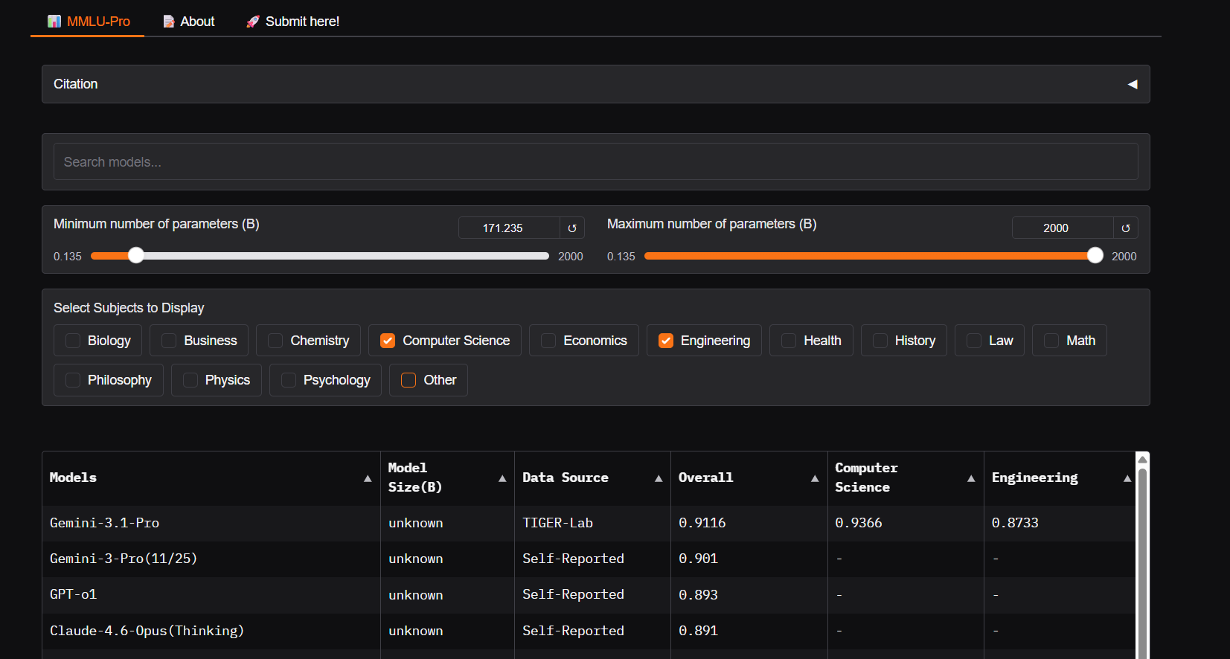
- Backs section 5 'What I found/observed': models are ranked here purely by an aggregate accuracy score across academic subjects (Computer Science, Engineering, etc.) — exactly the kind of single-number comparison that says nothing about whether a model can actually help a developer solve a real coding problem, which is the gap this project set out to investigate.

- Figure DL1-2 — Comparison of widely-cited benchmarks, their saturation status, and why they still matter
- 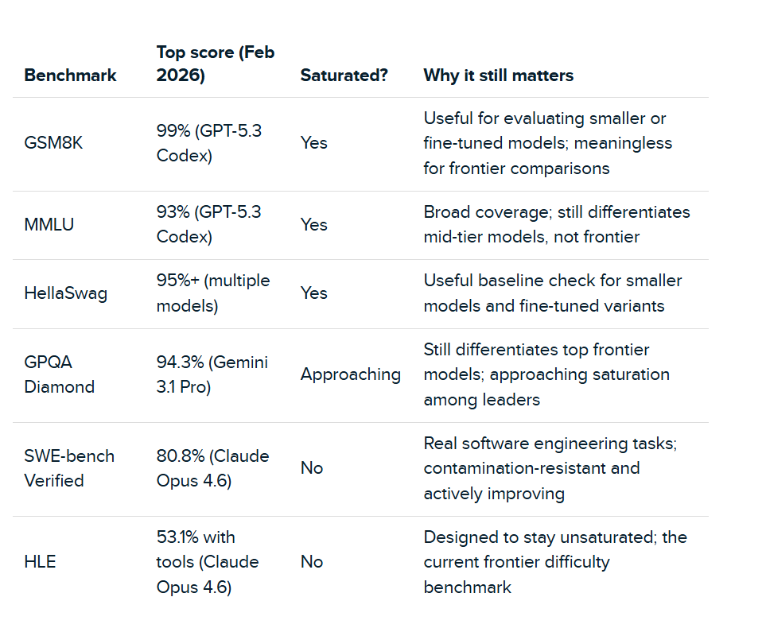
- Backs section 5 'What this means': several of the most widely cited academic benchmarks (GSM8K, MMLU, HellaSwag) are already saturated — near-perfect scores no longer separate strong models from weak ones — while task-grounded benchmarks like SWE-bench Verified remain meaningful precisely because they test real engineering work. This is the direct evidence for why a StackEval-style, task-based benchmark was the right direction to pursue, not an academic one.

- Figure DL1-3 — Overview of widely-used benchmarks and what each one actually measures
- 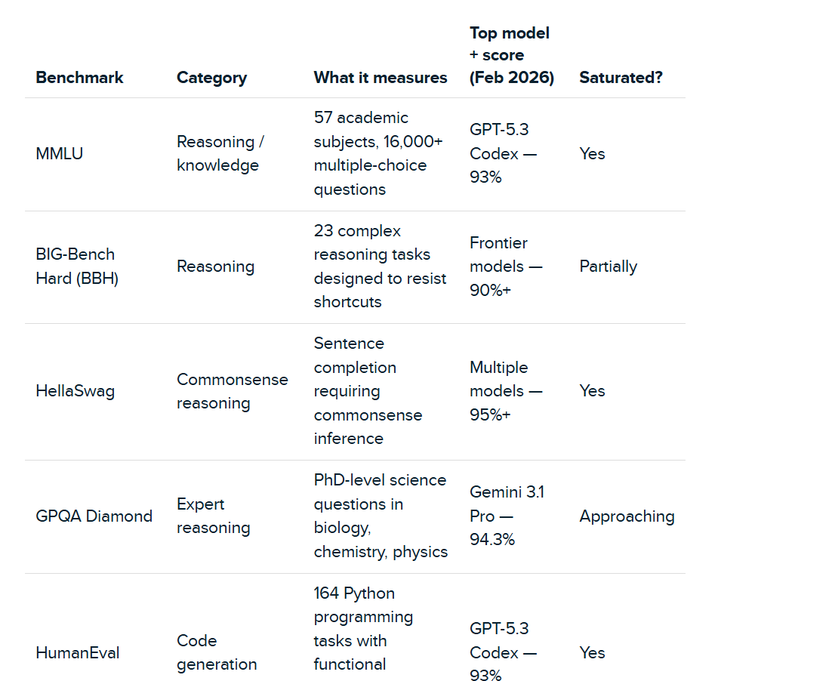
- Backs section 5 'What I found/observed' and 'What surprised me': MMLU measures broad academic/reasoning knowledge and HumanEval measures isolated function-level code generation — neither evaluates whether a model's answer would actually satisfy a developer asking a real, messy question, which is why models with similar scores on these benchmarks can still 'behave very differently in real-world tasks' as this log goes on to note.

So I decided:
I will focus my project on recreating a real-world benchmark (StackEval style) to evaluate how useful different LLMs are for coding problems.

6. Does this hold up?
How well this meets my criteria:
• Criterion 1: [🟡]
It requires collecting questions and human evaluation, which takes effort, but limiting it to 30–50 questions makes it manageable.
• Criterion 2: [✅ ]
The project will produce scores that allow comparison between models.
• Criterion 3: [✅]
The project focuses on real coding questions instead of academic datasets.
Assumptions I'm making:
- I will be able to find enough suitable Stack Overflow questions
- I can get at least 2 evaluators to score answers
What surprised me:
During the research, I revealed that models with similar benchmark scores can behave very differently in real-world tasks.

7. What this unlocks
🔗 Implementation evidence:
Domain understanding document

Next LO stage:
Advising
What I can now do (that I couldn't before):
- Explain clearly why academic benchmarks are not enough for real-world use
- Move forward to decide which benchmark approach like StackEval-style I will use
How I'll know this worked:
- I will explain the limitations of academic benchmarks like MMLU
- I will justify why a real-world benchmark approach is needed

