Decision Log Entry 2

0. Context: Why does this question exist?
Project/assignment this belongs to:
[Which project? Which sprint? Which research phase?]
LLM benchmark project in 1st print and in the phase of analyzing and advising
Why this matters right now:
I now understand the problem, but I need to decide how to evaluate LLMs properly. Without the understanding of which methodology suitable for the benchmark design also I will not know what kind of data to collect, what type of evaluation to use, or what exactly the benchmark should measure.
🔗 Where this fits:
- Assignment description: “Recreate StackEval benchmark”
- Sprint 1 goal: Domain understanding and experiment design
- Decision Log 1

1. My research question:
Which benchmarking approach should be used to evaluate LLMs for coding assistance ?

2. Current LO stage:
[X] Analyzing [X] Advising [ ] Designing [ ] Realizing [ ] Managing

3. What makes a good decision here?
My criteria for success:
• Criterion 1 : The benchmark should be feasible to run within the constraints of this project. The evaluation method must work with a dataset and give score 0-3 without requiring excessive resources or coordination.
• Criterion 2 : The benchmark must evaluate whether the model actually solves real coding problems and gives useful explanations.
• Criterion 3 : The benchmark should use reasonably recent and less-exposed questions to better reflect real-world usage and reduce the risk of benchmark leakage.

4. What I decided
I decided to use a StackEval-style benchmark design combined with an LLM-as-judge evaluation approach. In this approach, LLMs are evaluated on real Stack Overflow coding questions using accepted answers as reference, while a separate LLM model is used to score responses using a structured 0–3 rubric.

5. Why this decision
Method I used:
I used the literature study and benchmark comparison,
What I found/observed:
- From the research, I found that traditional text-based metrics such as BLEU and ROUGE are weak for evaluating coding tasks. They mainly compare overlap between texts, but in programming there can be multiple correct solutions to the same problem. A different answer can still be fully valid, even if it does not look similar to the reference answer.
- I also found that academic benchmarks such as HumanEval and general LLM benchmarks are useful for measuring parts of model performance, but they do not fully reflect real coding assistance. In a real coding support scenario, the model needs to do more than generate code that looks correct. It should also explain the problem clearly, give relevant reasoning, and actually help solve the user’s issue.
- StackEval uses real questions from Stack Overflow and focuses on practical usefulness. This is closer to real-world usage compared to academic benchmarks.
- For my benchmark, Stack Overflow accepted answers will be used as reference answers, but not as absolute truth, because some coding problems can have more than one valid solution.
- To reduce benchmark leakage, I want to use recent questions from 2025–2026 where possible. This gives a better chance of testing how the models perform on less exposed questions instead of well-known benchmark examples.
🔗 Evidence & artifacts:
[Links to everything this method produced: interview notes, comparison tables, test code, screenshots, data files, error logs, benchmark results]
https://www.evidentlyai.com/blog/llm-coding-benchmarks
https://orq.ai/blog/llm-benchmarks
Benchmark LLM - domain understand.docx
Document research of StackEval
- Small-scale validation experiment comparing human scoring and LLM-as-judge scoring (see attached spreadsheet)
- Results: An acceptable agreement threshold is defined as scores differing by no more than 1 point in the majority of cases.
- Conclusion: LLM-as-judge is sufficiently reliable for this benchmark
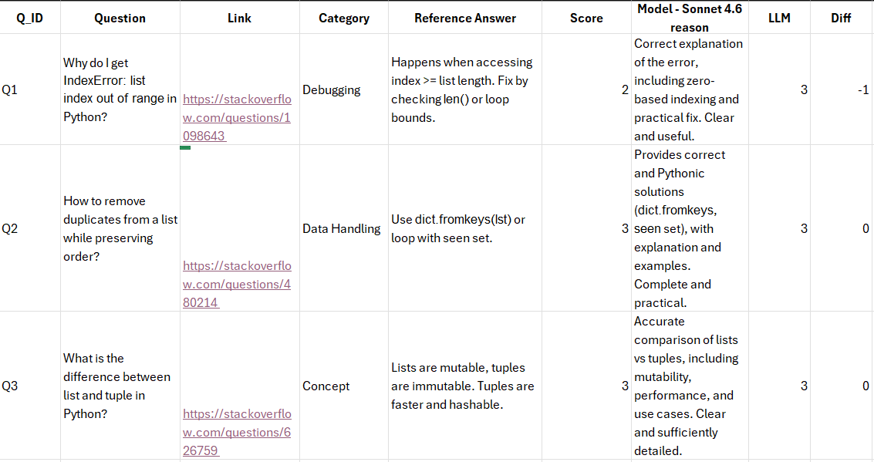
What this means:
This shows that a benchmark for coding assistance should not only test whether the generated code is technically similar to a reference answer. It should also test whether the response is practically helpful for a developer. StackEval-style evaluation with LLM-as-a-judge is the approach that best balances accuracy, feasibility, and consistency for this scope.
So I decided:
So I decided to use a StackEval-inspired benchmark combined with an LLM-as-judge evaluation method, as it allows evaluation of real-world coding usefulness while remaining feasible within project constraints.

6. Does this hold up?
How well this meets my criteria:
• Criterion 1: [✅] – LLM-as-a-judge is feasible because it doesn't require human recruiters, can handle 20–25 questions, and produces consistent scores through a rubric
• Criterion 2: [✅] - This approach evaluates actual coding assitance scenarios instead of only benchmark-style coding tasks.
• Criterion 3: [🟡] – The unseen questions will help lower the risk of data leakage but will not full guarantee
Assumptions I'm making:
- Stack Overflow questions represent real developer problems
- Accepted answers are useful enough as a reference, even if they are not perfect ground truth.
- The LLM judge can approximate human evaluation sufficiently for this small-scale benchmark.
What surprised me:
- I supprised by how limited traditional metrics like BLEU and ROUGE are for code evaluation

7. What this unlocks
🔗 Implementation evidence:
Benchmarking LLM approach research.docx

Next LO stage:
Design
What I can now do (that I couldn't before):
- define the actual benchmark structure
- choose the dataset source and question categories
- have choose the model to use and compare

How I'll know this worked:
- I can translate this benchmark approach into a concrete benchmark design
- I can explain why this approach is used when defining dataset and evaluation in the next decision log

