Decision Log Entry 3
LLM Benchmark Project — Sprint 2 (Design Phase)

0. Context: Why does this question exist?
Project: LLM Benchmark Project — Sprint 2, Design Phase
Sprint goal: Translate methodology decisions into a concrete benchmark design
After Decision Log 2 confirmed that LLM-as-judge is the right evaluation approach, the next required step is to define the actual benchmark structure. Without specifying the dataset, models, prompts, and pipeline design, the project cannot move into implementation. This log documents those design decisions and the reasoning behind each one.

Previous decision log:
- Real Stack Overflow questions are the correct data source
- LLM-as-judge is the evaluation method
- A 0-3 rubric based on correctness and usefulness is used for scoring
This log answers what was left open: exactly how to implement those choices.

1. Research Question
How should the benchmark be designed with the dataset, model and prompt that make the evaluation pipeline effective evaluate the performance of LLM in solving coding tasks?

2. Current Learning Outcome Stage
[ ] Analyzing [ ] Advising [X] Designing [ ] Realizing [ ] Managing

3. Criteria for a Good Decision
Criterion | Statement
Criterion 1 | Task types reflect real coding assistance use: debugging, implementation, and conceptual explanation that at least 3 distinct task types are covered with a minimum of 6 questions each, ensuring no single task type dominates the dataset and skews model comparisons.
Criterion 2 | Each question supports clear scoring using a Stack Overflow accepted answer and the 0-3 rubric.
Criterion 3 | The benchmark pipeline must support rapid iteration that it should be possible to re-run the full evaluation after making a change to the prompt or rubric without significant cost or delay. All outputs must be stored in a format that can be inspected and compared manually without additional tooling.

4. What I Decided
The benchmark is designed with the following concrete specifications:
- 30 Stack Overflow questions in Python, split across 3 task types: debugging, implementation, conceptual
- Questions include a mix of older well-known questions and 2024-2025 recent questions to reduce data leakage risk
- Models tested: GPT-4o mini, Claude Sonnet 4.6 and Llama 4 Scout (the models being evaluated)
- Judge model: GPT-4o (stronger than the models being tested, separate to avoid self-scoring bias)
- Scoring rubric: 0-3 scale, evaluated on correctness, completeness, and relevance
- Main metric: the average score per model and acceptance rate percentage of responses scoring 2 or higher per model
- All outputs saved to CSV files for inspection and evidence

5. Why This Decision

Method used
I reviewed the outputs of my pilot test (3 questions, 3 models), inspected the responses manually, and compared my own scoring against the LLM judge. I also applied reasoning from my literature study in Decision Log 2 to design the prompt and rubric.

Dataset design reasoning
Python was chosen as the single language for the following reasons:
- Python has the highest volume of coding assistance questions on Stack Overflow, giving the most real questions to choose from
- Python is the dominant language in AI and data work, making it the most relevant for a GenAI engineer context
- Using one language keeps the benchmark focused, patterns in model performance are easier to identify without language differences creating noise
Three task types were chosen because they cover the core of what coding assistance actually involves:
- Debugging: finding and fixing errors the most common real developer need
- Implementation: writing code to solve a specific problem
- Conceptual: explaining how something works or why tests depth of understanding, not just code generation

Model selection reasoning
Two models were selected for testing to keep the pipeline manageable:
- GPT-4o mini: widely used, low cost, strong baseline for coding tasks
- Claude Sonnet 4.6: different architecture and training approach, gives a genuine comparison point
- Llama Scout Instruct: included to introduce variation in model architecture and training data, allowing comparison beyond commercial API models
The judge model is GPT-4o (full version). The key principle from the StackEval research is that the judge must be more capable than the models it is evaluating. Using GPT-4o-mini as both a test model and judge would introduce self-scoring bias.

Prompt design reasoning
Two prompts are used in the pipeline:

Model prompt:
You are a coding assistant helping a developer solve a real programming problem.

When answering, always follow this structure:
1. DIAGNOSIS: Briefly identify what the core problem is (1-2 sentences)
2. SOLUTION: Provide the fix or answer with working code where relevant
3. EXPLANATION: Explain why this solution works so the developer understands it

Be clear and direct. Do not add unnecessary caveats or unrelated information.
Your answer should be complete enough that the developer can apply it immediately.

Judge prompt (sent to GPT-4o):
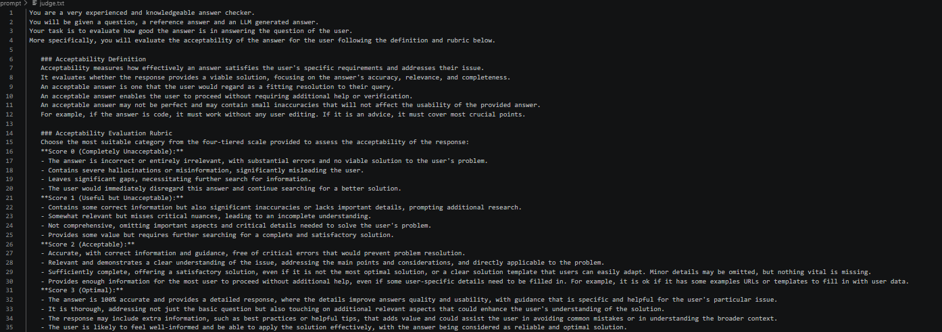
The judge receives: the original question, the Stack Overflow accepted answer as a reference, and the model response. It is asked to reason step-by-step (chain-of-thought) before assigning a score. Temperature is set to 0.0 for consistent scoring.
The accepted answer is included because StackEval research found this is the most important factor in improving judge accuracy. Chain-of-thought is included as a secondary reliability measure.

Evidence from pilot test
Before running the full pipeline, I tested 3 questions manually:
- Asked the same question to GPT-4o mini and Claude Haiku
- Scored the responses myself using the 0-3 rubric
- Then ran the LLM judge on the same responses and compared
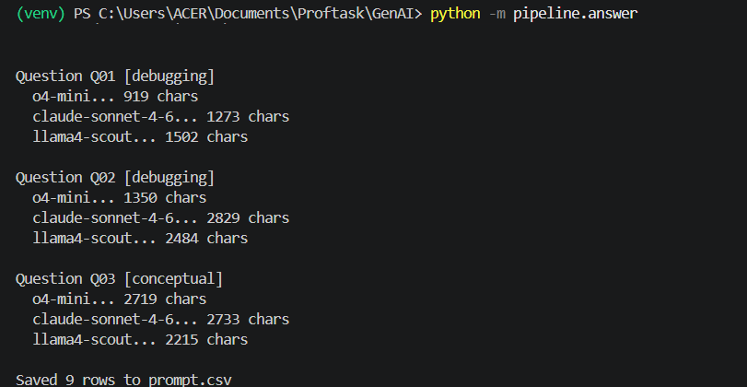
Result: My scores and the judge scores agreed within 1 point on 5 out of 6 responses. One disagreement occurred on a debugging question where I scored 2 and the judge scored 1. After reviewing the reasoning, the judge's lower score was justifiable, the model's answer was technically correct but missed explaining why the bug occurred.
This confirmed that the judge prompt is reliable enough to proceed with the full benchmark.
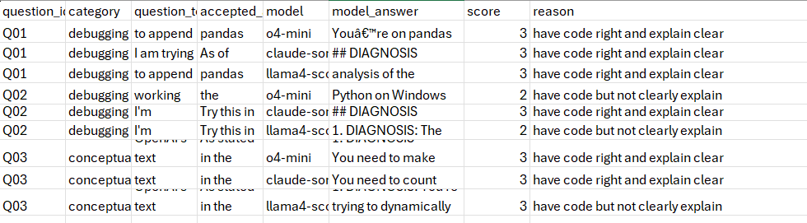
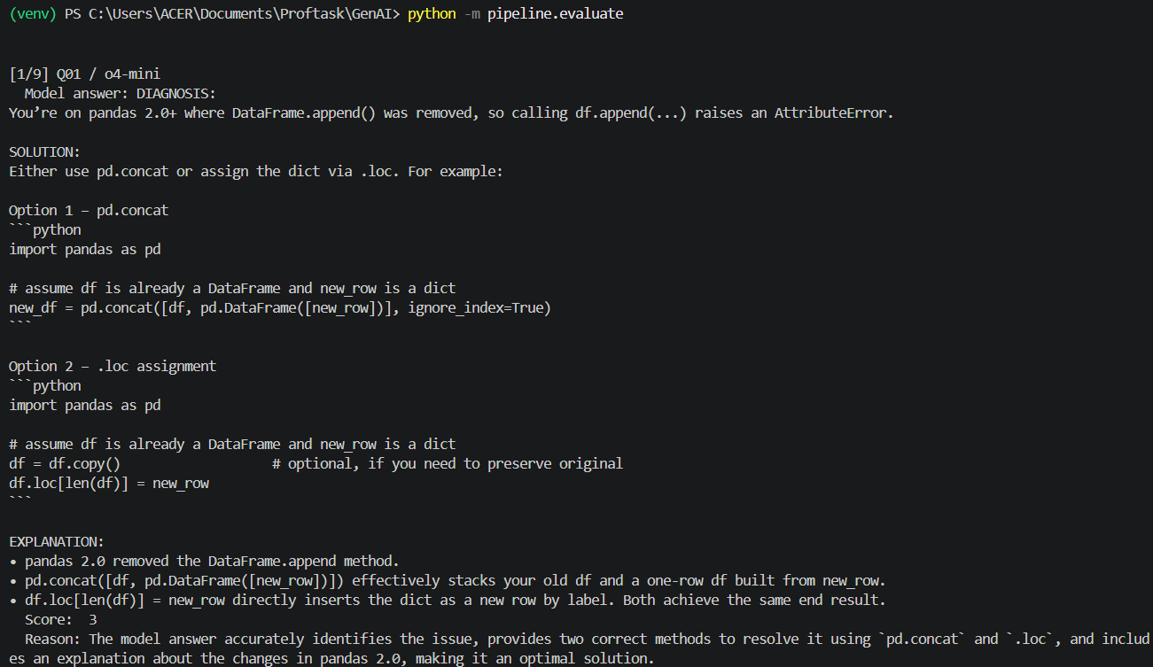
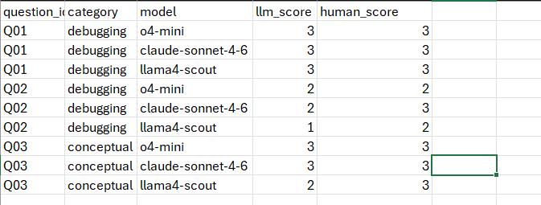

6. Does This Hold Up?
Criterion | Status | Evidence / result
Criterion 1: real task types | ✅ | Debugging, implementation, conceptual, confirmed from StackEval research and pilot test
Criterion 2: scoreable questions | ✅ | Pilot test showed 5/6 judge scores aligned with my manual scoring within 1 point
Criterion 3: pipeline iteration | 🟡 | Not yet fully tested at scale, to be confirmed in Decision Log 4 after full run

Assumptions being made
- Stack Overflow accepted answers are reliable enough as reference points even though they are not the only valid solution
- GPT-4o is capable enough to serve as judge without strong bias toward either test model
- Python questions at beginner-intermediate level are representative enough of the coding assistance domain

What surprised me
The pilot test showed that the judge gave lower scores than I did. I initially scored responses generously if the code was correct and have explanation enough about the answer. The judge was stricter about explanation quality, it penalized answers that gave code without specifically explaining the reasoning. After reflection I agree this is the right standard for a coding assistant, and I kept the rubric as designed.

7. What This Unlocks

Next stage
Realizing - full benchmark implementation

What I can now do
- Run answer.py on all questions with 3 models and produce outputs.csv
- Run judge.py to produce scores.csv with acceptance rates per model
- Calculate per-category acceptance rates and identify which task type each model handles better
- Use eval_outputs.csv as the evidence base for Decision Log 4

How I will know this worked
- scores.csv exists with 90+ rows of scores (30 questions x 3 models)
- Acceptance rates are different between the two models that confirm the benchmark reveals meaningful differences
- At least one finding contradicts what MMLU or HumanEval would predict — demonstrating the value of real-world evaluation

Evidence artifacts
- questions.csv— 30 Stack Overflow questions with accepted answers
- prompt_outputs.csv - the answer from test models

