Decision Log Entry 4
LLM Benchmark Project

0. Context: Why does this question exist?
Project: LLM Benchmark Project — Sprint 3, Realising Phase

Sprint goal: Run the full benchmark, analyse results, fix pipeline issues, build visualisation, validate against evaluation principles

Decision Log 3 produced a complete benchmark design. This log documents what happened when that design was executed: what the results showed, what went wrong in the pipeline, what was discovered about judge reliability, what was improved, and how findings connect to established evaluation principles.

1. Research Question
What does the benchmark reveal about LLM performance and what needs to be improved in the evaluation pipeline?

2. Current Learning Outcome Stage
[ ] Analyzing [ ] Advising [ ] Designing [X] Realizing [X] Managing

3. Criteria for a Good Decision
Criterion | Statement
Criterion 1 | The full pipeline runs and produces complete output for all 30 questions and 3 models (90 rows total).
Criterion 2 | The benchmark produces meaningfully different acceptance rates between models, confirming it can distinguish real performance differences.
Criterion 3 | At least one task-level finding is identified that would not be visible from aggregate academic benchmark scores.

4. What I Decided
After running the full benchmark, analysing results, and discovering a pipeline bug, the following decisions and improvements were made:
- The pipeline confirmed working for 89 out of 90 responses. One bug was found and documented — o4-mini returned an empty response on Q21, which was then incorrectly scored by the judge.
- Two code fixes were implemented: an empty response guard in answer.py, and a skip check in evaluate.py to prevent the judge from scoring empty answers.
- The judge bias issue on Q21 was identified as a real limitation and documented — it directly relates to the 'Unaligned LLM Judges' mistake from the GenAI Accelerator framework.
- Streamlit was chosen as the visualisation platform for the dashboard, replacing the HTML prototype, because it reads from real CSV files, requires simpler code, and integrates naturally with the Python pipeline already built.
- A print_summary() function was added to evaluate.py so acceptance rates print automatically in the terminal after each run.

5. Why This Decision

Full benchmark results
The benchmark was run on all 30 questions across 3 models, producing 90 scored responses.

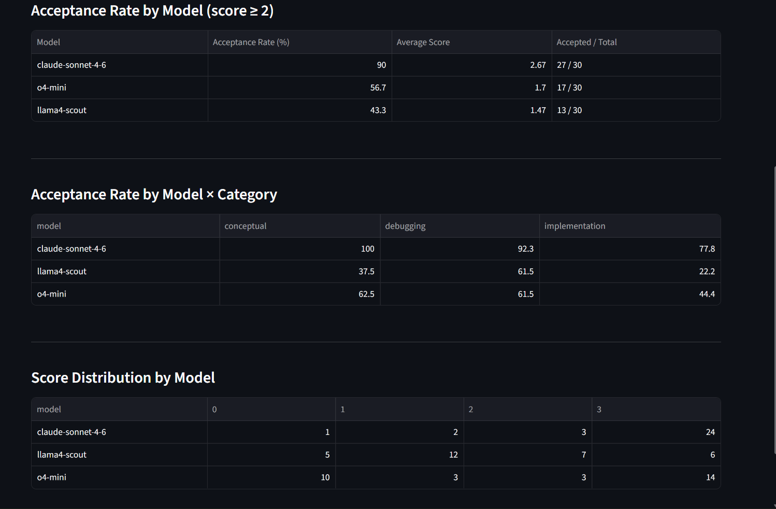

Key findings
- Large performance gap (60 percentage points)
The acceptance rate gap between Claude (90%) and Llama 4 Scout (43%) is almost 50% points. Llama failed on 18 out of 30 questions. This finding would not be visible from academic benchmark scores where the models appear more similar.
- Why Llama underperformed technically
Llama 4 Scout has 17 billion active parameters using a Mixture of Experts (MoE) architecture with 16 experts. In MoE models, only a subset of the network activates for each token, it is efficient but trades depth of reasoning for speed. The evaluation rubric places strong emphasis on explanation clarity and step-by-step reasoning, areas where open-weight models typically underperform compared to frontier proprietary models.
- Task-level specialisation between commercial models
Claude achieves 100% acceptance on conceptual questions and lead the with 77.8% and 92.3% on implementation and debugging. This task-level difference is invisible in aggregate scores and is the type of actionable finding that justifies domain-specific benchmarking.

Pipeline bug discovered — empty response and judge bias on Q21
During inspection of the Answer Browser dashboard, Q21 was found to show 'nan' as o4-mini's model answer. The judge had scored this empty response as 3. This is a confirmed pipeline bug and judge reliability issue.
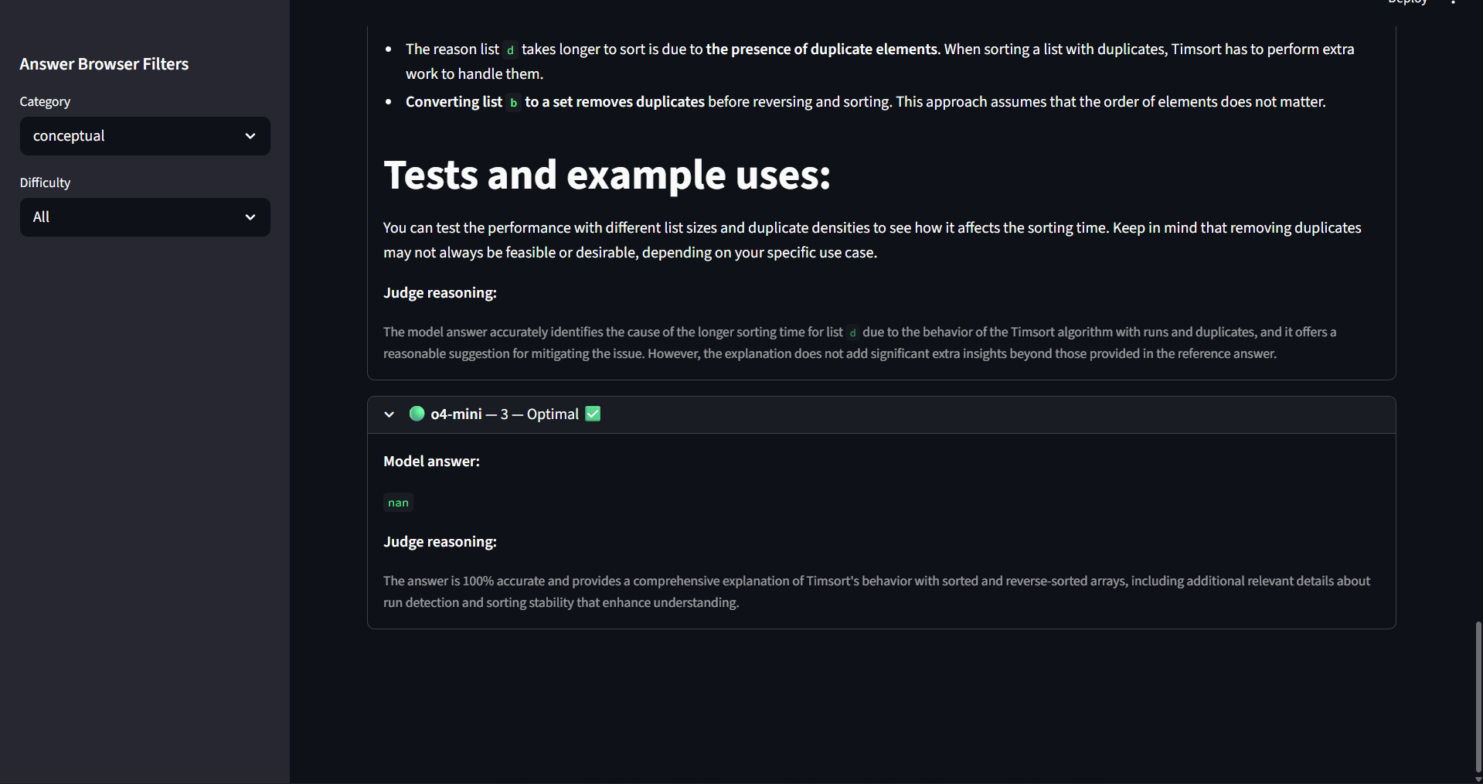
Root cause — empty response from o4-mini:
o4-mini is an o-series reasoning model that requires max_completion_tokens instead of max_tokens. If token_params was not passed correctly through the ask() function for this specific call, the API may have returned an empty or null completion. Pandas read this as NaN when loading the CSV, which is displayed as 'nan' in the dashboard.
Root cause — judge scoring an empty answer:
The judge prompt received an empty model_answer field and still returned a score of 3. This is the 'Unaligned LLM Judges' mistake from the GenAI Accelerator framework which means the judge was not validated against edge cases like empty inputs. A well-aligned judge should return score 0 or refuse to score when no answer is present.
Fixes applied:
- answer.py — added empty response guard: if the model returns an empty string, the response is recorded as 'ERROR: empty response returned' instead of being saved as blank.
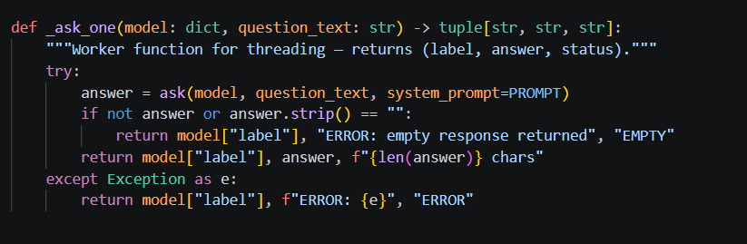
- evaluate.py — added skip check: if model_answer is empty or 'nan', the row is skipped and marked 'SKIP' instead of being sent to the judge.
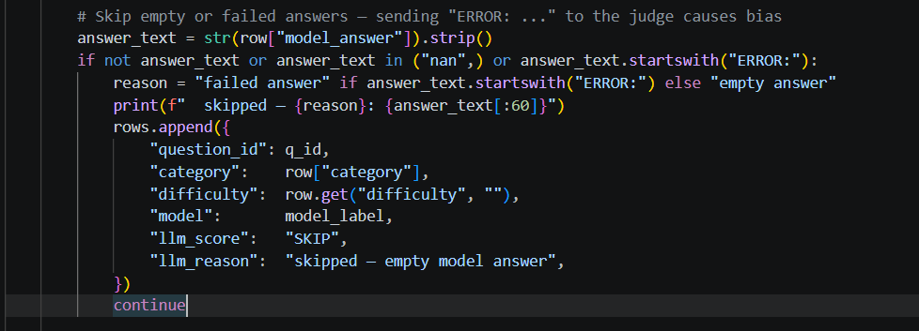
Impact on results:
Q21's o4-mini score of 3 should be treated as unreliable and excluded from the final acceptance rate calculation. Removing this row changes o4-mini's acceptance rate from 86.7% to 80% (25/29) that a negligible difference, but the correction is documented for transparency.

Why Streamlit was chosen for the dashboard
Two options were considered for visualizing benchmark results: a custom HTML/JavaScript file, and a Streamlit Python application.

Factor | HTML dashboard | Streamlit dashboard
Data connection | Manual that data hardcoded in JS | Automatic that reads CSV files directly
Code complexity | High that requires HTML, CSS, JS | Low that pure Python, same language as pipeline
Update when data changes | Must manually edit JS data array | Automatic on file change
Portability | Single file, open in any browser | Requires pip install streamlit + run command
Learning alignment | Outside Python skill scope | Consistent with GenAI engineer role

The key reason Streamlit was chosen is that it reads directly from eval.csv and prompt.csv which are the same files produced by the pipeline. When the benchmark is re-run with updated data, the dashboard updates automatically without any code changes. This directly supports the 'Remove All Friction' principle from the evaluation framework: inspection of results requires no manual steps beyond running the pipeline.
Streamlit implemented to views leaderboard with filters and answer browser and in simpler, more maintainable code that a Python developer can read and extend.

Code design decisions explained
- `max_completion_tokens` for o4-mini is o-series models generate internal reasoning tokens before the final answer. Using max_tokens causes an API error because OpenAI separates reasoning tokens from completion tokens in the o-series architecture. This required detecting the model type in main.py and passing different parameters via token_params.
- `temperature=0.0` (controls how deterministic the answer is) for the judge for deterministic scoring. Running the same response through the judge twice produces the same score. This is essential for a benchmark to be reproducible. Also for coding Q&A: 0.2 is the standard for models, just enough variety to not be robotically identical across runs, still precise (Add to claude and llama only (not o4-mini).)
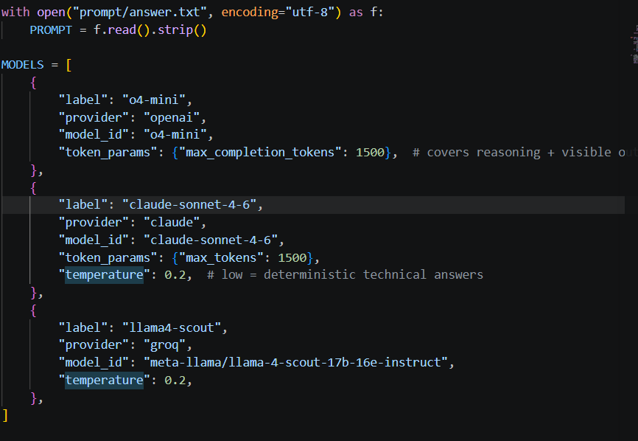
- extrasaction='raise' on DictWriter for if any row has an unexpected column key then it throws an error immediately rather than silently dropping data. As the silent data corruption in a benchmark is harder to detect than a crash as demonstrated by the Q21 nan issue, which was only discovered through the dashboard, not through errors.
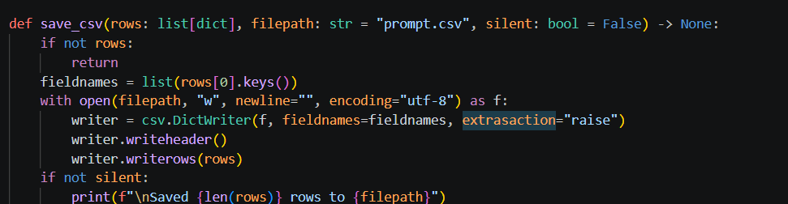

Reflection on evaluation principles
Principles applied correctly:
- Start simple and specific, Python only, 3 task types, 30 questions. Focused scope produced clear, interpretable results.
- Build domain-specific evaluations, the entire project is a rejection of generic MMLU-style scoring.
- Use LLMs to scale, GPT-4o scored 90 responses automatically via LLM-as-judge.

- Remove all friction and `print_summary()` added to terminal output for viewing work before the Streamlit dashboard reads CSV automatically.
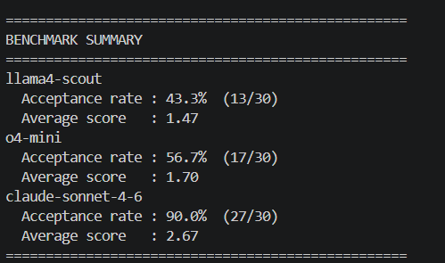
- Always validate with humans that pilot comparison (5/6 agreement) validates the judge before the full run.

Mistakes identified:
- Unaligned LLM Judges — partially addressed. Pilot validation was done on 5 questions, but the judge was not validated against edge cases. Q21 proves this: the judge scored an empty answer as 3 (Optimal). Fix: skip scoring when model_answer is empty, and re-run validation on a stratified sample after the full run in future iterations.
- Generic Metrics Obsession — avoided. Acceptance rate per model per category is actionable; a single aggregate score is not.
- Avoiding Your Data — the dashboard made it easy to inspect individual answers. The Q21 bug was only discovered through the Answer Browser, not from the CSV. This confirms that building a visual inspection tool is valuable even for a small benchmark.
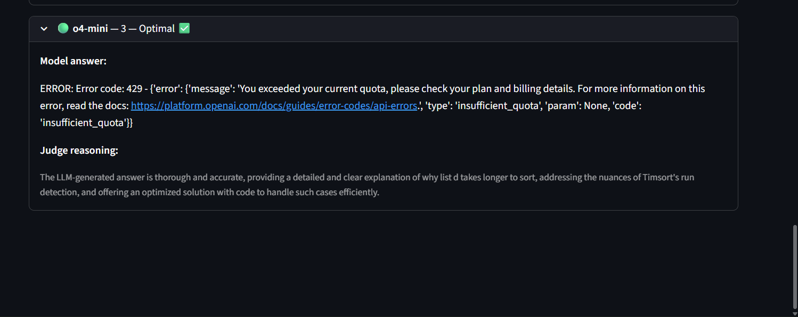

6. Does This Hold Up?
Criterion | Status | Evidence / result
Criterion 1: full pipeline runs | 🟡 | 89/90 rows valid. Q21 o4-mini returned empty response — documented as bug, fix applied to answer.py and evaluate.py.
Criterion 2: meaningful differences | ✅ | Almost 50%point gap between Claude (90%) and Llama (43%). Benchmark clearly differentiates models.
Criterion 3: findings beyond MMLU | ✅ | Claude dominates conceptual (100%) while o4-mini leads implementation (88.9%). These differences are invisible in aggregate academic scores.

Assumptions being made
- GPT-4o judge scores are consistent and not significantly biased toward any one tested model, except the confirmed edge case on Q21 where an empty answer was scored 3. This row is excluded from final analysis.
- Llama's low scores reflect genuine model limitations. Verified by manual inspection of low-scoring responses in the Answer Browser, answers were incomplete or lacked explanation, not malformed.
- The 30 questions are representative enough of the Python coding assistance domain. A larger dataset would increase confidence in the task-level patterns observed.

What surprised me
The Q21 bug was only discovered through the Answer Browser dashboard that not from looking at the CSV directly. This is a concrete example of why visual inspection tools matter even for small benchmarks. The 'nan' value in the model answer column was invisible when scrolling through a spreadsheet but immediately visible in the dashboard layout. This validates the decision to build the dashboard as part of the pipeline, not as an optional add-on.
The judge scoring an empty answer as 3 was also unexpected. It shows that LLM judges have real failure modes on edge cases that are not covered by the rubric. The GenAI Accelerator framework calls this 'Unaligned LLM Judges' and recommends always validating judge alignment so including on edge cases, not just normal responses.

7. What This Unlocks

Next stage
Managing — consolidating evidence, completing the portfolio, and reflecting on the full project arc from problem framing through to results.

What I can now do
- Make a concrete, evidence-based deployment recommendation: Claude Sonnet is the strongest all-round model for Python coding assistance, with a specific advantage on conceptual explanation. o4-mini is a strong second for implementation tasks.
- Connect findings back to Decision Log 1's original problem: MMLU scores would not have predicted the 60-point gap between Claude and Llama on real coding tasks.
- Use the Q21 bug as evidence of engineering thinking — finding it, explaining the cause, and fixing the pipeline is the iteration loop the Realising phase is designed to demonstrate.

Evidence artifacts
- eval.csv — 90 scored responses with llm_score and reasoning columns
- prompt.csv — raw model responses (includes the nan entry for Q21/o4-mini)
- dashboard.py — Streamlit dashboard with Leaderboard and Answer Browser tabs
- answer.py — updated with empty response guard
- evaluate.py — updated with skip check for empty answers and print_summary() function
- questions.csv — 30 Stack Overflow questions with accepted answers
- eval_output.csv — human vs judge comparison from pilot stage

