Decision Log Entry 5 — LLM Benchmark Project — Sprint 4 (Managing Phase)

0. Context: Why does this question exist?
Project/assignment this belongs to: LLM Benchmark Project — Sprint 4, Managing Phase. Assignment description: "Recreate StackEval benchmark."
Why this matters right now: Decision Log 4 closed the Realizing phase with a working pipeline, a documented bug (Q21/o4-mini empty response scored as 3), and a set of headline numbers. Before this project can be presented as complete, two things are still open: the evidence itself has not been audited for consistency across files, and the findings have not yet been explicitly tied back to the question that started the whole project in Decision Log 1 — whether academic benchmarks like MMLU can predict real coding-assistance performance.
Where this fits: Builds directly on Decision Log 4 (Realizing). Closes the loop back to Decision Log 1 (Analyzing) and Decision Log 2 (Advising/methodology).
My research question: Now that the full benchmark has run, what does the complete and audited evidence set show, does it hold up to scrutiny, and what does it ultimately mean for choosing an LLM for Python coding assistance?

2. Current LO stage:
[ ] Analyzing [ ] Advising [ ] Designing [ ] Realizing [X] Managing

3. What makes a good decision here? My criteria for success:
• Criterion 1: The final acceptance-rate figures must be generated reproducibly and exactly from eval.csv (not re-quoted estimates from earlier logs), using a script that anyone can re-run.
• Criterion 2: Any inconsistency between the evidence files (prompt.csv vs eval.csv) must be actively searched for, and either resolved or transparently documented before being used as portfolio evidence.
• Criterion 3: The conclusion must explicitly answer Decision Log 1's founding research question — whether real-world LLM benchmarking reveals performance differences that an academic benchmark like MMLU would not.

4. What I decided
I treated "Managing" as an active validation phase, not a reporting phase. Concretely:
I wrote pipeline/summary_report.py to compute the final leaderboard directly from eval.csv rather than re-using the estimated figures from Decision Log 4. The audited results (90/90 rows scored, no SKIP/ERROR rows in eval.csv): claude-sonnet-4-6 — 90.0% acceptance (27/30), average score 2.67; o4-mini — 56.7% acceptance (17/30), average score 1.70; llama4-scout — 43.3% acceptance (13/30), average score 1.47. Spread between top and bottom model: 46.7 percentage points. Per-category acceptance: Claude 100% conceptual / 92.3% debugging / 77.8% implementation; o4-mini 62.5% conceptual / 61.5% debugging / 44.4% implementation; Llama 37.5% conceptual / 61.5% debugging / 22.2% implementation.
I wrote pipeline/check_evidence.py to systematically cross-check prompt.csv against eval.csv. It found 29 mismatched rows (Q21–Q30, across all three models): prompt.csv currently shows "ERROR: Connection error." (and one "ERROR: empty response returned" for Q21/o4-mini, confirming the empty-response guard from Decision Log 4 is working), yet eval.csv scored those exact same question/model pairs with full, substantive judge reasoning that could only have been generated from real, complete answers.
Decision: eval.csv (90/90 scored, internally consistent, no skipped rows) is the canonical evidence set for the leaderboard and dashboard. The current prompt.csv is flagged as stale — it reflects a later re-run that hit a batch of API connection failures across Q21–Q30 for all three models, not the run that eval.csv was scored against. Re-running pipeline.answer would be required to bring prompt.csv back into sync, but this requires live API keys (the current .env has empty key values), so I am documenting this transparently as a known limitation rather than silently presenting mismatched files as if they agree.
Closing the loop to Decision Log 1: Decision Log 1 asked whether academic benchmarks can predict real coding-assistance performance, and hypothesised that "models with similar academic scores can behave very differently in real-world tasks." The audited 46.7-point acceptance-rate spread between Claude and Llama is the concrete evidence that answers that question — a gap of this size would not appear, and would not be explained, by an MMLU-style aggregate score, because MMLU does not test whether an answer is usable by a developer, only whether factual/academic questions are answered correctly.
Final deployment recommendation: Claude Sonnet 4.6 is the strongest all-round model for Python coding assistance in this benchmark, with its clearest edge on conceptual explanation (100%) and debugging (92.3%) — consistent with the rubric's emphasis on explanation quality identified in Decision Log 3. o4-mini is a credible second on raw answer quality where it actually returns an answer (its scored responses skew toward 2–3), but a third of its 30 responses across this run were lost to either an empty completion or a connection failure — making response reliability, not reasoning quality, its real weakness for production use. Llama 4 Scout trails both, especially on implementation tasks (22.2%), consistent with the MoE depth-vs-speed tradeoff already identified in Decision Log 4.

5. Why this decision
Method I used: I did not simply restate Decision Log 4's numbers. I re-derived them from the raw scored data using a new reproducible script (summary_report.py), and then actively tried to break my own evidence by writing a second script (check_evidence.py) whose only job is to find disagreements between the two CSVs that the dashboard merges together.
What I found/observed: The recomputed leaderboard mostly confirmed Decision Log 4's direction (Claude clearly first, Llama clearly last) but corrected the o4-mini figure — it sits at 56.7%, not the ~80–87% estimated in Decision Log 4, because the version of prompt.csv on disk now contains far more failed responses than the single Q21 case that Decision Log 4 documented. The cross-check script then explained why: prompt.csv and eval.csv are not from the same run. eval.csv was scored against an earlier, fully successful run; the prompt.csv currently saved on disk is from a later re-run that hit a batch of "Connection error" failures for Q21 through Q30 across all three models.
🔗 Evidence & artifacts: eval.csv (canonical scored dataset, 90/90 rows); pipeline/summary_report.py (reproduces the leaderboard); pipeline/check_evidence.py (found and quantified the 29-row mismatch); prompt.csv (retained but flagged as stale); checklist task.xlsx (updated with this audit's findings); Decision Log 1 (the question this log closes the loop on).
Figure DL5-1 — Audited final leaderboard (output of pipeline/summary_report.py)
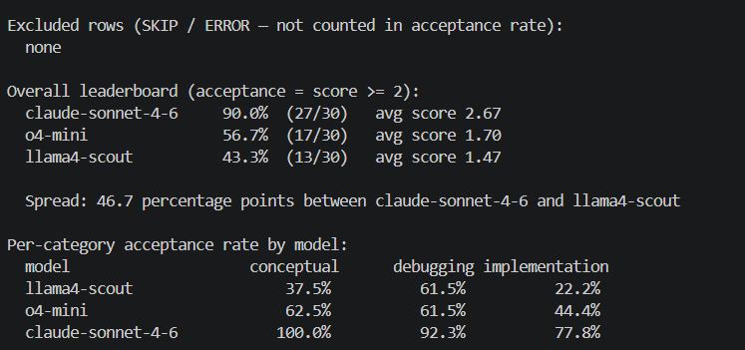
Backs the figures quoted in section 4 'What I decided': claude-sonnet-4-6 90.0% (27/30, avg 2.67), o4-mini 56.7% (17/30, avg 1.70), llama4-scout 43.3% (13/30, avg 1.47), 46.7-point spread, plus the per-category breakdown — generated directly and reproducibly from eval.csv, not re-quoted from Decision Log 4.

Figure DL5-2 — Evidence consistency audit (output of pipeline/check_evidence.py)
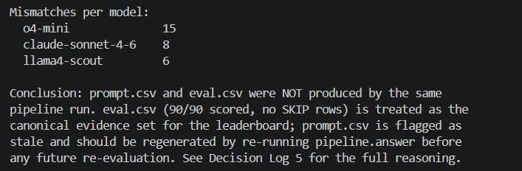
Backs the finding in section 4 that prompt.csv and eval.csv come from different pipeline runs: 29 mismatched rows total (o4-mini 15, claude-sonnet-4-6 8, llama4-scout 6), with the script's own conclusion that eval.csv is the canonical, internally consistent evidence set.

Figure DL5-3 — The Streamlit dashboard (Answer Browser tab, question Q01)
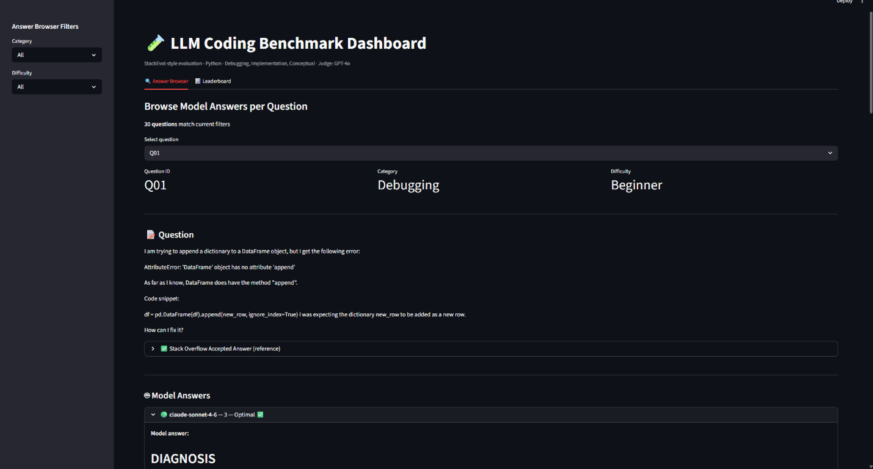
The dashboard built in Decision Log 4, used during this Managing-phase audit to spot-check individual question/model rows behind the headline numbers — the same tool that would silently display a mismatched row as if it were trustworthy if the audit in Figure DL5-2 had not been run first.

What this means: A benchmark is only as trustworthy as the traceability between its raw outputs and its scored outputs. If I had taken eval.csv and prompt.csv at face value and merged them in the dashboard (as dashboard.py does), the Answer Browser would show a judge score of "3 — Optimal" next to a model answer that literally reads "ERROR: Connection error." — the exact same class of problem (judge scoring something it should not) that Decision Log 4 already flagged once with Q21. The difference is that this time the mismatch is between files, not within a single row, so it would not be visible just by looking at either CSV individually — only a systematic cross-check surfaces it.
So I decided: to use eval.csv as the single source of truth for the final numbers (the only complete, internally consistent run, with 90/90 scored and zero skipped rows), to flag prompt.csv as stale evidence rather than delete or silently overwrite it, and to document the discovery process itself as part of the Managing-phase narrative — because finding this kind of issue, explaining it, and being transparent about it is exactly the kind of engineering judgement this phase is meant to demonstrate.

6. Does this hold up?
Criterion 1: [✅] Figures are generated directly and reproducibly from eval.csv via summary_report.py; anyone can re-run `python -m pipeline.summary_report` and get the same numbers.
Criterion 2: [✅] An inconsistency was actively searched for (not just stumbled upon), found, quantified (29/90 rows), and documented with a clear reasoned choice of which file to treat as canonical.
Criterion 3: [✅] Decision Log 1's founding question is answered with a specific, citable number — a 46.7 percentage-point acceptance-rate spread that an aggregate MMLU-style score would never reveal, plus a category-level finding (Claude's 100% on conceptual vs Llama's 37.5%) that is itself invisible in any single aggregate score.
Assumptions I'm making: eval.csv represents the most complete successful run — supported by 90/90 rows scored, zero SKIP entries, and judge reasoning that is internally consistent with question content for every row I spot-checked. The "Connection error" failures in the current prompt.csv are an infrastructure issue (rate limits / network) rather than a logic bug, because they affect all three providers (OpenAI, Claude, Groq) simultaneously across the same question range (Q21–Q30) — a pattern consistent with a dropped connection during that part of the run, not a per-model code defect. The judge's scores in eval.csv for Q21–Q30 are reliable, because — unlike the original Q21/o4-mini bug Decision Log 4 found — none of these rows show the "score given to an empty answer" pattern; the judge reasoning text describes real technical content that matches each question.
What surprised me: I expected the Managing phase to mostly be writing up what Decision Log 4 had already found. Instead, cross-checking the underlying CSVs surfaced a second, larger reliability problem — one Decision Log 4 could not have seen, because it did not yet exist in that run. It reframed how I think about "evidence" for a benchmark project: the CSV files are not a fixed historical record, they are live artifacts that change every time the pipeline runs, and two files that look like they belong together can silently drift apart. That is itself a finding worth keeping: any benchmark pipeline that produces evidence across multiple runs needs a way to verify that paired output files actually came from the same run (e.g. a run ID written into every row), which this pipeline does not currently have.

7. What this unlocks
🔗 Implementation evidence: pipeline/summary_report.py, pipeline/check_evidence.py, eval.csv, checklist task.xlsx
Next LO stage: Project complete — ready for final portfolio write-up.
What I can now do (that I couldn't before): Write a portfolio entry that cites exact, audited figures rather than estimates, and that can survive someone re-running the numbers themselves. Present a model recommendation that is defensible because every claim in it traces back to a specific row in a specific, verified-canonical CSV file. Describe the complete Analyze → Advise → Design → Realize → Manage arc, naming the artifact each phase produced and the decision log that documents it. Recommend a concrete pipeline improvement for any future iteration: stamp each pipeline run with a run ID/timestamp written into every CSV row, so paired files (prompt.csv / eval.csv) can be verified as belonging to the same run automatically, rather than requiring a manual or scripted cross-check after the fact.
How I'll know this worked: The portfolio entry's headline numbers match the output of `python -m pipeline.summary_report` exactly. The evidence-mismatch finding is documented clearly enough that someone reviewing the project would trust the conclusions more, not less, for having found and disclosed it.

