Design Document — LLM Coding Benchmark
What the system is, how it is built, and how it runs today (2026-06-07)

1. Purpose of this document
Decision Log 3 records the reasoning behind the benchmark's design choices — what was decided and why. This document is the companion to it: instead of the reasoning, it shows the system as it actually exists right now — the files, the pipeline stages, and the interface a reader can open and use. Where Decision Log 3 answers "what did we choose and why," this document answers "what does that choice look like once it is built and running."

2. System overview — what exists right now
The project is a working benchmark pipeline that tests three language models (Claude Sonnet 4.6, o4-mini, and Llama 4 Scout) against 30 real Stack Overflow Python questions, scores every answer with an LLM judge on a 0–3 acceptability rubric, and presents the results through a Streamlit web dashboard. Everything below is real, runnable code in the project's git repository — not a plan for future work.
The repository is organised into four areas:
- data/ — the source dataset. questions.csv holds the 30 Python questions used as benchmark input, each tagged with a category (Conceptual, Debugging, Implementation) and a difficulty level.
- prompt/ — the two prompt templates that drive the pipeline: answer.txt (the system prompt given to each model being tested) and judge.txt (the rubric given to the LLM judge).
- pipeline/ — the executable code: answer.py, evaluate.py, dashboard.py, summary_report.py, check_evidence.py, config.py, and main.py, described stage by stage in section 3.
- Output CSVs at the project root — prompt.csv (raw model answers) and eval.csv (judge scores and reasoning) — which are the canonical evidence files that the dashboard and the audit scripts read from.

3. Pipeline design
The diagram below shows the same flow documented in the project's README — the exact sequence of files and scripts that turns a raw question into a scored, browsable result. Each box is a real file in the repository; each arrow is a pipeline stage that can be run on its own from the command line.
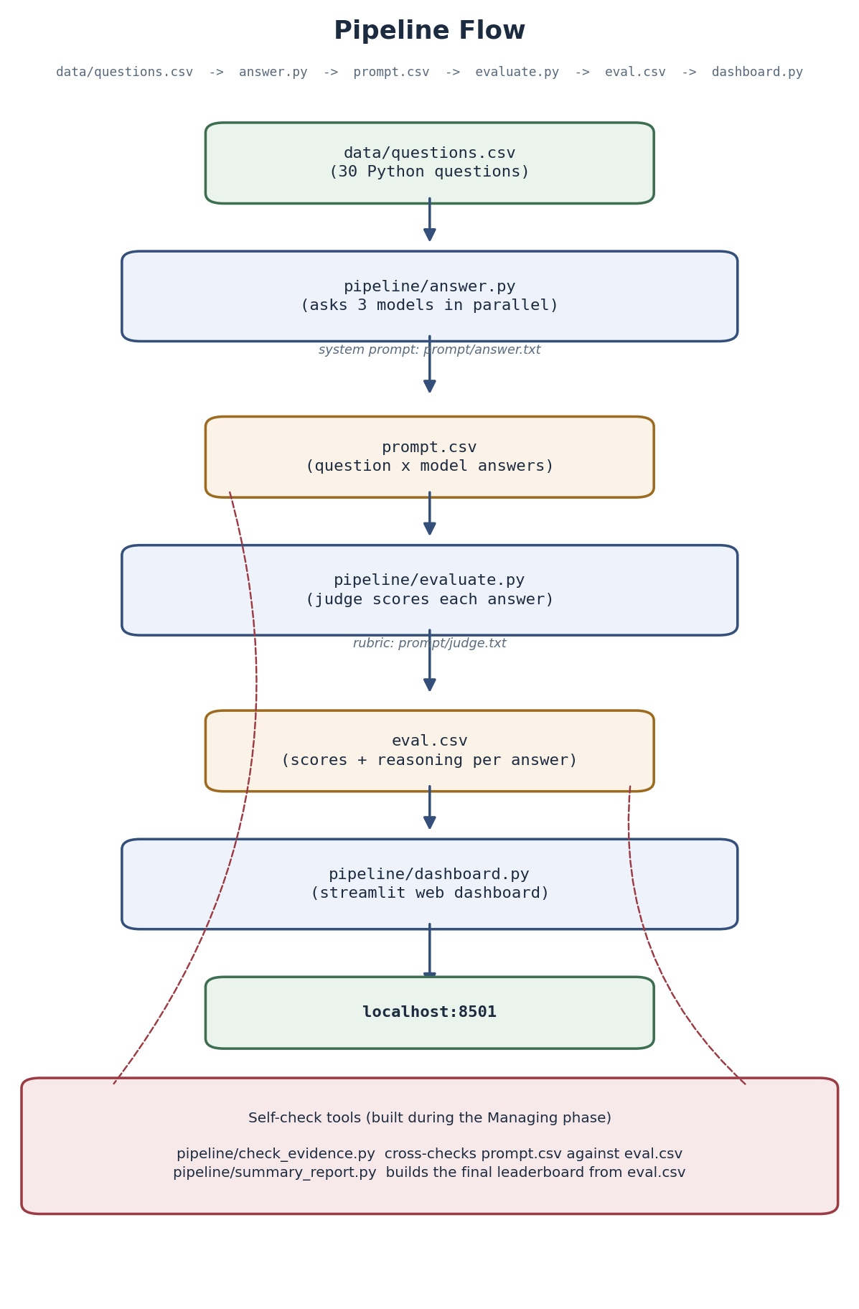
Figure 1: The benchmark pipeline, stage by stage — from the question set in data/questions.csv, through pipeline/answer.py and pipeline/evaluate.py, to the scored evidence in eval.csv and the live dashboard at localhost:8501. The shaded panel at the bottom shows the two self-check tools (check_evidence.py and summary_report.py) added during the Managing phase to keep that evidence trustworthy.

Walking through each stage:
- data/questions.csv holds the 30 benchmark questions. This is the only hand-curated input — everything downstream is generated by running the pipeline against it.
- pipeline/answer.py reads the question set, loads the system prompt from prompt/answer.txt, and asks all three models the same question in parallel. Its output is prompt.csv — one row per (question, model) pair containing the raw answer text.
- pipeline/evaluate.py reads prompt.csv, loads the judge rubric from prompt/judge.txt, and asks the LLM judge to score every answer from 0 to 3 with a written justification. Its output is eval.csv — the canonical, scored evidence file.
- pipeline/dashboard.py reads eval.csv (and prompt.csv) and serves an interactive Streamlit dashboard at localhost:8501, described in section 4.
- pipeline/check_evidence.py and pipeline/summary_report.py are two audit scripts written during the Managing phase: the first cross-checks prompt.csv against eval.csv to confirm both files come from the same run, and the second consolidates eval.csv into the final leaderboard and per-category acceptance rates. Both are run directly from eval.csv so the headline numbers can always be reproduced and re-checked.

4. The dashboard interface
pipeline/dashboard.py turns the scored evidence in eval.csv into a browsable, filterable interface — the "LLM Coding Benchmark Dashboard" shown below, running locally at localhost:8501. The screenshot is a real, working session of the tool, not a mock-up.
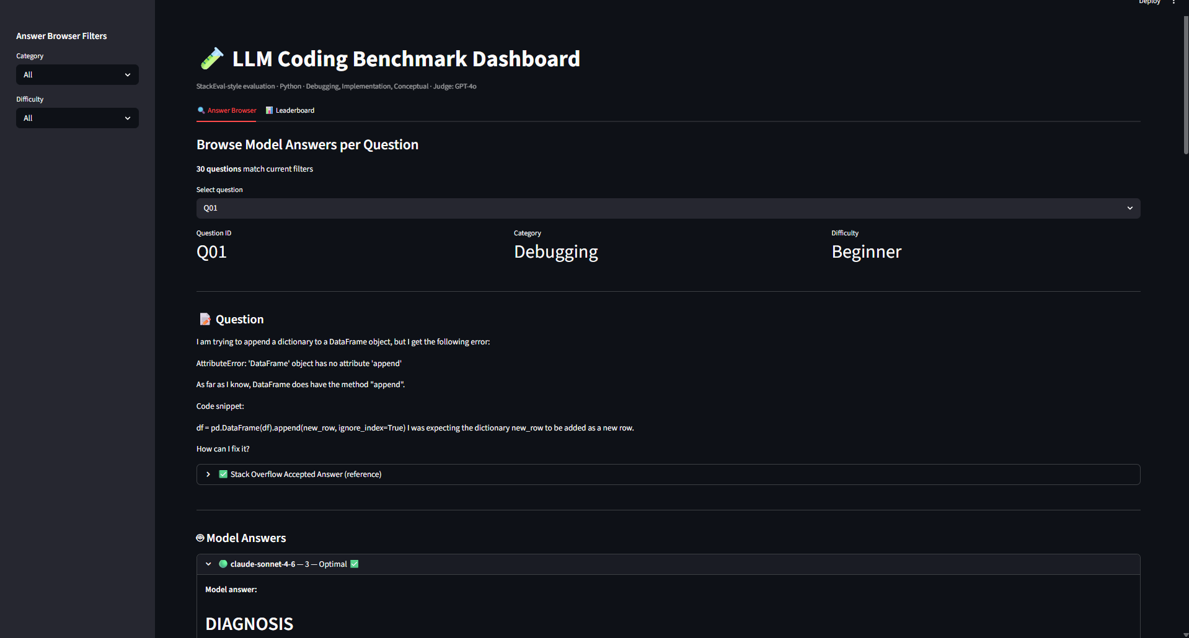
Figure 2: The dashboard's Answer Browser tab. The sidebar lets a reader filter the 30 questions by category and difficulty (here, all 30 match); selecting a question — Q01, a Debugging / Beginner question about a pandas DataFrame .append() error — shows the original question text, the Stack Overflow accepted answer used as the reference, and each model's answer alongside the judge's score and verdict (claude-sonnet-4-6 scored 3 — Optimal).

What the interface is designed to let a reader do:
- Browse every question in the benchmark side by side with the model answers it produced, rather than reading scores in isolation from the questions that produced them.
- See the Stack Overflow accepted answer used as the reference point for judging, so the reader can form their own opinion before reading the judge's verdict.
- See each model's score and the judge's written verdict (e.g. "3 — Optimal") directly underneath that model's answer, keeping evidence and judgment in one view.
- Filter by category and difficulty, so a reader can check whether a model's strength holds up across question types rather than relying on a single overall percentage.
This was a deliberate design choice recorded in Decision Log 4: a Streamlit dashboard was chosen over a static HTML report under a "remove all friction" principle — a reader should be able to open the evidence and start exploring immediately, with no setup beyond running one command.

5. Where the rest of the system lives
This document covers the design and the interface; it does not reproduce the code itself, since .py files cannot be meaningfully read inside a portfolio document. The full, runnable pipeline — every script named above, plus the prompt templates and the output CSVs — lives in the project's git repository, where it can be cloned and run end to end:
https://github.com/maihere/Benchmark-project
Decision Log 3 records why each of these design choices was made (why a 0–3 rubric, why an LLM judge, why three specific models, why these question categories); this document records what those choices look like once they were actually built.

