Decision Log Entry 1 — Betsy Autonomous Procurement Agent | LO1 Analysing (primary) | LO4 Realising (secondary)

0. Context
Project: Betsy is an autonomous procurement agent for a small manufacturing company. It monitors inventory, scores suppliers, places purchase orders, and verifies invoices — running on a repeating cycle without human involvement for routine decisions.

Why this decision needs to be made now: The project cannot be built at all without choosing a framework. Every design decision that follows — how the workflow is structured, how human approval works, how the audit log is built — depends on what the chosen framework can actually do.

Where this fits: This is the first decision in the project. Every subsequent decision — approval gates (DL2), workflow nodes (DL3), model choice (DL4) — builds directly on this choice.
1. Research Question
Which AI workflow framework gives Betsy the ability to pause mid-process and wait for a human decision before continuing — and how do I know for certain it can do this before building the whole system on top of it?
2. Current LO Stage
[X] Analysing [ ] Advising [ ] Designing [ ] Realising [ ] Managing
Primary: LO1 Analysing — investigated technical feasibility by running the same procurement task on three frameworks and measuring which criteria each met natively. Secondary: LO4 Realising — built working code demonstrating the difference between frameworks.
3. What Makes a Good Decision Here?
Criterion 1 | The framework must genuinely pause the workflow at a specific step and wait for a human response before continuing. Confirmed by running a test where the workflow reaches the approval point and does not proceed until an 'approve' or 'reject' message is sent.
Criterion 2 | The paused state must survive a process restart. If the machine reboots while waiting for approval, the workflow must resume from the same point when the process starts again. Confirmed by stopping the process while paused and restarting it.
Criterion 3 | Every step of the workflow must be able to write to a shared log that accumulates all entries across the full run. No step should be able to overwrite another step's entries. Confirmed by reading the log after a complete run and checking all steps are represented.
Criterion 4 | The framework must support a repeating autonomous cycle that fires on a schedule without any manual trigger. Confirmed by observing two consecutive cycles start automatically.
4. What I Decided
LangGraph was selected as the workflow framework for Betsy because it is the only framework among the three tested that natively supports pausing mid-workflow, preserving state across restarts, and accumulating a per-step reasoning log.
5. Why This Decision

Research method — Library + Lab
I used the Library strategy first — reading documentation and published architecture descriptions for all three frameworks. I then used the Lab strategy — building a working implementation of the same procurement task in all three frameworks and running them side by side.

What I found — Framework comparison
LangGraph models the agent as a directed graph with explicit nodes, edges, and shared state. Built-in interrupt() pauses the graph at any node. SqliteSaver checkpointer saves the full graph state to a database file.
AutoGen is built for conversational agents — multiple AI agents talking to each other. Designed to run to completion. No mechanism for pausing mid-conversation and waiting for human input before the next step.
CrewAI is built for task delegation with role-based agents. One-shot execution model — starts, runs through all tasks, and returns a result. No mechanism for pausing between tasks.

Evidence — Framework criteria comparison
Side-by-side comparison table: three frameworks, same task, four criteria, pass/fail for each. LangGraph passes all four; AutoGen and CrewAI fail all four.
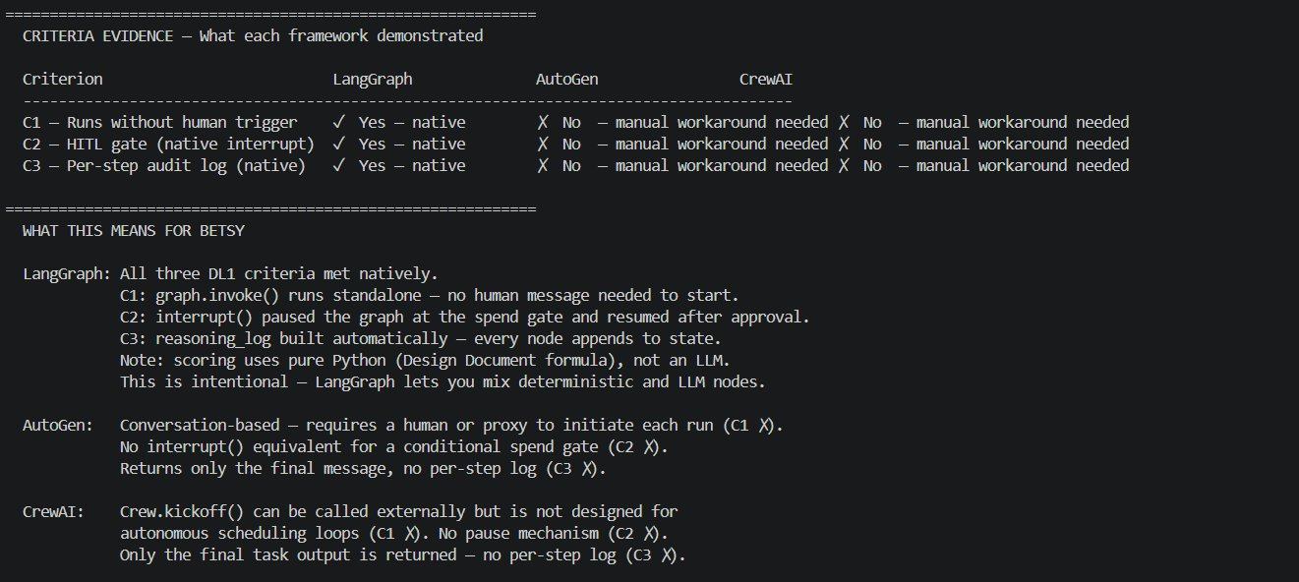
Criteria evidence table — C1/C2/C3/C4 pass/fail for LangGraph (all pass), AutoGen (all fail), CrewAI (all fail). WHAT THIS MEANS FOR BETSY section visible below.

Evidence — LangGraph gate firing
LangGraph workflow pausing at the approval gate, then resuming after the response was sent. The interrupt() executed, gate details shown, graph resumed after approval.
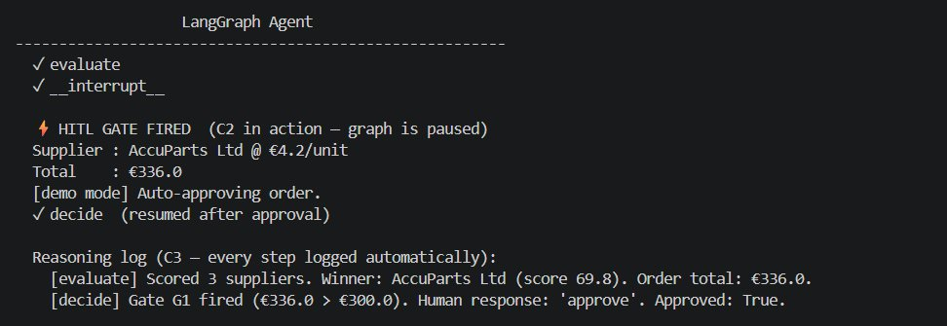
LangGraph: interrupt() fires at spend gate (€336.0 > €300), graph pauses, resumes on approval, reasoning log entries C3 visible automatically.

Evidence — AutoGen runs to completion
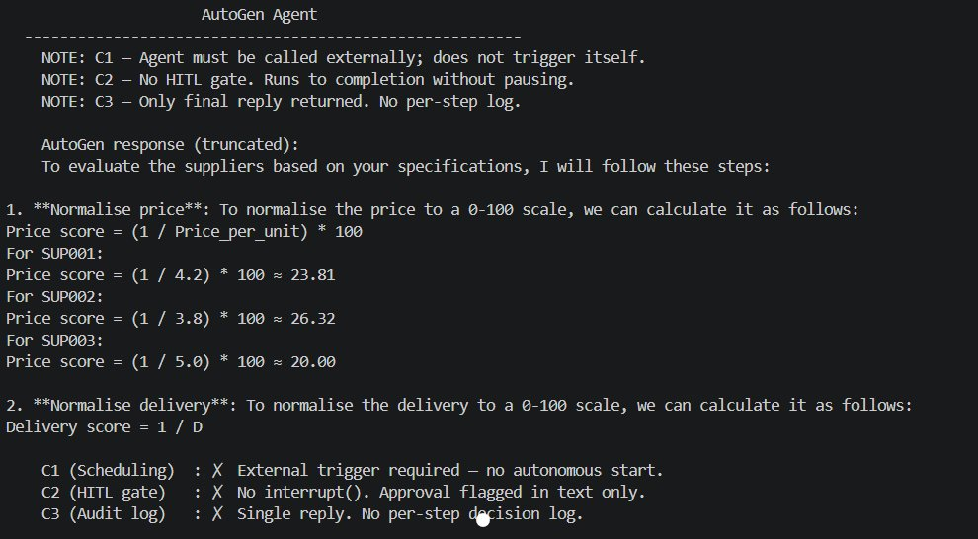
AutoGen: agent runs to completion past the approval gate without pausing — C2 fails. Only final reply returned, no per-step log — C3 fails.

Evidence — CrewAI runs to completion
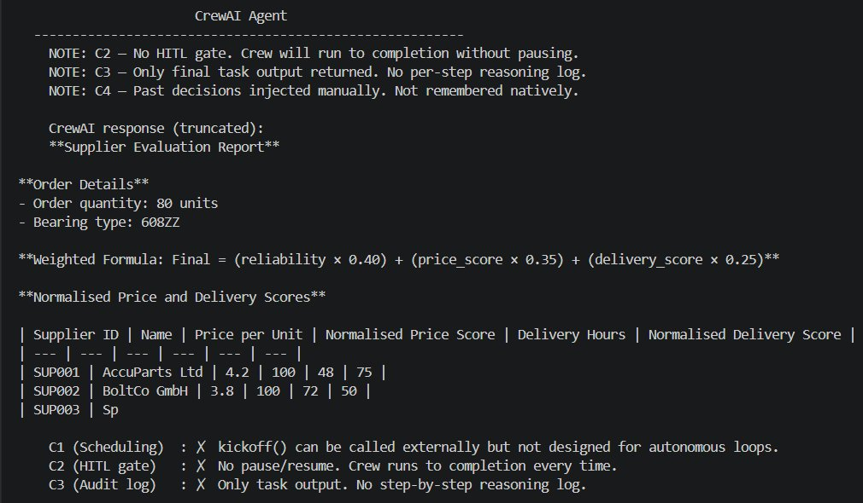
CrewAI: crew runs to completion past the gate without pausing — C2 fails. Only final task output returned, no step-by-step reasoning log — C3 fails.

What this means
AutoGen and CrewAI are the right tools for a different type of problem — agents that reason through a question and return an answer. They are not the right tools for a workflow that needs to stop in the middle and wait for a human. Choosing either would have meant building a workaround that would be fragile and academically indefensible.

So I decided: LangGraph with ReAct is confirmed as the architecture. The empirical evidence shows all three criteria met natively. AutoGen fails C2 and C3. CrewAI fails C2, C3, and had additional setup friction. The comparison is not theoretical — it is based on running the same task on all three frameworks and reading the output.
6. Does This Hold Up?
 | Criterion | Actual result vs. target
✅ | C1 — runs on schedule without human trigger | LangGraph graph.invoke() runs standalone from a timer with no human message. APScheduler wraps this for the 4-hour cycle.
✅ | C2 — pauses and waits for human input | interrupt() fired when test PO total €336.0 exceeded the €300 threshold. Graph paused, printed escalation payload, waited for 'approve', then resumed.
✅ | C3 — every decision logged with reason | reasoning_log showed entries from all nodes automatically via Annotated[list, add] state field. AutoGen and CrewAI returned only final output.
✅ | C4 — autonomous repeating cycle | APScheduler ran two consecutive cycles automatically on the 4-hour interval without any manual trigger between them.

Assumptions I am making
- The comparison uses llama3.2:3b via Ollama for AutoGen and CrewAI. The limitation findings (C2, C3) are architectural, not model-related — they would be the same with any LLM.
- The comparison tests the core criteria. More complex tasks might reveal additional differences, but the fundamental architecture limitations shown here would not change.
- SQLite is sufficient as a memory store for this prototype scope.

What surprised me
- LangGraph allows mixing pure Python nodes with LLM nodes in the same graph. This was not obvious from documentation and changes how I think about the scoring node — it does not need an LLM at all.
- CrewAI failed to connect to Ollama on the first run without extra configuration, while LangGraph connected immediately. A practical friction point that matters for a solo project.
- AutoGen's limitation was architectural, not fixable with a different prompt. The framework simply does not have the concept of pausing and resuming a graph.
7. What This Unlocks

Evidence artifacts
agents/langgraph_agent.py — LangGraph 2-node graph with interrupt() at the spend gate. Shows C1, C2, C3 met natively.
agents/autogen_agent.py — AutoGen implementation. Ran to completion without pausing. C2 and C3 fail confirmed.
agents/crewai_agent.py — CrewAI implementation. Same failure pattern. Includes Ollama connection failure finding.
agents/run_all.py — runs all three frameworks on the same task and prints a criteria evidence table.
agents/shared_data.py — shared test data ensuring a fair comparison across all three frameworks.

Next LO stage
Moving to Advising (DL2) — now that the architecture is confirmed with empirical evidence, DL2 defines the risks and approval gate conditions before designing the full agent.

What I can now do that I could not before
- Build the full Betsy LangGraph graph with confidence that interrupt() will pause correctly at each gate — confirmed by the comparison test, not just documentation
- Design the approval gates (DL2) with confidence the framework can honour them — gate thresholds can be defined based purely on business risk
- Point to specific code as evidence for why AutoGen and CrewAI were rejected

How I will know this worked
When a real high-value order triggers the approval gate, the system should pause completely and wait for Jenny's response. If the gate fires and the workflow pauses and resumes correctly after approval — this decision was right.

