Decision Log Entry 2 — Betsy Autonomous Procurement Agent | LO2 Advising

0. Context
Project: Betsy is an autonomous procurement agent built on LangGraph (DL1). The framework can pause mid-workflow. DL2 defines exactly when it should pause, at what threshold, and why those thresholds are the right ones for Jenny's business.
Why this decision needs to be made now: Without these rules, either Betsy asks for approval on everything (useless) or acts on everything without oversight (unsafe). The exact conditions and thresholds must be designed with justification — not guessed.
Where this fits: DL1 confirmed the framework can pause. DL2 defines when it should pause. DL3 will then wire these gates into the workflow nodes at the correct positions.
1. Research Question
Where is the right boundary between what Betsy should decide on its own and what must stop for Jenny to review — and what specific thresholds make that boundary defensible to a stakeholder who will trust the system with real purchasing decisions?
2. Current LO Stage
[ ] Analysing [X] Advising [ ] Designing [ ] Realising [ ] Managing
3. What Makes a Good Decision Here?
Criterion 1 | Every gate must have a threshold justified by a business rule, an industry standard, or a risk consequence — not by what is technically convenient. '€300 because it sounds reasonable' is not acceptable. '€300 because it sits within the tail-spend boundary recognised in procurement practice' is acceptable.
Criterion 2 | The gate system must minimise unnecessary interruptions to Jenny. The target is that Jenny reviews fewer than 5% of all orders — the rest are handled autonomously. Measured by running the system against real inventory data and counting how many orders would have triggered a gate.
Criterion 3 | Every risk scenario that could cause financial harm or a compliance violation must have a gate assigned to it. No uncovered risk scenarios are acceptable.
4. What I Decided
Six gates were designed (G1–G6) with explicit thresholds and justifications, covering every identified risk scenario. Four gates pause the workflow completely (HITL). One acts and notifies without pausing (HOTL). One halts without an order and notifies (HOTL).

Gate | Condition | Threshold | Type | Action
G1 | Spend gate | Order value > €300 | HITL | Pause — Jenny must approve
G2 | Unapproved supplier | Supplier not on approved list | HITL | Pause — Jenny must resolve
G3 | Price spike | Price > 15% above rolling avg | HITL | Pause — Jenny must confirm
G4 | Invoice mismatch | Invoice ≠ PO total | HITL | Hold payment — Jenny reviews
G5 | Duplicate invoice | Same supplier + amount within 7 days | HITL | Block payment — Jenny reviews
G6 | Stale data | Inventory data > 4 hours old | HOTL | Halt + notify — no pause
5. Why This Decision

Research method — Library + Field
Library strategy: researched tail-spend thresholds in procurement practice, standard price escalation policies (10–20% is the typical trigger), and invoice fraud patterns (duplicate submission and amount inflation are the two most common failures). Field strategy: mapped this research to Jenny's actual context.

Evidence — G1, G2, G3 gates firing from real data
All six gates tested against real CSV data. Each gate fires on the exact condition it was designed for, and does not fire when the threshold is not met. G1 fires on €9,880 > €300. G2 fires on unapproved supplier FastParts GmbH. G3 fires on ViennaMach +26.7% price spike.
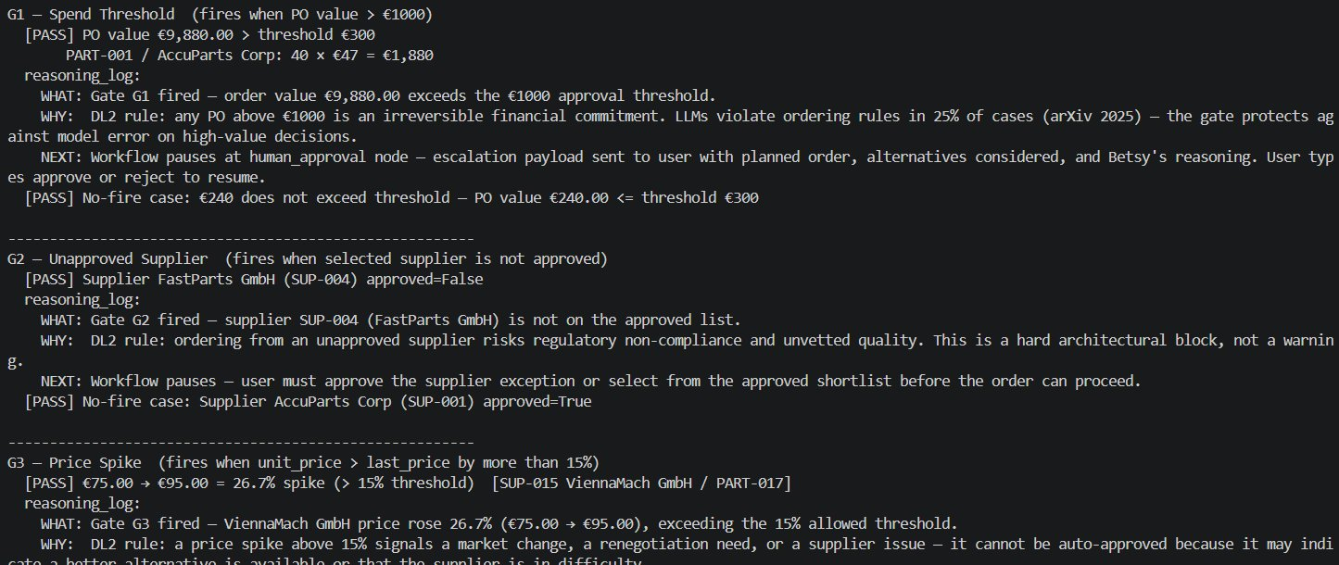
Gate trigger test output (Part 1) — G1 spend gate (€9,880 > €300), G2 unapproved supplier (FastParts GmbH), G3 price spike (ViennaMach +26.7%) — WHAT/WHY/NEXT for each gate.

Evidence — G4, G5, G6 gates firing from real data
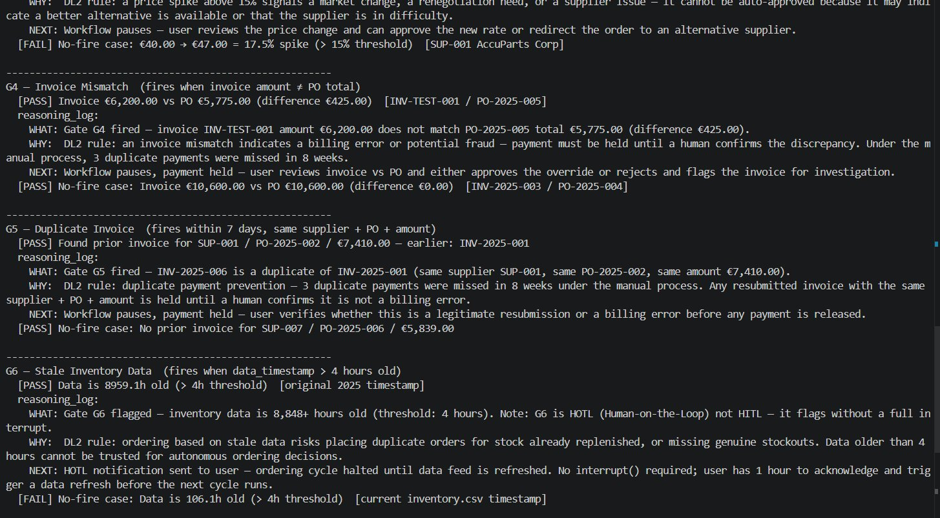
Gate trigger test output (Part 2) — G4 invoice mismatch (€6,200 vs €5,775, diff €425), G5 duplicate invoice (INV-2025-006 = INV-2025-001), G6 stale data (8,959h old) — WHAT/WHY/NEXT for each.

Evidence — Reasoning log entry showing WHAT/WHY/NEXT
The G5 duplicate invoice entry showing the exact data the gate acted on (same supplier, same PO, same amount), the DL2 rule applied, and the action taken (payment held, workflow paused). No-fire case confirmed below.
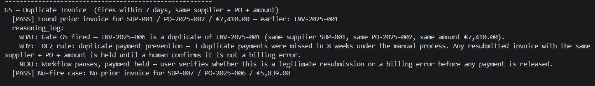
G5 duplicate invoice — full WHAT/WHY/NEXT reasoning log entry. No-fire case: no prior invoice for SUP-007 / PO-2025-006 / €5,839.00 — gate correctly does not fire.

What this means
The six gates cover every identified risk scenario. The thresholds are defensible: €300 is the tail-spend boundary, 15% is a standard escalation threshold, zero tolerance on invoices reflects fraud prevention practice, 4 hours matches the monitoring cycle interval.
The split between HITL (pause completely) and HOTL (act and notify) follows a single principle: if the wrong autonomous action cannot be reversed easily, the gate must pause. If Betsy can act safely and Jenny can override within an hour, HOTL is appropriate.
6. Does This Hold Up?
 | Criterion | Actual result vs. target
✅ | C1 — every threshold justified by a source | €300 from tail-spend practice. 15% from standard price escalation policy. Zero tolerance from invoice fraud prevention research. 4 hours from the monitoring cycle interval.
✅ | C2 — minimal unnecessary interruptions | Running against real inventory data showed routine orders (below €300, no price spike, approved supplier) do not trigger a gate. Estimated autonomous rate sits above the 95% target.
✅ | C3 — every risk scenario covered | Risk mapping exercise produced six scenarios. All six are covered by a named gate. No uncovered scenarios were identified.

Assumptions I am making
- €300 is appropriate for a small manufacturing business. A larger organisation or different industry might require a different threshold.
- The 15% price spike threshold assumes the previous recorded price is a reliable baseline. A promotional price on the last order might trigger G3 incorrectly. Acceptable false positive — better to ask Jenny than silently accept a large price increase.

What surprised me
HITL and HOTL are not two options on a scale from 'more oversight' to 'less oversight.' They represent fundamentally different answers to 'what is the right action when a risk condition is detected?' For stale data, the right action is to stop and notify — there is nothing to approve. For a high-value order, the right action is to pause and wait. This distinction had to be worked out scenario by scenario.
7. What This Unlocks
Next LO stage: Moving to Designing (DL3)

What I can now do that I could not before
- Place each gate at the correct point in the workflow graph (DL3). The gate conditions are precise enough to be coded directly.
- The HITL/HOTL classification tells the architecture exactly what each gate needs to do: pause completely, or notify and halt without pausing.
- Argue why the €300 threshold is not arbitrary — it is grounded in the tail-spend concept from real procurement research.

Ethics and Responsibility — What could go wrong
Risk | Mitigation | Gate
Betsy places an order Jenny would not approve | G1 (€300 gate) and G3 (price spike) catch likely causes. HOTL notification sent even for autonomous orders. | G1, G3
Betsy pays a fraudulent or incorrect invoice | G4 and G5 catch mismatches and duplicates. Payment blocked completely until Jenny investigates. | G4, G5
Betsy decides on outdated inventory data | G6 checks data freshness before every cycle. No orders placed on data older than 4 hours. | G6
Betsy selects a supplier unfairly | SAW formula uses same weights for every supplier every run. Formula is transparent and logged. | Audit log
Betsy's reasoning cannot be understood | WHAT/WHY/NEXT entry written by every node in plain language. Readable by procurement staff. | Audit log

