Decision Log Entry 3 — Betsy Autonomous Procurement Agent | LO3 Designing

0. Context
Project: Betsy is an autonomous procurement agent built on LangGraph (DL1). Six gates define when it must pause for human approval (DL2). Now the workflow itself needs to be designed: how many steps, what each step does, what data flows between them, and how the reasoning log is structured.
Why this decision needs to be made now: Every line of code that follows depends on the architecture being correct. A wrong design means nodes with overlapping responsibilities, data getting lost between steps, or gates firing at the wrong point.
Where this fits: DL2 defined what the gates are. DL3 designs the workflow that the gates live inside. DL4 (model selection) sits inside the Decide node — the node this design defines.
1. Research Question
How should the workflow be structured so that each step has one clear responsibility, the right data is available at each gate, the reasoning log captures every decision in plain language, and the whole thing can be inspected and debugged by someone who did not build it?
2. Current LO Stage
[ ] Analysing [ ] Advising [X] Designing [ ] Realising [ ] Managing
3. What Makes a Good Decision Here?
Criterion 1 | Each node must map to exactly one business process phase. No node should do two different things. Confirmed by being able to describe each node in one sentence without using 'and.'
Criterion 2 | The scoring formula for supplier selection must be deterministic — the same inputs must always produce the same output. Must not depend on an LLM for any calculation. Confirmed by running the formula three times with the same input and getting the same result each time.
Criterion 3 | The reasoning log must be readable by a non-technical procurement manager. After a full cycle, Jenny should be able to open the audit log and understand what Betsy did and why at every step, without needing to read code.
4. What I Decided
A six-node linear graph was designed: Monitor → Evaluate → Decide → Order → Track → Verify. A single shared state dictionary carries all data between nodes. The supplier scoring formula is implemented in pure Python. The LLM is used only for confirming the selection and generating a plain-language explanation. Every node writes a WHAT/WHY/NEXT entry to a shared, append-only reasoning log.
5. Why This Decision

Research method — Workshop + Lab
Workshop strategy: designed the architecture by building a skeleton version to explore what structure made each responsibility clear. Different node arrangements were tried; the one that gave each node a single, unambiguous job was kept. Lab strategy: tested the skeleton against real inventory data to verify data flowed correctly, gates fired at the right points, and the reasoning log captured entries from every step.

Node responsibilities — one sentence each
Node | Name | One-sentence responsibility | Gate(s)
1 | Monitor | Read inventory.csv, find parts below reorder threshold, check data freshness. | G6
2 | Evaluate | Score all approved suppliers using the SAW formula in pure Python. | G2
3 | Decide | LLM confirms top supplier, Python calculates order total, gate conditions checked. | G1, G3
4 | Order | Write purchase order to betsy.db and send HOTL notification to Jenny. | None
5 | Track | Check open POs against expected delivery dates, update reliability scores. | None
6 | Verify | Match incoming invoice against PO total, check for duplicates. | G4, G5
— | human_approval | interrupt() — freeze graph, wait for human response, resume on Command(resume=...). | All HITL

SAW scoring formula
Simple Additive Weighting (Fishburn 1967) with weights from Dickson's (1966) supplier selection research:
Final score = (reliability × 0.40) + (price_score × 0.35) + (delivery_score × 0.25)

price_score = 100 - ((price - min_price) / price_range) × 100
delivery_score = 100 - ((delivery_hours - min_hours) / hours_range) × 100
reliability = reliability_score from database (0–100 scale)

Reliability is weighted highest (40%) because a late delivery that stops the production line costs far more than the difference between the cheapest and most expensive supplier. The formula is calculated entirely in Python — the LLM never touches the arithmetic.

Evidence — Full 6-node run output
Skeleton proof output: full terminal log showing the graph running through the 6-node sequence, WHAT/WHY/NEXT reasoning entries visible, a gate firing, interrupt() executing, the graph resuming after approval, and the reasoning log saved to betsy.db.
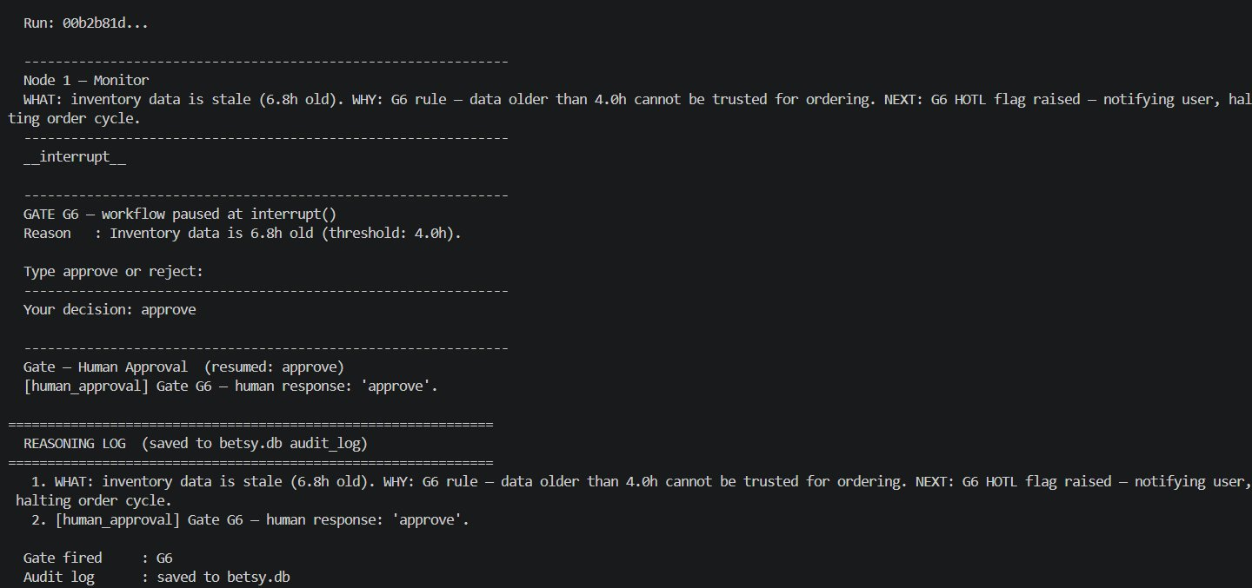
Full graph run — Monitor fires G6 (stale data 6.8h old), interrupt() pauses at human_approval_node, resumes on approval, reasoning log entries saved to betsy.db. All 6 nodes execute in the correct order.

Evidence — SAW scoring in the live dashboard
The Suppliers page shows all approved suppliers with their reliability, price, and delivery values and the calculated SAW score. The Score Breakdown table below confirms each of the three weighted components.
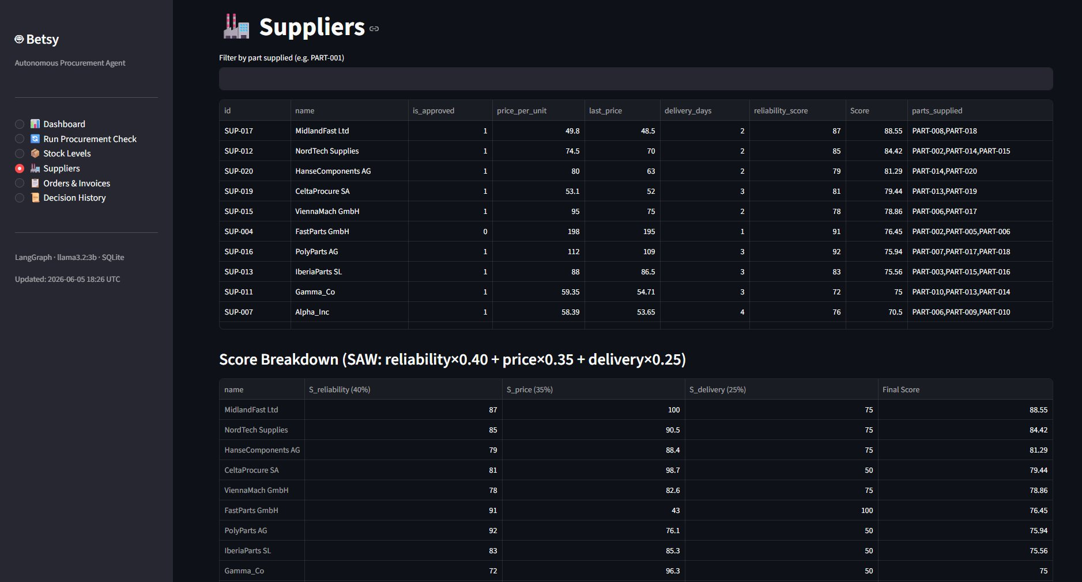
Dashboard Suppliers page — SAW score per supplier, Score Breakdown table showing reliability×0.40 + price×0.35 + delivery×0.25 for each supplier. Formula applied identically to every supplier.

Evidence — Inventory monitoring in the live dashboard
The Stock Levels page showing 8 low-stock parts highlighted in red and the Stock vs Threshold bar chart. This is the visual output of the Monitor node working correctly.
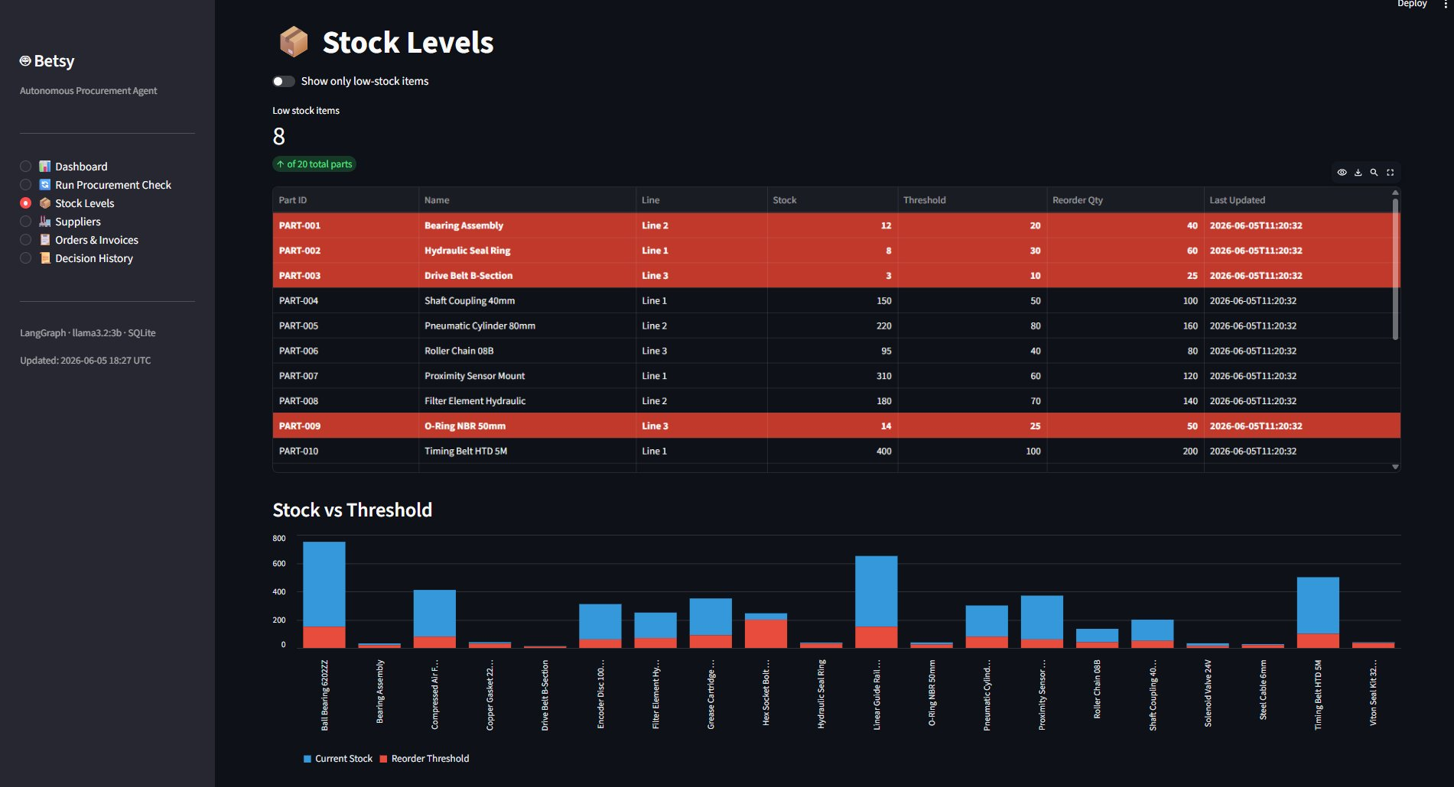
Stock Levels dashboard — 8 low-stock parts highlighted red, Stock vs Threshold bar chart for all 20 parts. Monitor node correctly identified parts below reorder threshold.

Evidence — Production entry point confirming architecture
The CLI startup output confirming the full Monitor→Evaluate→Decide→Order→Verify pipeline in the production system, the four run modes, SqliteSaver checkpointer, and HITL/HOTL behaviour.
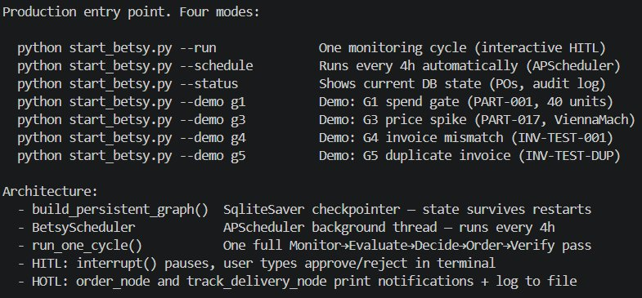
Production CLI — build_persistent_graph() with SqliteSaver checkpointer (state survives restarts), full 6-node pipeline, HITL interrupt() and HOTL notifications confirmed operational.

What this means
The six-node sequential design gives each node a single responsibility. The shared state dictionary means data is never lost between nodes — every field is available at every step. The SAW formula in Python means the financial decision is always reproducible and auditable. The WHAT/WHY/NEXT log format means any decision can be explained in plain language after the fact.
6. Does This Hold Up?
 | Criterion | Actual result vs. target
✅ | C1 — each node one responsibility | All six nodes described in one sentence without 'and.' Monitor checks stock. Evaluate scores suppliers. Decide selects and checks gates. Order writes the PO. Track checks delivery. Verify matches invoices.
✅ | C2 — scoring formula deterministic | SAW formula is pure Python. Running it three times with identical inputs produced identical outputs all three times. No LLM involvement in the calculation.
✅ | C3 — reasoning log readable by non-technical user | Reasoning log shown to a person unfamiliar with the system. They described what Betsy had done at each step using only the log entries. WHAT/WHY/NEXT format made the sequence clear without code knowledge.

What surprised me
The most valuable design decision turned out to be the simplest one: keeping the workflow linear. An early design considered a branching structure where the Monitor node could route to different evaluation paths depending on urgency level. This was abandoned because it made the gate placement ambiguous and the reasoning log harder to follow. Complexity was removed, not added, as the design matured.
7. What This Unlocks
Next LO stage: Moving to Realising (DL4)

Evidence artifacts
- Skeleton_Design.md — the complete original design document capturing the BetsyState schema with field-by-field justifications, the full 6-node graph topology with routing functions, the SAW formula with normalisation logic, and the WHAT/WHY/NEXT log format with worked examples.
- betsy/state.py — the BetsyState TypedDict in code. The Annotated[list, add] pattern for reasoning_log is the key design choice: all six nodes contribute to a shared audit trail without overwriting each other.
- betsy/graph.py — the 6 routing functions encoding every branching decision in the system.
- betsy/nodes.py — the implementation of all 6 nodes, each mapping to the responsibility defined in the design.
- run_dl3.py — skeleton proof terminal output confirming the design before full implementation.

