Decision Log Entry 4 — Betsy Autonomous Procurement Agent | LO4 Realising

0. Context
Project: Betsy is an autonomous procurement agent built on LangGraph. The Decide node uses an LLM for one specific task: confirm the highest-scored supplier and write a plain-language explanation of why that supplier was selected.
Why this decision needs to be made now: The Decide node is implemented and ready to call the LLM, but the model has not been chosen. Two local models are available via Ollama: llama3.2:3b and gemma4:e4b. Choosing the wrong one risks slow response times that make the system painful to use, or inconsistent JSON output that causes the node to fail.
Where this fits: DL3 defined that the LLM's role is narrow — confirm a selection from a scored list and explain it in plain language. DL4 chooses which model performs that narrow task reliably and fast enough. Once confirmed, DL5 can be written knowing the full system runs end-to-end.
1. Research Question
Which local language model produces reliable, parseable JSON output for the supplier selection task consistently and quickly enough that it does not become a bottleneck in development, testing, or demonstration?
2. Current LO Stage
[ ] Analysing [ ] Advising [ ] Designing [X] Realising [ ] Managing
3. What Makes a Good Decision Here?
Criterion 1 | The model must return valid, parseable JSON on every run. If the model returns prose instead of the required JSON format, the Decide node fails and the order cannot be placed. Confirmed by running the selection task three times per model and checking whether each response can be parsed without error.
Criterion 2 | The model must select the correct supplier — the one with the highest pre-calculated SAW score — on every run. The task is not ambiguous: the scores are provided in the prompt and the correct answer is the highest one. Confirmed across three runs per model.
Criterion 3 | The model must respond in under 10 seconds per run. Development and demonstration require short wait times. A 30-second wait per LLM call makes iterative testing and live demos painful. Confirmed by timing each run.
4. What I Decided
llama3.2:3b was selected. Both models passed the accuracy criteria. llama3.2:3b was 8.6 times faster than gemma4:e4b (2.6 seconds versus 30.2 seconds average) with no difference in output quality on this task.
5. Why This Decision

Research method — Lab + Showroom
Lab: Both models given the exact same prompt, the same supplier data, and the same task, outputs recorded across three runs each. Showroom: The selected model then demonstrated working inside the full Betsy system end-to-end, confirming correct performance in its actual operating context.

Evidence — Model comparison summary
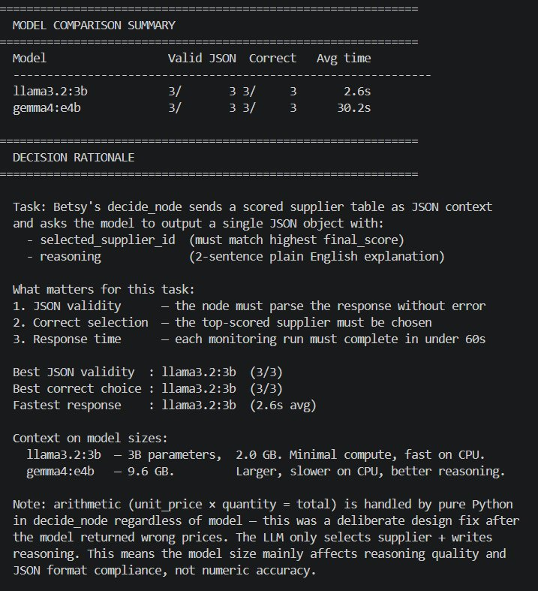
MODEL COMPARISON SUMMARY — llama3.2:3b: Valid JSON 3/3, Correct selection 3/3, Avg time 2.6s. gemma4:e4b: Valid JSON 3/3, Correct selection 3/3, Avg time 30.2s. Identical accuracy, 11.6× speed difference. Decision rationale visible below.

Key finding from the comparison
Both models achieved identical accuracy. The only measurable difference was speed: gemma4:e4b took 11.6 times longer to return the same quality output.
The supplier selection task is a structured, constrained problem: pick the highest score from a numbered list. This does not require deep reasoning or large model capacity — it requires reliable JSON output and correct reading of numerical values. A 3-billion-parameter model that is well-suited to structured output tasks can outperform a much larger model on those tasks — both in speed and practical reliability.

Critical point about model trust
Neither model is trusted to calculate the SAW scores. The scores are calculated by Python before the model sees them. The model only reads the pre-calculated scores and selects the highest. Even if the model were to hallucinate slightly, the hallucination cannot affect the arithmetic — the financial decision is determined by Python, not the model.

Evidence — Production CLI confirming Decide step
Production CLI startup output showing the full Monitor→Evaluate→Decide→Order→Verify pipeline. The Decide step is where llama3.2:3b runs on every cycle. This is Showroom evidence: the selected model integrated into a working production system with a scheduler, persistent state, and both HITL and HOTL mechanisms.
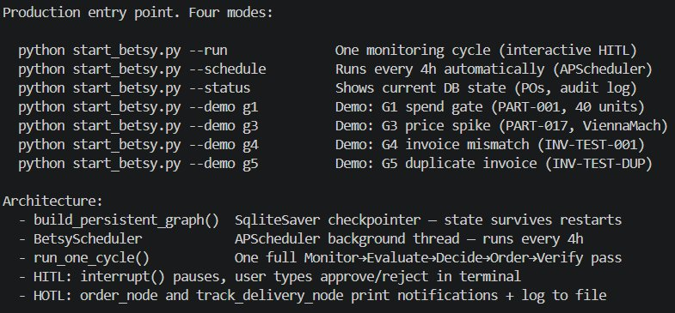
Production CLI — pipeline includes Decide step where llama3.2:3b runs. SqliteSaver checkpointer, BetsyScheduler, HITL interrupt() and HOTL notifications all operational. Selected model working in production context, not just test.

Additional constraint confirming the decision
Both models run locally via Ollama. No data leaves the machine. Supplier pricing, inventory levels, and purchase order data are commercially sensitive — local execution was a hard requirement, not a preference.
6. Does This Hold Up?
 | Criterion | Actual result vs. target
✅ | C1 — valid JSON on every run | llama3.2:3b returned valid, parseable JSON on all three test runs and in every full system run. One early version of the prompt occasionally produced prose — fixed by making the output format instruction explicit and using format='json' in the ChatOllama constructor.
✅ | C2 — correct supplier selected | The correct supplier (highest SAW score) was selected on all three test runs and in all subsequent full system runs.
✅ | C3 — under 10 seconds | Average response time of 2.6 seconds, well under the 10-second target. A full Betsy cycle from inventory check to purchase order takes under 30 seconds in demonstration mode.

Assumptions I am making
- llama3.2:3b is assumed to continue producing reliable JSON output as the prompt and input data vary. The JSON reliability has held across all test runs, but edge cases (unusual supplier names, very large supplier lists, non-Latin characters) have not been tested.
- A fallback to the highest Python-calculated score is coded into the Decide node in case JSON parsing ever fails — this fallback is logged in the reasoning log so the audit trail remains honest.
- The local Ollama setup requires the model to be pulled and the Ollama service to be running. If Ollama is not running when Betsy starts, the Decide node will fail. This is a deployment dependency.

What surprised me
The size of the speed gap was unexpected. A model 3× larger taking 11.6× longer to return the same quality output on a simple structured task was counterintuitive. The lesson: model size is not the right metric for task suitability. A 3-billion-parameter model well-suited to structured output tasks can outperform a much larger model — both in speed and practical reliability. The task defines the right model, not the other way around.
7. What This Unlocks
Next LO stage: Moving to Managing (DL5)

Evidence artifacts
- test_model_choice.py — comparison script. Sends the same supplier selection task to both models three times each, parses the JSON, checks the selection, prints timing and accuracy.
- betsy/prompts.py — the DECIDE_PROMPT template. Defines the exact instruction sent to the LLM: select from a pre-scored list, return JSON with supplier_id and reasoning. The model never performs arithmetic.
- betsy/nodes.py (decide_node) — where the LLM is called in the production workflow. Pre-computed SAW scores injected into the prompt; model returns JSON; order_value calculated in Python after response is parsed. Fallback coded and logged.

How I will know this worked
Over multiple monitoring cycles, the Decide node should call the model, receive valid JSON, select the correct supplier, and log the reasoning text without errors. If the JSON parsing fallback fires more than once in ten cycles, the prompt design needs revision. If response time increases above 10 seconds, the Ollama setup needs to be checked.

